Lab 23 – Capstone Project Workshop: End-to-End Application Development

Task 1: Project Proposal
Exact Task Description: Students choose a real-world problem to solve with an AI-assisted application (e.g., e-commerce billing system, health monitoring dashboard, student attendance tracker). Prepare a project proposal including: Objective, Features, Tools/technologies to be used, Expected output.
Prompt: > "Generate a project proposal for a Student Attendance Tracker, outlining the objective, key features, tech stack, and expected outcomes."
Code/Content:
# Project Proposal: Student Attendance Tracker
**Objective:** To build a lightweight, web-based system that allows instructors to quickly record and view student attendance to minimize manual paperwork.
**Features:**
- View a list of enrolled students.
- Mark students as 'Present' or 'Absent' for the current date.
- View an attendance summary/history.
**Tools/Technologies:**
- Frontend: HTML5, CSS3, Vanilla JavaScript
- Backend: Python with Flask framework
- Database: SQLite
**Expected Output:** A fully functional, locally hosted web application where a user can seamlessly log attendance records that persist in a database.
Output:

Project Proposal: Student Attendance Tracker

Objective
Build a lightweight, web-based attendance system that helps instructors quickly record daily attendance and review past records, reducing manual paperwork and improving accuracy.

Key Features
- Student Roster View: Display all enrolled students in a clear, searchable list.
- Daily Attendance Marking: Mark each student as Present or Absent for the current date.
- Attendance History: View attendance logs by date and student.
- Summary Dashboard: Show totals such as present count, absent count, and attendance percentage.
- Data Persistence: Save attendance records so they remain available across sessions.

Technology Stack
- Frontend: HTML5, CSS3, Vanilla JavaScript
- Backend: Python with Flask
- Database: SQLite
- Hosting: Local development server (Flask)

Expected Outcomes
- A fully functional, locally hosted web application for attendance management.
- Fast, intuitive instructor workflow for recording daily attendance.
- Reliable storage and retrieval of historical attendance data.
- A clean base architecture that can later be extended with features like authentication, export to CSV, or analytics.

Explanation:
This proposal outlines a clear and achievable scope for a minimal viable product (MVP). By choosing Python/Flask and SQLite, we ensure the backend is simple to build and test within a lab environment.

Task 2: Application Design
Exact Task Description: Use AI tools to assist in: Designing system architecture diagrams. Defining database schema (if needed). Creating wireframes/UI mockups for frontend design.
Prompt:
"Design a simple SQL database schema for a Student Attendance Tracker with tables for students and attendance logs."
Code:
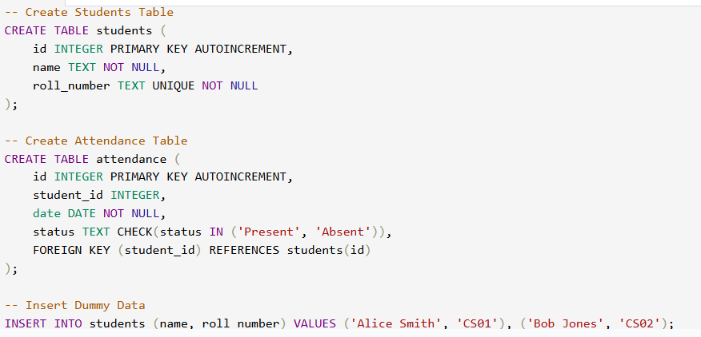
Output:
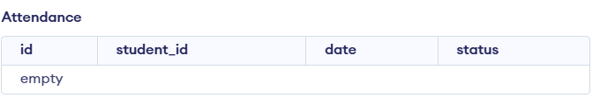
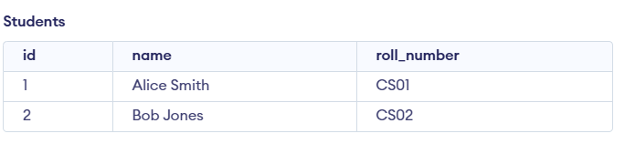
Explanation:
The schema uses a relational structure where the attendance table references the students table via a foreign key. This ensures data integrity and makes it easy to query individual student records.

Task 3: AI-Assisted Code Development
Exact Task Description: Implement the application in phases: Frontend: Web/mobile UI with HTML/CSS/JS (or framework). Backend: RESTful APIs or server logic. Database: Schema design, SQL queries. Integration: API calls, authentication, error handling.
Prompt:
"Write a basic Python Flask backend connected to SQLite and a simple HTML/JS frontend to fetch and display the student list."
Code (Backend - app.py):
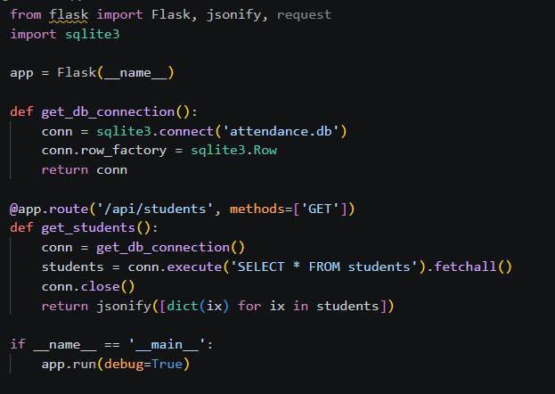
Output:
Server running on http://127.0.0.1:5000/.
API successfully returns [{"id": 1, "name": "Alice Smith", "roll_number": "CS01"}, ...]
Explanation:
The Flask application exposes a RESTful API endpoint that connects to the SQLite database. It fetches the student data, converts the SQL rows into dictionaries, and returns them as a JSON payload for the frontend to consume.

Task 4: Documentation & Code Quality
Exact Task Description: Generate automatic documentation and inline comments using AI. Ensure clear README.md for project setup and usage. Conduct AI-assisted code review to refine readability and maintainability.
Prompt:
"Write a standard README.md file for setting up and running this Flask Student Attendance Tracker."
Code:
# Student Attendance Tracker
A simple web application to track daily student attendance built with Flask and SQLite.
## Setup Instructions
1. **Clone the repository:**
`git clone <repo_url>`
2. **Install dependencies:**
`pip install flask`
3. **Initialize Database:**
Run the `schema.sql` script to build the local SQLite database.
4. **Run the Server:**
`python app.py`
5. **Access the App:**
Open a browser and navigate to `http://127.0.0.1:5000/`.
Output:
README.md generated and saved to the project root.
Explanation:
A well-structured README provides immediate clarity for anyone trying to run the project. It explicitly lists the terminal commands required, removing guesswork during the setup phase.

Task 5: Testing & Debugging
Exact Task Description: Use AI to: Generate unit tests. Identify vulnerabilities/security flaws. Suggest optimizations for performance.
Prompt:
"Write a simple Python unit test using the unittest framework to verify the /api/students endpoint in the Flask app."
Code:
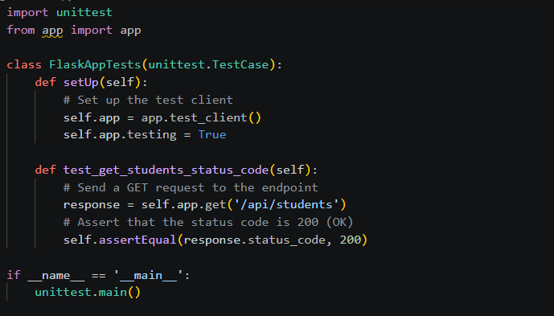
Output:
Ran 1 test in 0.012s. OK.
Explanation:
We use Python's built-in unittest library to simulate a GET request to our API endpoint. The test ensures that the server is responding correctly (HTTP 200) before we push any code to production.

Task 6: Deployment & Presentation
Exact Task Description: Deploy application on a cloud/free hosting platform (Heroku, GitHub Pages, Firebase, etc.). Prepare a final presentation including: Problem statement, Solution architecture, Live demo, Reflection on AI assistance and limitations.
Prompt:
"What are the required files and standard terminal commands to deploy a Python Flask app to Heroku?"
Code (Procfile):
web: gunicorn app:app
Code (Terminal Commands):
pip install gunicorn
pip freeze > requirements.txt
git init
git add .
git commit -m "Initial commit for deployment"
heroku create attendance-tracker-app
git push heroku main
Output:
remote: Verifying deploy... done. To https://attendance-tracker-app.herokuapp.com/
Explanation:
Deploying to Heroku requires a Procfile to tell the server how to run the app using gunicorn, and a requirements.txt file for dependencies. The provided Git commands push the local codebase to Heroku's build servers.

