AI Assisted Coding – Lab 8
Program: B.Tech
Academic Year: 2025–2026
Course Title: AI Assisted Coding
Course Code: 23CS002PC304
Coordinator: Dr. Rishabh Mittal
Year/Sem: III / II (R23)
Assignment No: 8.2 / 24 (Week 4 – Lab)
Student Name: R.seetharam
Roll No: 2303A52440

Lab Objective
To understand Test-Driven Development (TDD) using AI-generated test cases and Python implementations, ensuring correctness, validation, and robust error handling.

✅ Task 1 – Even / Odd Number Validator (TDD)

AI Explanation
In Test-Driven Development, test cases are written first to define expected behavior. The function is then implemented to satisfy all tests, including edge cases like zero, negative numbers, and invalid inputs.

Python Test Cases (AI-Generated)
import unittest
class TestEvenOdd(unittest.TestCase):
def test_even(self):
self.assertTrue(is_even(2))
self.assertTrue(is_even(0))
self.assertTrue(is_even(-4))
def test_odd(self):
self.assertFalse(is_even(7))
self.assertFalse(is_even(9))

Python Implementation
def is_even(n):
if not isinstance(n, int):
raise ValueError("Input must be an integer")
return n % 2 == 0
📸
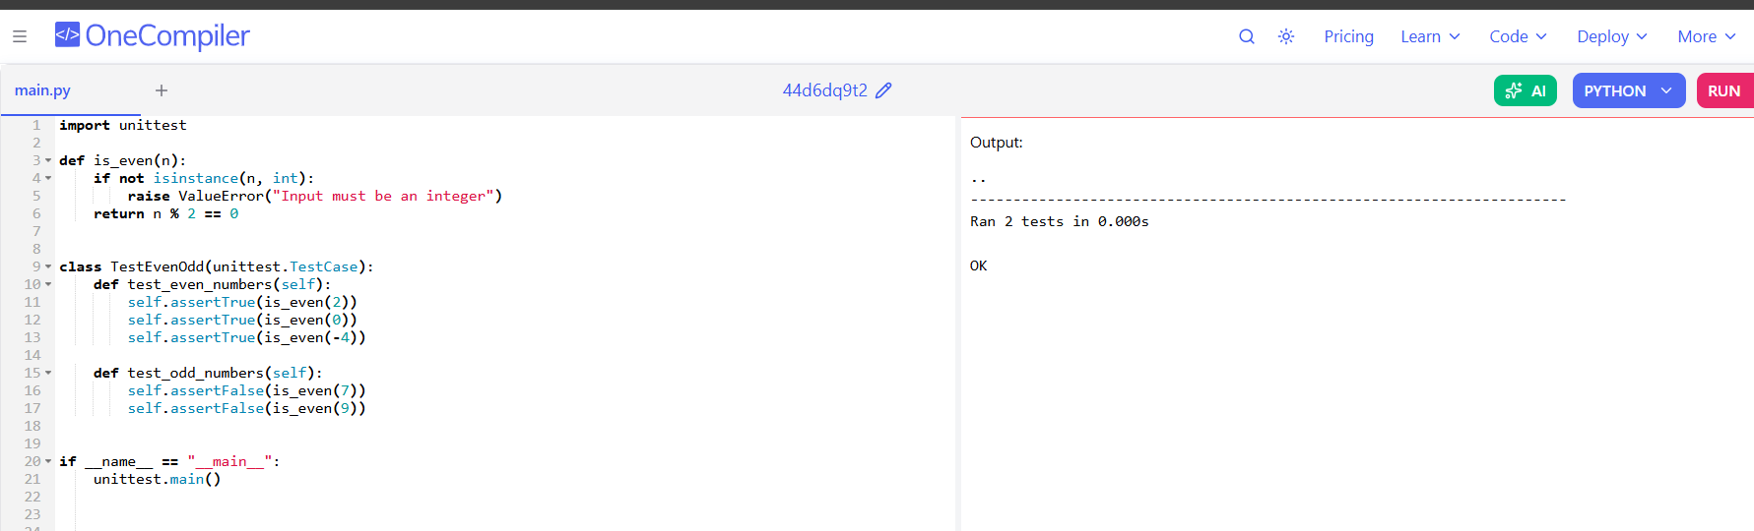

✅ Task 2 – String Case Converter (TDD)

AI Explanation
Test cases define how uppercase and lowercase conversions should behave for normal strings, empty strings, and invalid inputs. Functions are written to safely handle all cases.

Python Test Cases
class TestStringCase(unittest.TestCase):
def test_uppercase(self):
self.assertEqual(to_uppercase("ai coding"), "AI CODING")
self.assertEqual(to_uppercase(""), "")
def test_lowercase(self):
self.assertEqual(to_lowercase("TEST"), "test")

Python Implementation
def to_uppercase(text):
if not isinstance(text, str):
return ""
return text.upper()
def to_lowercase(text):
if not isinstance(text, str):
return ""
return text.lower()
📸
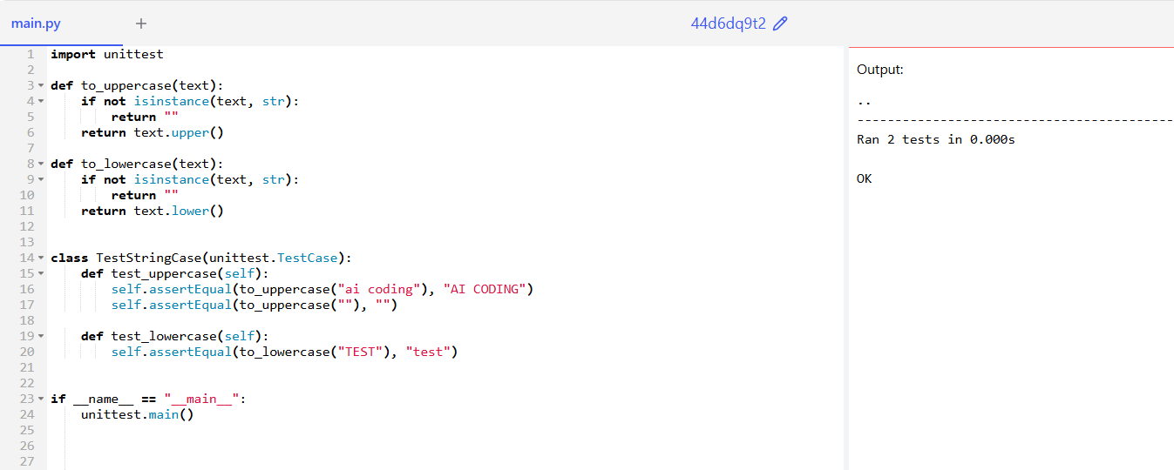

✅ Task 3 – List Sum Calculator (TDD)

AI Explanation
The function calculates the sum of numeric values while safely ignoring non-numeric elements. Tests ensure correct handling of empty lists and negative numbers.

Python Test Cases
class TestListSum(unittest.TestCase):
def test_sum(self):
self.assertEqual(sum_list([1,2,3]), 6)
self.assertEqual(sum_list([]), 0)
self.assertEqual(sum_list([-1,5,-4]), 0)
self.assertEqual(sum_list([2,'a',3]), 5)

Python Implementation
def sum_list(numbers):
total = 0
for n in numbers:
if isinstance(n, (int, float)):
total += n
return total
📸
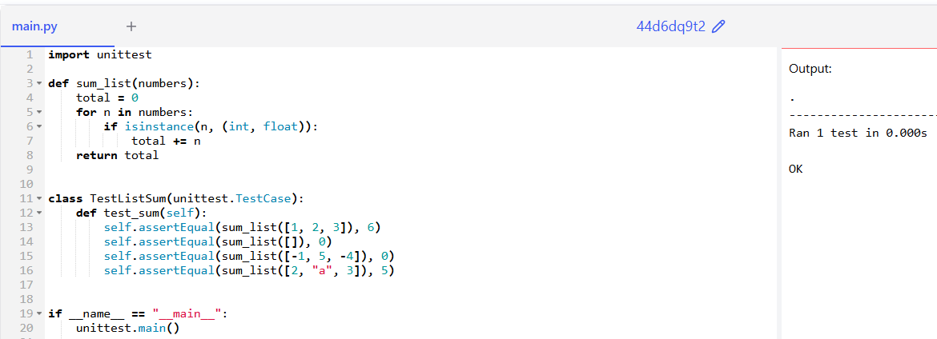

✅ Task 4 – Student Result Class (TDD)

AI Explanation
The StudentResult class validates marks, computes average, and determines pass/fail status based on defined rules.

Python Implementation
class StudentResult:
def __init__(self):
self.marks = []
def add_marks(self, mark):
if mark < 0 or mark > 100:
raise ValueError("Invalid mark")
self.marks.append(mark)
def calculate_average(self):
return sum(self.marks) / len(self.marks)
def get_result(self):
return "Pass" if self.calculate_average() >= 40 else "Fail"
📸
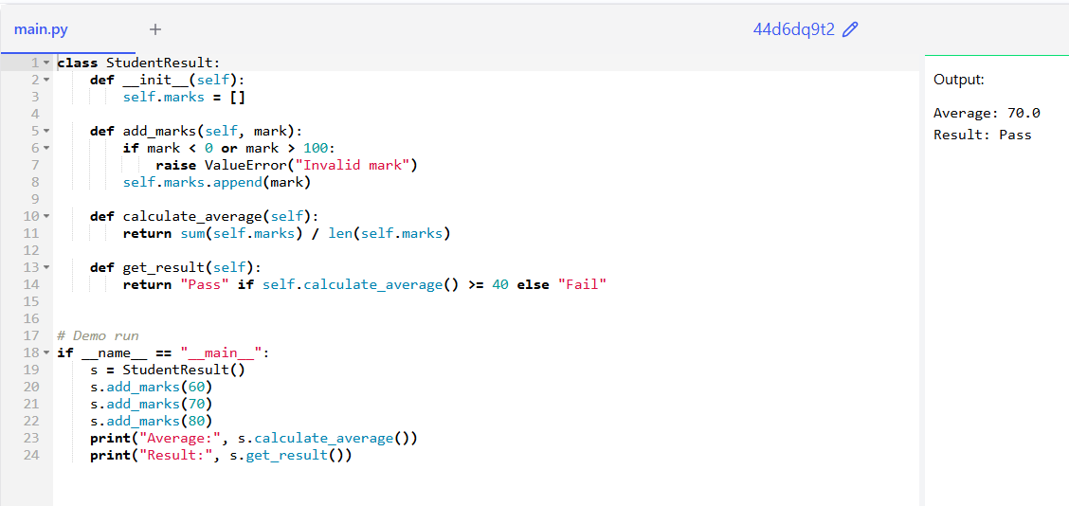

✅ Task 5 – Username Validator (TDD)

AI Explanation
The username validator ensures length, character validity, and absence of spaces using rule-based checks.

Python Implementation
import re
def is_valid_username(username):
if not isinstance(username, str):
return False
if len(username) < 5:
return False
if " " in username:
return False
return re.match("^[a-zA-Z0-9]+$", username) is not None
📸
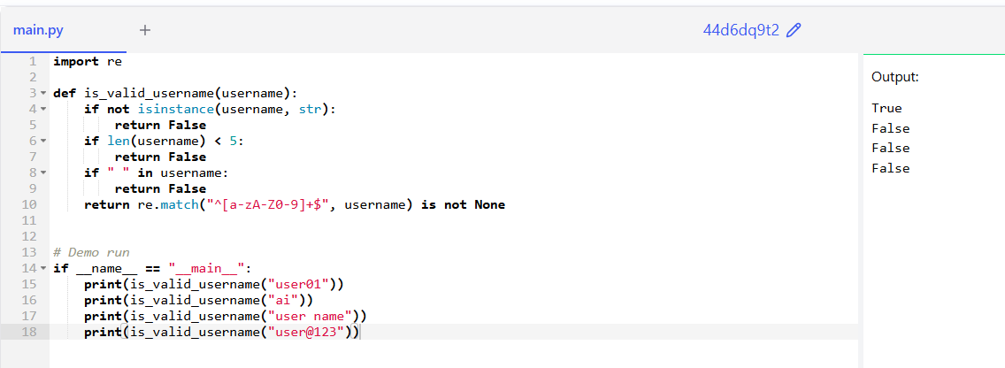

Conclusion
This lab successfully demonstrated Test-Driven Development using AI-generated test cases in Python, ensuring reliable, well-tested, and maintainable code.

