AI ASSISTANT CODING
ASSIGNMENT-9.5

Name: R.seetharam reddy
Enrollment no: 2303A52440
Batch: 34
Semester: VI
Branch: CSE(AIML)

Lab Experiment: Documentation Generation -Automatic documentation and code comments

Problem 1: String Utilities Function
Consider the following Python function:
def reverse_string(text):
return text[::-1]
Task:
1. Write documentation in:
o (a) Docstring
o (b) Inline comments
o (c) Google-style documentation
2. Compare the three documentation styles.
3. Recommend the most suitable style for a utility-based string library.

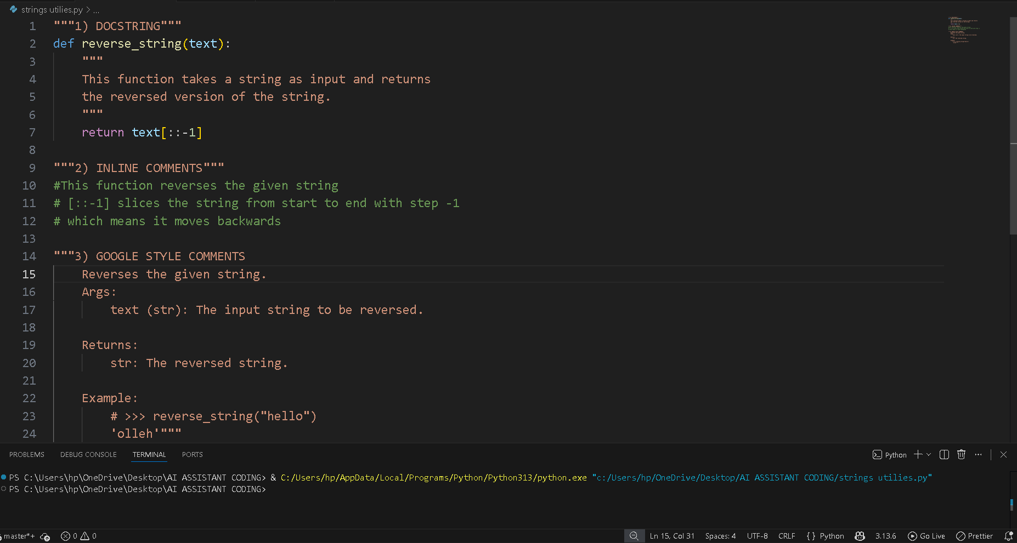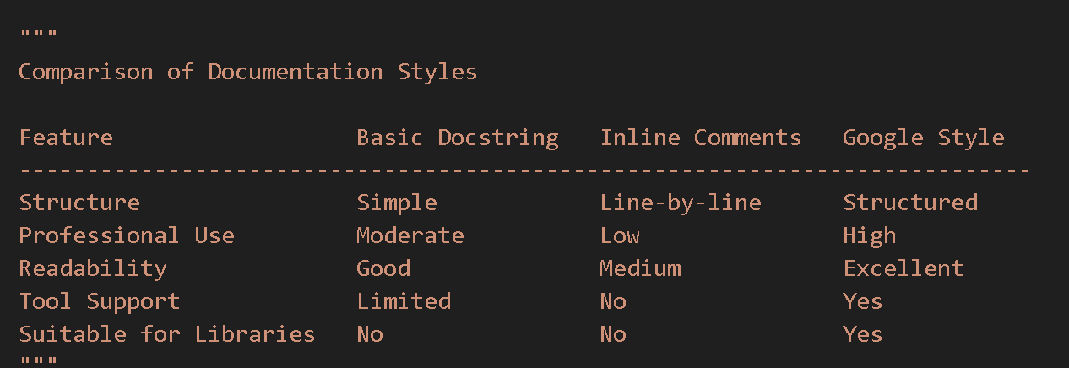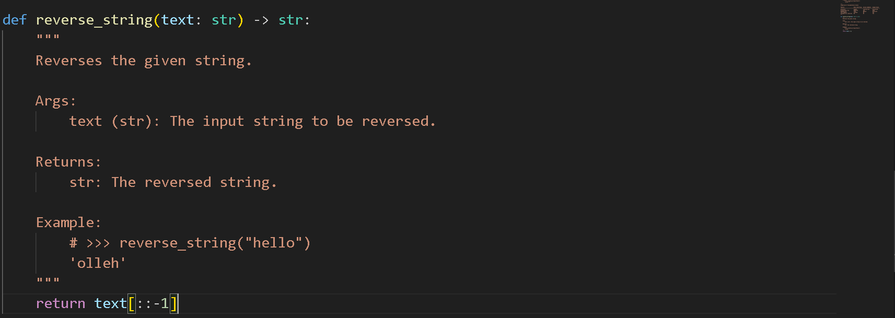

Problem 2: Password Strength Checker
Consider the function:
def check_strength(password):
return len(password) >= 8
Task:
1. Document the function using docstring, inline comments, and
Google style.
2. Compare documentation styles for security-related code.
3. Recommend the most appropriate style.
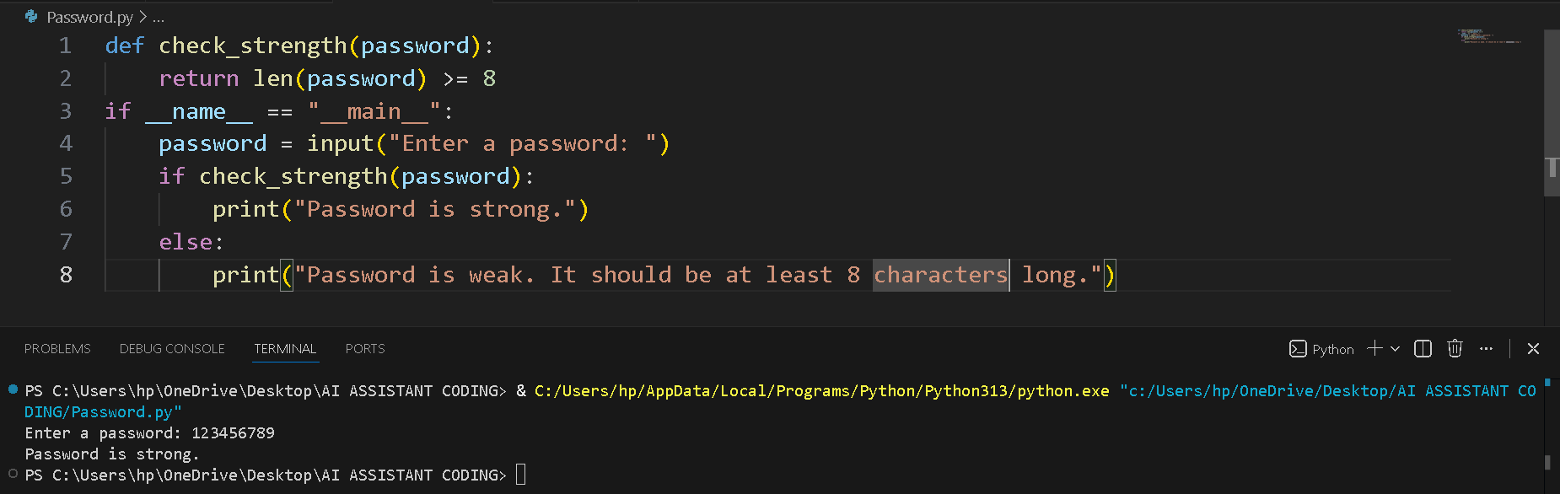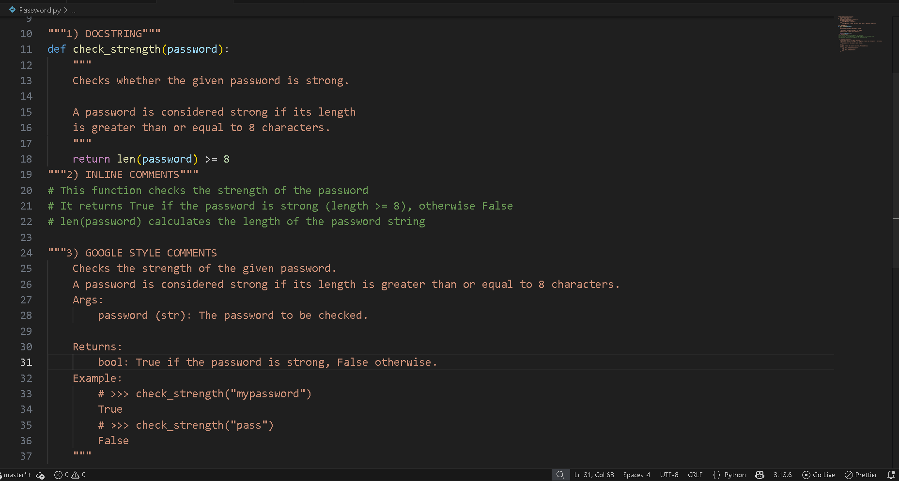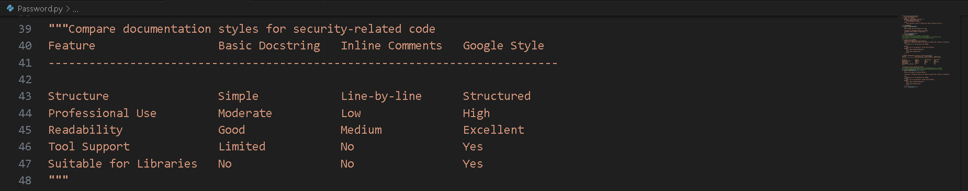
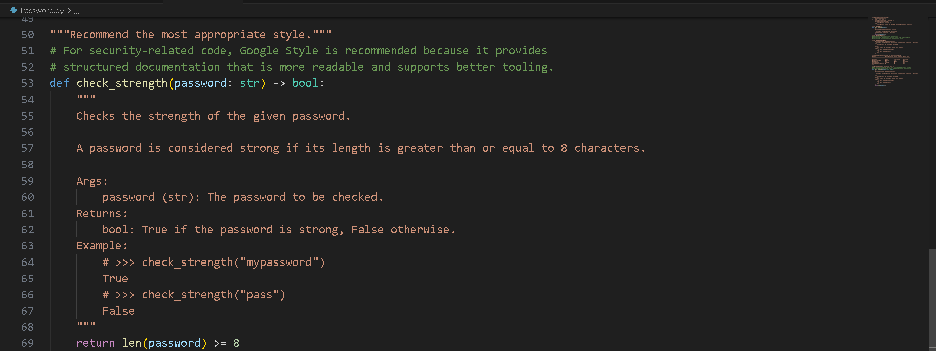
Problem 3: Math Utilities Module
Task:
1. Create a module math_utils.py with functions:
o square(n)
o cube(n)
o factorial(n)
2. Generate docstrings automatically using AI tools.
3. Export documentation as an HTML file.

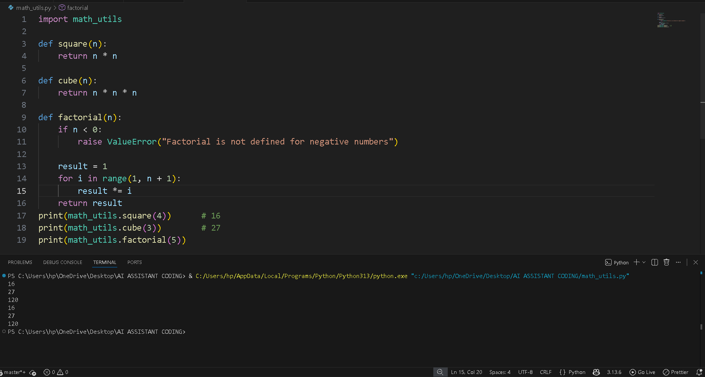

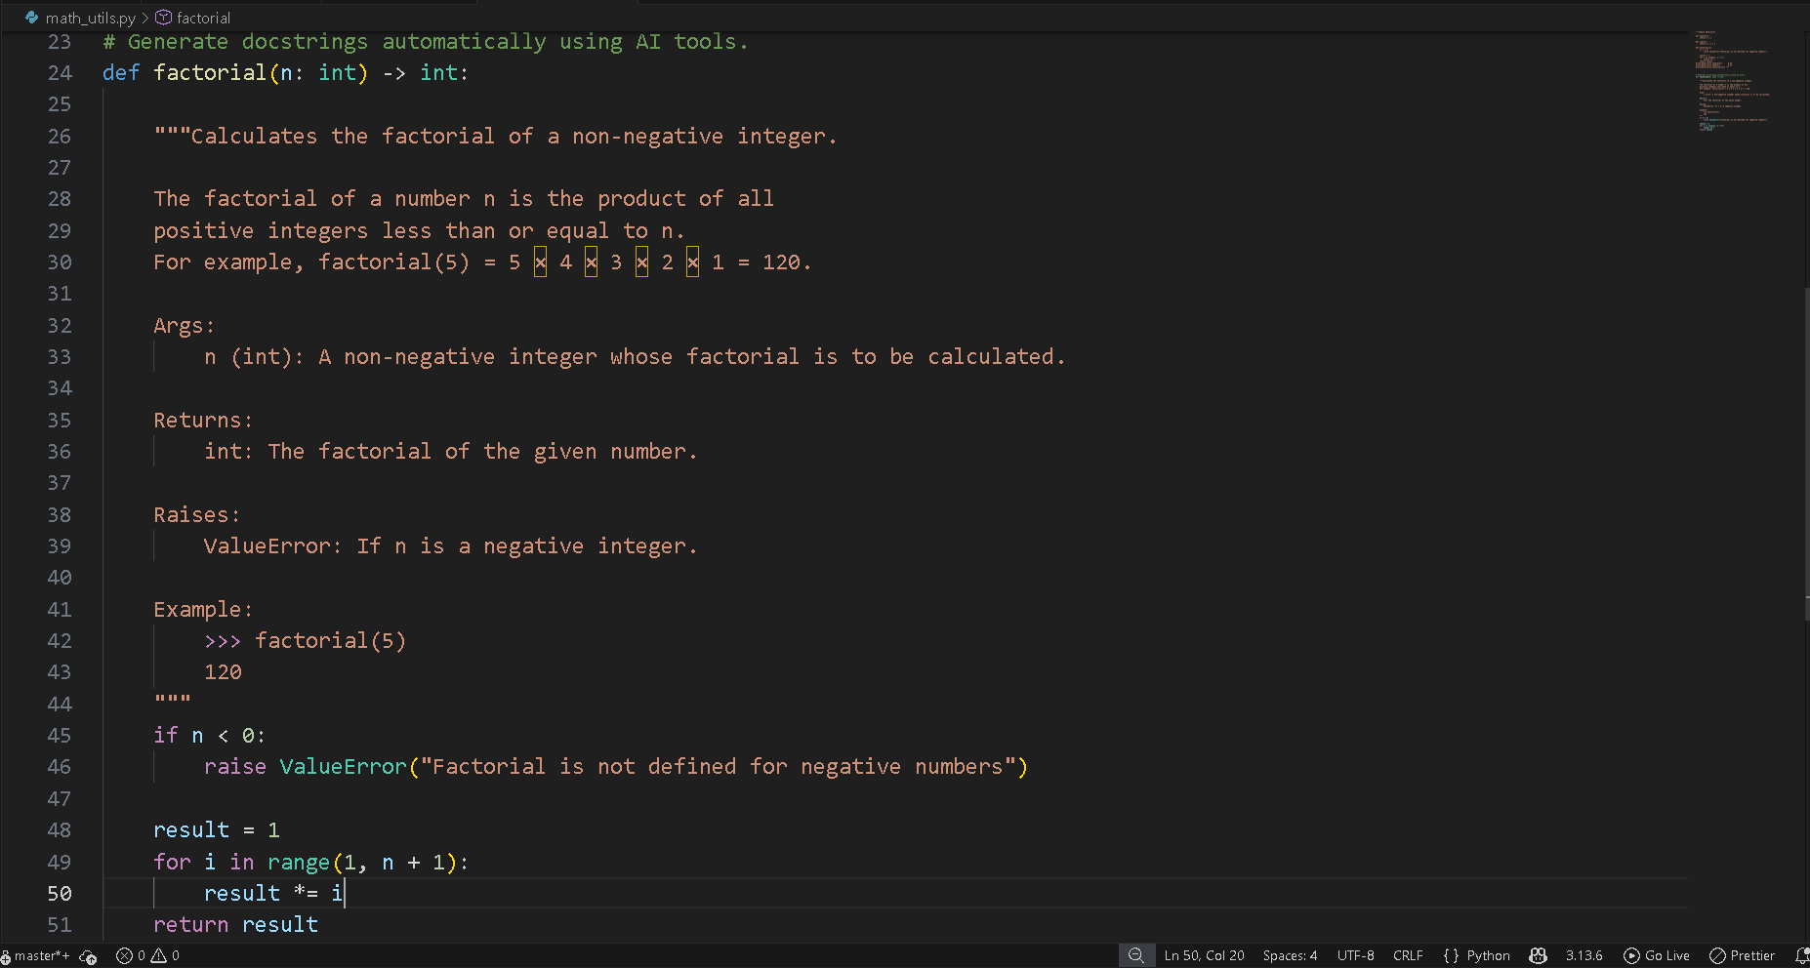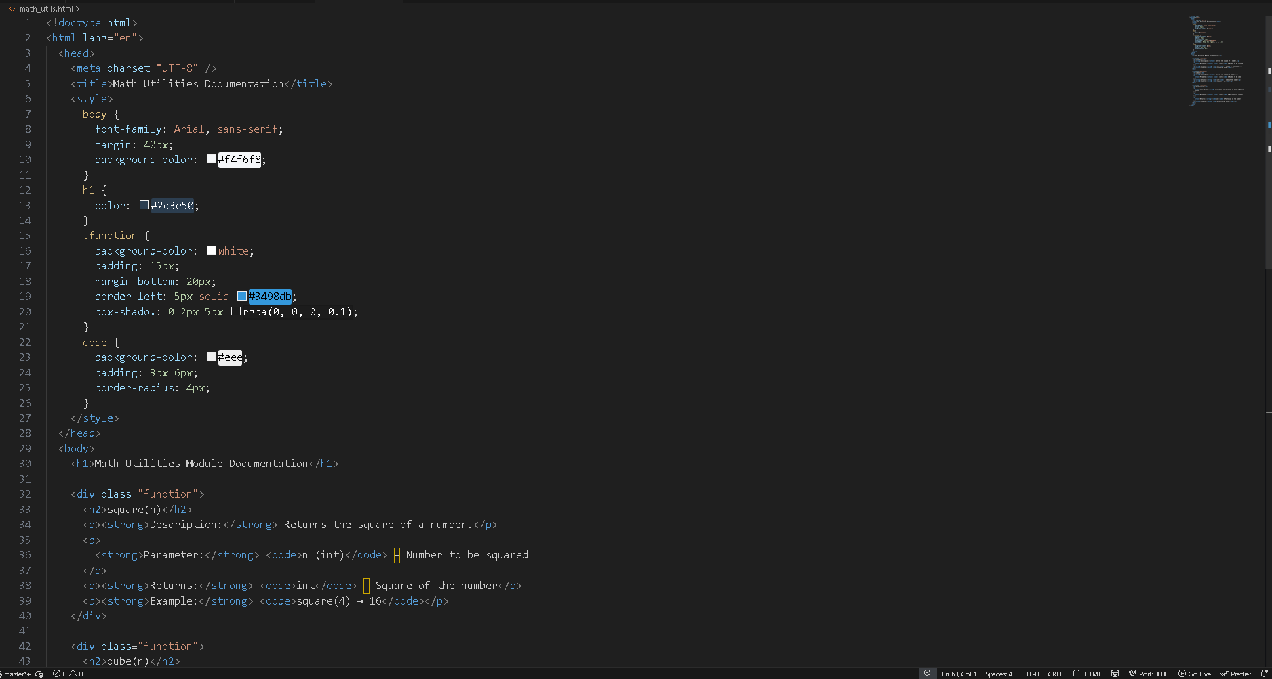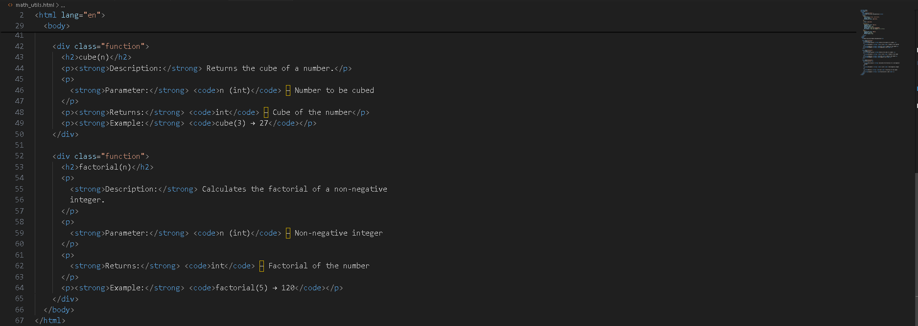

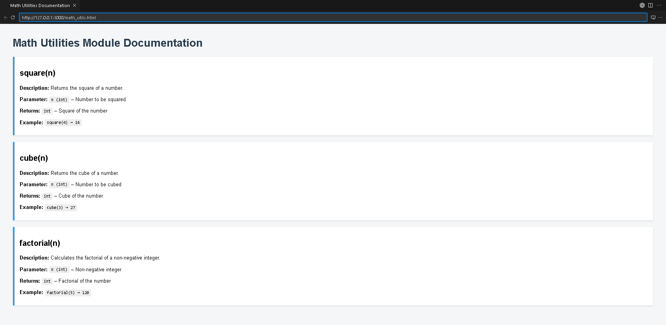
Problem 4: Attendance Management Module
Task:
1. Create a module attendance.py with functions:
o mark_present(student)
o mark_absent(student)
o get_attendance(student)
2. Add proper docstrings.
3. Generate and view documentation in terminal and browse
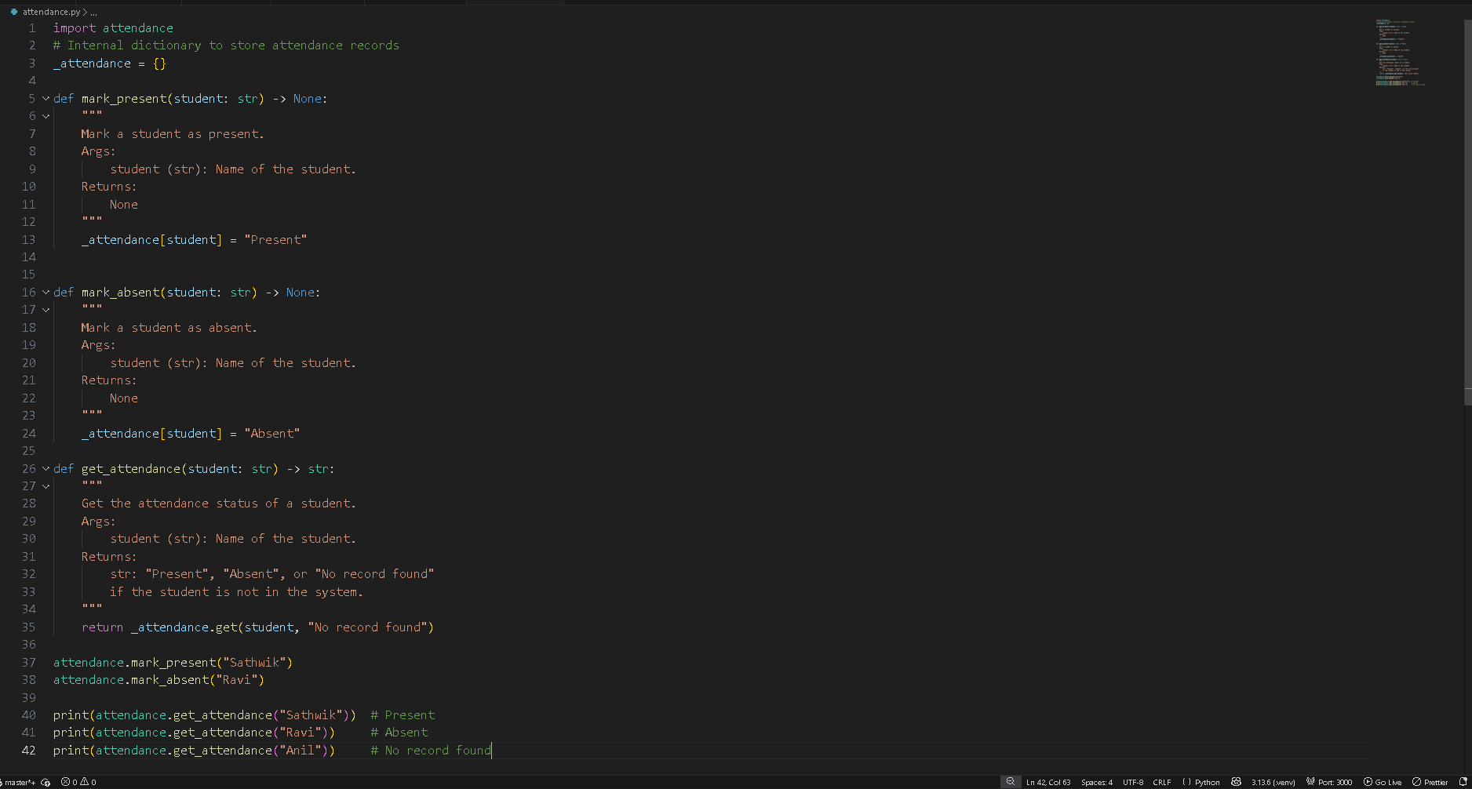
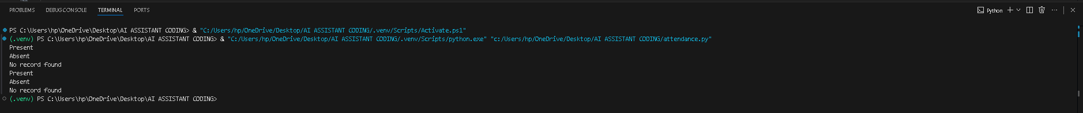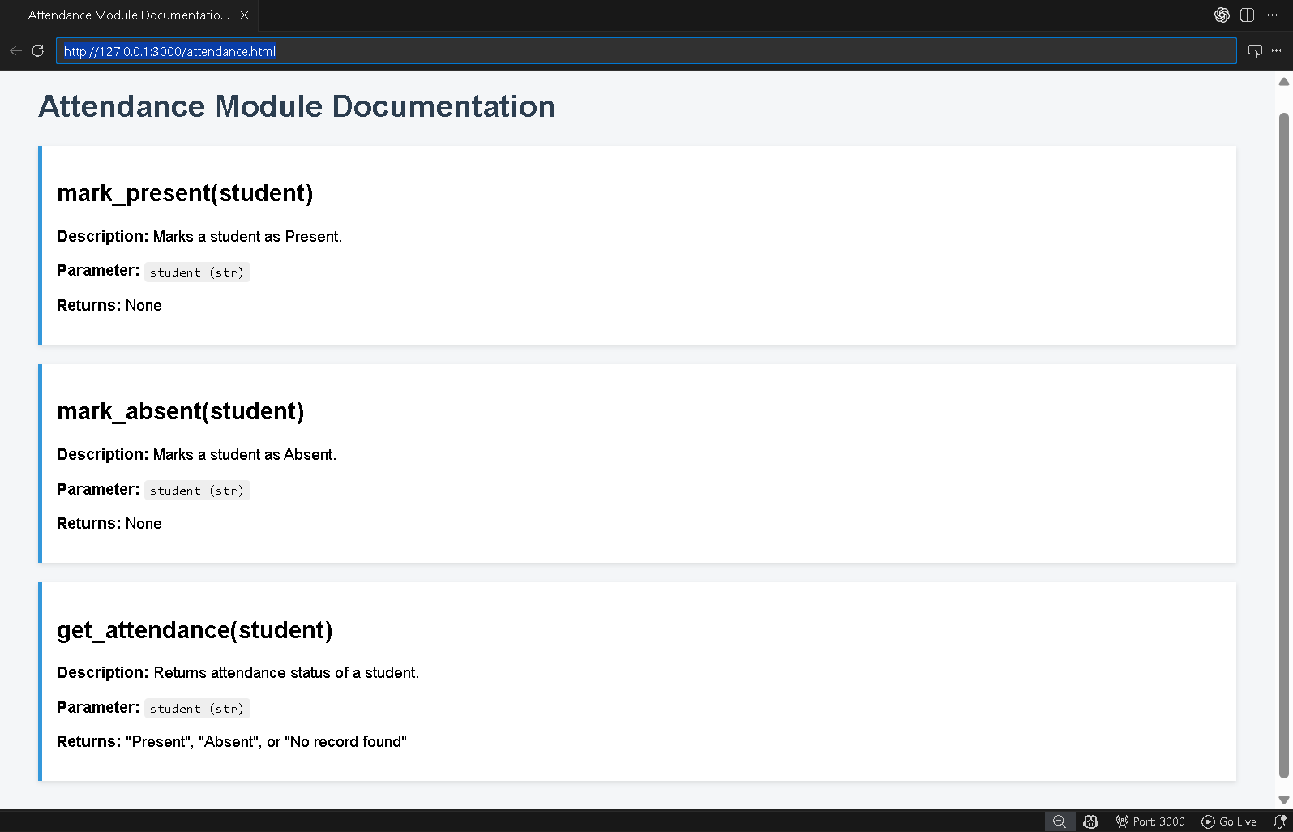

Problem 5: File Handling Function
Consider the function:
def read_file(filename):
with open(filename, 'r') as f:
return f.read()
Task:
1. Write documentation using all three formats.
2. Identify which style best explains exception handling.
3. Justify your recommendation.
