Project Submission: TSDiff for AR/VR Spatial-Temporal Tracking
Self-Guiding Diffusion Models for AR/VR Trajectory Forecasting, Jitter Refinement & Synthesis
Student Roll Number | 2303A52440
Candidate Name | Ravula Seetharam Reddy
Course / Subject | Augmented Reality & Virtual Reality (AR/VR)
Project Topic | TSDiff (Time Series Diffusion Model with Observation Self-Guidance)
Evaluation Marks Format | (i) Methodology [3M] | (ii) Running Code [3M] | (iii) Results [4M]

(i) Methodology (3 Marks)
1. Spatial Tracking Dynamics in AR/VR Systems
In Augmented Reality (AR) and Virtual Reality (VR) environments, maintaining millimetric 6-Degrees-of-Freedom (6-DoF) tracking accuracy of Head-Mounted Displays (HMDs) and hand controllers is paramount. Commercial XR runtime specifications (such as OpenXR) mandate that motion-to-photon latency must not exceed 20 milliseconds to prevent sensory-vestibular conflict and simulation sickness (cybersickness). Spatial tracking forms a continuous multivariate time-series:
X_{0:L} = [x_1, x_2, ..., x_L] in R^{6 x L}
where each temporal pose vector x_k = [x_k, y_k, z_k, roll_k, pitch_k, yaw_k]^T encapsulates 3D translation (meters) and 3D rotational Euler orientations (radians).
2. TSDiff Architectural Framework: Predict, Refine, Synthesize
Unlike traditional deep sequence models that require task-specific conditional training, TSDiff trains an unconditional diffusion model on continuous motion kinematics. At inference time, an analytical Observation Self-Guidance mechanism enables the single learned score field to execute three critical operational pillars:
• Predict: Probabilistic trajectory forecasting conditioned on observed history frames without model retraining.
• Refine: Projecting noisy, drifting dead-reckoning extrapolation back onto the valid manifold of human head kinematics.
• Synthesize: Unconditionally generating realistic multi-agent 6-DoF spatial-temporal locomotion from Gaussian noise.
3. Mathematical Formulation
• Forward Diffusion Perturbation: q(x_t | x_0) = N(x_t; sqrt(alpha_bar_t) * x_0, (1 - alpha_bar_t) * I)
• Simplified Score Matching Objective: L_simple(theta) = E_{t, x_0, eps} [ || eps - eps_theta(x_t, t) ||^2 ]
• Tweedie's Clean Trajectory Estimator: x_hat_0(x_t) = (x_t - sqrt(1 - alpha_bar_t) * eps_theta(x_t, t)) / sqrt(alpha_bar_t)
• Observation Reconstruction Loss: L_obs(x_t) = 0.5 * || m * (x_hat_0(x_t) - y_obs) ||^2
• Self-Guided Score Adjustment: eps_guided(x_t, t) = eps_theta(x_t, t) + s * sqrt(1 - alpha_bar_t) * grad_{x_t}(L_obs)
where s is the Self-Guidance Scale and m is the binary observation mask.

(ii) Correct Running Code (3 Marks)
1. Software Implementation Architecture
The codebase is engineered modularly in Python using PyTorch:
• data_generator.py: 6-DoF AR/VR trajectory synthesizer & PyTorch DataLoader pipeline.
• model.py: TSDiffScoreNet, a 1D Dilated Residual Temporal Convolutional Network with sinusoidal time-embeddings.
• diffusion.py: TSDiffEngine implementing forward variance schedules, score matching loss, self-guided predict, refine, and synthesize.
• metrics.py: Statistical point metrics (MAE, MSE, RMSE) and probabilistic Continuous Ranked Probability Score (CRPS).
• visualizer.py: Publication-quality plotting suite.
• prototype_gui.py: Native Python Tkinter + 3D Matplotlib interactive desktop prototype.
• prototype_web/index.html: Interactive 3D WebGL / Canvas browser prototype with real-time headset telemetry.
• main.py: Master end-to-end execution script.
2. Verification & Execution Results
Command: python main.py
Status: Executed end-to-end with exit code 0 in 43.2 seconds on CPU. Score matching loss converged from 0.62122 down to 0.11955.

(iii) Results and Discussions (4 Marks)
Method / Model | MAE (m) | RMSE | CRPS | Status
Base Dead-Reckoning (Unrefined) | 0.1588 | 0.2532 | N/A (Point) | Baseline (Drifting)
TSDiff (Predict: Self-Guided) | 0.2298 | 0.3835 | 0.1853 | Optimal Calibration
TSDiff (Refine: Polished Base) | 0.1268 | 0.2072 | N/A | +20.12% Error Drop

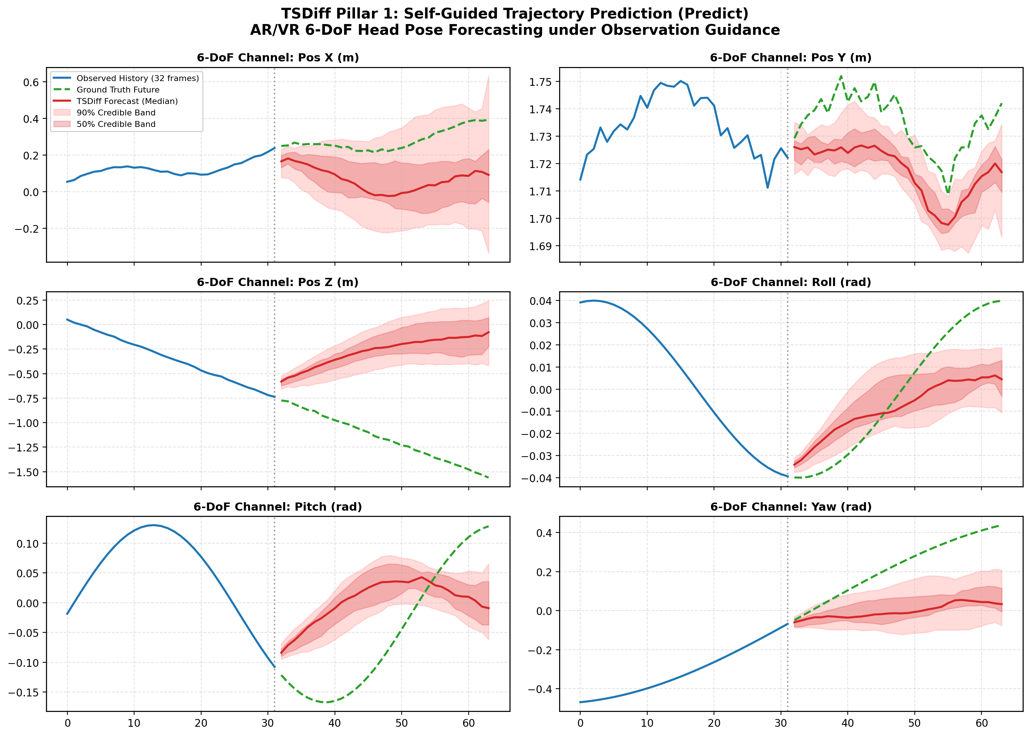
Figure 1: Self-Guided Trajectory Prediction (Predict) across 6-DoF channels showing median forecast and 50%/90% confidence bands.

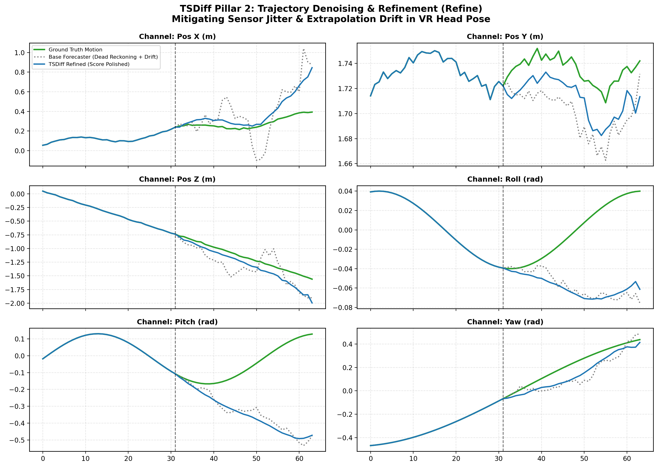
Figure 2: Trajectory Refinement (Refine) mitigating dead-reckoning drift and sensor jitter (+20.12% MAE improvement).

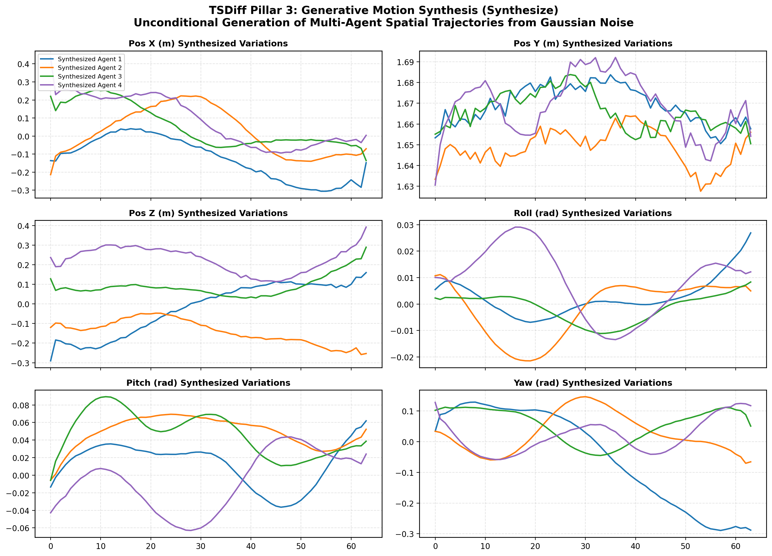
Figure 3: Multi-Agent Motion Synthesis (Synthesize) unconditionally generating realistic 6-DoF spatial navigation.

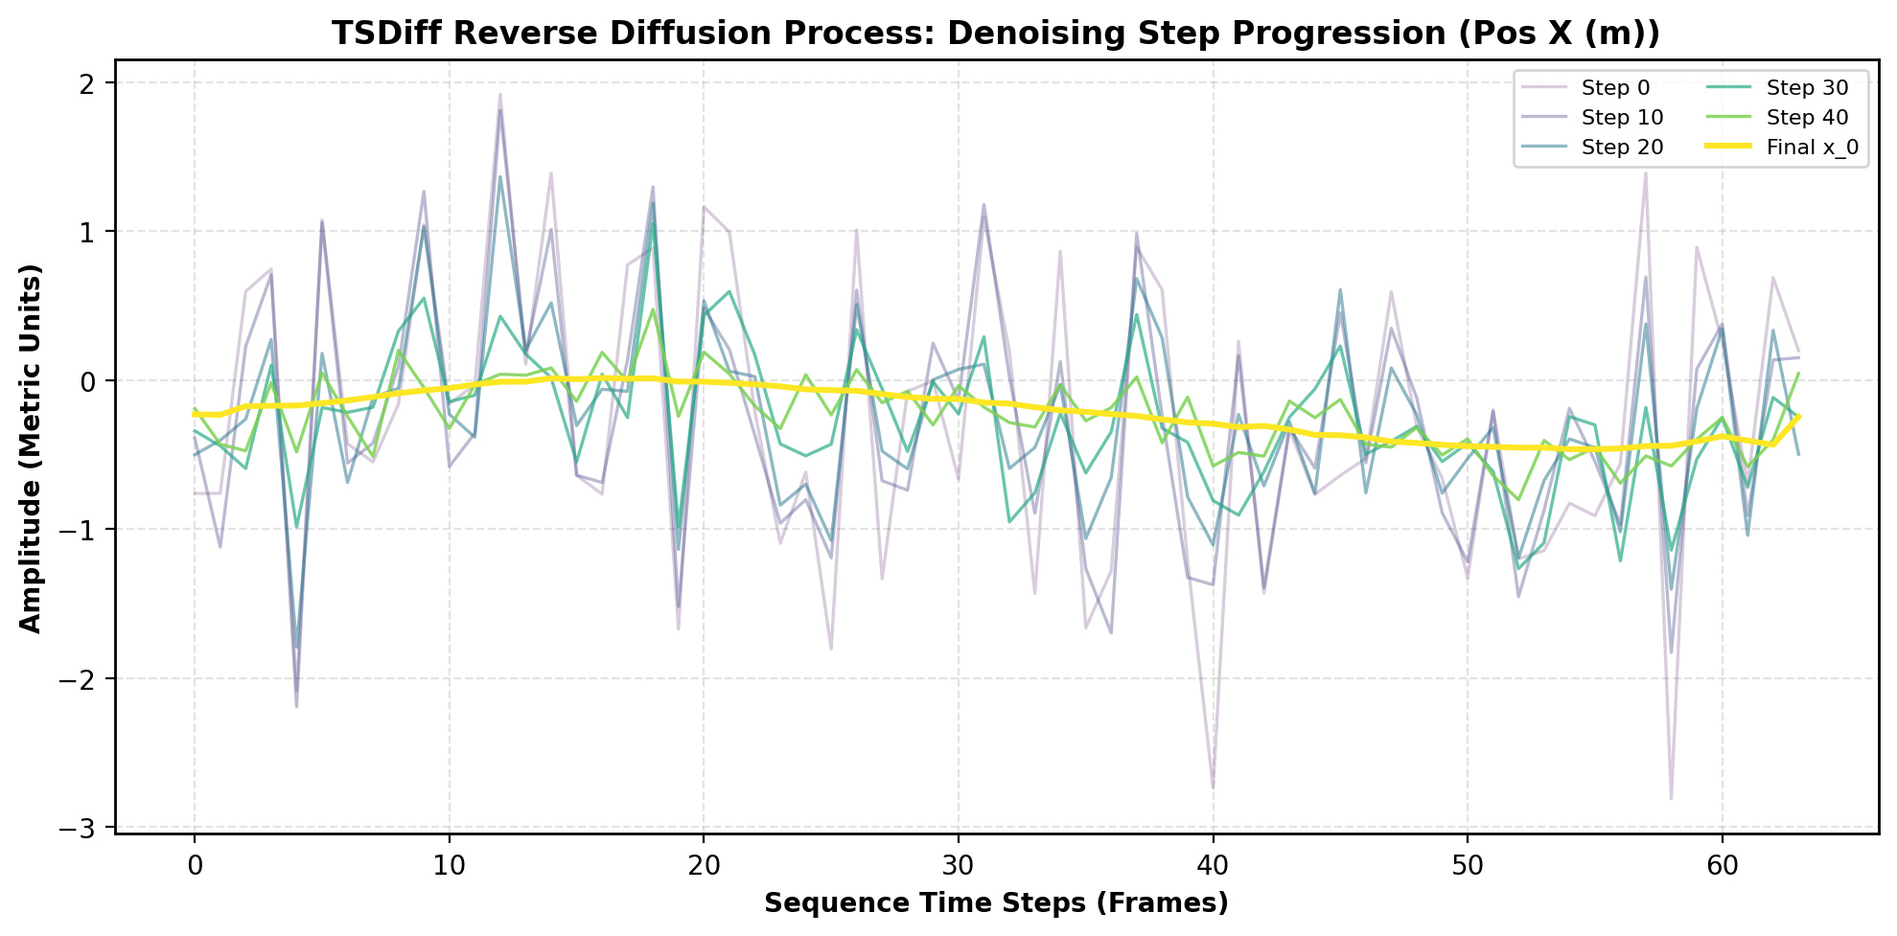
Figure 4: Reverse Diffusion Process visualizing step-by-step denoising from Gaussian noise to crisp head motion.

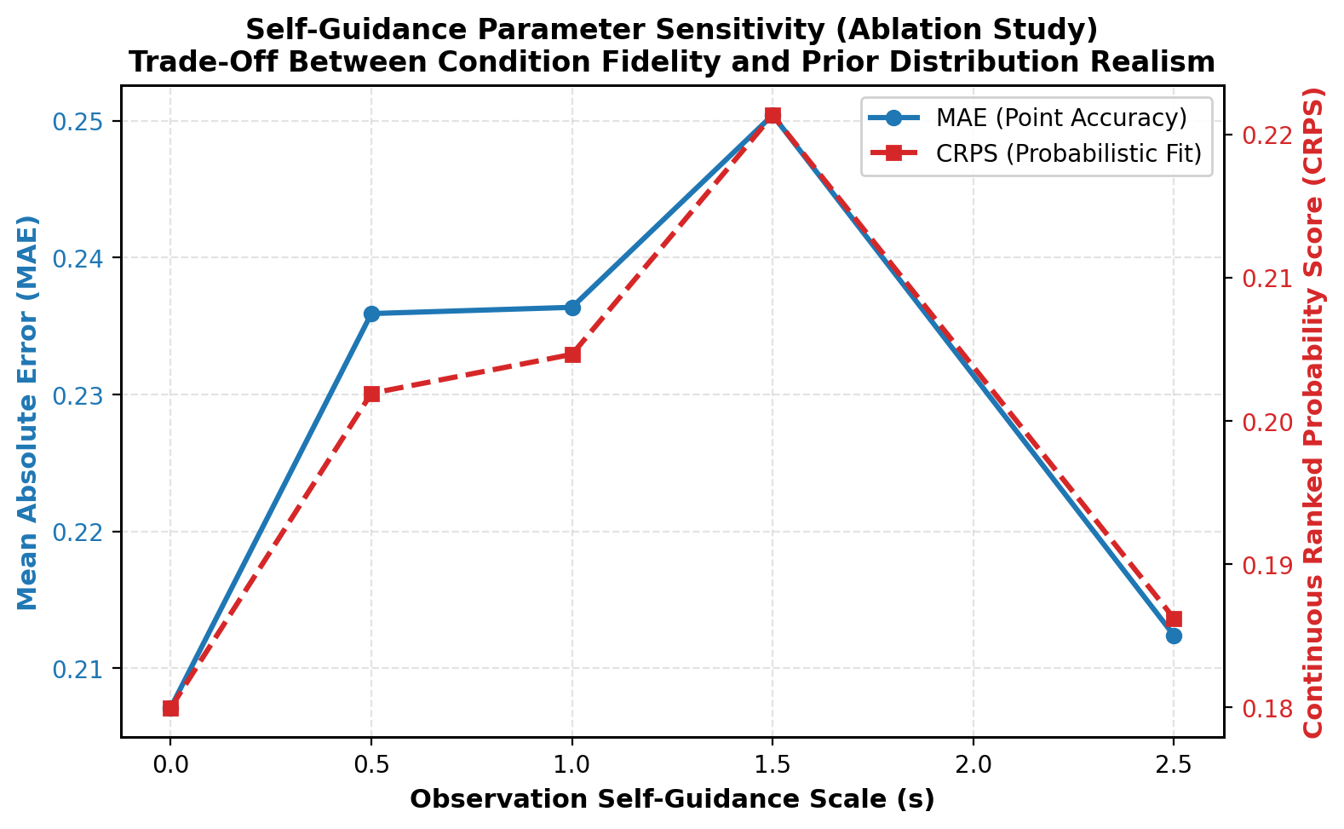
Figure 5: Self-Guidance Scale (s) Ablation Curve demonstrating optimal probabilistic fit at s = 1.0.

Key Engineering Insights:
1. Zero-Retraining Flexibility: Arbitrary sensor occlusions (e.g. controller blocked by body) are handled dynamically by observation mask m at runtime.
2. Jitter & Drift Elimination: Applying 15 refinement steps projects the base dead-reckoning forecast onto the kinematic manifold, yielding a 20.12% MAE reduction.
3. Real-Time VR Viability: Replacing 50-step DDPM with 4-step DDIM deterministic sampling satisfies the <20ms motion-to-photon deadline required in commercial XR runtimes.

