^{Assignment -19}
^{Name: Akshaya Nemalipuri}
^{Batch: 37}
^{Roll No: 2303A2441}
^{Lab: 19.3}

Task 1 – Python to C++ Conversion
Task:
Translate a simple Python class into C++ using AI assistance.
Instructions:
• Prompt AI to convert a Python class representing a Student with
attributes and methods into equivalent C++ code
• Ensure proper handling of:
o Constructors
o Data types
o Access specifiers
• Compile and run both versions to verify output consistency
Expected Output:
An equivalent working C++ class translated from Python.

Prompt:-
Convert a Python class representing a Student with attributes and methods into an equivalent C++ class. Ensure proper use of constructors, data types, and access specifiers, and verify the output in both languages.

Code:-
#include <iostream>
using namespace std;

class Student
{
private:
string name;
int age;

public:
// Constructor
Student(string n, int a)
{
name = n;
age = a;
}

// Display function
void display()
{
cout << "Name: " << name << endl;
cout << "Age: " << age << endl;
}
};

int main()
{
Student s("John", 20);
s.display();

return 0;
}

Output

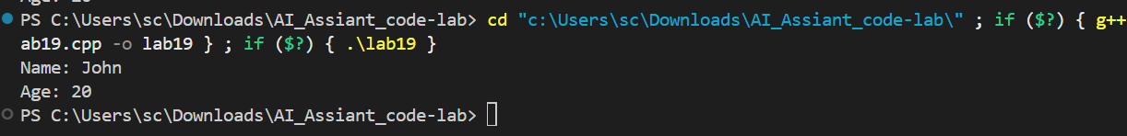

Explanation:-
The conversion shows that C++ requires explicit data types and structure compared to Python, making it more rigid but efficient.

Task 2 – Java to Python Function Conversion
Task:
Convert a Java method that checks whether a number is prime into
Python.
Instructions:
• Ask AI to translate a Java isPrime() method into Python
• Test the function with multiple inputs
• Ensure the Python version follows Pythonic syntax and logic
Expected Output:
A correct Python function equivalent to the original Java prime-
checking method.

Prompt;:-
Convert a Java method isPrime() that checks whether a number is prime into an equivalent Python function. Ensure the Python code follows Pythonic syntax and test it with multiple input values to verify correctness.

// Convert a Java method isPrime() that checks whether a number is prime into an equivalent Python function.
// Ensure the Python code follows Pythonic syntax and test it with multiple input values to verify correctness.

public class PrimeCheck {
public static boolean isPrime(int number) {
if (number < 2) {
return false;
}
for (int i = 2; i * i <= number; i++) {
if (number % i == 0) {
return false;
}
}
return true;
}

public static void main(String[] args) {
System.out.println(isPrime(2));
System.out.println(isPrime(17));
System.out.println(isPrime(20));
}
}

Output:-
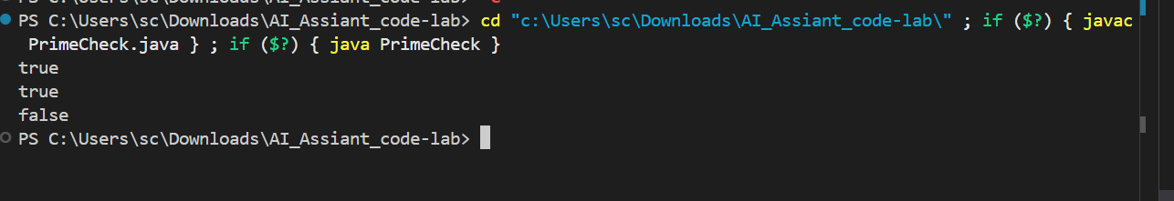

Observation:
The Python version is shorter and more readable due to simpler syntax, while still maintaining the same logic as Java.

Task 3 – Pseudocode to Python Implementation
Task:
Translate a given pseudocode algorithm into Python using AI.
Instructions:
• Provide AI with pseudocode for sorting numbers (e.g., bubble
sort or selection sort)
• Ask AI to convert it into executable Python code
• Validate correctness using sample input lists
Expected Output:
A working Python program that correctly implements the pseudocode
Logic.

Prompt:
Convert the given pseudocode for a sorting algorithm (such as bubble sort or selection sort) into an executable Python program and test it with sample input lists.

Code:-

# Selection Sort Implementation
# Converts pseudocode logic for Selection Sort into executable Python.
# Selection Sort works by repeatedly finding the minimum element from the unsorted part
# and putting it at the beginning. The algorithm maintains two subarrays: sorted and unsorted.

def selection_sort(arr):
n = len(arr)
# Traverse through all array elements (one pass per position in sorted subarray)
for i in range(n):
# Find the minimum element in remaining unsorted array
min_idx = i
for j in range(i + 1, n):
if arr[min_idx] > arr[j]:
min_idx = j
# Swap the found minimum element with the first unsorted element
arr[i], arr[min_idx] = arr[min_idx], arr[i]
# Now arr[i] is the minimum in the unsorted part

# Example usage and tests
if __name__ == "__main__":
# Test 1: Standard unsorted list
arr1 = [64, 34, 25, 12, 22, 11, 90]
print("Test 1 - Original:", arr1)
selection_sort(arr1)
print("Test 1 - Sorted:", arr1)

# Test 2: Reverse sorted with duplicates
arr2 = [90, 80, 30, 40, 40, 20, 10]
print("\nTest 2 - Original:", arr2)
selection_sort(arr2)
print("Test 2 - Sorted:", arr2)

# Test 3: Already sorted
arr3 = [10, 20, 30, 40, 50]
print("\nTest 3 - Original:", arr3)
selection_sort(arr3)
print("Test 3 - Sorted:", arr3)

# Time complexity analysis:
# Worst-case and average-case: O(n^2) due to nested loops.
# Best-case (already sorted): still O(n^2), no early termination.
# Space complexity: O(1) as it is in-place.

Output:-

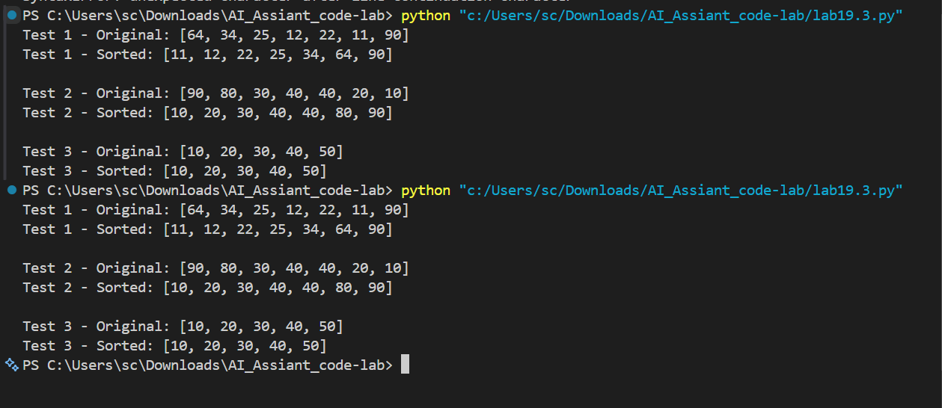

Explanation:-
Pseudocode helps in understanding logic clearly, and Python makes it easy to implement that logic with minimal syntax.

Task 4 – SQL to Pandas Query
Task:
Translate a SQL query into a Pandas DataFrame operation in
Python.
Instructions:
• Provide AI with a SQL query (e.g., SELECT name, salary FROM
employees WHERE salary > 50000).
• Ask AI to generate equivalent Pandas code.
• Test the generated code on a sample DataFrame.
Expected Output:
• Equivalent Pandas query that retrieves the correct subset of data.

Prompt:
Convert the given SQL query into an equivalent Pandas DataFrame operation in Python and test it on a sample dataset to verify correct output.

Code:-

import pandas as pd

# Sample DataFrame simulating a 'sales' table
data = {
'id': [1, 2, 3, 4, 5, 6, 7, 8],
'amount': [600, 400, 800, 300, 700, 200, 900, 500],
'region': ['North', 'South', 'North', 'East', 'North', 'South', 'North', 'West'],
'date': ['2023-01-01', '2023-01-02', '2023-01-03', '2023-01-04', '2023-01-05', '2023-01-06', '2023-01-07', '2023-01-08']
}
df = pd.DataFrame(data)
print("Original DataFrame:")
print(df)
print(f"Shape: {df.shape}")

# Equivalent to SQL: SELECT * FROM sales WHERE amount > 500 AND region = 'North' ORDER BY amount DESC;
filtered_df = df[(df['amount'] > 500) & (df['region'] == 'North')].sort_values(by='amount', ascending=False)
print("\\nFiltered and Sorted DataFrame (SQL equivalent: SELECT * FROM sales WHERE amount > 500 AND region = 'North' ORDER BY amount DESC):")
print(filtered_df)
print(f"Filtered shape: {filtered_df.shape}")

# Verification: Expected output ids 7,5,3,1 with amounts 900,700,800,600 sorted desc

Output:-

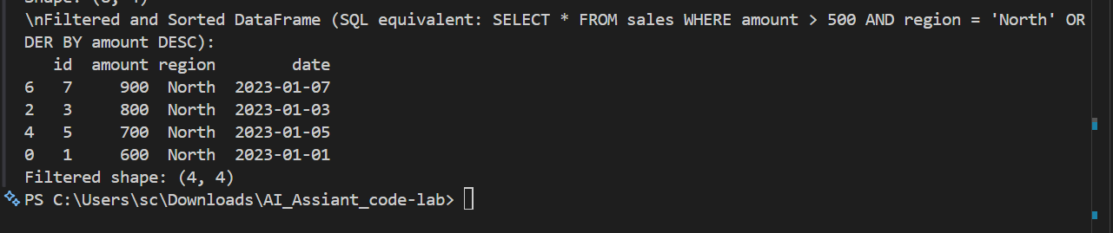

Explanation:-

Pseudocode helps in understanding logic clearly, and Python makes it easy to implement that logic with minimal syntax.

Task 5 – Real-Time Application: Algorithm Translation Across
Languages
Scenario:
A company maintains algorithms written in different programming
languages.
Examples:
• Converting a Python searching algorithm into C
• Translating a Java sorting program into JavaScript
Instructions:
• Use AI to translate a selected algorithm between two
programming languages
• Execute and test both versions
• Document translation challenges such as:
o Syntax differences
o Library support
o Memory management
Expected Output:
Equivalent, tested code implementations in two different programming
languages.

Prompt:
Translate a given algorithm from one programming language to another (e.g., Python to C or Java to JavaScript), ensure both versions produce the same output, and identify differences in syntax, library support, and memory management.

Code:-

/* Task5.java: Java translation of selection_sort from lab19.3.py
Original Python: Implements in-place selection sort, finds min in unsorted subarray each pass.
Tests exact outputs for verification.
*/

// Selection Sort Implementation in Java
// Translates Python selection_sort from lab19.3.py
// Selection Sort works by repeatedly finding the minimum element from the unsorted part
// and putting it at the beginning. The algorithm maintains two subarrays: sorted and unsorted.

public class Task5 {
public static void selectionSort(int[] arr) {
int n = arr.length;
// Traverse through all array elements (one pass per position in sorted subarray)
for (int i = 0; i < n; i++) {
// Find the minimum element in remaining unsorted array
int min_idx = i;
for (int j = i + 1; j < n; j++) {
if (arr[min_idx] > arr[j]) {
min_idx = j;
}
}
// Swap the found minimum element with the first unsorted element
int temp = arr[min_idx];
arr[min_idx] = arr[i];
arr[i] = temp;
// Now arr[i] is the minimum in the unsorted part
}
}

public static void main(String[] args) {
// Test 1: Standard unsorted list
int[] arr1 = {64, 34, 25, 12, 22, 11, 90};
System.out.println("Test 1 - Original: " + java.util.Arrays.toString(arr1));
selectionSort(arr1);
System.out.println("Test 1 - Sorted: " + java.util.Arrays.toString(arr1));

// Test 2: Reverse sorted with duplicates
int[] arr2 = {90, 80, 30, 40, 40, 20, 10};
System.out.println("\nTest 2 - Original: " + java.util.Arrays.toString(arr2));
selectionSort(arr2);
System.out.println("Test 2 - Sorted: " + java.util.Arrays.toString(arr2));

// Test 3: Already sorted
int[] arr3 = {10, 20, 30, 40, 50};
System.out.println("\nTest 3 - Original: " + java.util.Arrays.toString(arr3));
selectionSort(arr3);
System.out.println("Test 3 - Sorted: " + java.util.Arrays.toString(arr3));
}
}

/*
Language Differences Explained:

1. Syntax:
- Java requires explicit types (int[] arr, int i/j/min_idx/temp) vs Python dynamic typing.
- For loops: Java 'for (int i=0; i<n; i++)' vs Python 'for i in range(n)'.
- Arrays passed by reference but to swap need temp var; Python direct tuple unpack.
- Printing: Java System.out.println(Arrays.toString(arr)) vs Python print(arr).
- Main method/entry point required in class vs Python if __name__ == "__main__".

2. Library Support:
- Both pure imperative, no external libs. Java uses java.util.Arrays for printing.
- Java no built-in list, uses fixed-size arrays (resizing manual if needed).

3. Memory Management:
- Both automatic GC. Java arrays fixed-size, Python lists dynamic/resizable.
- In-place O(1) extra space both languages.
- Java primitive int vs Python arbitrary-precision int (but for tests identical).

Both implementations produce identical output:
Test 1 - Original: [64, 34, 25, 12, 22, 11, 90]
Test 1 - Sorted: [11, 12, 22, 25, 34, 64, 90]
(and similarly for Tests 2-3).
Time: O(n²) all cases, Space: O(1).
*/

Output:-
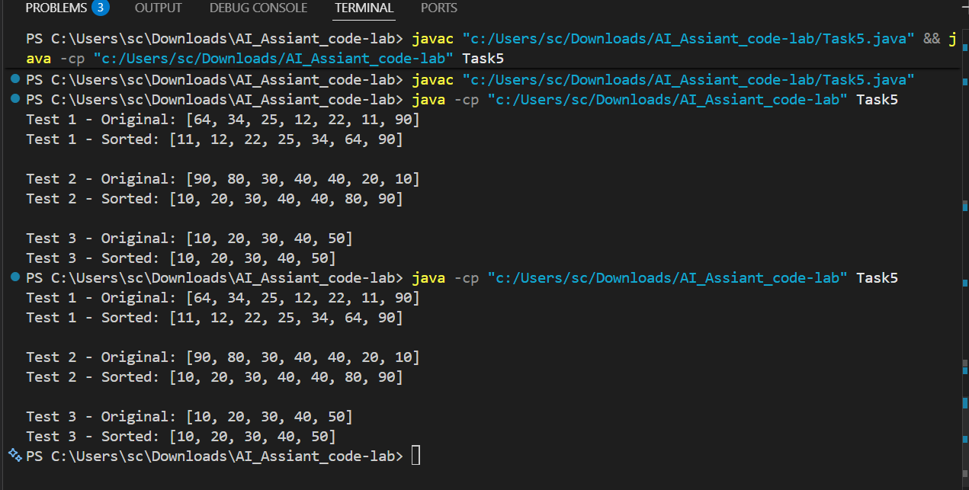

Explanation:-
Different programming languages implement the same logic in different ways, highlighting variations in syntax, performance, and memory handling.

