ASSIGNMENT-2.2

  - Name: Akshaya Nemalipuri
  - Batch: 37
  - Roll No: 2303A2441
  - Lab: 02

Question:-
Exploring Additional AI Coding Tools beyond Copilot – Gemini (Colab) and Cursor AI.
Task 1: Cleaning Sensor Data
❖ Scenario:
❖ You are cleaning IoT sensor data where negative values are invalid.
❖ Task:
Use Gemini in Colab to generate a function that filters out all negative
numbers from a list.
❖ Expected Output:
➢ Before/after list
➢ Screenshot of Colab execution

Prompt:-
Write a program that takes a list of numbers and separates them into two different lists: one containing negative numbers and the other containing non-negative numbers. The program should then display the original list, the list of negative numbers, and the list of non-negative numbers.

Code:-

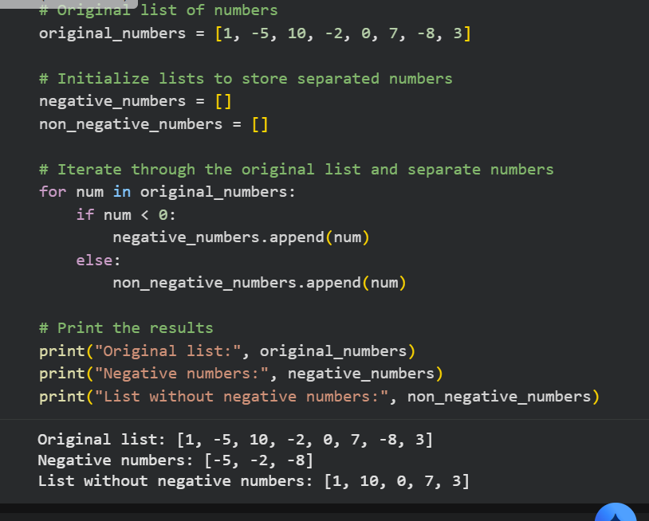

Explain code:-

- This program takes a list of numbers as input.
- It checks each number in the list one by one.
- Numbers less than zero are stored in a separate negative numbers list.
- Numbers that are zero or positive are stored in a non-negative numbers list.
- Finally, the program displays the original list along with both separated lists.

Task 2: String Character Analysis
❖ Scenario:
You are building a text-analysis feature.
❖ Task:
Use Gemini to generate a Python function that counts vowels, consonants,
and digits in a string.
❖ Expected Output:
➢ Working function
➢ Sample inputs and outputs

Prompt:-
Write a Python function that counts the number of vowels, consonants, and digits in a given string. Then, demonstrate the use of this function with an example string and display the count of vowels, consonants, and digits.
Code:-

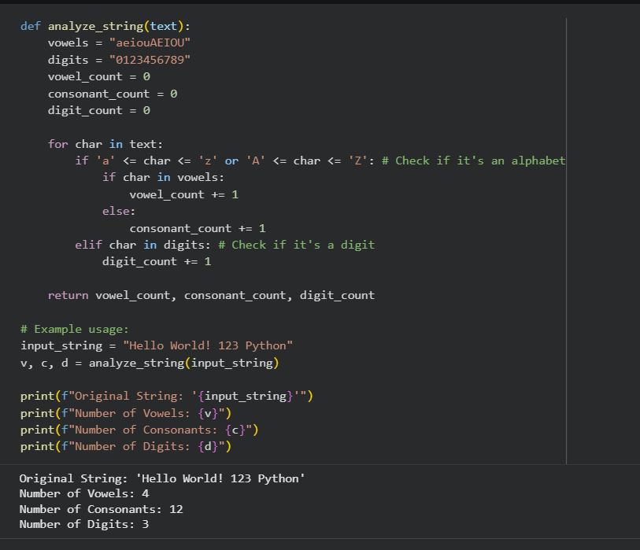

Explain code:-

- This program defines a function named analyze_string that takes a string as input.
- It examines each character in the string one by one.
- Vowels, consonants, and digits are identified and counted separately.
- After processing the entire string, the function returns the total counts.
- An example demonstrates the function using the string "Hello World! 123 Python" and displays the final results.

Task 3: Palindrome Check – Tool Comparison
❖ Scenario:
You must decide which AI tool is clearer for string logic.
❖ Task:
Generate a palindrome-checking function using Gemini and Copilot, then
compare the results.
❖ Expected Output:
➢ Side-by-side code comparison
➢ Observations on clarity and structure

Prompt:-
Write a Python program that uses a function to check whether a given text is a palindrome. The program should take input from the user and display an appropriate message indicating whether the text is a palindrome or not.
Code:-
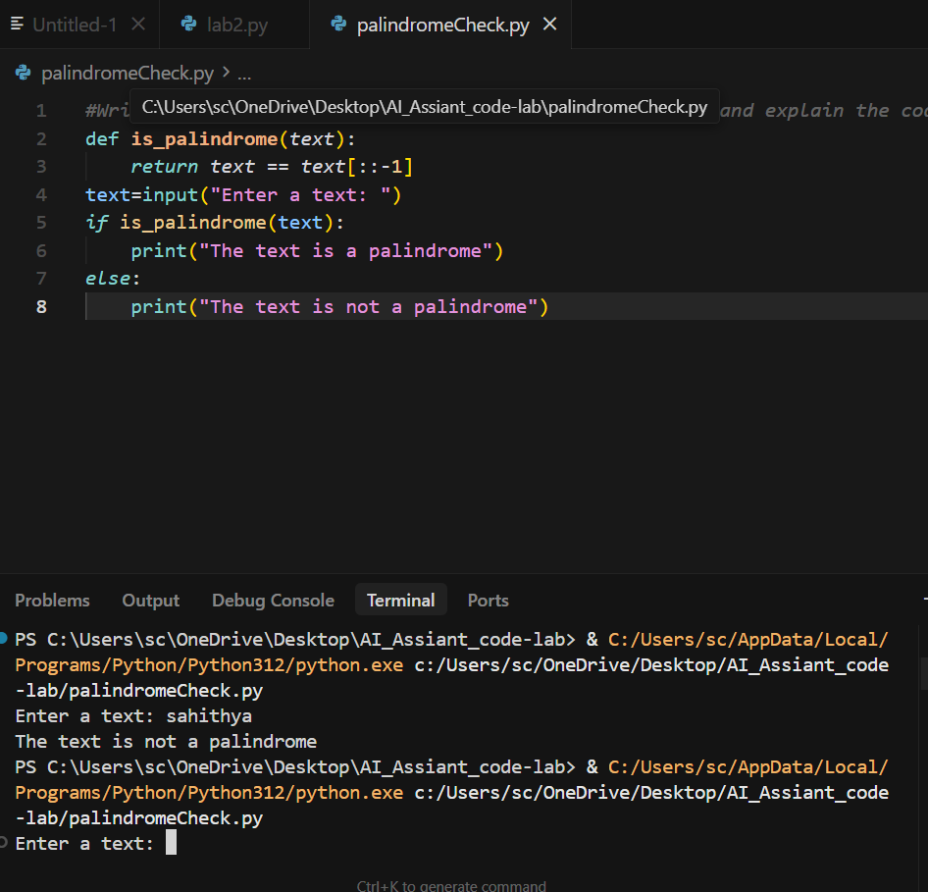

Explain Code:-

- This program defines a function called is_palindrome that checks whether a given text reads the same forwards and backwards.
- It compares the original text with its reversed version.
- The program then asks the user to enter a text as input.
- If the function returns true, it displays that the text is a palindrome.
- Otherwise, it displays that the text is not a palindrome.

Task 4: Code Explanation Using AI
❖ Scenario:
You are reviewing unfamiliar code written by another developer.
❖ Task:
Ask Gemini to explain a Python function (prime check OR palindrome
check) line by line.
❖ Expected Output:
➢ Code snippet
➢ AI explanation
➢ Student comments on understanding

Prompt:-
Write a Python program that uses a function to check whether a given number is a prime number. The program should test the function with sample numbers and display the results.
Code:-

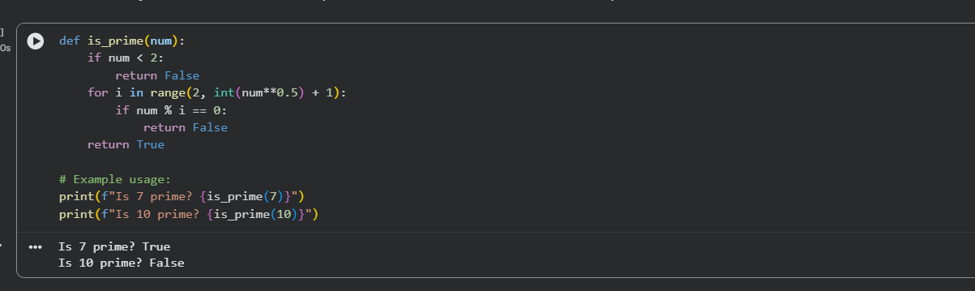

Explain Code:-

- This program defines a function named is_prime to check whether a number is prime.
- It first eliminates numbers less than 2.
- Then, it checks whether the number is divisible by any value up to its square root.
- If the number is divisible, the function returns false; otherwise, it returns true.
- An example demonstrates the function by printing the results for the numbers 7 and 10.

 THE END 

