AI Assisted Coding
Assignment-6.3
Name: M. Akhila
HT No: 2303A52442
Batch: 31
Task1: (Loops – Automorphic Numbers in a Range)
Prompt:
#Generate Automorphic numbers within range 1 to 1000 using for loop and calculate the time taken to execute the code
#Generate Automorphic numbers within range 1 to 1000 using while loop and calculate the time taken to execute the code
Code:
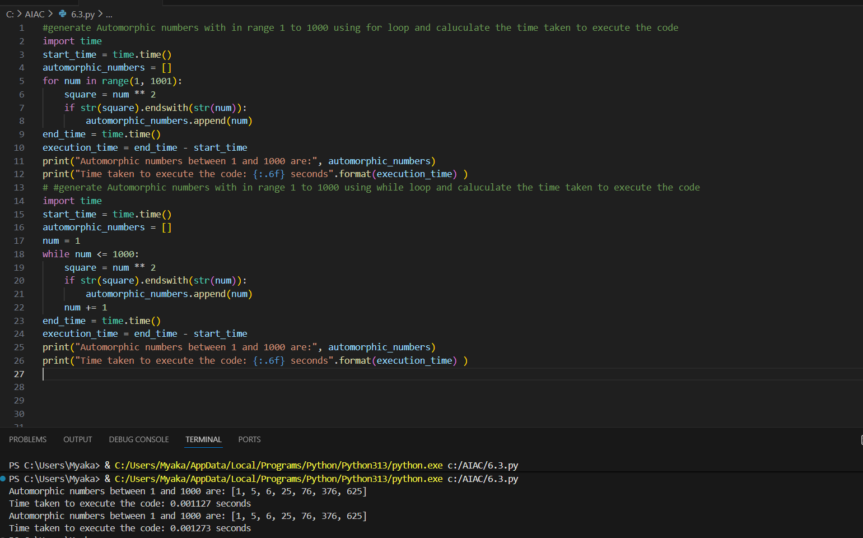
Explanation:
In this task, AI-generated code is used to display automorphic numbers between 1 and 1000 using a for loop by checking whether the square of a number ends with the number itself. The execution time is calculated using the time module. The same logic is implemented using a while loop and both outputs are compared. Since the range is fixed, the for loop is more efficient and readable than the while loop.

Task2: (Conditional Statements – Online Shopping Feedback
Classification)
Prompt:
write a python program that classify online shopping feedback as positive, neutral or negative based on numerical rating 1-5 using nested if else statement
#rewrite above code using dictionary-based match case structure
Code:
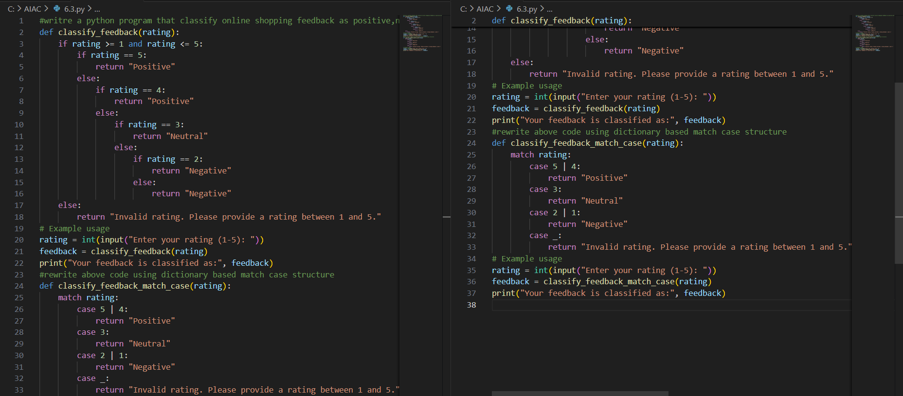
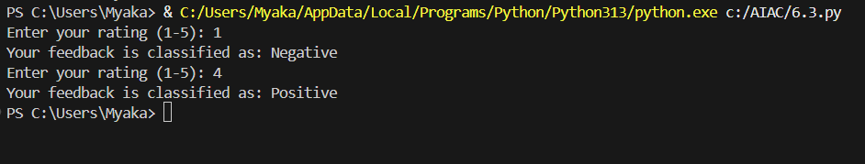
Explanation:
In this task, the program checks the user’s rating from 1 to 5 and decides whether the feedback is Positive, Neutral, or Negative. First, nested if-else conditions are used to check each rating one by one. The logic works correctly but looks long and a bit confusing. Then the same program is written using match-case, which is simpler and easier to understand. The match-case method is better because it makes the code clean and readable.

Task3: (Conditional Statements – Online Shopping Feedback
Classification)
Code:
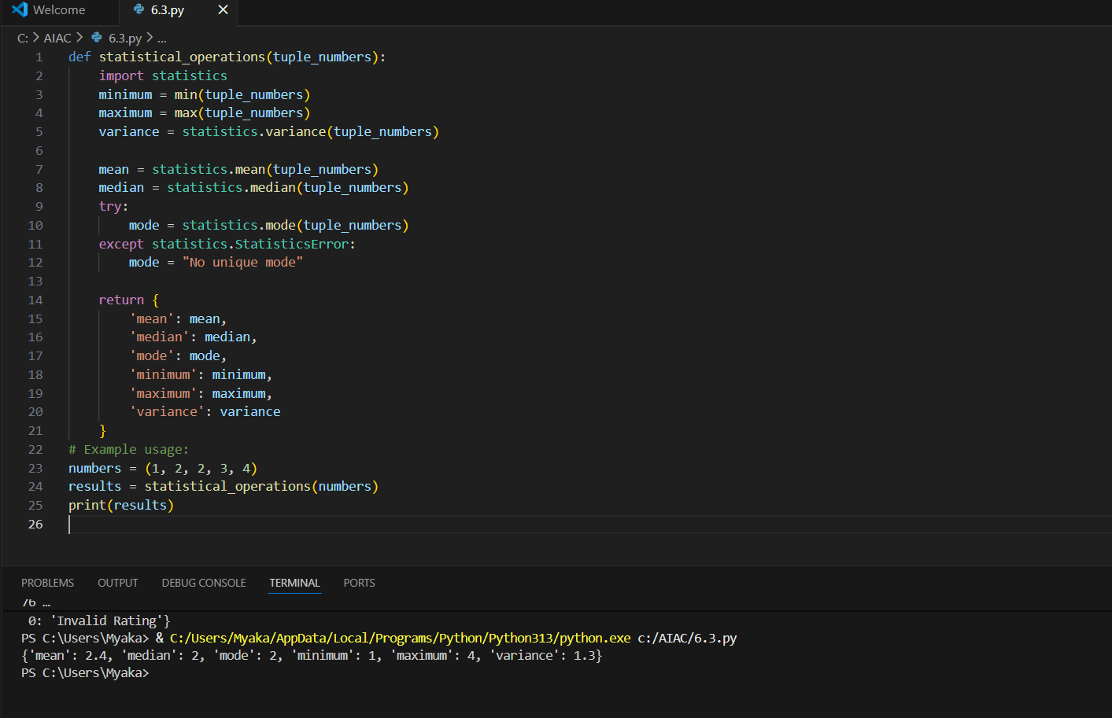
Explanation:
In this task, the program finds different math values from a group of numbers. It finds the smallest number, biggest number, average, middle value, most repeated number, and variance. Ready-made functions are used to make the work easy and correct. The program also checks if a mode is not available and handles it
Task4: Teacher Profile
Prompt: write a python code create a class teacher with attributes teacher_id, name, subject, and experience. Add method to display teacher details

Code:
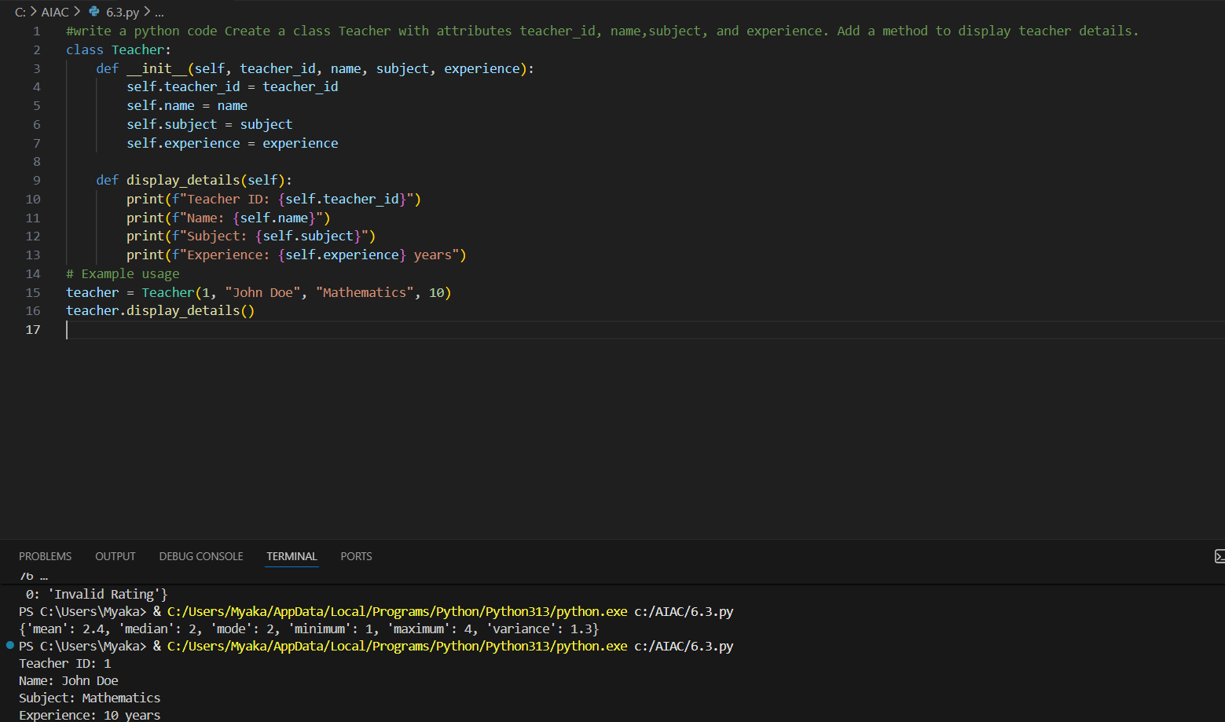
Explanation:
In this task, a teacher class is created to store teacher details. The class has teacher ID, name, subject, and experience as its data. A function is written to show all the teacher details clearly. An object is created and the details are displayed using the method.
Task5: Zero-Shot Prompting with Conditional Validation
Prompt:
#Write a python code that validates Indian phone numbers. The number must starts with 6, 7, 8 or 9 and contains exactly 10 digits write code the perform all required validations and take input from user
Code: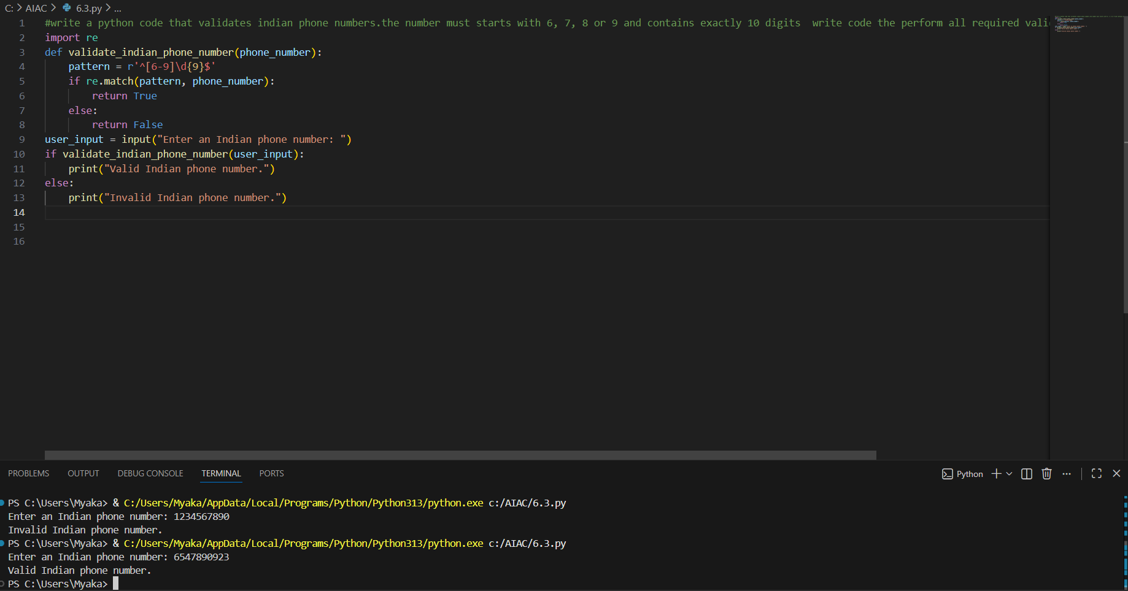
Explanation:
In this task, a program is written to check whether an Indian mobile number is valid or not. The number is checked to see if it starts with 6, 7, 8, or 9 and has exactly 10 digits. A pattern is used to match the correct format of the number. If the number follows all rules, it is shown as valid; otherwise, it is shown as invalid
Task6: (Loops – Armstrong Numbers in a Range)
Prompt:
# Write a python code that finds Armstrong numbers in a given range 1 to 1000 use for loop and digit power logic
#Generate optimized version of above code using list comprehensions

Code:
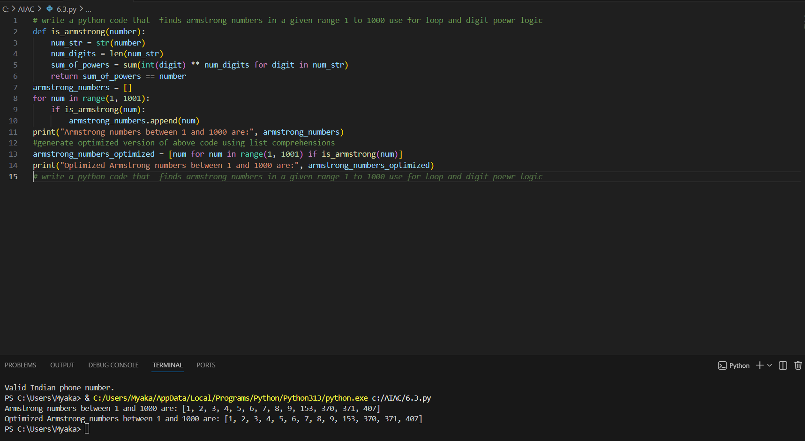
Explanation:
In this task, the program finds Armstrong numbers between 1 and 1000. Each number is checked by adding the powers of its digits and comparing the sum with the original number. A for loop is used to go through all numbers in the range. The same logic is written again using list comprehension to make the code shorter and faster

Task7: (Loops – Happy Numbers in a Range)
Prompt:
Write a python code that displays all happy numbers within a range of user specified limit
Regenerate optimized version of above code using set to detect cycles instead of infinite loops
Code:
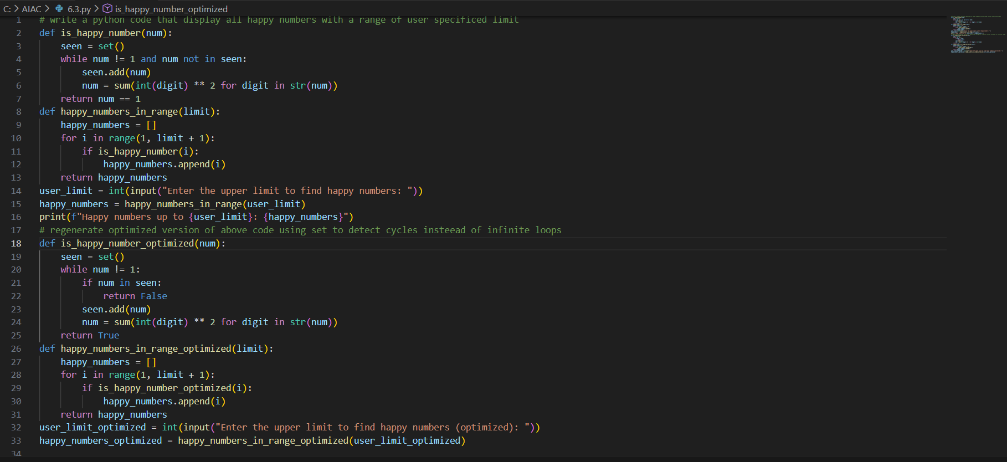
Explanation:
In this task, the program finds happy numbers within a user-given range. Each number is checked by adding the squares of its digits again and again. If the number becomes 1, it is called a happy number. An optimized version uses a set to stop the program when a number repeats, which makes the code faster and safer
Task8:( Loops – Strong Numbers in a Range)
Prompt:
write a python code that print strong numbers with in a given range
1-strong number
2-strong number
145 strong number
using loops
Code:
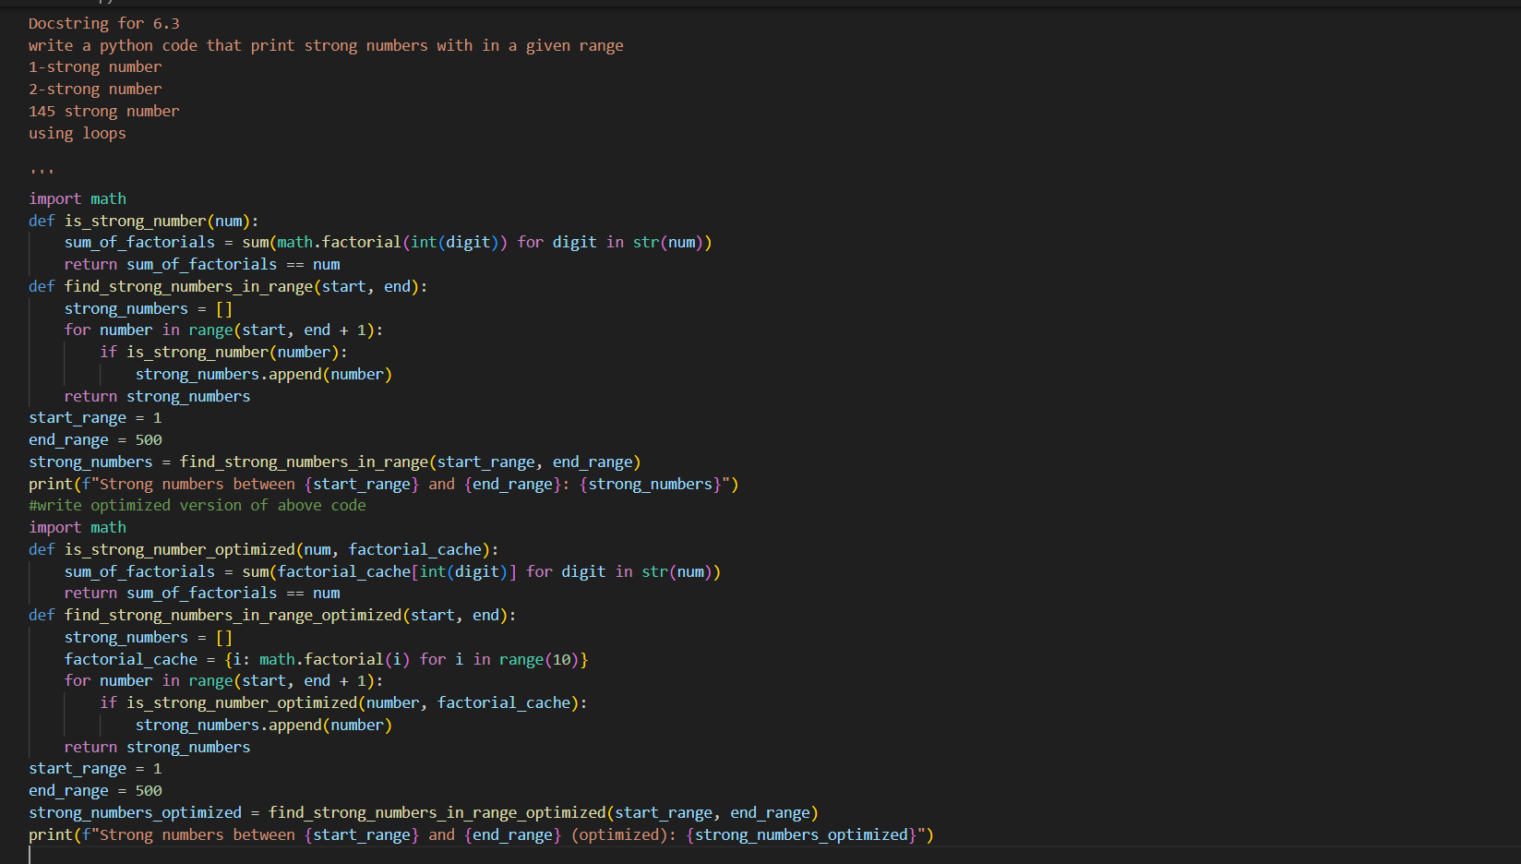
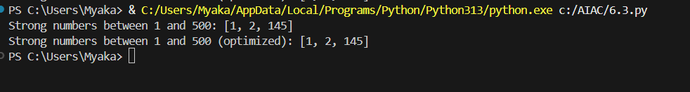
Explanation:
In this task, the program finds strong numbers within a given range. A number is checked by adding the factorial of each of its digits and comparing the sum with the original number. Loops are used to extract digits and calculate factorial values. An optimized version stores factorials in advance so the program runs faster
Task9: Few-Shot Prompting for Nested Dictionary Extraction
Prompt:
'''
Docstring for 6.3
Create a Python function that extracts full name, branch, and SGPA from a nested dictionary representing student information.
Examples:
{
"personal": {
"full_name": "ram"
},
"academic": {
"branch": "EEE",
"sgpa": 8.6
}
}
2.
{
"personal": {
"full_name": "raju"
},
"academic": {
"branch": "CSE",
"sgpa": 9.4
}
}

Code:
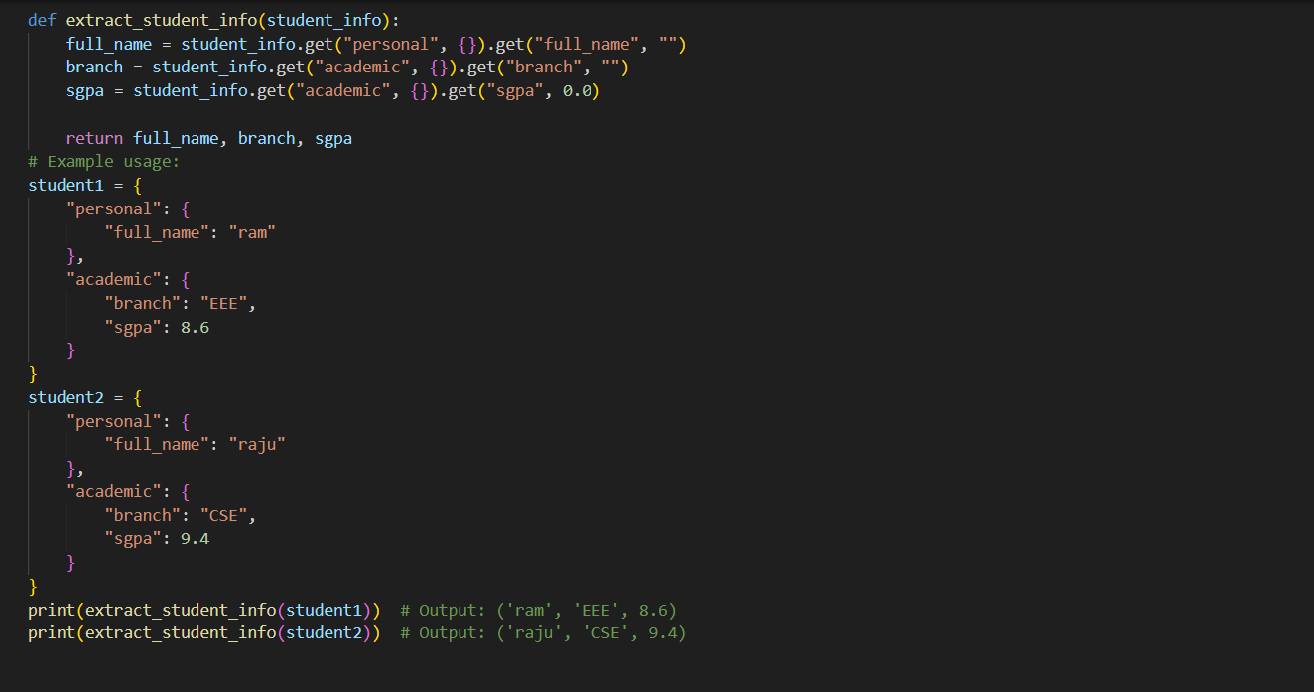
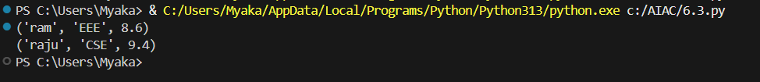
Explanation:
In this task, the program gets student details from a nested dictionary. It correctly takes the full name, branch, and SGPA by moving through the inner keys. A try–except block is used to handle missing keys safely. The function works properly for the given examples and gives the required output
Task10: Loops – Perfect Numbers in a Range)
Prompt:
# Write a python code that displays all perfect numbers within a range given by user using for loop
#Regenerate an optimized version of the code using divisor check up to square root of the number
Code:
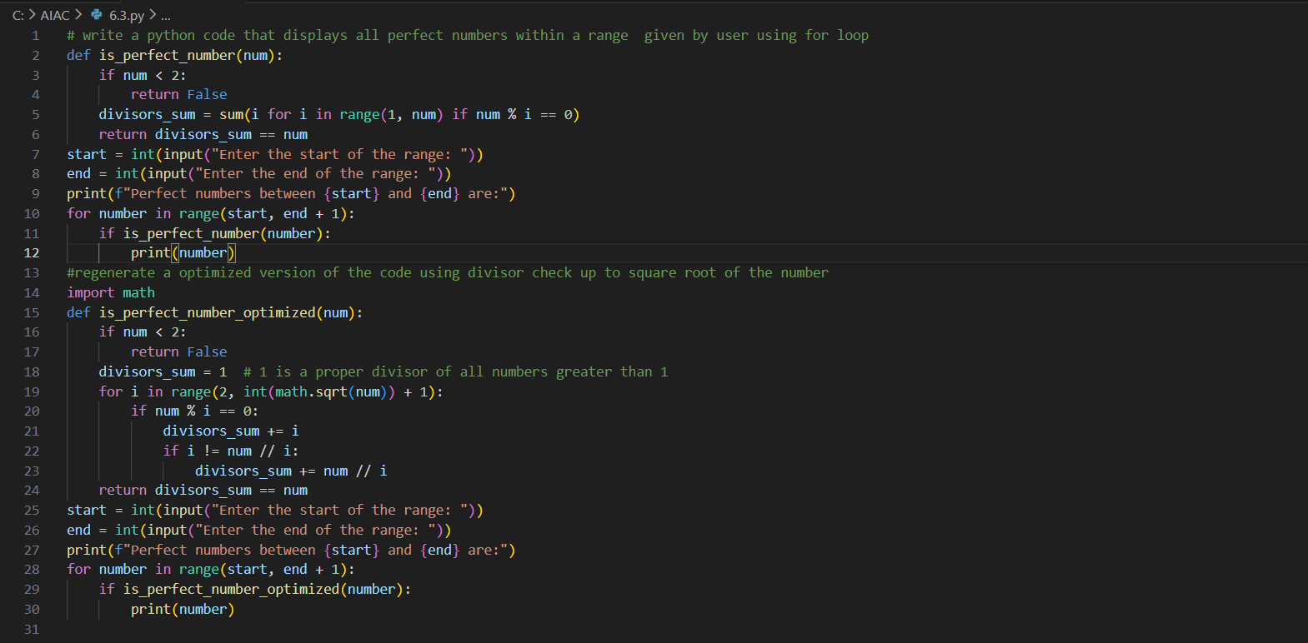
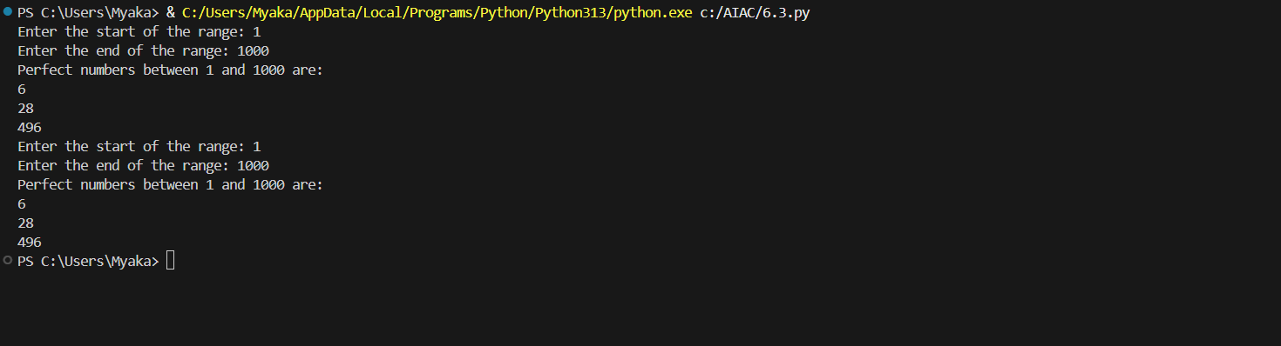
Explanation:
In this task, the program finds perfect numbers within a range given by the user. A perfect number is a number whose divisors add up to the same number, like 6 and 28. First, a for loop is used to check all divisors of each number. Then an optimized version checks divisors only up to the square root, which makes the program faster.

