AI Assisted Coding
ASSIGNMENT 3.3

Name: M.Akhila
HT No: 2303A52442
Batch: 31

Lab 3: Application for TGNPDCL - Electricity Bill Generation Using Python & AI Tools

Question 1:
Prompt: #Write a Python program for an electricity billing system that reads previous units, current units, and type of customer. Calculate units consumed and display the bill details clearly without using functions
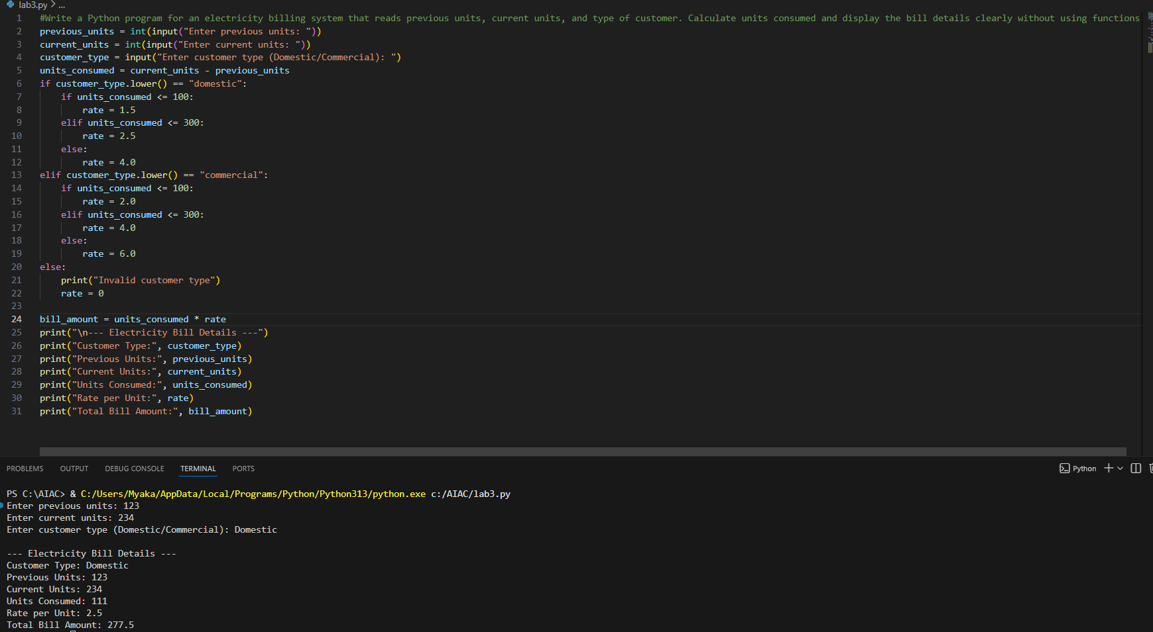
The program reads meter readings and customer type from the user. It calculates the units consumed by subtracting previous units from current units. Based on customer type, the rate per unit is applied
Question2:
Prompt: # Extend the electricity billing program to calculate energy charges based on units consumed and customer type (Domestic, Commercial, Industrial) using simple and optimized conditional statements

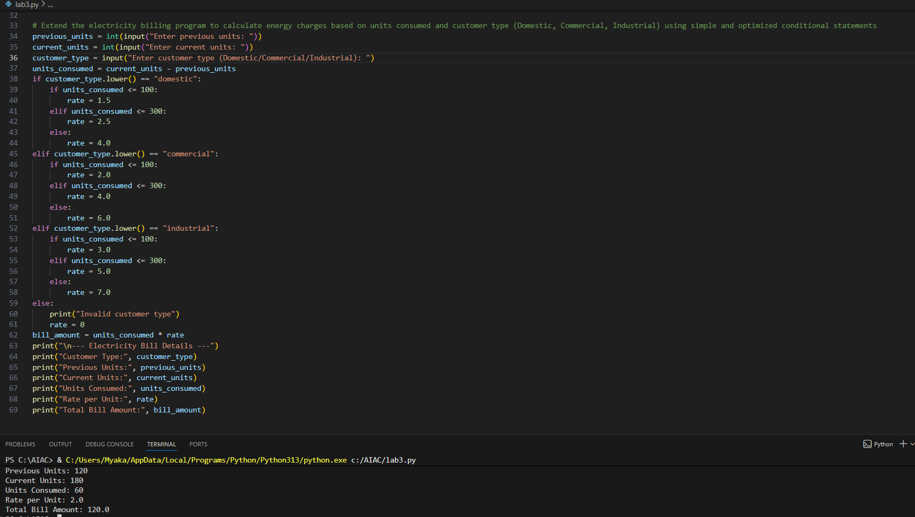
The program uses conditional statements to calculate energy charges. Different rates are applied for Domestic, Commercial, and Industrial customers. The logic is simplified to improve readability and understanding
Task3:
Prompt: # Generate a Python program using user-defined functions to calculate energy charges and fixed charges for different types of electricity consumers. The functions should return values and include clear comments

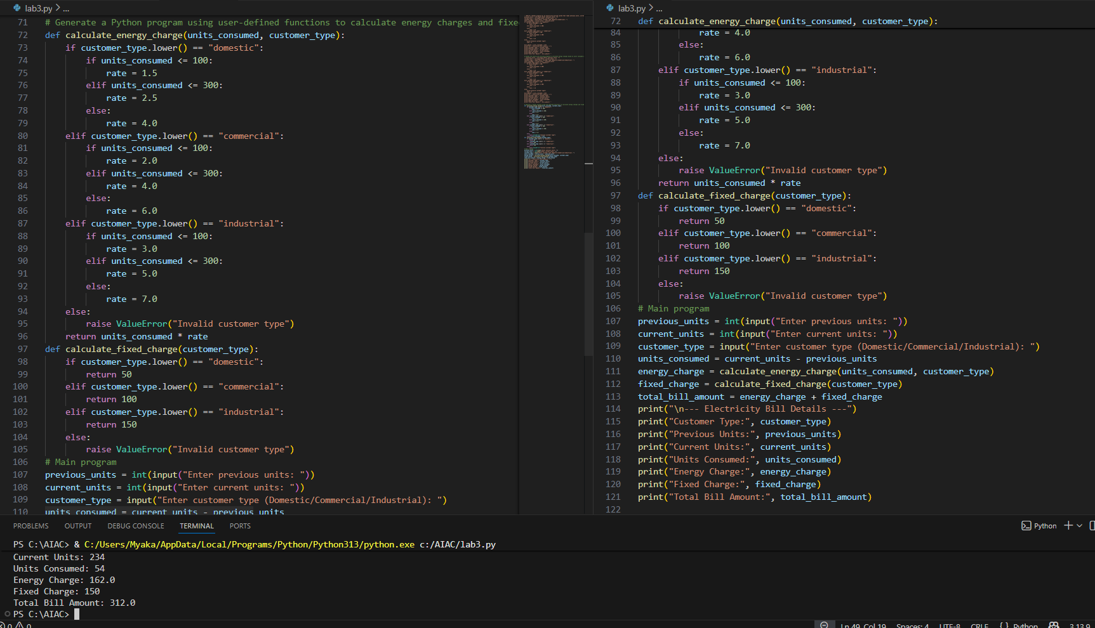
The program is divided into functions to improve reusability. One function calculates energy charges based on units and customer type. Another function calculates fixed charges based on customer category
Task 4:
Prompt: # Extend the electricity billing program to calculate additional charges such as fixed charges, customer charges, and electricity duty. Display each charge separately to improve billing accuracy

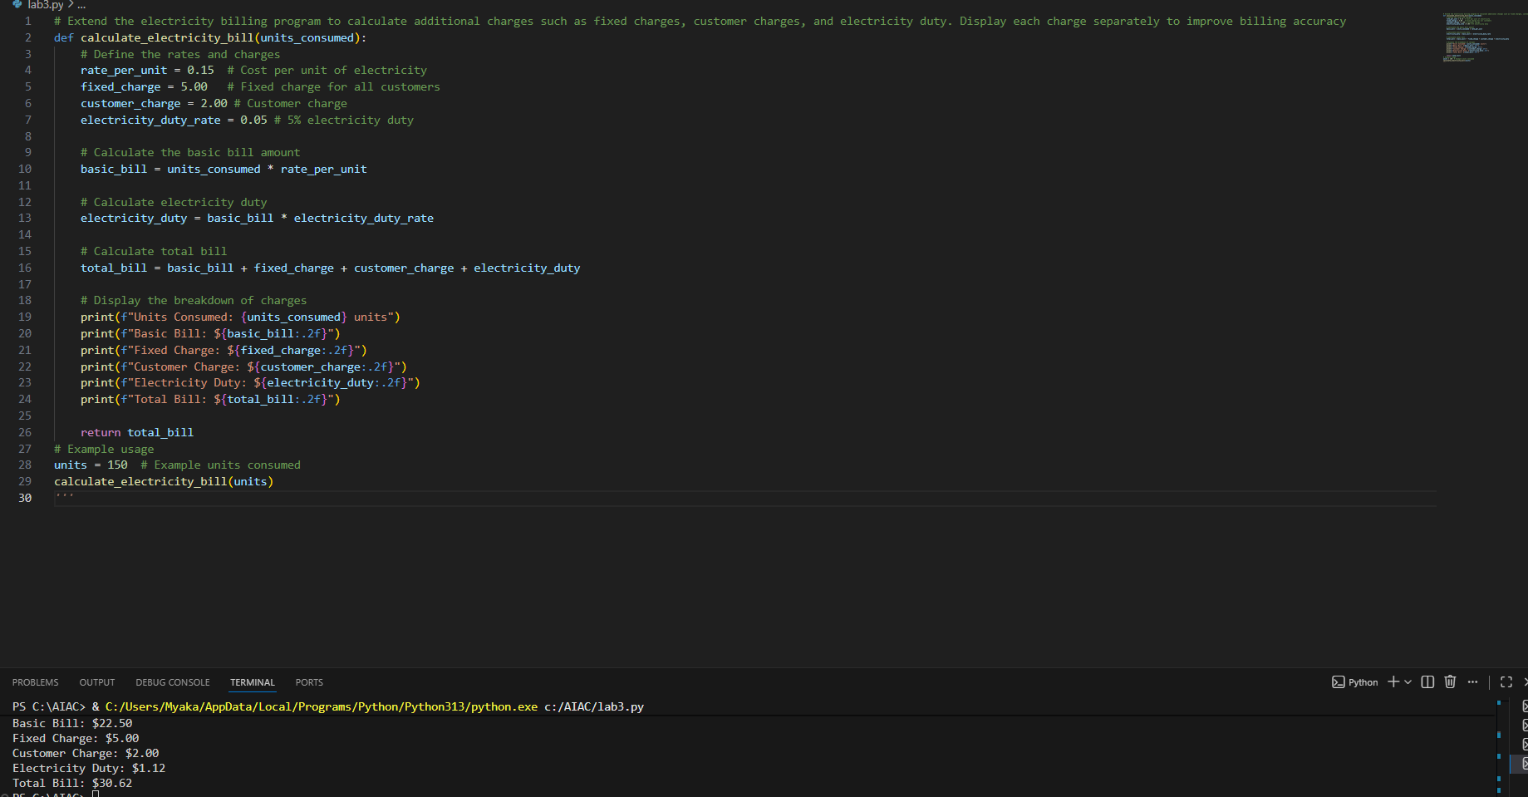
The program calculates additional charges required in an electricity bill. Fixed charges and customer charges are added based on customer type. Electricity duty is calculated as a percentage of energy charges
Task5:
Prompt: Develop the final Python program to calculate the total electricity bill by adding energy charges, fixed charges, customer charges, and electricity duty. Display all bill components clearly in a structured format.
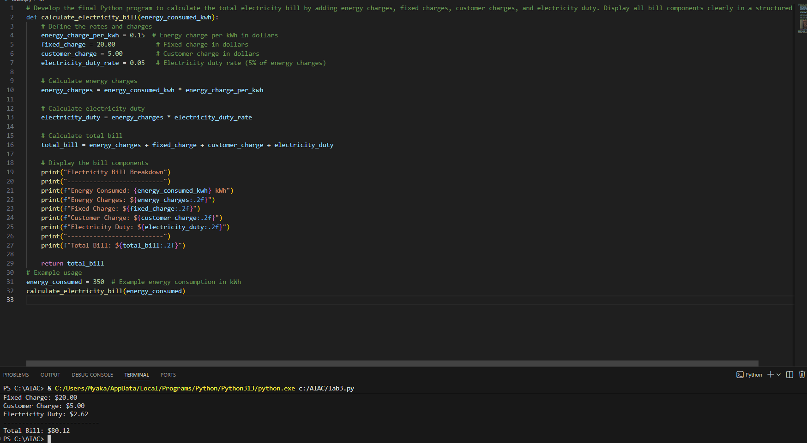
The program calculates the total bill by adding all charge components. Each value is displayed clearly to resemble a real electricity bill. The output format improves readability and user understanding. This makes the program suitable for real-world billing systems.

