AIAC-LAB-ASSIGNMENT4.1

NAME: M. Akhila
BATCH: 31
HTNO: 2303A52442
Zero-Shot Prompting
Prompt: #write a python program that classifies the text spam or not spam

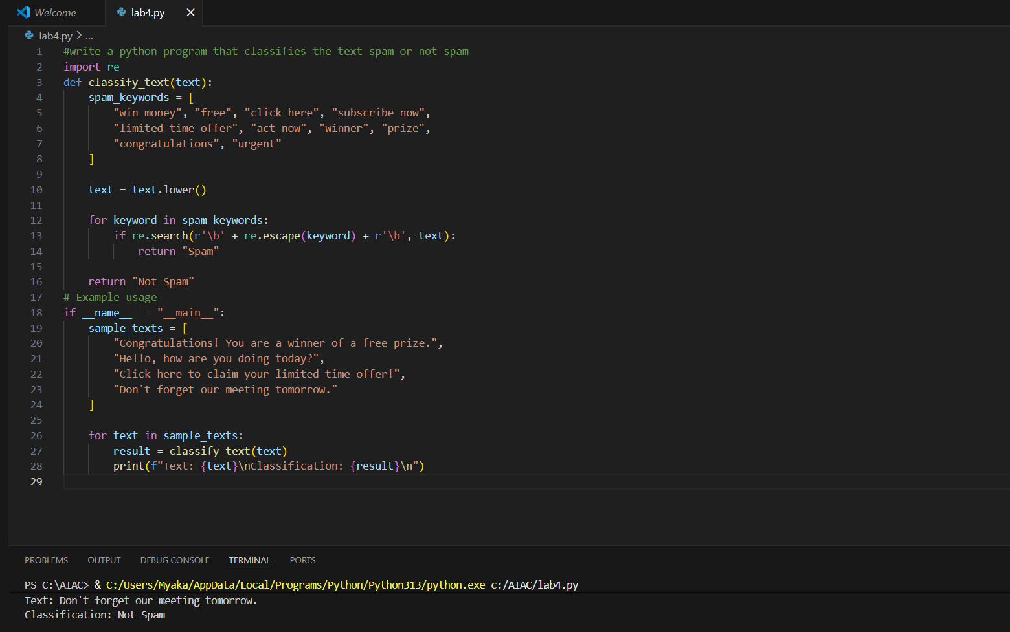
This program classifies a given text as Spam or Not Spam by checking for predefined spam-related keywords.
It converts the input text to lowercase and uses regular expressions to accurately detect spam words.
If any spam keyword is found, the text is labeled Spam; otherwise, it is labeled Not Spam
One-Shot Prompting
Prompt: Write a python code to detect emotion of a sentence
example input : "I am very happy today"
example output: "happy"

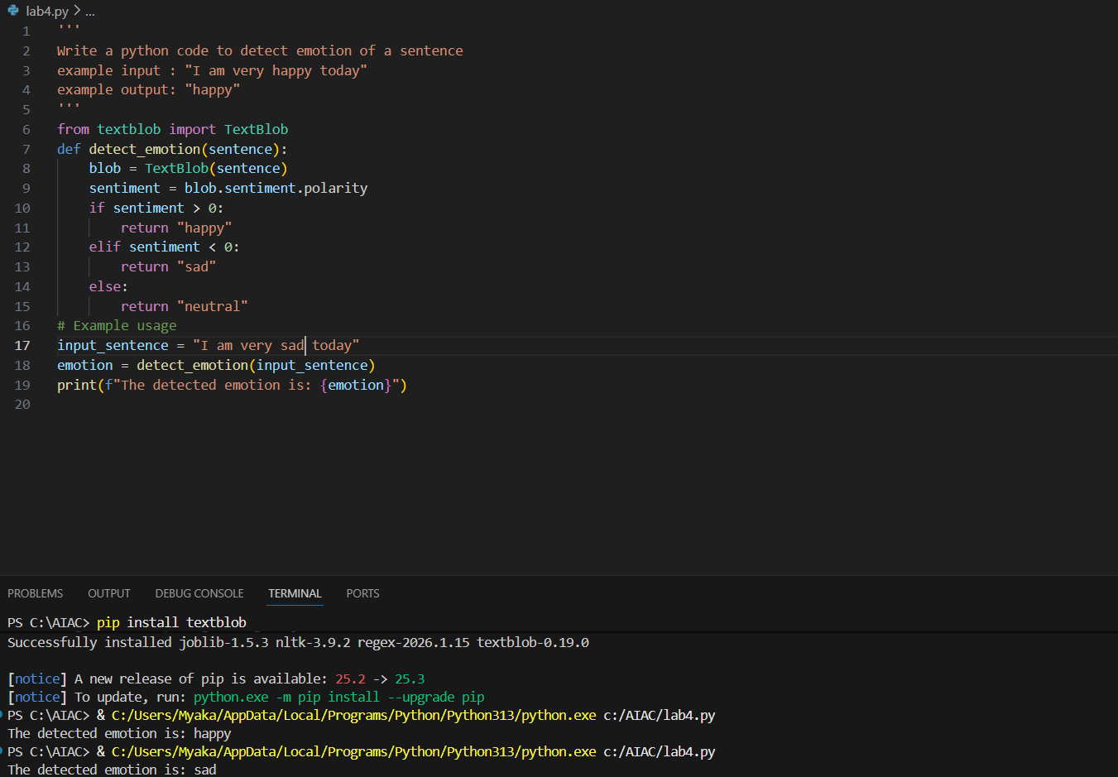
This program finds the emotion of a sentence using sentiment analysis.
If the sentence has positive meaning, it shows happy; if negative, it shows sad; otherwise neutral.
After installing TextBlob, the program runs correctly and prints the detected emotion.
Few-Shot Prompting
Prompt: predict the student grades based on marks
Example:
90–100 → A
80–89 → B
70–79 → C
60–69 → D
Below 60 → F
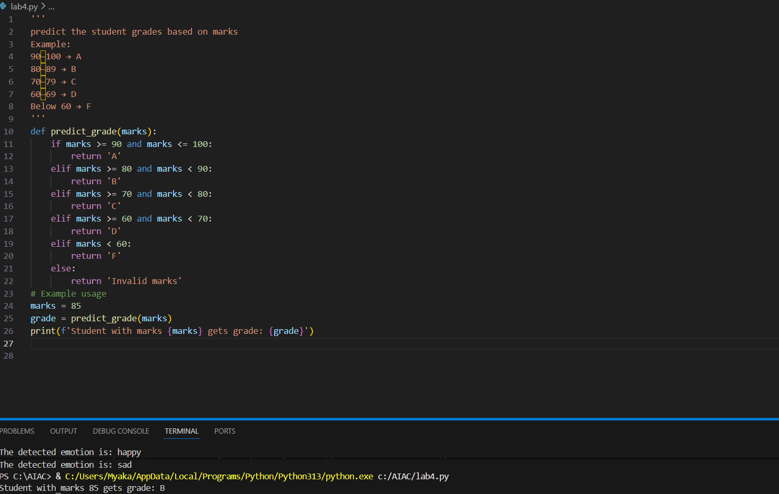
This program predicts a student’s grade based on the marks scored.
It uses conditional statements to check the marks range and assigns grades from A to F
Multi-Shot Prompting
Prompt: predict the indian zodiac sign based on birth month,take input from user
March → Mesha
April → Vrishabha
May → Mithuna
June → Karka
July → Simha
August → Kanya
September → Tula
October → Vrischika
November → Dhanu
December → Makara
January → Kumbha
February → Meena

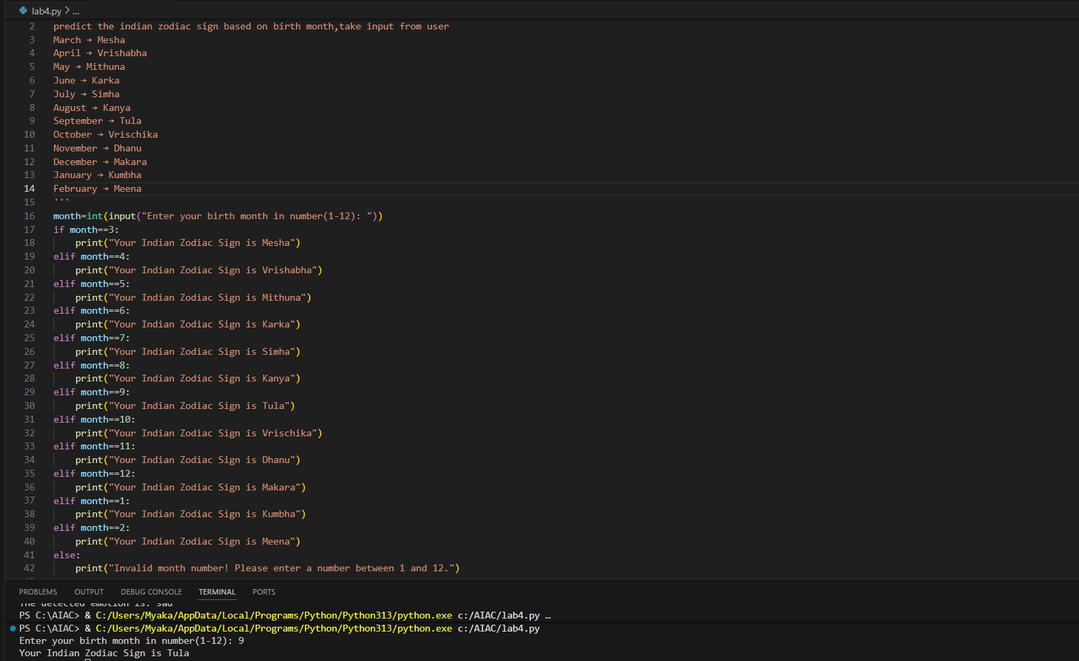
This program predicts the Indian Zodiac sign based on the user’s birth month.
It takes the month number as input and uses conditional statements to match it with the correct zodiac sign
Result Analysis Based on Marks
Prompt:
take input from user
check the pass and fail criteriaa
if pass print "pass" else print "fail"
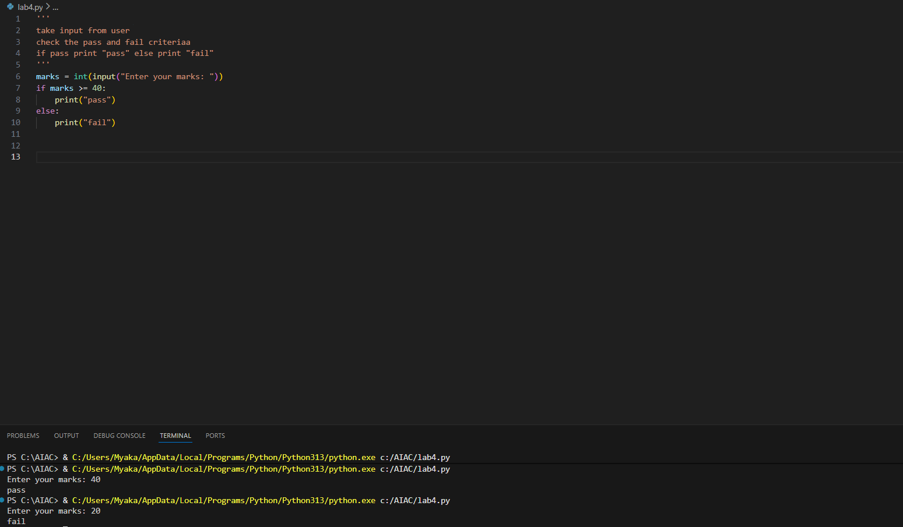
This program checks whether a student has passed or failed based on the marks entered by the user.
If the marks are 40 or above, it prints Pass; otherwise, it prints Fail.

Voting Eligibility Check (Chain-of-Thought Prompting)
Prompt: take input from user
check the voting elgibility
if yes print eligible otherwise not eligible

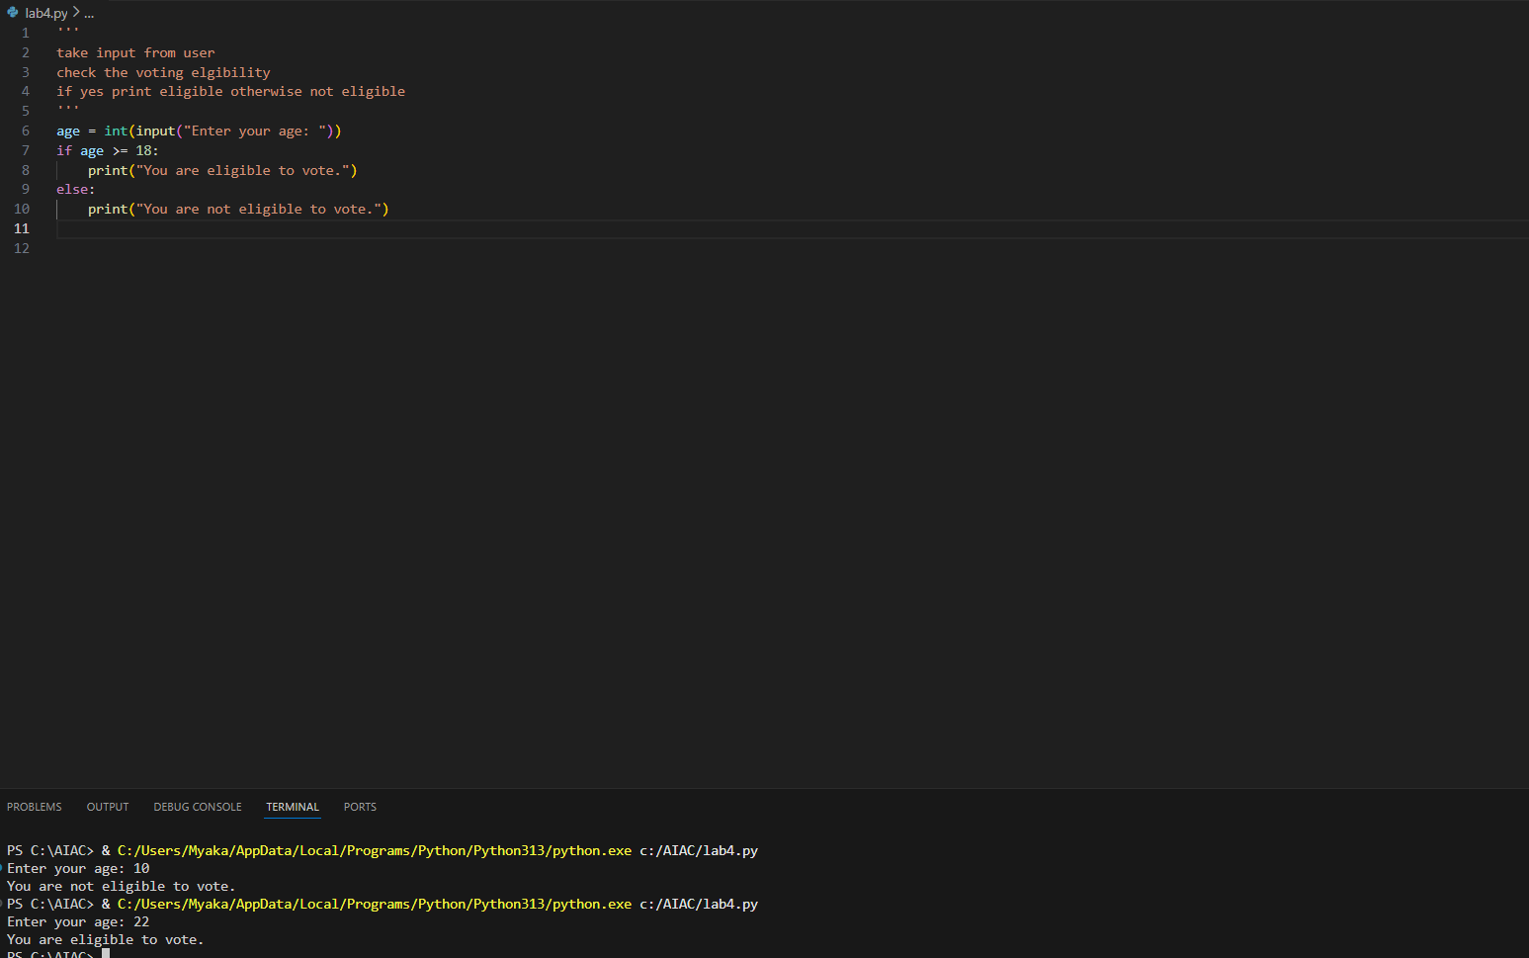
This program checks whether a person is eligible to vote based on age.
If the age entered is 18 or above, it prints Eligible to vote; otherwise, it prints Not eligible to vote
Prompt Chaining (String Processing – Palindrome Names)
Prompt: 1. Given the following list of student names, check palindrome or not
Names: ["madam", "level", "rahul", "radar","aka"]
2. Print only those names which are palindrome from the given list

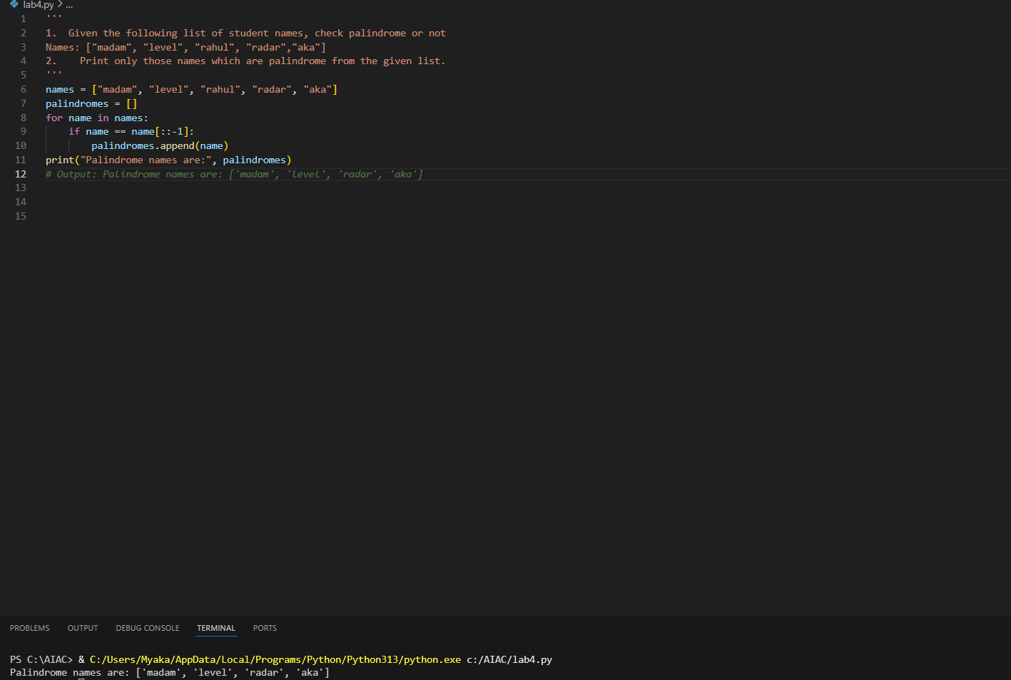
This program checks a list of student names to find which ones are palindromes.
A name is considered a palindrome if it reads the same forwards and backwards.
The program prints only the names that satisfy this condition from the given list
Prompt Chaining (String Processing – Word Length Analysis)
Prompt: 1. From the previous results, display only the names that are palindromes.
2. Using the generated list of words, calculate the length of each word.
3. Using the word lengths from the previous step, classify each word as:
Short if length < 5
Long if length >= 5
Display each word with its classification

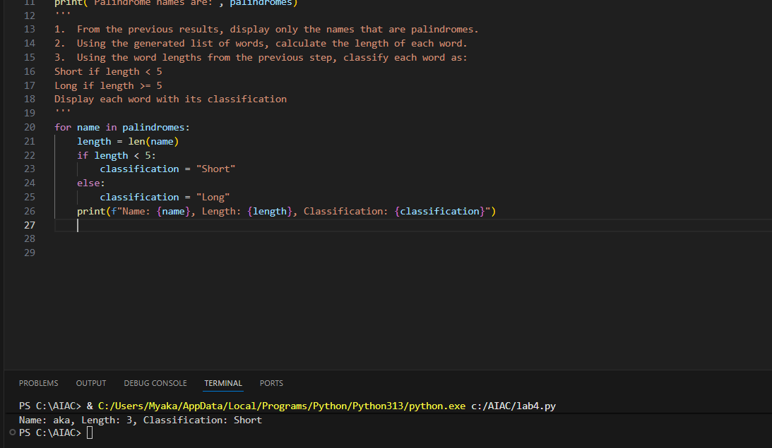
This program first picks out the palindrome names from the list.
Then it checks how long each name is.
Based on the length, it labels the name as Short or Long and prints the result.

