AI Assisted Coding
Assignment 18.1
Name: M. Akhila
HT No: 2303A52442
Batch: 31

Task 1 – Weather API Integration
Connect to a Weather API to fetch current weather details for a given city.
Instructions:
• Prompt AI to generate Python code using the requests library.
• Handle errors: invalid city name, API key errors, and network
failures.
• Display temperature, humidity, and weather description in a
readable format.
Expected Output:
• A working Python script that fetches and displays weather data
with proper error handling.
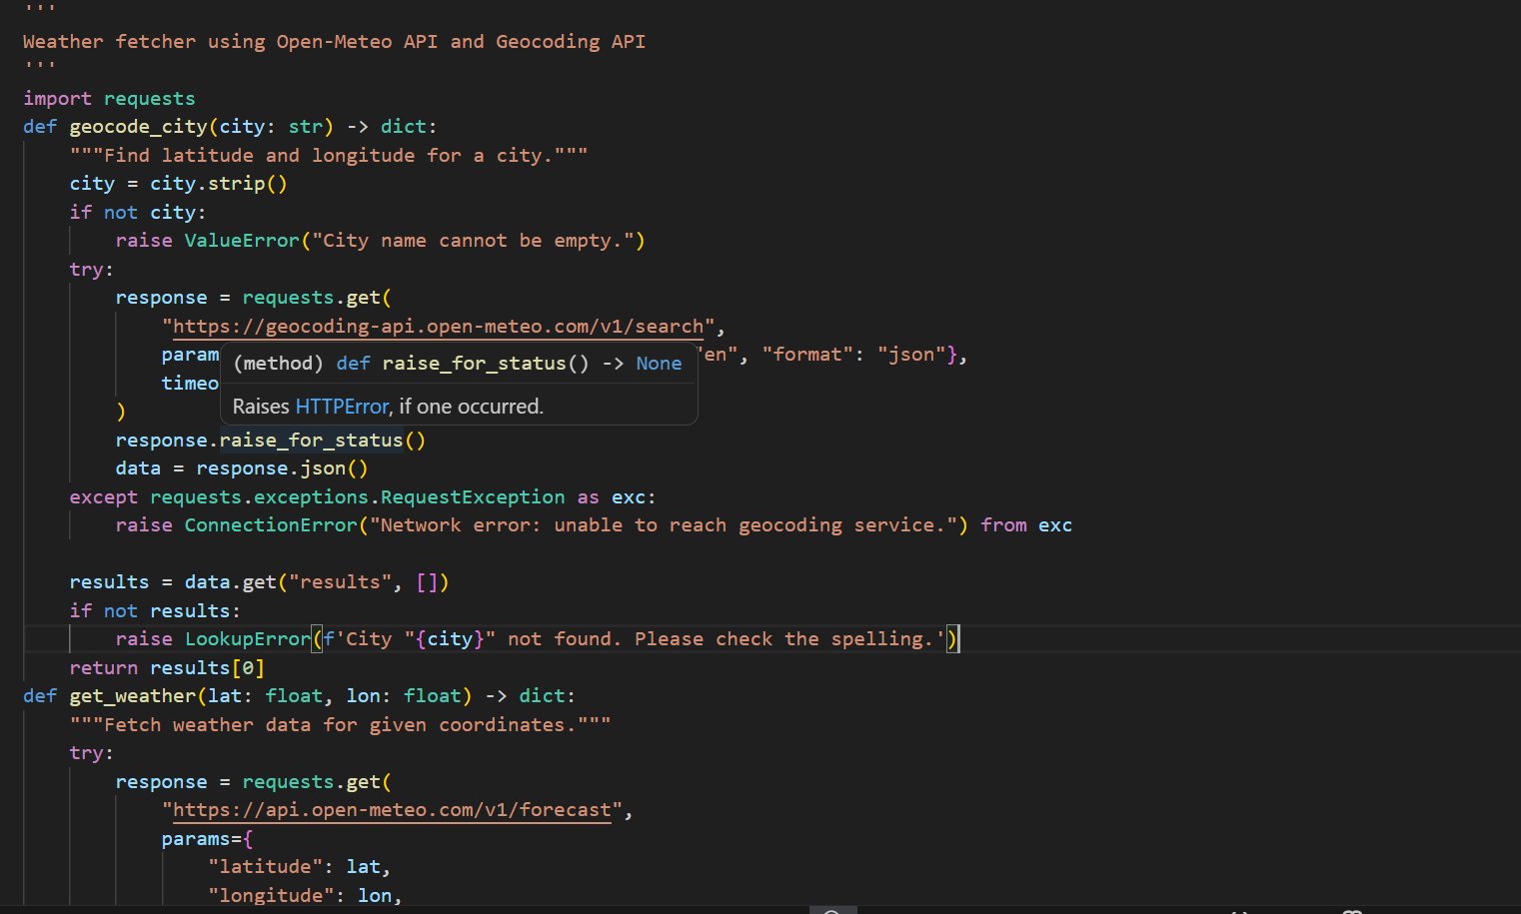
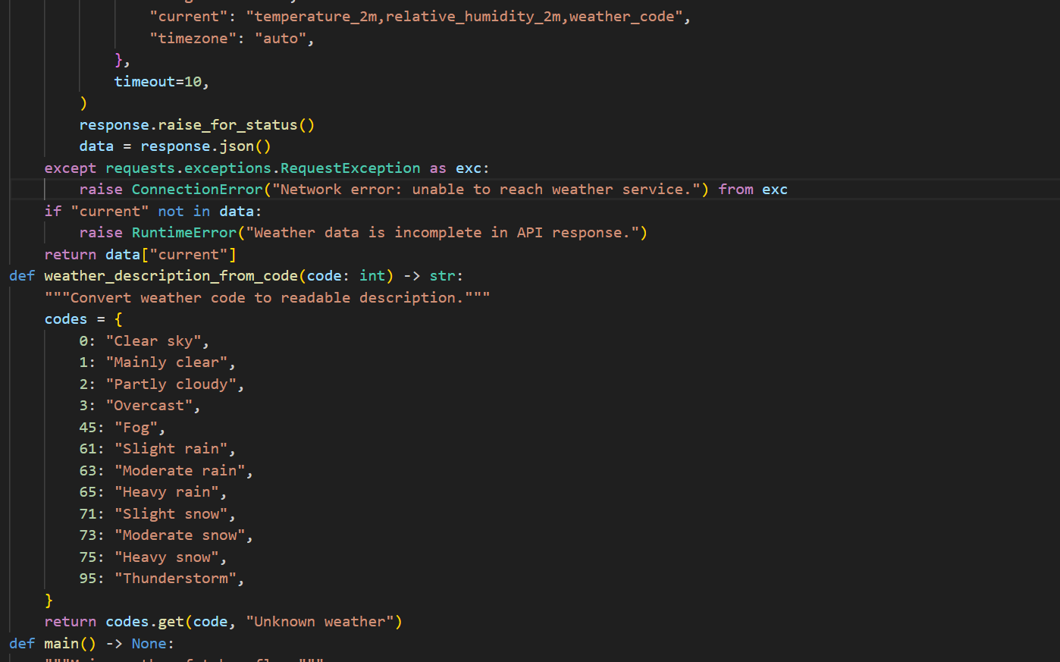
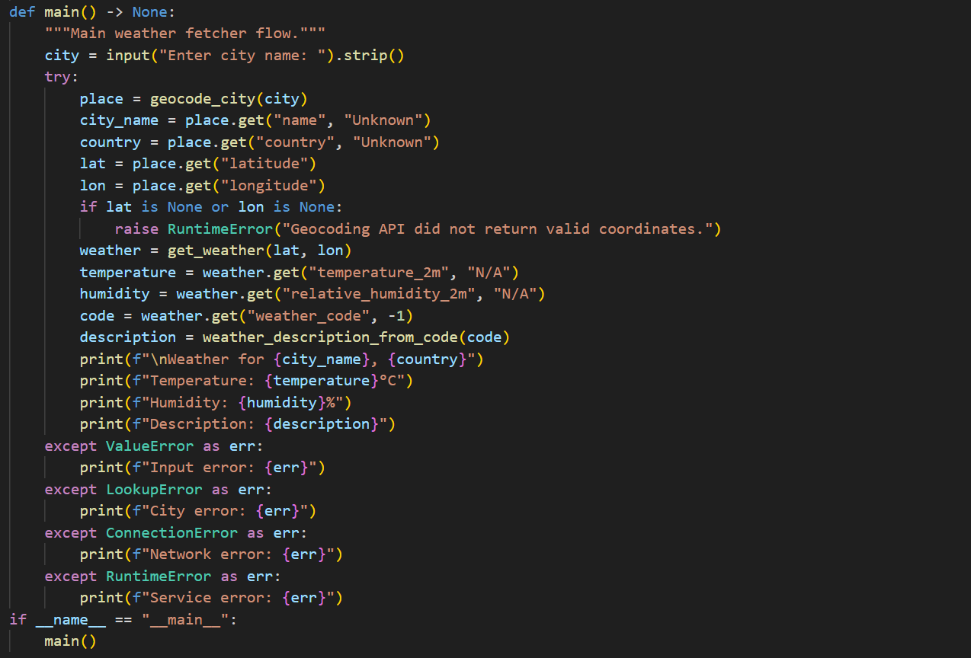
Output:
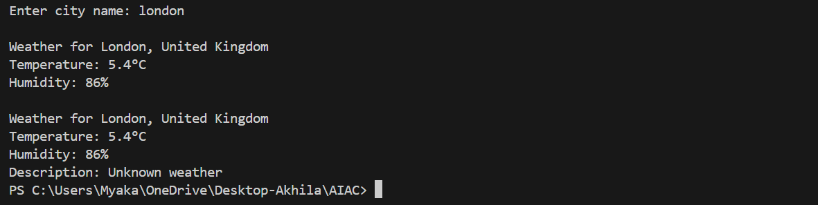
Task 2 – Currency Exchange Rates
Integrate a Currency Exchange API to convert INR to USD, EUR, and GBP.
Instructions:
• Use AI to generate API request code.
• Validate user input for amount and currency codes.
• Implement error handling for invalid responses and API
downtime.
• Show conversion results clearly in tabular format.
Expected Output:
• A script that converts INR to multiple currencies with graceful
error handling.
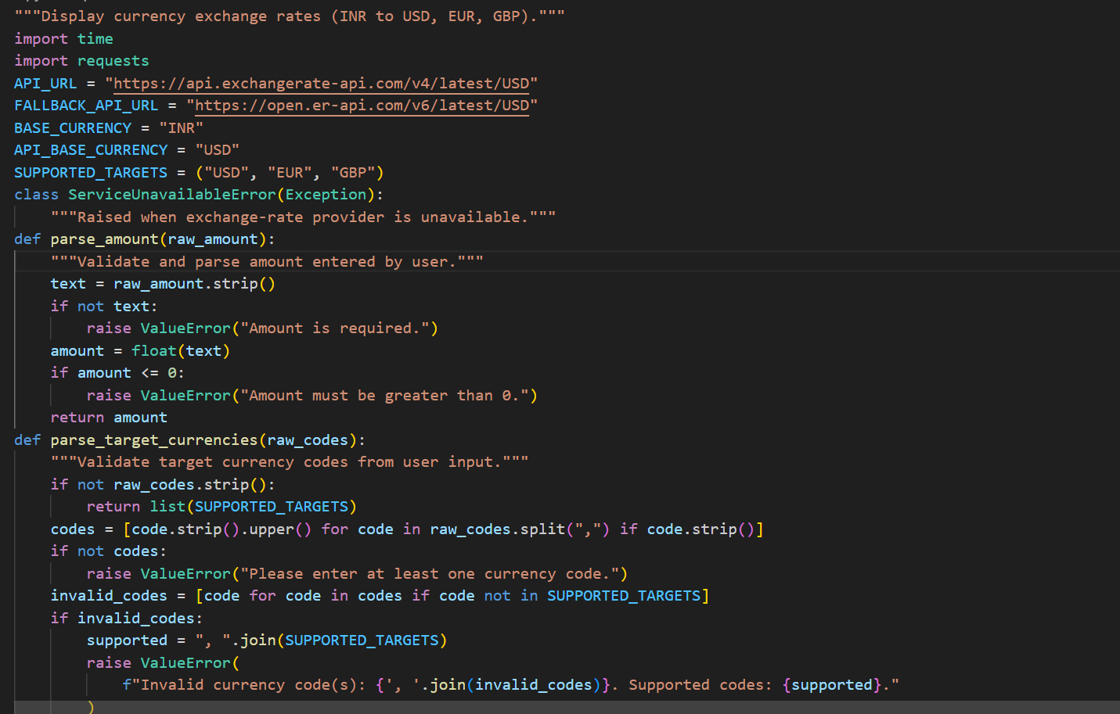
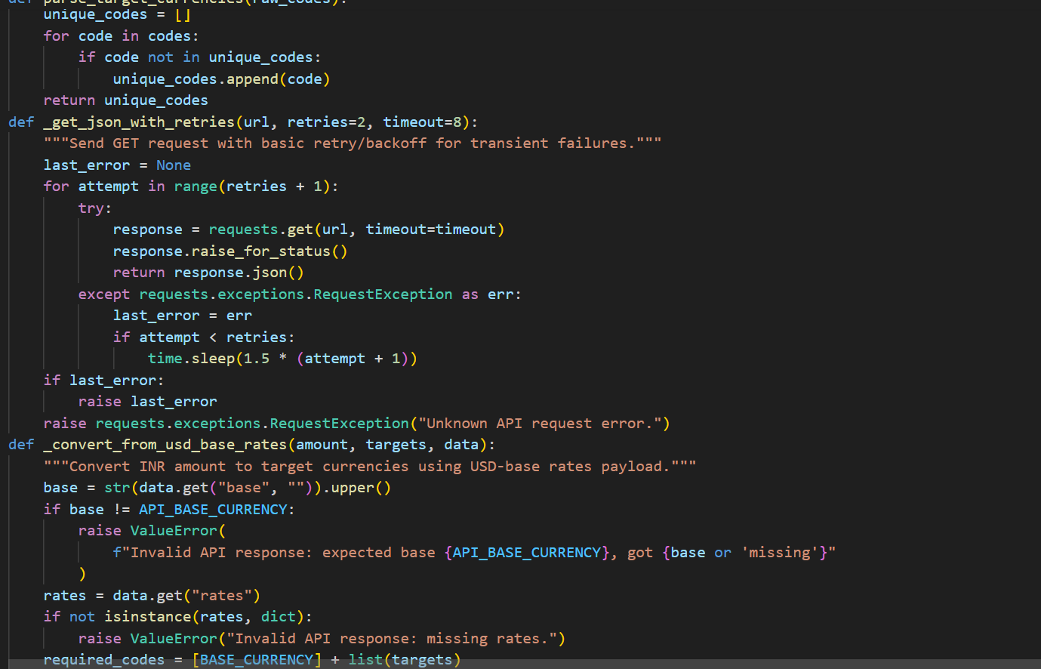
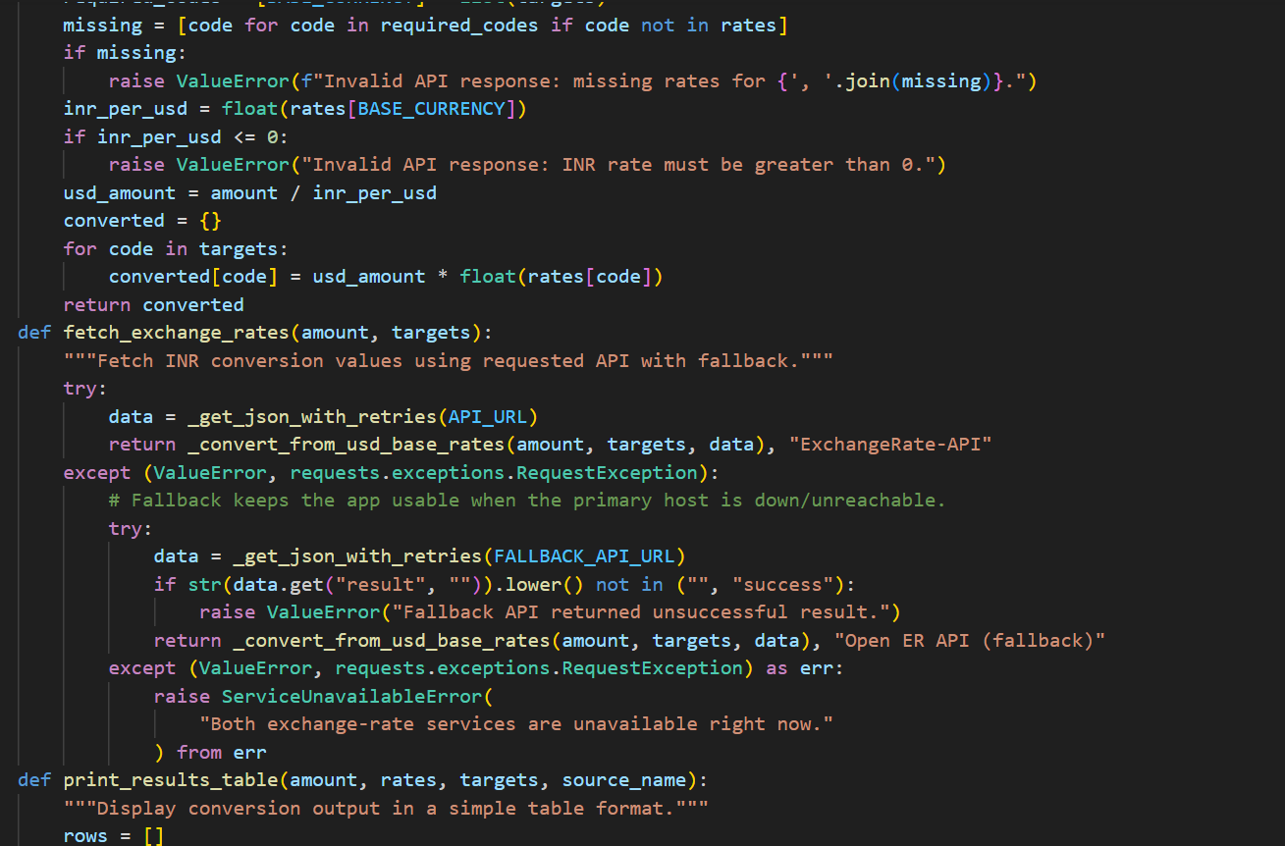
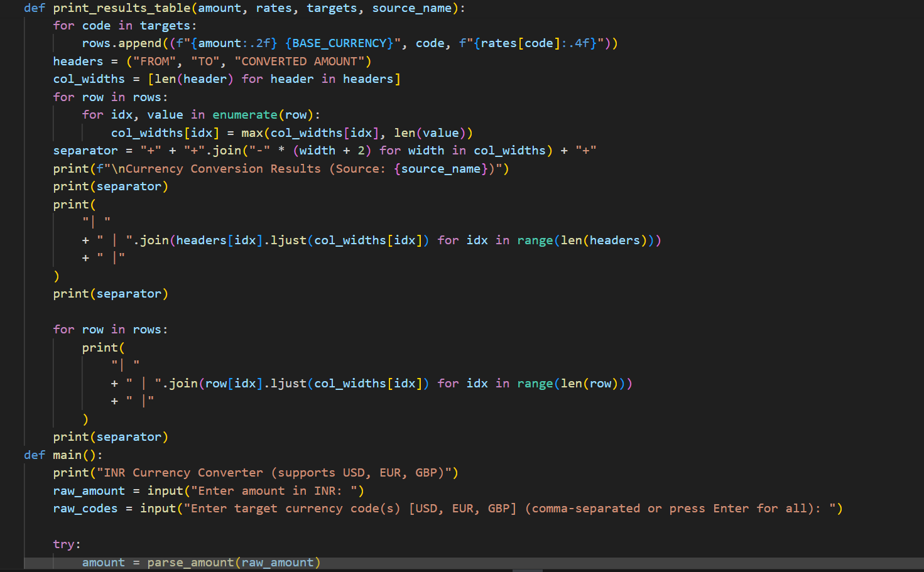
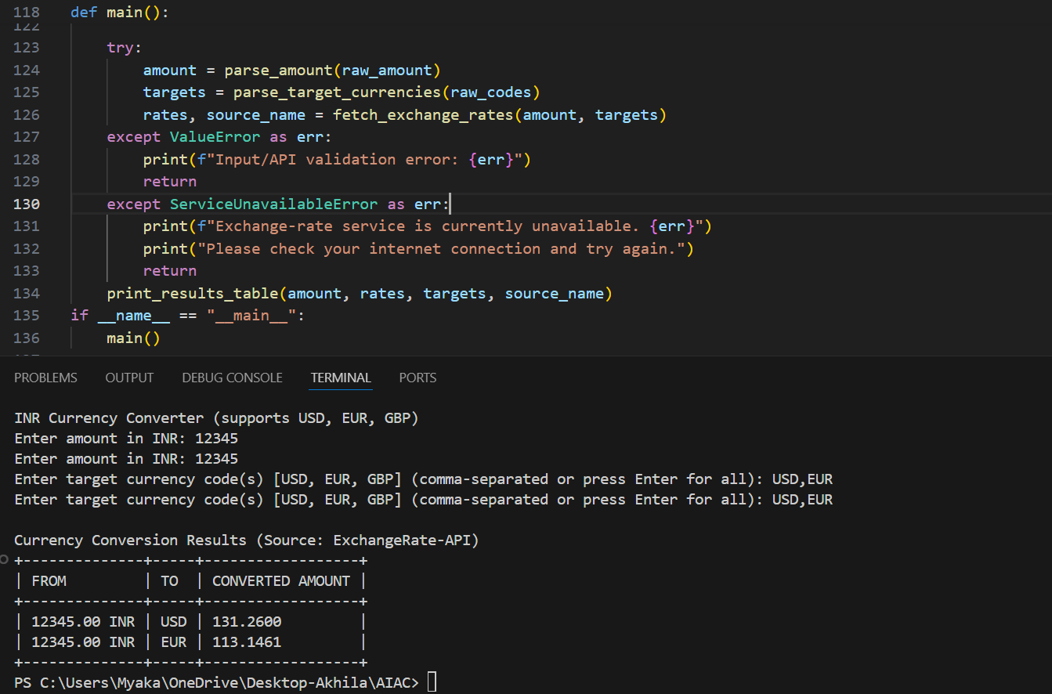
Task 3 – GitHub Repository Info Fetcher
Connect to the GitHub API to fetch details of a repository (e.g., stars,
forks, issues).
Instructions:
• Prompt AI to write a Python function to send GET requests to
GitHub API.
• Handle rate limit errors, 404 (repo not found), and invalid input.
• Display repository name, description, stars, forks, and open
issues.
Expected Output:
• A Python program that retrieves and displays GitHub repository
information with robust error handling.
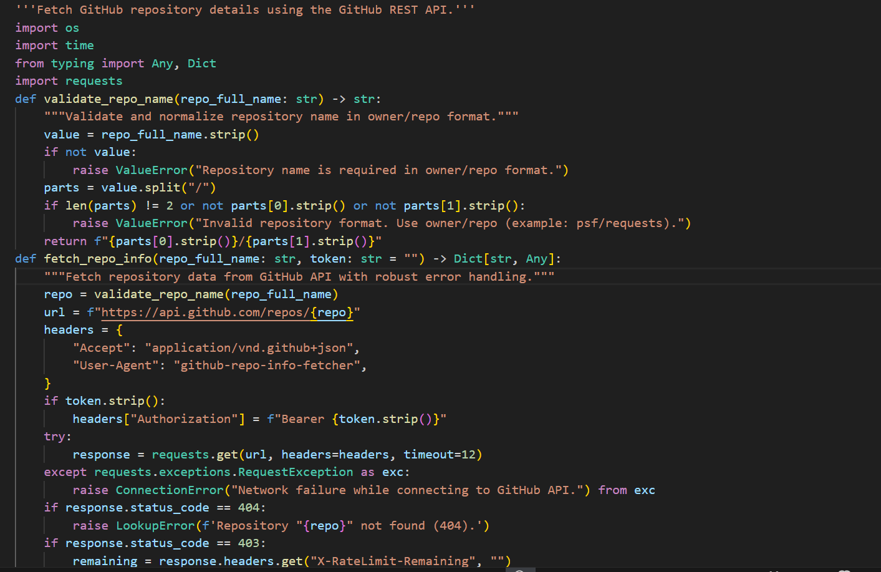
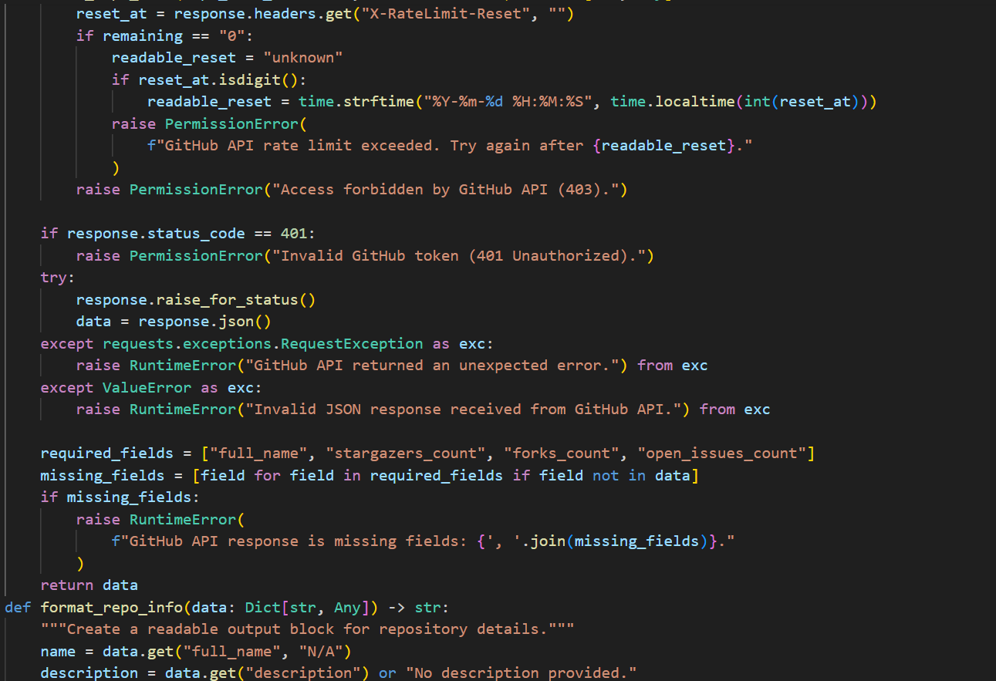
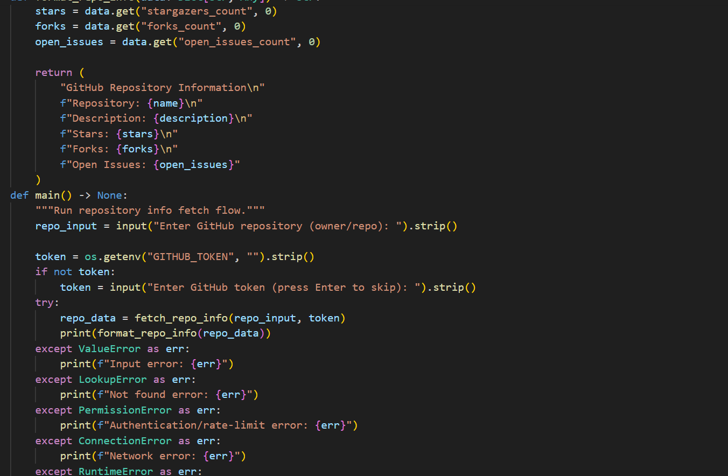
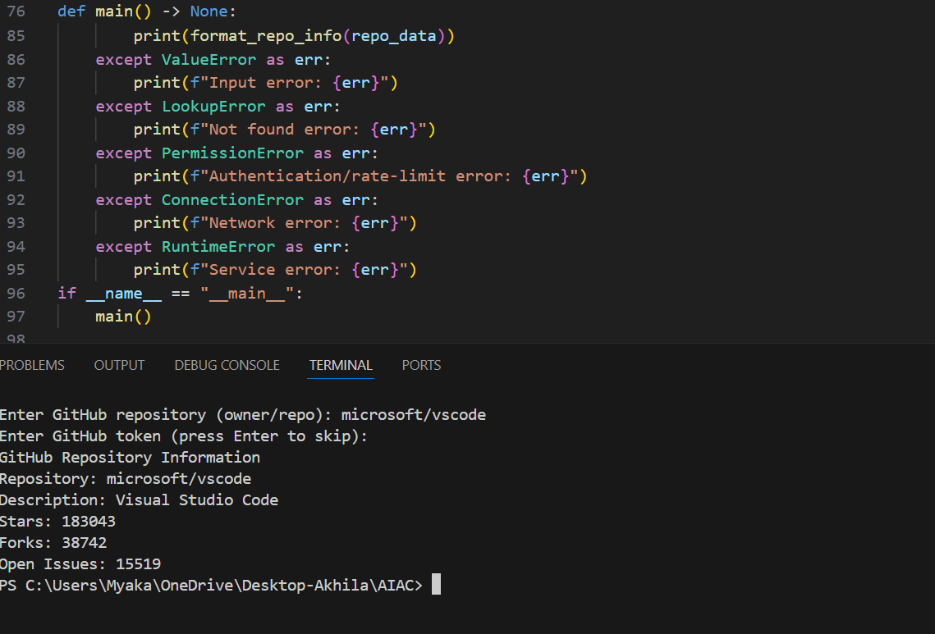

Task 4 – Real-Time Application: News Headlines Aggregator
Scenario: Build a News Aggregator using a free News API.
Requirements:
• Fetch top 5 headlines for a given category (sports, technology,
health).
• Handle errors like invalid category, missing API key, and request
failures.
• Display headlines in a user-friendly numbered list format.
• Include a retry mechanism if the first request fails.
Expected Output:
• A working Python script that retrieves and displays news
headlines with proper error handling
