AI Assisted Coding
Assignment-1
HTNO:2303A52442
Batch:31

Task-1
Prompt: #write a python program to find a factorial without any user defined functions
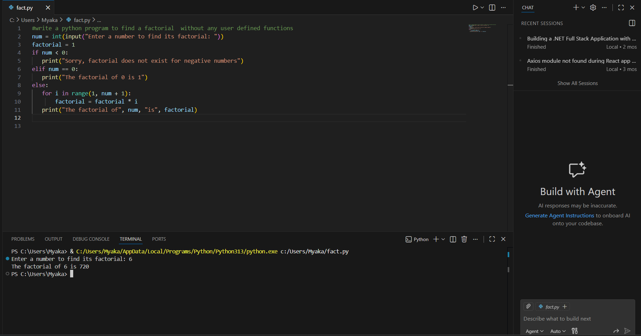
Brief reflection
GitHub Copilot helped in generating the factorial logic quickly and correctly.It followed the given constraint by not using any user-defined functions.The generated code was simple, readable, and easy to understand for beginners.
Task-2
Prompt: #write a python program to find a factorial without any user defined functions, optimize the code
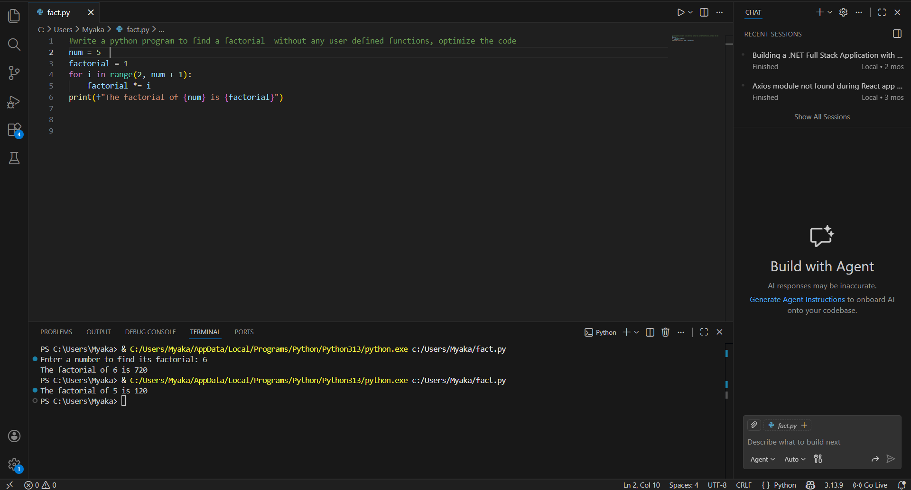
Written explanation:
In this task, the code generated in Task 1 was optimized using GitHub Copilot. The AI simplified the loop by starting the iteration from 2 and removed unnecessary operations. Variable usage was kept minimal while maintaining the same output. The optimized code is more readable and efficient
Task-3
Prompt: #write a python program to calculate factorial using a function
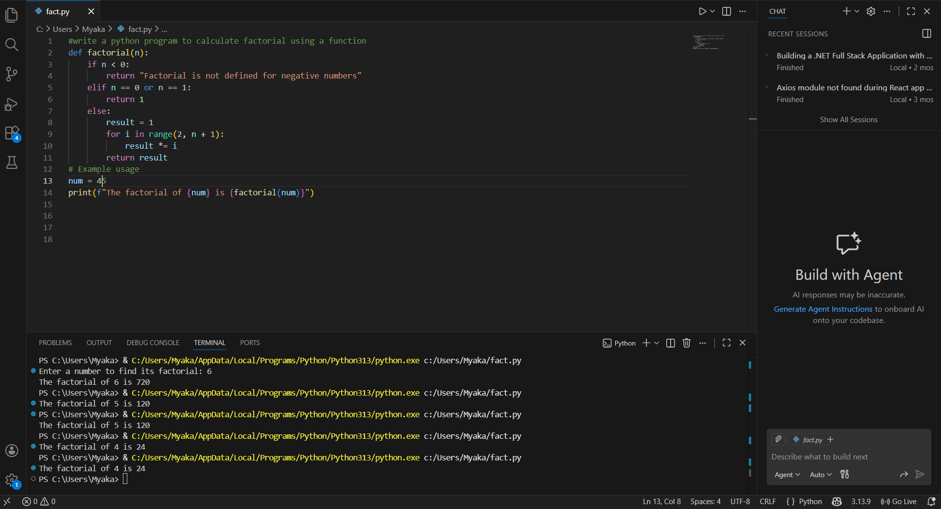
How Modularity Improves Reusability
Modularity allows the factorial logic to be written once and reused in multiple programs without rewriting the code. By placing the logic inside a function, it can be called with different inputs whenever needed. This reduces code duplication and makes updates easier. Modular code is also easier to test, debug, and maintain in larger projects.
Task-4
Comparative Analysis – Procedural vs Modular AI Code
In this task, the factorial programs generated using GitHub Copilot with and without functions were compared. The procedural version places all logic in the main program, making it simple but difficult to reuse and debug. The modular version separates the logic into a function, which improves clarity, reusability, and maintainability. For larger projects, modular code is more suitable, while procedural code is only effective for small, one-time scripts.
Criteria | Without Functions | With Functions
Logic clarity | Moderate | High
Reusability | Low | High
Debugging ease | Difficult | Easy
Suitability for large projects | poor | Good
AI dependency risk | Higher | Lower
Conclusion
This comparison shows that modular programming is more efficient and scalable. While AI can generate both styles, function-based code is preferred in real-world applications due to better structure and reuse.
Task-5
Prompt: # write a python program to calculate factorial using an iterative approach
# do not use recursion

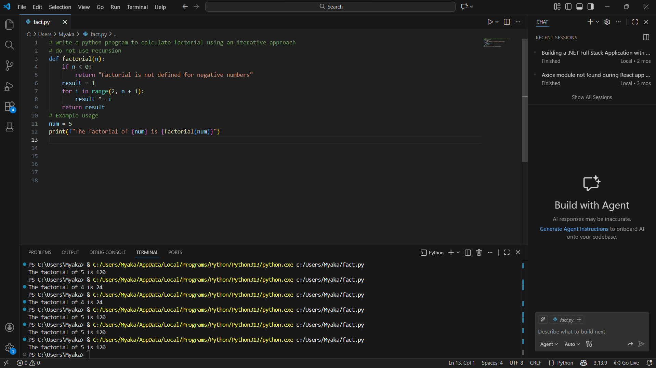
Prompt: # write a python program to calculate factorial using recursion
# include a base condition

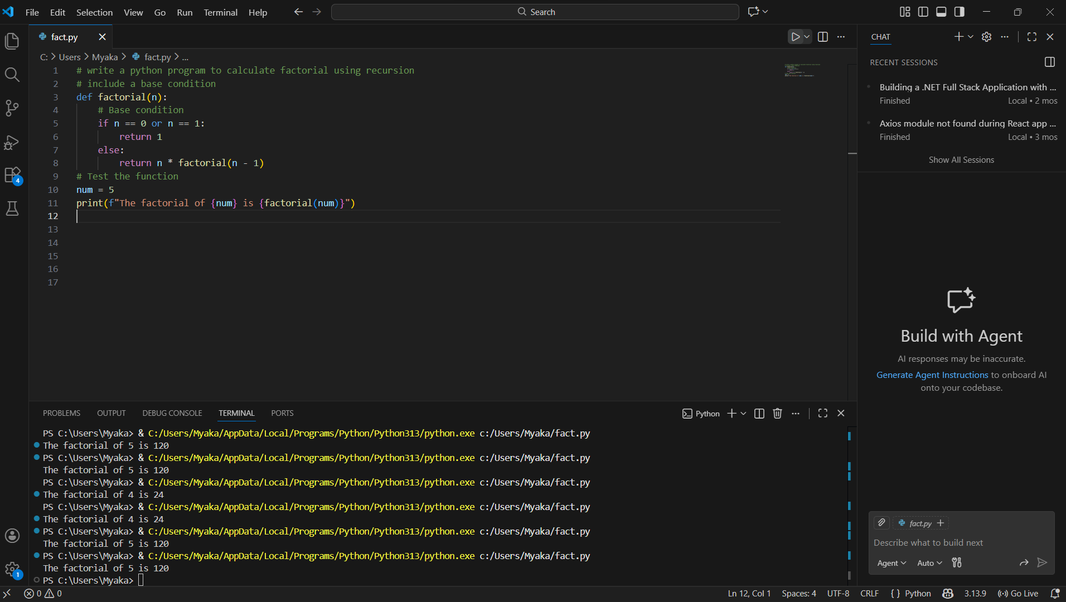

Aspect | Iterative Approach | Recursive Approach
Logic clarity | Very clear and straightforward | Less clear for beginners
Code flow | Executes step-by-step in a loop | Uses repeated function calls
Ease of understanding | Easy to understand and follow | Requires understanding of recursion
Error tracing | Simple to debug | Difficult to trace errors
Beginner friendliness | Highly suitable | Less suitable
Overall clarity | High | Moderate

