AI Assisted Coding
ASSIGNMENT 2.3
Name: Akhila
HT No: 2303A52442
Batch: 31

Task 1: Word Frequency from Text File
Prompt: Generate Python code that reads a text file, counts the frequency of each word using an efficient approach, and provide a clear line-by-line explanation of the code
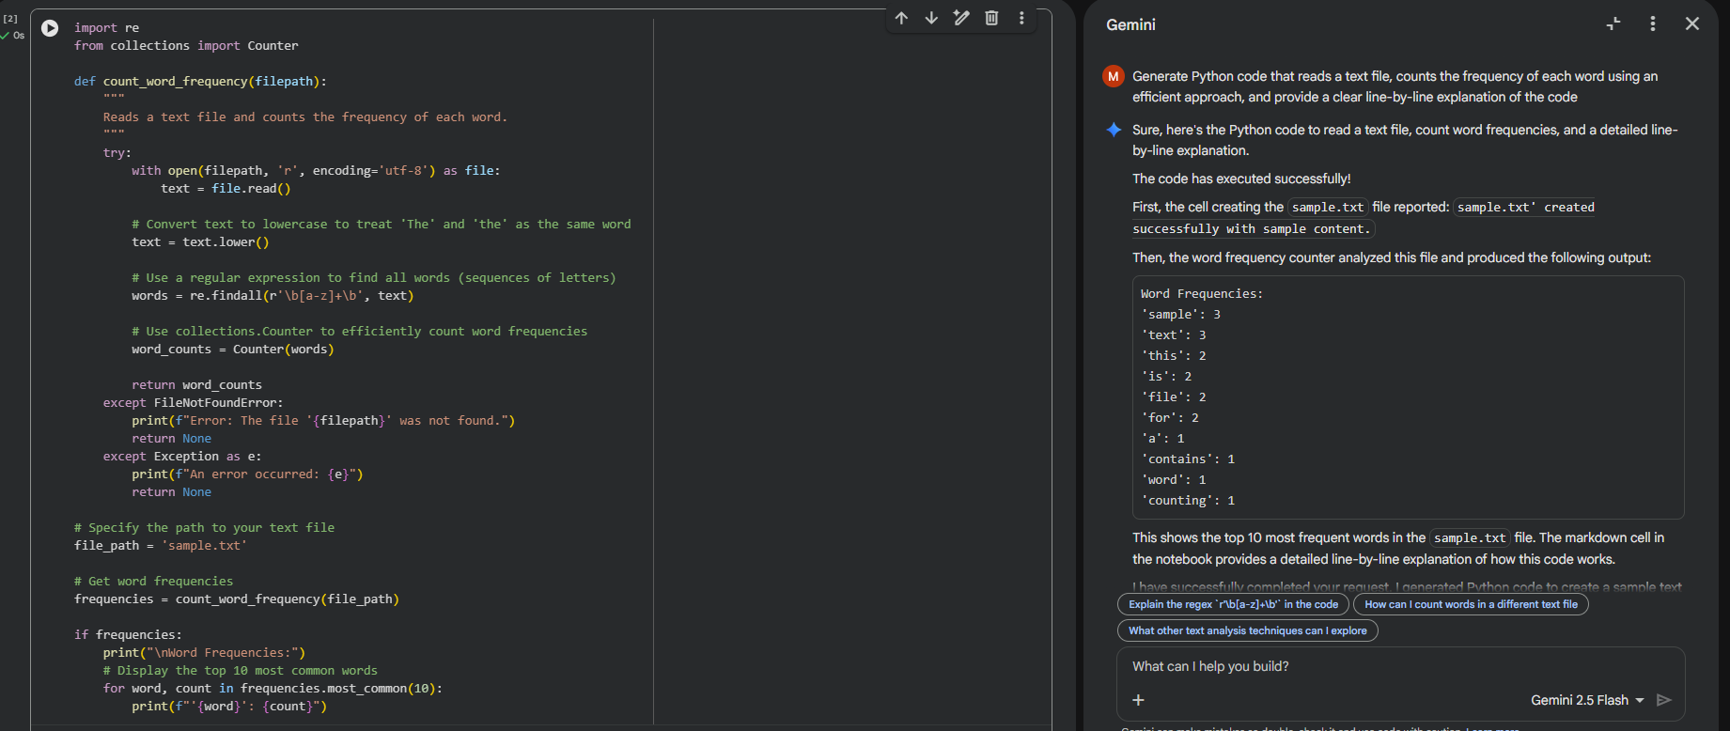
Output:
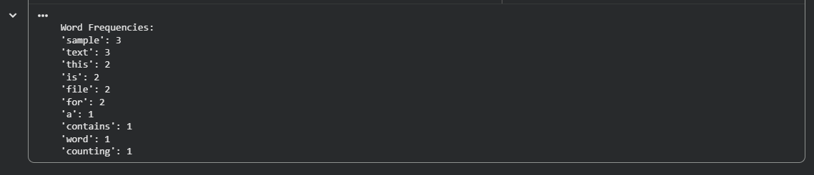
Explanation:
The program reads a text file and converts all words to lowercase to maintain consistency.
It splits the text into individual words and uses the Counter class to count their occurrences.
This avoids manual counting and makes the code efficient and easy to understand.
Finally, the program prints each word along with its frequency from the file.
Task2:
Prompt: Generate a Python program to create a text file, write sample text into it, then read and display the file content.
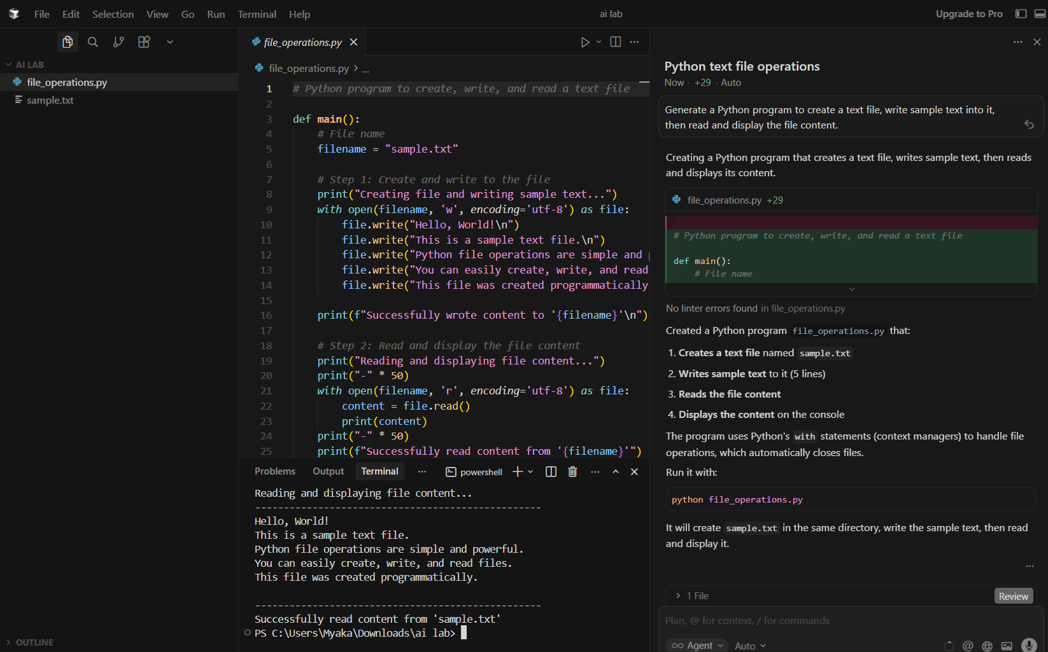
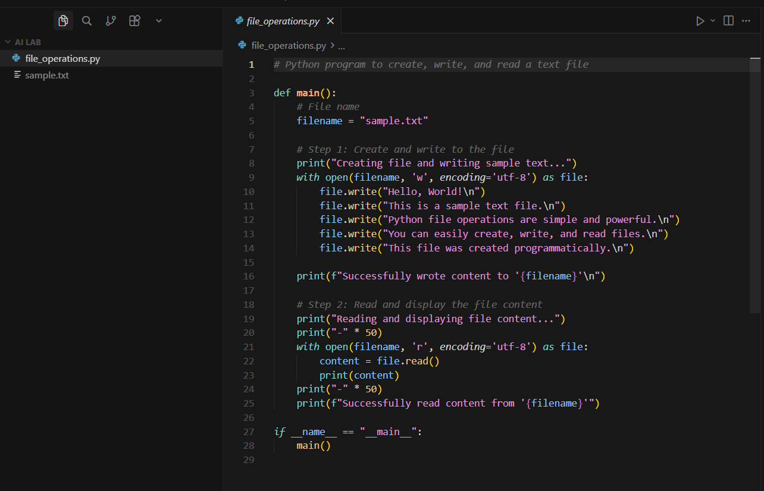

Explanation:
The program creates a text file named sample.txt using Python’s file handling functions.
It writes multiple lines of sample text into the file in write mode.
The file is then reopened in read mode to retrieve its contents.
Finally, the program displays the file content on the console, confirming successful file operations.
Task3:
Prompt:
Generate Python code to read a CSV file and calculate the mean, minimum, and maximum values of a numeric column.
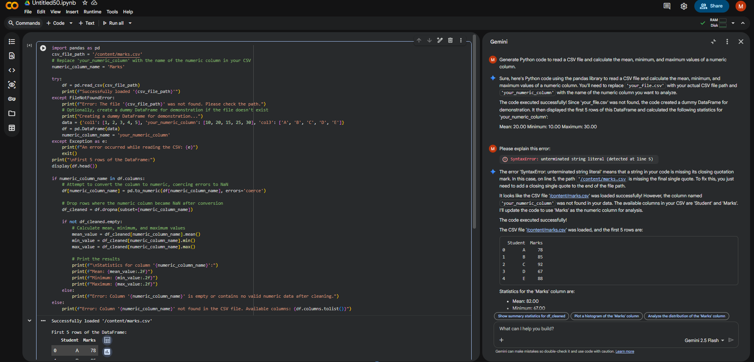
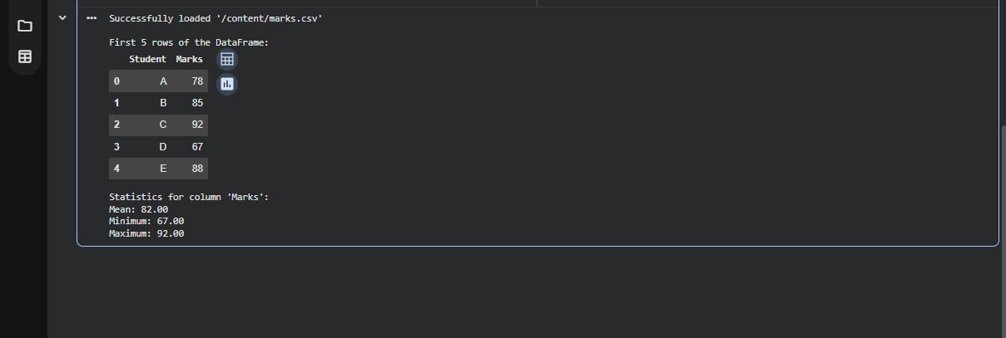
Explanation:
The program reads data from a CSV file using the pandas library.
It processes the numerical column to calculate statistical values.
The mean, minimum, and maximum values are computed using built-in functions.
This approach provides an efficient way to analyze structured data.

Task4:
Prompt: Generate Python code for Bubble Sort and Python’s built-in sort function
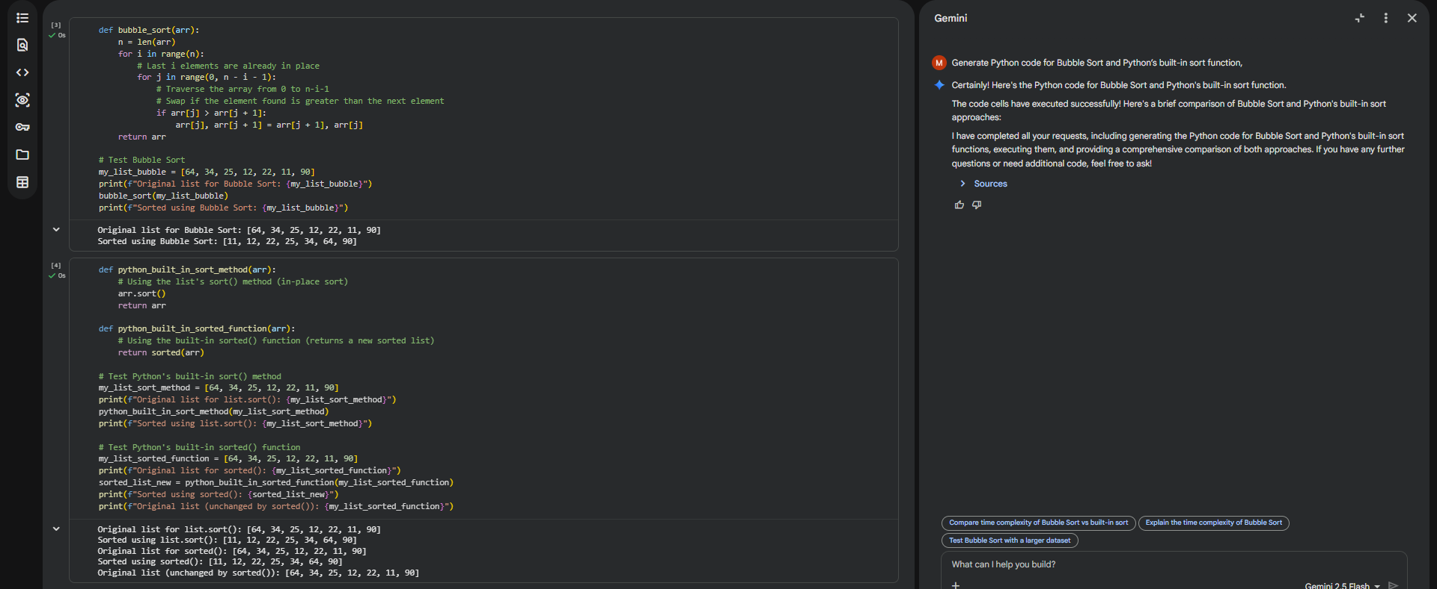
Explanation:
Bubble sort uses repeated comparisons and swaps, making it slow for large datasets.
The built-in sort() function uses an optimized algorithm and performs faster.
Bubble sort is mainly useful for learning purposes.
Built-in sorting is recommended for real-world applications.

