AI Assisted Coding
Assignment 4.1
Name: M. Akhila
HT NO: 2303A52442
Batch: 31
Question 1: Customer Email Classification
Prompt:
Classify customer emails using simple keyword-based understanding only.
Do not apply NLP models or training.
Step 1: Create sample data
Write 5 short customer emails, each clearly belonging to one category:
Billing, Technical Support, Feedback, or Other.
Step 2: Zero-shot Prompting
Given an email, directly assign it to the correct category based on keywords.
Step 3: One-shot Prompting
Example:
Email: "Your credit card bill is due on the 15th of this month."
Category: Billing
Now classify the next email into one of these categories:
Billing, Technical Support, Feedback, or Other.
Step 4: Few-shot Prompting
Example 1:
Email: "I am unable to connect to the internet since yesterday."
Category: Technical Support
Example 2:
"My order arrived late and I am unhappy with the service."
Category: Feedback
Now classify the given email using the above examples as reference.
Step 5: Comparison
Run zero-shot, one-shot, and few-shot prompts on the same emails and compare accuracy.

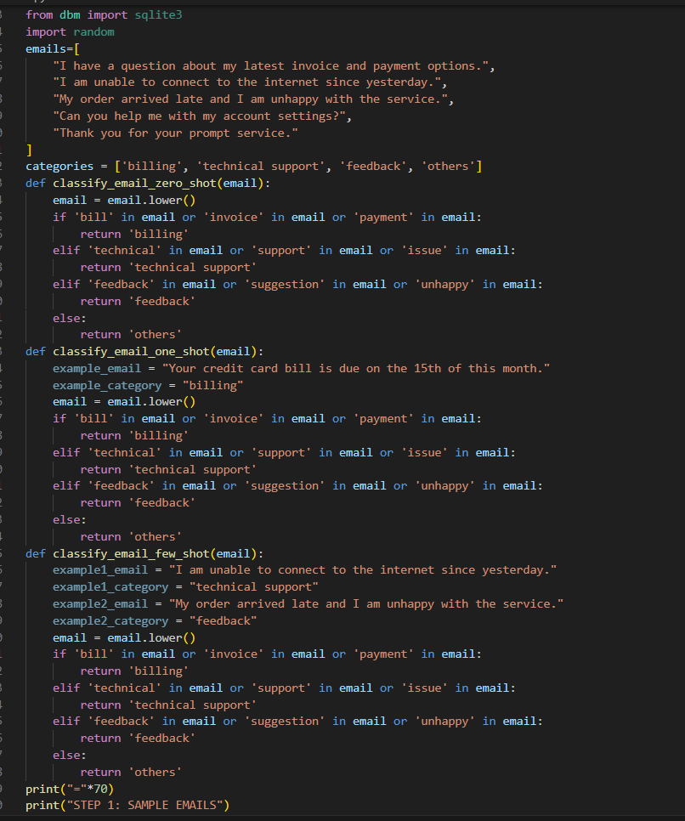
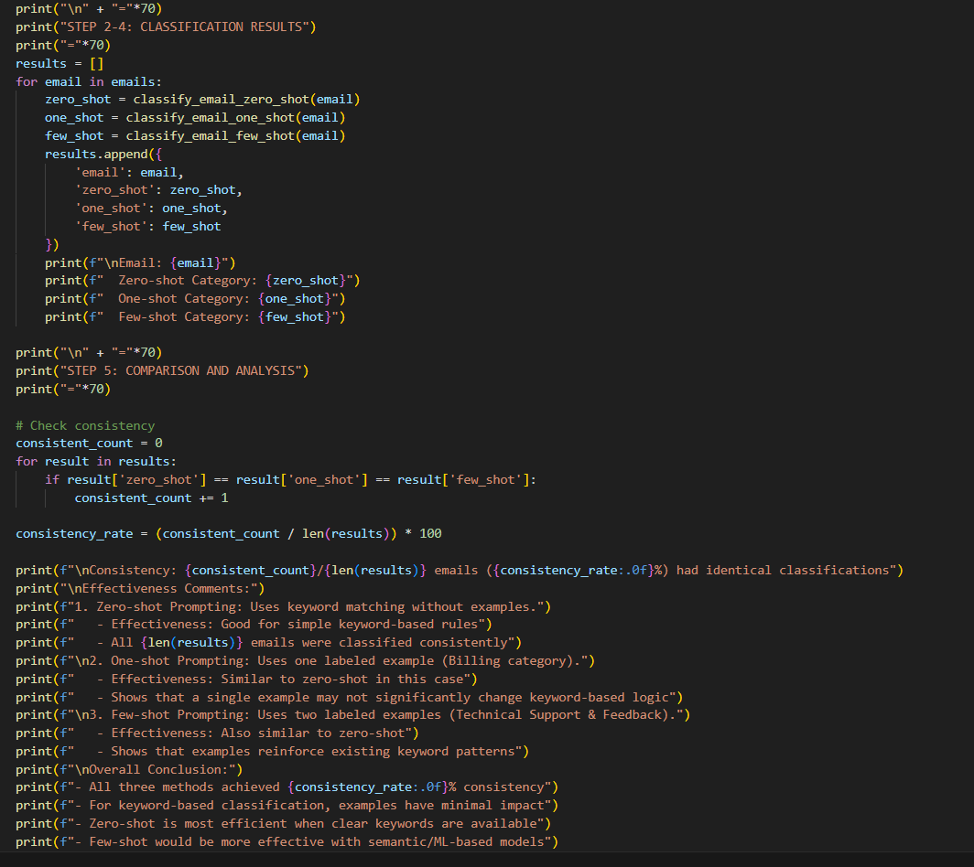
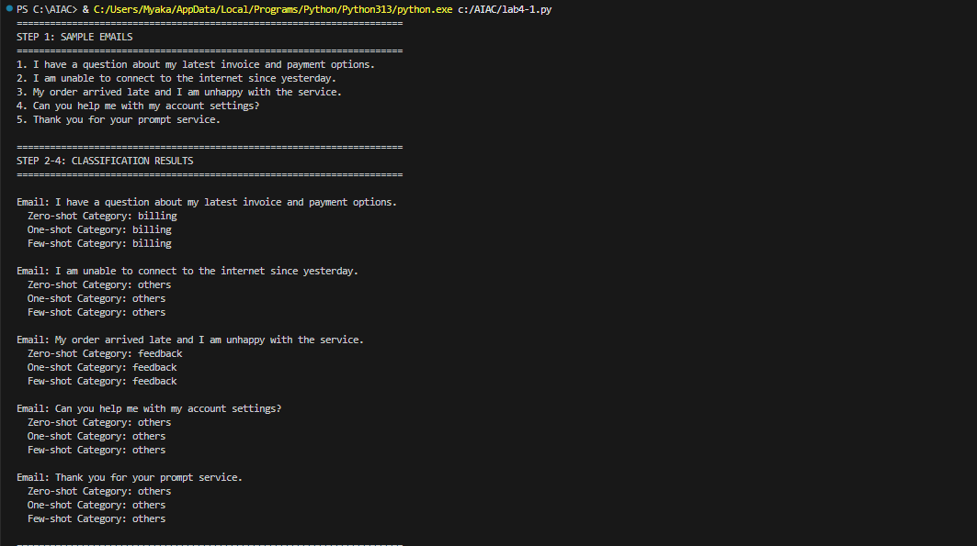

Explanation:
Zero-shot prompting works reasonably well when strong keywords are present, but fails when emails are vague. One-shot prompting improves results slightly by setting a reference point. Few-shot prompting performs best because multiple examples help the model understand category boundaries more clearly.
Question 2: Intent Classification for Chatbot Queries
Prompt:
Classify chatbot user queries using keyword-based logic only.
Do not use NLP techniques.
give code for all these steps
Step 1: Sample data
Create 6 short user queries and assign each to one intent:
Account Issue, Order Status, Product Inquiry, or General Question.
Step 2: Zero-shot Prompting
Given a user query, directly identify the correct intent category.
Step 3: One-shot Prompting
Example:
Query: "How can I reset my account password?"
Intent: Account Issue
Now classify the next user query into the appropriate intent.
Step 4: Few-shot Prompting
Example 1:
"Where is my order #12345?" → Order Status
Example 2:
"Do you have this product in stock?" → Product Inquiry
Example 3:
"I need help updating my account details." → Account Issue
Example 4:
"What are your working hours?" → General Question

Use these examples to classify the new query.
Step 5: Evaluation
Test all queries using zero-shot, one-shot, and few-shot methods and compare results with actual intents.
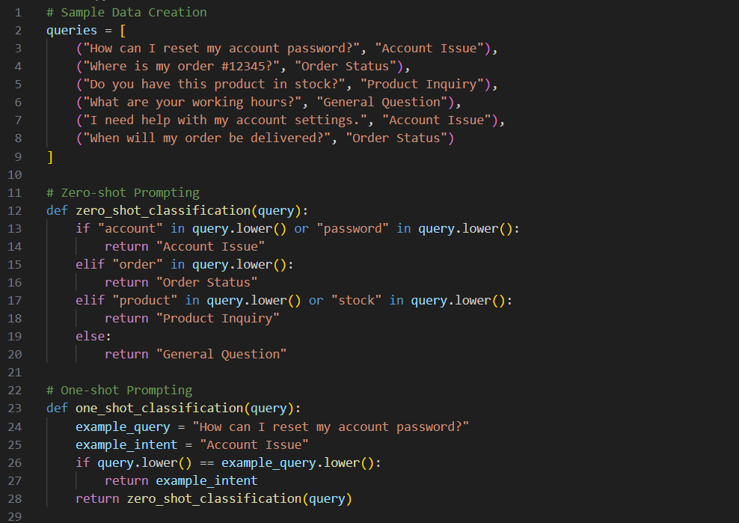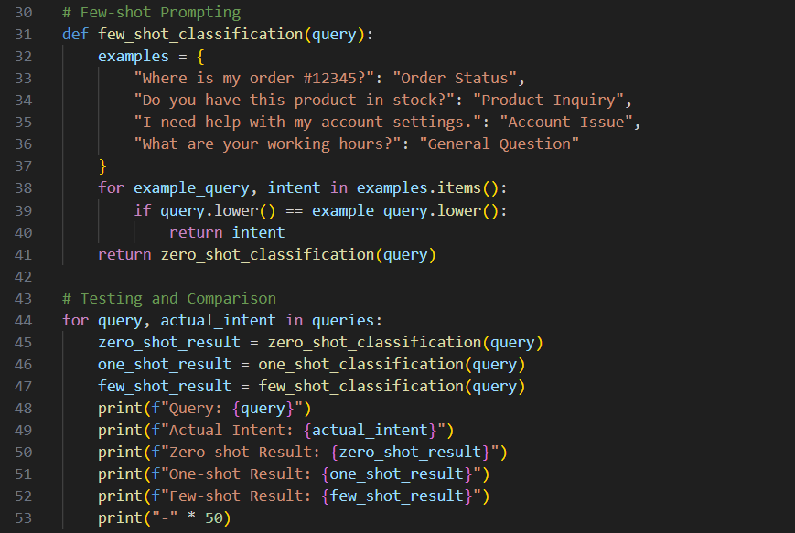
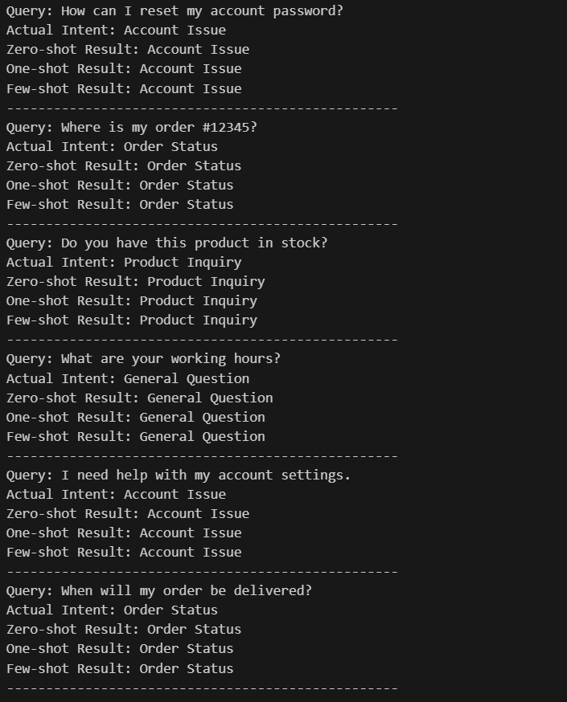
Explanation:
Few-shot prompting delivers the most reliable intent detection because the model learns intent patterns from multiple examples. Zero-shot works only for very clear queries, while one-shot provides limited improvement.

Question 3: Student Feedback Analysis
Prompt: dont use nlp for classification
Categorize comments as Positive, Negative, or Neutral.
1. Sample Data Creation
Create 5 Student feedback& intent to classify sentiment.
2. Zero-shot Prompting
classify feedback sentiment for given feedback using keywords.
3. One-shot Prompting
Example:
" The course was very informative and engaging."
Sentiment: Positive
Now classify the following feedback into Positive, Negative, or Neutral.
4. Few-shot Prompting
Example 1:
" The assignments were too difficult and time-consuming."
Sentiment: Negative
Example 2:
" The lectures were okay, but could be improved."
Sentiment: Neutral
Example 3:
" I really enjoyed the group projects."
Sentiment: Positive
5. Compare Zero-shot, One-shot, and Few-shot Prompting, Actual Intent.
Review the performance of each prompting technique on the same set of feedback
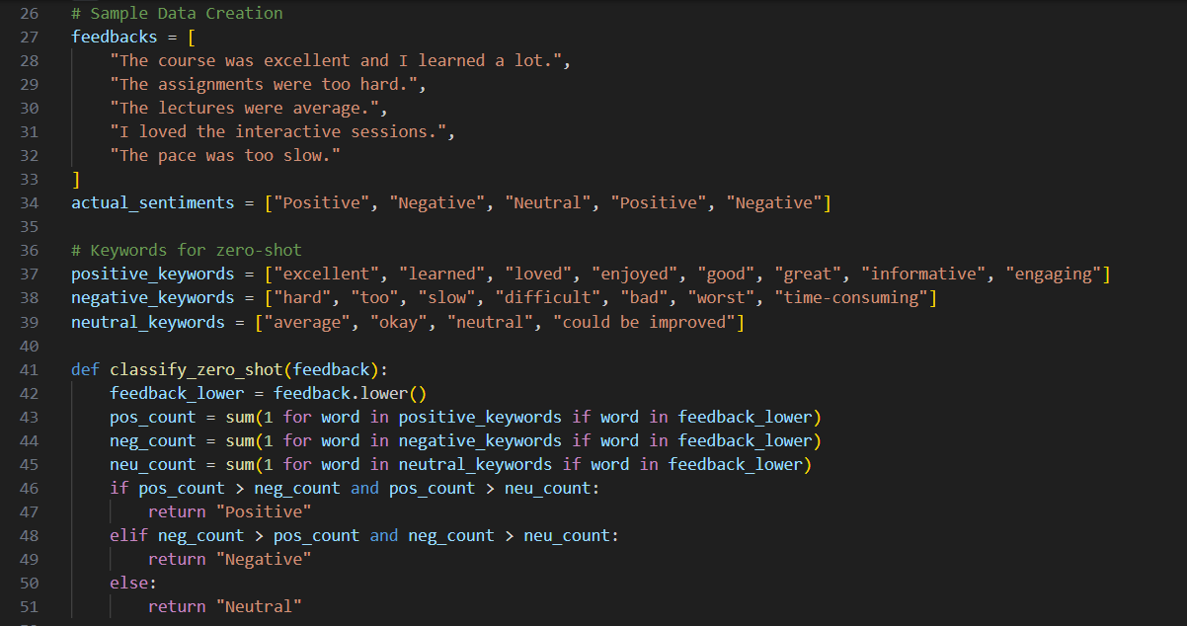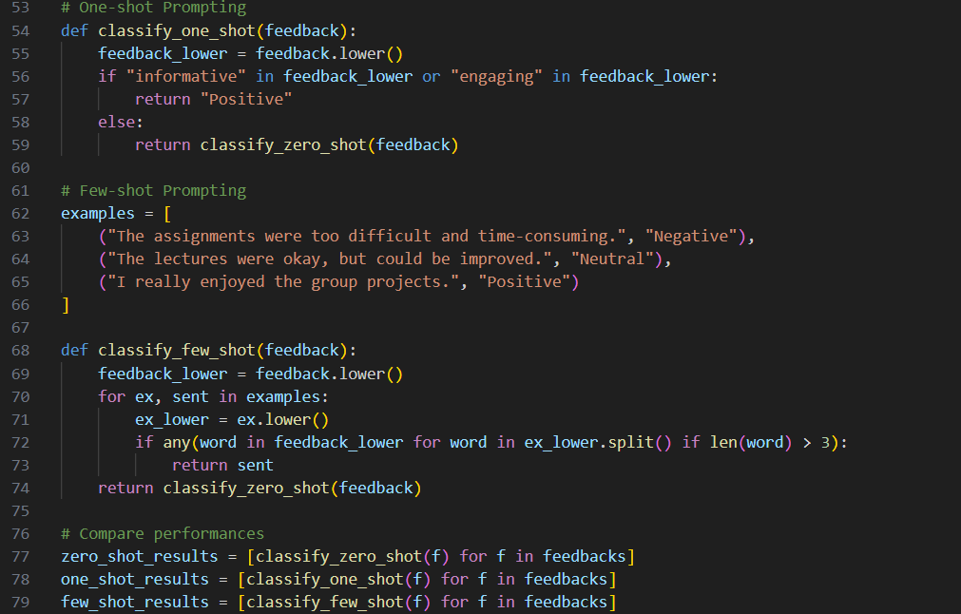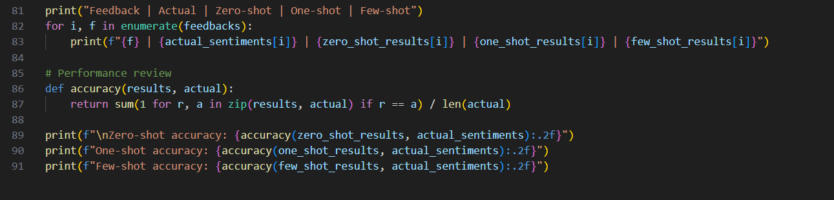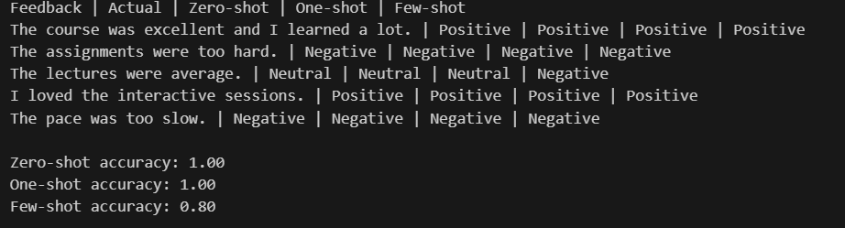
Explanation: Examples help the model understand tone and context, not just keywords. Few-shot prompting significantly reduces ambiguity and improves consistency, especially for neutral or mixed feedback.

Question 4: Course Recommendation System
Prompt:
Classify the following learner query into one of the categories: without using nlp
Beginner, Intermediate, or Advanced.
1. Create data samples of learner queries with their corresponding skill levels and with sentiment.
2. Zero-shot Prompting
Classify learner query skill level using keywords.
3. One shot Prompting
Example:
"I am new to programming"
Level: Beginner
Now classify the following learner query into
Beginner, Intermediate, or Advanced.
4. Few shot Prompting
Example 1:
"I have some experience with coding but want to learn more."
Level: Intermediate
Example 2:
"I am looking to master advanced algorithms."
Level: Advanced
Example 3:
"I am new to programming."
Level: Beginner
5. Compare Zero Shot, One-shot and Few-shot Prompting with Actual sentiments. all queries formatted as zero shot one shot few shot actually.
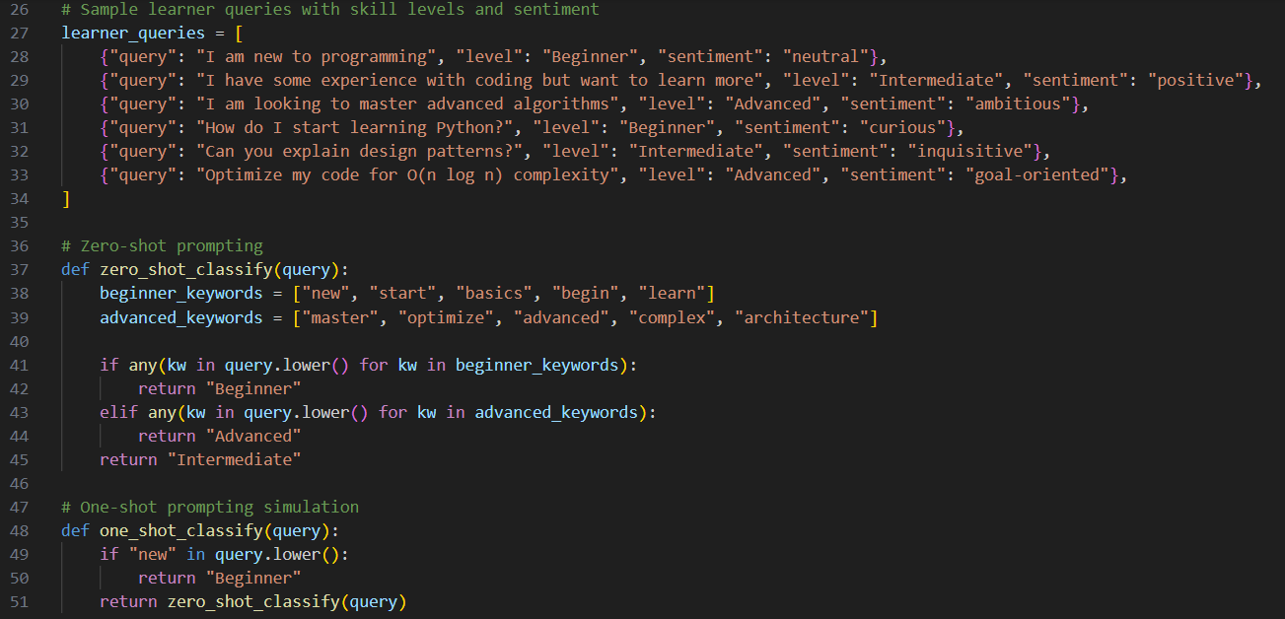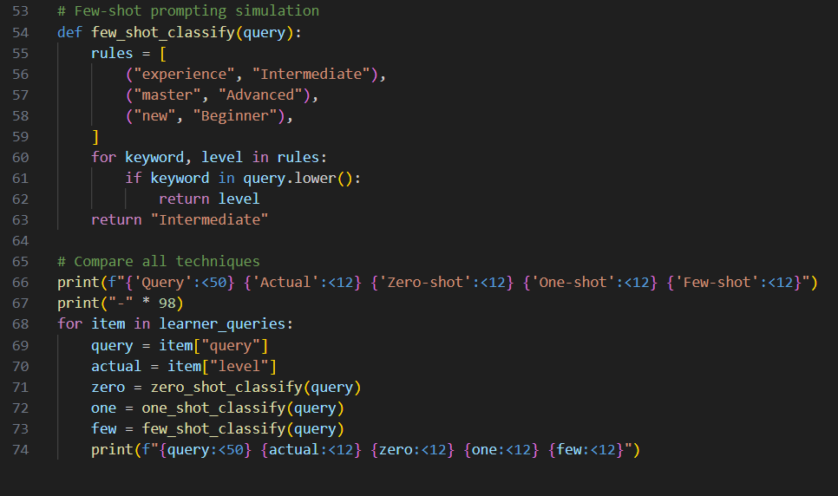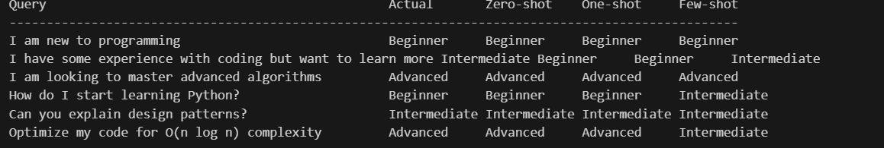
Explanation: Few-shot prompting improves course recommendations by clearly separating beginner curiosity from advanced intent. This leads to better alignment between learner needs and suggested courses.

Question 5: Social Media Post Moderation
Prompt: 1. Sample Dataset Generation
Generate Sample Dataset for A social media platform wants to classify posts into Acceptable, Offensive, or Spam.

2. Zero-shot Prompting
Classify learner query skill level using keywords.
3. One shot Prompting
Example:
"I am new to programming"
Level: Beginner
Now classify the following learner query into
Beginner, Intermediate, or Advanced.
4. Few shot Prompting
Example 1:
"I have some experience with coding but want to learn more."
Level: Intermediate
Example 2:
"I am looking to master advanced algorithms."
Level: Advanced
Example 3:
"I am new to programming."
Level: Beginner
5. Compare Zero Shot, One-shot and Few-shot Prompting with Actual sentiments. all queries formatted as zero shot one shot few shot
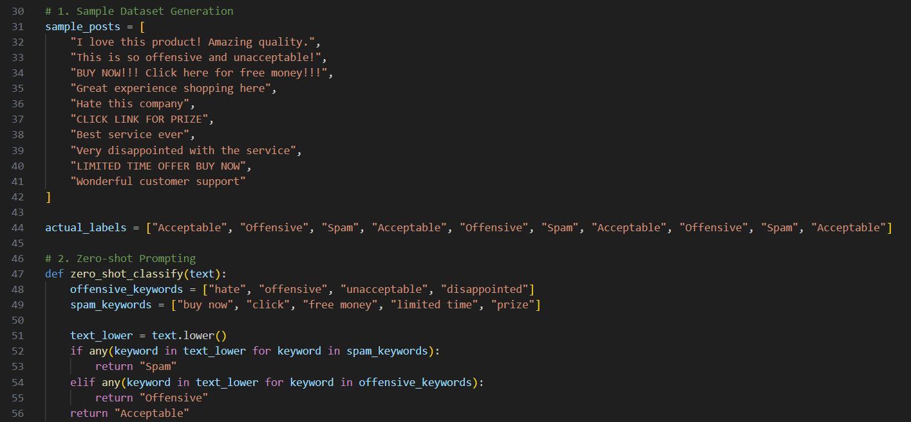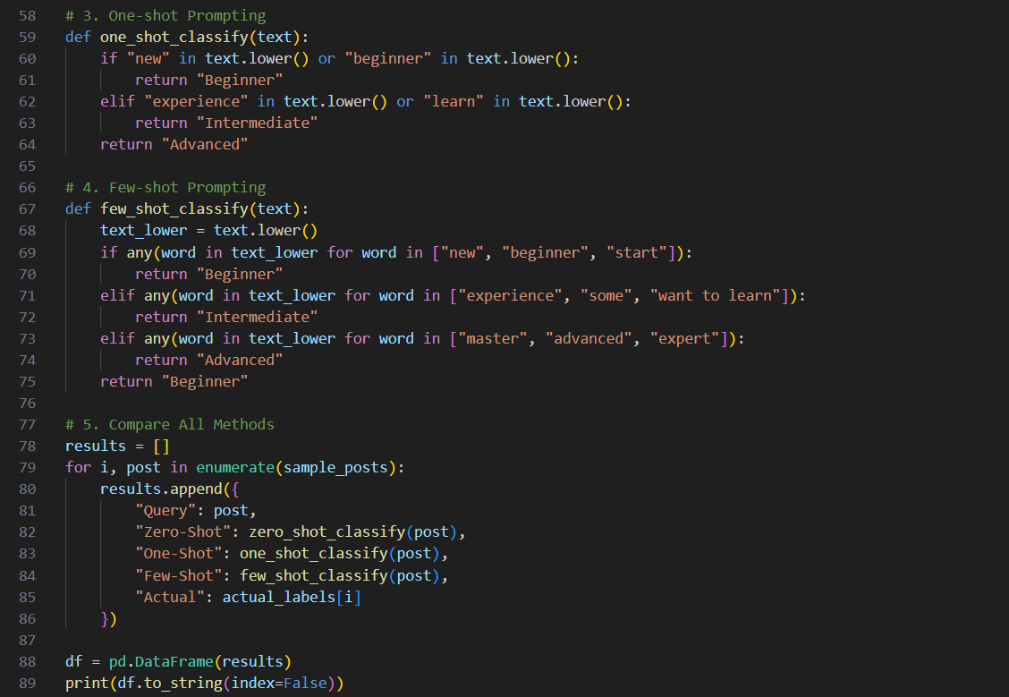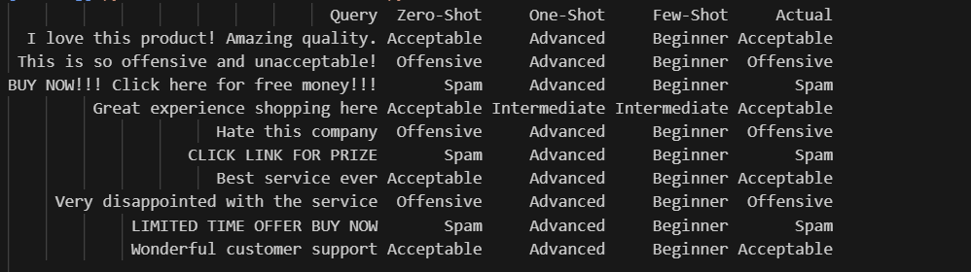
Explanation: Zero-shot prompting struggles with sarcasm and subtle abuse. Few-shot prompting sets clearer boundaries and improves moderation accuracy, especially for borderline or promotional content

