AI Assisted Coding
Assignment-3.1
Name:M.Akhila
HT NO: 2303A52442
Batch:31

Question 1: Zero-Shot Prompting (Palindrome Number Program)
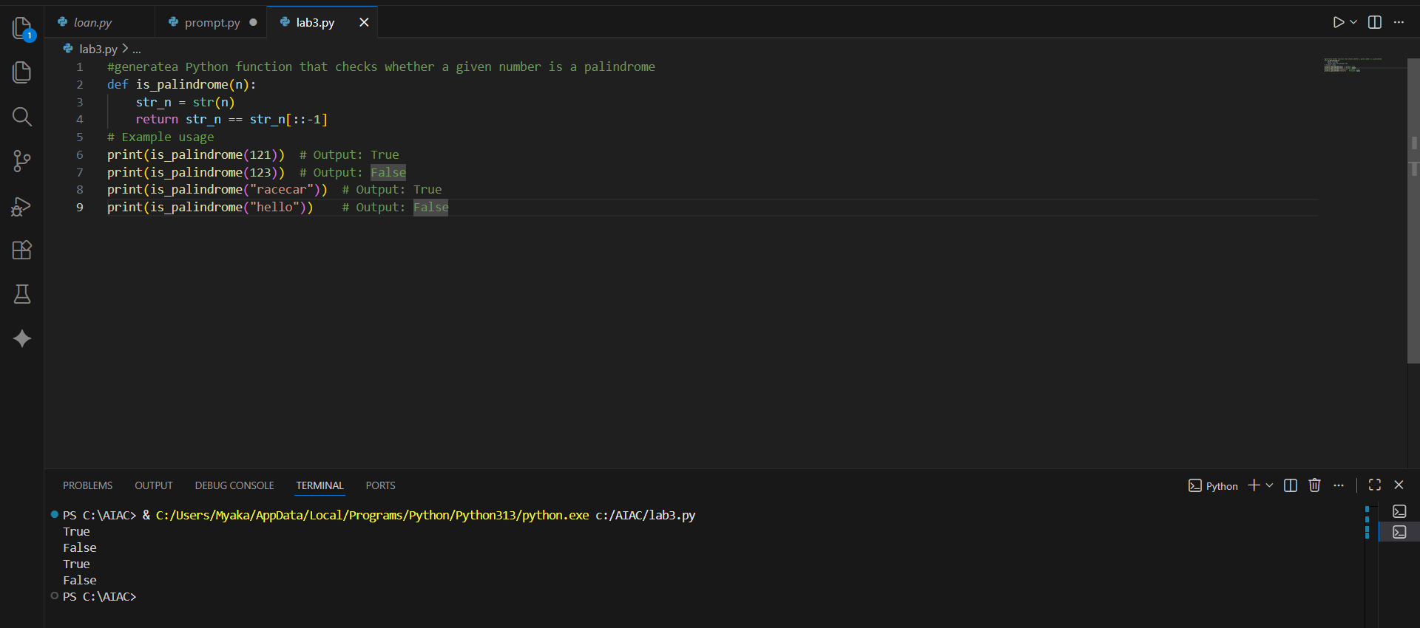
Task:
In zero-shot prompting, no examples are given to the AI. The AI generates basic code to check whether a number is a palindrome. It works for normal inputs but does not handle edge cases. The solution is simple but limited.
Question 2: One-Shot Prompting (Factorial Calculation)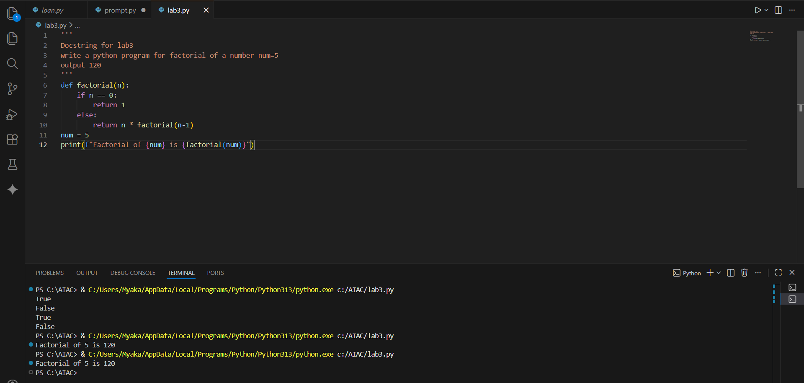
Comparison:
One-shot prompting gives better results than zero-shot. The code is more clear and readable. Providing an example helps the AI understand the problem better.
Question 3: Few-Shot Prompting (Armstrong Number Check)

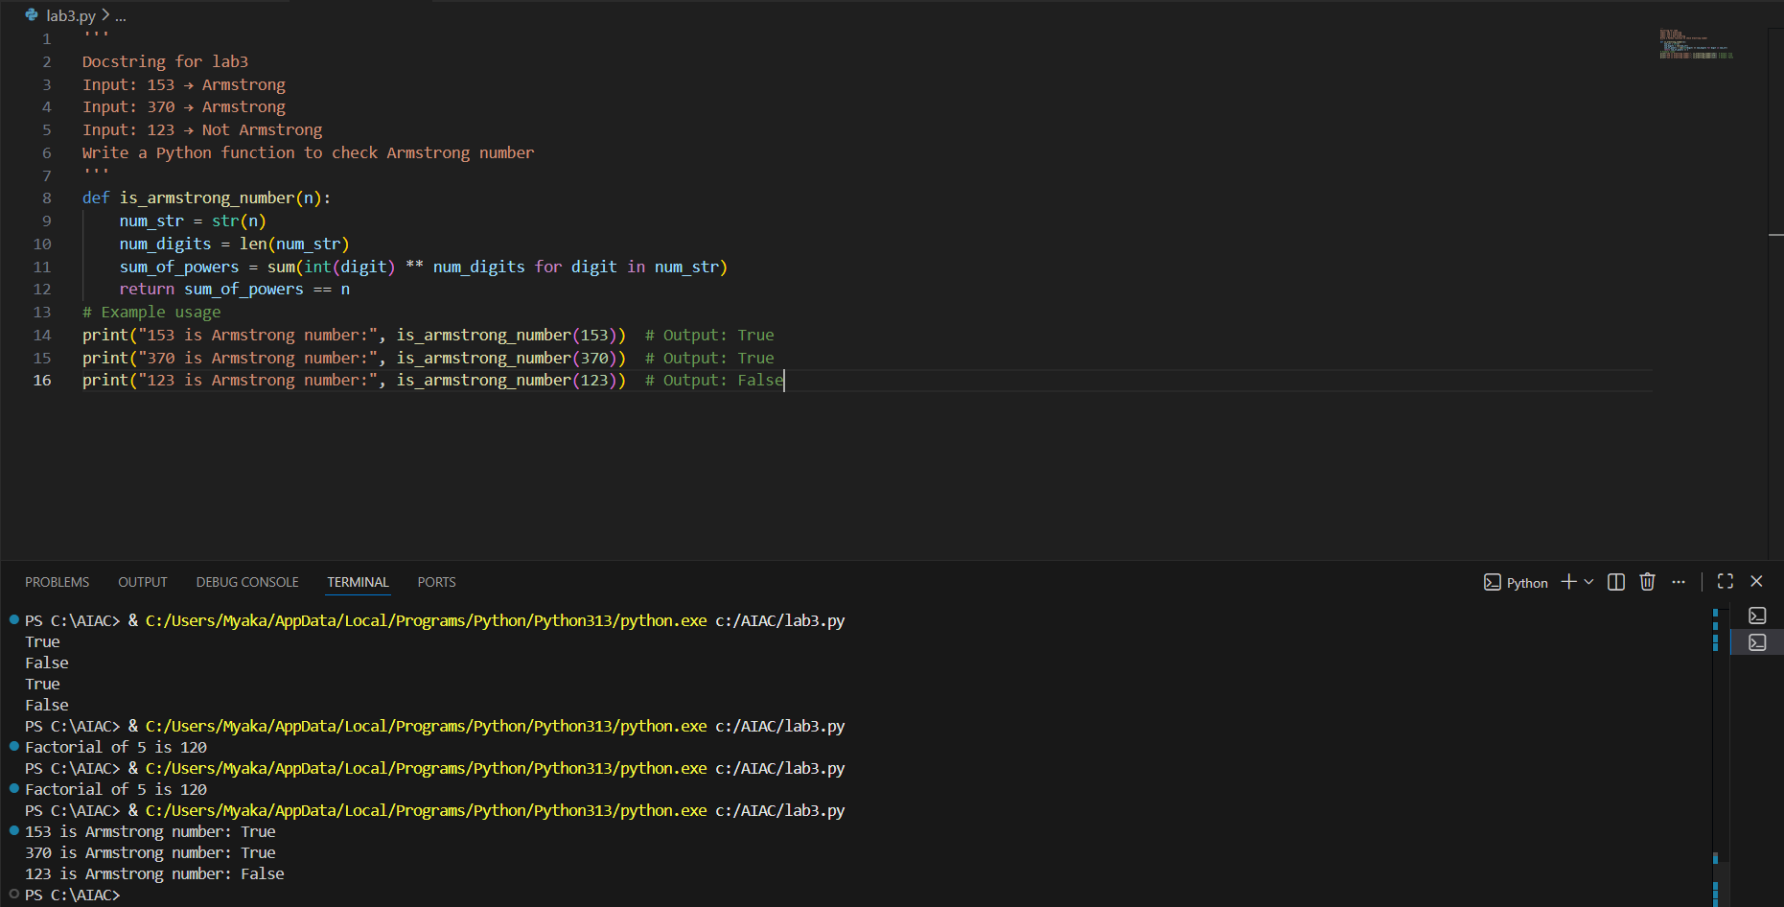
Task:
Few-shot prompting uses multiple examples. This helps the AI generate accurate and well-structured code. The logic works correctly for valid inputs. Few-shot prompting gives better results.
Question 4: Context-Managed Prompting (Optimized Number Classification)
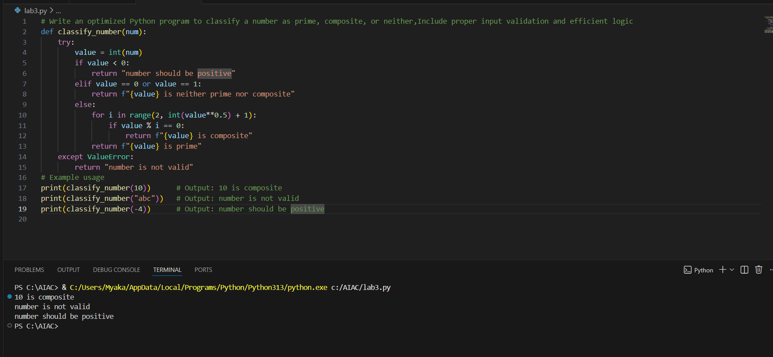
Task:
The program checks whether the input is valid and handles invalid values properly.
Efficient logic is used by checking divisibility only up to the square root of the number.
This approach gives faster and more accurate results.
Compared to earlier prompting methods, this produces clearer and better output.
Question5:Zero-Shot Prompting (Perfect Number Check)

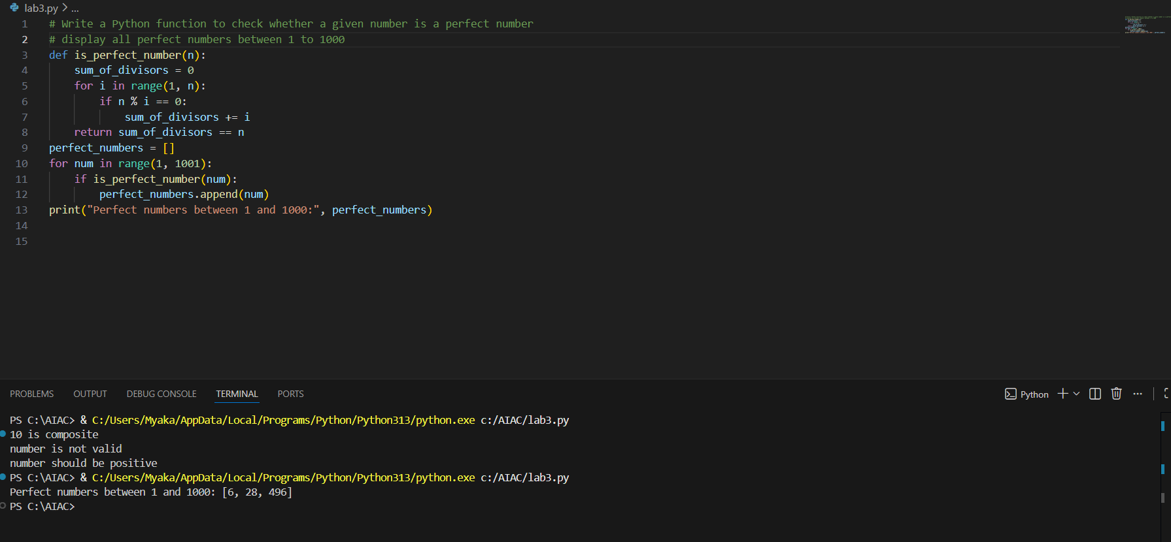
Task:
The program checks whether a number is a perfect number by adding all its divisors.
If the sum of the divisors equals the number, it is marked as perfect.
The program tests numbers from 1 to 1000 and prints all perfect numbers.
The logic works correctly but is not efficient because it checks all values up to the number.

Question6:Few-Shot Prompting (Even or Odd Classification with Validation)

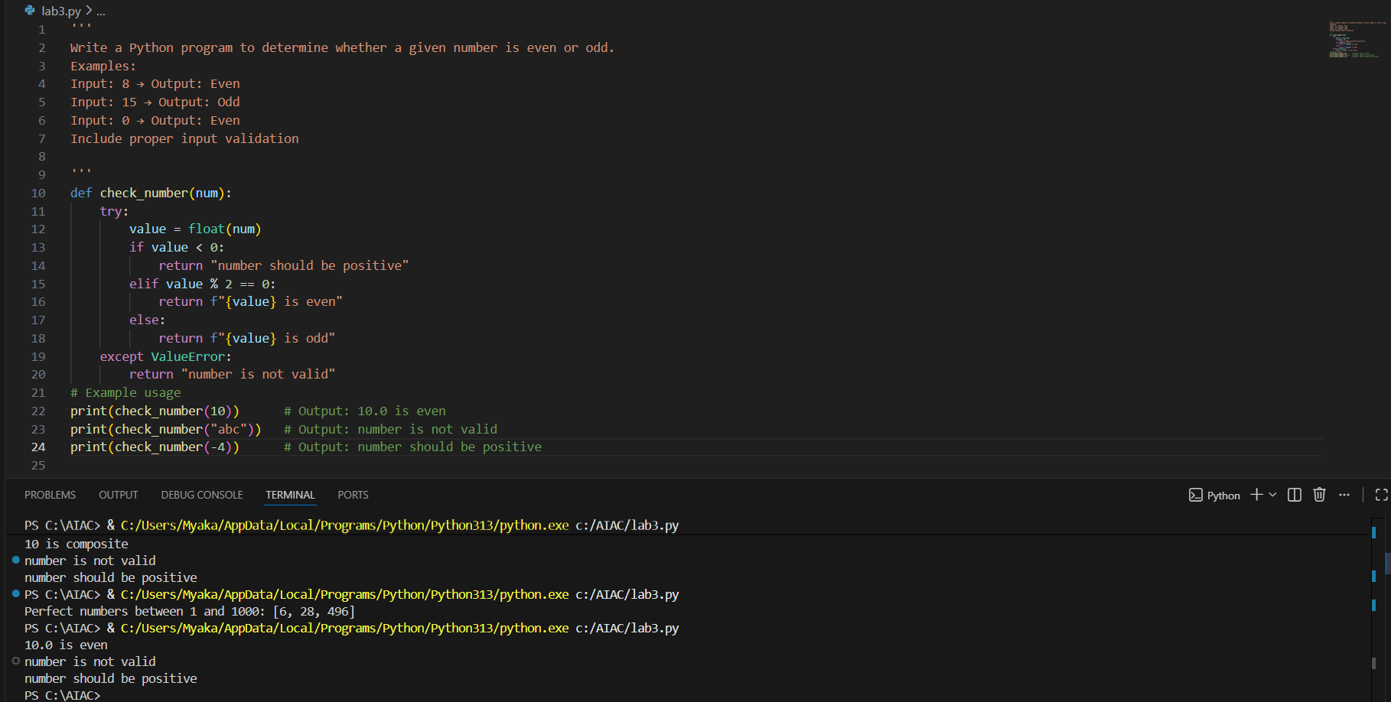
Task:
The given examples help the AI clearly understand the expected output format.
The program correctly handles even, odd, and zero values.
Negative numbers are also classified correctly.
Non-integer inputs are identified as invalid, improving output clarity

