AI ASSISTED CODING
ASSIGNMENT 08
Name: M . Akhila
HT No: 2303A52442
Batch: 31

Task Description #1 (Username Validator – Apply AI in
Authentication Context)
• Task: Use AI to generate at least 3 assert test cases for a
function is_valid_username(username) and then implement
the function using Test-Driven Development principles.
• Requirements:
o Username length must be between 5 and 15 characters.
o Must contain only alphabets and digits.
o Must not start with a digit.
o No spaces allowed.
Example Assert Test Cases:
assert is_valid_username("User123") == True
assert is_valid_username("12User") == False
assert is_valid_username("Us er") == False
Expected Output #1:
• Username validation logic successfully passing all AI-
generated test cases.
Code:
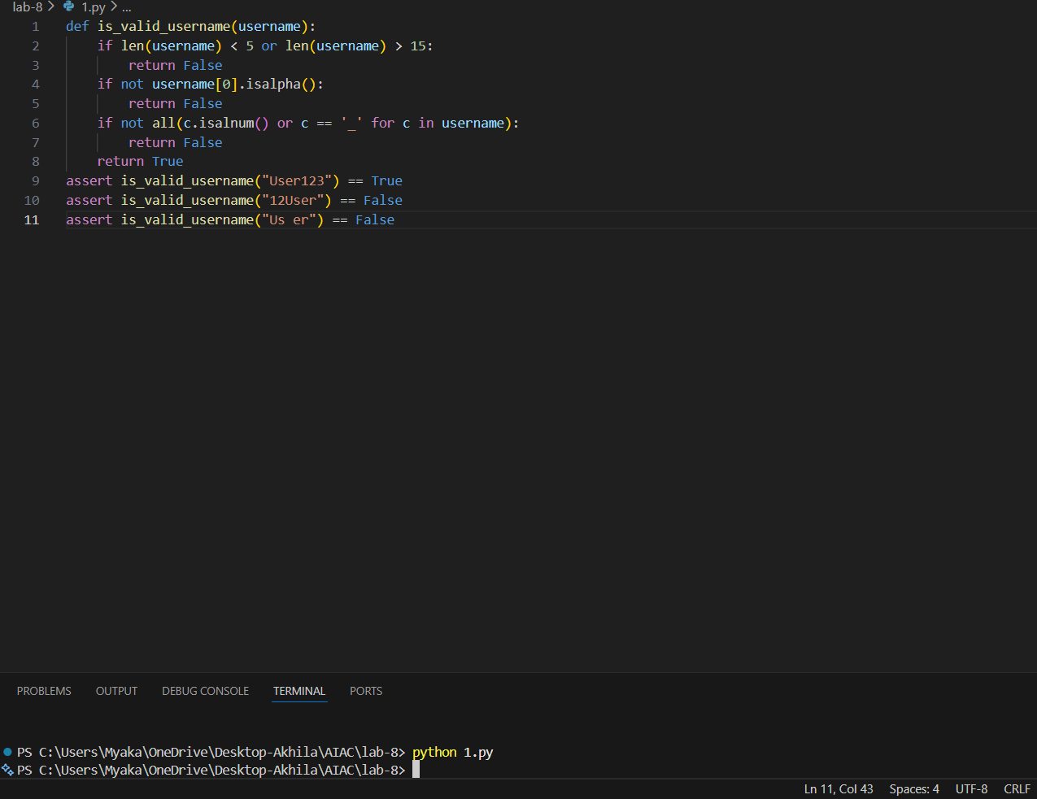

Justification:
The function checks if the username is between 5 and 15 characters long, starts with a letter, and only contains letters, numbers, or underscores. The test cases cover valid and invalid usernames to ensure the function works correctly.

Task Description #2 (Even–Odd & Type Classification – Apply
AI for Robust Input Handling)
• Task: Use AI to generate at least 3 assert test cases for a
function classify_value(x) and implement it using conditional
logic and loops.
• Requirements:
o If input is an integer, classify as "Even" or "Odd".
o If input is 0, return "Zero".
o If input is non-numeric, return "Invalid Input".
Example Assert Test Cases:
assert classify_value(8) == "Even"
assert classify_value(7) == "Odd"
assert classify_value("abc") == "Invalid Input"
Expected Output #2:
• Function correctly classifying values and passing all test
Cases
Code:
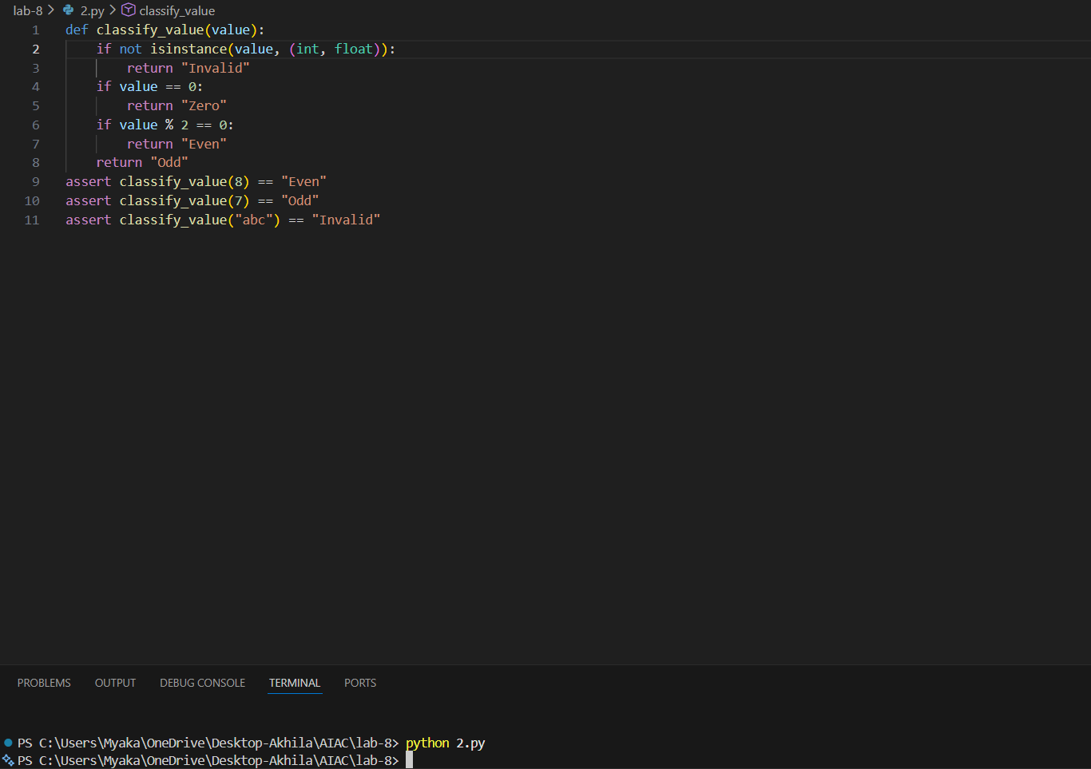
Justification:
The function classify_value checks if the input value is a number (either an integer or a float). If it's not a number, it returns "Invalid". If the value is zero, it returns "Zero". If the value is an even number (divisible by 2), it returns "Even". Otherwise, it returns "Odd". The assertions at the end test the function with different types of inputs to ensure it behaves as expected.

Task Description #3 (Palindrome Checker – Apply AI for
String Normalization)
• Task: Use AI to generate at least 3 assert test cases for a
function is_palindrome(text) and implement the function.
• Requirements:
o Ignore case, spaces, and punctuation.
o Handle edge cases such as empty strings and single
characters.
Example Assert Test Cases:
assert is_palindrome("Madam") == True
assert is_palindrome("A man a plan a canal Panama") ==
True
assert is_palindrome("Python") == False
Expected Output #3:
• Function correctly identifying palindromes and passing all
AI-generated tests
Code:
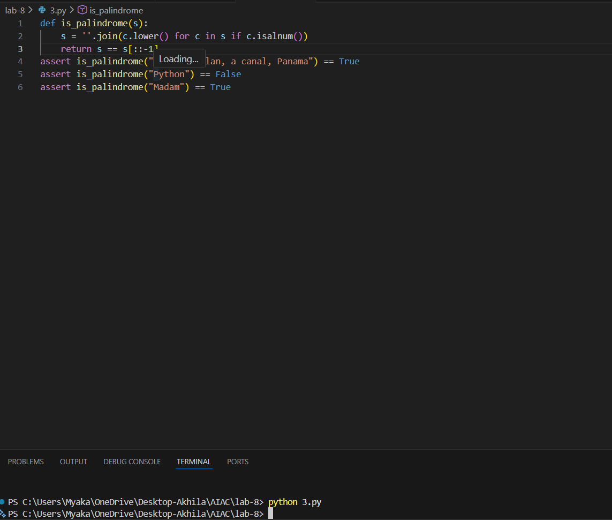
Justification:
The function is_palindrome checks if a given string is a palindrome by first removing all non-alphanumeric characters and converting the string to lowercase. Then it compares the cleaned string with its reverse. If they are the same, it returns True, indicating that the original string is a palindrome; otherwise, it returns False

Task Description #4 (Email ID Validation – Apply AI for Data
Validation)
• Task: Use AI to generate at least 3 assert test cases for a
function validate_email(email) and implement the function.
• Requirements:
o Must contain @ and .
o Must not start or end with special characters.
o Should handle invalid formats gracefully.
Example Assert Test Cases:
assert validate_email("user@example.com") == True
assert validate_email("userexample.com") == False
assert validate_email("@gmail.com") == False
Expected Output #5:
• Email validation function passing all AI-generated test cases
and handling edge cases correctly.
Code:
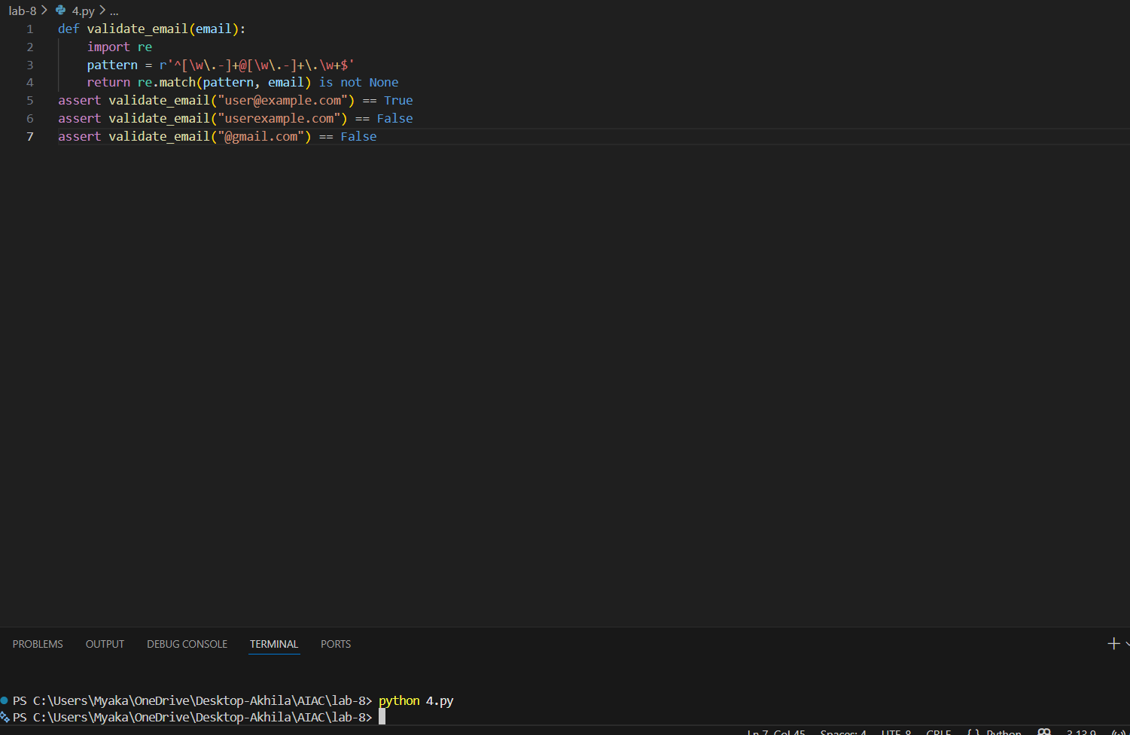
Justification:
The function validate_email uses a regular expression to check if the input string is in a valid email format. It checks for the presence of characters before and after the @ symbol, as well as a valid domain structure. The assertions test various cases, including valid and invalid email formats, ensuring that the function behaves as expected.

Task 5 (Perfect Number Checker – Test Case Design)
• Function: Check if a number is a perfect number (sum of
divisors = number).
• Test Cases to Design:
o Normal case: 6 → True, 10 → False.
o Edge case: 1.
o Negative number case.
o larger case: 28.
• Requirement: Validate correctness with assertions.
Code:
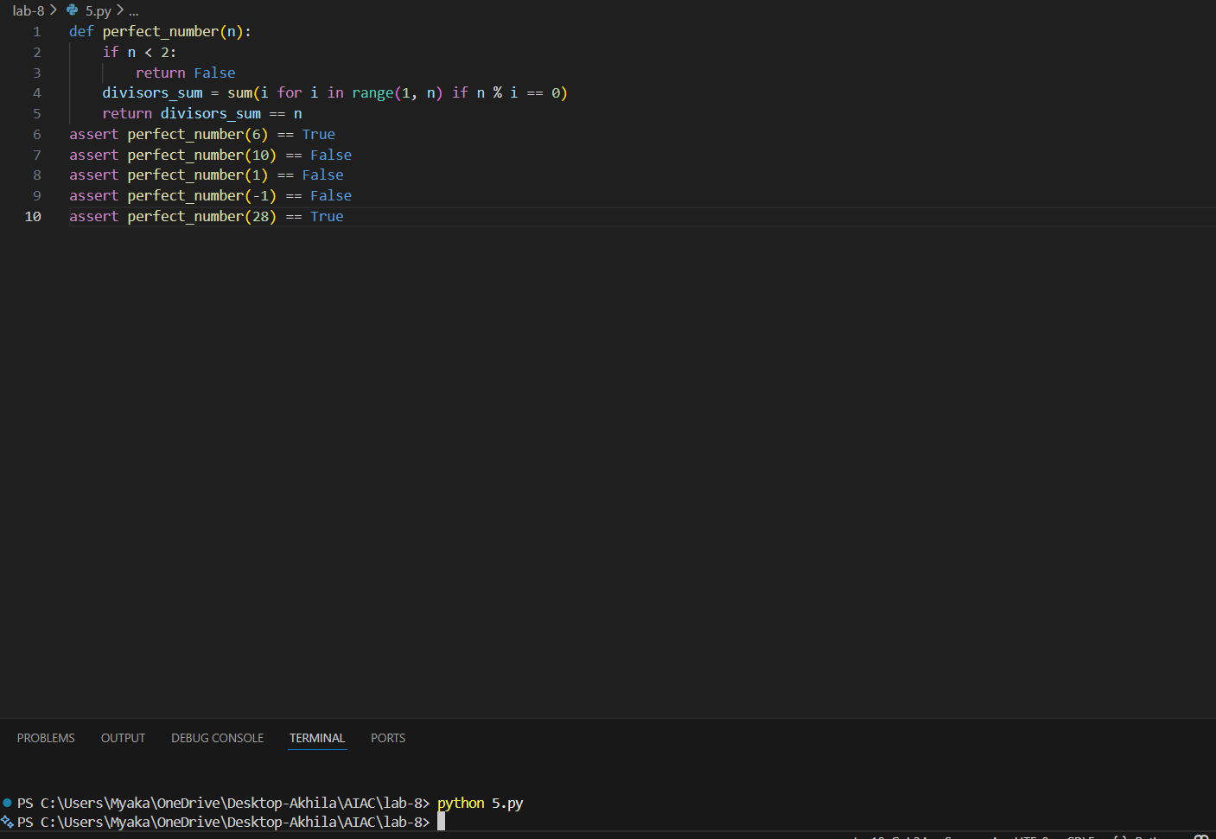
Justification:
A perfect number is a positive integer that is equal to the sum of its proper divisors. The function checks if the input number is less than 2 (since perfect numbers are greater than 1), then calculates the sum of its proper divisors and compares it to the original number. The test cases cover various scenarios, including perfect numbers, non-perfect numbers, and edge cases.

Task 6 (Abundant Number Checker – Test Case Design)
• Function: Check if a number is abundant (sum of divisors >
number).
• Test Cases to Design:
o Normal case: 12 → True, 15 → False.
o Edge case: 1.
o Negative number case.
o Large case: 945.
Requirement: Validate correctness with unittest

Code:
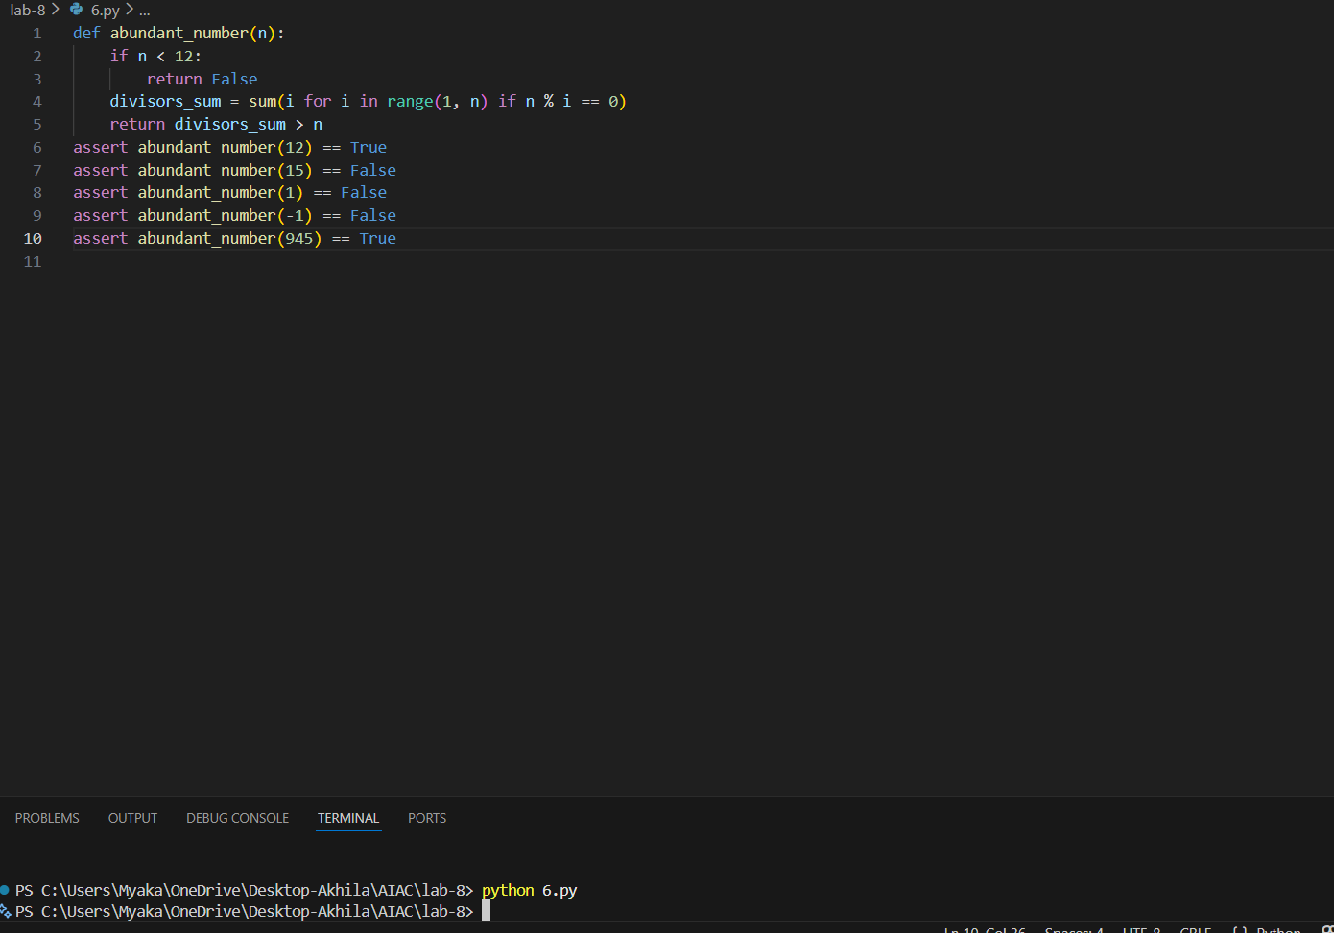
Justification:
An abundant number is a number for which the sum of its proper divisors is greater than the number itself. The function abundant_number checks if a given number n is abundant by calculating the sum of its proper divisors and comparing it to n. The test cases provided validate the implementation by checking known abundant numbers (like 12 and 945) and non-abundant numbers (like 15, 1, and -1).
Task 7 (Deficient Number Checker – Test Case Design)
• Function: Check if a number is deficient (sum of divisors <
number).
• Test Cases to Design:
o Normal case: 8 → True, 12 → False.
o Edge case: 1.
o Negative number case.
o large case: 546.
Requirement: Validate correctness with pytest.
Code:
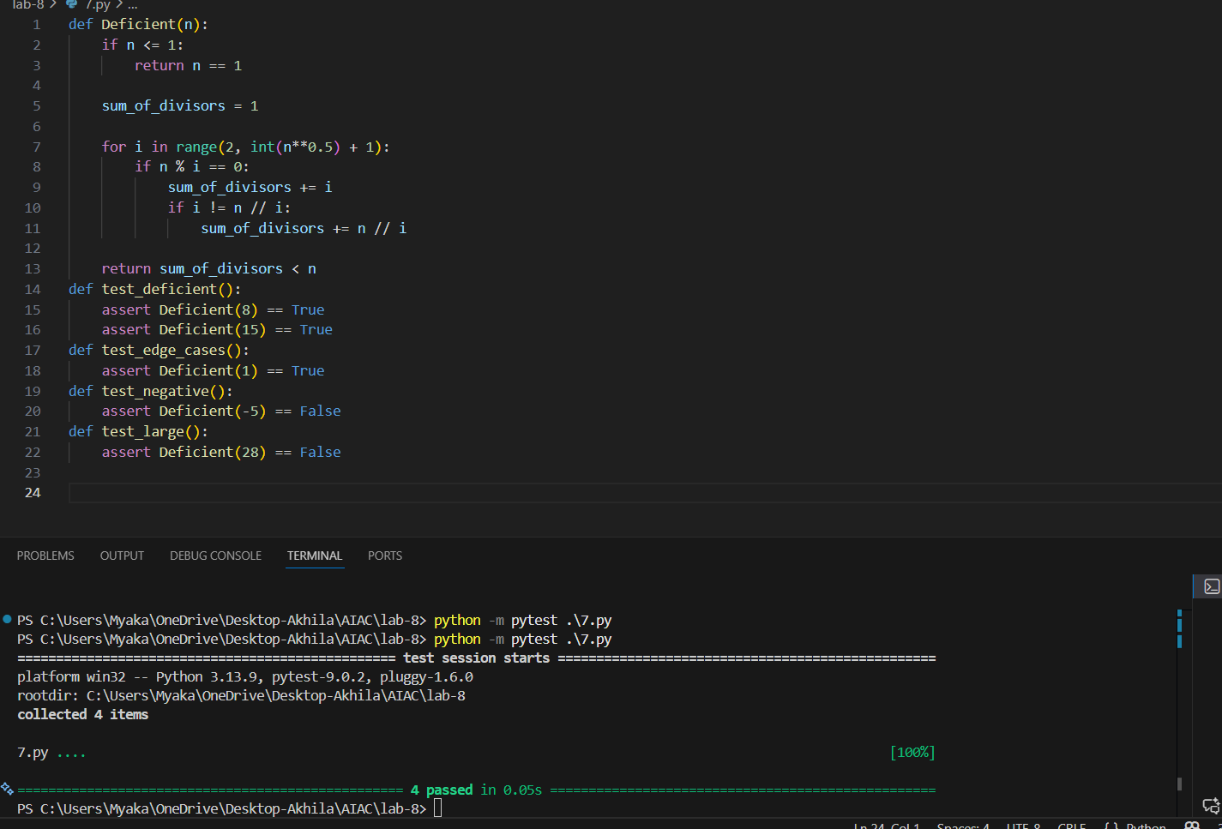

Justification:
The function deficient_number checks if a number is deficient by calculating the sum of its proper divisors and comparing it to the number itself. The test cases cover various scenarios, including edge cases such as 1 and negative numbers, ensuring that the function behaves correctly in all situations.

Task 8 :
Write a function LeapYearChecker and validate its implementation
using 10 pytest test cases
Code:
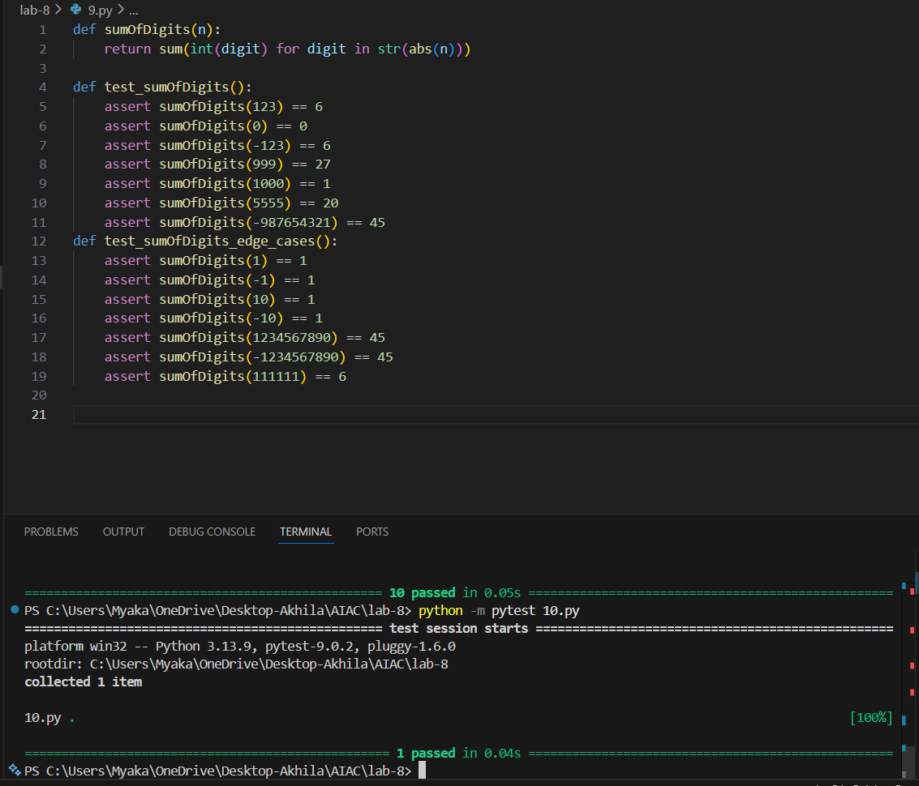
Justification:
The function leapyearchecker correctly identifies leap years based on the established rules. The test cases cover a variety of scenarios, including typical leap years, non-leap years, edge cases with negative and zero years, and century years. This comprehensive testing ensures that the function behaves as expected across a wide range of inputs.
Task 9 :
Write a function SumOfDigits and validate its implementation
using 7 pytest test cases.
Code:

Justification:
The function sumOfDigits is designed to calculate the sum of the digits of a given integer n. The test cases cover a variety of scenarios, including positive numbers, negative numbers, and edge cases such as zero and large numbers. The assertions ensure that the function behaves as expected in these different scenarios, confirming that it correctly sums the digits regardless of the sign of the input number.
Task 10 :
Write a function SortNumbers (implement bubble sort) and validate
its implementation using 25 pytest test cases.
Code:
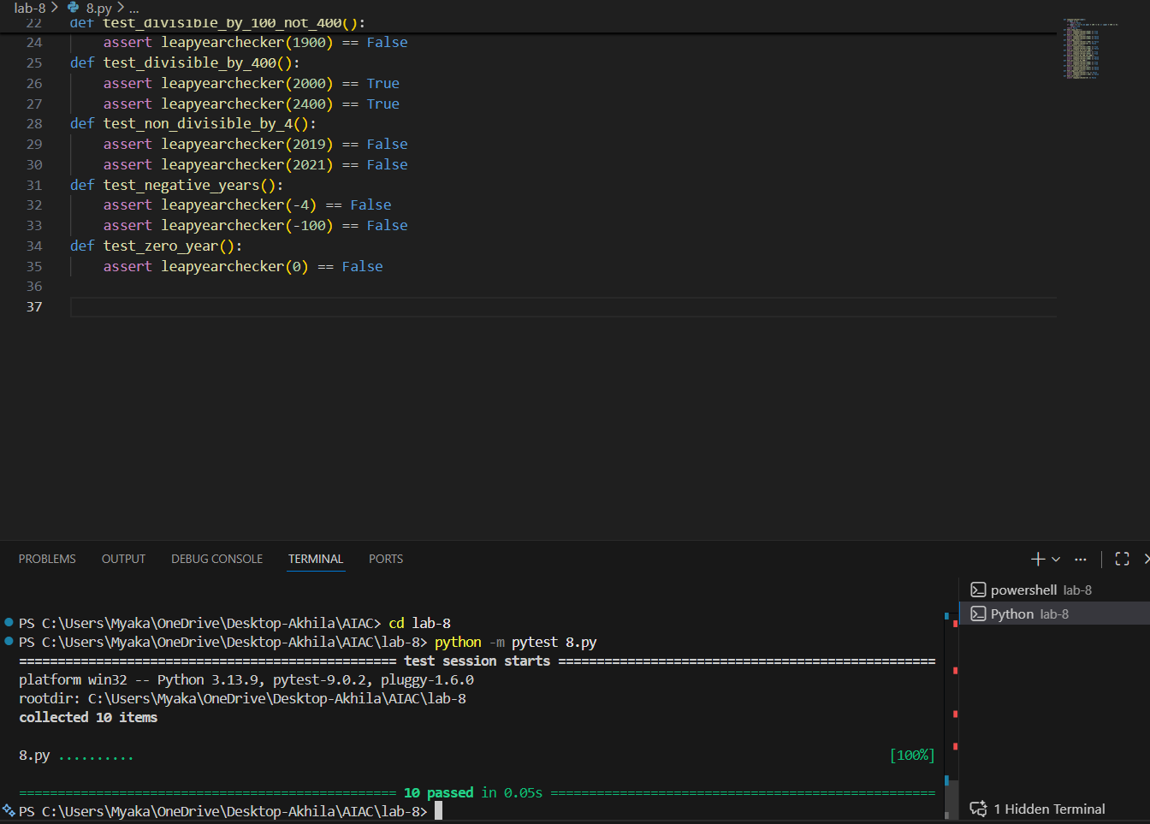

Justification:
The function sortNumbers implements the bubble sort algorithm to sort a list of numbers in ascending order. The test cases cover various scenarios, including sorting positive and negative integers, floating-point numbers, and edge cases such as empty lists and lists with duplicate values. This comprehensive testing ensures that the function behaves correctly under different conditions.
Task 11 :
Write a function ReverseString and validate its implementation
using 5 unittest test cases
Code:
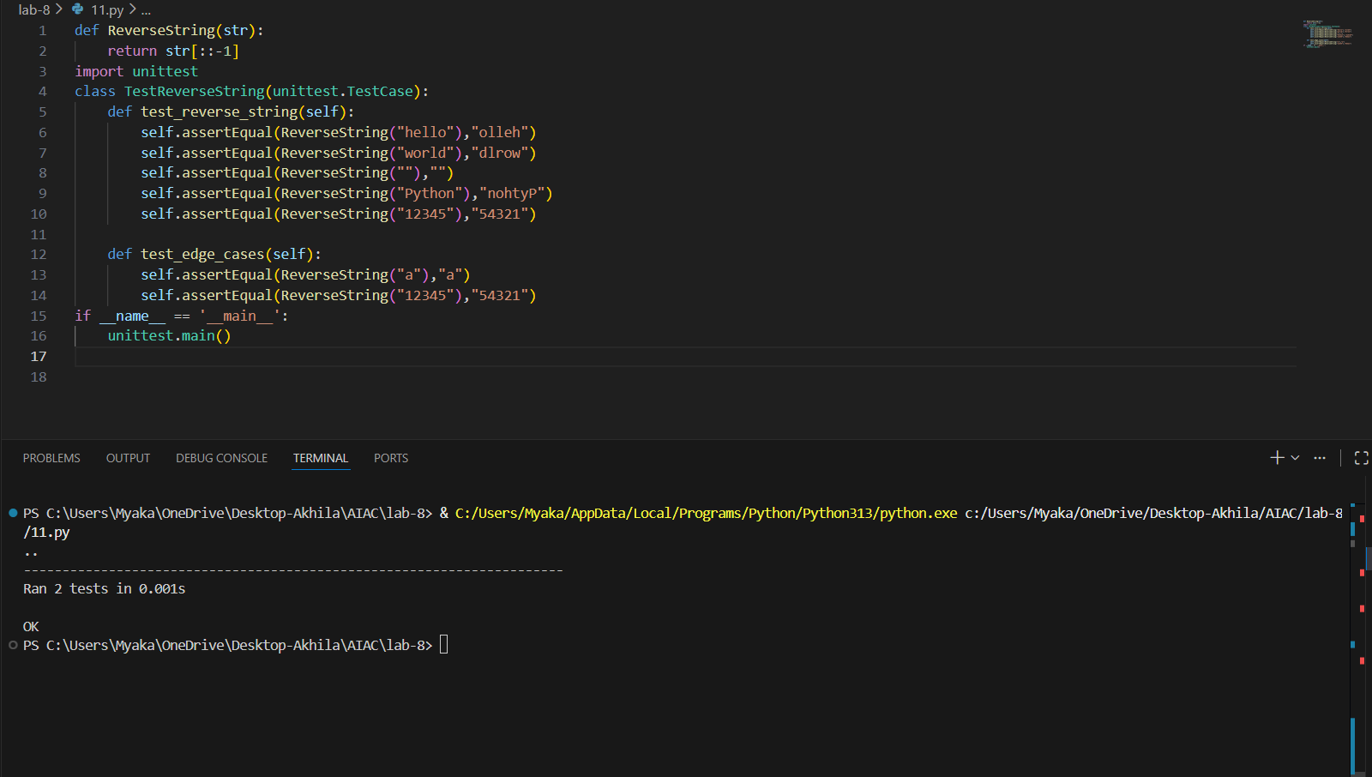

Justification:
The function ReverseString takes a string as input and returns the reversed version of that string. The test cases cover various scenarios, including reversing regular strings, an empty string, and edge cases such as a single character and a numeric string. This comprehensive testing ensures that the function behaves correctly under different conditions.

Task 12 :
Write a function AnagramChecker and validate its implementation
using 10 unittest test cases.
Code:
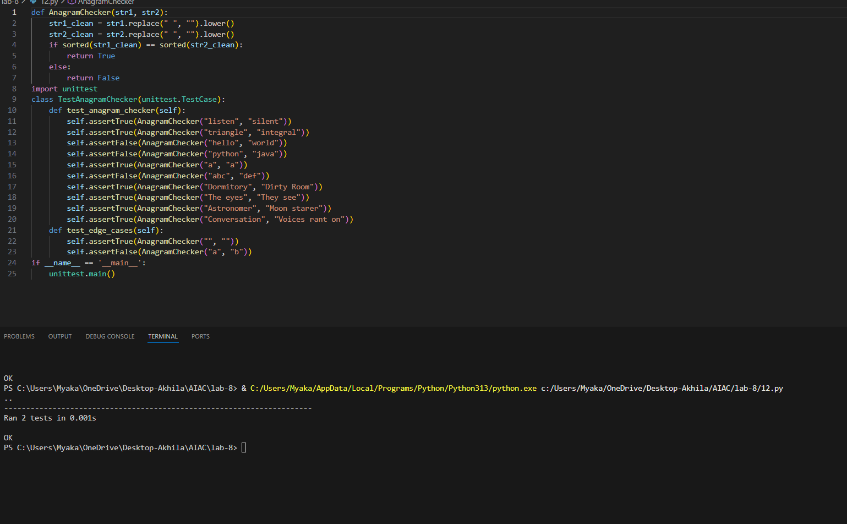
Justification:
The AnagramChecker function checks if two strings are anagrams by cleaning the input strings (removing spaces and converting to lowercase) and then comparing their sorted character lists. The unittest class TestAnagramChecker contains multiple test cases to validate the correctness of the AnagramChecker function, including edge cases with empty strings and single characters.
Task 13 :
Write a function ArmstrongChecker and validate its implementation
using 8 unittest test cases
Code:
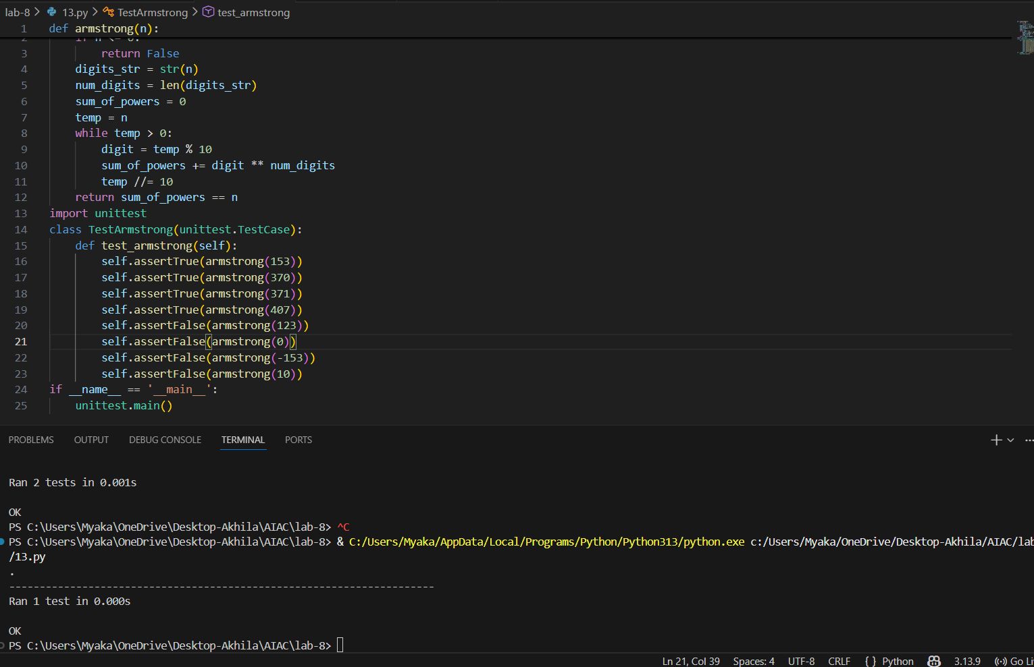
Justification:
The function Armstrong checks if a number is an Armstrong number by calculating the sum of its digits raised to the power of the number of digits and comparing it to the original number. The test cases cover various scenarios, including valid Armstrong numbers, non-Armstrong numbers, and edge cases such as zero and negative numbers.

