AI Assisted Coding
Assignment-5.1&6
Name: M. Akhila
Batch: 31
HT NO: 2303A52442

Task1:
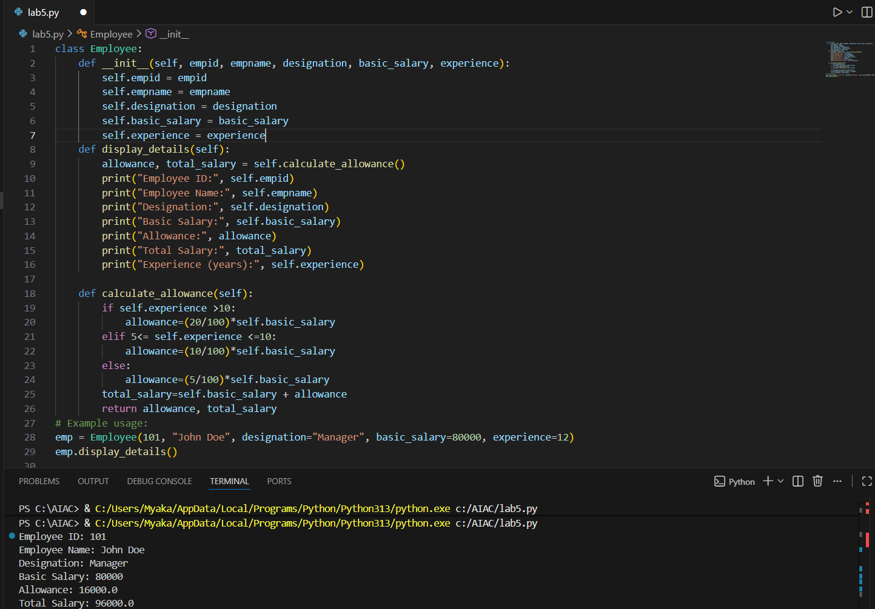
Task 2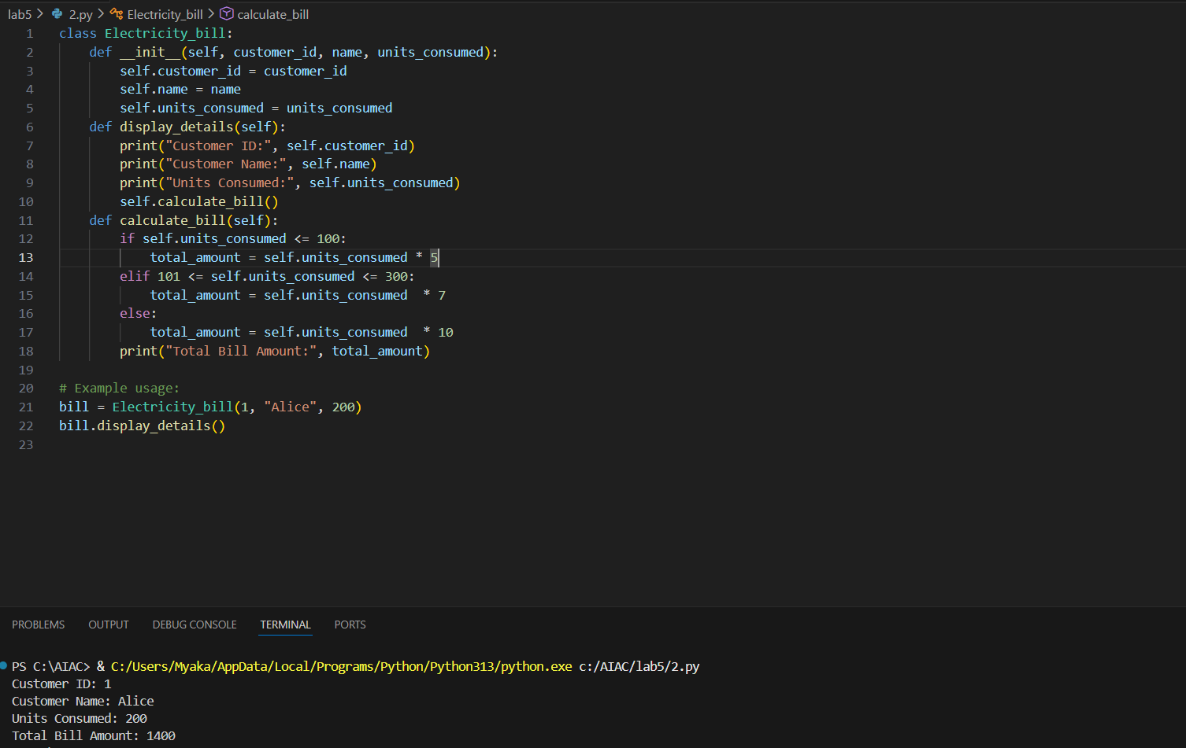
Task3:
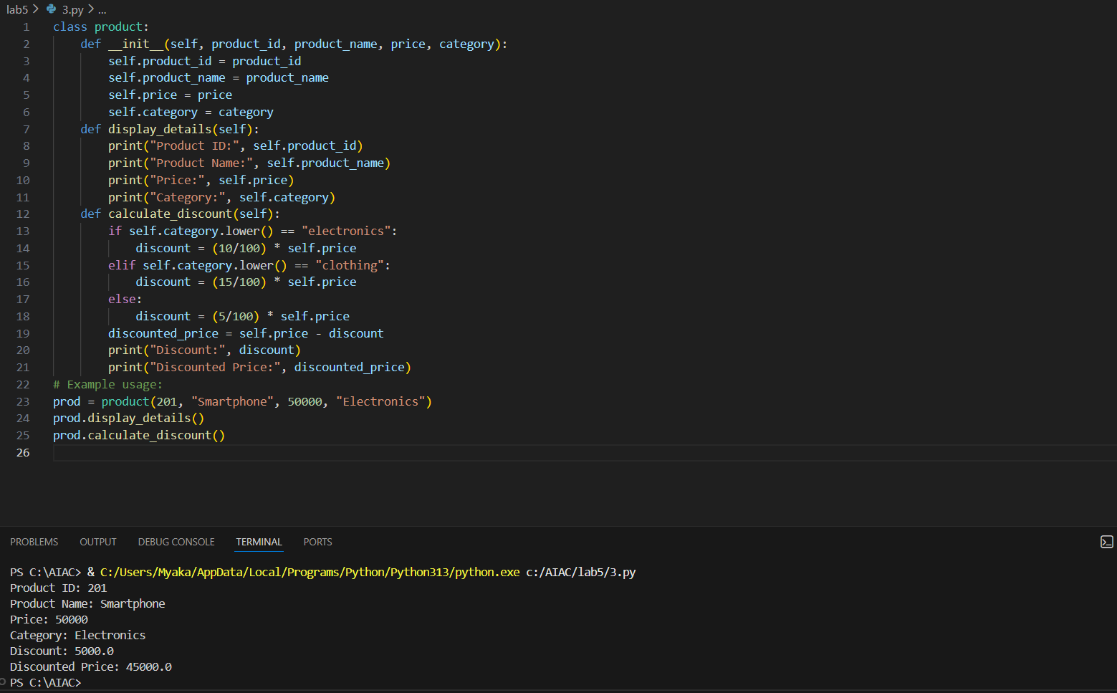

Task 4:
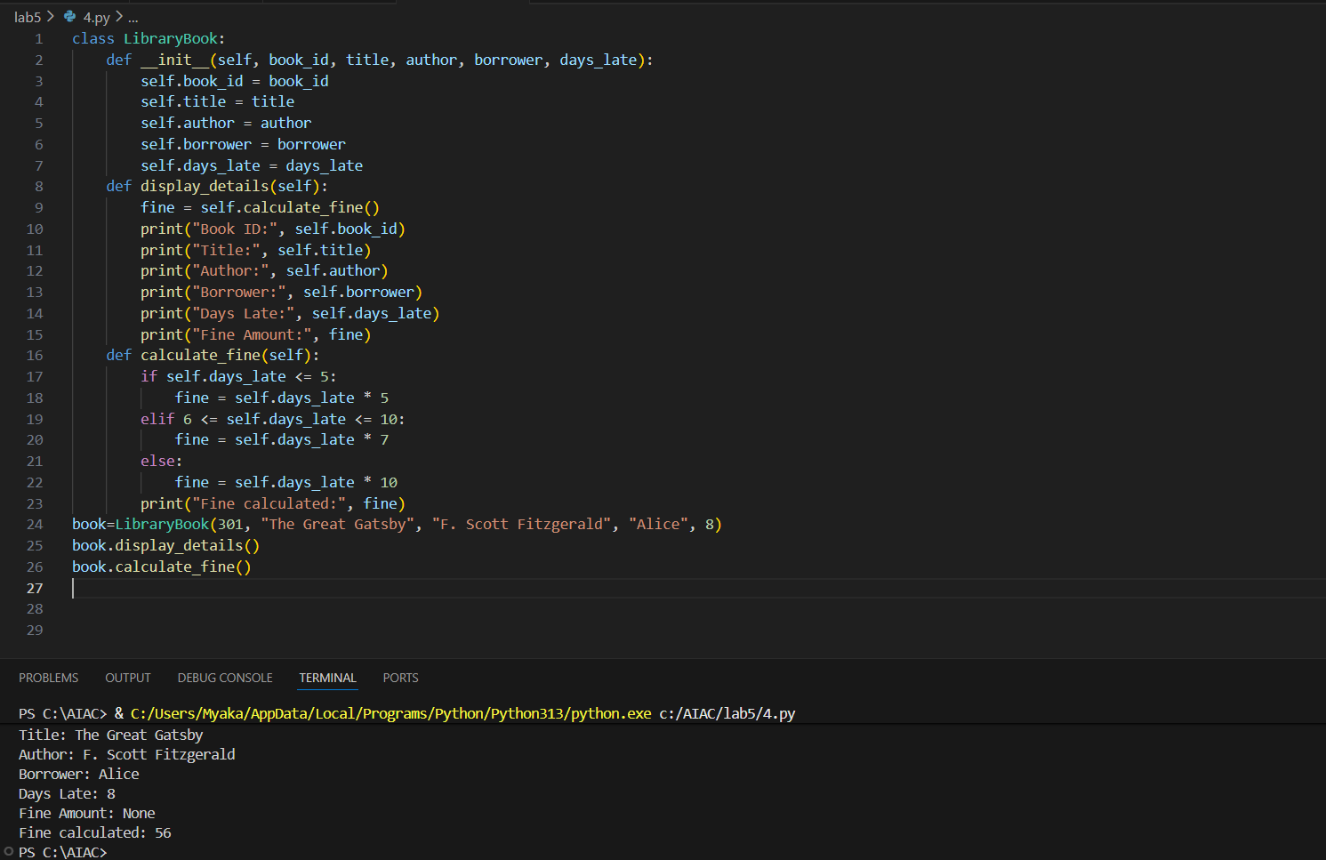
Task4:


Task 5:
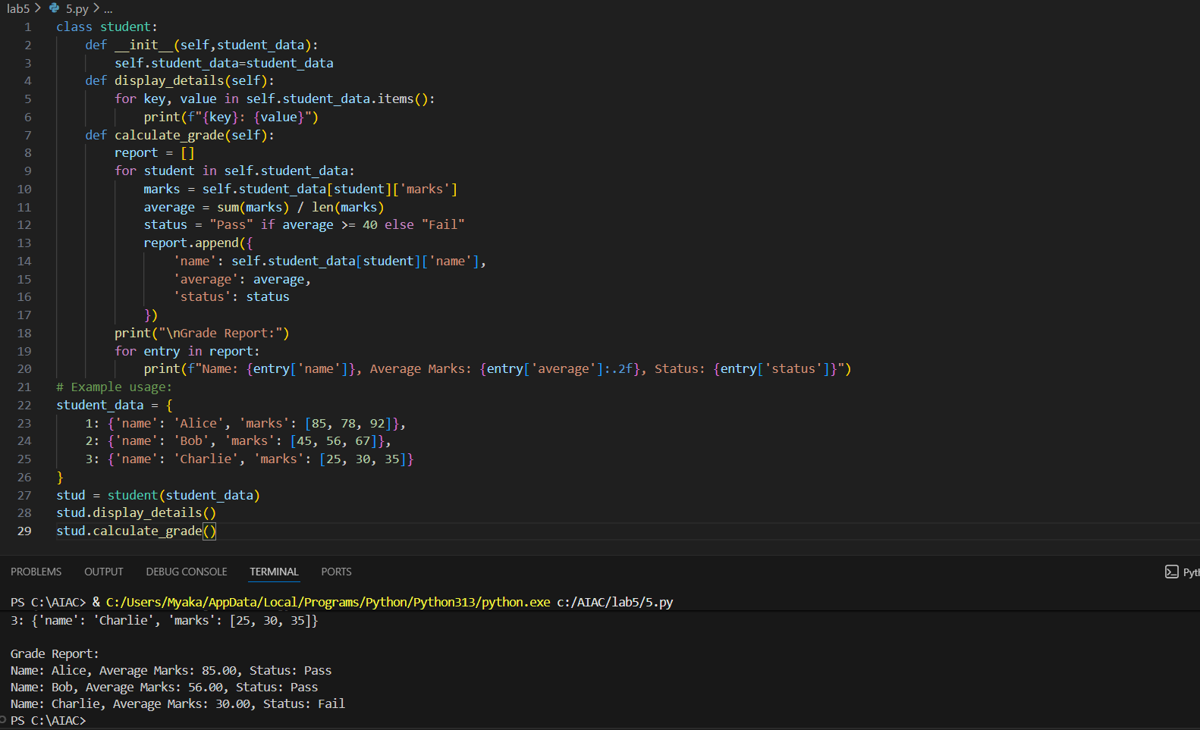

Task 6:
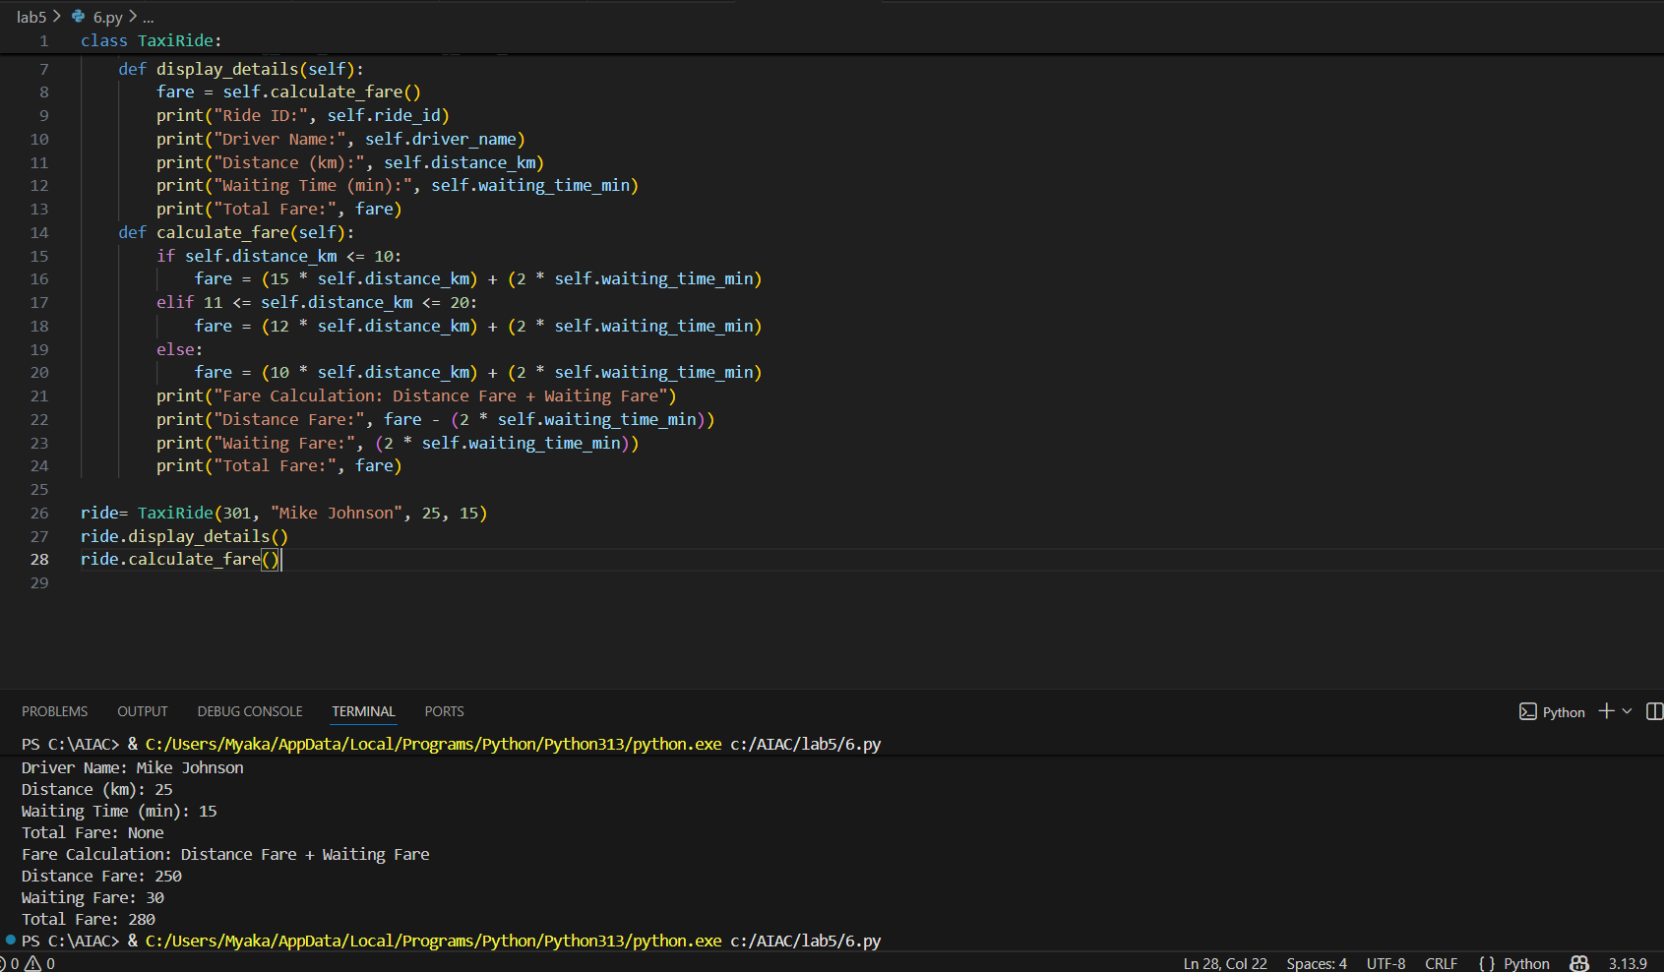

Task 7:
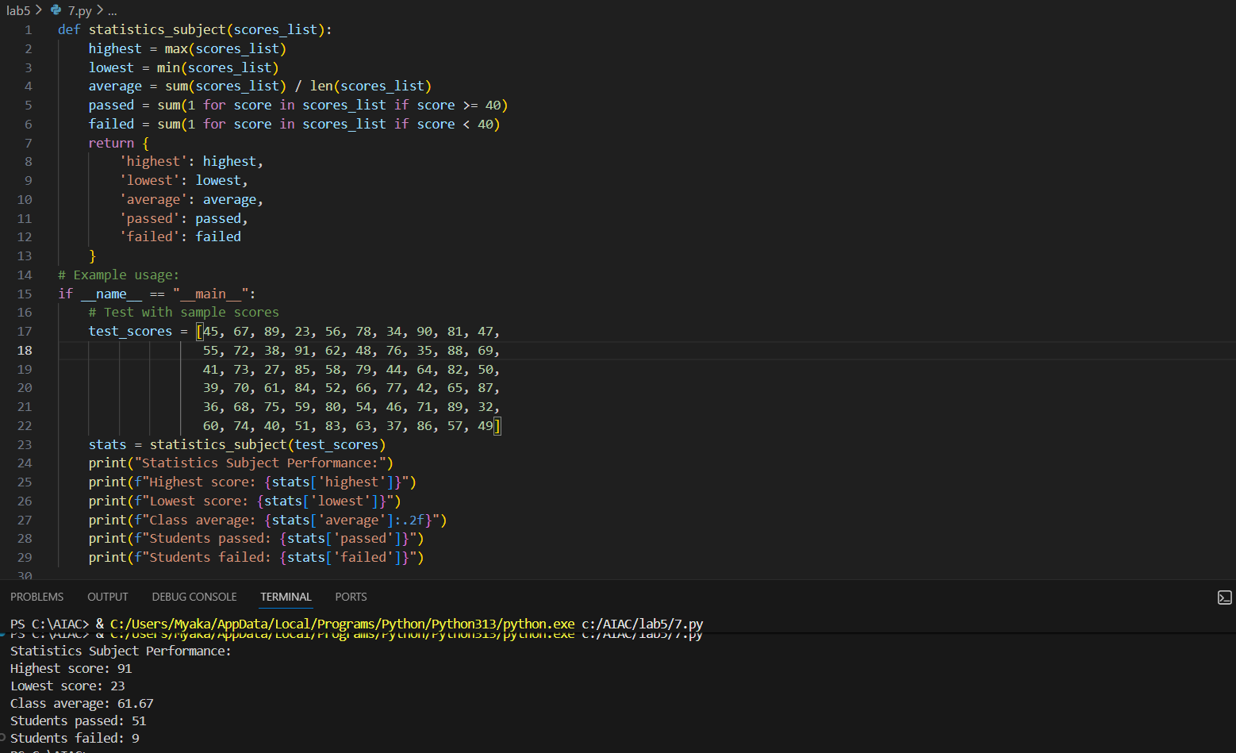

Task 8:
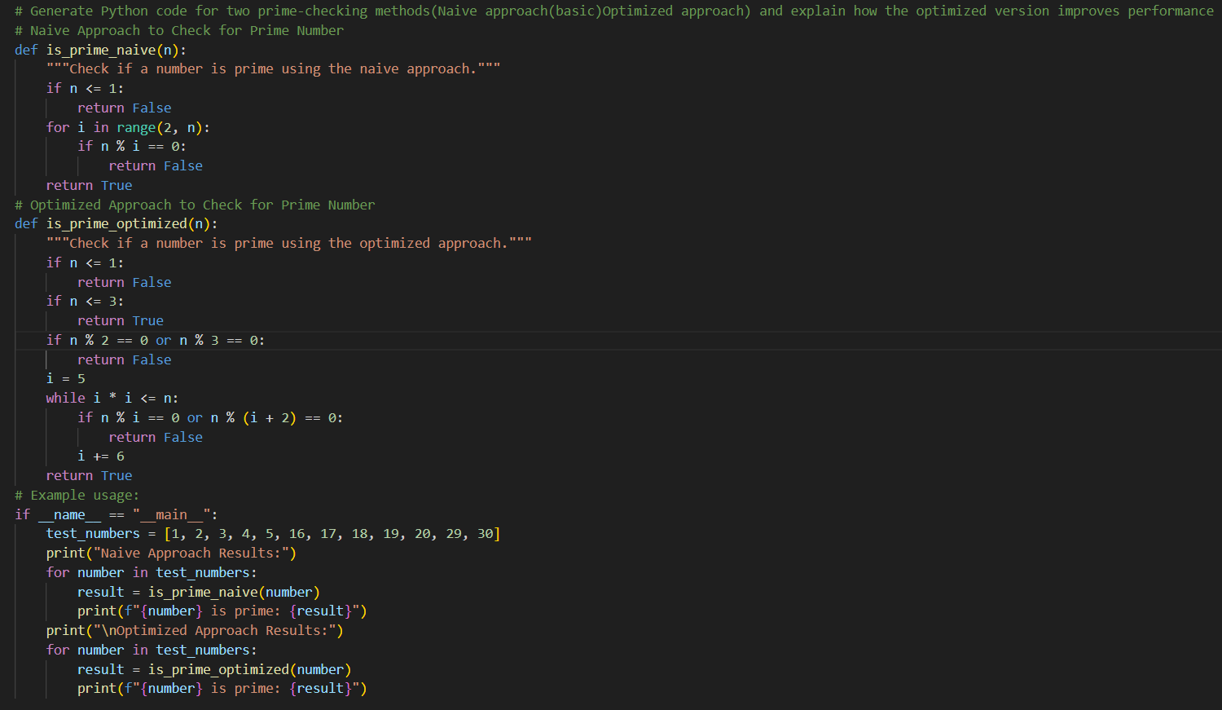
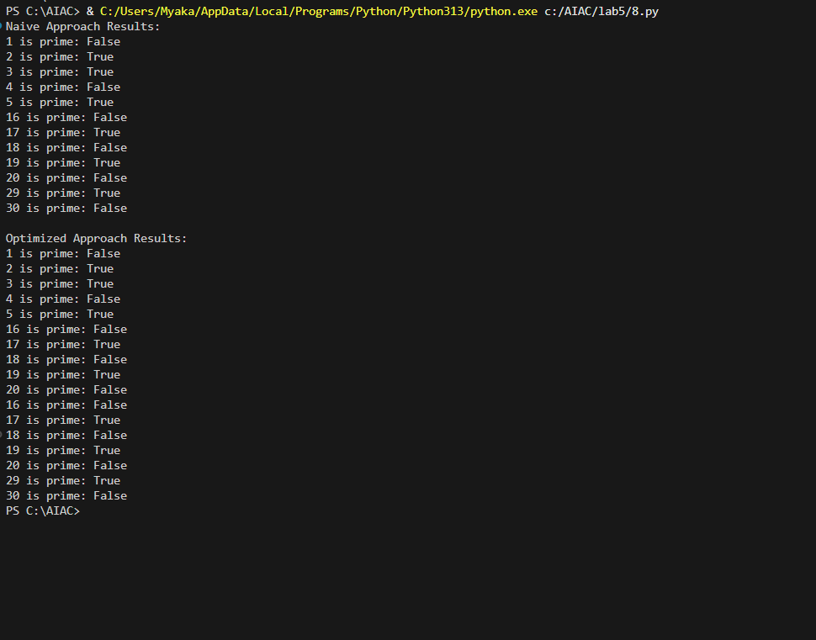
Explanation:
Naive Method (Simple Method)
- This method checks the number by dividing it with every number before it
- If the number is big, it has to do many checks
- So, it takes more time
Time Complexity:
O(n) (time increases as the number increases)

Optimized Method (Smart Method)
- This method checks the number only up to its square root
- It skips even numbers and numbers that are already checked
- So, it does less work and saves time
Time Complexity:
O(√n) (much faster than O(n))

Task 9:
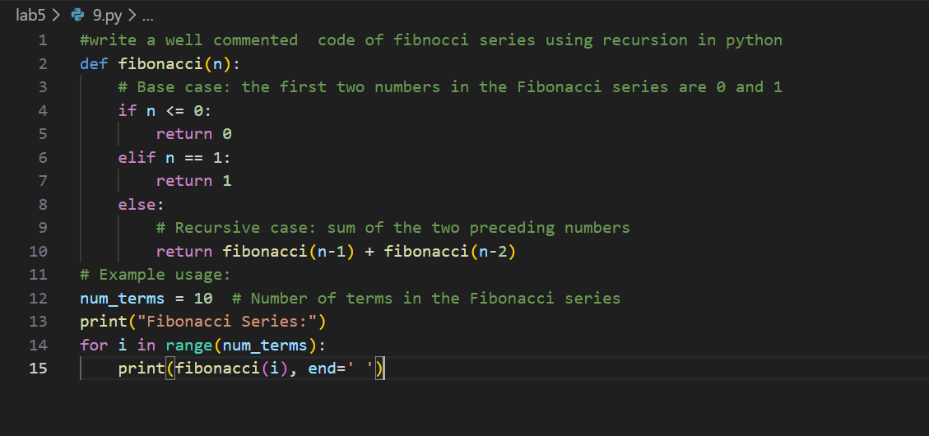

Task 10: