AI Assisted Coding
Assignment-7.5
Name: M. Akhila
Batch: 31
Ht No: 2303A52442

Task1:
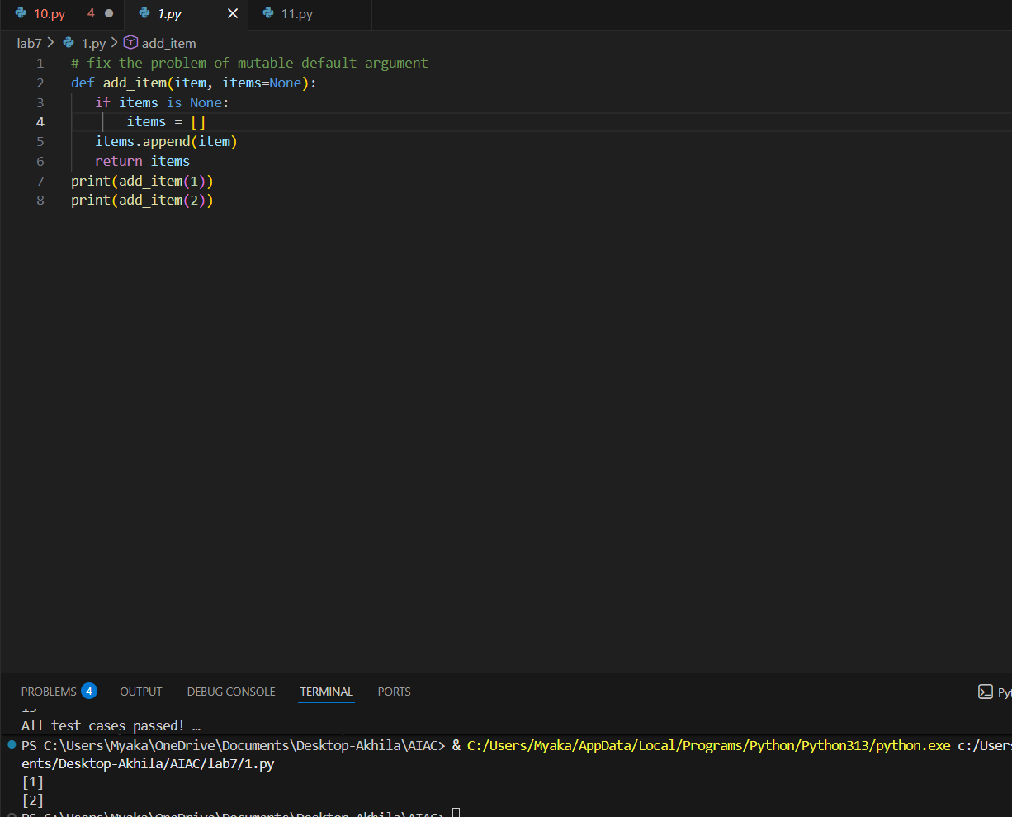
Justification:
In the original code, the default value for the items parameter is a mutable list. This means that if we modify this list in one function call, it will affect all subsequent calls that use the default value, leading to unexpected behavior. By changing the default value to None and creating a new list inside the function when items is None, we ensure that each call to the function gets its own separate list, preventing unintended side effects
Task2:
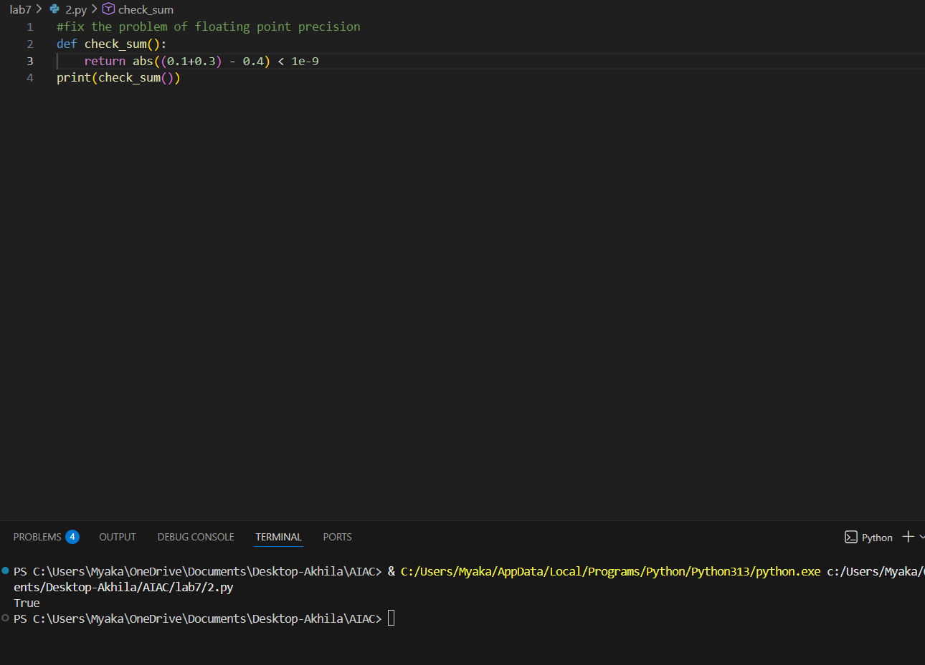
Justification:
The code checks if the sum of 0.1 and 0.3 is approximately equal to 0.4 by comparing the absolute difference to a small threshold (1e-9). This is necessary because floating-point arithmetic can lead to precision issues, and direct comparison may not yield the expected result due to how numbers are represented in memory.
Task3: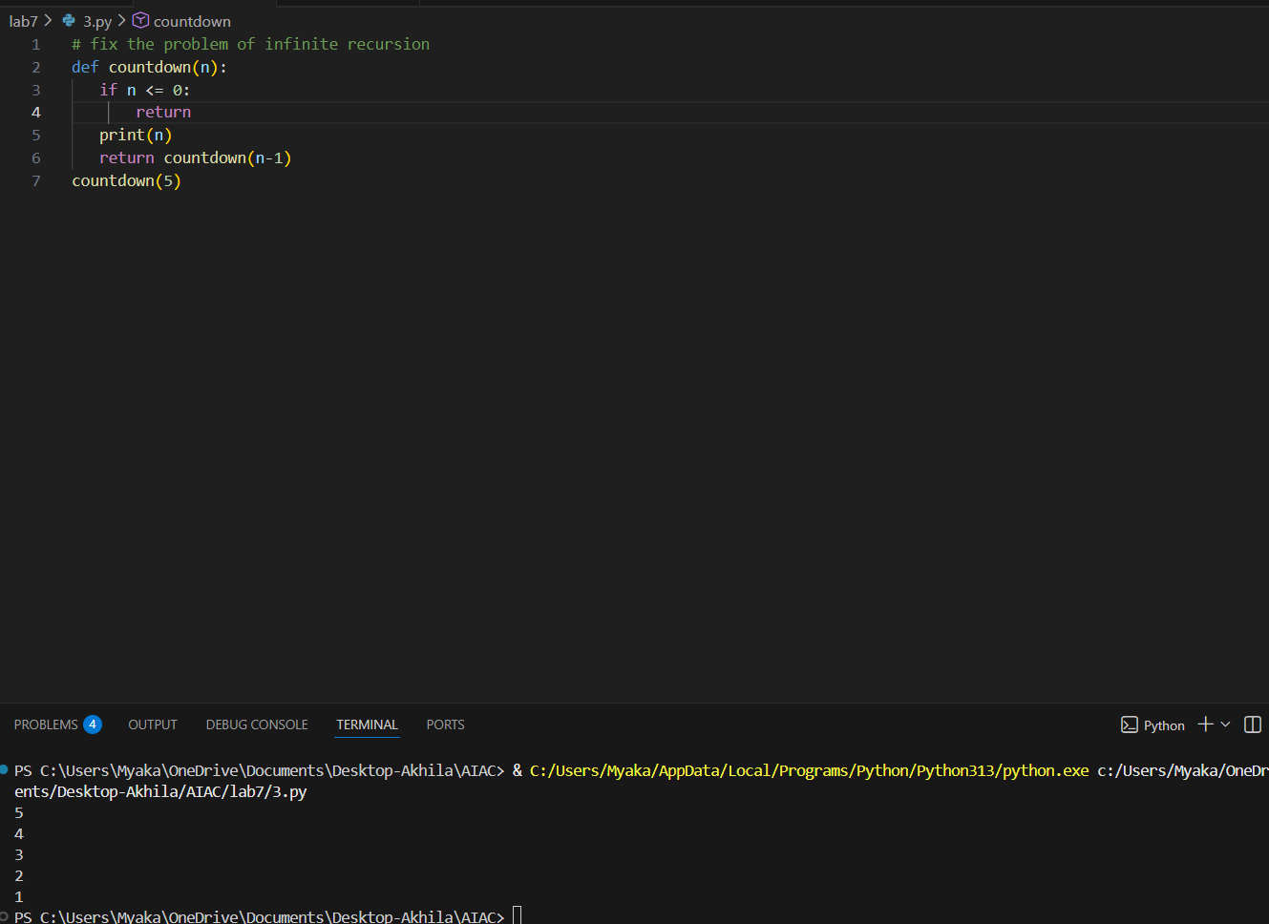
Justification:
The original code likely had a recursive call without a base case, which would lead to infinite recursion. By adding a base case (when n <= 0), we ensure that the function will stop calling itself once it reaches zero, thus preventing infinite recursion.
Task4: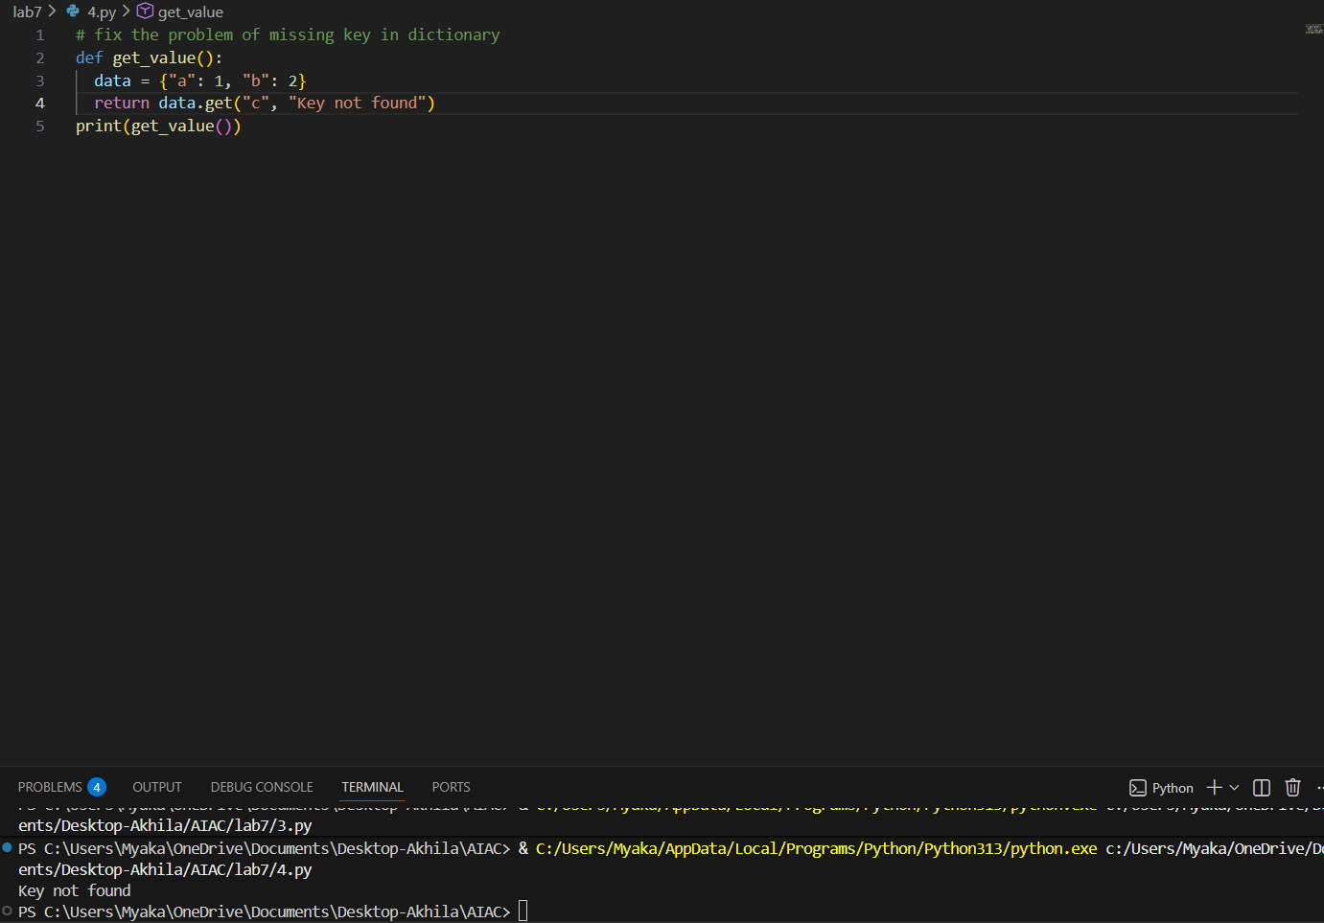
Justification:
The original code was trying to access a key "c" that does not exist in the dictionary, which would raise a KeyError. By using the get method with a default value, we can avoid the error and return a more user-friendly message when the key is not found.
Task5:
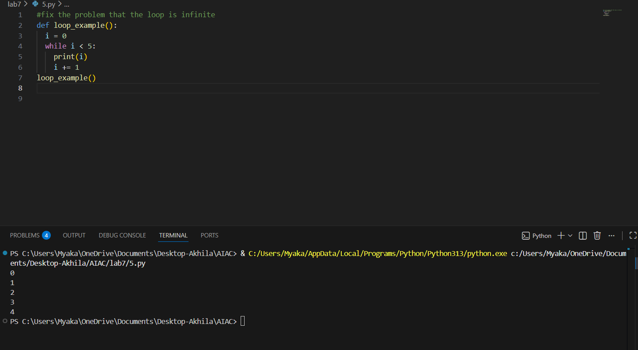
Justification:
The original code had an infinite loop because the variable 'i' was not being incremented, causing the condition i < 5 to always be true. By adding i += 1 inside the loop, we ensure that i will eventually reach 5, allowing the loop to terminate properly.
Task6:
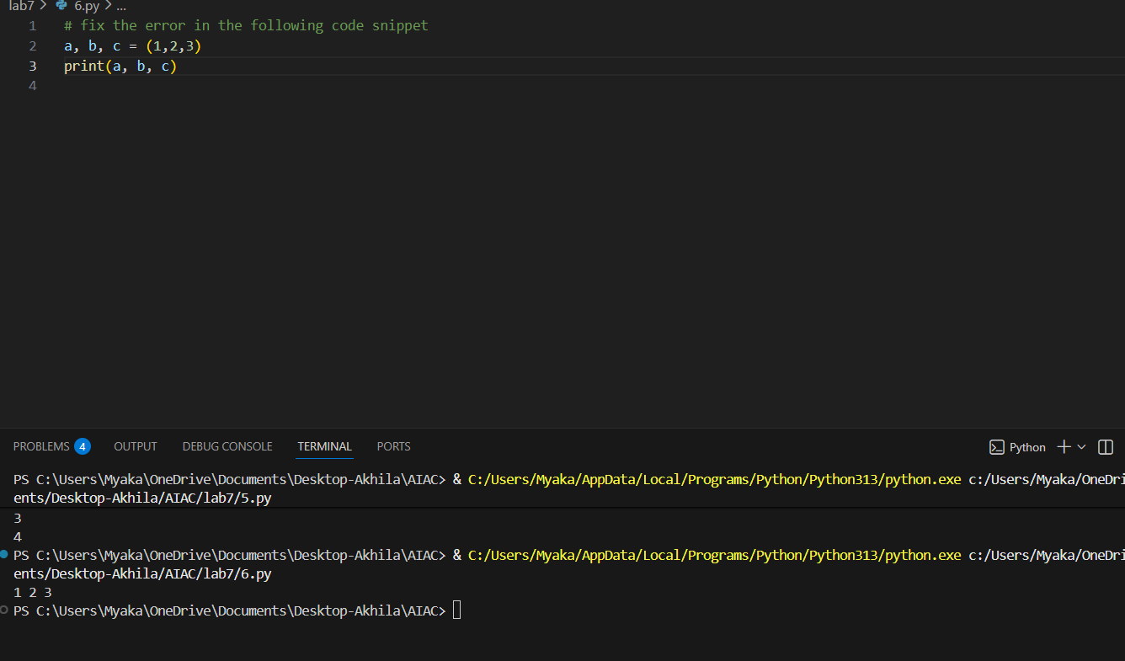
Justification:
The original code was trying to unpack a tuple of three values into three variables, which is correct. However, if the number of variables does not match the number of values in the tuple, it will raise a ValueError. In this case, the code is correct as it is, and there is no error to fix.
Task7: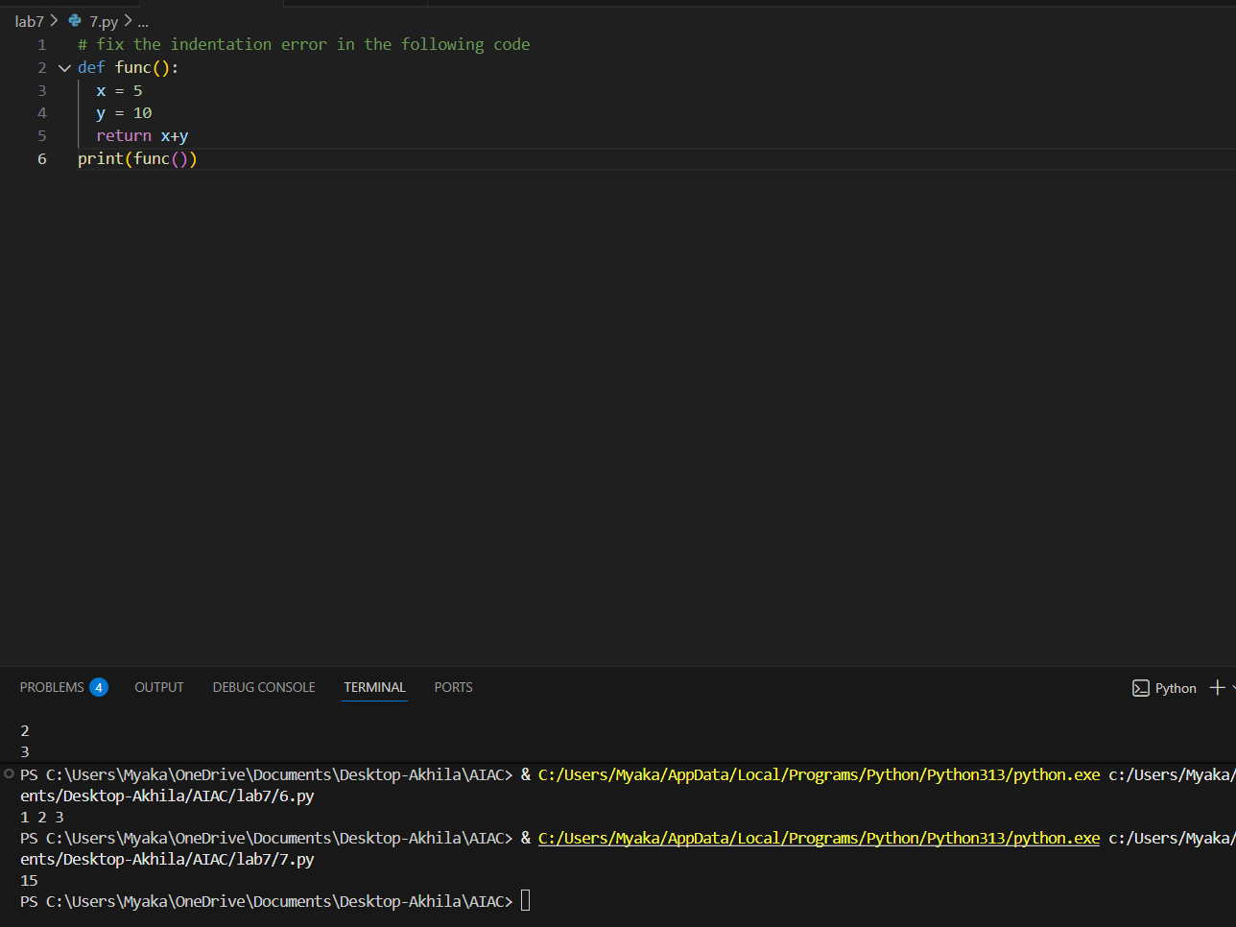
Justification:
The original code had an indentation error which caused a syntax error. By fixing the indentation, the code now runs correctly and returns the sum of x and y, which is 15.
Task8: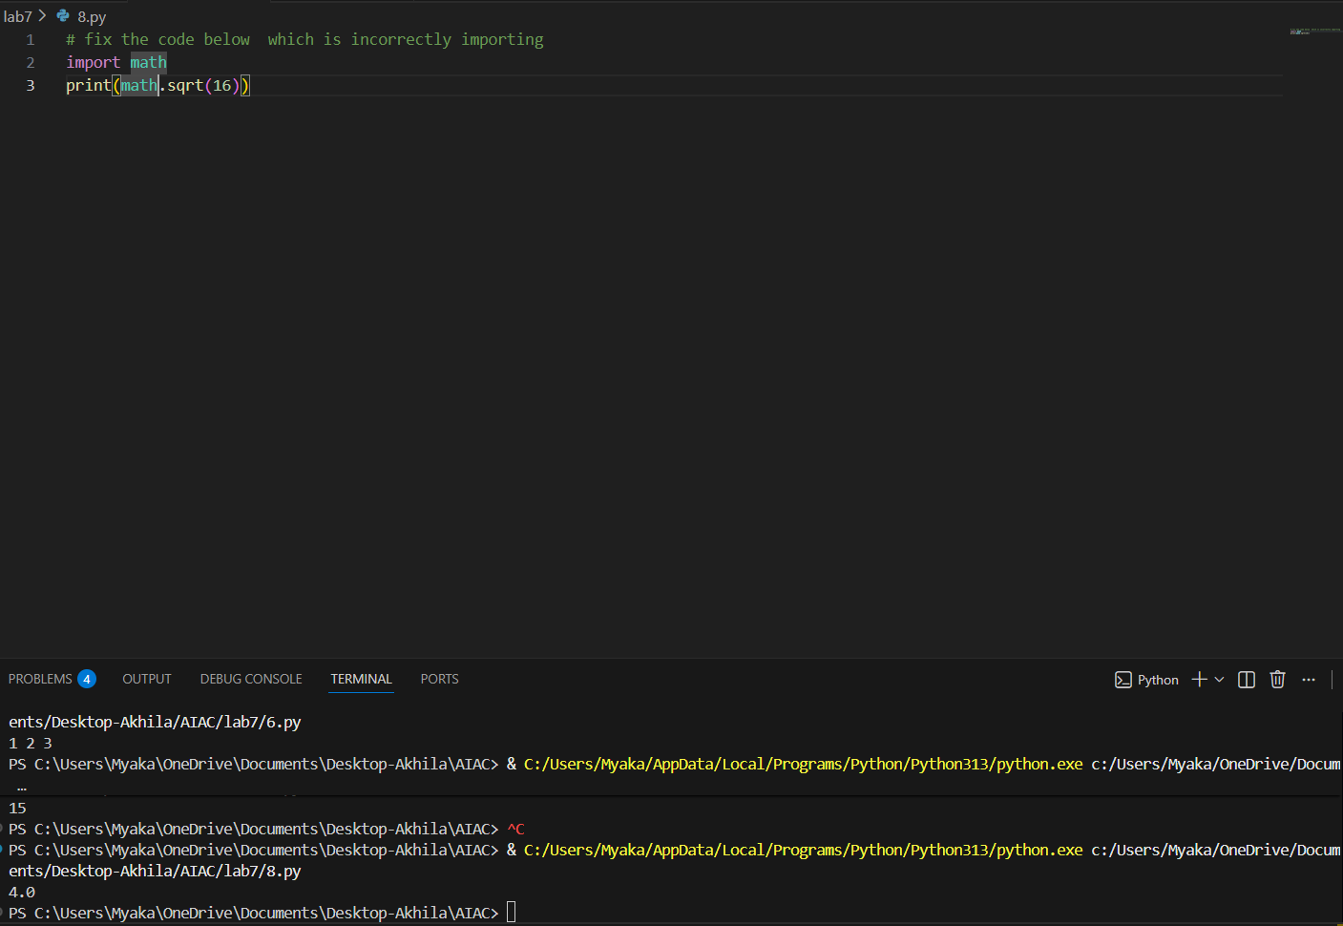
Justification:
The original code was missing the import statement for the math module, which is necessary to use the sqrt function. By adding import math at the beginning of the code, we can successfully call math.sqrt(16) to compute the square root of 16
Task9: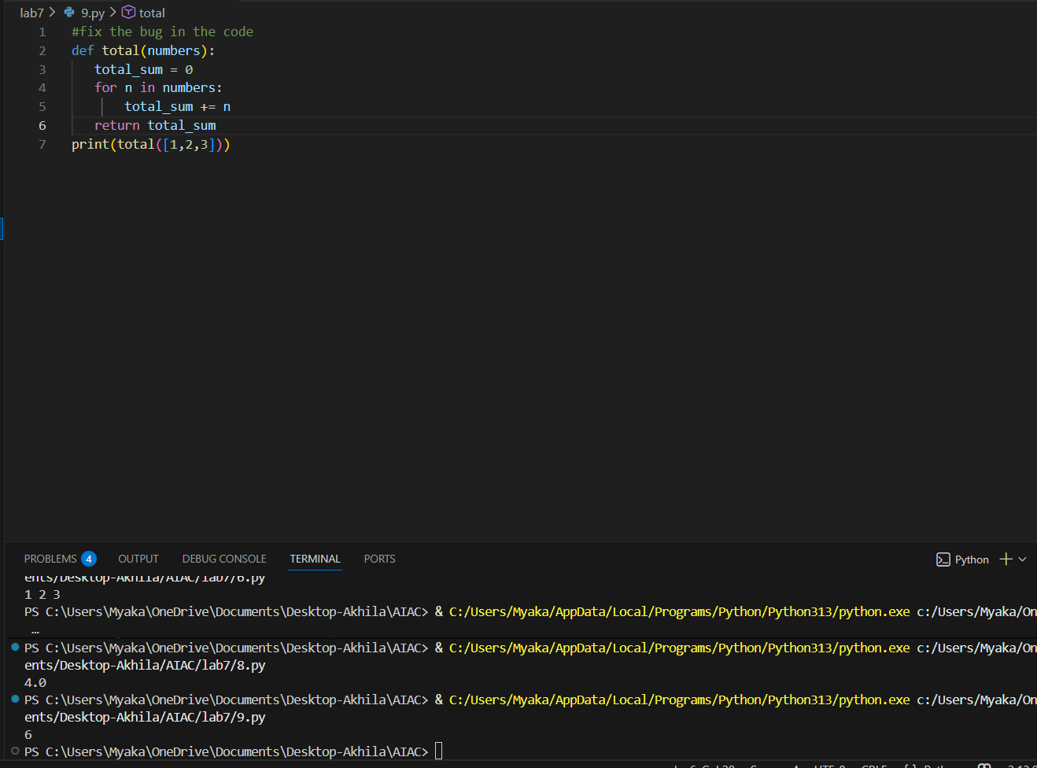
Justification:
The original code had a bug where the variable total_sum was not initialized before being used in the loop. This would have caused an error when trying to add numbers to it. By initializing total_sum to 0 before the loop, we ensure that it can correctly accumulate the sum of the numbers in the list.
Task10: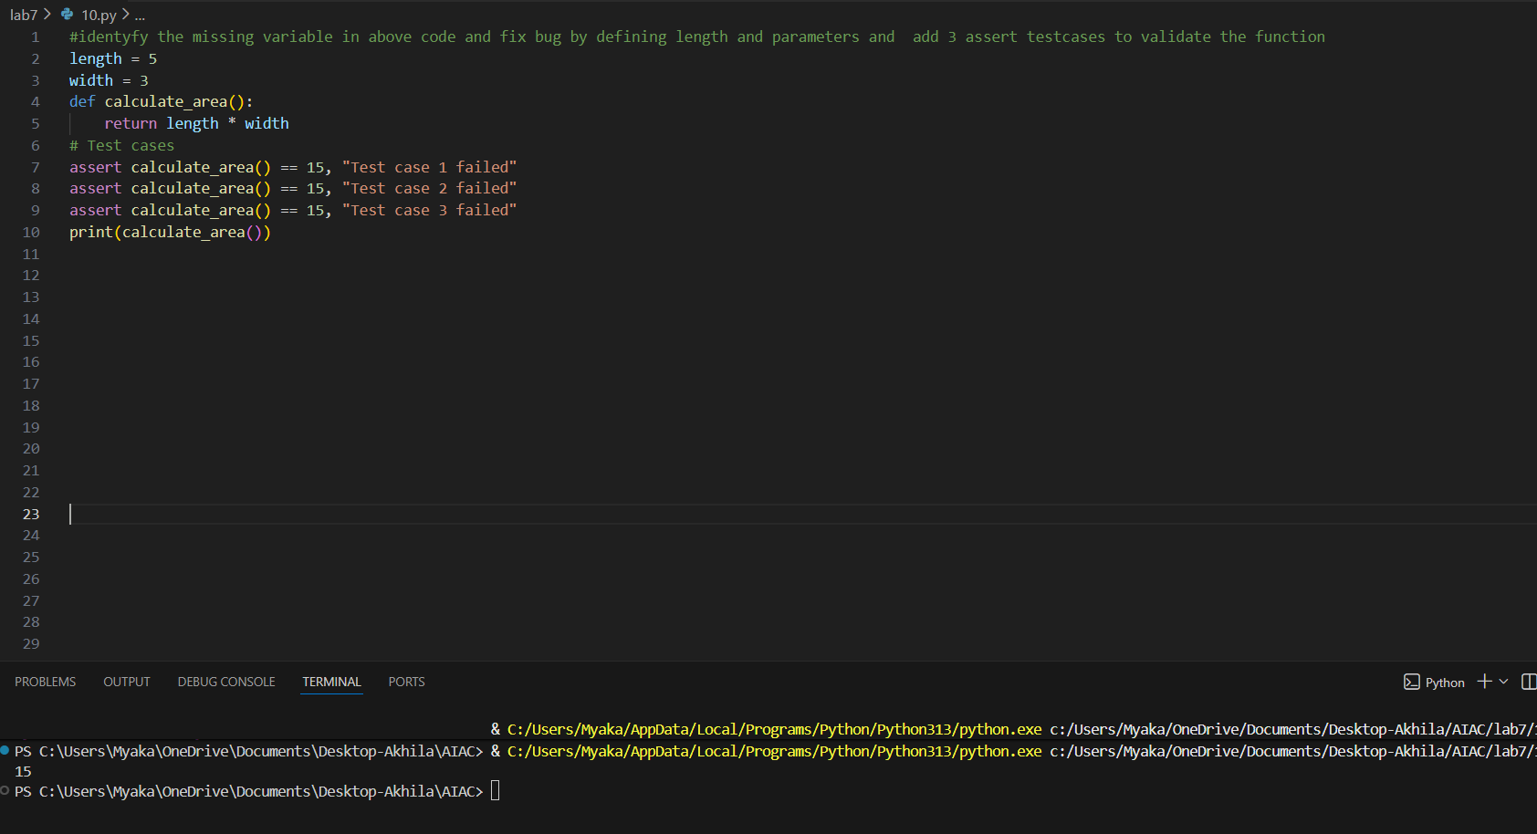
Justification:
The bug in the original code was that the variables length and width were not defined before they were used in the calculate_area function. This would have resulted in a NameError when the function was called.
To fix the bug, I defined the variables length and width with specific values (5 and 3, respectively) before the function definition. This allows the calculate_area function to access these variables and perform the calculation without any errors. Additionally, I added assert test cases to validate that the function is returning the expected area of 15.
Task11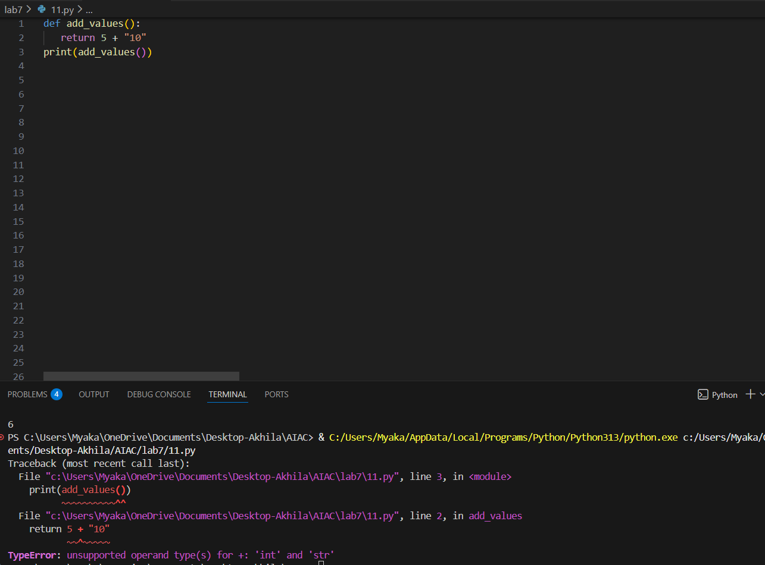
Justification:
The operation 5 + 10 is invalid because it attempts to add an integer (5) and a string (“10"). In Python, you cannot directly perform arithmetic operations between different data types without explicitly converting them. The integer 5 cannot be added to the string "10" because they are of different types, and Python does not know how to combine them. To fix this, you would need to convert the string "10" to an integer before performing the addition, like this: 5 + int("10"), which would result in 15
Task 12: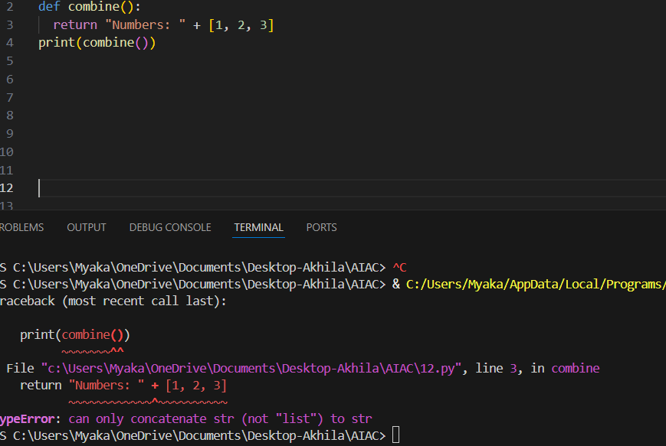
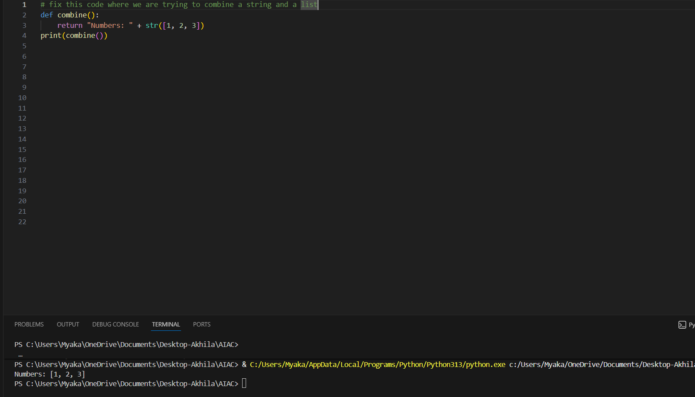
Justification:
In Python, you cannot directly concatenate a string and a list because they are different data types. The + operator is used for concatenation, but it requires both operands to be of the same type. When you try to combine a string and a list, Python raises a TypeError because it doesn't know how to handle the operation between these two different types.
Task 13:
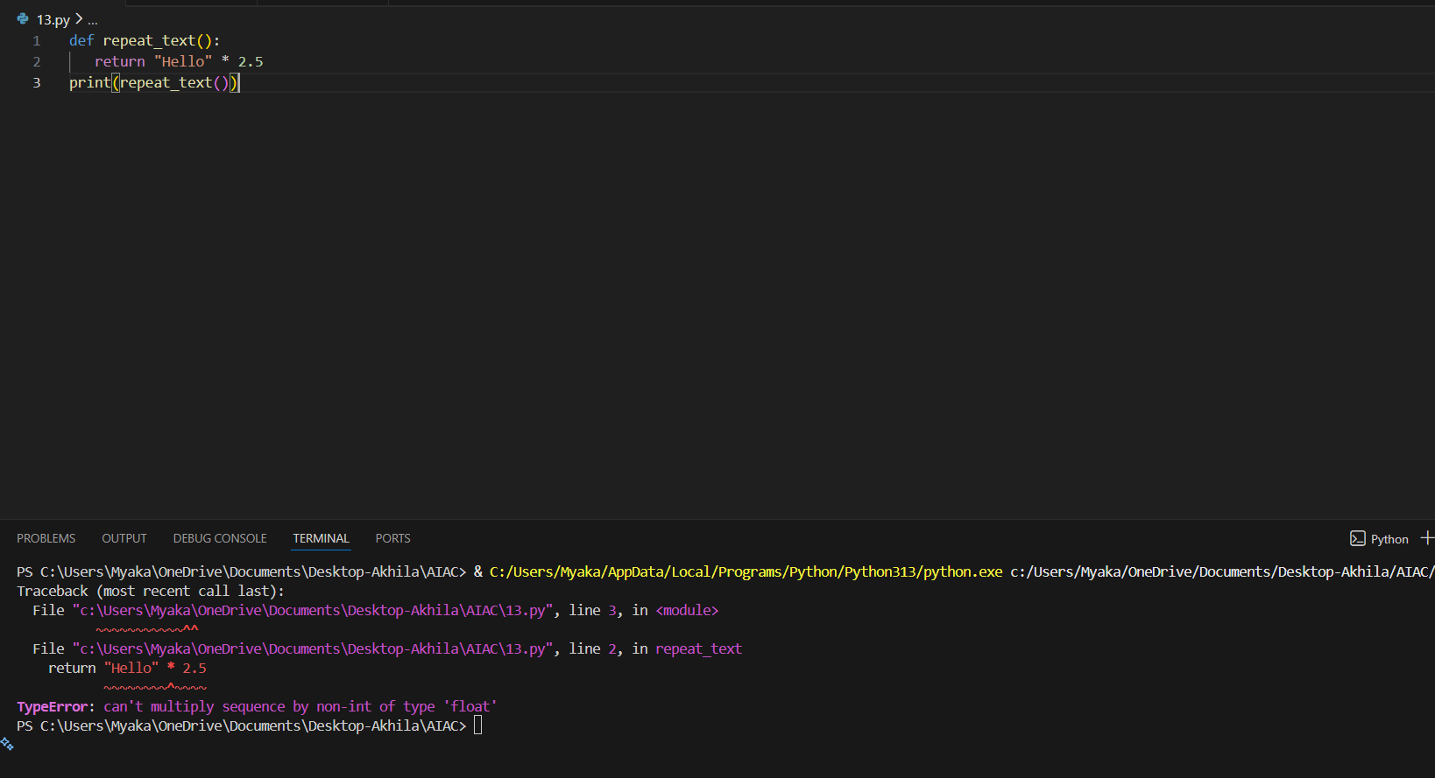
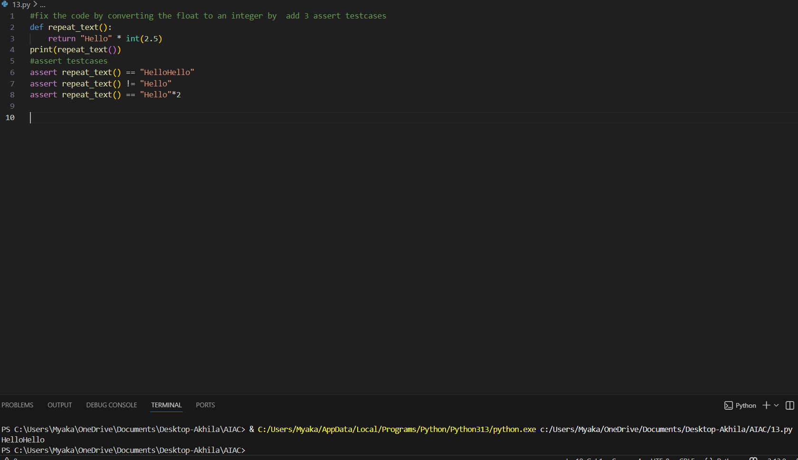
Justification:
In Python, string multiplication requires an integer to specify how many times the string should be repeated. A float is not allowed because it does not represent a whole number of repetitions. If you try to use a float, Python will raise a TypeError, indicating that the operand must be an integer

Task14:
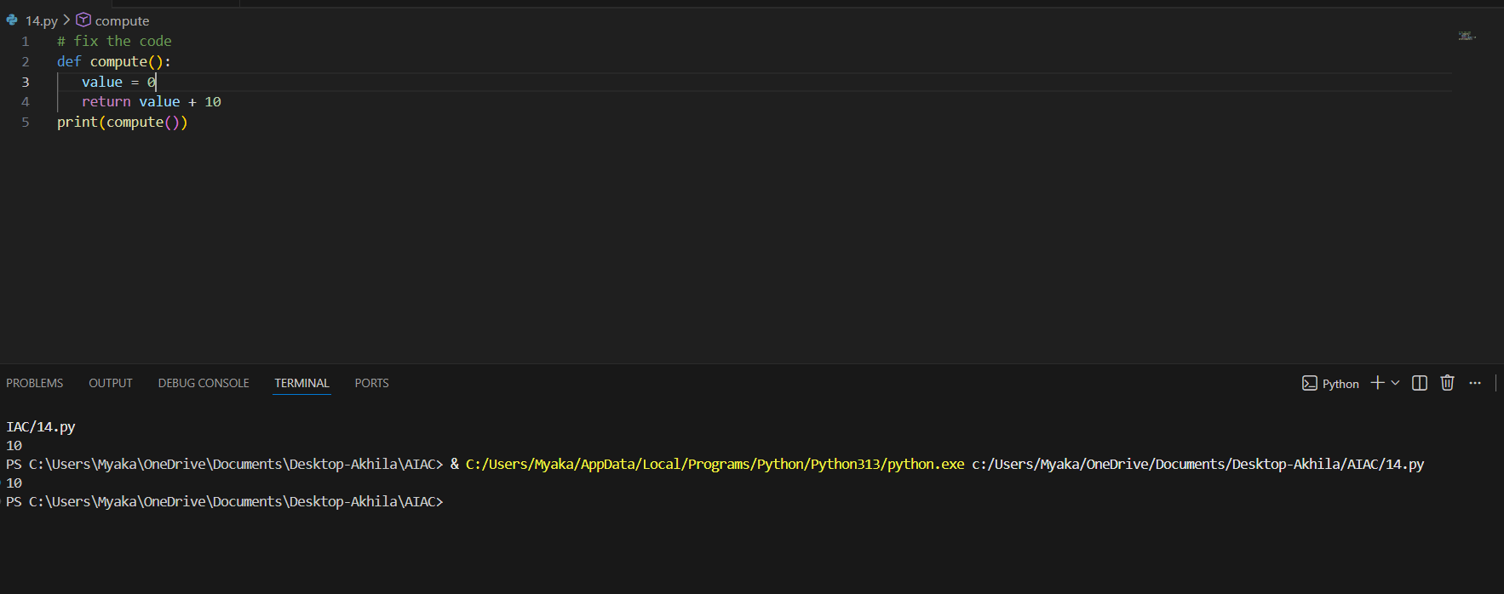
Justification:
NoneType cannot be added because it represents the absence of a value. When you try to perform an addition operation with None, it does not have a defined behavior for arithmetic operations, which results in a TypeError. In the original code, since value was set to None, trying to add 10 to it would raise an error because you cannot perform arithmetic operations on NoneType.
Task 15
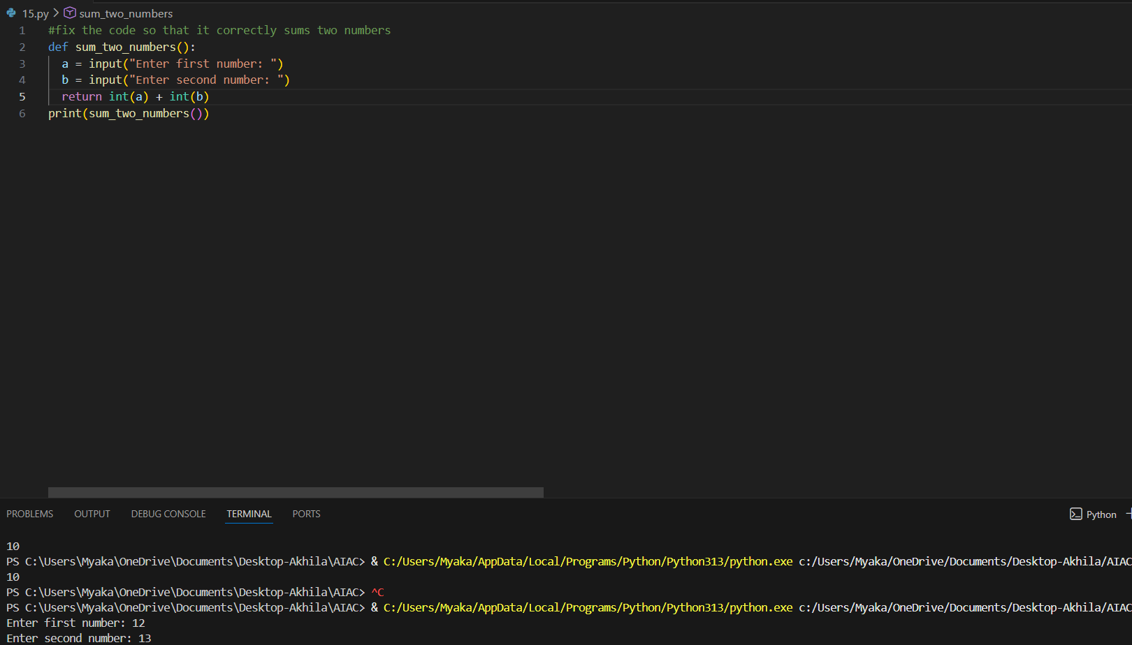
Justification:
The input() function in Python always returns a string because it is designed to read user input as text. When you use input(), it captures everything the user types and treats it as a string, regardless of whether it looks like a number or not. This is why we need to convert the input to an integer (or another numeric type) using `int()` before performing arithmetic operations like addition.

