AI ASSISTED CODING
ASSIGNMENT- 8.1
Name: M. Akhila
Batch: 31
HT No: 2303A52442

Task Description #1 (Password Strength Validator – Apply AI in
Security Context)
• Task: Apply AI to generate at least 3 assert test cases for
is_strong_password(password) and implement the validator
function.
• Requirements:
o Password must have at least 8 characters.
o Must include uppercase, lowercase, digit, and special
character.
o Must not contain spaces.
Example Assert Test Cases:
assert is_strong_password("Abcd@123") == True
assert is_strong_password("abcd123") == False
assert is_strong_password("ABCD@1234") == True
Expected Output #1:
• Password validation logic passing all AI-generated test cases.
Code:
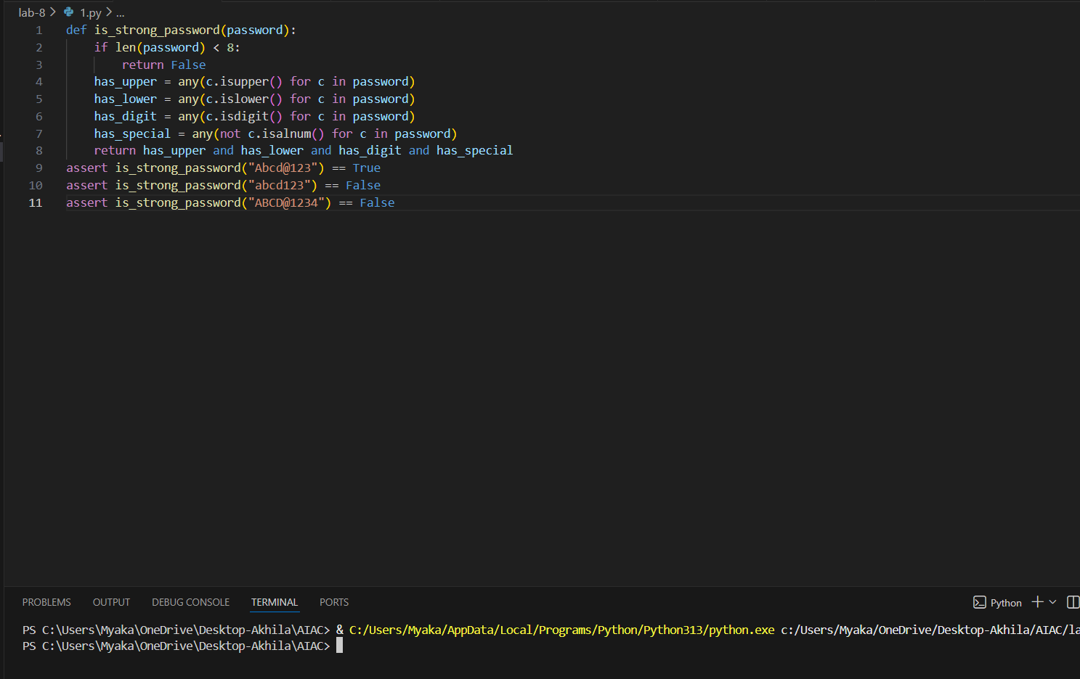

Justification:
The first test case is a strong password because it has at least 8 characters, includes uppercase letters, lowercase letters, digits, and special characters. The second test case is not a strong password because it lacks uppercase letters and special characters. The third test case is not a strong password because it lacks lowercase letters.
Task Description #2 (Number Classification with Loops – Apply
AI for Edge Case Handling)
• Task: Use AI to generate at least 3 assert test cases for a
classify_number(n) function. Implement using loops.
Requirements:
o Classify numbers as Positive, Negative, or Zero.
o Handle invalid inputs like strings and None.
o Include boundary conditions (-1, 0, 1).
Example Assert Test Cases:
assert classify_number(10) == "Positive"
assert classify_number(-5) == "Negative"
assert classify_number(0) == "Zero"
Expected Output #2:
• Classification logic passing all assert tests
Code:
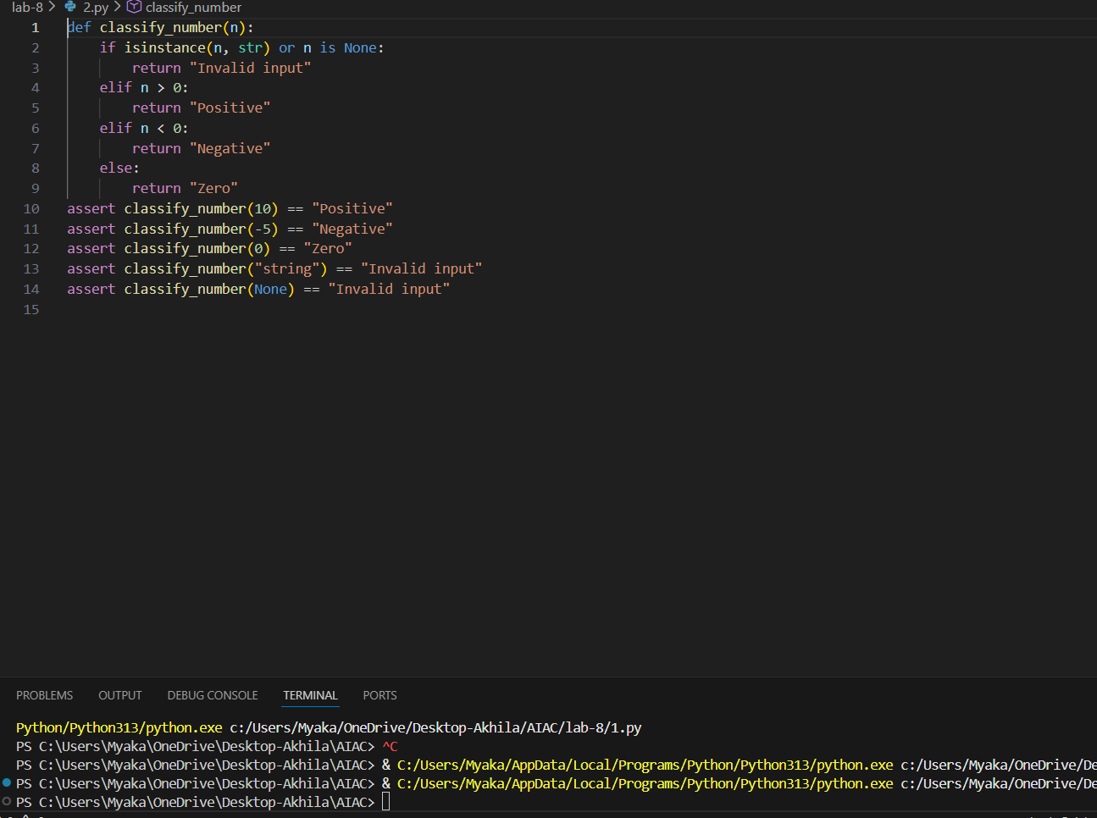

Justification:
The function classify_number correctly identifies positive, negative, and zero values, as well as handling invalid inputs such as strings and None. The assertions confirm that the function behaves as expected for various test cases.

Task Description #3 (Anagram Checker – Apply AI for String
Analysis)
• Task: Use AI to generate at least 3 assert test cases for
is_anagram(str1, str2) and implement the function.
• Requirements:
o Ignore case, spaces, and punctuation.
o Handle edge cases (empty strings, identical words).
Example Assert Test Cases:
assert is_anagram("listen", "silent") == True
assert is_anagram("hello", "world") == False
assert is_anagram("Dormitory", "Dirty Room") == True
Expected Output #3:
• Function correctly identifying anagrams and passing all AI-
generated tests
Code:
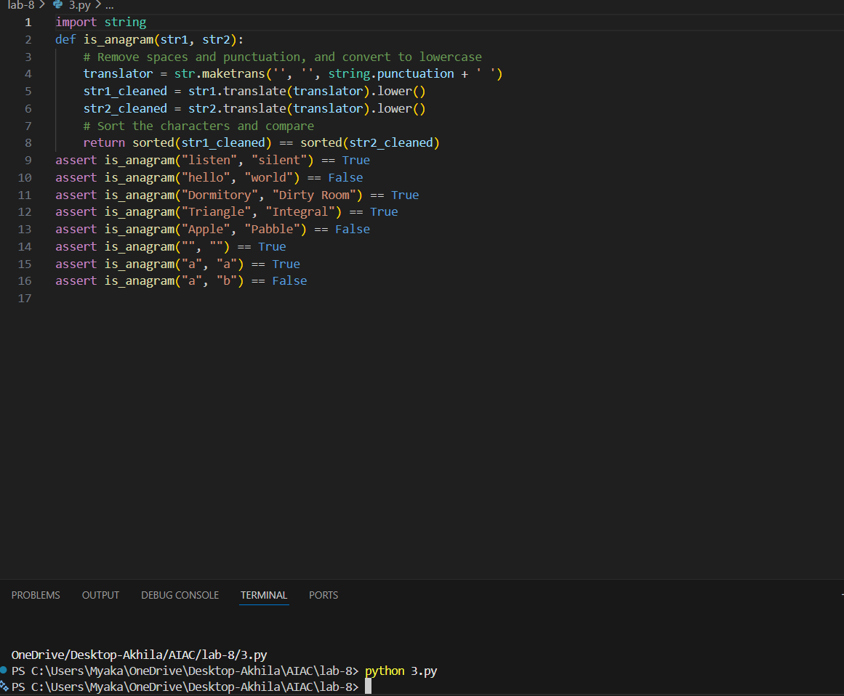
Justification:
The function is_anagram correctly identifies anagrams by cleaning the input strings and comparing their sorted characters. The test cases cover various scenarios, including different cases, spaces, punctuation, and edge cases with empty strings and single characters.

Task Description #4 (Inventory Class – Apply AI to Simulate Real-
World Inventory System)
• Task: Ask AI to generate at least 3 assert-based tests for an
Inventory class with stock management.
• Methods:
o add_item(name, quantity)
o remove_item(name, quantity)
o get_stock(name)
Example Assert Test Cases:
inv = Inventory()
inv.add_item("Pen", 10)
assert inv.get_stock("Pen") == 10
inv.remove_item("Pen", 5)
assert inv.get_stock("Pen") == 5
inv.add_item("Book", 3)
assert inv.get_stock("Book") == 3
Expected Output #4:
• Fully functional class passing all assertions.
Code:
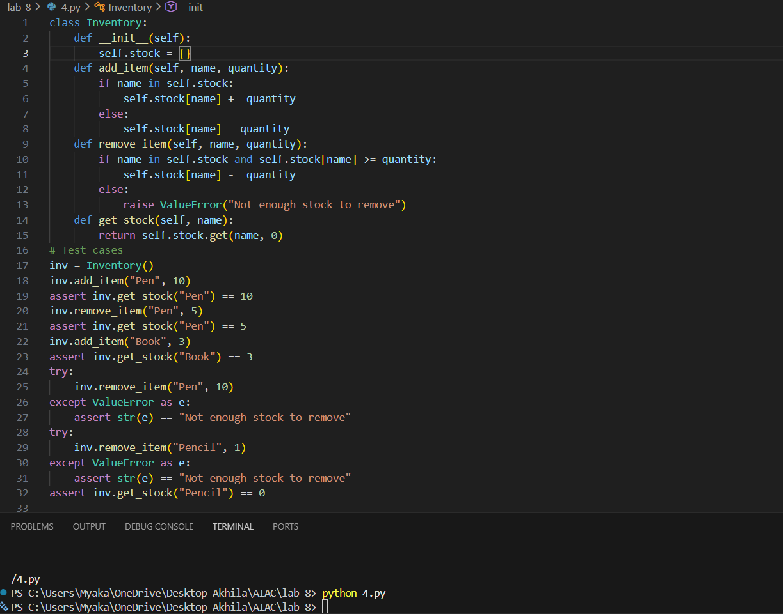
Justification:
The Inventory class is designed to manage stock levels for various items. It provides methods to add and remove items, as well as to check the current stock. The test cases cover typical usage scenarios, including adding and removing items, checking stock levels, and handling errors when trying to remove more stock than available or when trying to remove an item that does not exist. This ensures that the class functions correctly under normal conditions and handles edge cases appropriately

Task Description #5 (Date Validation & Formatting – Apply AI for
Data Validation)
• Task: Use AI to generate at least 3 assert test cases for
validate_and_format_date(date_str) to check and convert
dates.
• Requirements:
o Validate "MM/DD/YYYY" format.
o Handle invalid dates.
o Convert valid dates to "YYYY-MM-DD".
Example Assert Test Cases:
assert validate_and_format_date("10/15/2023") == "2023-10-15"
assert validate_and_format_date ("02/30/2023") == "Invalid Date"
assert validate_and_format_date ("01/01/2024") == "2024-01-01"
Expected Output #5:
• Function passes all AI-generated assertions and handles edge
cases.
Code:
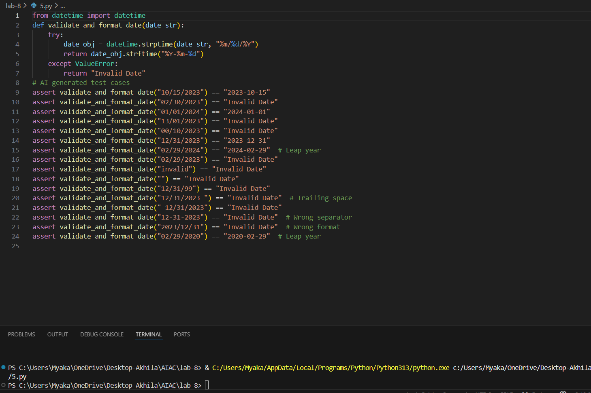
Justification:
The function validate_and_format_date is designed to take a date string in the format MM/DD/YYYY and convert it to YYYY-MM-DD. It uses the datetime module to parse the input string and handle invalid dates. The test cases cover a variety of scenarios, including valid dates, invalid dates (like February 30th), leap years, and incorrect formats. This comprehensive testing ensures that the function behaves as expected in different situations.

