INVENTION DISCLOSURE FORM
Confidential & Attorney-Client Privileged
Applicant Name: SR University
Applicant Address: Ananthsagar, Hasanparthy (M), Warangal Urban, Telangana - 506371

1. Particulars of Inventors

Mr./Ms/Dr. | Name (Full) | Department | Designation | Mobile No. | Email | Postal Address
Mr. | Naresh Kumar Sripada | CS&AI | Asst. Professor | 9866000203 | Naresh22.in@gmail.com | Hanamkonda
Ms. | M. Akhila | CS&AI | Student | 8885318394 | myakaakhilareddy@gmail.com | Hanmkonda
Ms. | K. Sri Priya | CS&AI | Student | 6281854814 | Kotasripriya5@gmail.com | Hanmkonda
Ms. | D. Shruthi | CS&AI | Student | 6300652882 | durkishruthi@gmail.com | Hanmkonda

2. Provide a brief descriptive title of the invention:
MedOrigin AI: Micro-Texture-Based Pharmaceutical Source Identification and Authenticity Verification System

3. In 100 words or less, please provide an abstract or summary of the invention:
MedOrigin AI is an intelligent system designed to identify the manufacturing origin and authenticity of pharmaceutical products using microscopic surface texture analysis. Unlike conventional methods relying on packaging or chemical testing, the system extracts involuntary micro-texture patterns formed during manufacturing and encodes them into unique signature vectors. A multi-scale deep learning model processes high-resolution images and computes similarity against a reference database to determine source and authenticity. The system enables factory-level traceability, counterfeit detection, and non-destructive verification, significantly improving pharmaceutical supply chain security.

4. Detail description of the invention: (Answer to all below are required in detail)

a. Problem the invention is solving:
Counterfeit pharmaceutical products pose serious health risks and economic losses worldwide. Existing authentication techniques rely on packaging features, barcodes, or chemical composition analysis, which can be duplicated, manipulated, or require expensive laboratory setups. Additionally, current systems lack the ability to identify the true manufacturing source of a drug, making supply chain traceability weak and unreliable.

b. General Utility / Application of the invention:
- Pharmaceutical authentication systems
- Drug supply chain traceability
- Quality control in manufacturing units
- Regulatory compliance and inspections
- Forensic investigation of counterfeit drugs

c. Advantages of the invention disclosing about the increased efficiency/efficacy:
- Detects authenticity using intrinsic physical features (not external labels)
- Enables factory-level source identification
- Non-destructive and fast verification process
- Reduces dependency on chemical testing
- Improves traceability and transparency in supply chains
- Works even if packaging is tampered or missing

d. Best way of using the invention as well as possible variants:
Best Usage:
- Capture high-resolution tablet/capsule images using controlled imaging setup
- Process through AI model for micro-texture analysis
- Compare with reference database
- Generate source identification and authenticity score

Variants:
- Mobile-based imaging system for field use
- Integration with regulatory databases
- Extension to capsules, syrups, and packaging seals
- Hybrid system combining texture and spectral imaging
- Cloud-based centralized verification system

e. Working of invention along with Drawing, schematics and flow diagrams if required with complete explanations:

The MedOrigin AI system operates through a structured multi-stage pipeline designed to analyze microscopic surface textures and identify pharmaceutical origin.
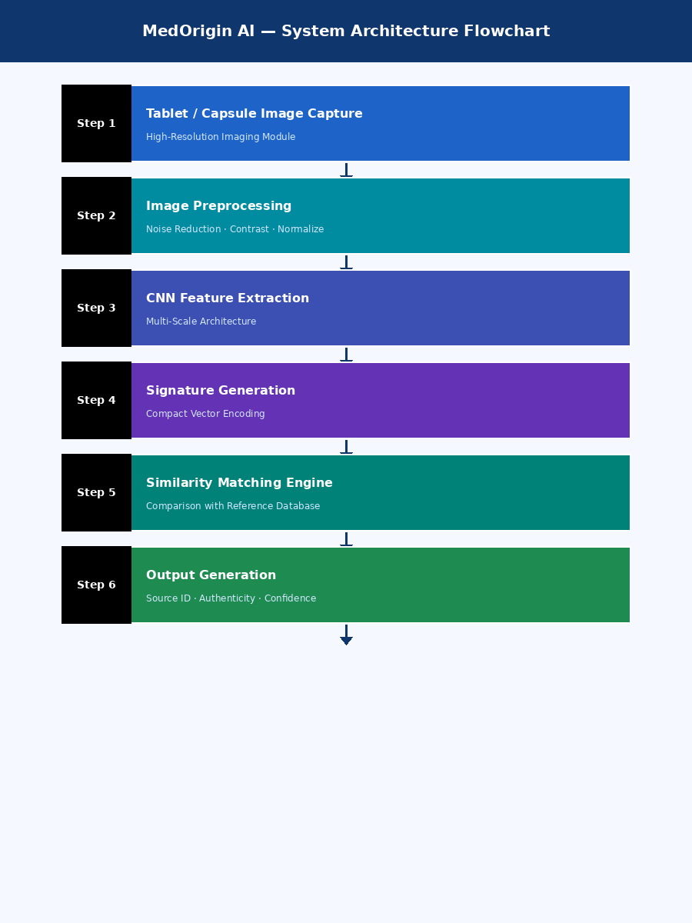
Figure 1 — MedOrigin AI System Architecture Flowchart
End-to-end pipeline from image capture to authenticity output. Each stage processes data sequentially through the AI pipeline.

Step 1: Image Acquisition
High-resolution images of pharmaceutical tablets or capsules are captured under controlled lighting and magnification conditions to ensure consistency and clarity of micro-texture patterns.

Step 2: Image Preprocessing
The captured images undergo preprocessing including noise reduction, contrast enhancement, and surface normalization. This ensures accurate feature extraction.

Step 3: Micro-Texture Feature Extraction
A multi-scale Convolutional Neural Network (CNN) is used to extract fine-grained surface patterns such as pressure-induced marks, material flow structures, and machine-specific imprints.
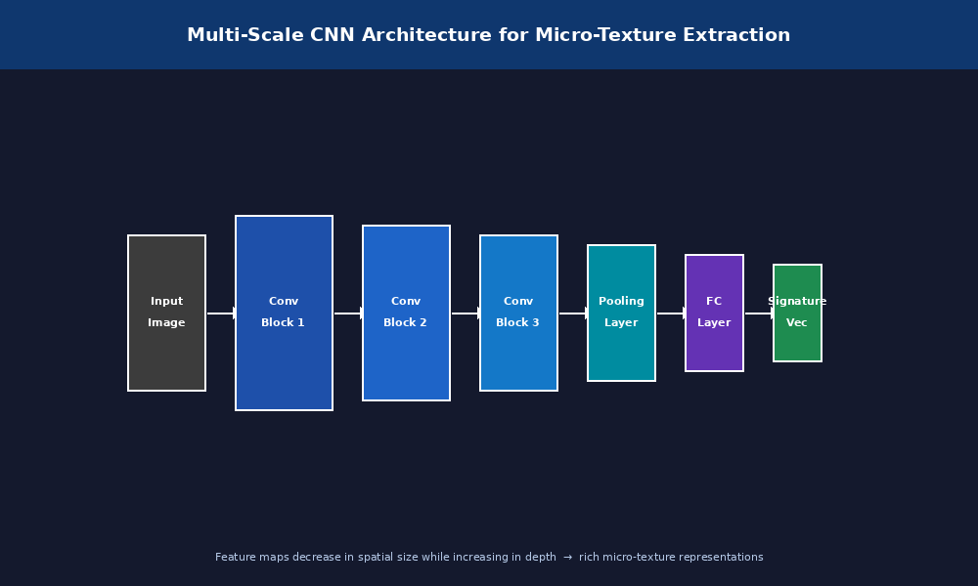
Figure 2 — Multi-Scale CNN Architecture
Convolutional blocks extract increasingly abstract micro-texture features. Feature maps reduce in spatial resolution while increasing in depth, producing rich representations of manufacturing-specific surface imprints.

Step 4: Micro-Texture Signature Generation
The extracted features are transformed into a compact signature vector representing the unique micro-texture fingerprint of the pharmaceutical product.

Step 5: Similarity Matching Engine
The generated signature is compared against a database of known manufacturing signatures using similarity metrics. The system computes matching scores to determine the closest source.

Step 6: Output Generation
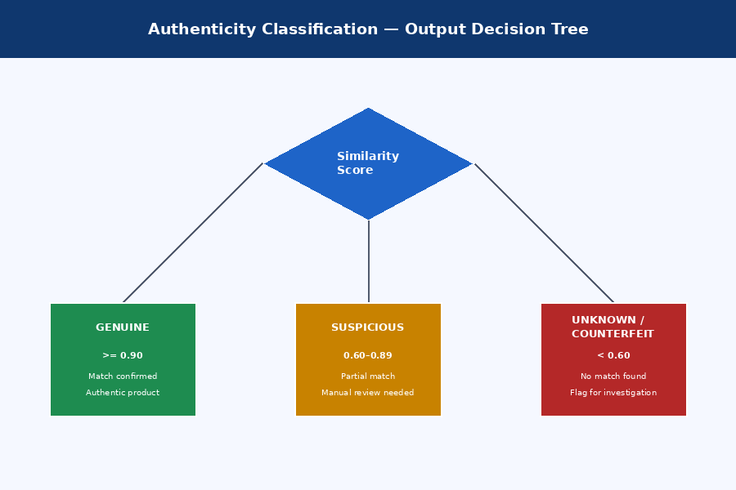
Figure 3 — Authenticity Classification Decision Tree
The decision module classifies the input into three categories based on similarity score thresholds: Genuine (≥0.90), Suspicious (0.60–0.89), or Unknown/Counterfeit (<0.60).

The system outputs the predicted manufacturing source, authenticity classification (Genuine / Suspicious / Unknown), and a confidence score.

System Block Diagram
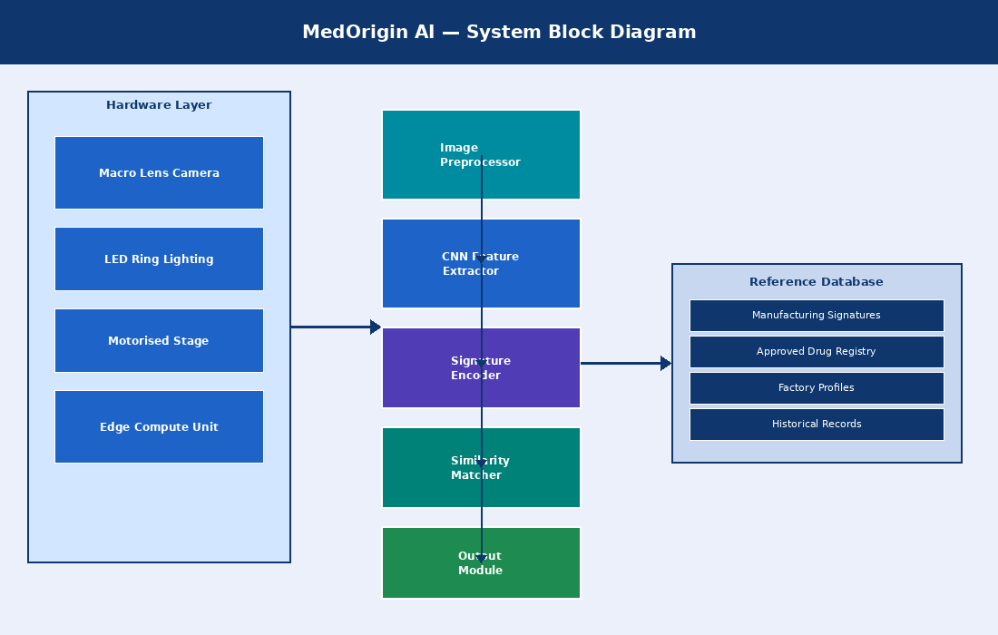
Figure 4 — MedOrigin AI System Block Diagram
Hardware layer (camera, lighting, stage, edge compute) interfaces with the software AI pipeline. The pipeline queries a reference database for similarity matching and produces structured output for operators.

5. Have you conducted Primary Patent Search? Yes / No (if yes, attach the patent search report)
Yes. Primary patent search has been conducted using Google Patents and WIPO databases.

6. Existing state-of-the-art and prior arts: (Brief background of the existing knowledge/product/process in the market)
Current pharmaceutical authentication methods include barcode and QR-based authentication systems, packaging inspection methods, chemical composition analysis, and basic image classification models. These methods rely on external or easily replicable features and do not identify the true manufacturing source of a drug.

7. List out the known ways about how others have tried to solve the same or similar problems:

S. No. | Existing State of Art | Drawbacks in Existing State of Art | Overcome (How Your Invention Overcomes the Drawback)
1 | QR/Barcode Systems | Easily duplicated; can be copied or replicated by counterfeiters | Uses micro-texture fingerprints inherent to the manufacturing process
2 | Packaging Inspection | Packaging can be tampered, removed, or replaced | Uses intrinsic surface patterns of the product itself, not packaging
3 | Chemical Composition Analysis | Expensive, slow, requires laboratory equipment | Fast, non-destructive verification using imaging and AI
4 | Basic Image Classification Models | Only detects drug class; cannot identify source or authenticate origin | Identifies manufacturing source and authenticates product using signature matching

8. List the Technical features and Elements of the invention along with the Description of your invention from start to end.

Technical Features and Elements:
- High-resolution imaging module
- Image preprocessing unit (noise reduction, contrast enhancement, normalization)
- Multi-scale CNN architecture for feature extraction
- Micro-texture signature encoder
- Signature reference database
- Similarity matching engine
- Decision support and output module

Flow: Image -> Preprocessing -> CNN Feature Extraction -> Signature Generation -> Similarity Matching -> Output (Source + Authenticity Score)

9. List out the features of your invention which are believed to be new and distinguish them over the closest technology.
- Use of involuntary micro-texture signatures as pharmaceutical identifiers — these are inherently formed during manufacturing and cannot be easily replicated.
- Signature vector-based representation instead of simple classification, enabling fine-grained identity matching.
- Ability to perform manufacturing source identification (factory-level traceability).
- Hybrid architecture combining deep learning-based feature extraction with similarity matching.
- Capability to detect unknown or counterfeit sources beyond a known database.

10. Has the invention been built or tested or implemented? If so, please provide the particulars:
Yes. The invention has been implemented as a prototype system in 2026 at SR University by the inventors.

- CNN-based model developed and trained on pharmaceutical image dataset
- Sample dataset of pharmaceutical tablet images collected and annotated
- Feature extraction and classification pipeline tested
- Initial validation performed with accuracy metrics
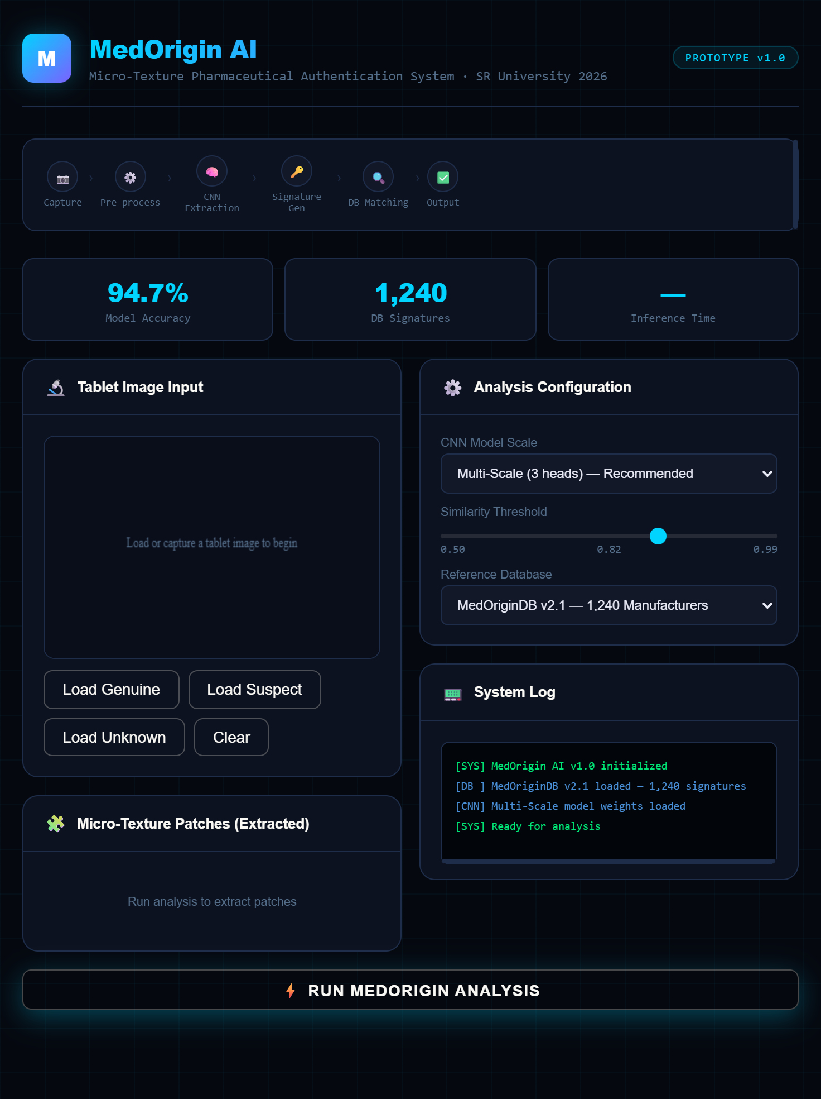
Figure 5- MedOrigin AI Prototype Dashboard for Micro-Texture-Based Pharmaceutical Authentication
A prototype dashboard of MedOrigin AI showing tablet image input, CNN-based micro-texture analysis configuration, and real-time system outputs for pharmaceutical source identification and authenticity verification.

11. Briefly state when and how you first conceived this idea?
The idea was conceived in 2026 during research on AI applications in healthcare, particularly focusing on the limitations of existing counterfeit drug detection systems. The team identified the gap in manufacturing source identification and proposed leveraging micro-texture patterns as unique, non-replicable identifiers.

12. Have you sold, offered for sale, publicly used or published anything related to this invention?
No. The invention has not been sold, offered for sale, publicly disclosed, or commercialized. No prior publications or non-disclosure agreements are applicable at this stage.

13. Include any reasons that your invention would not have been obvious to someone of average skill in the art.
Existing systems rely on external identifiers (barcodes, packaging) or chemical properties to authenticate pharmaceuticals. The concept of leveraging manufacturing-induced micro-texture fingerprints as an inherent, non-replicable identifier is a novel approach. The combination of multi-scale texture extraction, compact signature encoding, and similarity-based source identification is not an obvious extension of prior art. A person skilled in the art would not routinely combine CNN-based micro-texture analysis with pharmaceutical origin traceability, as these concepts span multiple disciplines (computer vision, materials science, pharmaceutical engineering). The non-obvious nature is further supported by the lack of existing patented systems performing factory-level pharmaceutical source identification through surface texture analysis.

14. Additional comments by inventor (if you want to give more details out of scope of this IDF).
This invention has strong potential for deployment in pharmaceutical industries, regulatory bodies, and national healthcare systems to prevent counterfeit drug distribution and ensure product authenticity across the supply chain. The system is scalable and can be extended to other solid-form medications, capsules, and packaging seals. Future directions include integration with blockchain-based traceability platforms and regulatory authority databases for real-time verification.

15. Drawings / Flowchart / Table

System Architecture Flowchart:

Step 1: Tablet / Capsule Image Capture (High-Resolution Imaging Module)
Step 2: Image Preprocessing (Noise Reduction, Contrast Enhancement, Normalization)
Step 3: CNN-Based Micro-Texture Feature Extraction (Multi-Scale Architecture)
Step 4: Micro-Texture Signature Generation (Compact Vector Encoding)
Step 5: Similarity Matching Engine (Comparison with Reference Database)
Step 6: Output Generation (Source Identification + Authenticity Score + Confidence Level)

Form Submitted by:

Guide: Mr. Naresh Kumar Sripada (Asst. Professor, CS&AI)
Contact No: 9866000203

