LAB ASSIGNMENT 8.1

Subject: AI ASST CODING
K.Sunny
2303A52444
Batch-43
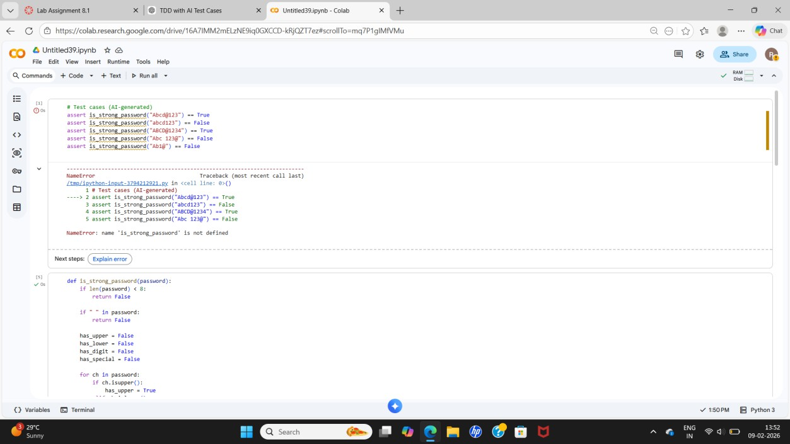
Task 1: Password Strength Validator
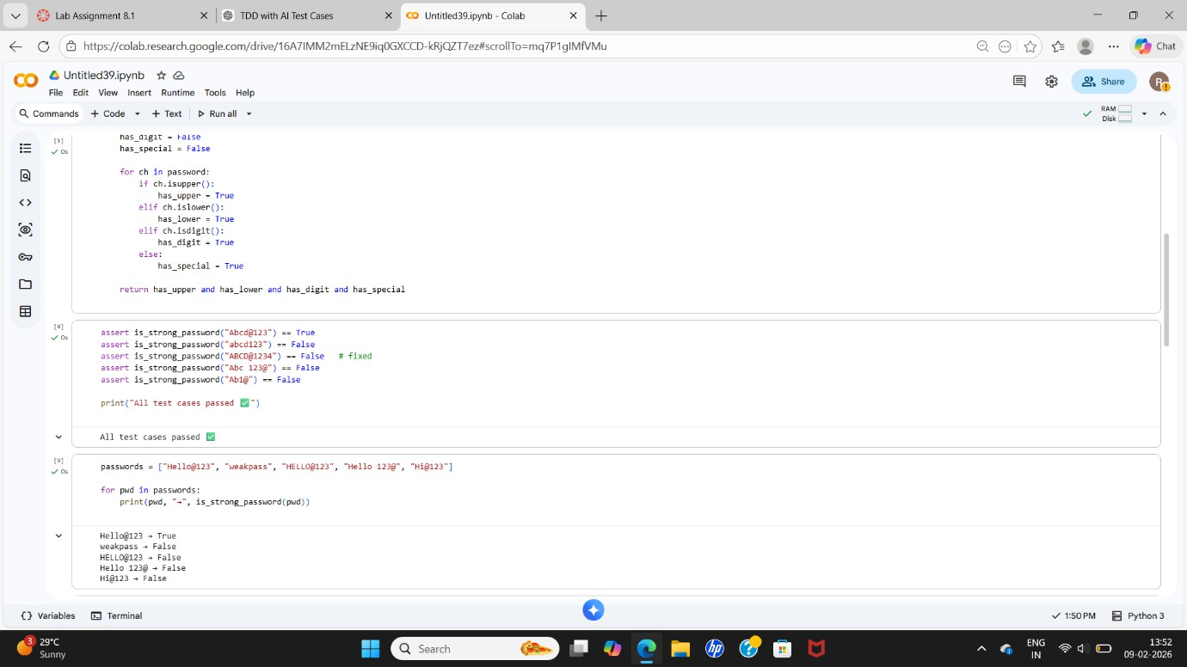

Code Explanation:
The function checks whether a password is strong by verifying length, presence of
uppercase, lowercase, digit, special character, and absence of spaces. It returns True for strong passwords and False otherwise.
AI Explanation:
AI generated test cases for strong and weak passwords. These tests helped verify security rules and identify incorrect password patterns.
Task 2: Number Classification Using Loops
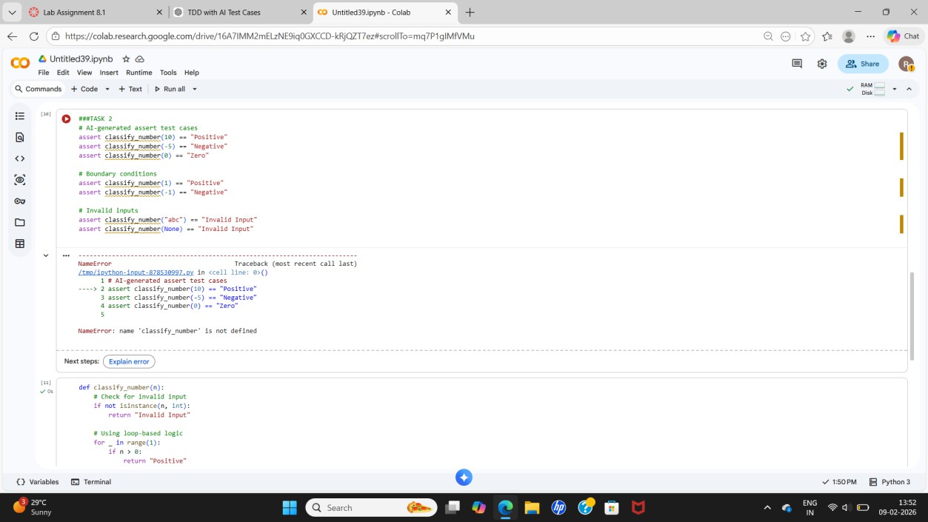
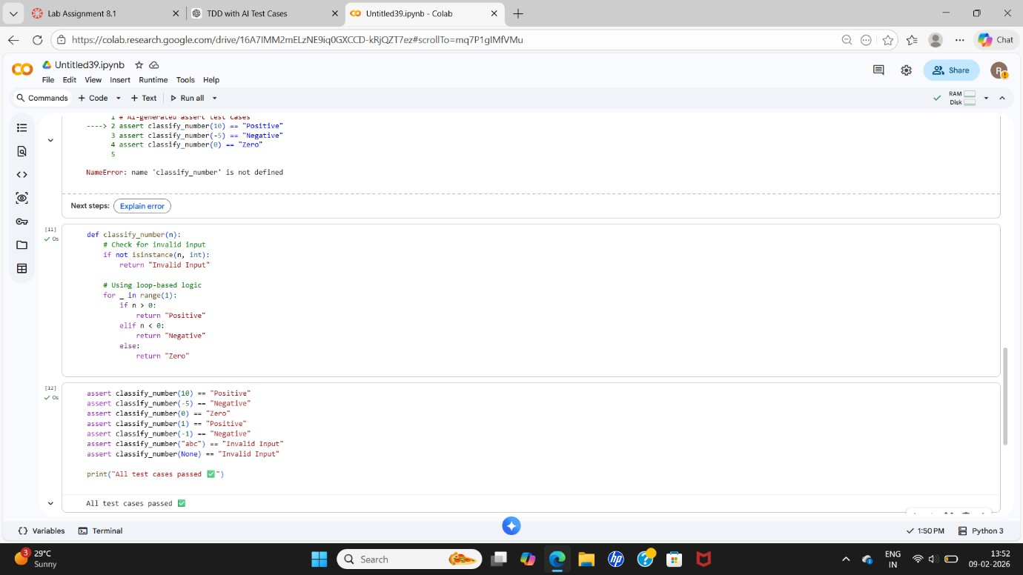

Code Explanation:
The function classifies a number as Positive, Negative, or Zero. It first checks for invalid inputs like strings or None and then uses logic inside a loop to return the correct classification.
AI Explanation:
AI generated test cases including boundary values (-1, 0, 1) and invalid inputs, ensuring correct classification.

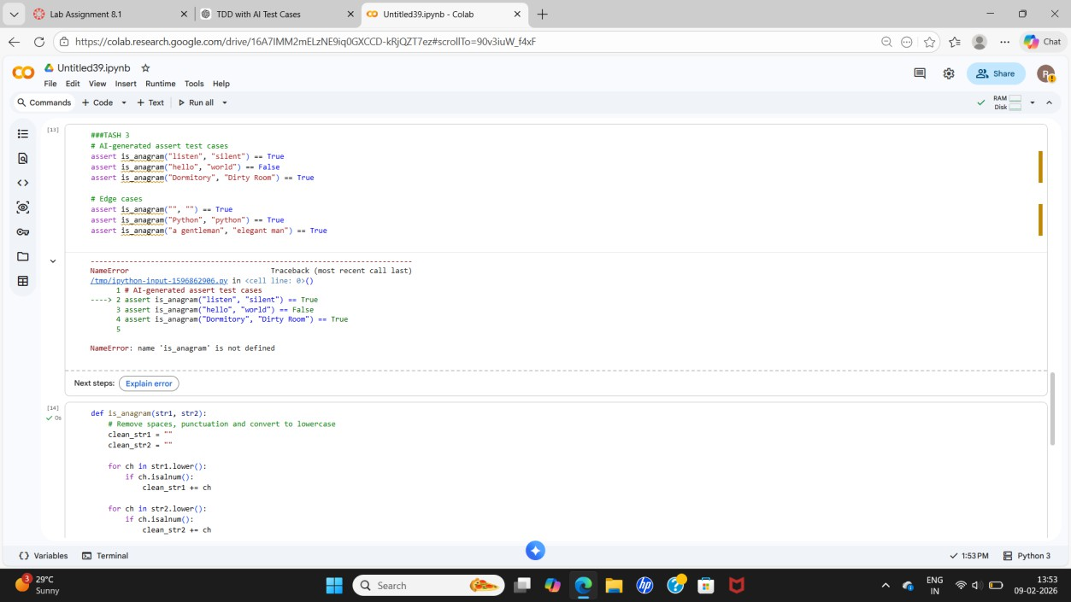
Task 3: Anagram Checker

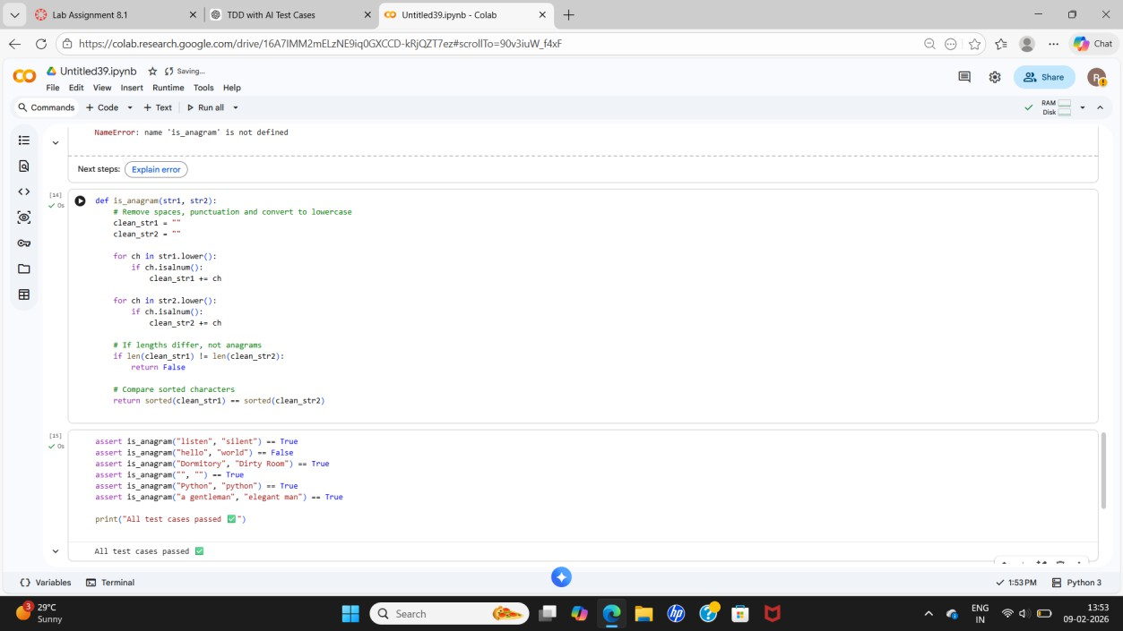

Code Explanation:
The function removes spaces and punctuation, converts strings to lowercase, and compares characters to check if two strings are anagrams.
AI Explanation:
AI-generated tests helped cover case differences, spaces, and empty strings for accurate string comparison.

Task 4: Inventory Class (Real-World Simulation)
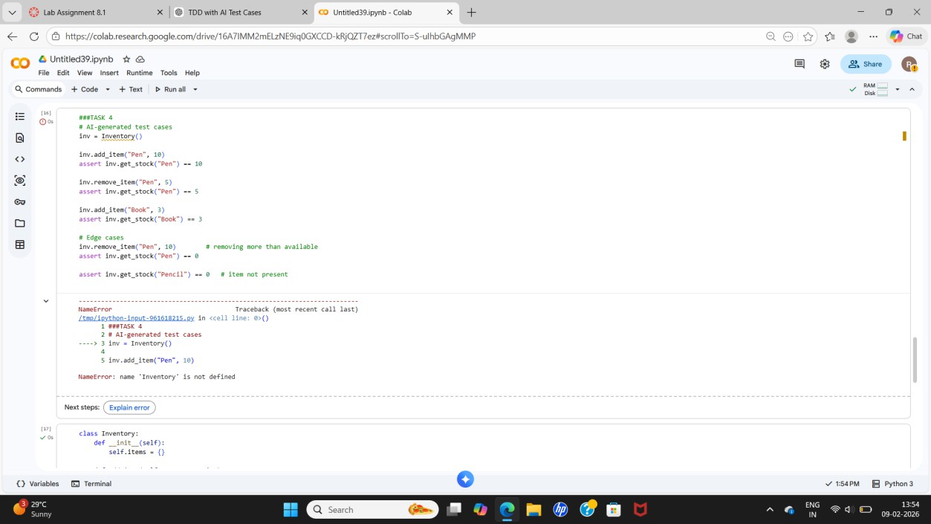

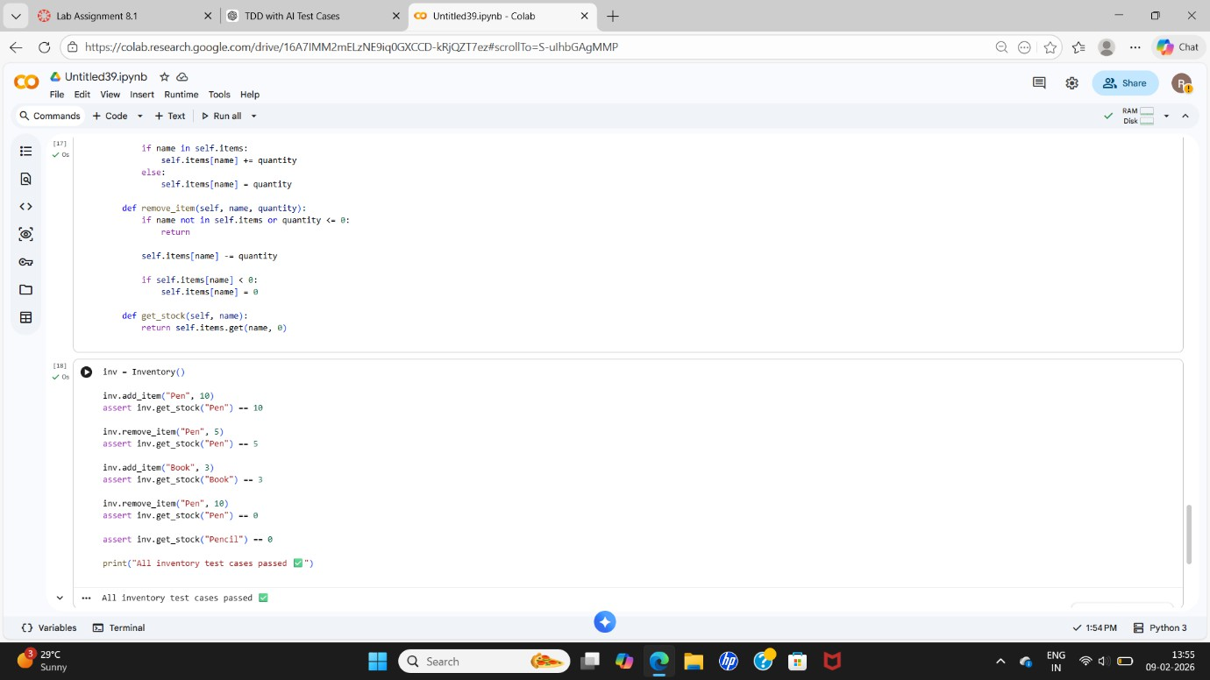
Code Explanation:
The Inventory class manages item stock. It allows adding items, removing items safely, and checking stock quantity.
AI Explanation:
AI provided test cases simulating real inventory actions like adding, removing, and checking items.

Task 5: Date Validation & Formatting
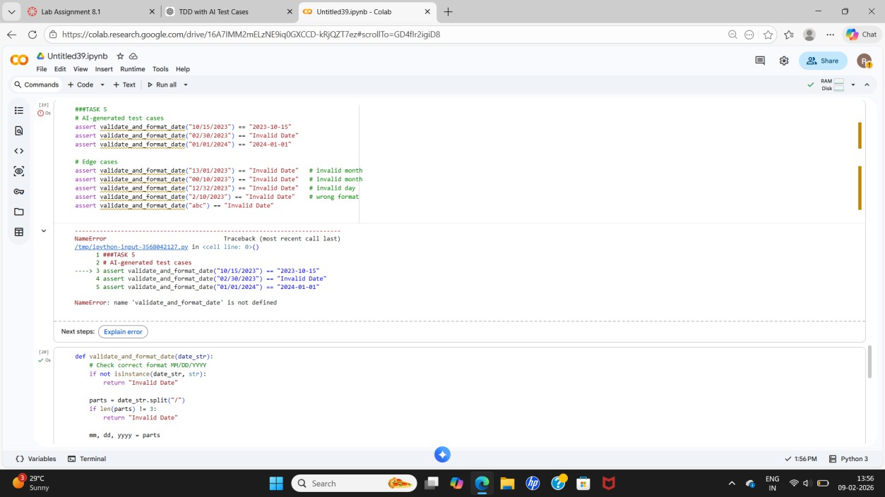
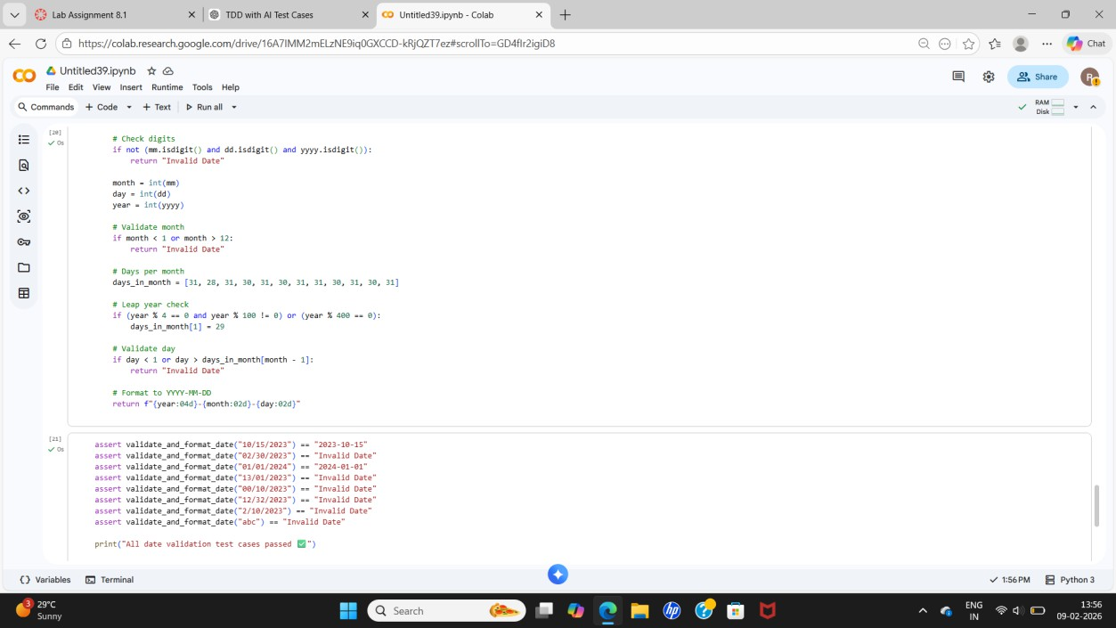

Code Explanation:
The function checks whether a date is in MM/DD/YYYY format, validates the date, and converts valid dates to YYYY-MM-DD.
AI Explanation:
AI generated test cases for valid dates, invalid formats, and edge cases like leap years.

