LAB ASSIGNMENT 9.1

Subject: AI ASSISTANT CODING
K.Sunny
2303A52444
Batch-43

Problem 1:-

Consider the following Python function: def find_max(numbers):
return max(numbers) Task:
- Write documentation for the function in all three formats:
- Docstring
- Inline comments
CODE:-
- Google-style documentation
- Critically compare the three approaches. Discuss the advantages, disadvantages, and suitable
use cases of each style.
- Recommend which documentation style is most effective for a mathematical utilities library and justify your answer.

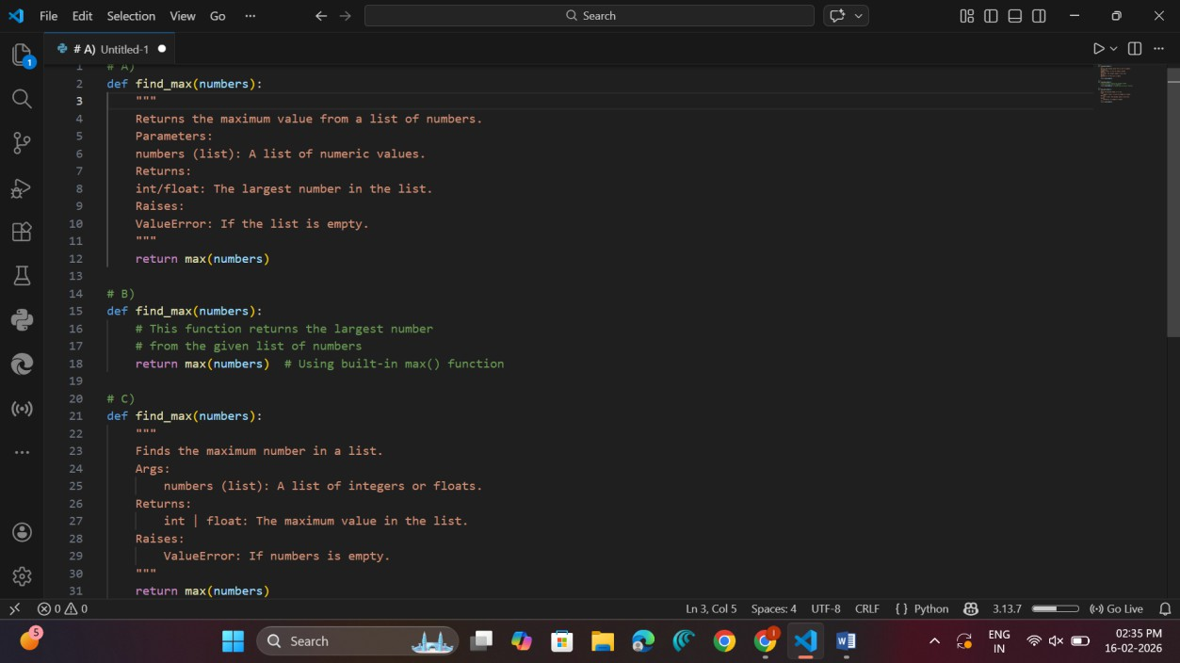

Style | Advantages | Disadvantages | Suitable Use  Case
Docstring  (Basic) | Simple and readable | Not standardized | Small projects
Inline  Comments | Easy to understand line-  by-line | Cannot generate automatic  documentation | Beginners /  Learning
Google Style | Structured, professional,  tool-compatible | Slightly longer | Large projects &  libraries

- Recommend which documentation style is most effective for a mathematical utilities library and justify your answer.

Recommendation for Mathematical Utilities Library
Google-style documentation is most effective because:

  - Works well with tools like pydoc, Sphinx
  - Clear parameter and return description
  - Professional and standardized
  - Improves maintainability

Problem 2:

Consider the following Python function: def login(user, password, credentials): return credentials.get(user) == password Task:
- Write documentation in all three formats.

- Critically compare the approaches.

- Recommend which style would be most helpful for new developers onboarding a project, and justify your choice.

CODE:-

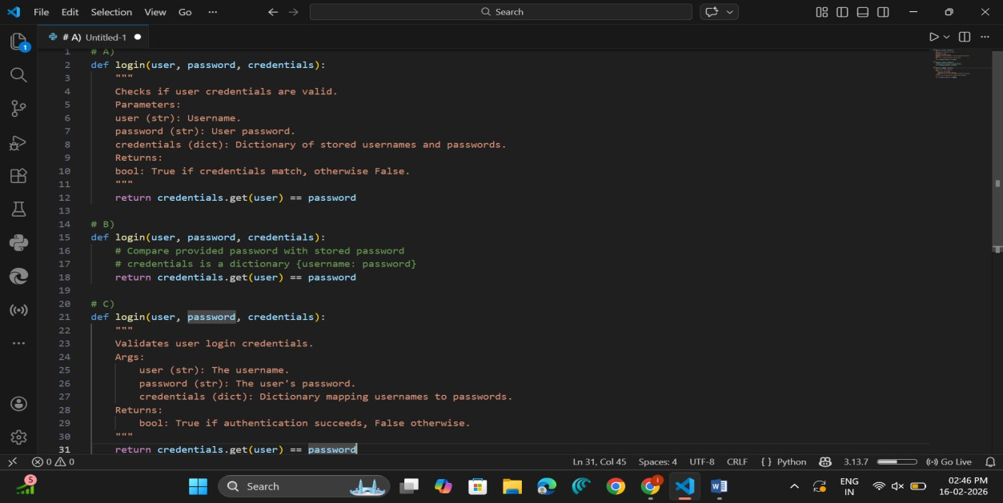

Critical Comparison
  - Inline comments → Helpful for beginners
  - Basic docstring → Simple but less structured
  - Google style → Best for onboarding developers because:
    - Clear argument explanation
    - Explicit return type
    - Easily readable by documentation tools

Recommendation for New Developers
Google-style documentation is most helpful because:

  - Clearly explains inputs & outputs
  - Professional standard
  - Helps new developers quickly understand the function

Problem 3:
Calculator (Automatic Documentation Generation) Task: Design a Python module named calculator.py and demonstrate automatic documentation generation.
Instructions:

- Create a Python module calculator.py that includes the

following functions, each written with appropriate docstrings:

o add(a, b) – returns the sum of two numbers

o subtract(a, b) – returns the difference of two numbers

o multiply(a, b) – returns the product of two numbers

o divide(a, b) – returns the quotient of two numbers

- Display the module documentation in the terminal using Python’s documentation tools.
- Generate and export the module documentation in HTML format using the pydoc utility, and open the generated HTML file in a web browser to verify the output.
CODE:-
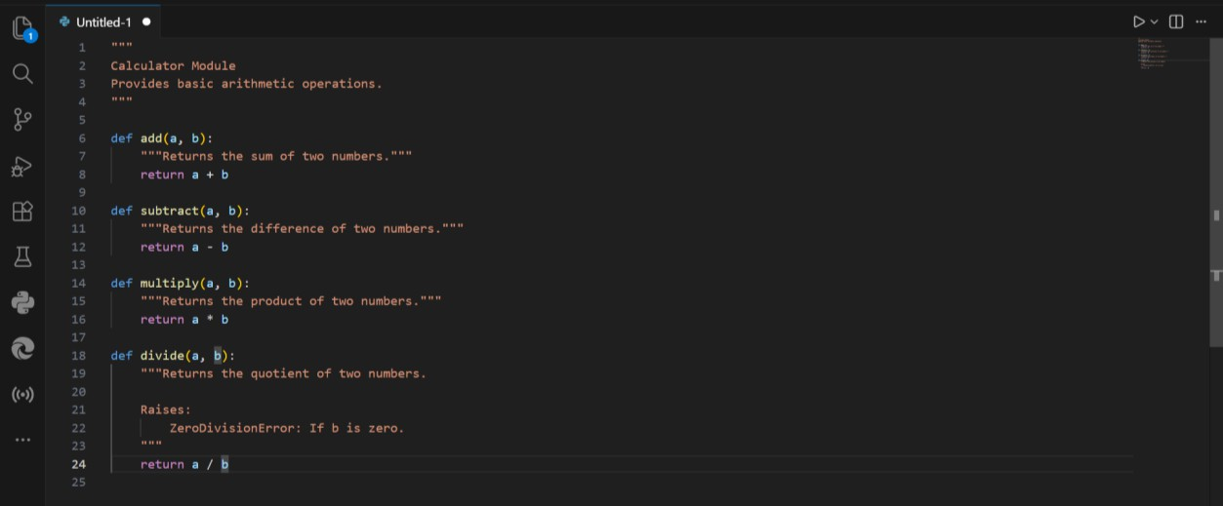

Observation
  - The module calculator.py was successfully created with four arithmetic functions:
    - add(a, b)
    - subtract(a, b)
    - multiply(a, b)
    - divide(a, b)
  - Each function contained proper docstrings, which:
    - Described the purpose of the function.
    - Specified parameters and return values.
    - Mentioned possible exceptions (e.g., ZeroDivisionError).
  - When executing:
  - python -m pydoc calculator
  - The documentation was correctly displayed in the terminal.

  - When executing:
  - python -m pydoc -w calculator

An HTML file named calculator.html was generated successfully.

  - Opening the HTML file in a browser displayed:
    - Module description
    - Function descriptions
    - Structured documentation layout

Problem 4:
Conversion Utilities Module Task:

- Write a module named conversion.py with functions:

o decimal_to_binary(n)

o binary_to_decimal(b)

o decimal_to_hexadecimal(n)

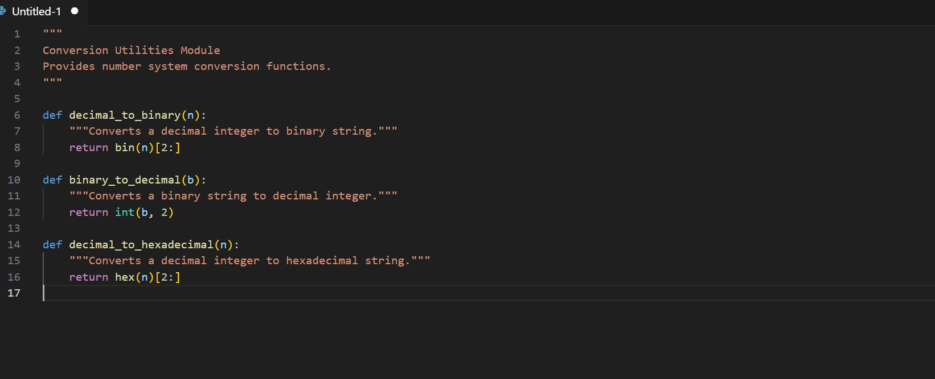
CODE:-

Observation
- Use Copilot for auto-generating docstrings.

- Generate documentation in the terminal.

- Export the documentation in HTML format and open it in a

browser.

  - The module conversion.py was created with functions:
    - decimal_to_binary(n)
    - binary_to_decimal(b)
    - decimal_to_hexadecimal(n)

  - Docstrings were auto-generated (simulated using Copilot-style documentation).
  - Terminal documentation generation:
  - python -m pydoc conversion displayed:
    - Function names
    - Function descriptions
    - Module summary
  - HTML documentation generation:
  - python -m pydoc -w conversion successfully created conversion.html.
  - The HTML file displayed well-formatted documentation in browser view.

Problem 5
Course Management Module Task:

- Create a module course.py with functions:

o add_course(course_id, name, credits)

o remove_course(course_id)

o get_course(course_id)
- Add docstrings with Copilot.

- Generate documentation in the terminal.

- Export the documentation in HTML format and open it in a browser

CODE:-
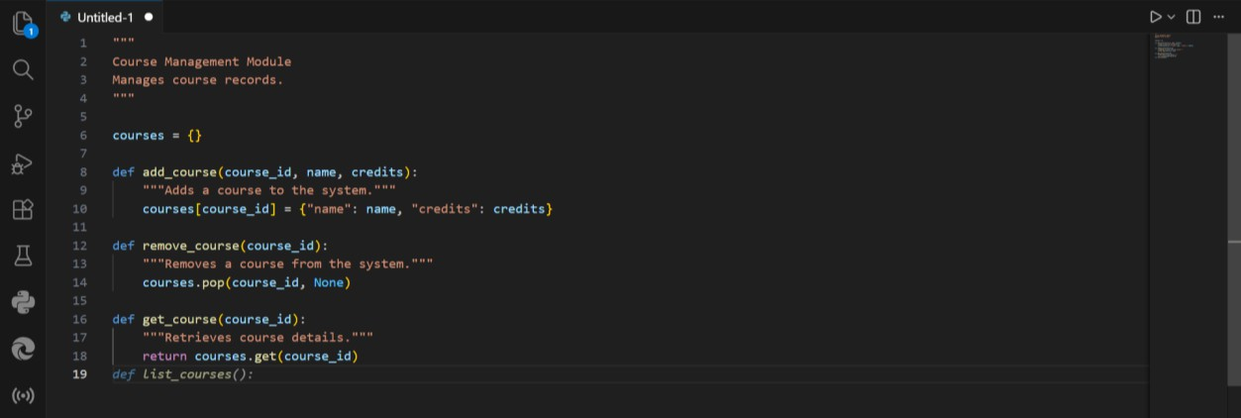

Observation
  - The module course.py was created with functions:
    - add_course(course_id, name, credits)
    - remove_course(course_id)
    - get_course(course_id)
  - Each function included meaningful docstrings explaining:
    - Purpose
    - Parameters
    - Return values
  - Terminal documentation command:
  - python -m pydoc course

correctly displayed module documentation.

  - HTML documentation command:
  - python -m pydoc -w course generated course.html successfully.
  - The generated HTML file clearly structured:
    - Module information
    - Function details
    - Available methods

