ASSIGMENT-16.1
Name: s.vrishank
HALL NO:2303A52450

Task 1 – Student Information System Schema
Task:
Design a database schema for a Student Information System and
generate queries using AI.
Instructions:
• Tables: Students, Courses, Enrollments.
• Define primary keys, foreign keys, and relationships.
• Generate queries:
o Insert a new student record.
o Fetch all courses enrolled by a student.
o Count number of students in each course.

Expected Output:
• SQL CREATE TABLE statements and queries for student–
course relationships.
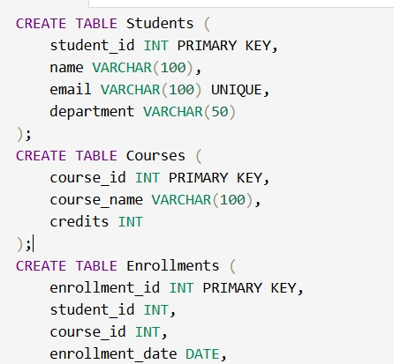

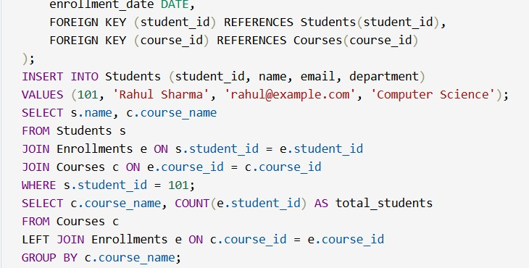

OUTPUT:
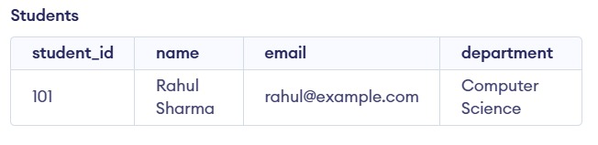
PROMT:
Design a normalized SQL schema for a Student Information System with tables Students, Courses, and Enrollments. Include primary keys and foreign keys. Generate SQL queries to insert a student, fetch all courses of a student, and count students in each course.

Task 2 – Hospital Management Database
Task:
Create schema and queries for a Hospital Management System.
Instructions:
• Tables: Doctors, Patients, Appointments.
• Use AI to define constraints (unique IDs, valid dates).
• Generate queries:
o List all appointments for a specific doctor.
o Retrieve patient history by patient ID.
o Count total patients treated by each doctor.
Expected Output:
• Normalized schema and SQL queries with joins.
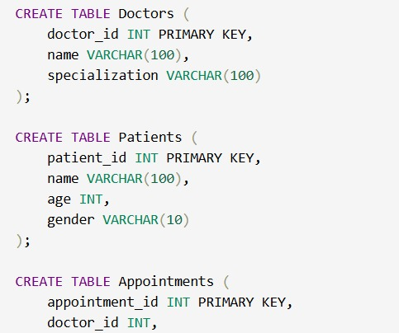

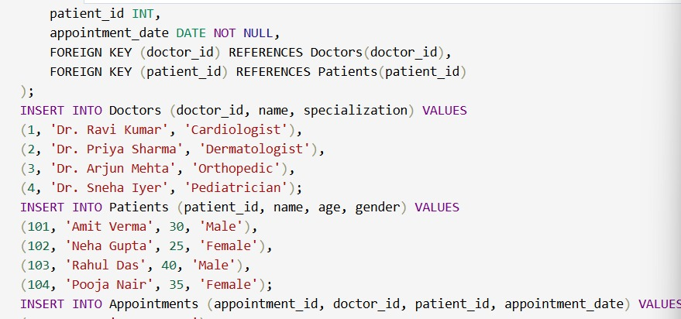

OUTPUT:
• Tables: Doctors, Patients, Appointments.
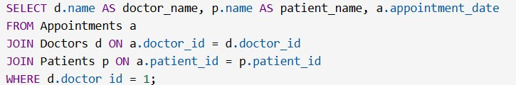
• Use AI to define constraints (unique IDs, valid dates).
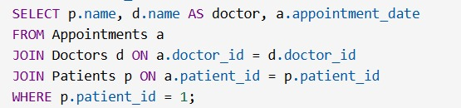
• Generate queries:
o List all appointments for a specific doctor.
o Retrieve patient history by patient ID.
o Count total patients treated by each doctor.
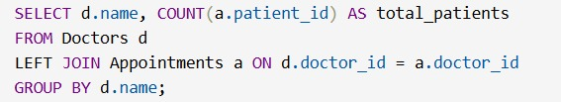

PROMT:
Create a SQL schema for a Hospital Management System with Doctors, Patients, and Appointments. Add constraints like primary keys and valid dates. Generate queries to list appointments by doctor, retrieve patient history, and count patients per doctor.
Task 3 – Library Database
Task:
Design schema for a Library Management System.
Instructions:
• Tables: Books, Members, Loans.
• Use AI to suggest indexing strategy for faster queries.
• Generate queries:
o Retrieve all books currently issued.
o Find overdue books (loan date > 30 days).
o Count number of books loaned by each member.
Expected Output:
• Schema + SQL queries demonstrating joins and conditions.
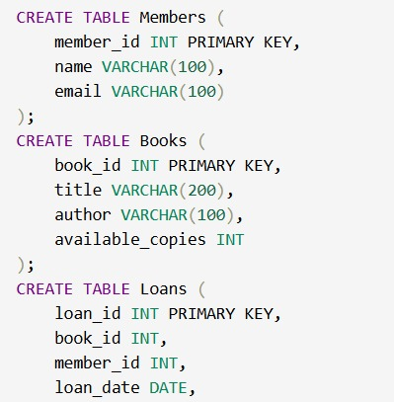
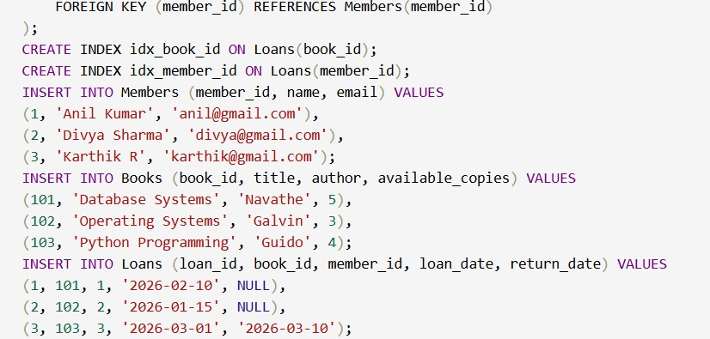
OUTPUT:
• Tables: Books, Members, Loans.
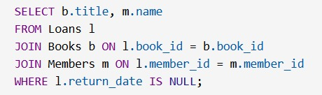
• Use AI to suggest indexing strategy for faster queries.
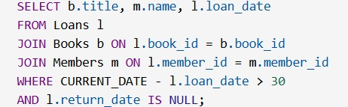
• Generate queries:
o Retrieve all books currently issued.
o Find overdue books (loan date > 30 days).
o Count number of books loaned by each member.
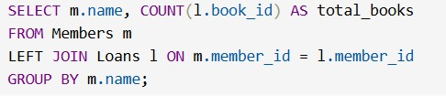
OUTPUT:

PROMT:
Design a normalized SQL schema for a Library System with Books, Members, and Loans. Suggest indexing for performance. Generate queries to find issued books, overdue books (more than 30 days), and total books borrowed by each member.

Task 4 – Real-Time Application: Online Shopping Database
Scenario:
Design a database for an E-commerce platform.
Requirements:
• Tables: Users, Products, Orders, OrderDetails.
• Generate queries to:
o Retrieve all orders by a user.
o Find the most purchased product.
o Calculate total revenue in a given month.
• AI should also suggest normalization improvements and
query optimization.
Expected Output:
• Complete schema with relationships + SQL queries for
Analytics



• Tables: Users, Products, Orders, OrderDetails.
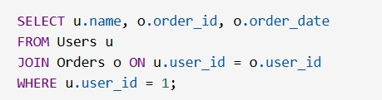

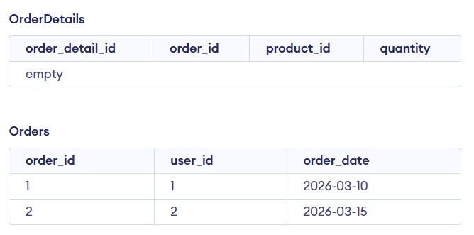
• Generate queries to:
o Retrieve all orders by a user.
o Find the most purchased product.
o Calculate total revenue in a given month.
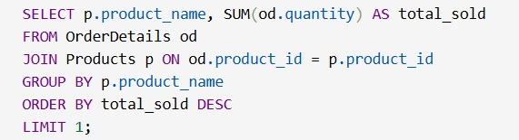

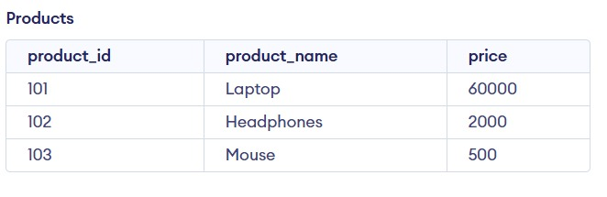

• AI should also suggest normalization improvements and
query optimization.
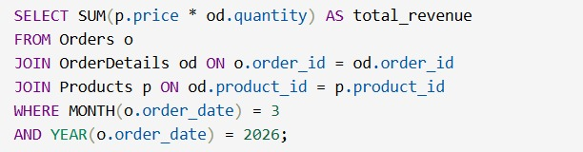
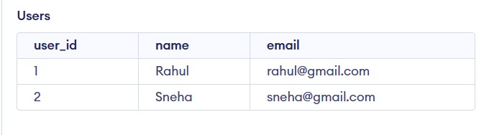
PROMT:
Create an e-commerce database schema with Users, Products, Orders, and OrderDetails. Include relationships and normalization. Generate queries to get user orders, find the most purchased product, and calculate monthly revenue. Suggest query optimizations.

Task 5 – University Examination Database
Design a database schema for a University Examination System and
generate SQL queries using AI.
Instructions:
• Tables: Students, Subjects, Exams, Results.
• Define primary keys, foreign keys, and referential integrity
constraints.
• Generate queries:
o Insert examination results for a student.
o Retrieve subject-wise marks for a student.
o Calculate average marks for each subject.
Expected Output:
• Normalized schema and SQL queries involving aggregation and
Joins

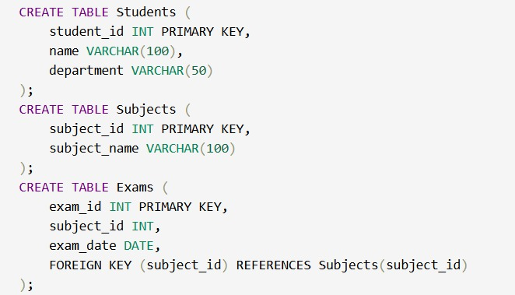

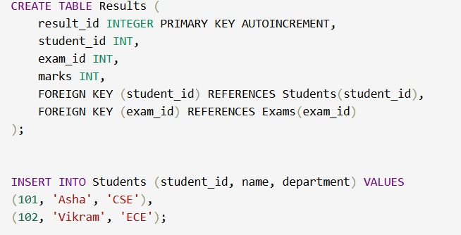
Instructions:
• Tables: Students, Subjects, Exams, Results.

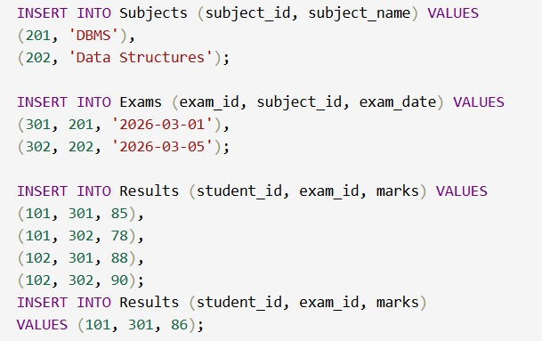
• Define primary keys, foreign keys, and referential integrity
constraints.
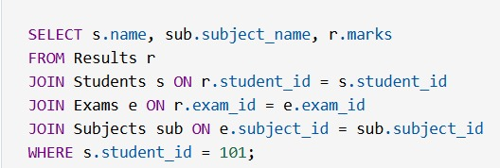
• Generate queries:
o Insert examination results for a student.
o Retrieve subject-wise marks for a student.
o Calculate average marks for each subject.

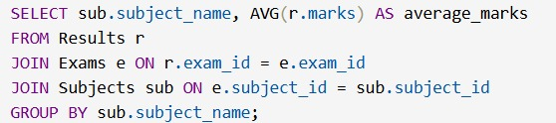

OUTPUT:

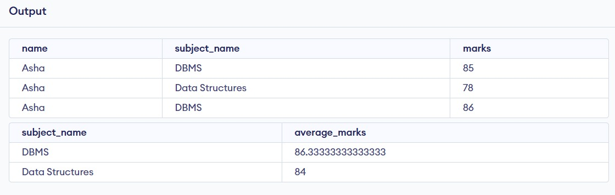

PROMT:

Design a SQL schema for a University Examination System with Students, Subjects, Exams, and Results. Define primary and foreign keys. Generate queries to insert results, get subject-wise marks for a student, and calculate average marks per subject.

