AI ASSIGNMENT-7.1
Name:Mahanand
Ht no:2303A52462
Batch no:35
Task-1:
(Syntax Errors – Missing Parentheses in Print Statement)
Task: Provide a Python snippet with a missing parenthesis in a print statement (e.g., print "Hello"). Use AI to detect and fix the syntax error.
# Bug: Missing parentheses in print statement def greet():
print "Hello, AI Debugging Lab!" greet()
Requirements:
- Run the given code to observe the error.
- Apply AI suggestions to correct the syntax.
- Use at least 3 assert test cases to confirm the corrected code works.
Expected Output #1:
- Corrected code with proper syntax and AI explanation.

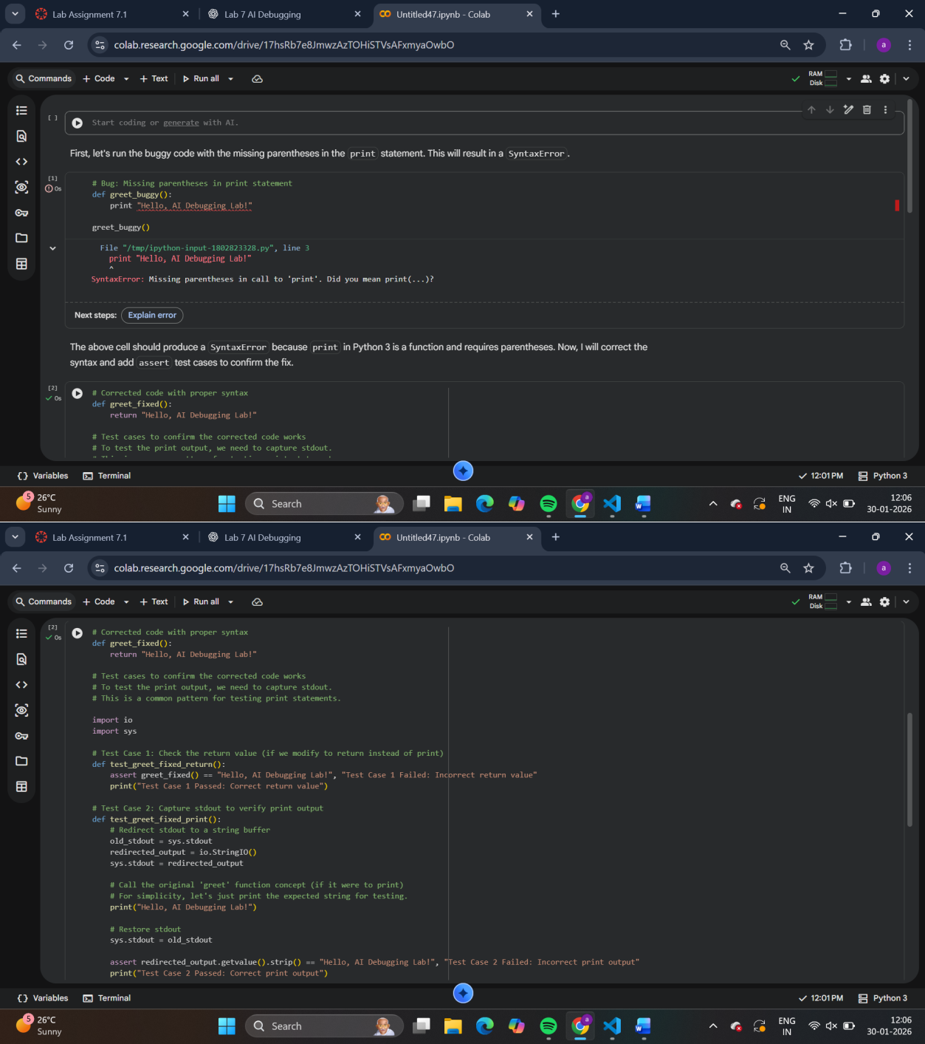

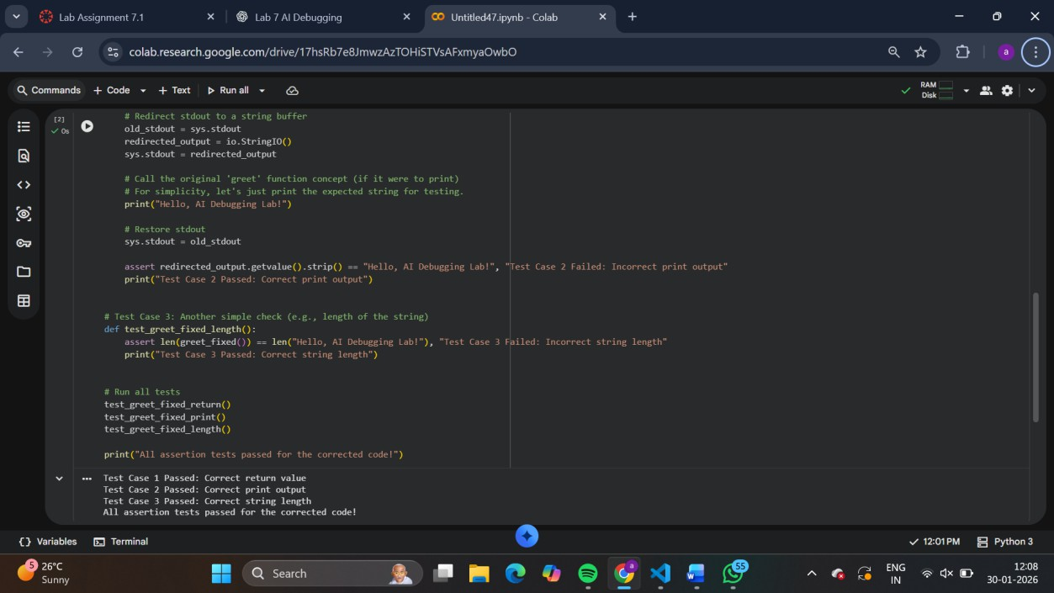
TASK-02: (Syntax Errors – Missing Parentheses in Print Statement)
Task: Provide a Python snippet with a missing parenthesis in a print statement (e.g., print "Hello"). Use AI to detect and fix the syntax error.
# Bug: Missing parentheses in print statement def greet():
print "Hello, AI Debugging Lab!" greet()
Requirements:
- Run the given code to observe the error.
- Apply AI suggestions to correct the syntax.
- Use at least 3 assert test cases to confirm the corrected code works.
Expected Output #1:
- Corrected code with proper syntax and AI explanation.

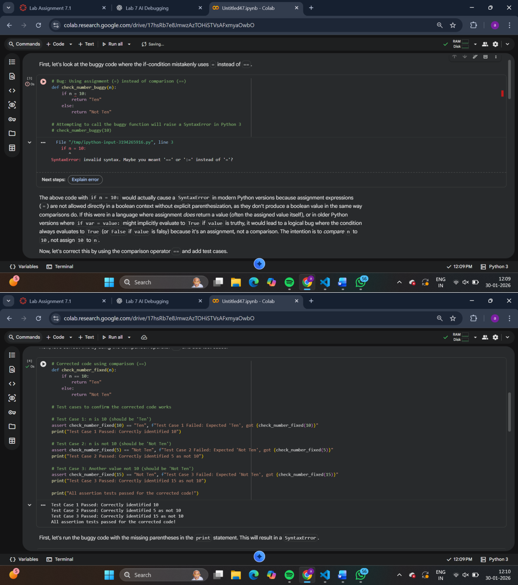
TASK-03:
(Runtime Error – File Not Found)
Task: Provide code that attempts to open a non-existent file and crashes. Use AI to apply safe error handling.
# Bug: Program crashes if file is missing def read_file(filename):
with open(filename, 'r') as f: return f.read()

print(read_file("nonexistent.txt")) Requirements:
- Implement a try-except block suggested by AI.
- Add a user-friendly error message.
- Test with at least 3 scenarios: file exists, file missing, invalid path.
Expected Output #3:
- Safe file handling with exception management.

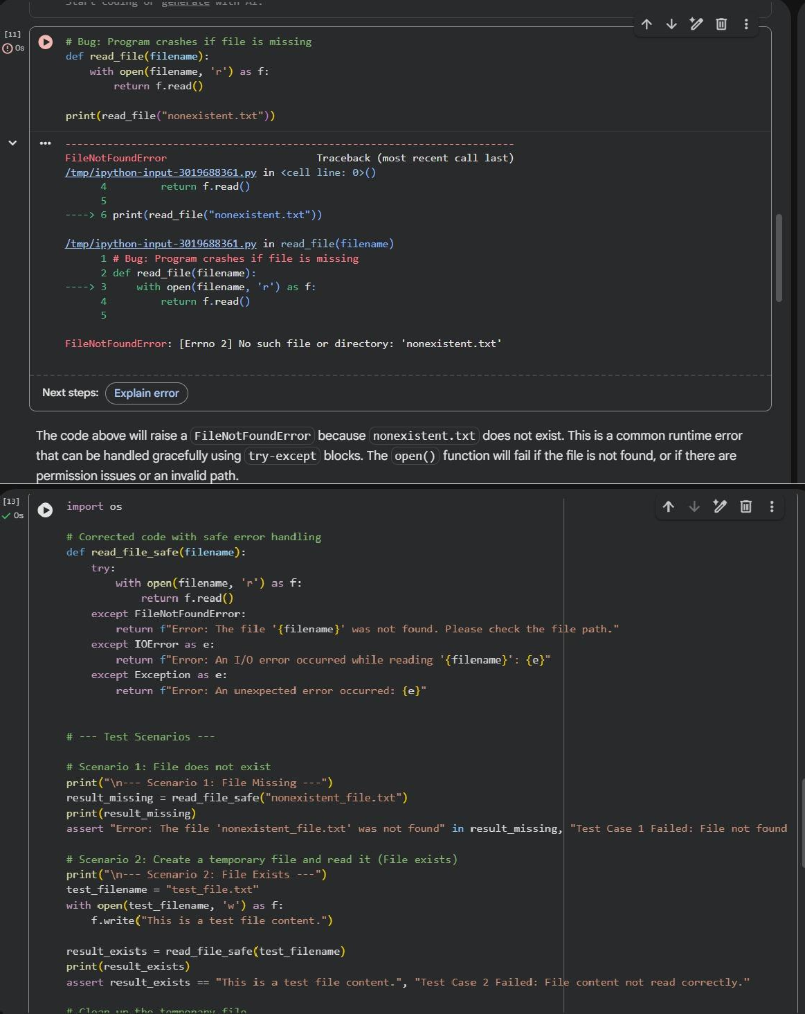

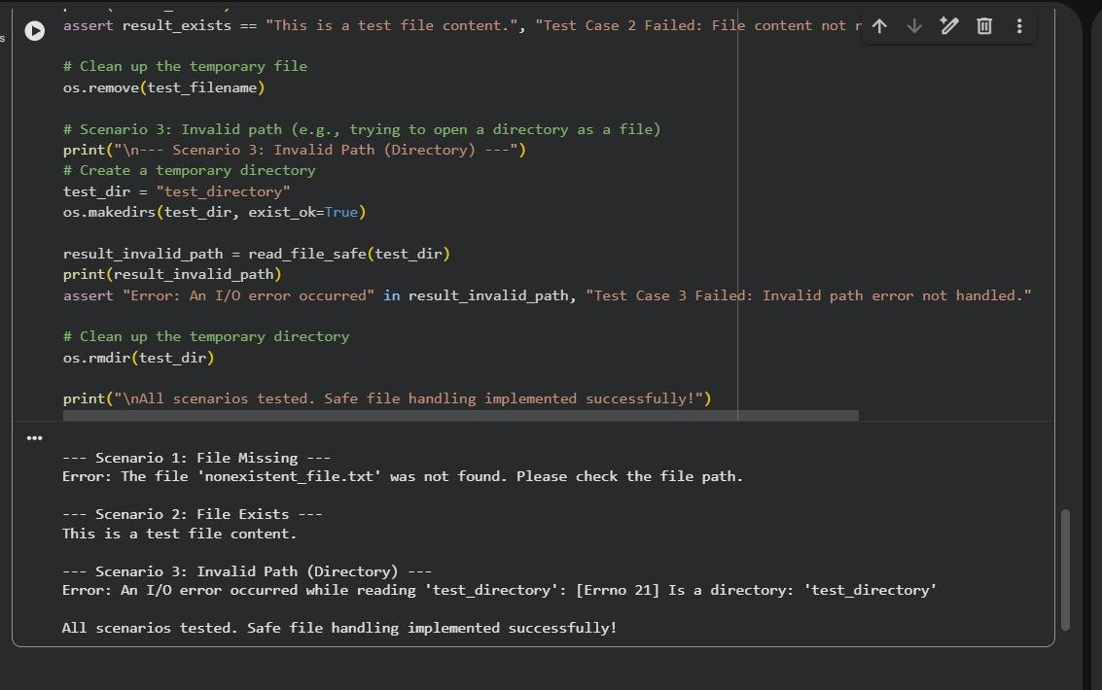
TASK-04: (Calling a Non-Existent Method)
Task: Give a class where a non-existent method is called (e.g., obj.undefined_method()). Use AI to debug and fix.
# Bug: Calling an undefined method class Car:
def start(self):
return "Car started" my_car = Car()
print(my_car.drive()) # drive() is not defined Requirements:
- Students must analyze whether to define the missing method or correct the method call.
- Use 3 assert tests to confirm the corrected class works. Expected Output #4:
- Corrected class with clear AI explanation.

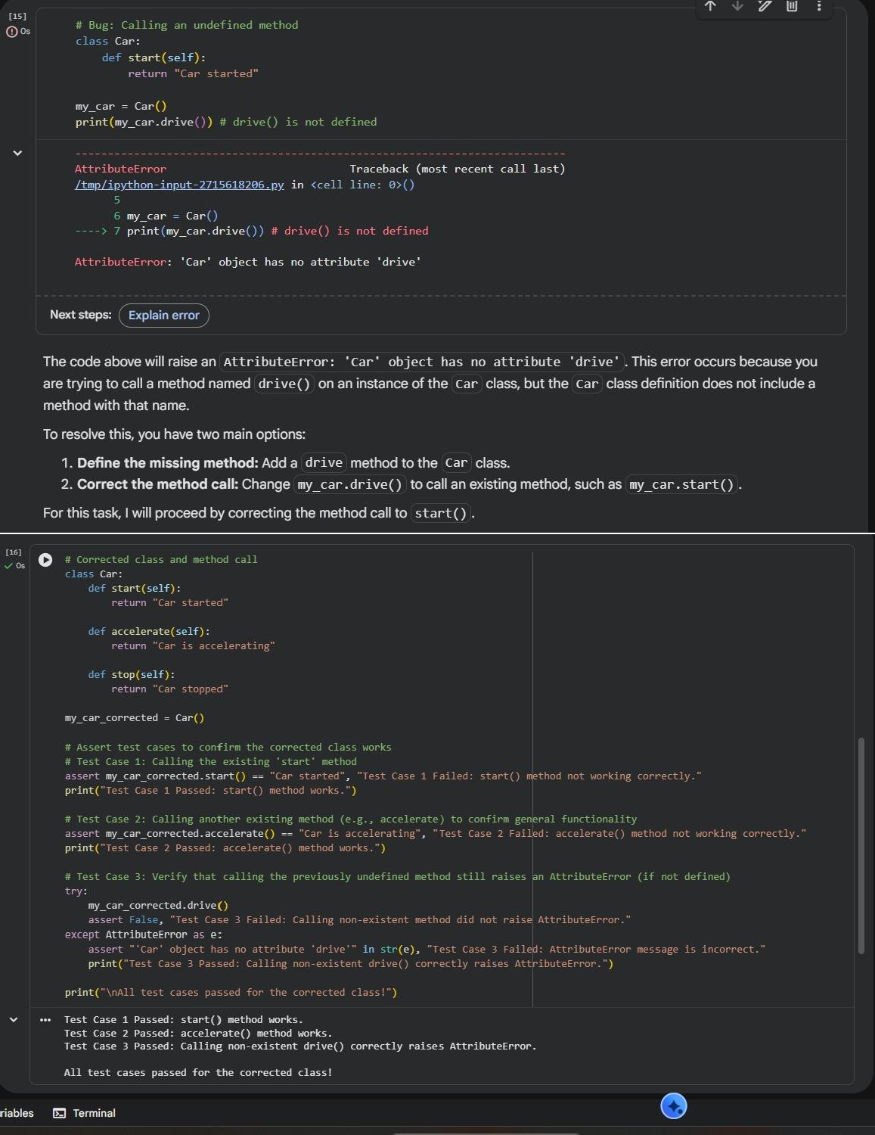
TASK-05: (TypeError – Mixing Strings and Integers in Addition)
Task: Provide code that adds an integer and string ("5" + 2) causing a TypeError. Use AI to resolve the bug.
# Bug: TypeError due to mixing string and integer

def add_five(value):
return value + 5 print(add_five("10")) Requirements:
- Ask AI for two solutions: type casting and string concatenation.
- Validate with 3 assert test cases. Expected Output #5:
- Corrected code that runs successfully for multiple inputs.
Note: Report should be submitted a word document for all tasks in a single document with prompts, comments & code explanation, and output and if required, screenshots

