LAB ASSIGNMNET 1.5
Subject : AI Assistant Coding
Hall Ticket No : 2303A52465
Name : M.Avinash
Batch : 50
Date : 9/1/26
Task 1: AI-Generated Logic Without Modularization (String Reversal Without
Functions)
❖ Task Description
Use GitHub Copilot to generate a Python program that:
➢ Reverses a given string
➢ Accepts user input
➢ Implements the logic directly in the main code
➢ Does not use any user-defined functions
Prompt Given : Write a Python program to reverse a string that Take input from the user, Do not use functions, Write logic directly in main code without using slices or reversed()
CODE:
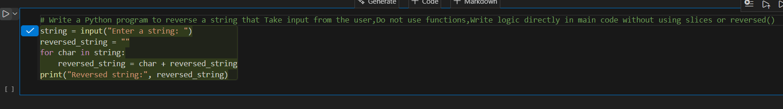
OUTPUT:

Justification: In this task, we reverse a string using only the main program. We use a loop to take each character and place it in front of a new string. This helps us understand how string reversal works step by step. No functions are used, so the logic is easy to follow.

Task 2: Efficiency & Logic Optimization (Readability Improvement)
❖ Task Description
Examine the Copilot-generated code from Task 1 and improve it by:
➢ Removing unnecessary variables
➢ Simplifying loop or indexing logic
➢ Improving readability
➢ Use Copilot prompts like:
▪ “Simplify this string reversal code”
▪ “Improve readability and efficiency”
Prompt : Optimize and Simplified code for the reverse a string, make this code more readable and efficient
Original Code :
Optimized Code :
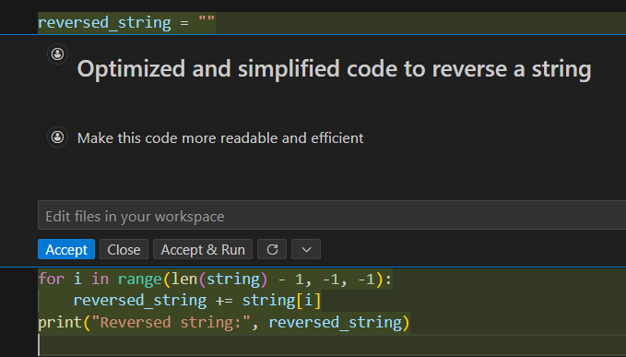
Output:
Justification :
This code reverses a string by starting from the last character and moving towards the first using a loop. Each character is added one by one to a new string in reverse order. This method clearly shows how indexing and loops work. It is easy for us to understand and learn basic string manipulation. Both programs run in O(n) time because each character of the string is processed once.

Task 3: Modular Design Using AI Assistance (String Reversal Using Functions)
❖ Task Description :
Use GitHub Copilot to generate a function-based Python program that:
➢ Uses a user-defined function to reverse a string
➢ Returns the reversed string
➢ Includes meaningful comments (AI-assisted)
Prompt : Create a reusable Python function code for string reversal. Make the code clean and easy to understand

Code :
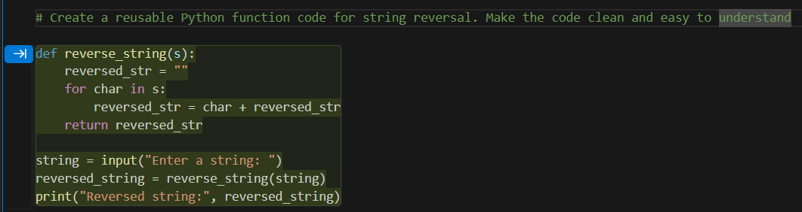

Output :
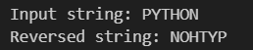

Justification :
This program reverses a string by using a user-defined function. The function takes the input string and returns the reversed string. Separating the logic into a function makes the code clean and reusable. It helps avoid repeating the same code again and again. Overall, this approach makes the program simple, clear, and easy for us to understand.

Task 4: Comparative Analysis – Procedural vs Modular Approach (With vs
Without Functions)
❖ Task Description
Compare the Copilot-generated programs:
➢ Without functions (Task 1)
➢ With functions (Task 3)
Analyze them based on:
➢ Code clarity
➢ Reusability
➢ Debugging ease
➢ Suitability for large-scale applications

Prompt : Give a complete Comparative Analysis for both the approaches used in above two programs for string reversal in Tabular Form
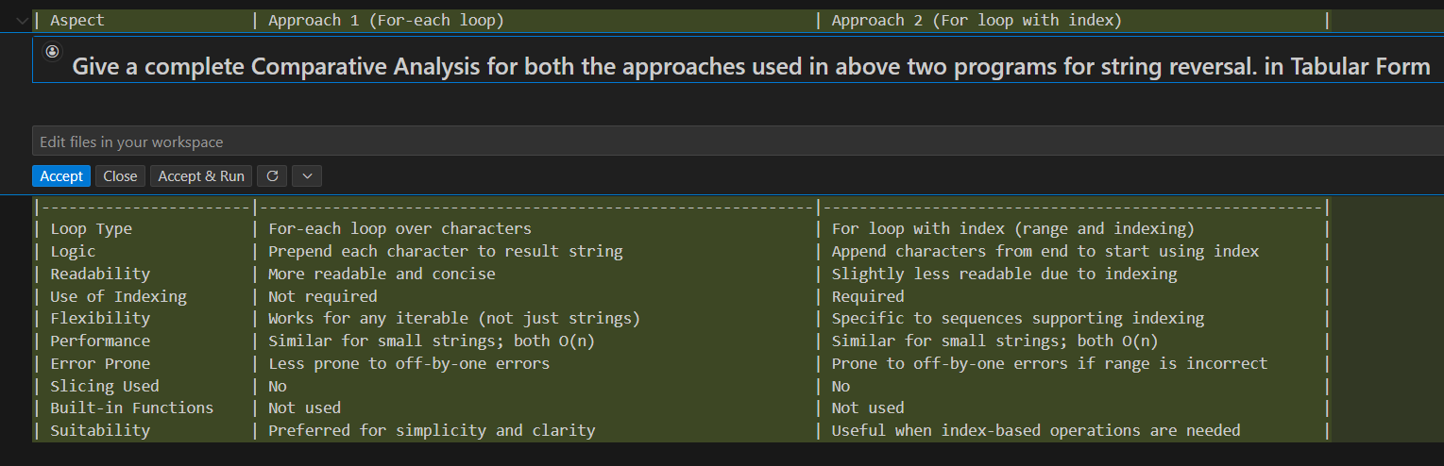
Justification :
The program without functions is simple but all the logic is written in one place. This makes the code harder to reuse and manage when the program becomes large. The function-based program separates the logic, which makes the code clean and well organized. Using functions helps in reusing the same code multiple times. It also makes debugging easier because errors can be found inside the function. Therefore, modular programming is more suitable for large-scale applications.

Task 5: AI-Generated Iterative vs Recursive Fibonacci Approaches (Different
Algorithmic Approaches to String Reversal)
❖ Task Description
Prompt GitHub Copilot to generate:
➢ A loop-based string reversal approach
➢ A built-in / slicing-based string reversal approach
Prompt : Generate different approaches to reverse a string in Python with outputs, Include a loop-based approach and a slicing-based approach and explain the Comparison discussion in tabular form
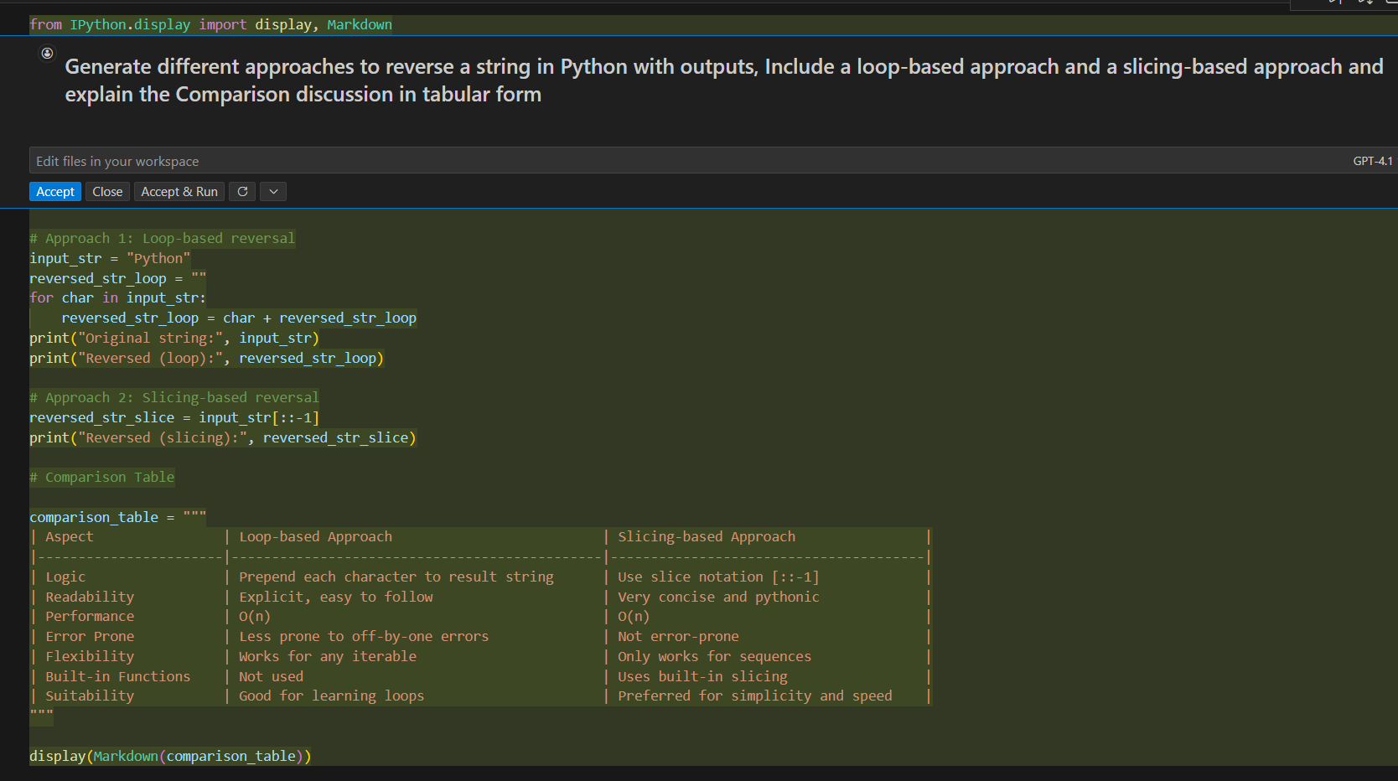
Output : 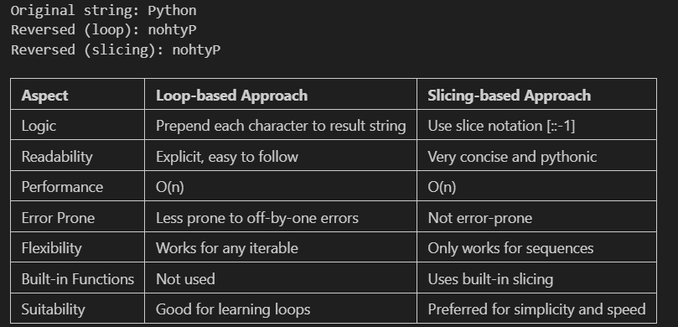
Justification :
This task shows that the same problem can be solved using different logic approaches. The loop-based method helps students understand the step-by-step process of reversing a string. The slicing-based method provides a shorter and faster solution. Both approaches have the same time complexity but differ in readability and performance. This comparison helps uss learn when to use each approach.

