AI Assisted Coding (III Year) Assignment
Name: B. Bhargava Reddy
HT NO: 2303A52476
Batch: 35

Assignment Number: 11.5 / 24

Lab 11 – Data Structures with AI: Implementing Fundamental Structures

Week 6 – Friday

Lab Objectives
- Use AI to assist in designing and implementing fundamental data structures in Python
- Learn prompt-based structure creation, optimization, and documentation
- Improve understanding of Lists, Stacks, Queues, Linked Lists, Graphs, and Hash Tables
- Enhance readability and performance with AI-generated suggestions

Task #1 – Stack Implementation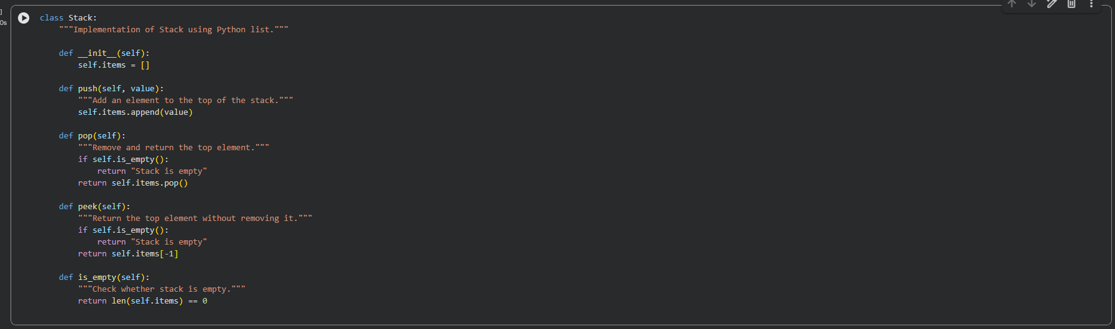

Task #2 – Queue Implementation
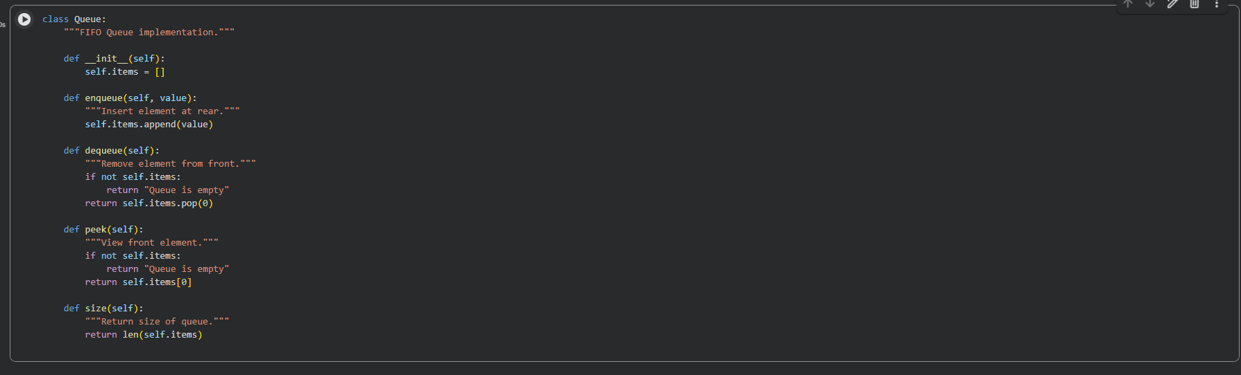

Task #3 – Singly Linked List
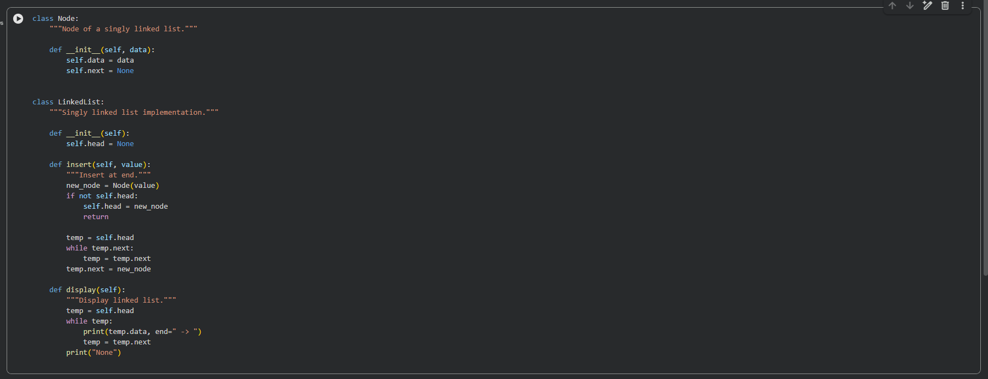
Task #4 – Hash Table
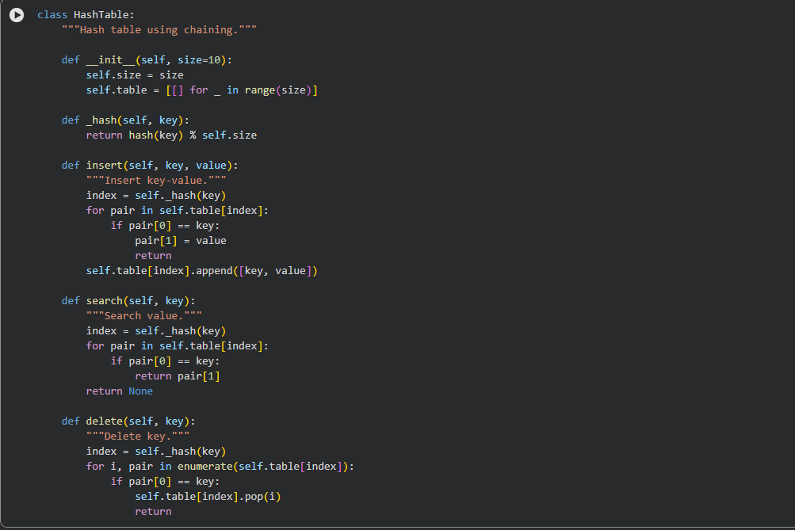
Task #5 – Graph (Adjacency List) 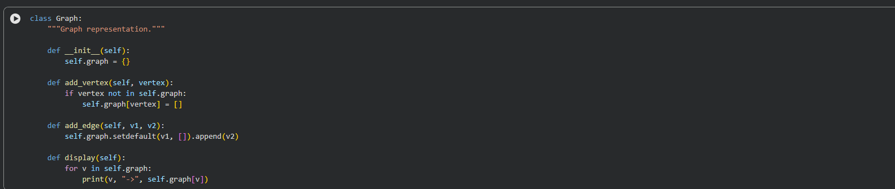
Task #6 – Smart Hospital Management System
Feature Mapping
Feature | Data Structure | Justification
Patient Check-In | Queue | Patients are handled in arrival order which ensures fairness and efficiency.
Emergency Cases | Priority Queue | Critical patients must be treated first. This allows priority-based processing.
Medical Records | Hash Table | Provides fast search and update using patient ID.
Appointment Scheduling | Binary Search Tree | Appointments are sorted by time, making retrieval faster.
Room Navigation | Graph | Hospital structure is a network of connected locations.

Implementation – Emergency Case Handling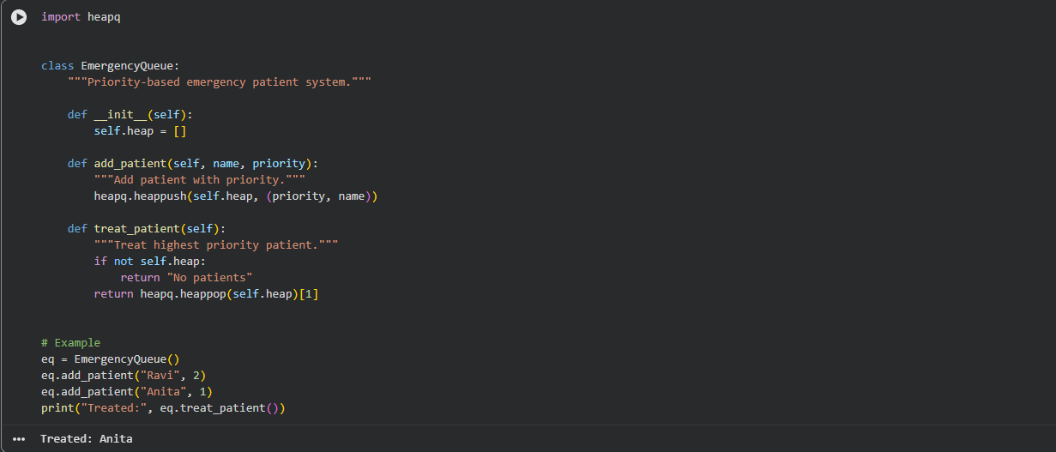
Task #7 – Smart City Traffic Control System
Feature Mapping
Feature | Data Structure | Justification
Traffic Signal | Queue | Vehicles pass in order of arrival.
Emergency Priority | Priority Queue | Ambulances and fire trucks handled first.
Vehicle Lookup | Hash Table | Fast access using registration number.
Road Network | Graph | Roads and intersections form a connected network.
Parking Slots | Deque | Efficient insertion and removal from both ends.

Implementation – Vehicle Lookup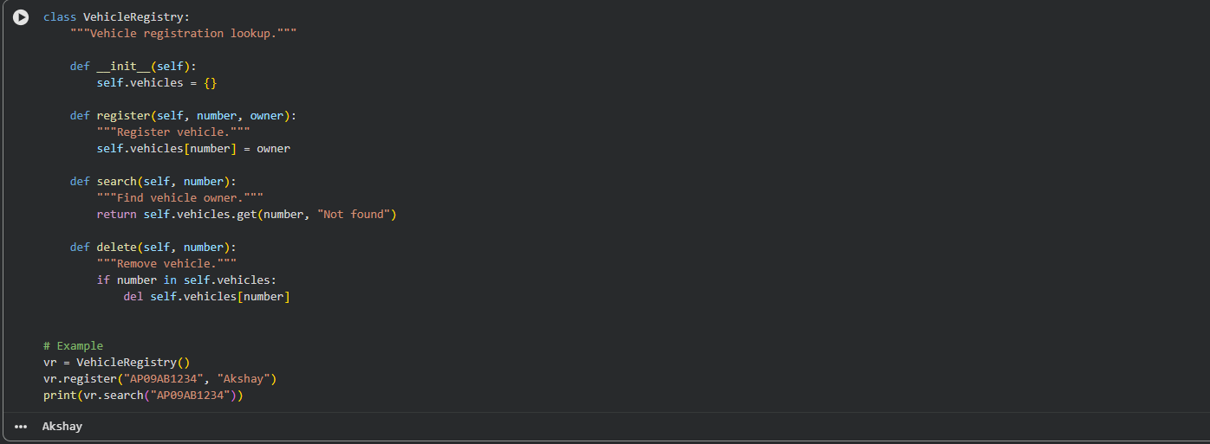
Task #8 – Smart E-Commerce Platform

Feature | Data Structure | Justification
Shopping Cart | Linked List | Dynamic insertion and deletion of products.
Order Processing | Queue | Orders processed sequentially.
Top Products | Priority Queue | Ranking based on sales.
Product Search | Hash Table | Fast lookup by ID.
Delivery Routes | Graph | Efficient route representation.

Implementation – Product Search using Hash Table

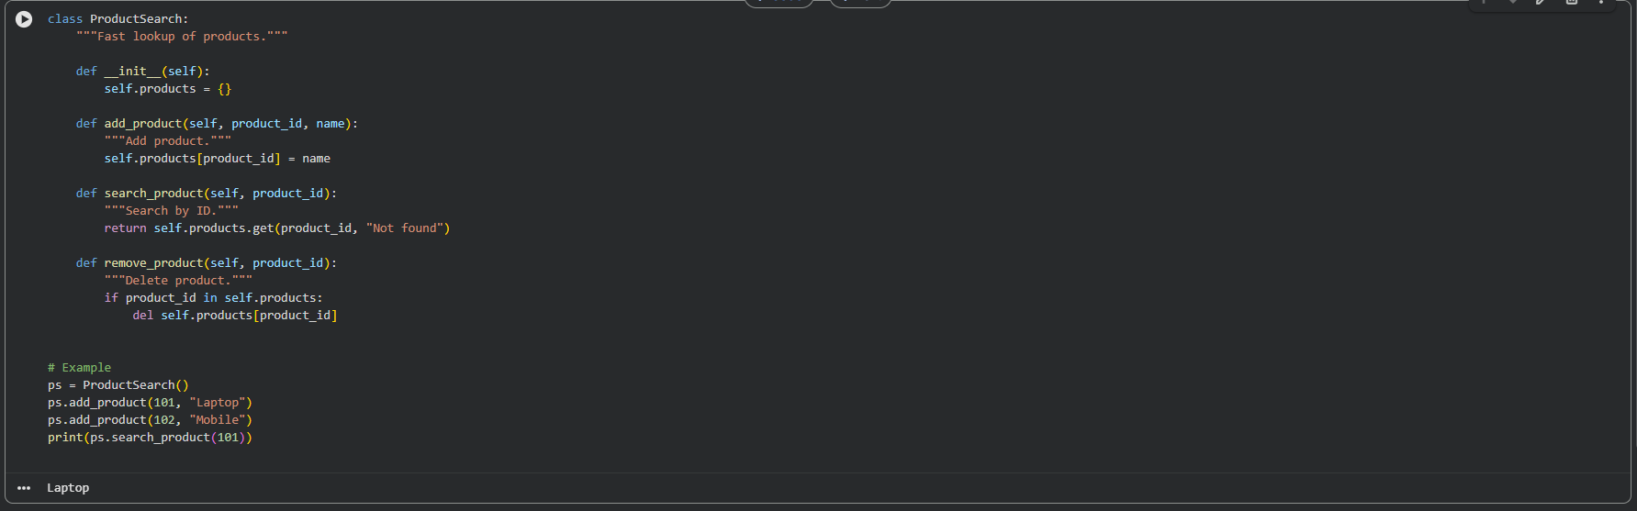
Conclusion
This lab demonstrated how AI-assisted development improves data structure implementation, readability, performance, and real-world system design.

