AI ASSISTED CODING
ASSIGNMENT - 10.3

NAME-S.SAI

H:NO-2303A52492

BATCH-50

TASK-1

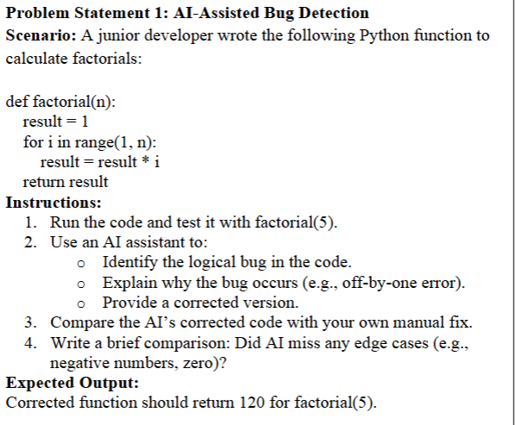

PROMPT:

There is a given code available and there is a logical error in that code fix the bug , explain the why the bug occurs and also
Provide correct code

CODE LOGIC:
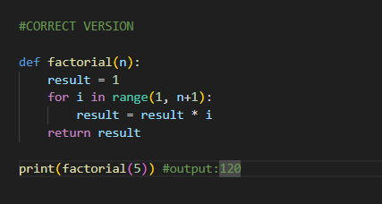

OUTPUT:

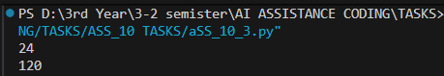

JUSTIFICATION:

- Focuses the model on locating the classic loop boundary/off-by-one error.
- Requires a clear, testable correction and example so output formatting is verified.
- A one-line explanation plus labeled output makes the fix obvious to readers and graders.

TASK-2

QUESTION:

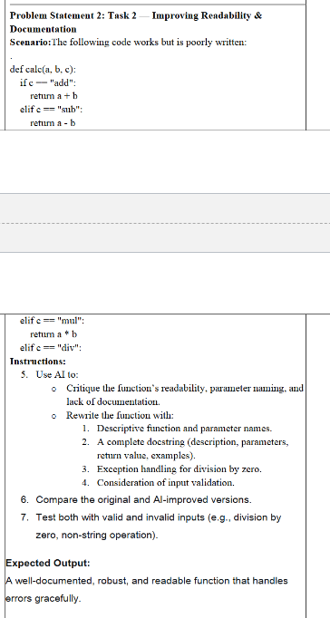

PROMPT:

Given a python code Improving Readability &Documentation Rewrite the function with:
1. Descriptive function and parameter names.
2. A complete docstring (description, parameters,
return value, examples).
3. Exception handling for division by zero.
4. Consideration of input validation.

CODE:

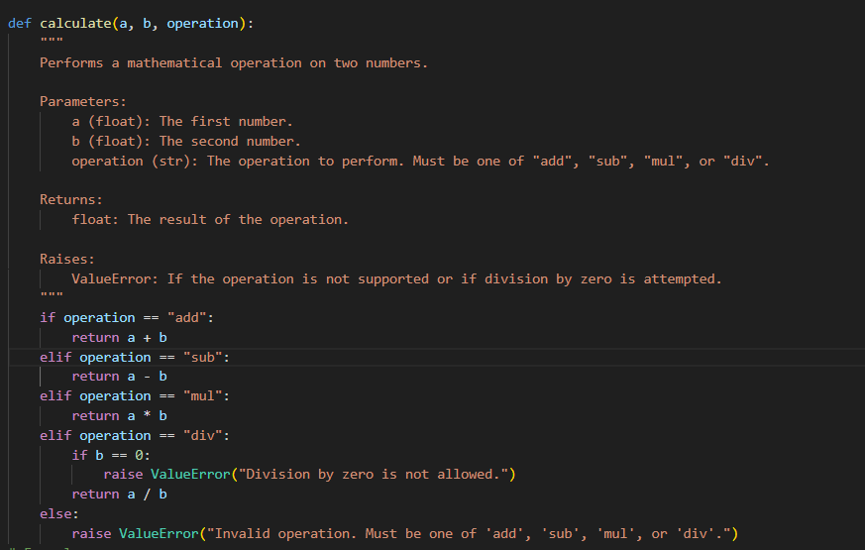

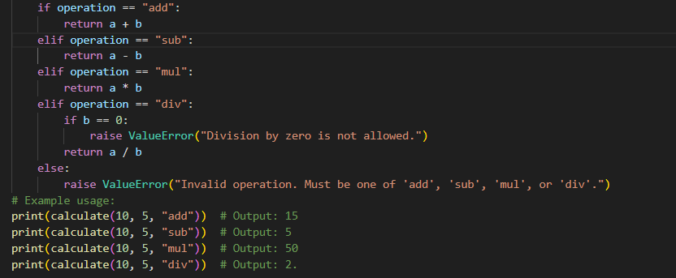

OUTPUT:

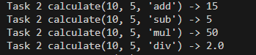

JUSTIFICATION:

- Ensures the model improves naming and documents intent for maintainability.
- Validation and examples verify correctness and show output format expectations.
- Enforcing explicit errors improves safety and clarity in team projects.

TASK 3

QUESTION:

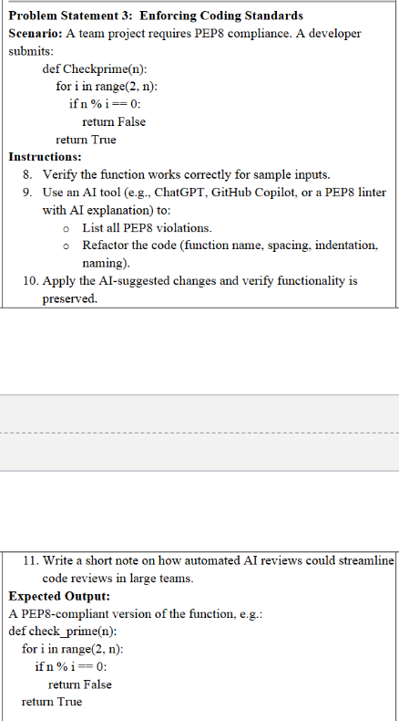

PROMPT:

- List PEP8/style violations in Checkprime and produce a PEP8-compliant check_prime(n) with a docstring and type hints.
- Improve correctness (handle n<=1) and use an efficient loop bound (sqrt); include two labeled example calls and outputs.
- Briefly note the style changes made (naming, spacing, docstring) in one line.

CODE:

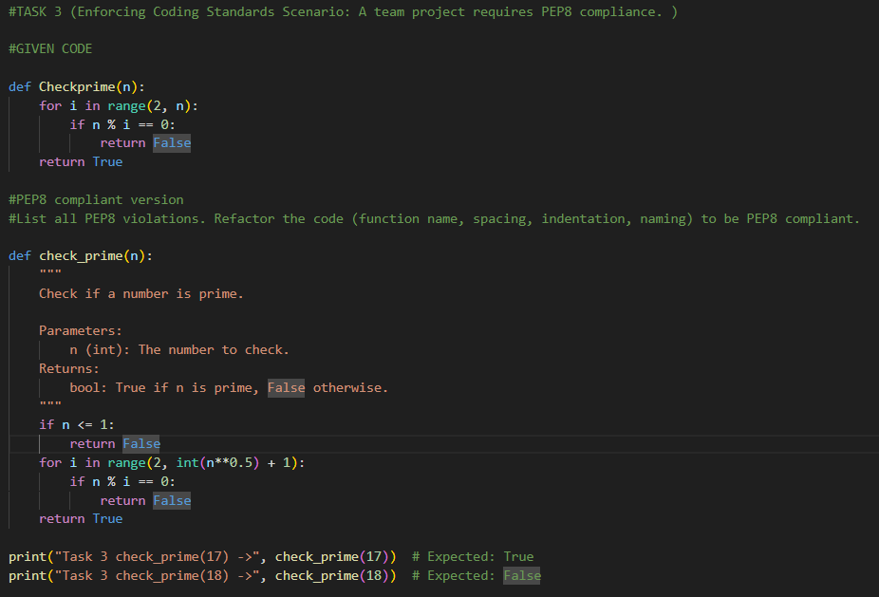
OUTPUT:
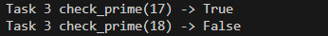

JUSTIFICATION:

- Combines style review and correctness fixes so the function meets team standards.
- Efficiency and boundary handling make the function safer for real use.
- A short summary documents the applied PEP8 changes for reviewers.

TASK 4
QUESTION:

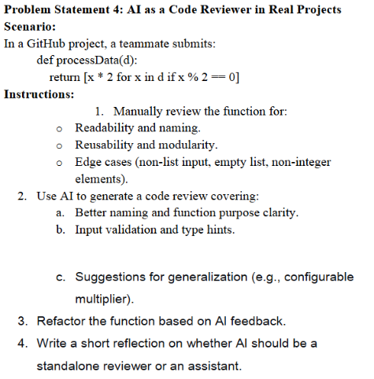

PROMPT:

- Provide a short code review of processData(d) focusing on naming, input validation, and edge cases.
- Refactor into process_data(data, multiplier=2) with type hints, input checks, and a docstring; include a labeled example run.
- Recommend whether to generalize further (e.g., predicates) in one sentence.

CODE:

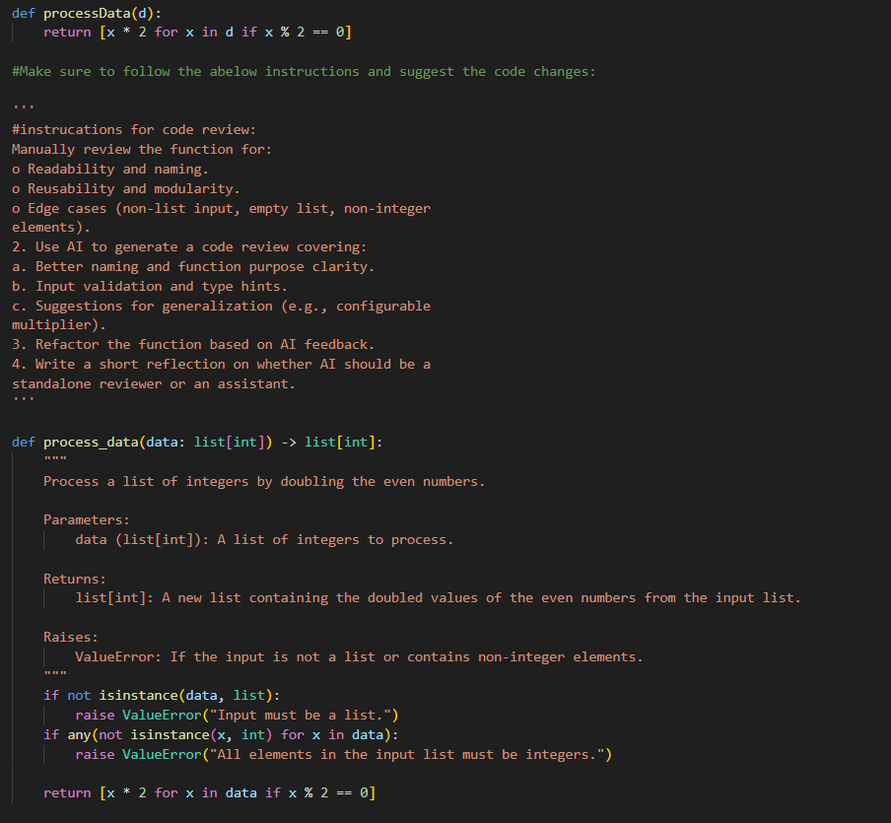
Justification:

- Reviews + refactor ensure immediate improvements and suggest long-term generalization.
- Adding multiplier and validation increases reusability and prevents runtime surprises.
- A labeled example confirms expected output formatting for graders.

OUTPUT:

TASK 5

QUESTION:
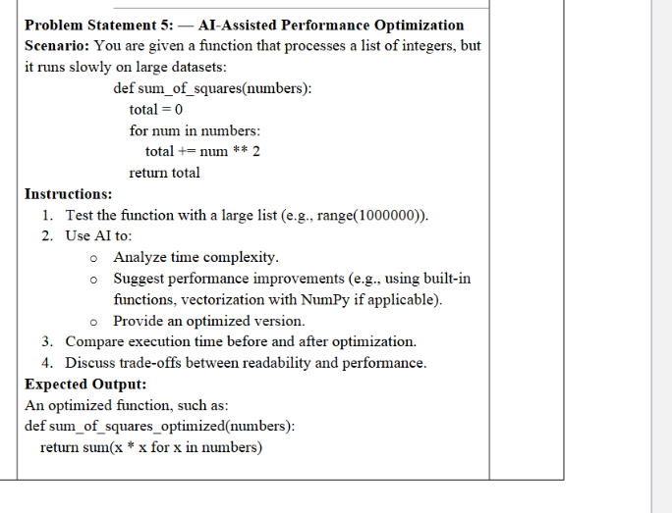

PROMPT:

- Analyze the time complexity of the provided sum_of_squares(numbers) and explain costs for large inputs (e.g., range(1_000_000)).
- Provide two optimized variants: one using Python built-ins (generator with sum) and one using NumPy vectorization, each with short pros/cons.
- Include a tiny benchmark snippet that prints labeled timings for original vs optimized implementations.

CODE:

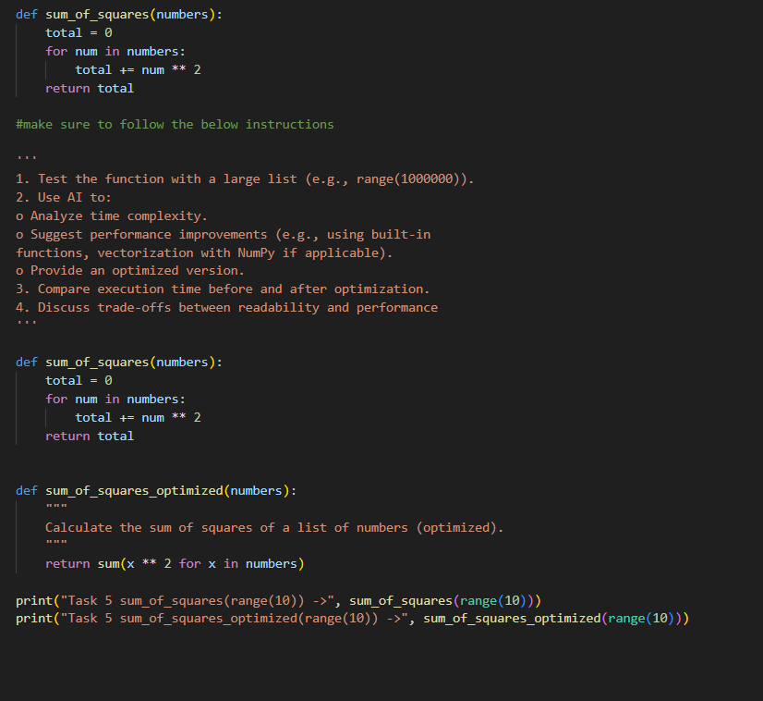

OUTPUT:

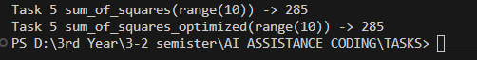

JUSTIFICATION:

- Makes the model justify trade-offs and quantify performance improvements.
- Offering both pure-Python and NumPy options addresses portability vs raw speed trade-offs.

