SCHOOL OF COMPUTER SCIENCE AND ARTIFICIAL  INTELLIGENCE  2303A53011(B-46) |  |  |  |  | DEPARTMENT OF COMPUTER SCIENCE ENGINEERING
Program Name: B. Tech |  |  |  | Assignment Type: Lab |  |  | Academic Year:2025-2026
Course Coordinator Name |  |  |  | Dr. Rishabh Mittal
Instructor(s) Name
  Mr. S Naresh Kumar
  Ms. B. Swathi
  Dr. Sasanko Shekhar Gantayat
  Mr. Md Sallauddin
  Dr. Mathivanan
  Mr. Y Srikanth
  Ms. N Shilpa
  Dr. Rishabh Mittal (Coordinator)
  Dr. R. Prashant Kumar
  Mr. Ankushavali MD
  Mr. B Viswanath
  Ms. Sujitha Reddy
  Ms. A. Anitha
  Ms. M.Madhuri
  Ms. Katherashala Swetha
  Ms. Velpula sumalatha
  Mr. Bingi Raju
Course Code |  |  | 23CS002PC304 | Course Title |  | AI Assisted Coding
Year/Sem |  |  | III/I | Regulation |  | R23
Date and Day  of Assignment |  |  | Week 2 - Wednesday | Time(s) |  | 23CSBTB01 To 23CSBTB52
Duration |  |  | 2 Hours | Applicableto  Batches |  | All batches
Assignment Number: 3.3(Present assignment number)/24(Total number of assignments)
 | Q.No. | Question |  |  |  |  |  | Expected Time  to complete
 | 1 | Lab 4: Advanced Prompt Engineering – Zero-shot, One-shot, and Few-shot Techniques  Lab Objectives  - To explore and apply different levels of prompt examples in AI-assisted code generation  - To understand how zero-shot, one-shot, and few-shot prompting affect AI output quality  - To evaluate the impact of context richness and example quantity on AI performance  - To build awareness of prompt strategy effectiveness for different problem types  Lab Outcomes (LOs)  After completing this lab, students will be able to:  - Use zero-shot prompting to instruct AI with minimal context  - Use one-shot prompting with a single example to guide AI code generation  - Apply few-shot prompting using multiple examples to improve AI responses  - Compare AI outputs across different prompting strategies  Task 1: Zero-Shot Prompting – Leap Year Check  Scenario  Zero-shot prompting involves giving instructions without providing examples.  Task Description  Use zero-shot prompting to instruct an AI tool to generate a Python function that:  - Accepts a year as input  - Checks whether the given year is a leap year  - Returns an appropriate result  Note: No input-output examples should be provided in the prompt.  Expected Output  - AI-generated leap year checking function  - Correct logical conditions  - Sample input and output  - Screenshot of AI-generated response (if required)  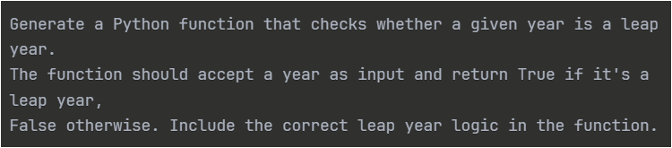  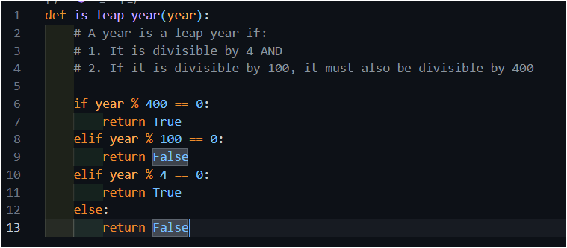  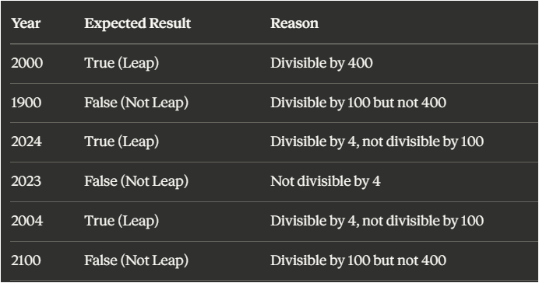  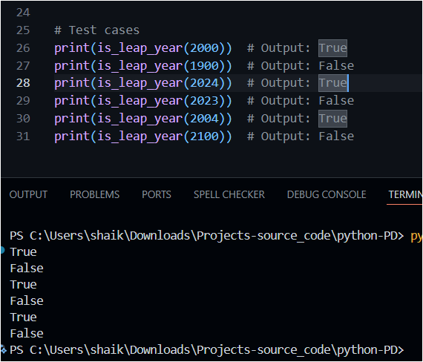  Task 2: One-Shot Prompting – Centimeters to Inches Conversion  Scenario  One-shot prompting guides AI using a single example.  Task Description  Use one-shot prompting by providing one input-output example to generate a Python function that:  - Converts centimeters to inches  - Uses the correct mathematical formula  Example provided in prompt:  Input: 10 cm → Output: 3.94 inches  Expected Output  - Python function with correct conversion logic  - Accurate calculation  - Sample test cases and outputs  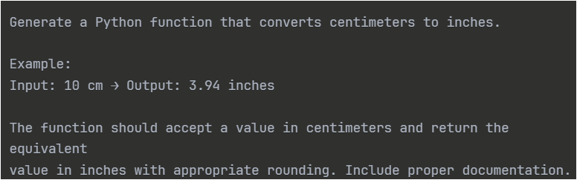  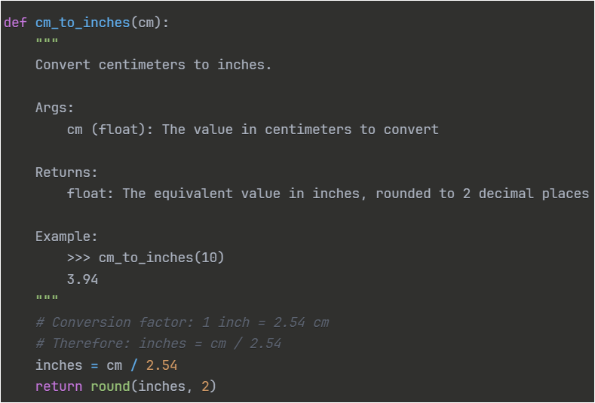  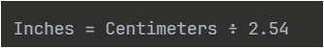  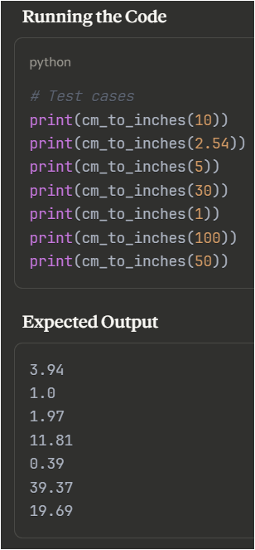  Task 3: Few-Shot Prompting – Name Formatting  Scenario  Few-shot prompting improves accuracy by providing multiple examples.  Task Description  Use few-shot prompting with 2–3 examples to generate a Python function that:  - Accepts a full name as input  - Formats it as “Last, First”  Example formats:  - "John Smith" → "Smith, John"  - "Anita Rao" → "Rao, Anita"  Expected Output  - Well-structured Python function  - Output strictly following example patterns  - Correct handling of names  - Sample inputs and outputs  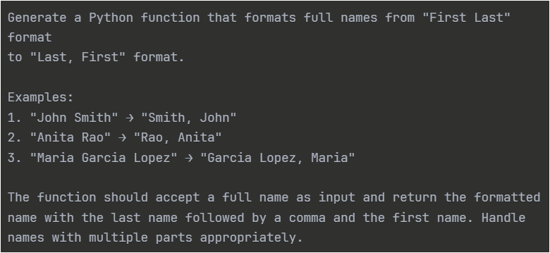  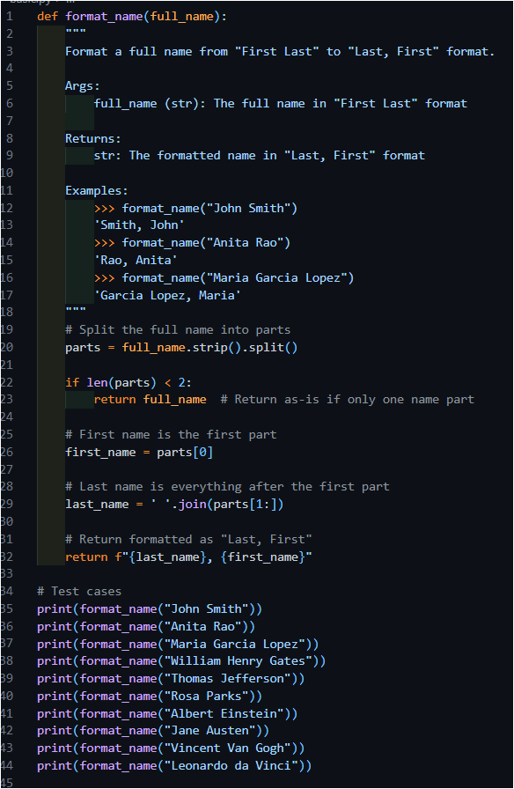  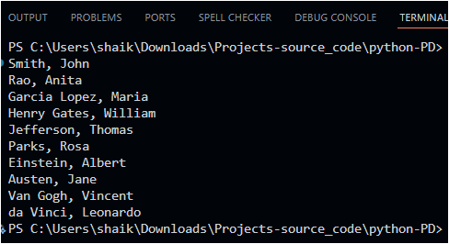  Task 4: Comparative Analysis – Zero-Shot vs Few-Shot  Scenario  Different prompt strategies may produce different code quality.  Task Description  - Use zero-shot prompting to generate a function that counts vowels in a string  - Use few-shot prompting for the same problem  - Compare both outputs based on:  - Accuracy  - Readability  - Logical clarity  Expected Output  - Two vowel-counting functions  - Comparison table or short reflection paragraph  - Conclusion on prompt effectiveness  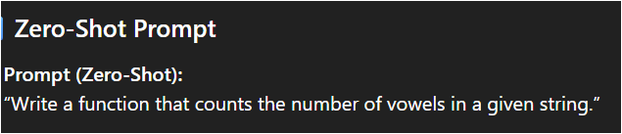  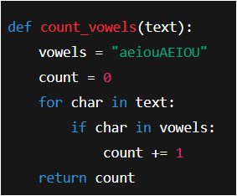  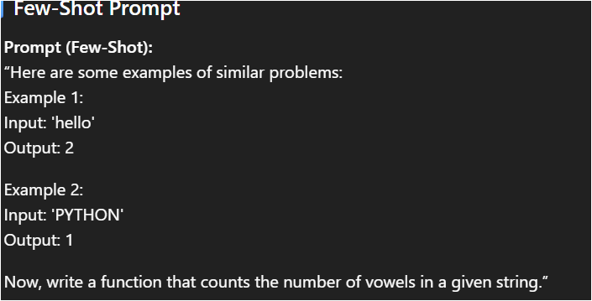  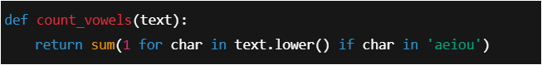  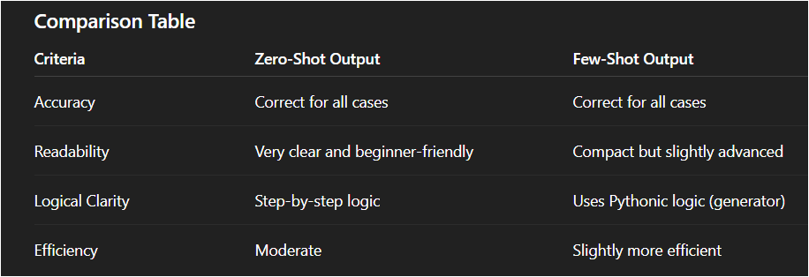  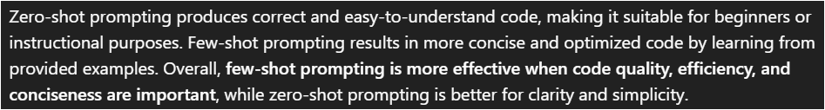  Task 5: Few-Shot Prompting – File Handling  Scenario  File processing requires clear logical understanding.  Task Description  Use few-shot prompting to generate a Python function that:  - Reads a .txt file  - Counts the number of lines in the file  - Returns the line count  Expected Output  - Working Python file-processing function  - Correct line count  - Sample .txt input and output  - AI-assisted logic explanation  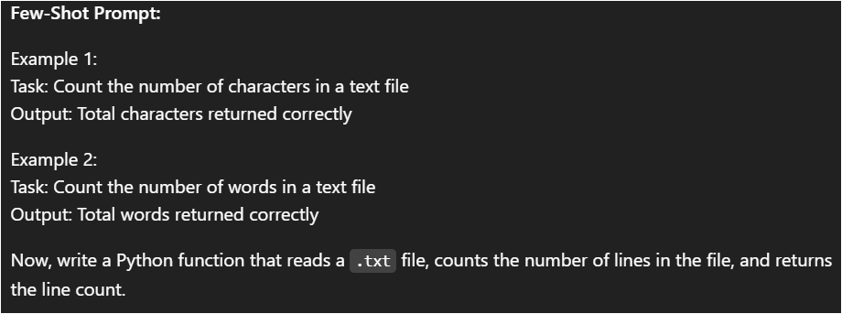  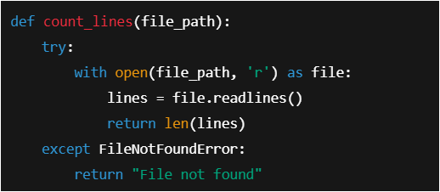  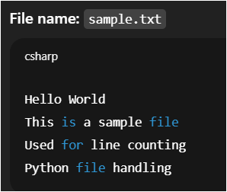  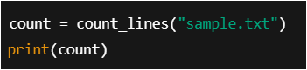  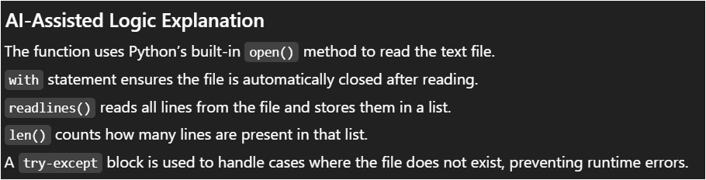 |  |  |  |  |  | Week2 - Wednesday

