ASSIGNMENT – 11.1
NAME:MAMIDALA ANIRUDH KUMAR
Roll.no:2303A53033
BATCH:46
Lab 11 – Data Structures with AI: Implementing Fundamental Structures

Lab Objectives
- Use AI to assist in designing and implementing fundamental data structures in Python.
- Learn how to prompt AI for structure creation, optimization, and documentation.
- Improve understanding of Lists, Stacks, Queues, Linked Lists, Trees, Graphs, and Hash Tables.
- Enhance code quality with AI-generated comments and performance suggestions.

Task Description #1 – Stack Implementation
Task: Use AI to generate a Stack class with push, pop, peek, and is_empty methods. Sample Input Code: class Stack:
pass
Expected Output:
- A functional stack implementation with all required methods and docstrings.

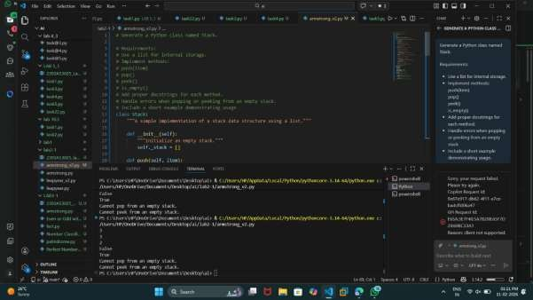
Task Description #2 – Queue Implementation Task: Use AI to implement a Queue using Python lists.
Sample Input Code: class Queue:
pass
Expected Output:
- FIFO-based queue class with enqueue, dequeue, peek, and size
Methods
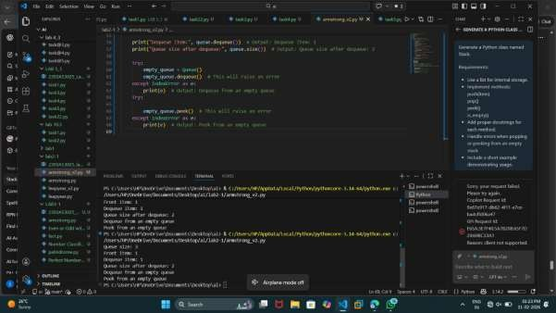
Task Description #3 – Linked List
Task: Use AI to generate a Singly Linked List with insert and display methods.
Sample Input Code: class Node:
pass class LinkedList:
pass
Expected Output:
- A working linked list implementation with clear method documentation.
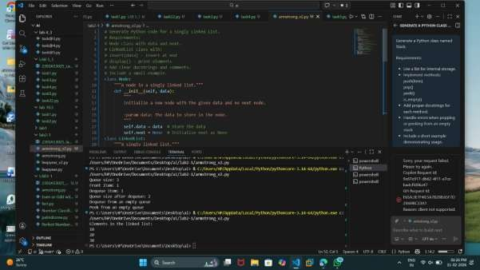

Task Description #4 – Binary Search Tree (BST)
Task: Use AI to create a BST with insert and in-order traversal methods.
Sample Input Code: class BST:
pass
Expected Output:
• BST implementation with recursive insert and traversal method
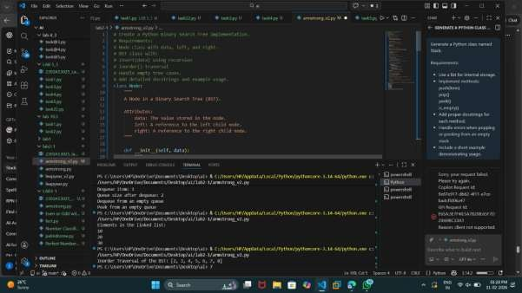

Task Description #5 – Hash Table
Task: Use AI to implement a hash table with basic insert, search, and delete methods. Sample Input Code: class HashTable:
pass
Expected Output:
• Collision handling using chaining, with well-commented methods.
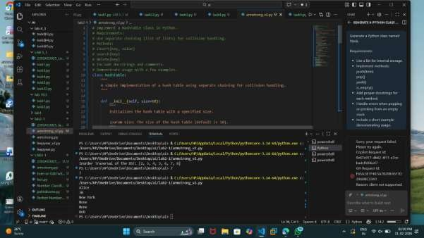

Task Description #6 – Graph Representation
Task: Use AI to implement a graph using an adjacency list.
Sample Input Code: class Graph:
pass
Expected Output:
• Graph with methods to add vertices, add edges, and display connections.
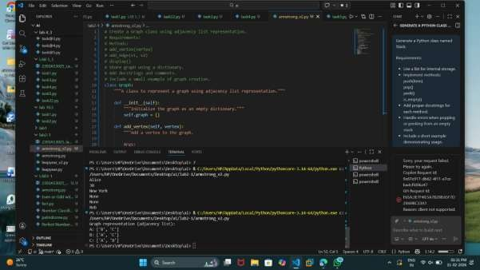

Task Description #7 – Priority Queue
Task: Use AI to implement a priority queue using Python’s heapq module.
Sample Input Code: class PriorityQueue:
pass
Expected Output:
• Implementation with enqueue (priority), dequeue (highest priority), and display methods.
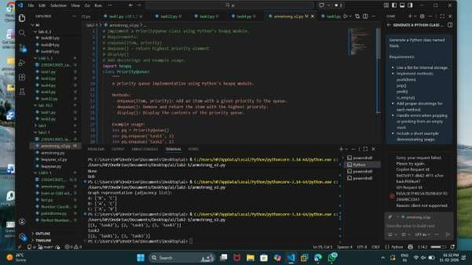

Task Description #8 – Deque
Task: Use AI to implement a double-ended queue using collections.deque. Sample Input Code: class DequeDS:
pass
Expected Output:
• Insert and remove from both ends with docstrings.
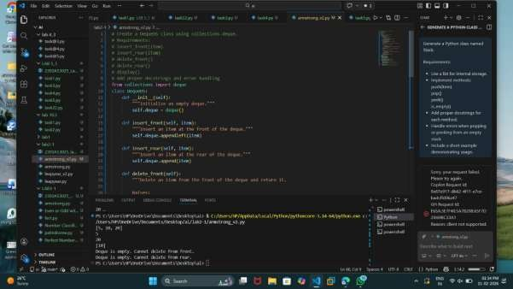

Task Description #9 Real-Time Application Challenge – Choose the
Right Data Structure Scenario:
Your college wants to develop a Campus Resource Management System that handles:
- Student Attendance Tracking – Daily log of students entering/exiting the campus.
- Event Registration System – Manage participants in events with quick search and removal.
- Library Book Borrowing – Keep track of available books and their due dates.
- Bus Scheduling System – Maintain bus routes and stop connections.
- Cafeteria Order Queue – Serve students in the order they arrive.
Student Task:
• For each feature, select the most appropriate data structure from the list below:
o Stack o Queue o Priority Queue o Linked List o Binary Search Tree (BST) o Graph o Hash Table o Deque
- Justify your choice in 2–3 sentences per feature.
- Implement one selected feature as a working Python program with AI-assisted code generation.
Expected Output:
- A table mapping feature → chosen data structure → justification. • A functional Python program implementing the chosen feature with comments and docstrings.
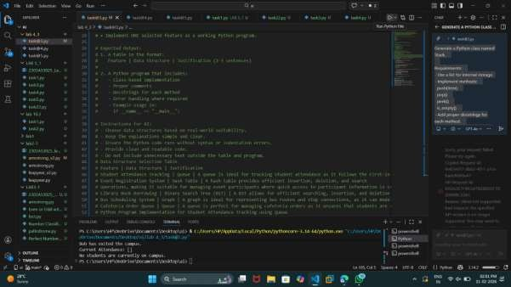

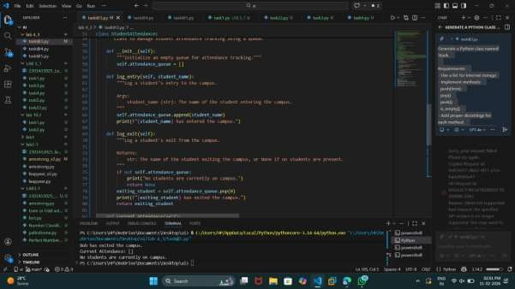

Task Description #10: Smart E-Commerce Platform – Data Structure Challenge
An e-commerce company wants to build a Smart Online Shopping System with:
- Shopping Cart Management – Add and remove products dynamically.
- Order Processing System – Orders processed in the order they are placed.
- Top-Selling Products Tracker – Products ranked by sales count.
- Product Search Engine – Fast lookup of products using product ID. 5. Delivery Route Planning – Connect warehouses and delivery locations. Student Task:
• For each feature, select the most appropriate data structure from the list below:
o Stack o Queue o Priority Queue o Linked List o Binary Search Tree (BST) o Graph o Hash Table o Deque
- Justify your choice in 2–3 sentences per feature.
- Implement one selected feature as a working Python program with AI-assisted code generation.
Expected Output:
- A table mapping feature → chosen data structure → justification.
- A functional Python program implementing the chosen feature
with comments and docstrings.

