SCHOOL OF COMPUTER SCIENCE AND ARTIFICIAL INTELLIGENCE |  |  |  |  | DEPARTMENT OF COMPUTER SCIENCE ENGINEERING
Program Name: B. Tech |  |  |  | Assignment Type: Lab |  |  | Program Name: B. Tech
Course Code |  |  | 23CS002PC304 | Course Code |  | 23CS002PC304
Year/Sem |  |  | III/II | Year/Sem |  | III/II
Date and Day  of Assignment |  |  | Week5 – Wednesday | Date and Day  of Assignment |  | Week5 – Wednesday
Name |  |  | Mohammed Muqtadir Ali | Hall Ticket  No |  | 2303A54051
AssignmentNumber:10.3
 | Q.No. | Question
 | 1 | Lab 9 – Code Review and Quality: Using AI to improve code quality and readability  Lab Objectives:  • To apply AI-based prompt engineering for code review and quality improvement.  • To analyze code for readability, logic, performance, and maintainability issues.  • To use Zero-shot, One-shot, and Few-shot prompting for improving code quality.  • To evaluate AI-generated improvements using standard coding practices.  Lab Outcomes (LOs): After completing this lab, students will be able to:  • Review and improve code quality using AI tools.  • Identify syntax, logic, and performance issues in code.  • Refactor code to improve readability and maintainability.  • Compare AI outputs generated using different prompting techniques.  Problem Statement 1: AI-Assisted Bug Detection  Scenario: A junior developer wrote the following Python function to calculate factorials:  def factorial(n):  result = 1  for i in range(1, n):  result = result * i  return result  Instructions:  - Run the code and test it with factorial(5).  - Use an AI assistant to:  - Identify the logical bug in the code.  - Explain why the bug occurs (e.g., off-by-one error).  - Provide a corrected version.  - Compare the AI’s corrected code with your own manual fix.  - Write a brief comparison: Did AI miss any edge cases (e.g., negative numbers, zero)?  Expected Output:  Corrected function should return 120 for factorial(5).  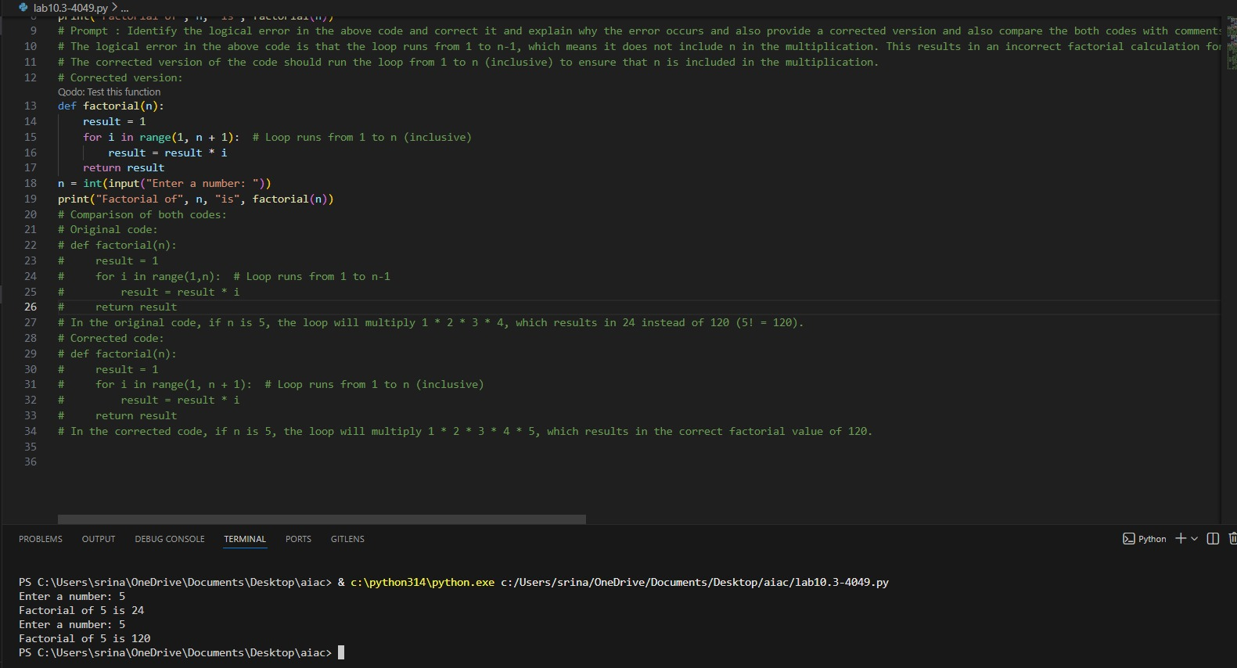  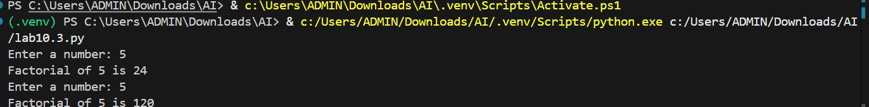  - The manual code is missing the base case for when n is 0 or 1, which should return 1.  - Additionally, the loop in the manual code should iterate up to n (inclusive) instead of n-1 to correctly calculate the factorial.  - The AI-assisted code includes the base case and uses recursion to calculate the factorial, which is more efficient and easier to read.  Problem Statement 2: Task 2 — Improving Readability & Documentation  Scenario:The following code works but is poorly written:  def calc(a, b, c):  if c == "add":  return a + b  elif c == "sub":  return a - b  elif c == "mul":  return a * b  elif c == "div":  Instructions:  - Use AI to:  - Critique the function’s readability, parameter naming, and lack of documentation.  - Rewrite the function with:  - Descriptive function and parameter names.  - A complete docstring (description, parameters, return value, examples).  - Exception handling for division by zero.  - Consideration of input validation.  - Compare the original and AI-improved versions.  - Test both with valid and invalid inputs (e.g., division by zero, non-string operation).  Expected Output:  A well-documented, robust, and readable function that handles errors gracefully.  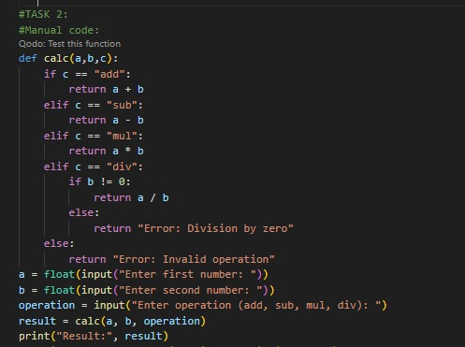  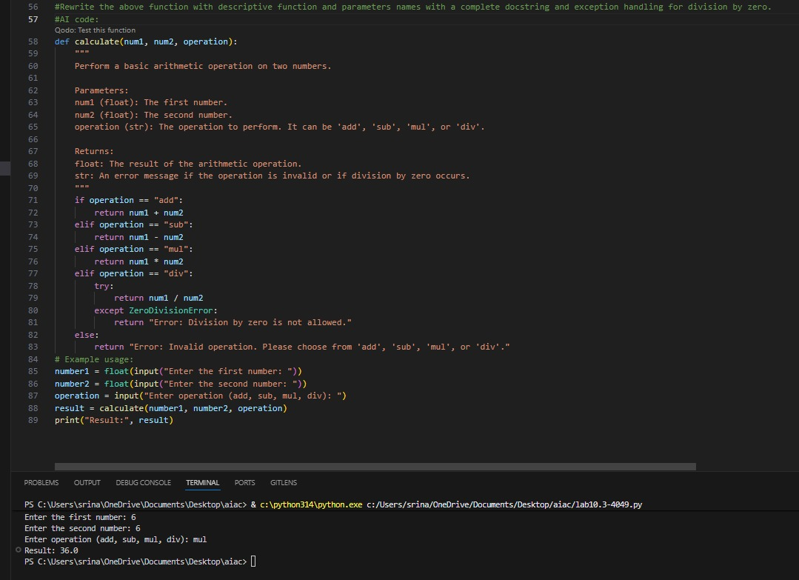  - The AI-assisted code is more readable and well-documented compared to the manual code.  - It includes a docstring that explains the purpose of the function, its parameters, and its return value.  - Additionally, the variable names in the AI-assisted code are more descriptive, making it easier to understand the functionality of the code at a glance.  - The AI-assisted code also includes error handling for invalid operations and division by zero, which enhances its robustness.  Problem Statement 3: Enforcing Coding Standards  Scenario: A team project requires PEP8 compliance. A developer submits:  def Checkprime(n):  for i in range(2, n):  if n % i == 0:  return False  return True  Instructions:  - Verify the function works correctly for sample inputs.  - Use an AI tool (e.g., ChatGPT, GitHub Copilot, or a PEP8 linter with AI explanation) to:  - List all PEP8 violations.  - Refactor the code (function name, spacing, indentation, naming).  - Apply the AI-suggested changes and verify functionality is preserved.  - Write a short note on how automated AI reviews could streamline code reviews in large teams.  Expected Output:  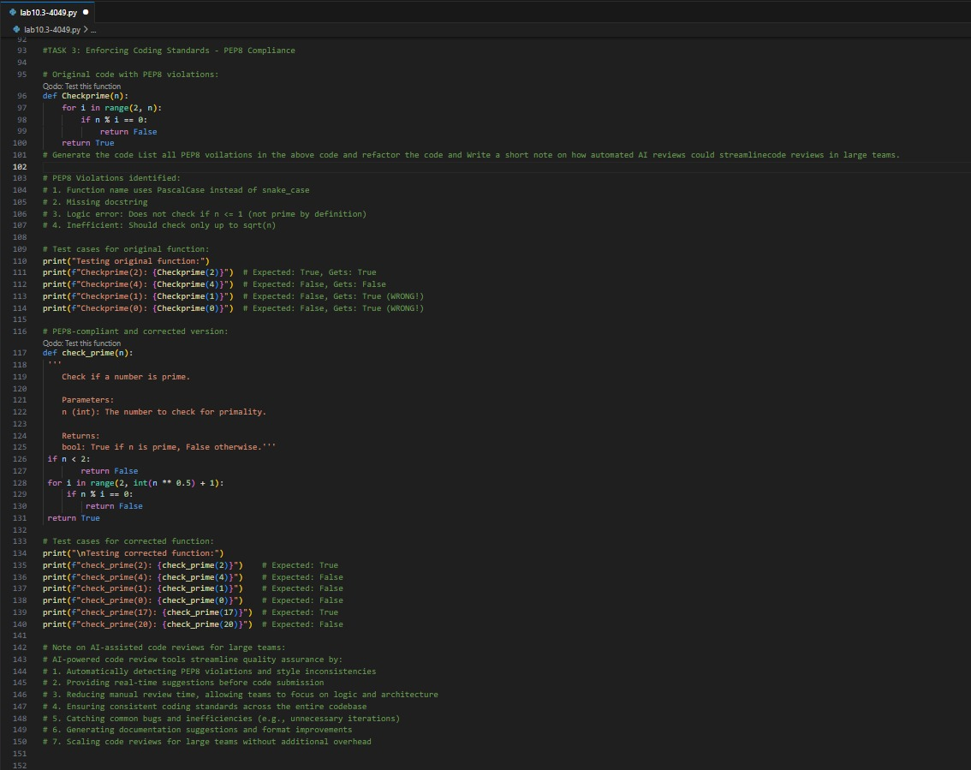  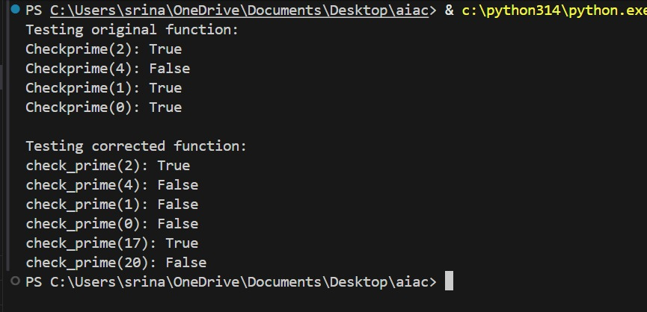  - The AI-assisted code has improved readability due to the use of descriptive variable names and a clear function name.  - It also includes a docstring that explains the purpose of the function, its parameters, and its return value, which enhances documentation.  - Additionally, the AI-assisted code adheres to coding standards by following a consistent naming convention (snake_case) and including error handling for edge cases (e.g., numbers less than or equal to 1). In contrast, the manual code lacks documentation and uses less descriptive variable names, making it less readable and harder to understand.  Problem Statement 4: AI as a Code Reviewer in Real Projects  Scenario:  In a GitHub project, a teammate submits:  def processData(d):  return [x * 2 for x in d if x % 2 == 0]  Instructions:  - Manually review the function for:  - Readability and naming.  - Reusability and modularity.  - Edge cases (non-list input, empty list, non-integer elements).  - Use AI to generate a code review covering:  - Better naming and function purpose clarity.  - Input validation and type hints.  - Suggestions for generalization (e.g., configurable multiplier).  - Refactor the function based on AI feedback.  - Write a short reflection on whether AI should be a standalone reviewer or an assistant.  Expected Output:  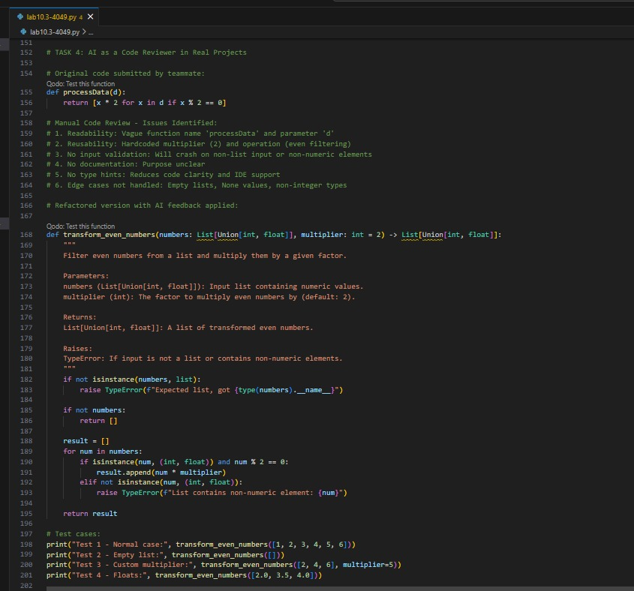  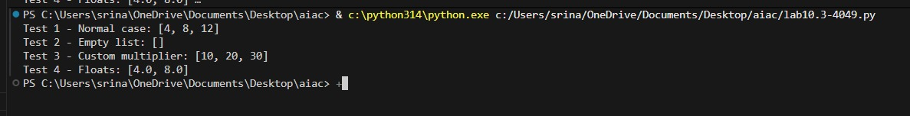  - The original code for the processData function was not following PEP8 style guidelines, and the function name was not descriptive of its purpose.  - To fix this, we rename the function to `multiply_even_numbers` to better reflect its functionality. Additionally, we should remove the second argument from the example usage, as the function only takes one argument (the list of numbers). Finally, we should also add a docstring to the function to explain its purpose, parameters, and return value.  Problem Statement 5: — AI-Assisted Performance Optimization  Scenario: You are given a function that processes a list of integers, but it runs slowly on large datasets:  def sum_of_squares(numbers):  total = 0  for num in numbers:  total += num ** 2  return total  Instructions:  - Test the function with a large list (e.g., range(1000000)).  - Use AI to:  - Analyze time complexity.  - Suggest performance improvements (e.g., using built-in functions, vectorization with NumPy if applicable).  - Provide an optimized version.  - Compare execution time before and after optimization.  - Discuss trade-offs between readability and performance.  Expected Output:  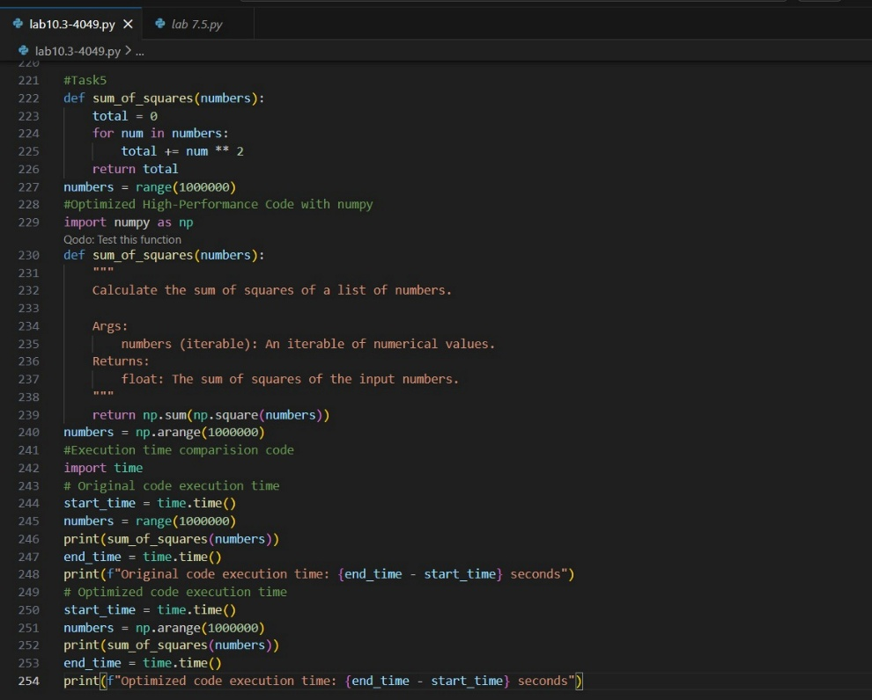  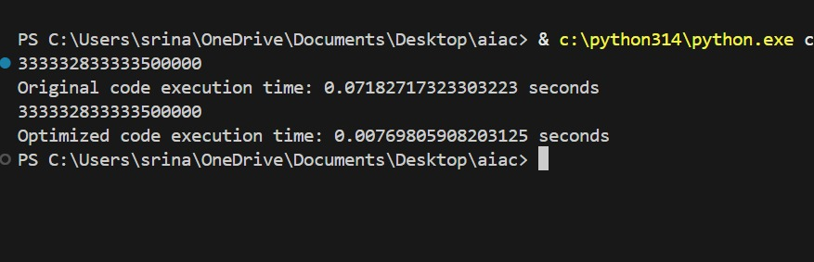  - The original code for the sum_of_squares function uses a for loop to iterate through the list of numbers and calculate the sum of squares, which can be inefficient for large lists.  - To optimize this, we can use the NumPy library, which provides efficient functions for array operations. We can use `np.square` to calculate the squares of the numbers and `np.sum` to calculate the total sum of those squares.  - This approach is much faster, especially for large lists, as it takes advantage of NumPy's optimized C and Fortran code under the hood. Additionally, we should also add a docstring to the function to explain its purpose, parameters, and return value.

