Ai Assissted Coding
Name : A.Rithika Roll No : 2303A54048
Batch : 48
Lab 9: Documentation Generation – Automatic Documentation and Code Comments Task 1: Basic Docstring Generation Scenario
You are developing a utility function that processes numerical lists and must be properly documented for future maintenance.

Requirements
- Write a Python function to return the sum of even numbers and sum of odd numbers in a given list
- Manually add a Google Style docstring to the function
- Use an AI-assisted tool (Copilot / Cursor AI) to generate a function-level docstring
- Compare the AI-generated docstring with the manually written docstring
- Analyze clarity, correctness, and completeness

Expected Output
- Python function with manual Google-style docstring
- AI-generated docstring for the same function
- Comparison explaining differences between manual and AI-generated documentation
- Improved understanding of AI-generated function-level documentation

Expected Output :
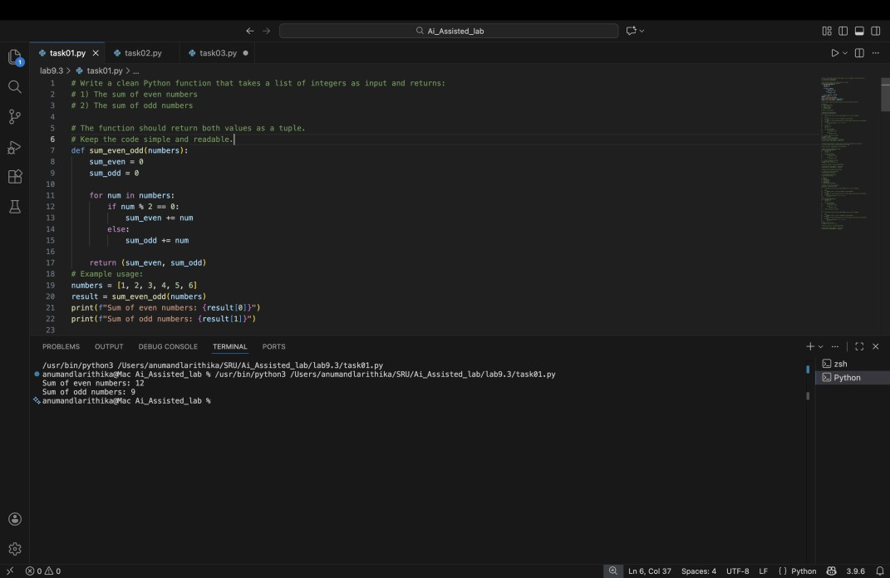
Prompt 1 – Generate Python Function :
Prompt 2 – Generate Google Style Docstring :

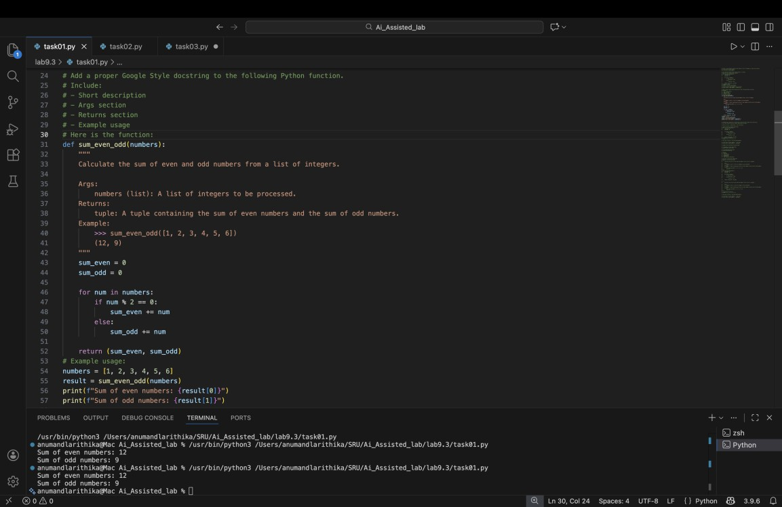

Prompt 3 – AI Docstring Generation (for comparison)
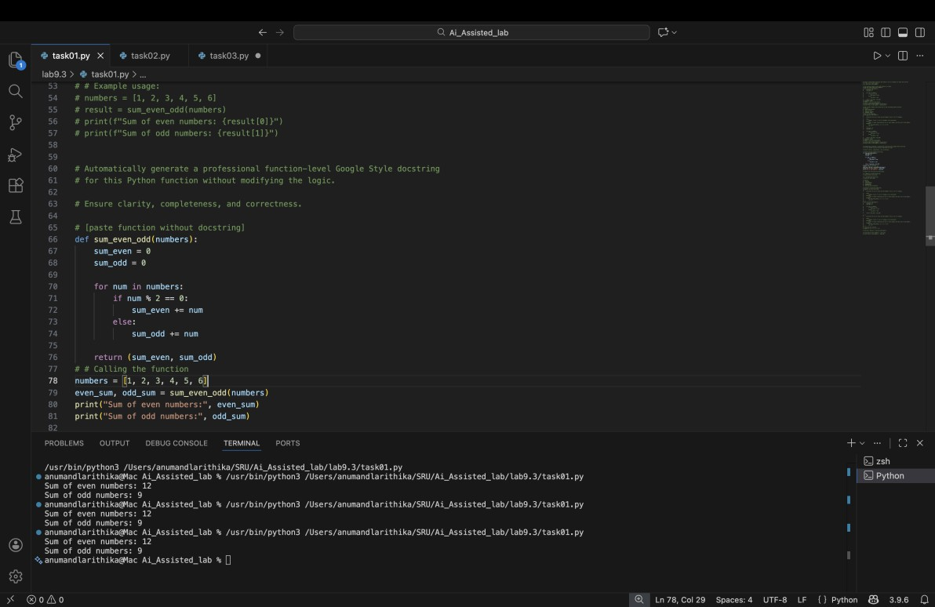

Prompt 4 – Comparison Prompt :

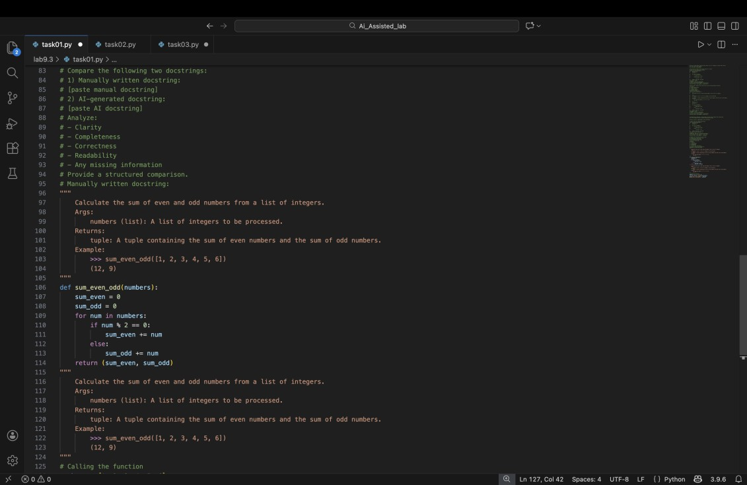

Criteria | Manual Docstring | AI Docstring
Clarity | Clear but short | More detailed
Completeness | Basic explanation | Includes  examples
Accuracy | Correct | Correct
Readability | Simple | Professional tone

Explanation :
In this task, I wrote a Python function to calculate the sum of even numbers and odd numbers from a list.
First, I added a manual Google-style docstring to explain:
  - What the function does
  - What input it takes
  - What it returns
Then, I used an AI tool to generate a docstring automatically. After comparing both, I observed that:
  - The AI-generated docstring was more detailed.
  - My manual docstring was shorter and simple.
  - AI documentation looked more professional.
  - Both were correct, but AI saved time.
This task helped me understand how AI tools can generate function-level documentation quickly and clearly.

Task 2 – Automatic Inline Comments :
Prompt 1 – Generate Class :
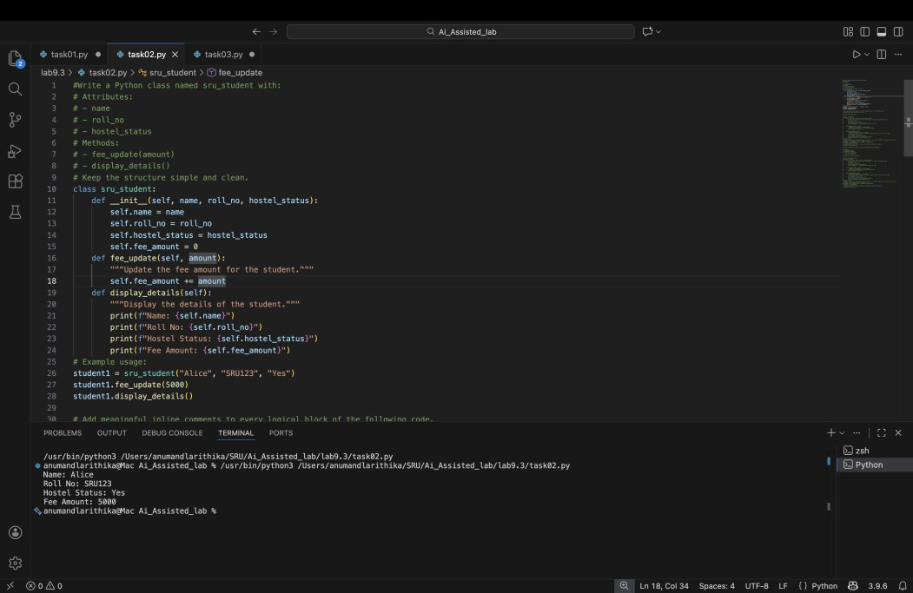

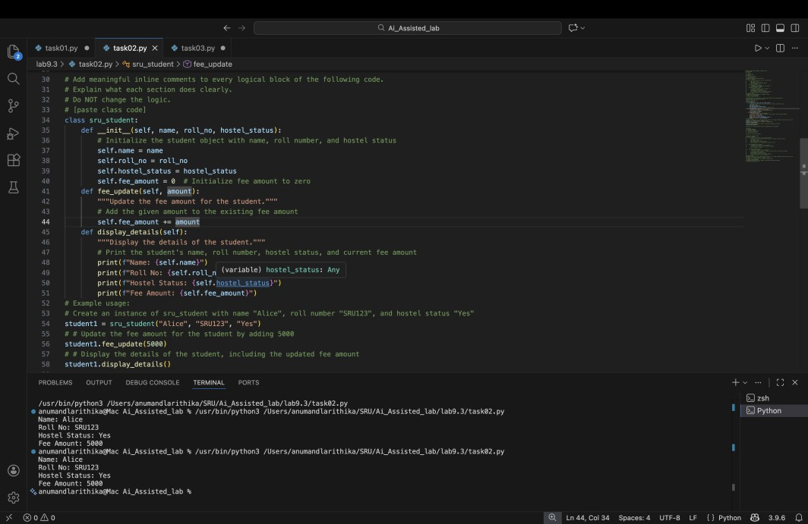
Prompt 2 – Add Manual Inline Comments :
Prompt 3 – Evaluate AI Comments :

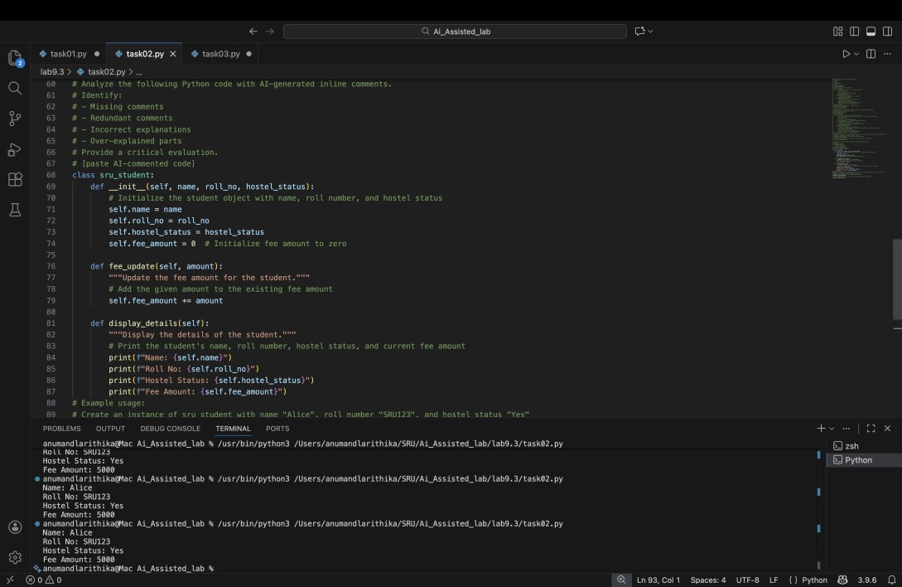

Explanation :
In this task, I created a Python class called sru_student with attributes like name, roll number, and hostel status.
First, I wrote inline comments manually to explain each part of the code. Then, I used an AI tool to automatically generate inline comments.
After comparing them, I found:
  - AI added comments for almost every line.
  - Some AI comments were too detailed.
  - Manual comments were shorter and focused.
  - AI comments are helpful but need checking.
This task helped me understand how AI can automatically explain code logic.

TASK 3 – Module-Level & NumPy Style Documentation :
Prompt 1 – Generate Calculator Module :

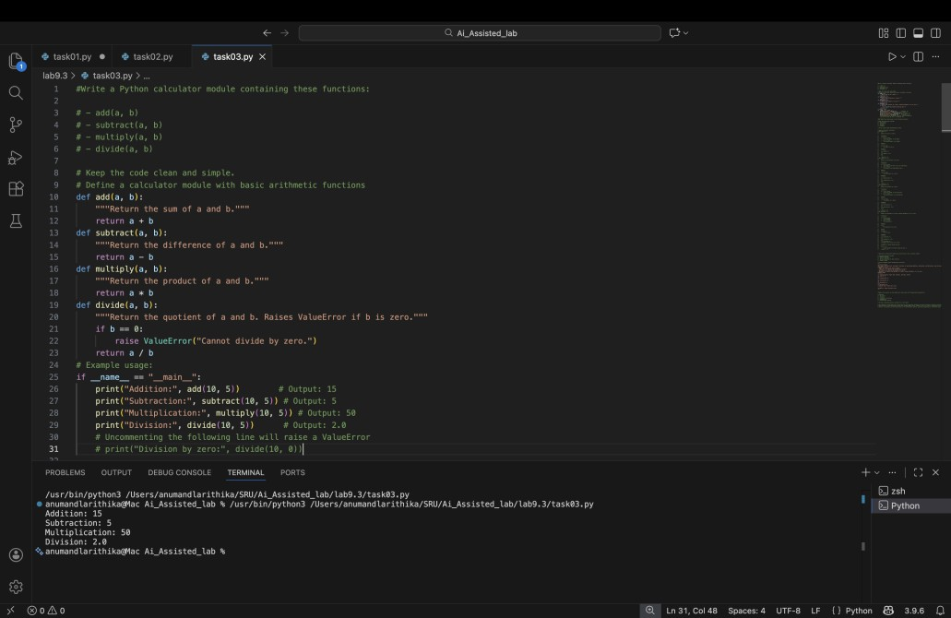
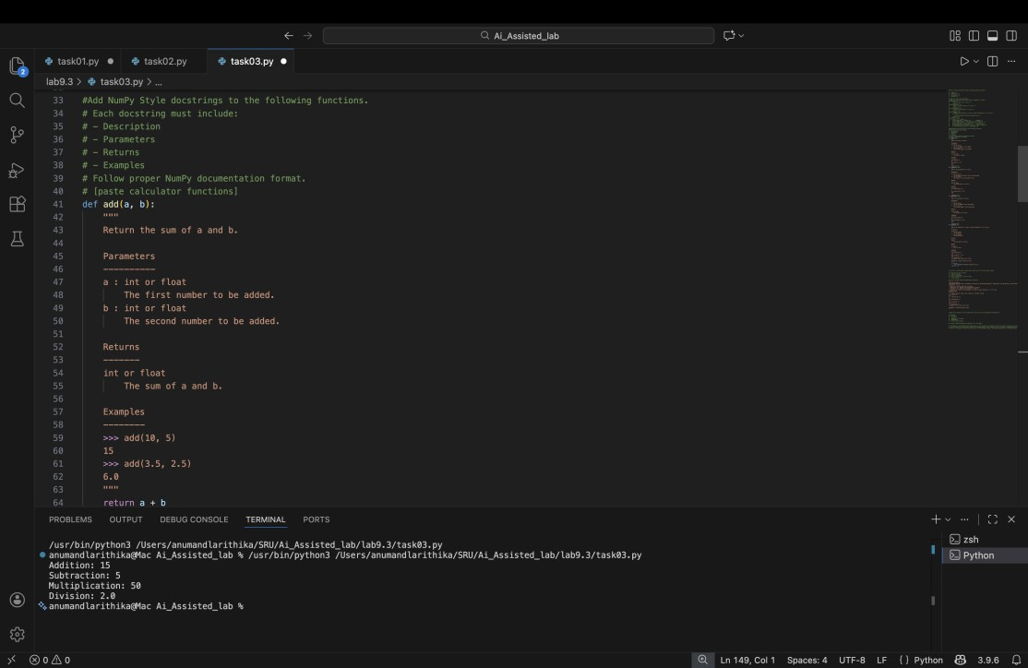
Prompt 2 – Add NumPy Style Docstrings :
Prompt 3 – Generate Module-Level Docstring :

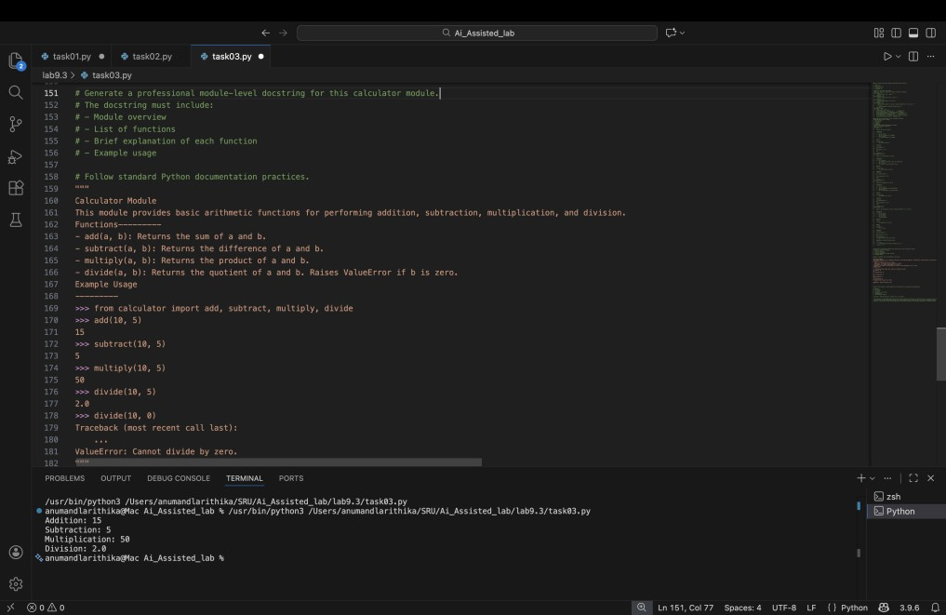

Explanation :
In this task, I created a small calculator module with functions like add, subtract, multiply, and divide.
First, I wrote NumPy-style docstrings manually for each function. Then, I used AI to generate:
  - A module-level docstring
  - Function-level docstrings After comparing them, I observed:
  - AI documentation was well structured.
  - It followed proper formatting.
  - Manual documentation was simple but correct.
  - AI helps in maintaining consistency in large projects.
This task helped me understand structured documentation for multiple functions.

