SCHOOL OF COMPUTER SCIENCE AND ARTIFICIAL INTELLIGENCE |  |  |  |  | DEPARTMENT OF COMPUTER SCIENCE ENGINEERING
Program Name: B. Tech |  |  |  | Assignment Type: Lab |  |  | Academic Year:2025-2026
Name |  |  |  | Numera Mahveen
CourseCode |  |  | 23CS002PC304 | Course Title |  | AI Assisted Coding
Year/Sem |  |  | III/II | Regulation |  | R23
Hall ticket |  |  | 2303A54061 | Batches |  | 23CSBTB 47_B
Assignment Number: 7.5(Present assignment number)/24(Total number of assignments)
 | Q.No. | Question |  |  |  |  |  | Expected Time  to complete
 | 1 | Lab 7: Error Debugging with AI: Systematic approaches to finding and fixing bugs  Lab Objectives:  - To identify and correct syntax, logic, and runtime errors in Python programs using AI tools.  - To understand common programming bugs and AI-assisted debugging suggestions.  - To evaluate how AI explains, detects, and fixes different types of coding errors.  - To build confidence in using AI to perform structured debugging practices.  Lab Outcomes (LOs):  After completing this lab, students will be able to:  - Use AI tools to detect and correct syntax, logic, and runtime errors.  - Interpret AI-suggested bug fixes and explanations.  - Apply systematic debugging strategies supported by AI-generated insights.  Refactor buggy code using responsible and reliable programming patterns. |  |  |  |  |  | Week4 -Monday
Task 1 (Mutable Default Argument – Function Bug)
Task: Analyze given code where a mutable default argument causes unexpected behavior. Use AI to fix it.
# Bug: Mutable default argument
def add_item(item, items=[]):
items.append(item)
return items
print(add_item(1))
print(add_item(2))
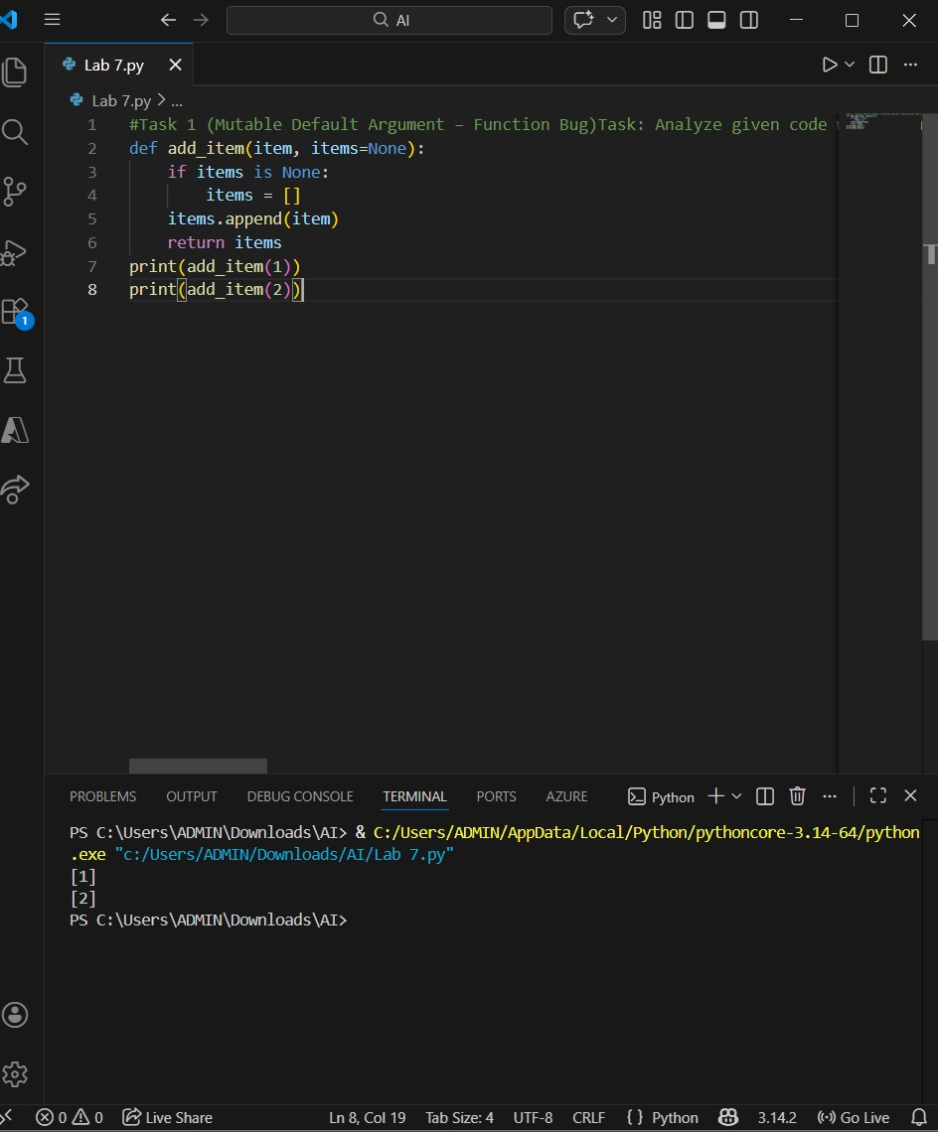
Expected Output: Corrected function avoids shared list bug.
Task 2 (Floating-Point Precision Error)
Task: Analyze given code where floating-point comparison fails. Use AI to correct with tolerance.
# Bug: Floating point precision issue
def check_sum():
return (0.1 + 0.2) == 0.3
print(check_sum())
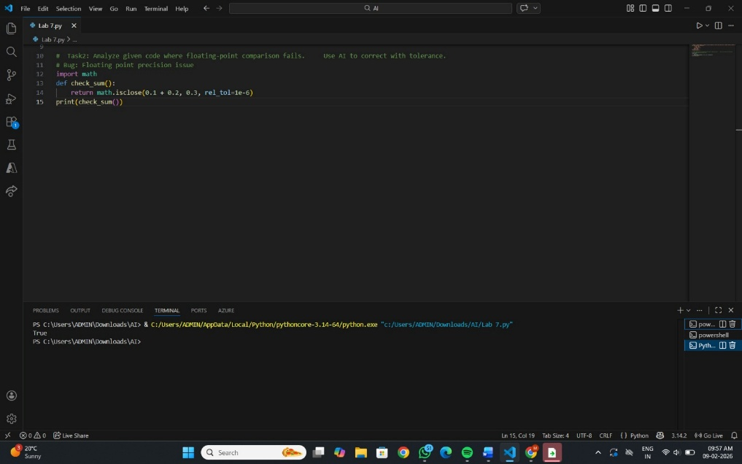
Expected Output: Corrected function
Task 3 (Recursion Error – Missing Base Case)
Task: Analyze given code where recursion runs infinitely due to missing base case. Use AI to fix.
# Bug: No base case
def countdown(n):
print(n)
return countdown(n-1)
countdown(5)
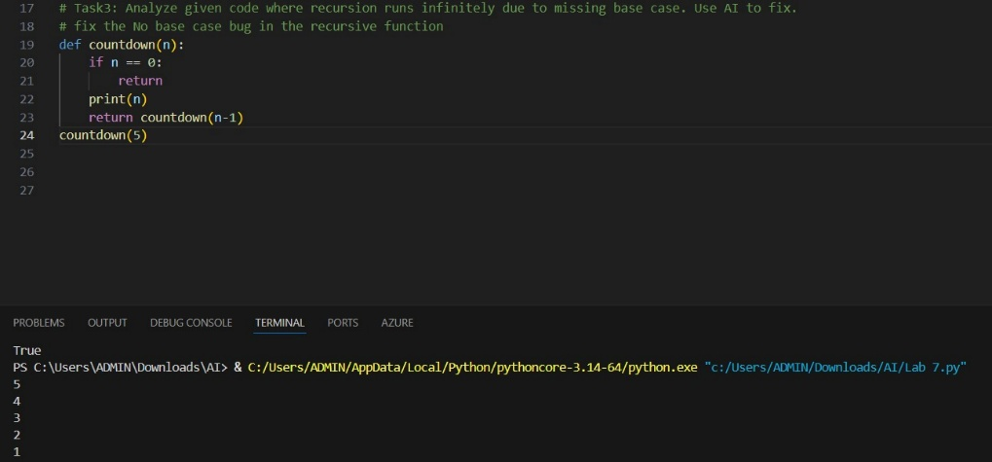
Expected Output : Correct recursion with stopping condition.
Task 4 (Dictionary Key Error)
Task: Analyze given code where a missing dictionary key causes error. Use AI to fix it.
# Bug: Accessing non-existing key
def get_value():
data = {"a": 1, "b": 2}
return data["c"]
print(get_value())
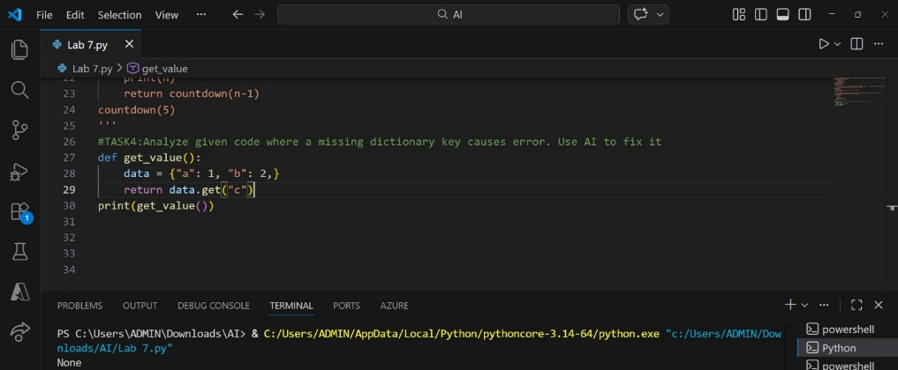
Expected Output: Corrected with .get() or error handling.
Task 5 (Infinite Loop – Wrong Condition)
Task: Analyze given code where loop never ends. Use AI to detect and fix it.
# Bug: Infinite loop
def loop_example():
i = 0
while i < 5:
print(i)
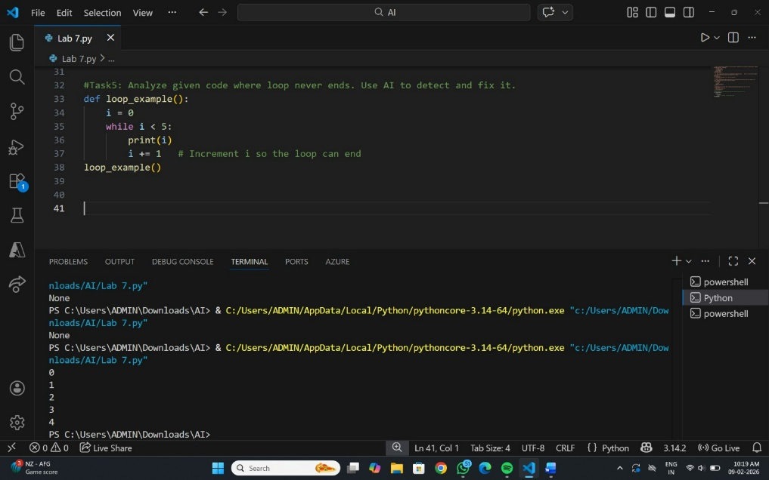
Expected Output: Corrected loop increments i.
Task 6 (Unpacking Error – Wrong Variables)
Task: Analyze given code where tuple unpacking fails. Use AI to fix it.
# Bug: Wrong unpacking
a, b = (1, 2, 3)
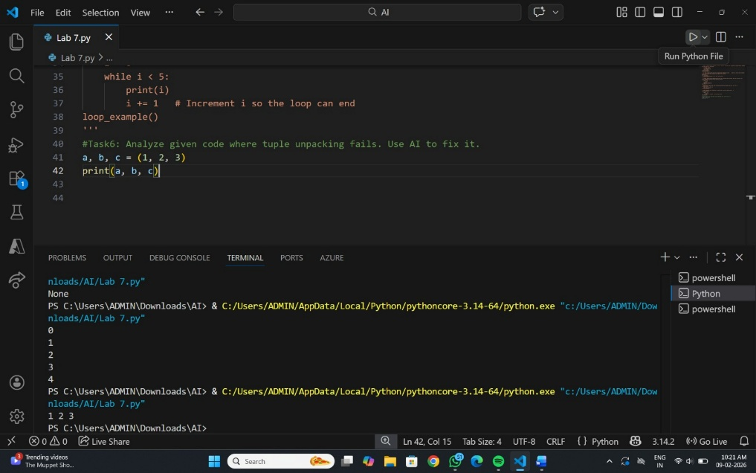
Expected Output: Correct unpacking or using _ for extra values.

Task 7 (Mixed Indentation – Tabs vs Spaces)
Task: Analyze given code where mixed indentation breaks execution. Use AI to fix it.
# Bug: Mixed indentation
def func():
x = 5
y = 10
return x+y
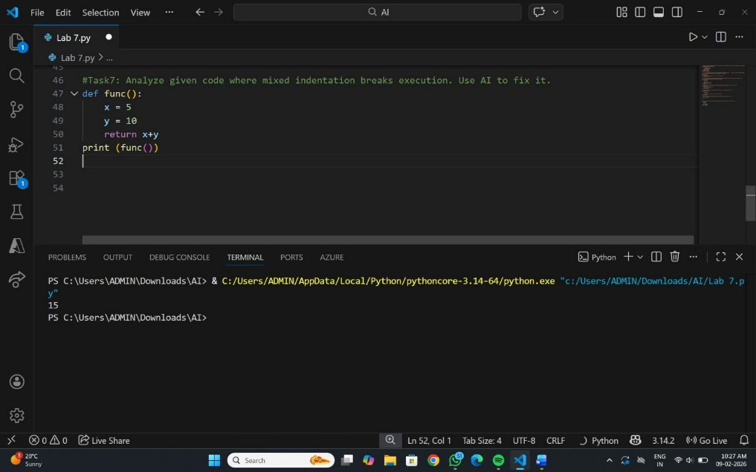
Expected Output : Consistent indentation applied.
Task 8 (Import Error – Wrong Module Usage)
Task: Analyze given code with incorrect import. Use AI to fix.
# Bug: Wrong import
import maths
print(maths.sqrt(16)) 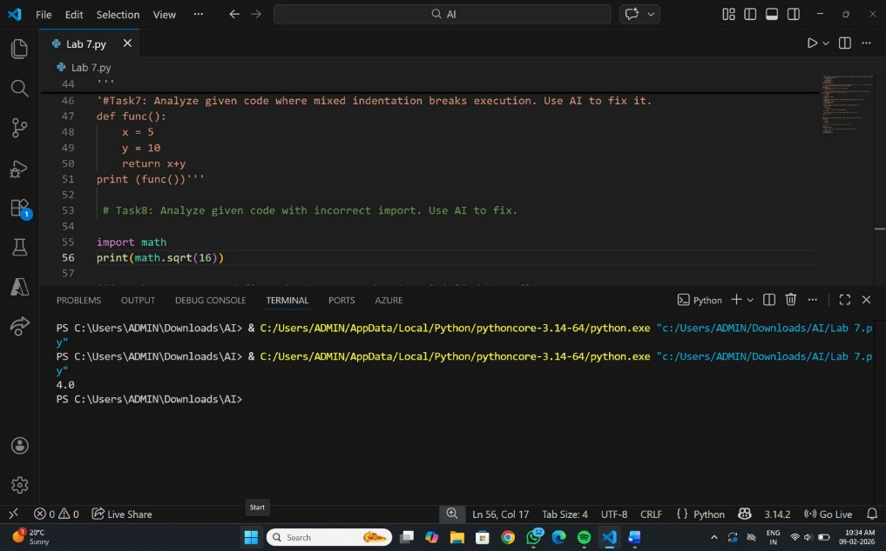
Expected Output: Corrected to import math

Task 9 (Unreachable Code – Return Inside Loop)
Task: Analyze given code where a return inside a loop prevents full iteration. Use AI to fix it.
# Bug: Early return inside loop
def total(numbers):
for n in numbers:
return n
print(total([1,2,3]))
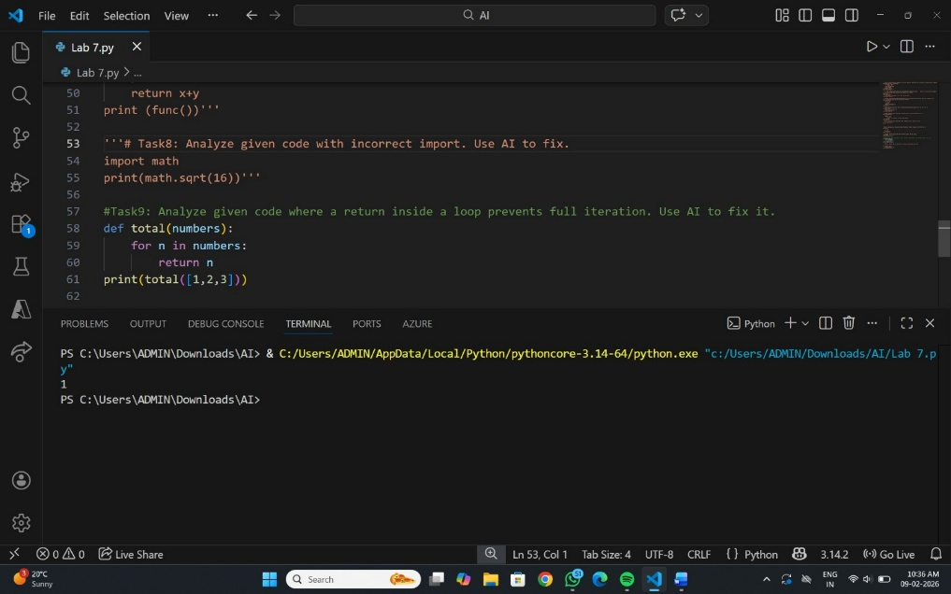
Expected Output: Corrected code accumulates sum and returns after loop.
Task 10 (Name Error – Undefined Variable)
Task: Analyze given code where a variable is used before being defined. Let AI detect and fix the error.
# Bug: Using undefined variable
def calculate_area():
return length * width
print(calculate_area())
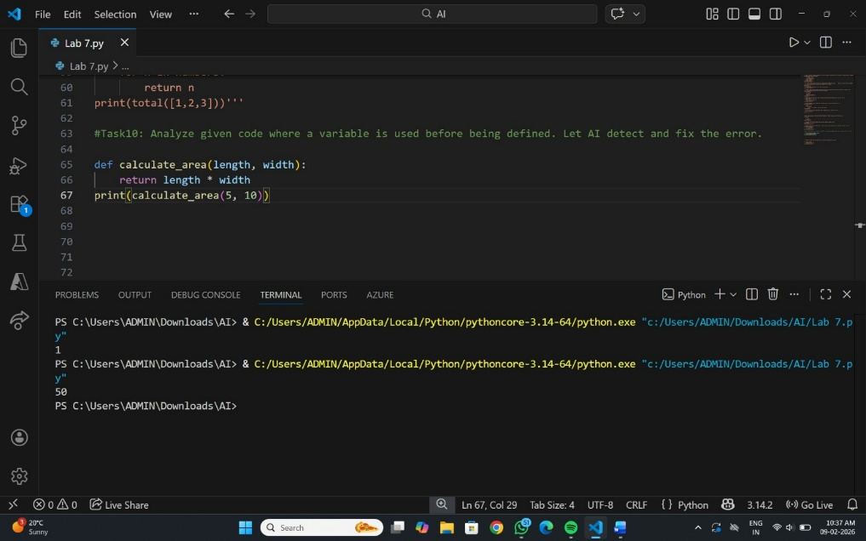
Requirements:
- Run the code to observe the error.
- Ask AI to identify the missing variable definition.
- Fix the bug by defining length and width as parameters.
- Add 3 assert test cases for correctness.
Expected Output :
- Corrected code with parameters.
- AI explanation of the bug.
Successful execution of assertions.
Task 11 (Type Error – Mixing Data Types Incorrectly)
Task: Analyze given code where integers and strings are added incorrectly. Let AI detect and fix the error.
# Bug: Adding integer and string
def add_values():
return 5 + "10"
print(add_values())
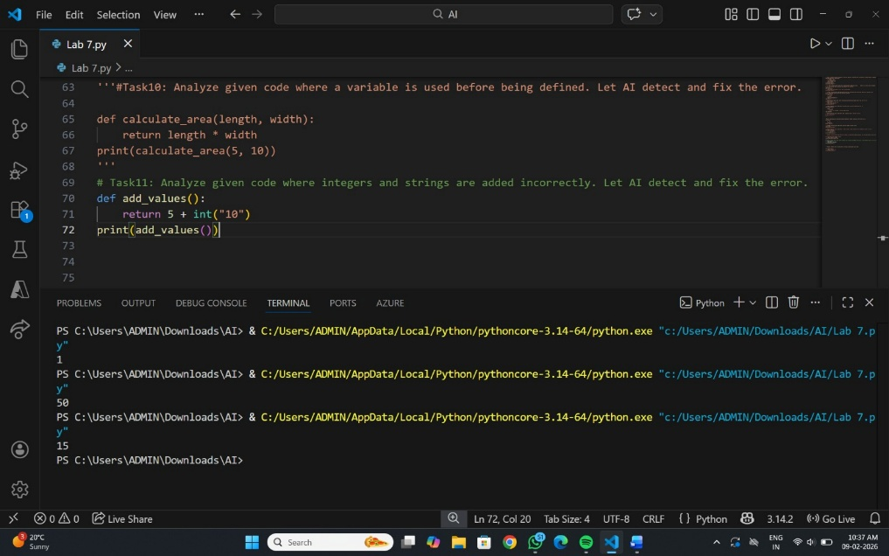
Requirements:
- Run the code to observe the error.
- AI should explain why int + str is invalid.
- Fix the code by type conversion (e.g., int("10") or str(5)).
- Verify with 3 assert cases.
Expected Output #6:
- Corrected code with type handling.
- AI explanation of the fix.
Successful test validation.
Task 12 (Type Error – String + List Concatenation)
Task: Analyze code where a string is incorrectly added to a list.
# Bug: Adding string and list
def combine():
return "Numbers: " + [1, 2, 3]
print(combine())
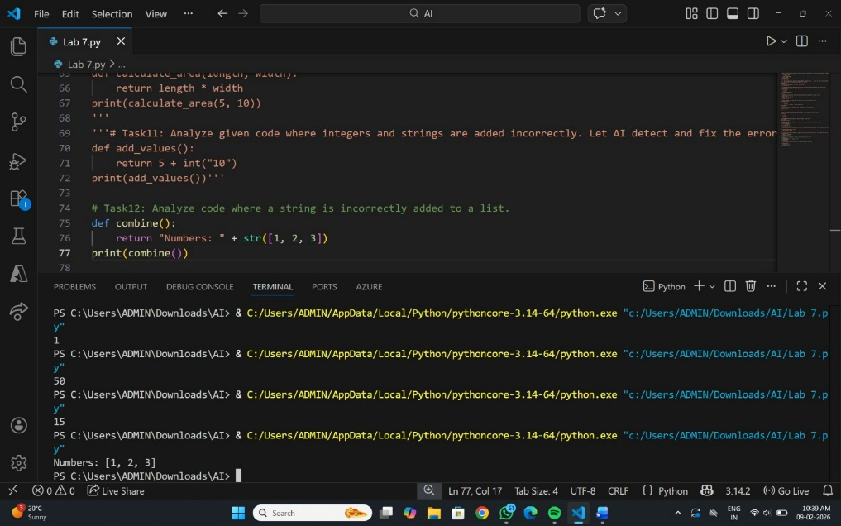
Requirements:
- Run the code to observe the error.
- Explain why str + list is invalid.
- Fix using conversion (str([1,2,3]) or " ".join()).
- Verify with 3 assert cases.
Expected Output:
- Corrected code
- Explanation
- Successful test validation

Task 13 (Type Error – Multiplying String by Float)
Task: Detect and fix code where a string is multiplied by a float.
# Bug: Multiplying string by float
def repeat_text():
return "Hello" * 2.5
print(repeat_text())
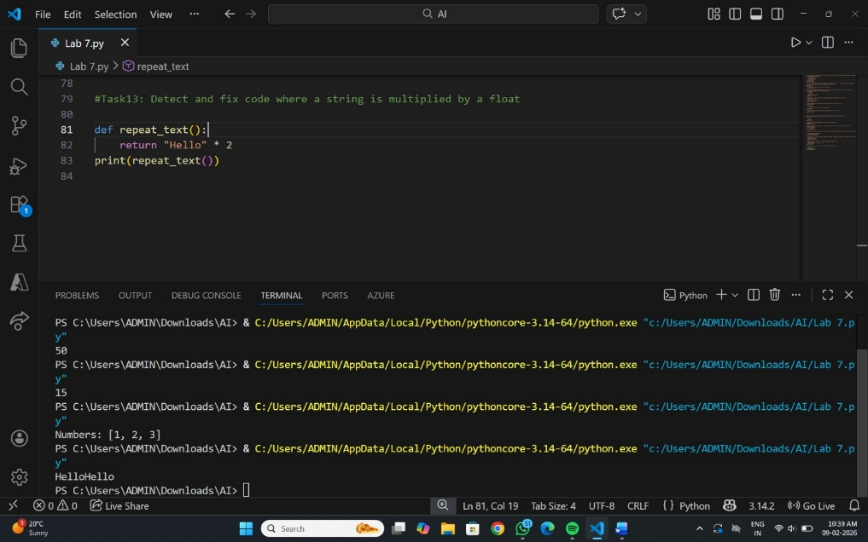
Requirements:
- Observe the error.
- Explain why float multiplication is invalid for strings.
- Fix by converting float to int.
- Add 3 assert test cases.

Task 14 (Type Error – Adding None to Integer)
Task: Analyze code where None is added to an integer.
# Bug: Adding None and integer
def compute():
value = None
return value + 10

print(compute())
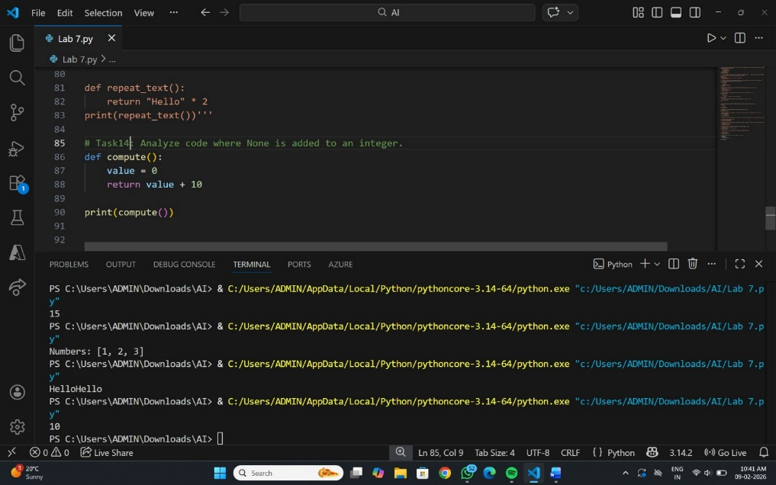
Requirements:
- Run and identify the error.
- Explain why NoneType cannot be added.
- Fix by assigning a default value.
- Validate using asserts.

Task 15 (Type Error – Input Treated as String Instead of Number)
Task: Fix code where user input is not converted properly.
# Bug: Input remains string
def sum_two_numbers():
a = input("Enter first number: ")
b = input("Enter second number: ")
return a + b

print(sum_two_numbers())
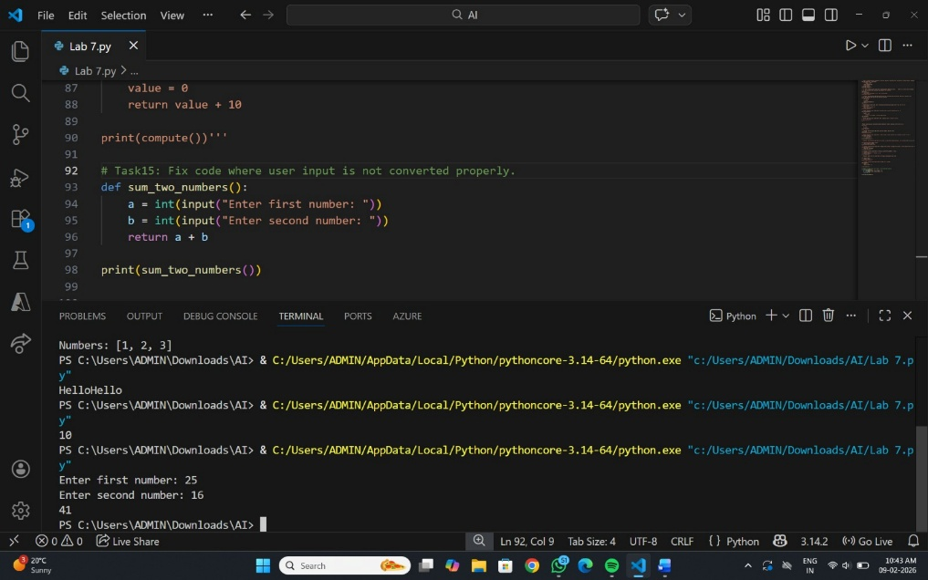
Requirements:
- Explain why input is always string.
- Fix using int() conversion.
- Verify with assert test cases.

