AIAC Lab Assignment-20.5
A.Vishwa Tej
Hall No:2303A51002

Task 1 – Password Storage Vulnerability Check
Task:
Analyze an AI-generated signup script for insecure password storage. Instructions:
- Prompt AI to generate a Python user registration program.
- Check whether passwords are stored in plain text.
- Improve the script using hashing (bcrypt or hashlib).
- A secure registration script with hashed password storage.

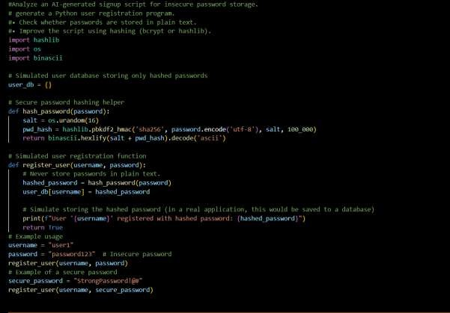
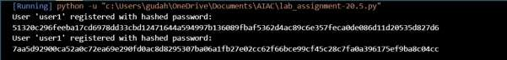

Task 2 – Hardcoded Secrets Detection Task:
Evaluate AI-generated code for hardcoded API keys or credentials. Instructions:
- Ask AI to generate a script that connects to an external API.
- Identify if API keys/passwords are written directly in code.
- Refactor using environment variables or config files. Expected Output:
- A secure script with secrets managed properly.
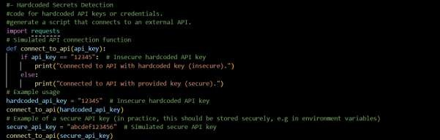
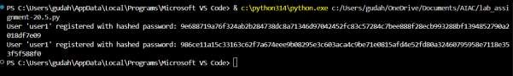
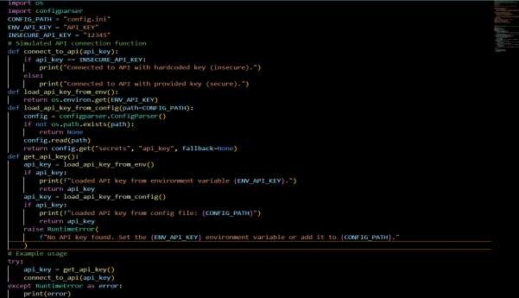

Task 3 – File Upload Security Validation Task:
Test an AI-generated file upload program for unsafe file handling. Instructions:
- Prompt AI to generate a Flask file upload example.
- Check for vulnerabilities like uploading executable files.
- Add validation for file type, size, and secure filename handling.
Expected Output:
- A secure file upload implementation.
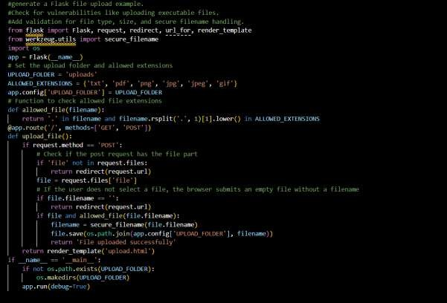
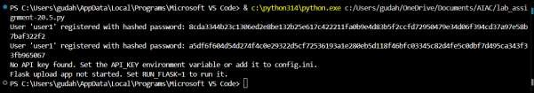

Task 4 – Command Injection Prevention Task:
Analyze an AI-generated Python script that executes system commands.
Instructions:
- Ask AI to generate code using os.system() or subprocess.
- Identify command injection risks with user input.
- Fix using safe subprocess calls and input validation. Expected Output:
- A secure command execution script.
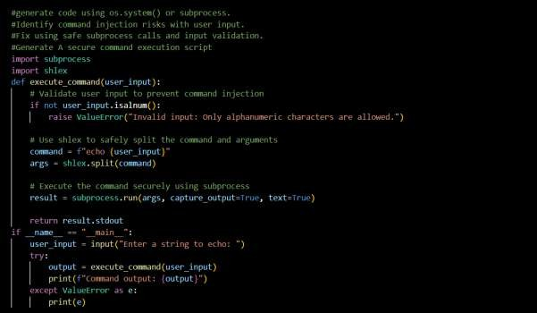
Task 5 – Secure Input Handling in Web Forms Task:
Check AI-generated web form code for improper input validation. Instructions:
- Ask AI to generate an HTML + Flask feedback form.
- Identify missing validation and unsafe rendering.
- Fix using server-side validation and sanitization. Expected Output:

- A secure form resistant to injection attacks.
