Lab Assignment – 12.5

Name: B.Bharath kumar
HT. No: 230351007
Batch: 01
Task Description #1 (Sorting – Merge Sort Implementation)
- Task: Use AI to generate a Python program that implements the Merge Sort algorithm.
- Instructions:
  - Prompt AI to create a function merge_sort(arr) that sorts a list in ascending order.
  - Ask AI to include time complexity and space complexity in the function docstring.
  - Verify the generated code with test cases.
- Expected Output:
o A functional Python script implementing Merge Sort with proper documentation.
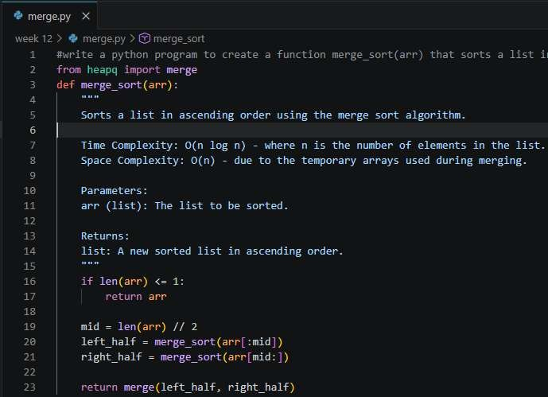

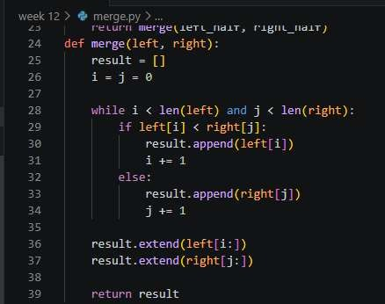
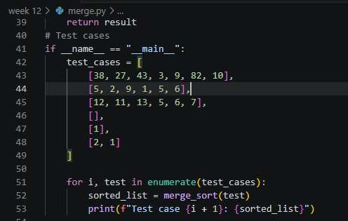
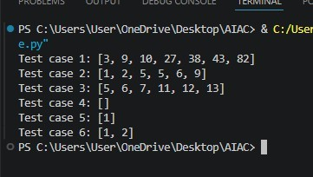

Task Description #2 (Searching – Binary Search with AI Optimization)
  - Task: Use AI to create a binary search function that finds a target element in a sorted list.
  - Instructions:

    - Prompt AI to create a function binary_search(arr, target) returning the index of the target or -1 if not found.
    - Include docstrings explaining best, average, and worst-case complexities.
    - Test with various inputs.
  - Expected Output:
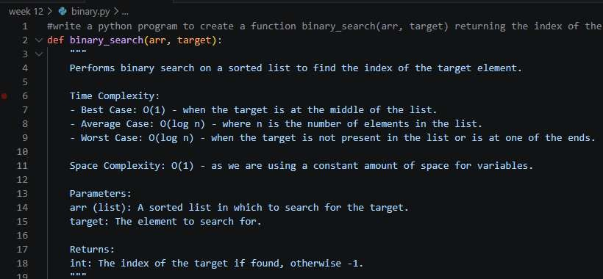
    - Python code implementing binary search with AI- generated comments and docstrings.

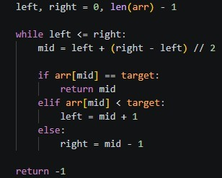
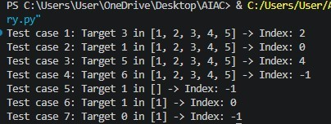

Task Description #3: Smart Healthcare Appointment Scheduling System
A healthcare platform maintains appointment records containing appointment ID, patient name, doctor name, appointment time, and consultation fee. The system needs to:
- Search appointments using appointment ID.
- Sort appointments based on time or consultation fee. Student Task
  - Use AI to recommend suitable searching and sorting algorithms.
  - Justify the selected algorithms.
  - Implement the algorithms in Python.

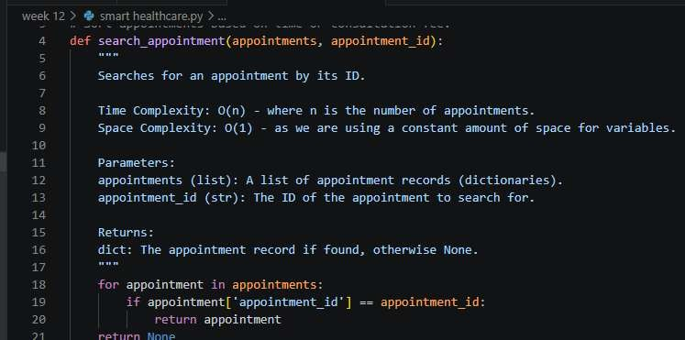
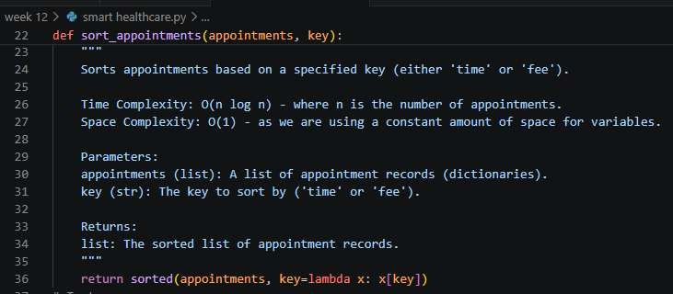

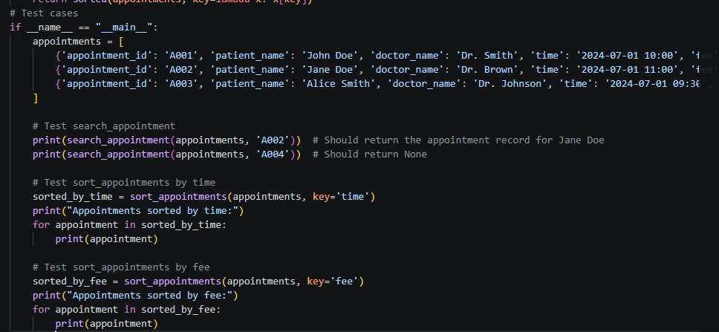
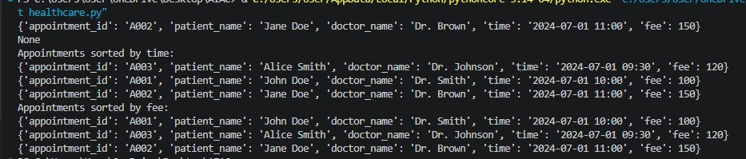

Task Description #4: Railway Ticket Reservation System Scenario
A railway reservation system stores booking details such as ticket
ID, passenger name, train number, seat number, and travel date. The system must:
- Search tickets using ticket ID.
- Sort bookings based on travel date or seat number. Student Task
  - Identify efficient algorithms using AI assistance.
  - Justify the algorithm choices.
  - Implement searching and sorting in Python.

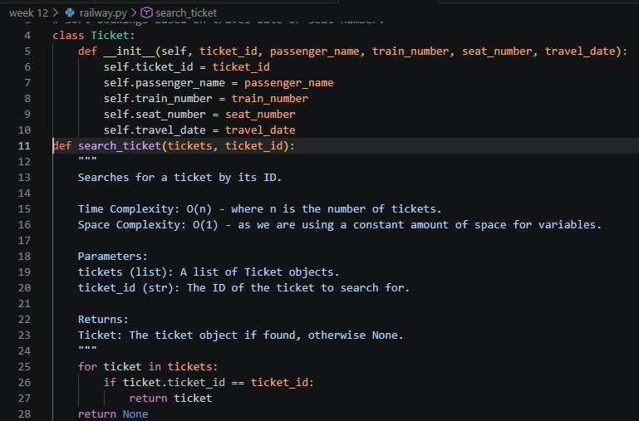
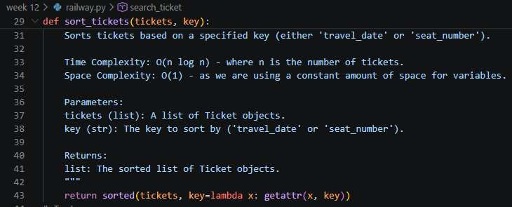

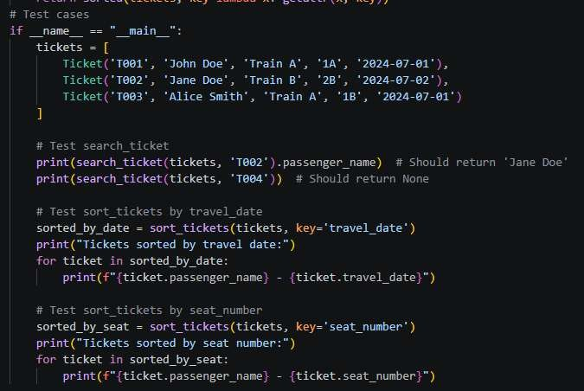
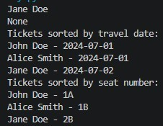
Task Description #5: Smart Hostel Room Allocation System
A hostel management system stores student room allocation details including student ID, room number, floor, and allocation date. The
system needs to:
- Search allocation details using student ID.
- Sort records based on room number or allocation date. Student Task
  - Use AI to suggest optimized algorithms.
  - Justify the selections.
  - Implement the solution in Python.

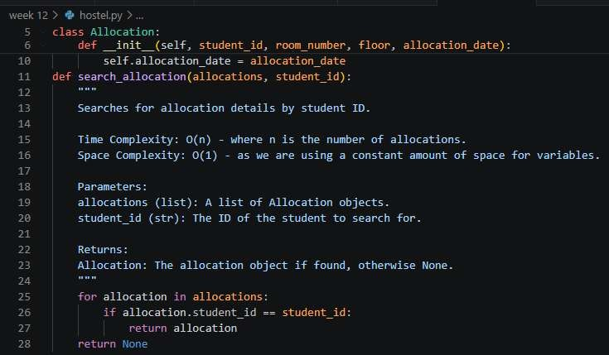
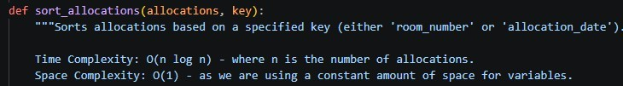
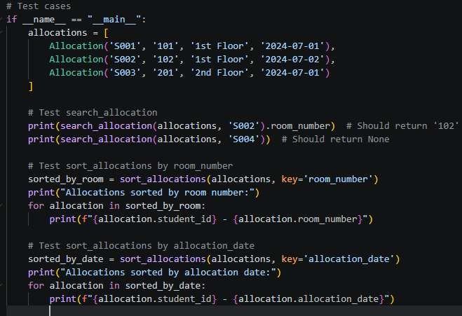

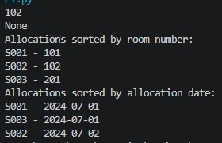

Task Description #6: Online Movie Streaming Platform
A streaming service maintains movie records with movie ID, title, genre, rating, and release year. The platform needs to:
- Search movies by movie ID.
- Sort movies based on rating or release year. Student Task
  - Recommend searching and sorting algorithms using AI.
  - Justify the chosen algorithms.
  - Implement Python functions.
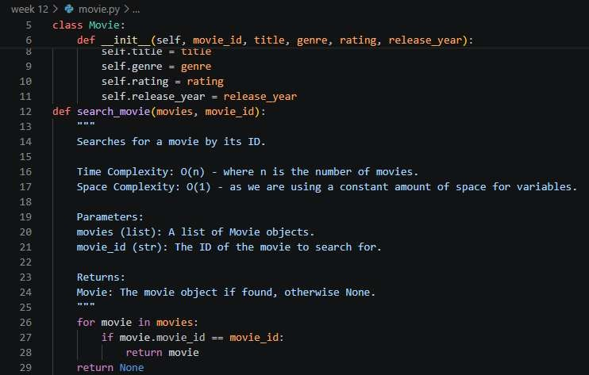

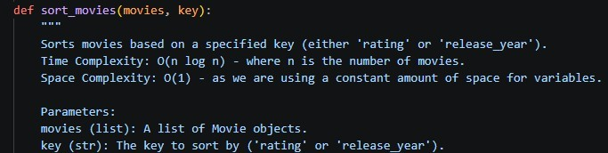
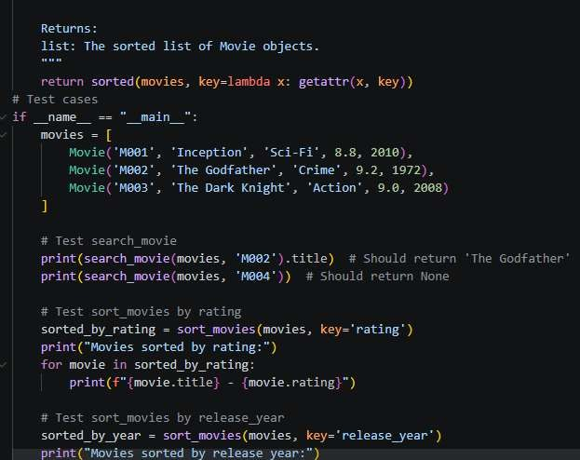
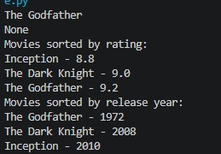

Task Description #7: Smart Agriculture Crop Monitoring System
An agriculture monitoring system stores crop data with crop ID, crop name, soil moisture level, temperature, and yield estimate. Farmers need to:
- Search crop details using crop ID.

- Sort crops based on moisture level or yield estimate. Student Task
  - Use AI-assisted reasoning to select algorithms.
  - Justify algorithm suitability.
  - Implement searching and sorting in Python.
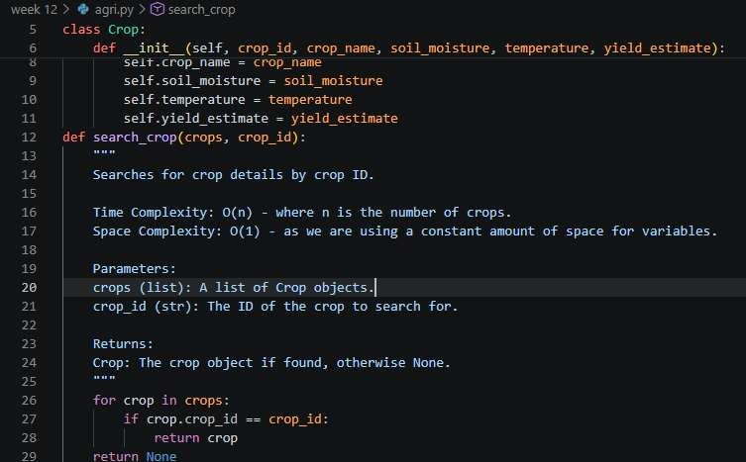
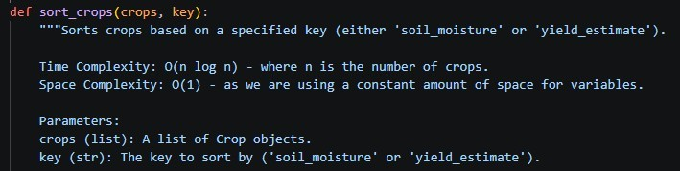

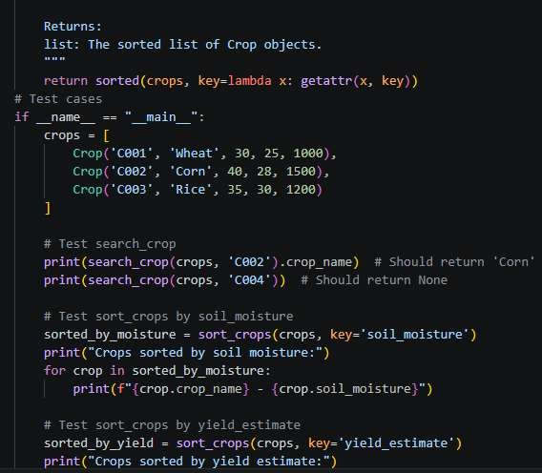
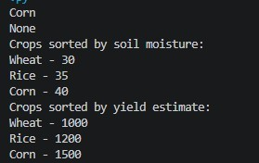

Task Description #8: Airport Flight Management System
An airport system stores flight information including flight ID, airline name, departure time, arrival time, and status. The system must:
- Search flight details using flight ID.
- Sort flights based on departure time or arrival time. Student Task
    - Use AI to recommend algorithms.
    - Justify the algorithm selection.
    - Implement searching and sorting logic in Python.

