AI ASSISTED CODING ASSIGNMENT – 14.5
D.Nagateja (2303A51008)
BATCH-01
Task 1 – Image Gallery Website
Create an image gallery web page.
Requirements:
• Display images in a grid layout.
• Use AI to:
o Optimize layout using CSS Grid.
o Add hover zoom or overlay effects.
o Ensure mobile responsiveness.

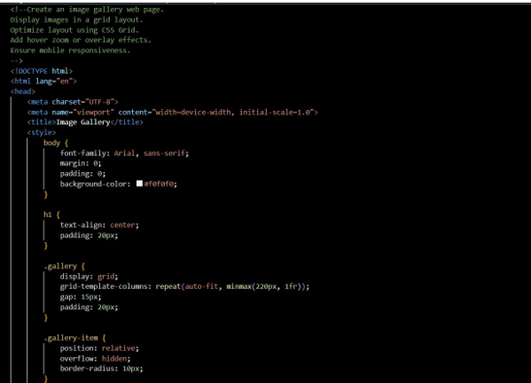

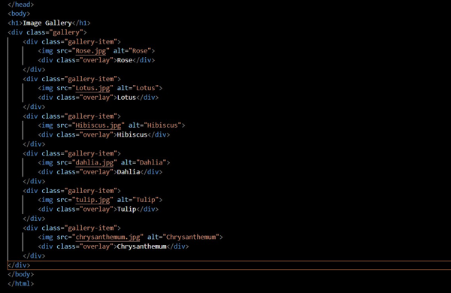

Task 2 – Profile Card Generator
Create a profile card web page.
Requirements:
• Display user image, name, role, and social media links.
• Use AI to:
o Suggest modern UI colors and fonts.
o Design the card using Flexbox.
o Add hover animation and shadow effects
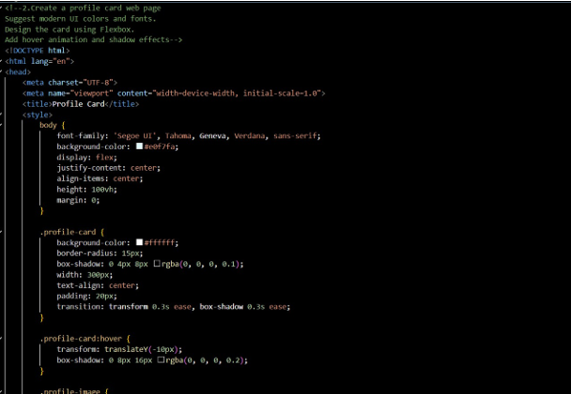

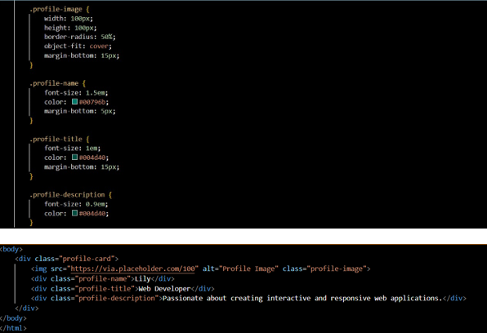
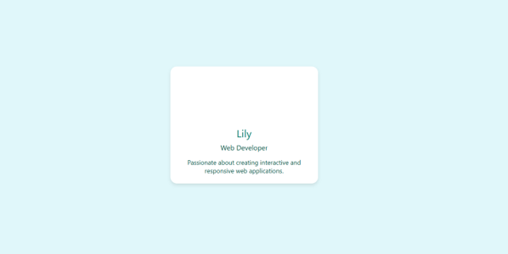

Task 3 -Develop a dynamic shopping cart system.
Requirements:
• Add, remove, and update product quantities.
• Display real-time total price.
• Use AI to:
o Manage cart state using JavaScript objects.
o Persist cart data in localStorage
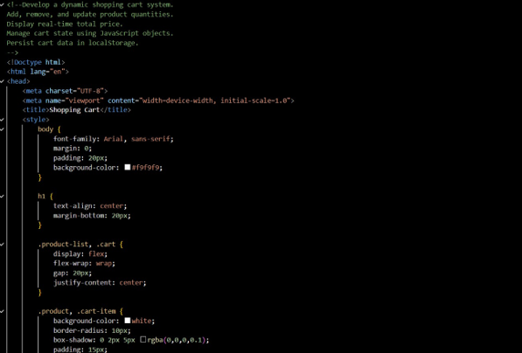
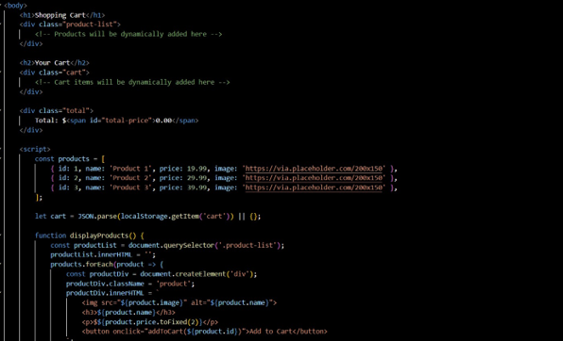
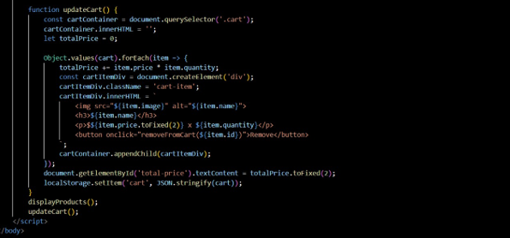
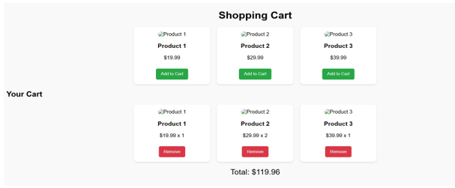

Task 4 – Role-Based Access Control Application
Create a role-based web application.
Requirements:
• Admin, Editor, User roles.
• Conditional UI rendering.
• Use AI to:
o Design access control logic.
o Maintain secure state transitions.
o Create scalable UI components.
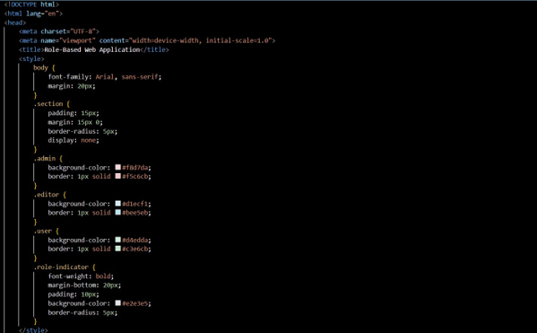
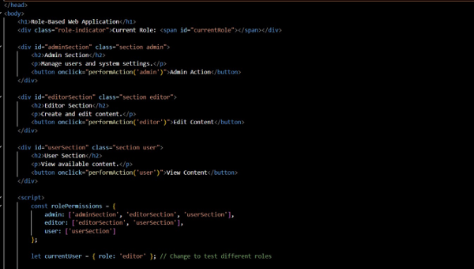
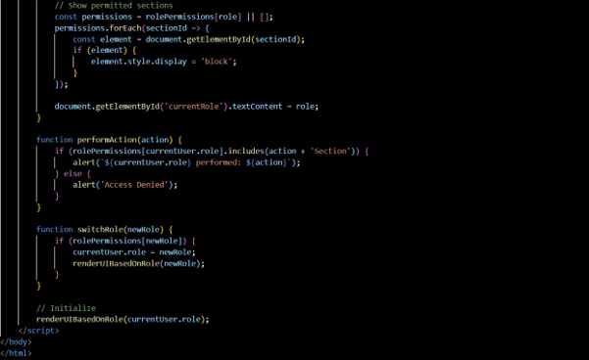
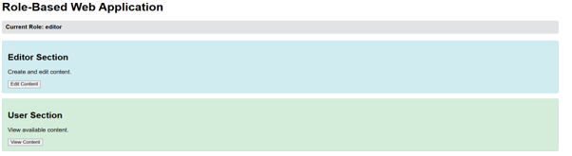

Task 5 – Multi-Language Website
Design a multilingual website.
Requirements:
• Switch languages dynamically.
• Persist language preference.
• Use AI to:
o Structure translation files.
o Handle RTL/LTR layouts.
o Improve accessibility.

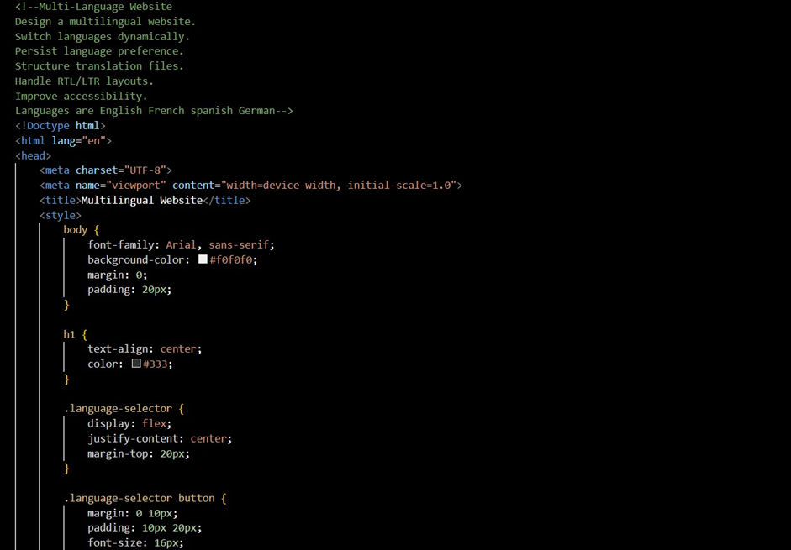
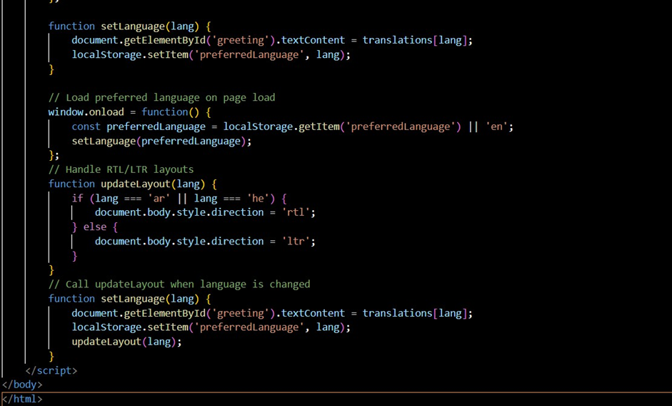
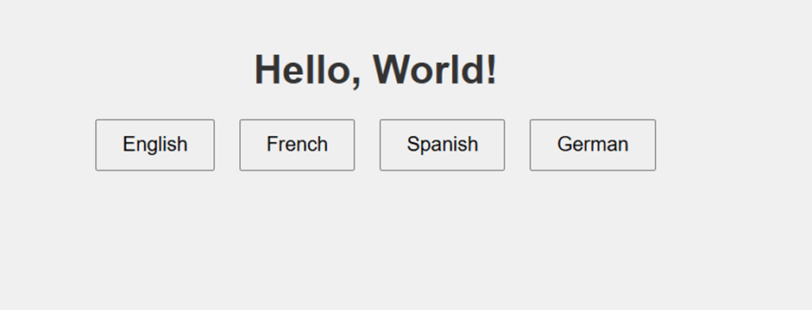

Task 6 – Online Examination System
Create an online exam interface.
Requirements:
• Timer, questions, and submission.
• Prevent multiple submissions.
• Use AI to:
o Manage exam state.
o Improve exam UX.
o Ensure accessibility.
