Lab_Assignment_11.2
Name:E.Asmaja
Batch:01
Hallticket :2303a51011
1
Lab 11 – Data Structures with AI: Implementing Fundamental
Structures
Lab Objectives
• Use AI to assist in designing and implementing fundamental data
Week6 -
Monday
structures in Python.
• Learn how to prompt AI for structure creation, optimization, and
documentation.
• Improve understanding of Lists, Stacks, Queues, Linked Lists,
Trees, Graphs, and Hash Tables.
• Enhance code quality with AI-generated comments and
performance suggestions.
Task Description #1 – Stack Implementation
Task: Use AI to generate a Stack class with push, pop, peek, and is_empty
methods.
Sample Input Code:
class Stack:
pass
Expected Output:
• A functional stack implementation with all required methods and
docstrings.
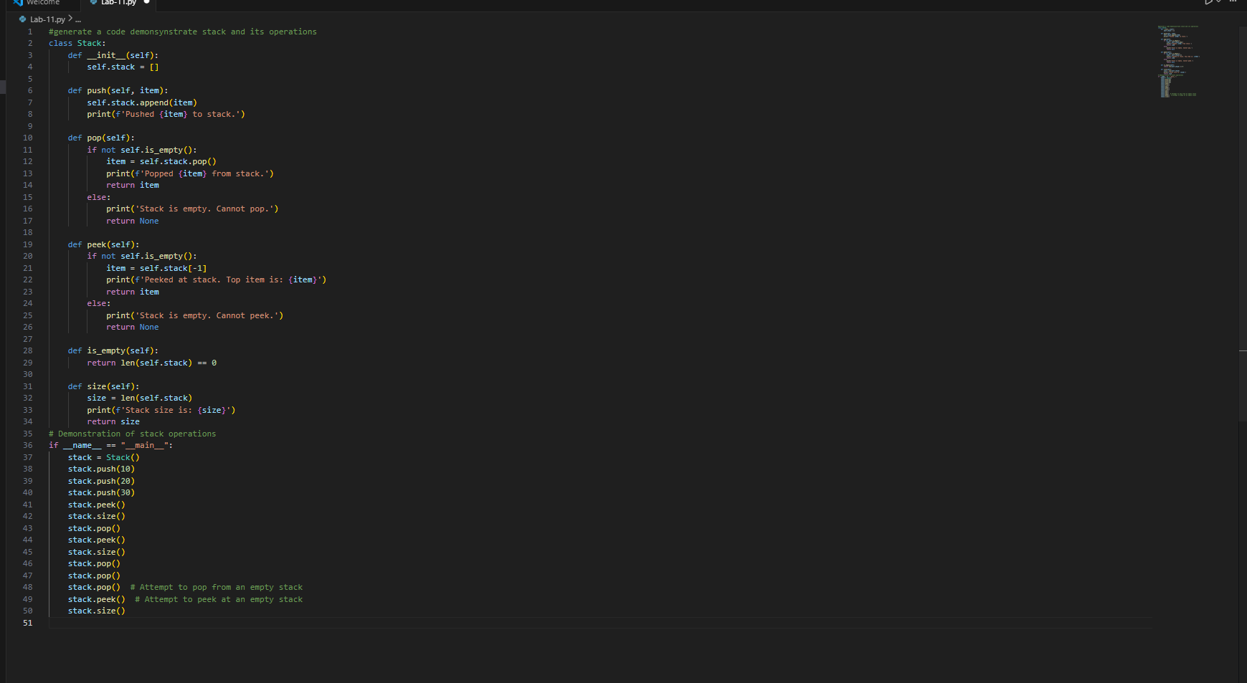
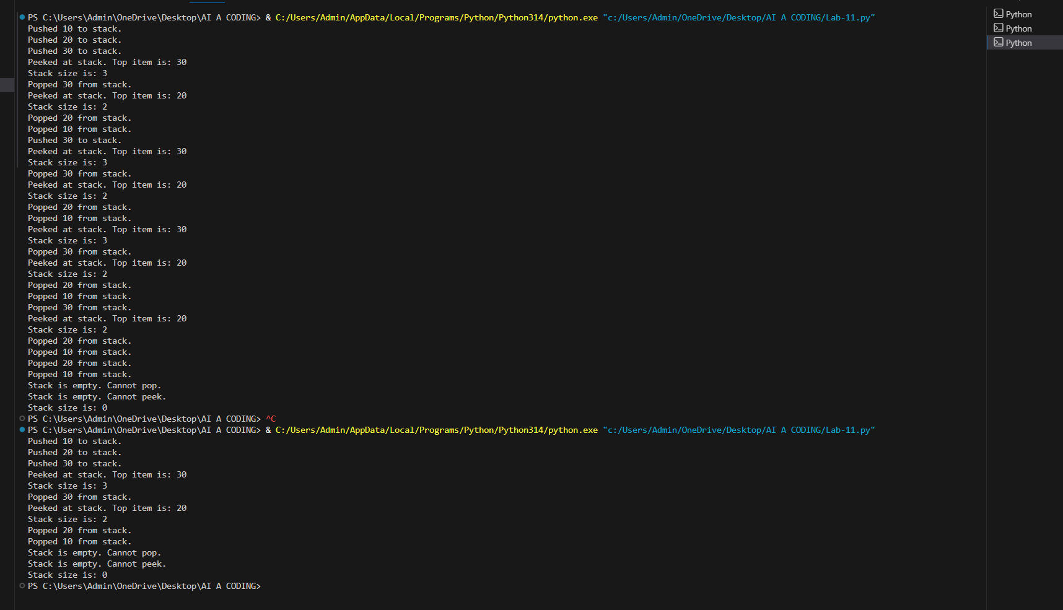
Task Description #2 – Queue Implementation
Task: Use AI to implement a Queue using Python lists.
Sample Input Code:
class Queue:
pass
Expected Output:
• FIFO-based queue class with enqueue, dequeue, peek, and size
methods.
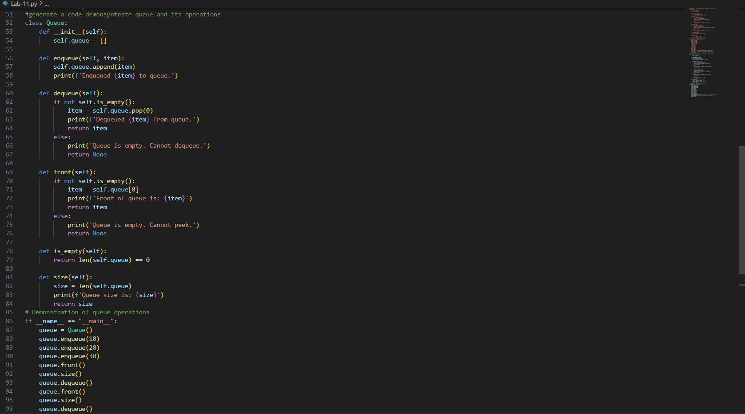
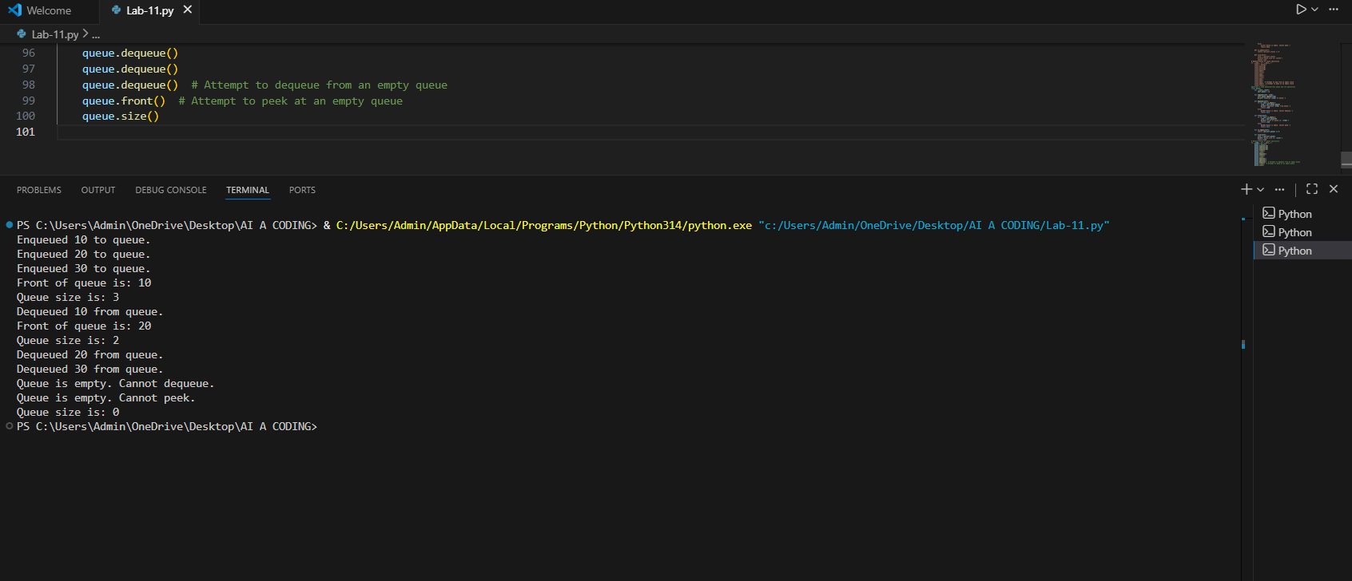
Task Description #3 – Linked List
Task: Use AI to generate a Singly Linked List with insert and display
methods.
Sample Input Code:
class Node:
pass
class LinkedList:
pass
Expected Output:
• A working linked list implementation with clear method
documentation.
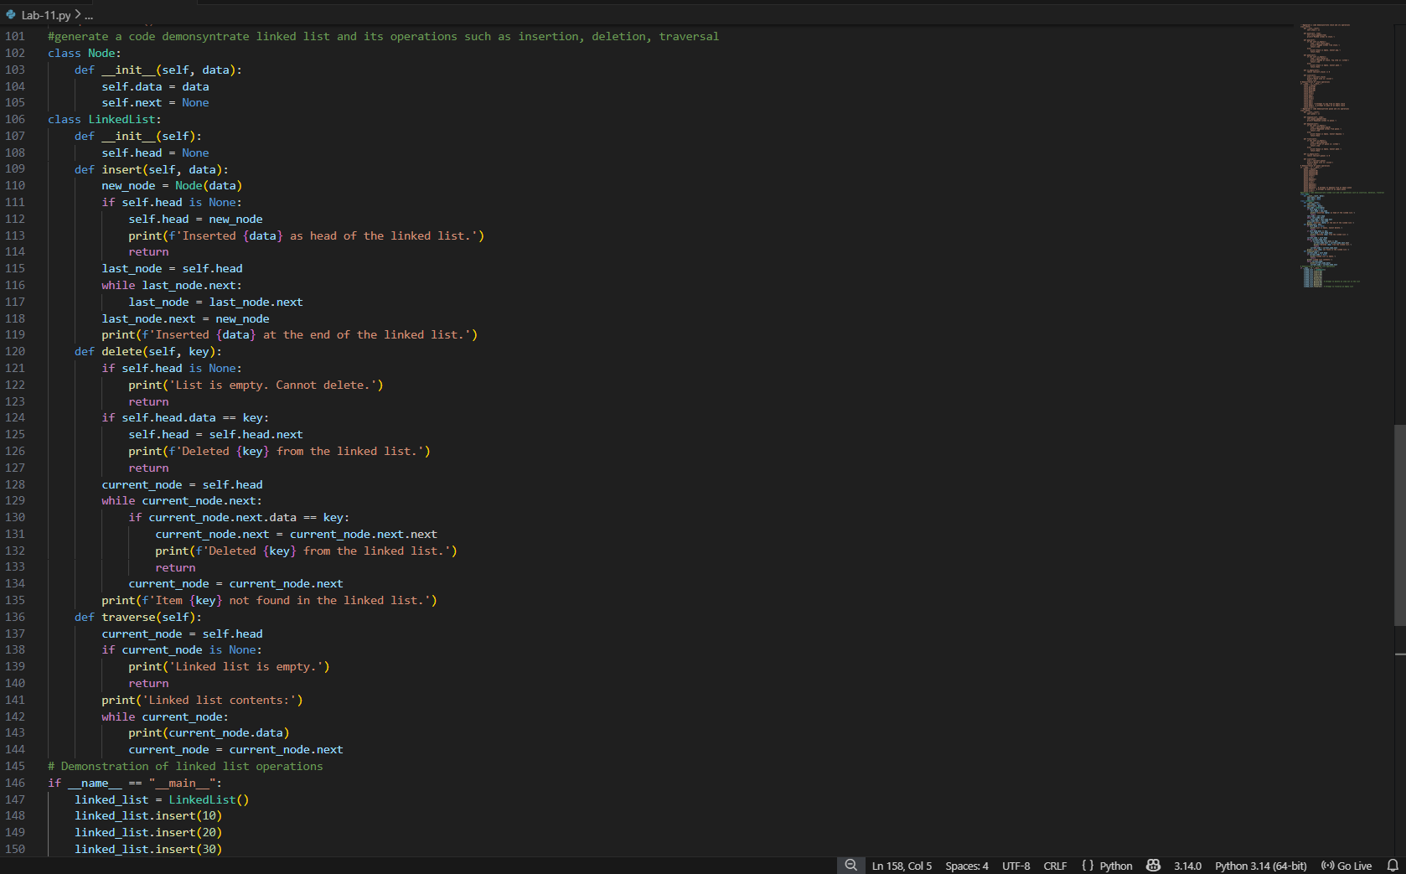
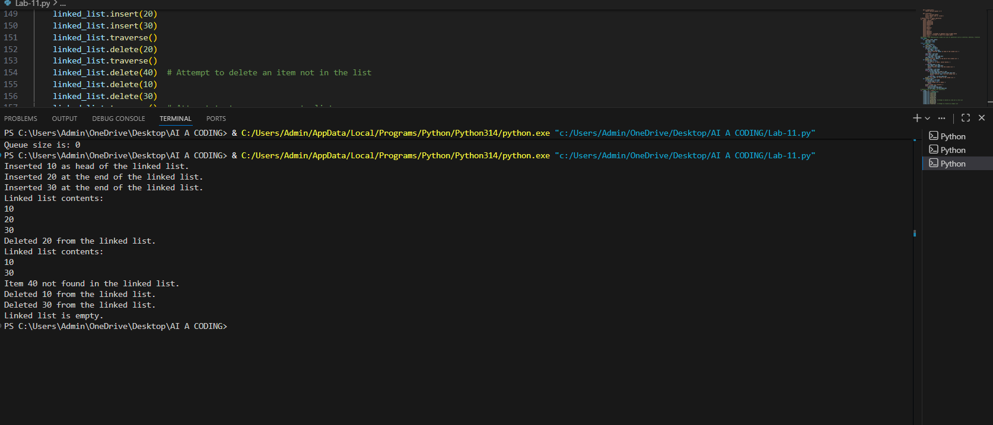
Task Description #4 – Binary Search Tree (BST)
Task: Use AI to create a BST with insert and in-order traversal methods.
Sample Input Code:
class BST:
pass
Expected Output:
• BST implementation with recursive insert and traversal methods.
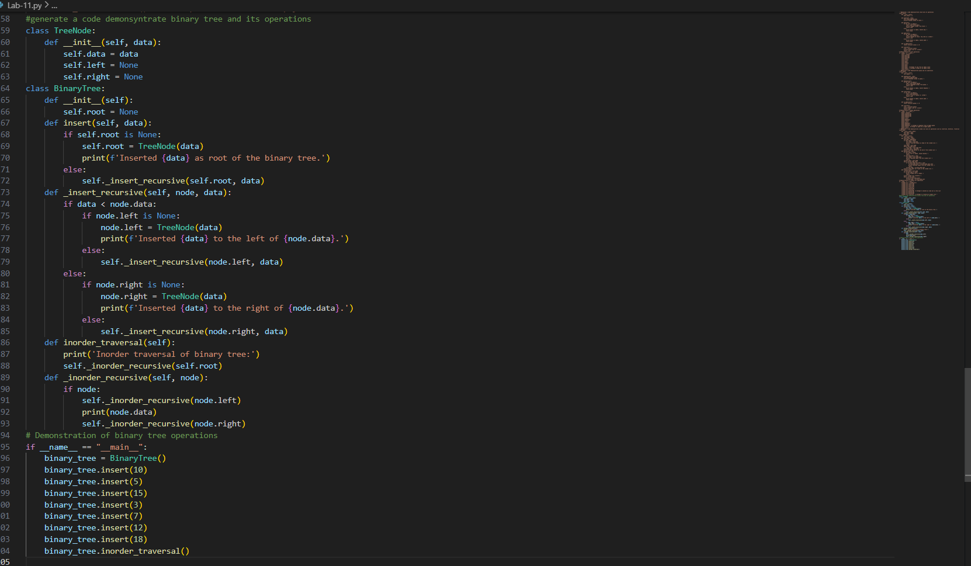
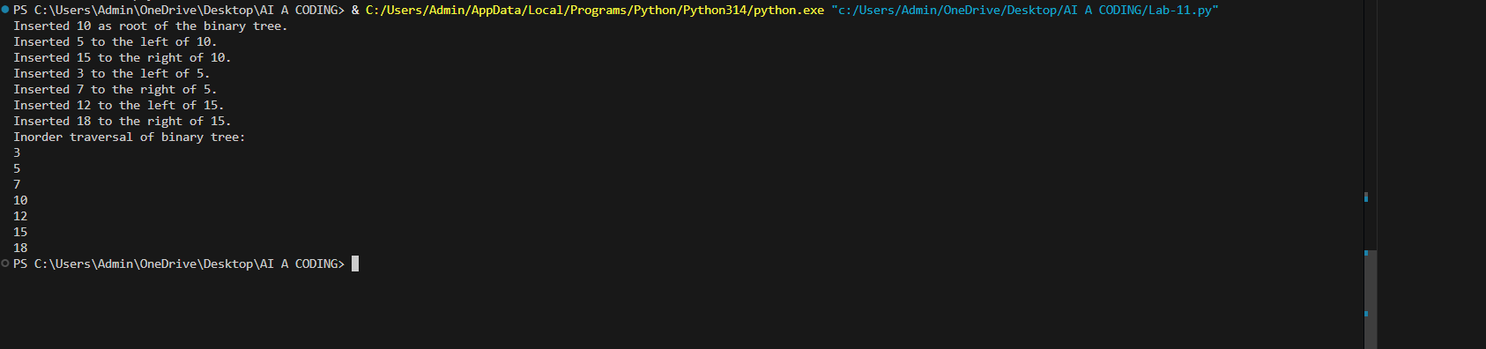
Task Description #5 – Hash Table
Task: Use AI to implement a hash table with basic insert, search, and
delete methods.
Sample Input Code:
class HashTable:
pass
Expected Output:
• Collision handling using chaining, with well-commented methods.
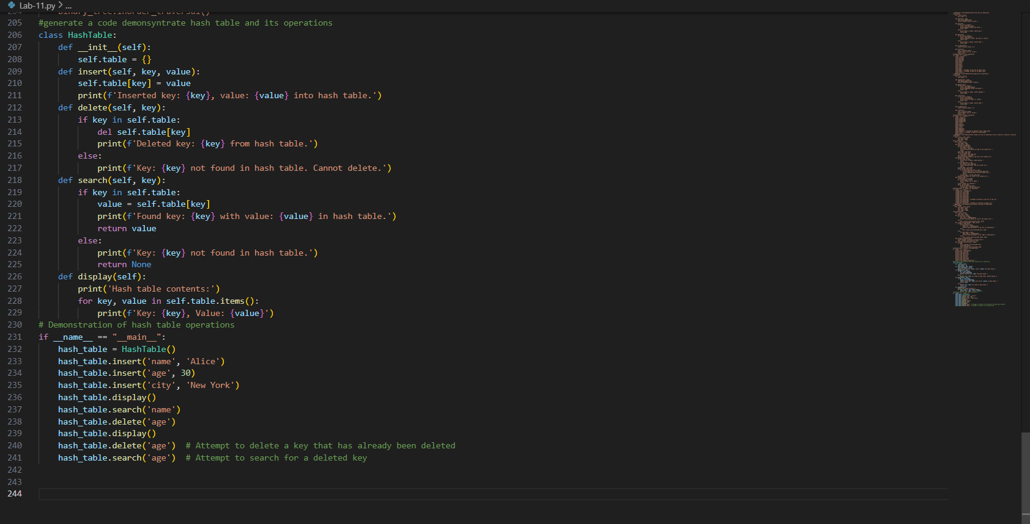
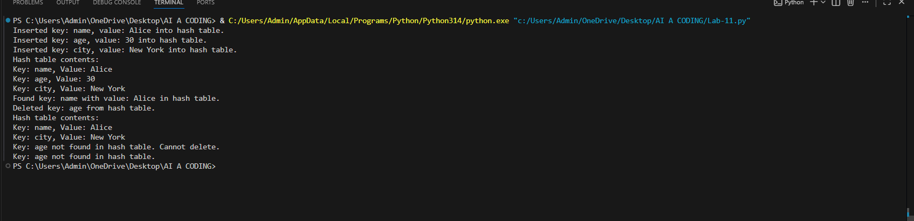
Task Description #6 – Graph Representation
Task: Use AI to implement a graph using an adjacency list.
Sample Input Code:
class Graph:
pass
Expected Output:
• Graph with methods to add vertices, add edges, and display
connections.
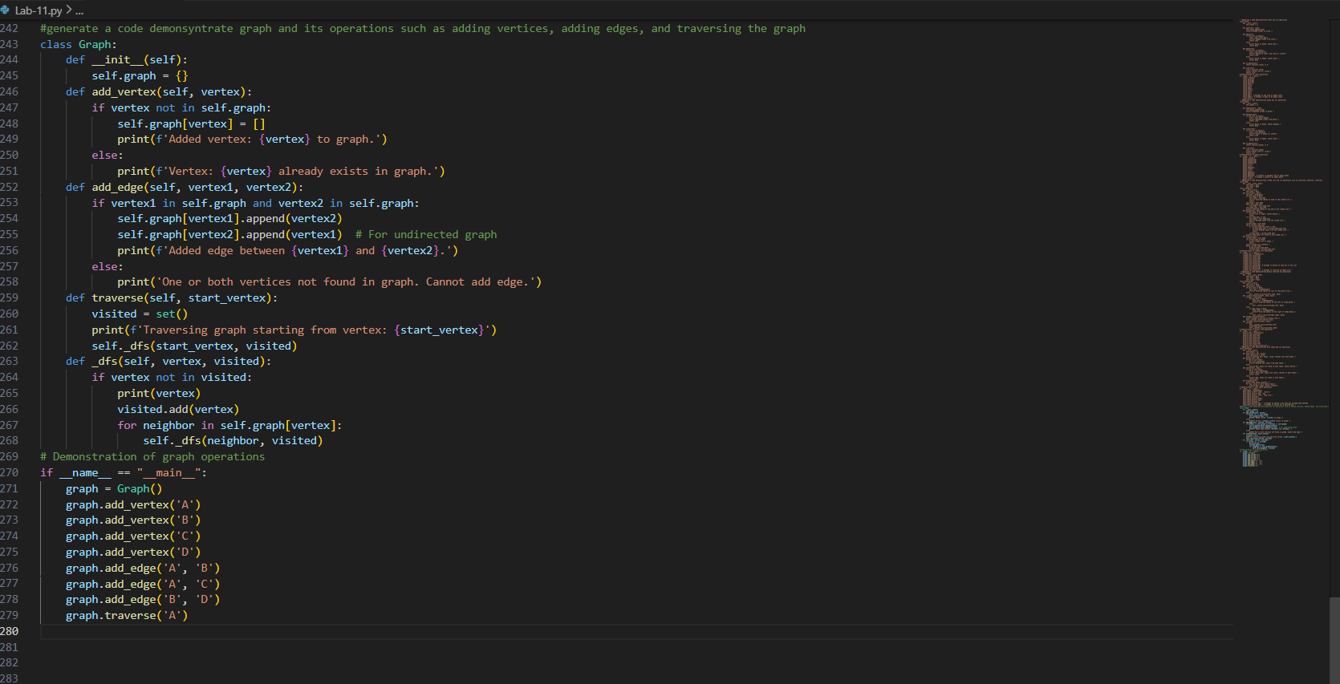
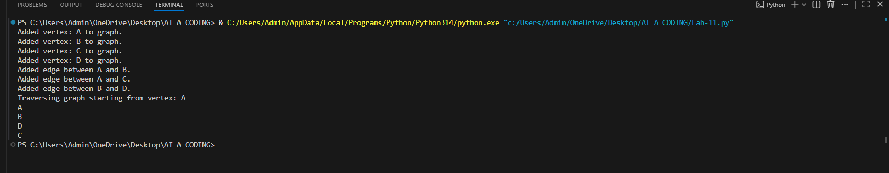
Task Description #7 – Priority Queue
Task: Use AI to implement a priority queue using Python’s heapq
module.
Sample Input Code:
class PriorityQueue:
pass
Expected Output:
• Implementation with enqueue (priority), dequeue (highest priority),
and display methods.
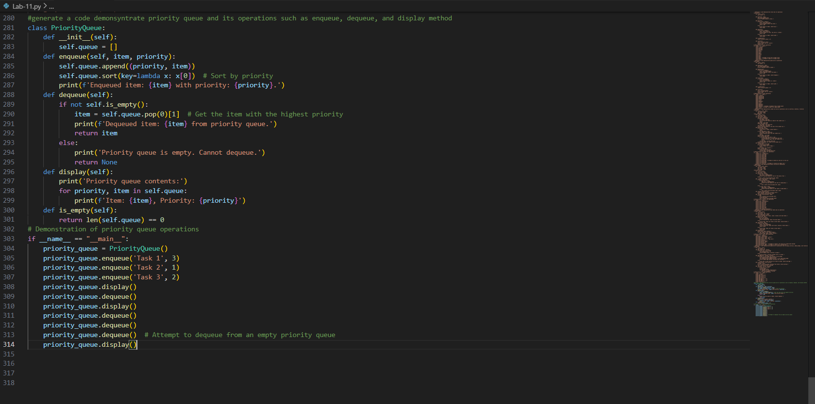
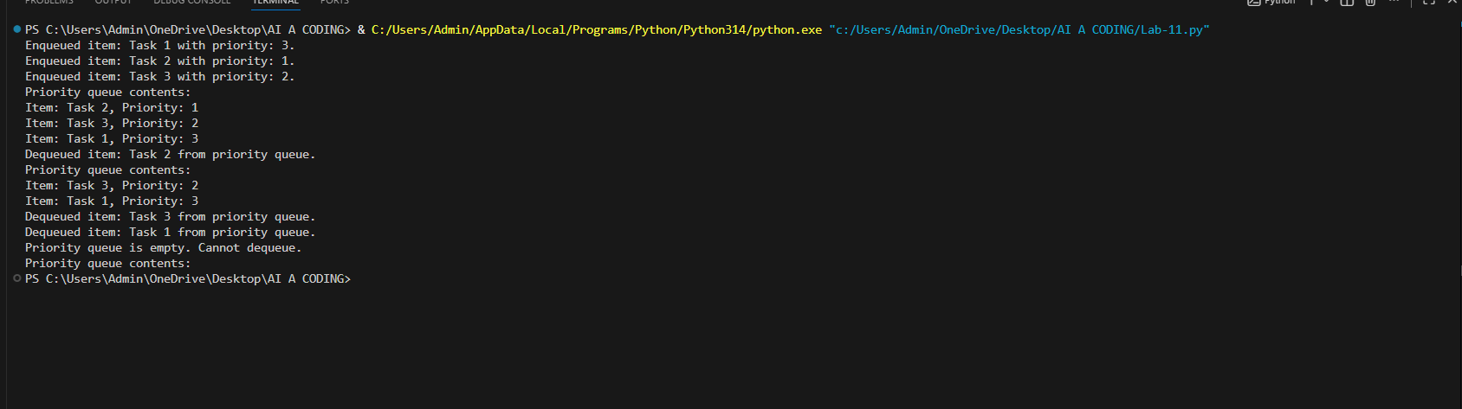
Task Description #8 – Deque
Task: Use AI to implement a double-ended queue using
collections.deque.
Sample Input Code:
class DequeDS:
pass
Expected Output:
• Insert and remove from both ends with docstrings.
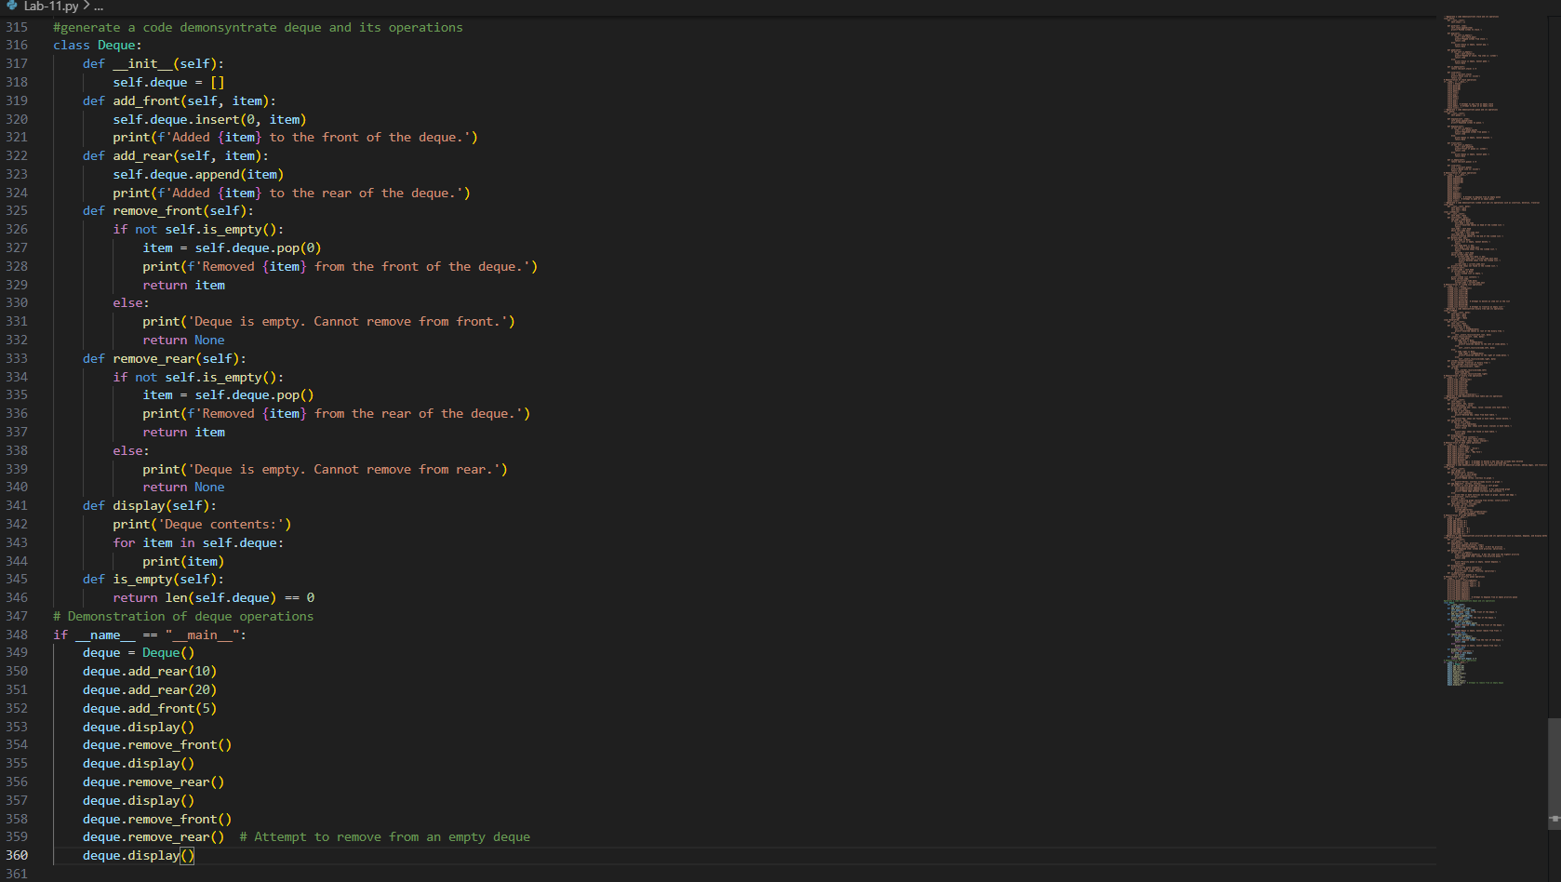
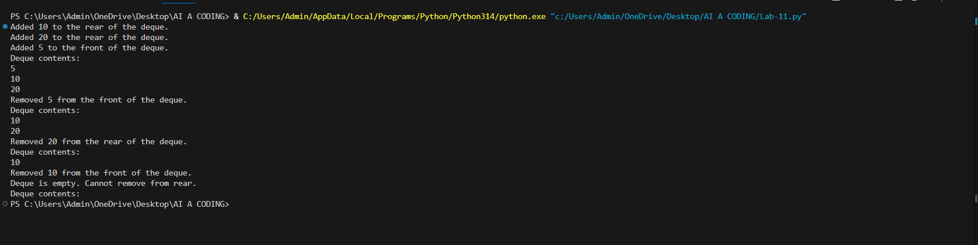
Task Description #9 Real-Time Application Challenge – Choose the
Right Data Structure
Scenario:
Your college wants to develop a Campus Resource Management System
that handles:
1. Student Attendance Tracking – Daily log of students
entering/exiting the campus.
2. Event Registration System – Manage participants in events with
quick search and removal.
3. Library Book Borrowing – Keep track of available books and their
due dates.
4. Bus Scheduling System – Maintain bus routes and stop
connections.
5. Cafeteria Order Queue – Serve students in the order they arrive.
Student Task:
• For each feature, select the most appropriate data structure from
the list below:
o Stack
o Queue
o Priority Queue
o Linked List
o Binary Search Tree (BST)
o Graph
o Hash Table
o Deque
• Justify your choice in 2–3 sentences per feature.
• Implement one selected feature as a working Python program with
AI-assisted code generation.
Expected Output:
• A table mapping feature → chosen data structure → justification.
• A functional Python program implementing the chosen feature
with comments and docstrings
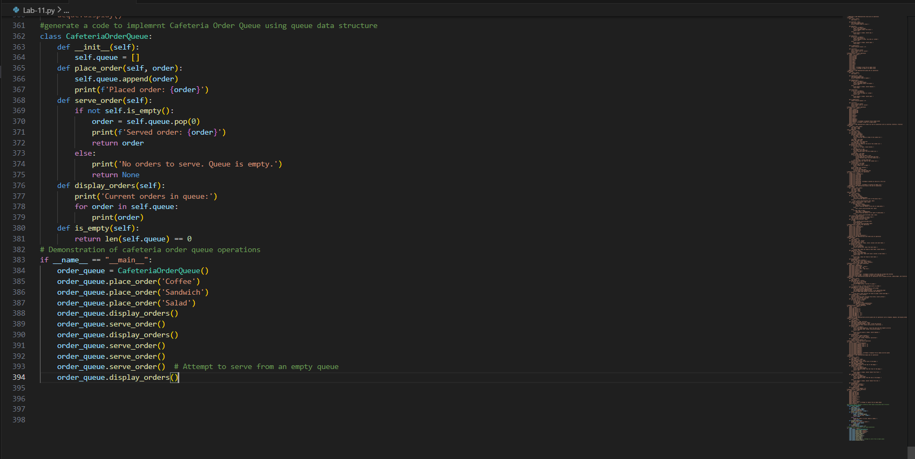
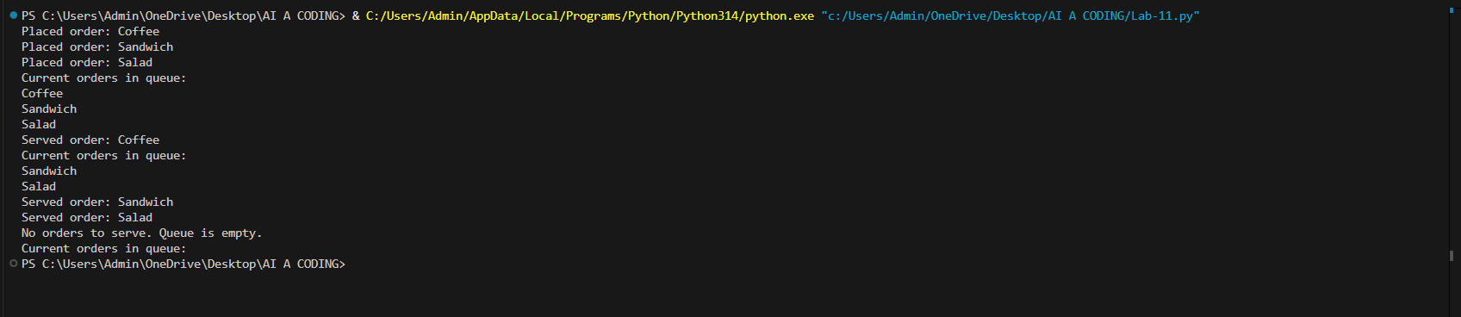
Justification :
1. Student Attendance Tracking → Hash Table
A hash table is ideal because each student can be uniquely identified by their student ID. This allows constant-time insertion and lookup when recording entry/exit logs. It avoids scanning through lists and ensures fast updates even with thousands of students.
2. Event Registration System → Binary Search Tree (BST)
A BST supports efficient searching, insertion, and deletion operations. Since event management requires quick participant lookup (by name or ID) and sometimes removal, a BST ensures logarithmic time complexity for these operations. It also keeps participants sorted, which is useful for generating ordered lists.
3. Library Book Borrowing → Linked List
A linked list is suitable for tracking borrowed books because it allows easy insertion and deletion when books are borrowed or returned. Unlike arrays, it doesn’t require shifting elements, making it efficient for dynamic updates. Due dates can be stored as part of each node for quick reference.
4. Bus Scheduling System → Graph
Bus routes and stops naturally form a graph structure, where stops are nodes and routes are edges. This allows modeling connections, finding shortest paths, and analyzing route connectivity. Graph algorithms (like BFS/DFS or Dijkstra’s) can be applied to optimize scheduling and routing.
5. Cafeteria Order Queue → Queue
A queue follows the FIFO (First-In-First-Out) principle, which directly matches the cafeteria serving process. Students are served in the order they arrive, ensuring fairness and simplicity. Queue operations (enqueue and dequeue) are efficient and straightforward to implement.

Task Description #10: Smart Hospital Management System – Data
Structure Selection
A hospital wants to develop a Smart Hospital Management System that
handles:
1. Patient Check-In System – Patients are registered and treated in
order of arrival.
2. Emergency Case Handling – Critical patients must be treated first.
3. Medical Records Storage – Fast retrieval of patient details using
ID.
4. Doctor Appointment Scheduling – Appointments sorted by time.
5. Hospital Room Navigation – Represent connections between
wards and rooms.
Student Task
• For each feature, select the most appropriate data structure from
the list below:
o Stack
o Queue
o Priority Queue
o Linked List
o Binary Search Tree (BST)
o Graph
o Hash Table
o Deque
• Justify your choice in 2–3 sentences per feature.
• Implement one selected feature as a working Python program with
AI-assisted code generation.
Expected Output:
• A table mapping feature → chosen data structure → justification.
• A functional Python program implementing the chosen feature
with comments and docstrings.
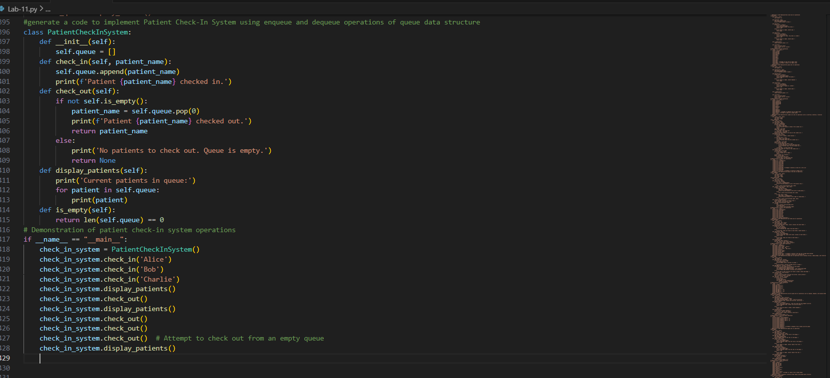
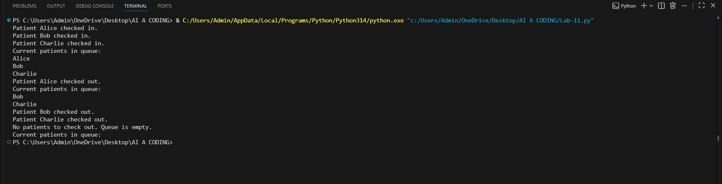
Justification :
1. Patient Check-In System → Queue
Patients are registered and treated in the order they arrive, which follows the FIFO (First-In-First-Out) principle. A queue ensures fairness and efficiency, as each patient is served in the exact sequence of arrival without skipping.
2. Emergency Case Handling → Priority Queue
Critical patients must be treated first, regardless of arrival time. A priority queue allows assigning urgency levels to patients, ensuring that those with higher priority (e.g., emergencies) are treated before less critical cases.
3. Medical Records Storage → Hash Table
Medical records need fast retrieval using patient ID. A hash table provides constant-time access for searching, inserting, and updating records, making it ideal for storing large volumes of patient data efficiently.
4. Doctor Appointment Scheduling → Binary Search Tree (BST)
Appointments are naturally sorted by time. A BST maintains sorted order and allows efficient insertion, deletion, and search operations. This ensures doctors’ schedules remain organized and can be quickly queried for available slots.
5. Hospital Room Navigation → Graph
Hospital rooms and wards are interconnected, much like nodes and edges in a graph. A graph structure allows modeling these connections, enabling navigation, shortest path finding, and route optimization for patients and staff.
Task Description #11: Smart City Traffic Control System
A city plans a Smart Traffic Management System that includes:
1. Traffic Signal Queue – Vehicles waiting at signals.
2. Emergency Vehicle Priority Handling – Ambulances and fire trucks
prioritized.
3. Vehicle Registration Lookup – Instant access to vehicle details.
4. Road Network Mapping – Roads and intersections connected
logically.
5. Parking Slot Availability – Track available and occupied slots.
Student Task
• For each feature, select the most appropriate data structure from
the list below:
o Stack
o Queue
o Priority Queue
o Linked List
o Binary Search Tree (BST)
o Graph
o Hash Table
o Deque
• Justify your choice in 2–3 sentences per feature.
• Implement one selected feature as a working Python program with
AI-assisted code generation.
Expected Output:
• A table mapping feature → chosen data structure → justification.
• A functional Python program implementing the chosen feature
with comments and docstrings.

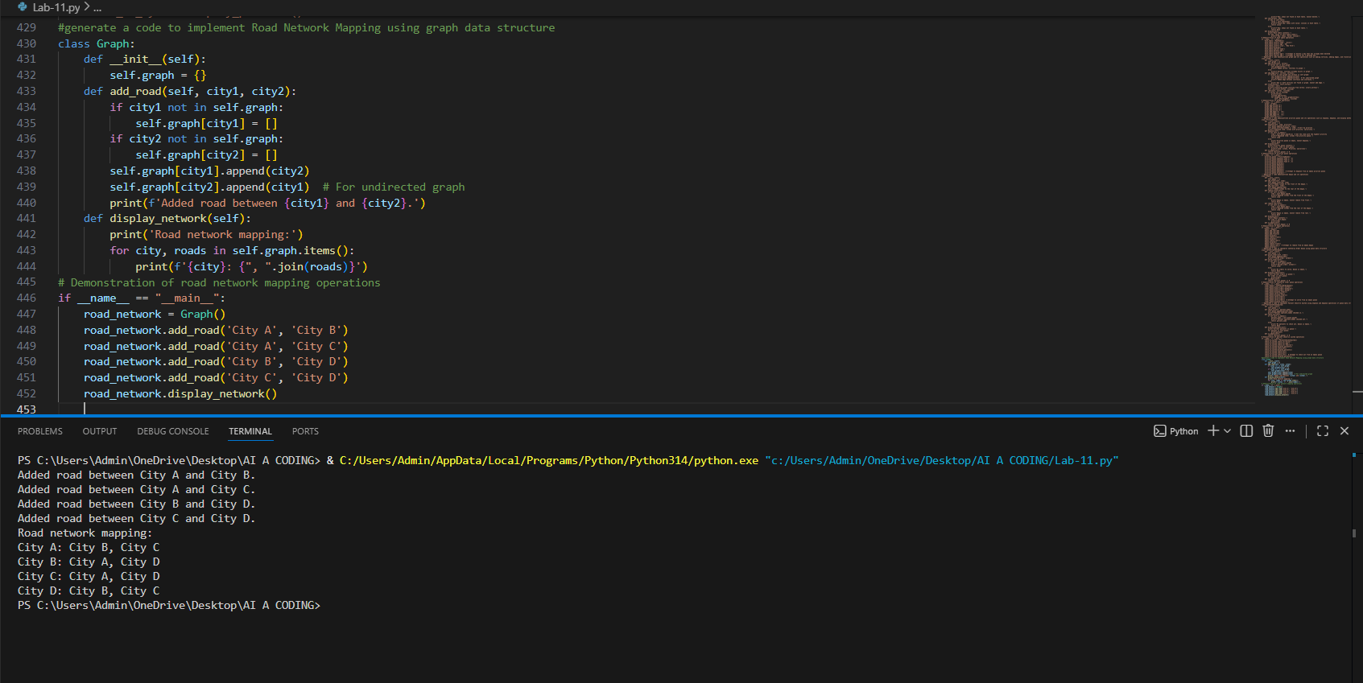
Justification
1. Traffic Signal Queue → Queue
A queue is ideal because vehicles at a signal follow the First-In, First-Out (FIFO) principle. The first car to arrive is the first to leave when the light turns green, which matches the natural behavior of traffic flow.
2. Emergency Vehicle Priority Handling → Priority Queue
A priority queue ensures that vehicles with higher priority (like ambulances and fire trucks) are processed before normal vehicles. This allows emergency services to bypass regular waiting times and guarantees faster passage.
3. Vehicle Registration Lookup → Hash Table
A hash table provides constant-time average lookup for vehicle details using the registration number as a key. This makes it the most efficient choice for instant access to vehicle information in a large dataset.
4. Road Network Mapping → Graph
Roads and intersections are naturally represented as a graph, where intersections are nodes and roads are edges. Graphs can capture connectivity, direction (for one-way roads), and weights (distance or travel time), making them perfect for navigation and route optimization.
5. Parking Slot Availability → Binary Search Tree (BST)
A BST allows efficient insertion, deletion, and search operations for parking slots organized by slot number. It helps quickly determine whether a slot is available or occupied, and scales well for large parking facilities.
Task Description #12: Smart E-Commerce Platform – Data Structure
Challenge
An e-commerce company wants to build a Smart Online Shopping System
with:
1. Shopping Cart Management – Add and remove products
dynamically.
2. Order Processing System – Orders processed in the order they are
placed.
3. Top-Selling Products Tracker – Products ranked by sales count.
4. Product Search Engine – Fast lookup of products using product ID.
5. Delivery Route Planning – Connect warehouses and delivery
locations.
Student Task
• For each feature, select the most appropriate data structure from
the list below:
o Stack
o Queue
o Priority Queue
o Linked List
o Binary Search Tree (BST)
o Graph
o Hash Table
o Deque
• Justify your choice in 2–3 sentences per feature.
• Implement one selected feature as a working Python program with
AI-assisted code generation.
Expected Output:
• A table mapping feature → chosen data structure → justification.
• A functional Python program implementing the chosen feature
with comments and docstrings.
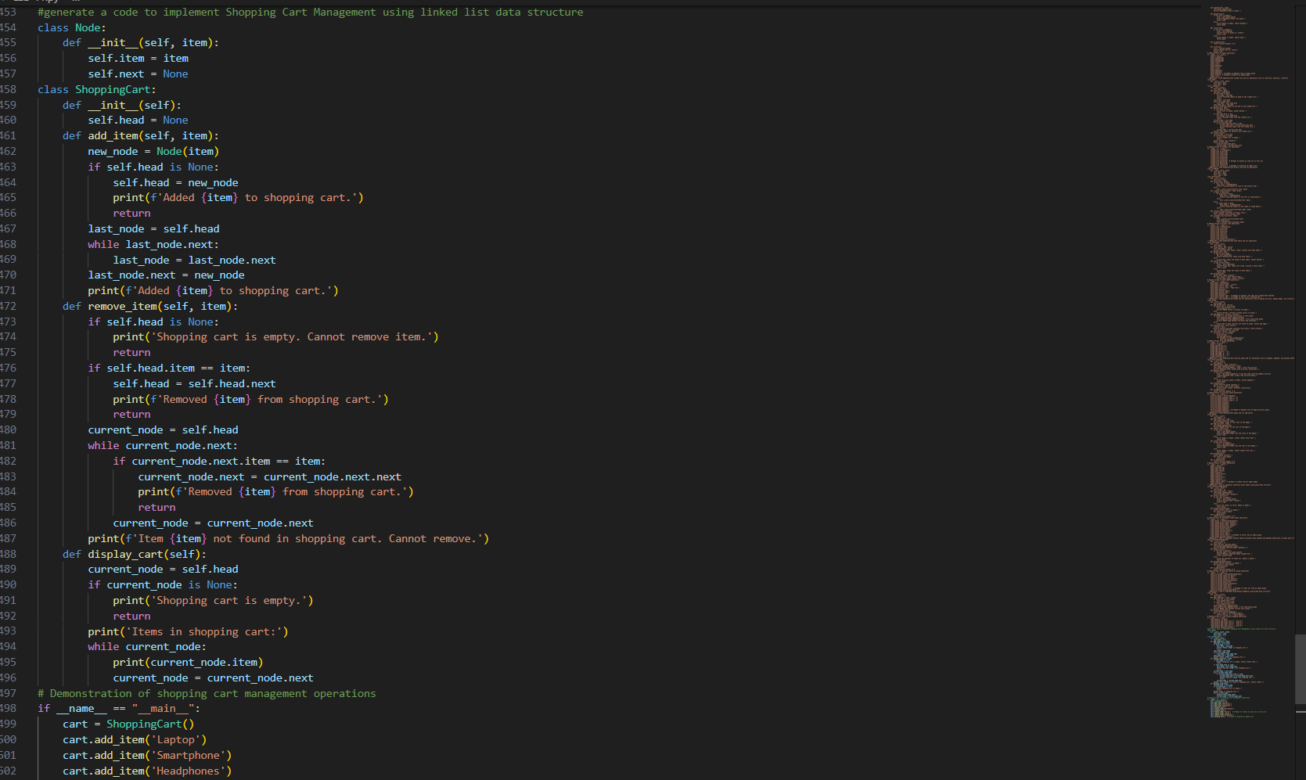
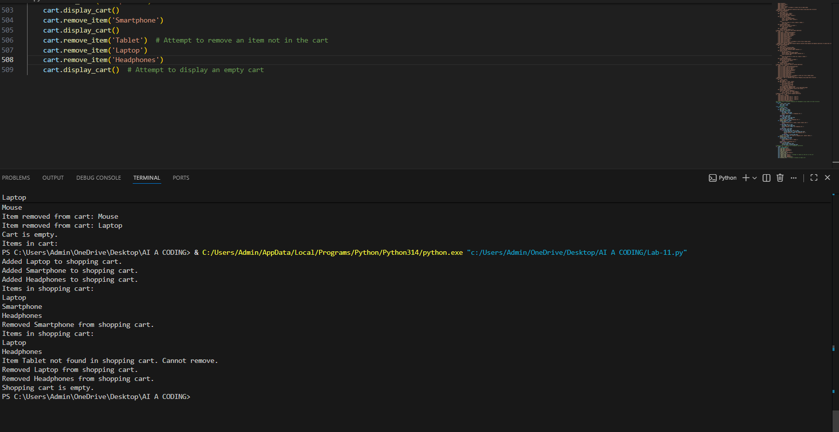
Justification:
1. Shopping Cart Management → Linked List
A linked list allows dynamic addition and removal of products without needing to shift elements, making it efficient for managing a cart where items can be inserted or deleted at any position.
2. Order Processing System → Queue
Orders must be processed in the First-In, First-Out (FIFO) order to ensure fairness and accuracy. A queue naturally models this behavior, as the first order placed is the first to be processed.
3. Top-Selling Products Tracker → Priority Queue
A priority queue can rank products based on their sales count, ensuring that the most popular items are always at the top. This makes it easy to track and display top-selling products dynamically.
4. Product Search Engine → Hash Table
A hash table provides constant-time average lookup for product details using product IDs as keys. This ensures fast and efficient product searches in a large catalog.
5. Delivery Route Planning → Graph
Warehouses and delivery locations can be represented as nodes, and routes as edges. Graphs are ideal for modeling connectivity and applying shortest-path algorithms (like Dijkstra or A*) to optimize delivery routes.
Task #13: Smart Logistics & Warehouse Management
Scenario:
A logistics company wants to implement:
1. Shipment Processing
2. Urgent Shipment Priority
3. Product Lookup by Code
4. Warehouse Network Connectivity
5. Inventory Add/Remove Operations
Student Task
• For each feature, select the most appropriate data structure from
the list below:
o Stack
o Queue
o Priority Queue
o Linked List
o Binary Search Tree (BST)
o Graph
o Hash Table
o Deque
• Justify your choice in 2–3 sentences per feature.
• Implement one selected feature as a working Python program with
AI-assisted code generation.
Expected Output:
• A table mapping feature → chosen data structure → justification.
• A functional Python program implementing the chosen feature
with comments and docstrings.

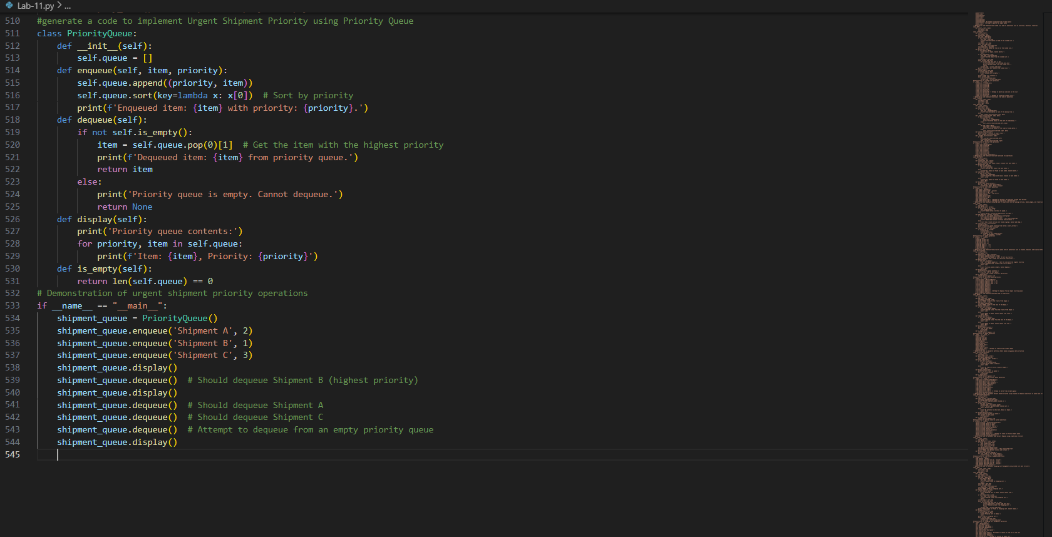
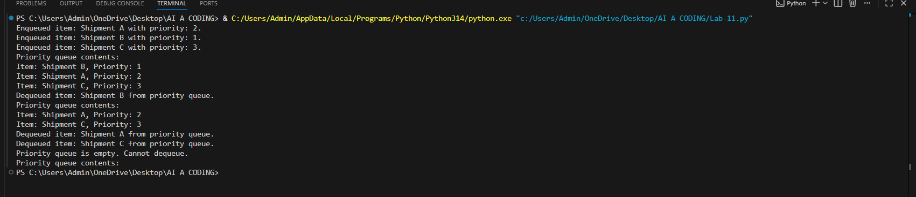
Justification:
1. Shipment Processing → Queue
Shipments should be processed in the order they arrive, following the First-In, First-Out (FIFO) principle. A queue ensures fairness and efficiency by handling shipments sequentially.
2. Urgent Shipment Priority → Priority Queue
Urgent shipments, such as express or perishable goods, must be prioritized over regular ones. A priority queue allows assigning higher priority to urgent shipments so they are processed first regardless of arrival order.
3. Product Lookup by Code → Hash Table
A hash table provides constant-time average lookup for product details using product codes as keys. This ensures fast and efficient retrieval of product information in large inventories.
4. Warehouse Network Connectivity → Graph
Warehouses and distribution centers can be represented as nodes, with routes between them as edges. Graphs are ideal for modeling connectivity and applying shortest-path algorithms to optimize delivery and transfer routes.
5. Inventory Add/Remove Operations → Linked List
A linked list allows dynamic addition and removal of inventory items without shifting elements, making it efficient for managing stock levels where products are frequently added or removed.
Task Description #14: Smart Banking Management System – Data
Structure Challenge
A bank plans to develop a Smart Banking System that includes:
1. Customer Service Token System – Customers are served in order
of arrival.
2. Loan Approval Priority Handling – High-value or urgent loans
processed first.
3. Account Information Lookup – Fast retrieval of customer details
using Account Number.
4. Transaction History Management – Maintain chronological
transaction records.
5. ATM Network Connectivity – Represent connections between
ATMs across cities.
Student Task:
• For each feature, select the most appropriate data structure from
the list below:
o Stack
o Queue
o Priority Queue
o Linked List
o Binary Search Tree (BST)
o Graph
o Hash Table
o Deque
• Justify your choice in 2–3 sentences per feature.
• Implement one selected feature as a working Python program
with AI-assisted code generation.
Expected Output:
• A table mapping feature → chosen data structure → justification.
• A functional Python program implementing the chosen feature
with comments and docstrings.
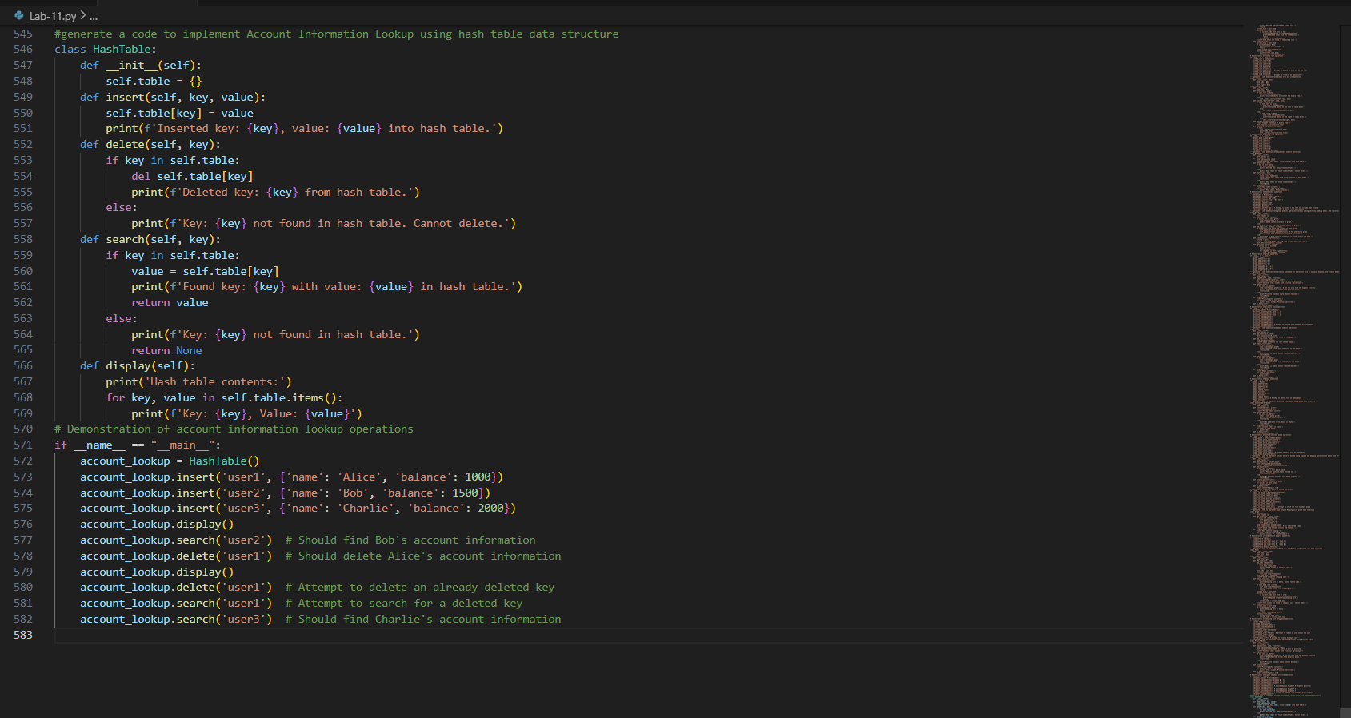
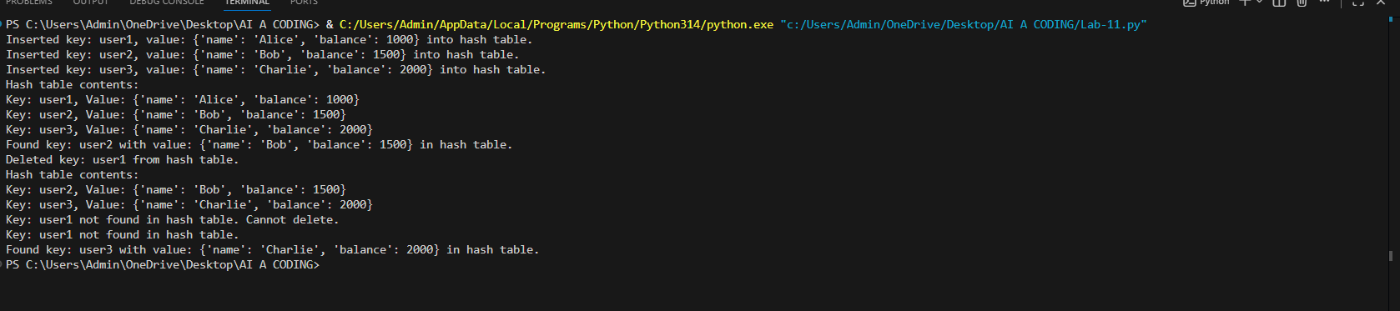
Justification:
1. Customer Service Token System → Queue
Customers should be served in the order they arrive, following the First-In, First-Out (FIFO) principle. A queue models this behavior perfectly, ensuring fairness and orderly service.
2. Loan Approval Priority Handling → Priority Queue
High-value or urgent loan requests must be processed before regular ones. A priority queue allows assigning priority levels so that critical loans are handled first regardless of arrival order.
3. Account Information Lookup → Hash Table
Account numbers can be used as keys in a hash table, enabling constant-time average lookup for customer details. This ensures fast and efficient retrieval of account information in large banking systems.
4. Transaction History Management → Linked List
Transactions are recorded chronologically, and a linked list allows efficient insertion at the end while maintaining order. It also supports easy traversal to review past transactions in sequence.
5. ATM Network Connectivity → Graph
ATMs across cities can be represented as nodes, with connections between them as edges. Graphs are ideal for modeling network connectivity and applying shortest-path algorithms to optimize cash routing and maintenance.
Task Description #15: Online Learning Management System – Data
Structure Selection
An online education platform wants to develop a Learning Management
System that handles:
1. Student Login Authentication – Quick validation of user
credentials.
2. Assignment Submission Queue – Submissions processed in order
of upload.
3. Top Performer Ranking – Rank students based on scores.
4. Course Prerequisite Structure – Represent subject dependencies.
5. Undo Feature in Online Editor – Reverse recent actions.
Student Task:
• Select the most appropriate data structure for each feature from
the given list.
• Justify your selection in 2–3 sentences per feature.
• Implement one selected feature in Python using AI-assisted code
generation.
Expected Output:
• Feature → Data Structure → Justification table.
• Functional Python program with proper documentation.
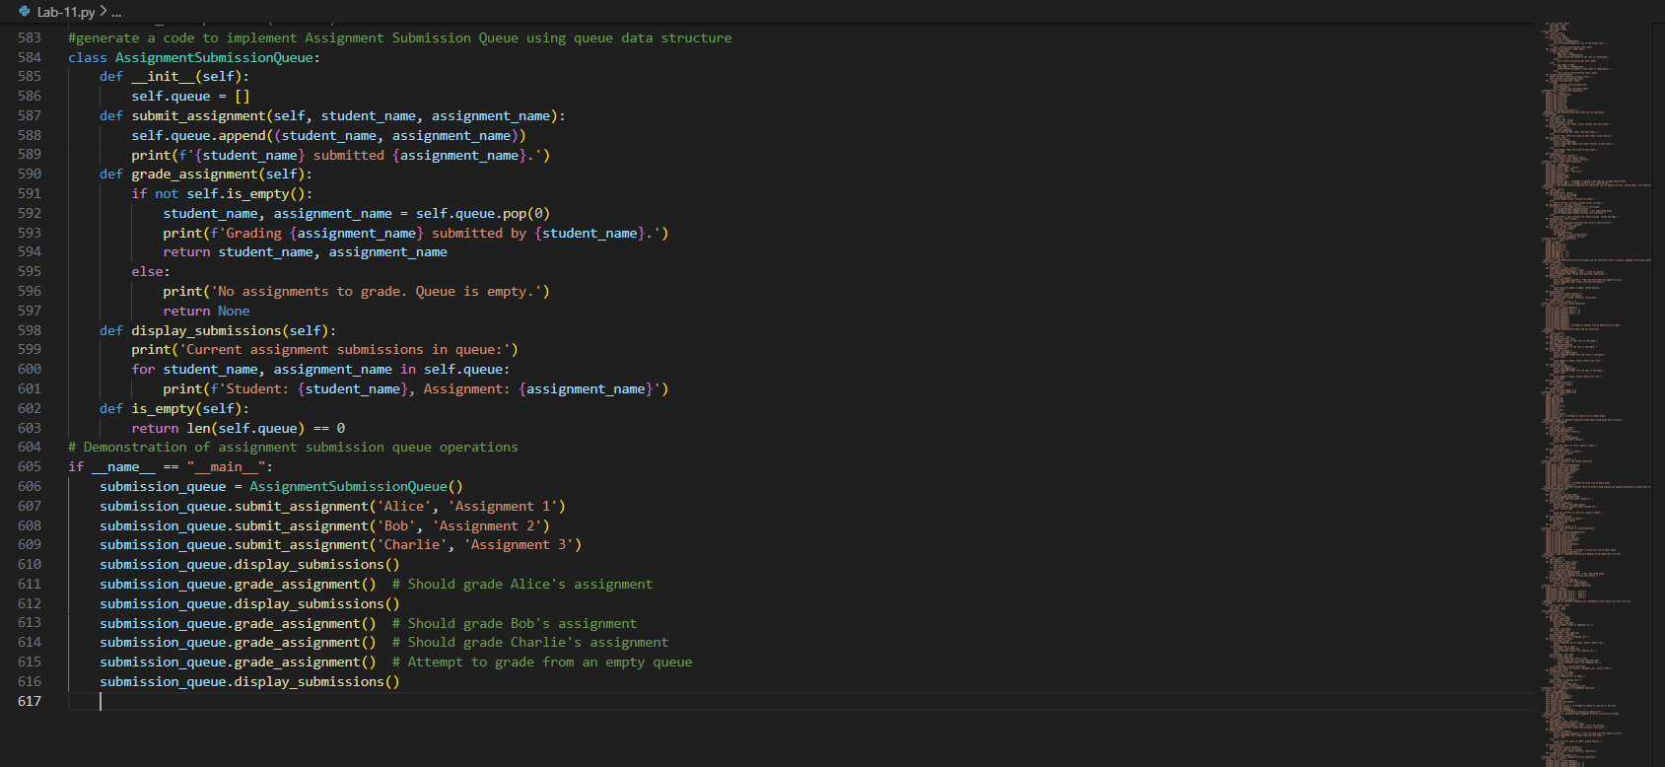
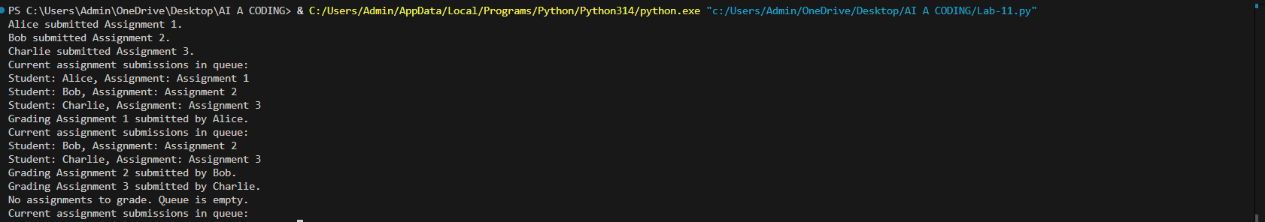
Justification :
1. Student Login Authentication → Hash Table
User credentials (like username or account ID) can be stored as keys in a hash table, allowing constant-time average lookup for quick validation. This ensures fast and efficient authentication even with a large number of students.
2. Assignment Submission Queue → Queue
Assignments should be processed in the order they are uploaded, following the First-In, First-Out (FIFO) principle. A queue models this behavior perfectly, ensuring fairness and sequential handling of submissions.
3. Top Performer Ranking → Priority Queue
Students can be ranked based on scores, with higher scores given higher priority. A priority queue ensures that top performers are always at the front, making it easy to display rankings dynamically.
4. Course Prerequisite Structure → Graph
Courses and their prerequisites can be represented as nodes and directed edges. A graph is ideal for modeling dependencies and applying algorithms like topological sorting to determine valid course sequences.
5. Undo Feature in Online Editor → Stack
The undo operation requires reversing the most recent action first, which follows the Last-In, First-Out (LIFO) principle. A stack is the natural choice, as it allows pushing actions and popping them when undone.

Task Description #16: Smart Airport Management System – Data
Structure Challenge
An airport authority plans to implement:
1. Passenger Check-In Queue – Process passengers in order of
arrival.
2. Emergency Landing Priority – Aircraft in emergency get priority.
3. Flight Information Lookup – Fast search using Flight ID.
4. Air Route Connectivity – Airports connected via routes.
5. Boarding Process (Last-In First-Out Cabin Storage) – Overhead
luggage management simulation.
Student Task:
• Choose suitable data structures from the provided list.
• Provide 2–3 sentence justification per feature.
• Implement one feature in Python with comments and docstrings
using AI assistance.
Expected Output:
• Mapping table.
• Working Python implementation.
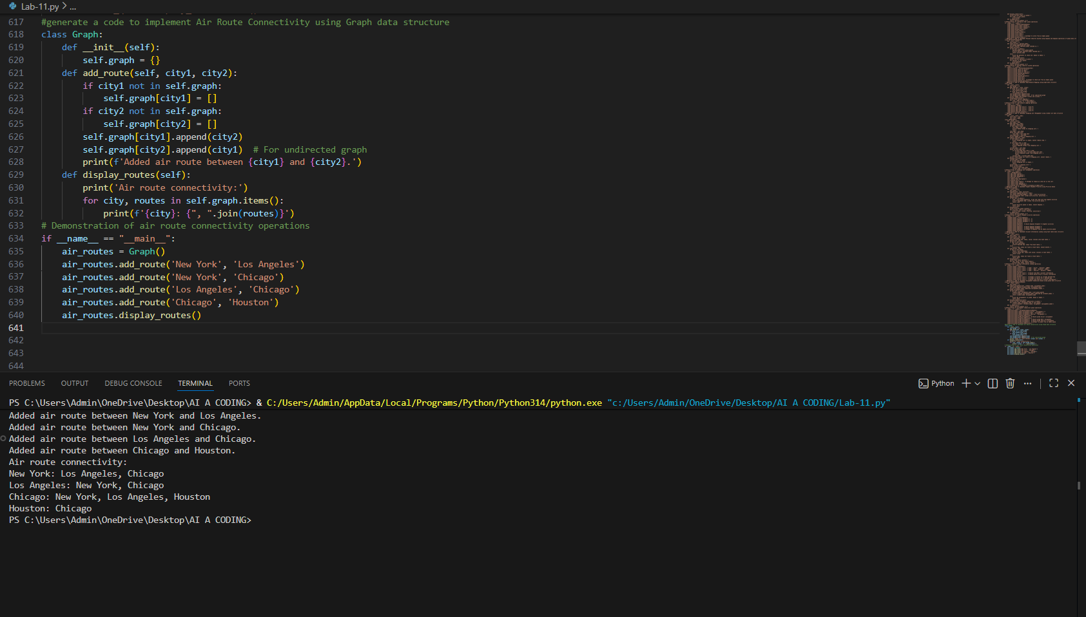
justification:
1. Passenger Check-In Queue → Queue
Passengers should be processed in the order they arrive, following the First-In, First-Out (FIFO) principle. A queue ensures fairness and orderly handling of check-ins.
2. Emergency Landing Priority → Priority Queue
Aircraft in emergency situations must be prioritized over regular landings. A priority queue allows assigning higher priority to emergency flights so they are handled first regardless of arrival order.
3. Flight Information Lookup → Hash Table
Flight IDs can be used as keys in a hash table, enabling constant-time average lookup for flight details. This ensures fast and efficient retrieval of information in a large flight database.
4. Air Route Connectivity → Graph
Airports and their connecting routes can be represented as nodes and edges. Graphs are ideal for modeling connectivity and applying shortest-path algorithms to optimize flight paths and route planning.
5. Boarding Process (Last-In First-Out Cabin Storage) → Stack
Overhead luggage storage follows a Last-In, First-Out (LIFO) principle, as the last bag placed in is the first to be removed. A stack models this behavior perfectly, making it suitable for simulating cabin storage operations.
Task Description #17: Smart Social Media Platform – Data Structure
Selection
A social media company wants to develop a system that includes:
1. News Feed Generation – Display posts chronologically.
2. Trending Hashtags Tracker – Rank hashtags by usage frequency.
3. User Profile Search – Quick lookup using username.
4. Friend Network Representation – Represent user connections.
5. Message Undo Feature – Allow last sent message to be
withdrawn.
Student Task:
• Select appropriate data structures from the list.
• Justify your choices clearly.
• Implement one selected feature as a Python program using AI-
assisted code generation.
Expected Output:
• Table mapping features to data structures with justification.
• Working Python code with docstrings and comments.
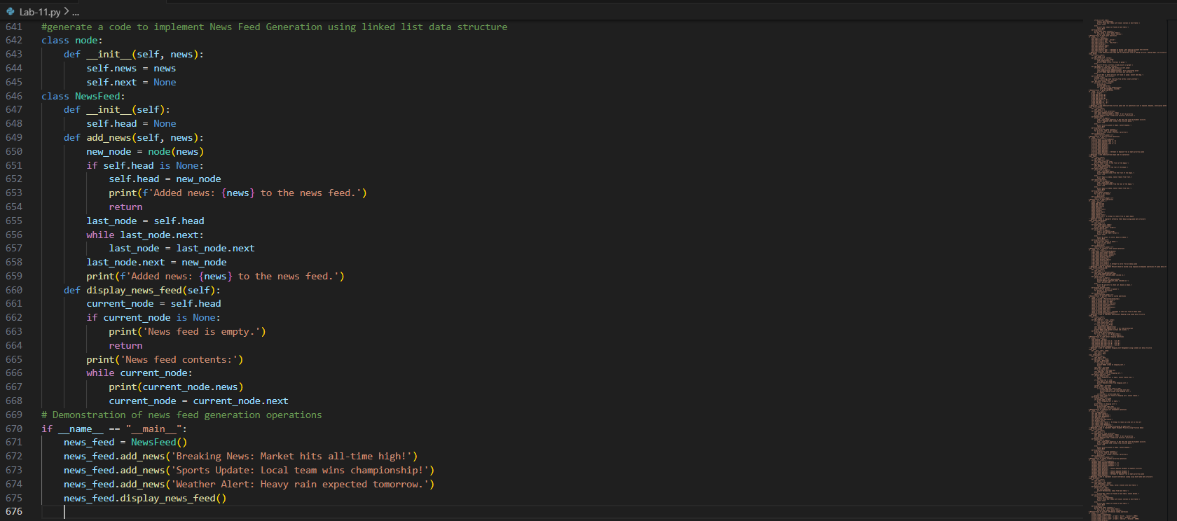
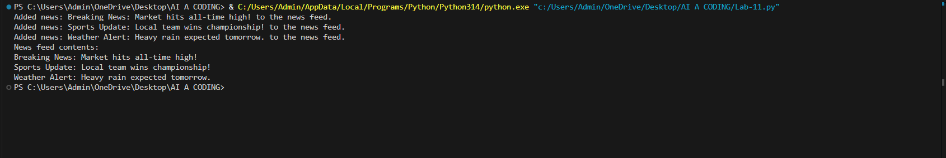
justification :
1. News Feed Generation → Linked List
Posts in a news feed are displayed chronologically, and a linked list allows efficient insertion of new posts at the end while maintaining order. It also supports sequential traversal to display posts in the correct timeline.
2. Trending Hashtags Tracker → Priority Queue
Hashtags can be ranked based on usage frequency, with the most popular ones given higher priority. A priority queue ensures that trending hashtags are always at the top for quick retrieval and display.
3. User Profile Search → Hash Table
Usernames can be stored as keys in a hash table, enabling constant-time average lookup for profile details. This ensures fast and efficient search even in a large user base.
4. Friend Network Representation → Graph
Users are nodes and friendships are edges, making a graph the natural choice to represent social connections. Graphs allow efficient traversal for mutual friends, recommendations, and connectivity analysis.
5. Message Undo Feature → Stack
Undoing a sent message requires reversing the most recent action first, which follows the Last-In, First-Out (LIFO) principle. A stack is ideal for storing actions and popping them when undone.

Task #18: Smart University Hostel Management
Scenario:
A university wants to build a hostel management system that manages:
1. Room Allotment
2. Medical Emergency Handling
3. Student Record Retrieval
4. Hostel Block Connectivity
5. Visitor Entry Log
Student Task
• For each feature, select the most appropriate data structure from
the list below:
o Stack
o Queue
o Priority Queue
o Linked List
o Binary Search Tree (BST)
o Graph
o Hash Table
o Deque
• Justify your choice in 2–3 sentences per feature.
• Implement one selected feature as a working Python program with
AI-assisted code generation.
Expected Output:
• A table mapping feature → chosen data structure → justification.
• A functional Python program implementing the chosen feature
with comments and docstrings.
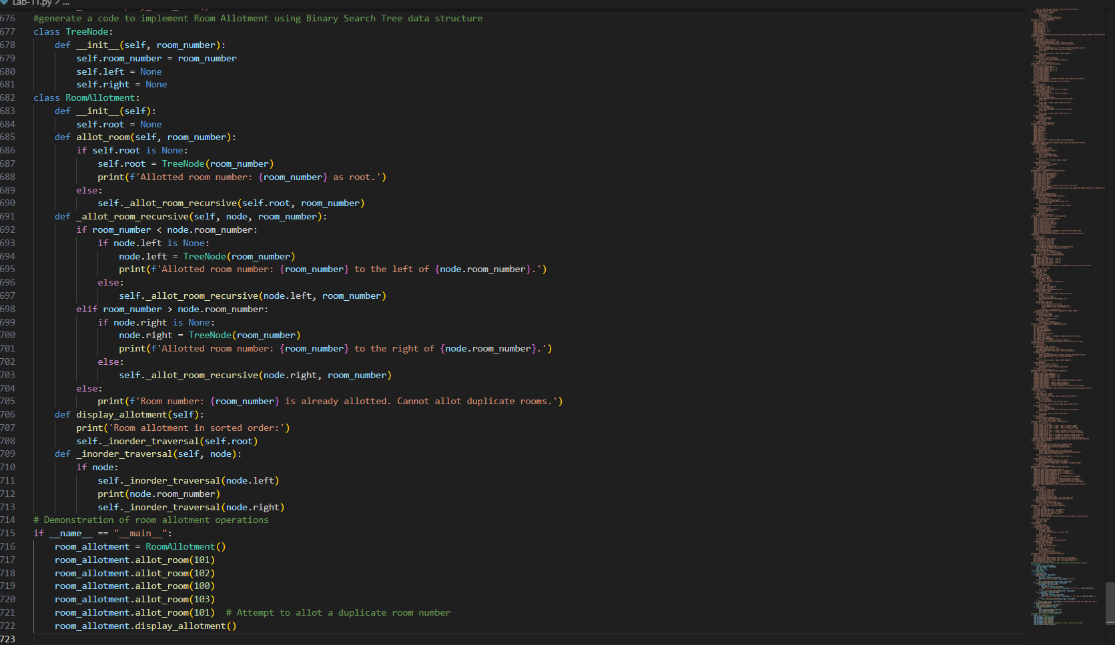

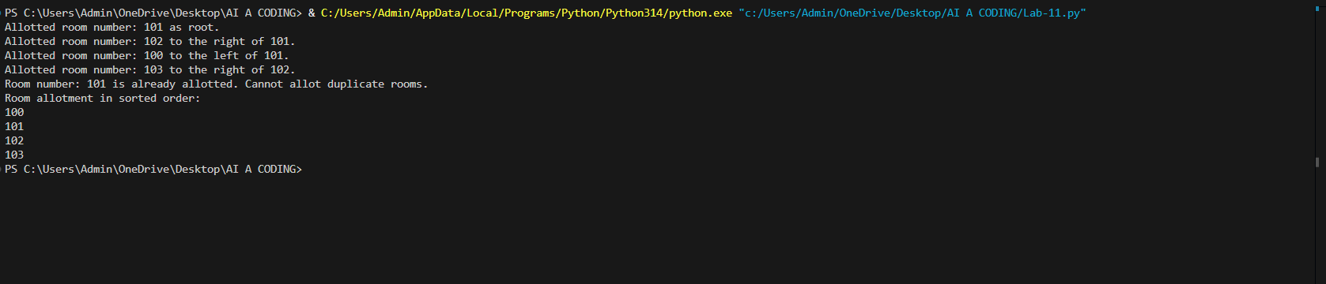
Justification:
1. Room Allotment → Binary Search Tree (BST)
Rooms can be organized by room numbers, and a BST allows efficient insertion, deletion, and search operations. This makes it easy to quickly find available rooms or check occupancy status.
2. Medical Emergency Handling → Priority Queue
Medical emergencies must be prioritized over regular hostel activities. A priority queue ensures that urgent cases are handled first by assigning higher priority to emergency requests.
3. Student Record Retrieval → Hash Table
Student records can be stored with unique identifiers (like student ID) as keys. A hash table provides constant-time average lookup, making retrieval of student details fast and efficient.
4. Hostel Block Connectivity → Graph
Hostel blocks and their connecting paths can be represented as nodes and edges. Graphs are ideal for modeling connectivity and applying traversal algorithms to optimize movement or resource distribution across blocks.
5. Visitor Entry Log → Queue
Visitors enter and exit in the order they arrive, following the First-In, First-Out (FIFO) principle. A queue models this behavior perfectly, ensuring orderly tracking of visitor entries and exits.

Task #19: Smart Electricity Distribution System
Scenario:
An electricity board plans to develop a system that includes:
1. Complaint Handling
2. Fault Priority Handling
3. Consumer Record Lookup
4. Power Grid Connectivity
5. Meter Reading History Tracking
Student Task
• For each feature, select the most appropriate data structure from
the list below:
o Stack
o Queue
o Priority Queue
o Linked List
o Binary Search Tree (BST)
o Graph
o Hash Table
o Deque
• Justify your choice in 2–3 sentences per feature.
• Implement one selected feature as a working Python program with
AI-assisted code generation.
Expected Output:
• A table mapping feature → chosen data structure → justification.
• A functional Python program implementing the chosen feature
with comments and docstrings.
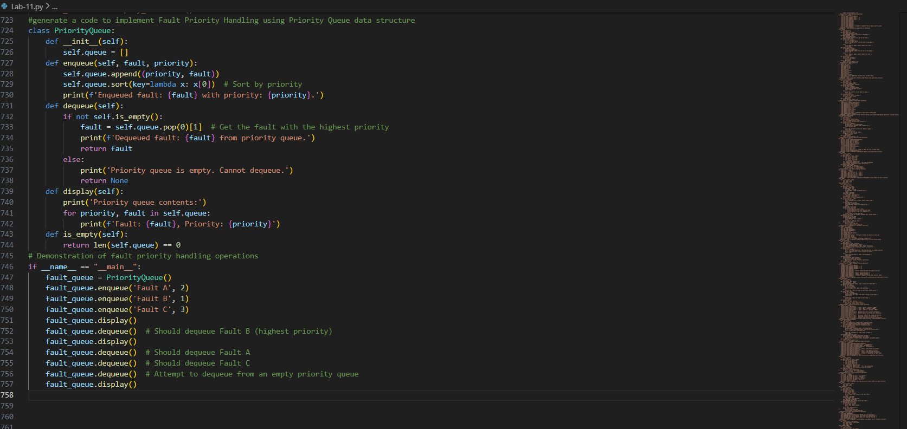
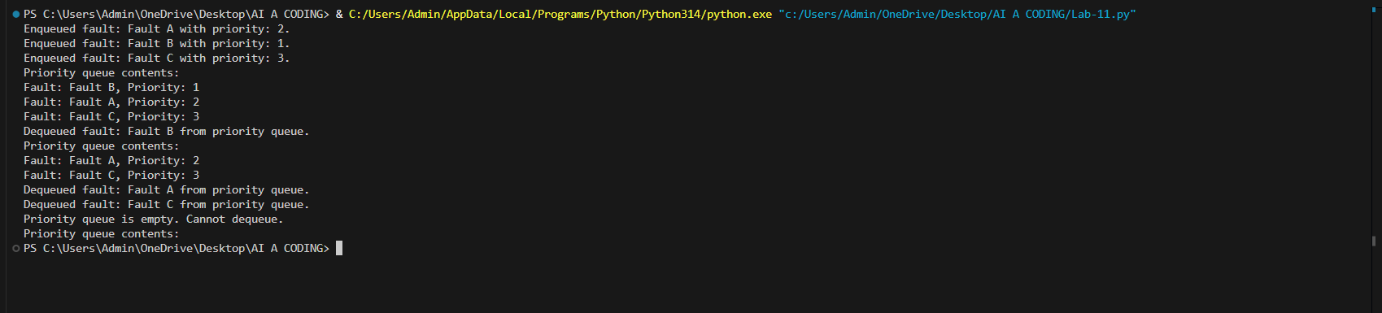
justification:
1. Complaint Handling → Queue
Complaints should be addressed in the order they are received, following the First-In, First-Out (FIFO) principle. A queue ensures fairness and systematic resolution of customer issues.
2. Fault Priority Handling → Priority Queue
Critical faults, such as major outages, must be resolved before minor issues. A priority queue allows assigning higher priority to urgent faults so they are handled first regardless of arrival order.
3. Consumer Record Lookup → Hash Table
Consumer records can be stored with unique identifiers (like account numbers) as keys. A hash table provides constant-time average lookup, ensuring quick and efficient retrieval of consumer details.
4. Power Grid Connectivity → Graph
Power stations, substations, and distribution points can be represented as nodes, with transmission lines as edges. Graphs are ideal for modeling connectivity and applying traversal or shortest-path algorithms to optimize electricity distribution.
5. Meter Reading History Tracking → Linked List
Meter readings are recorded chronologically, and a linked list allows efficient insertion of new readings while maintaining order. It also supports sequential traversal to review past readings in the correct timeline.

