AI ASSISTED CODING
ASSIGNMENT-17
Name: E.Asmaja
H.T.No:2303A51011

Task 1: Perform EDA on Penguin dataset(from seaborn)
- Load and display entire dataset
- Display country wise count
- Visualize bar chart (country wise)
- Visualize bar chart with values count at top
- Visualize pairplot and other plots
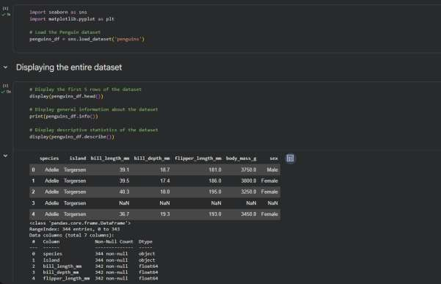
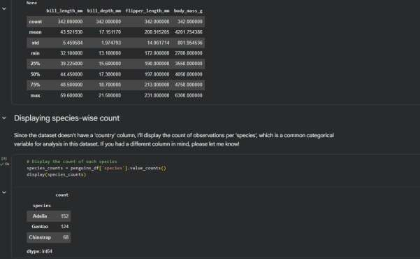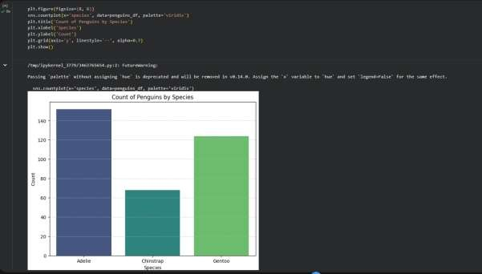
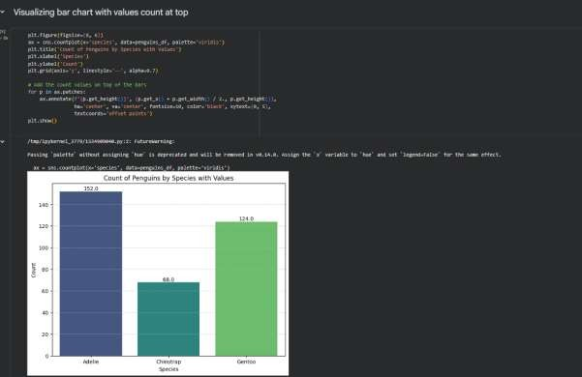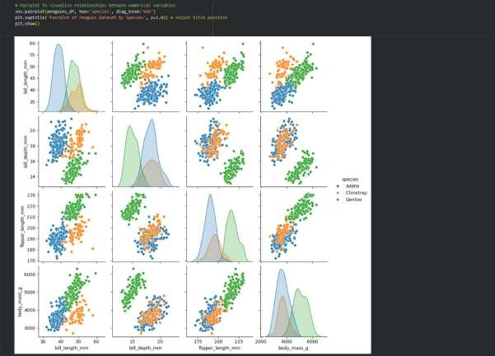
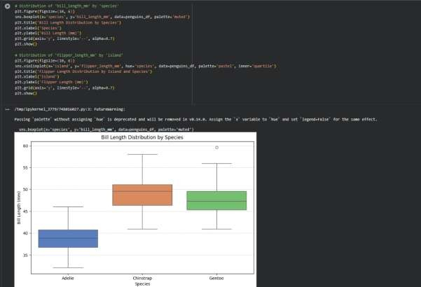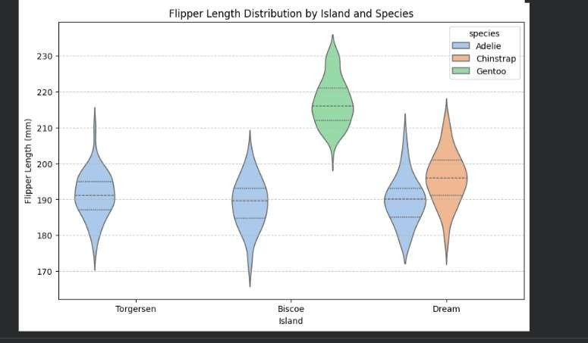

Task 2: Perform EDA on HealthExp dataset(seaborn)
- Load and display entire dataset
- Display columns and statistical summary(describe)
- Display missing values , and draw bar chart
- Visualize pairplot, regplot and box plot, scatter plot etc
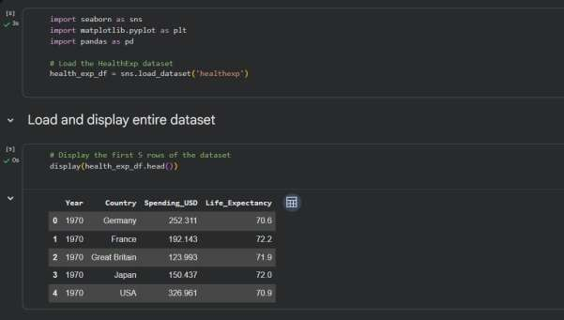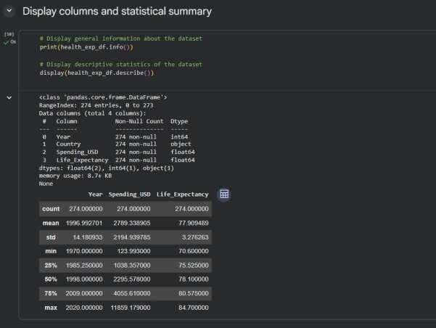
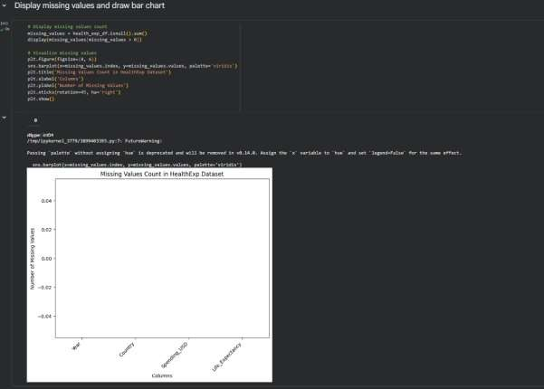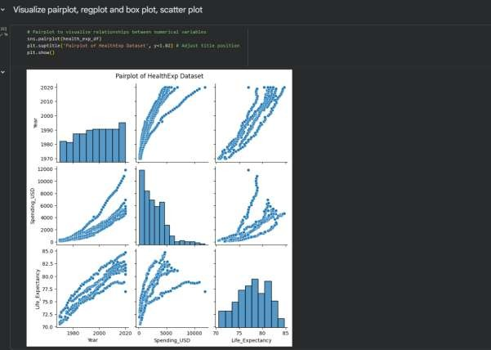
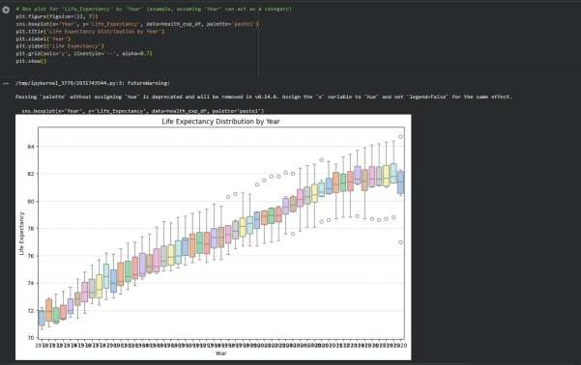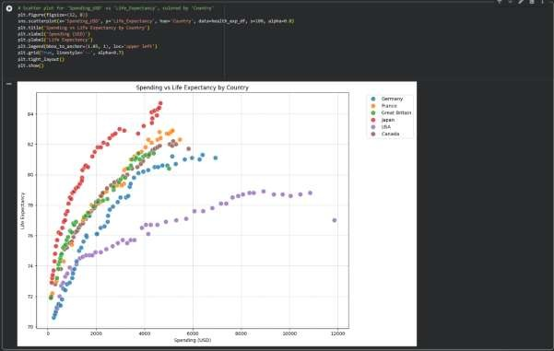

Task 3: Perform following task on given dataset (Train the model)
- Analyze the Planets dataset to understand its structure, features, and missing values.
- Perform data cleaning and preprocessing to handle missing or incorrect data.
- Train the dataset using different machine learning models to make predictions.
- Compare and explain the performance of all trained models with proper reasoning.
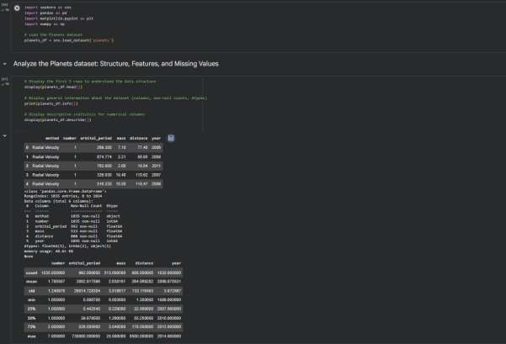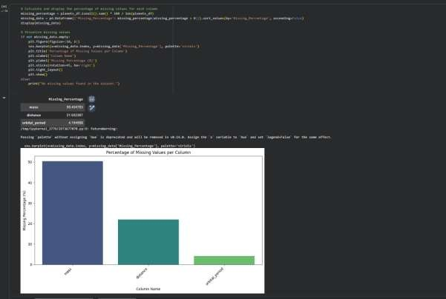
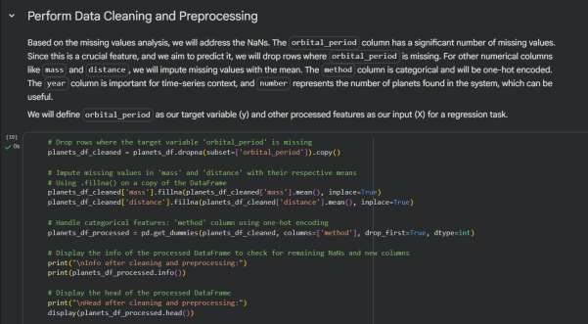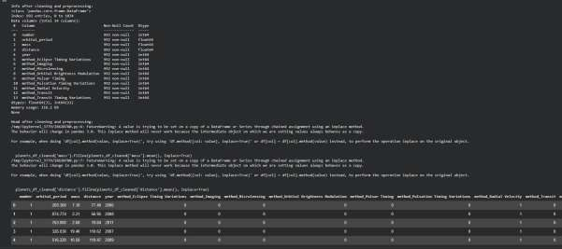
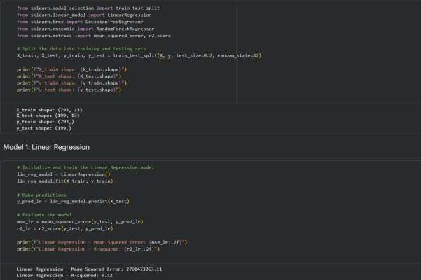

Task 4: Perform following task on given dataset (Train the model)
- Load the MNIST dataset from PyTorch.
- Display basic information and visualize sample input images with their class labels.
- Perform data preprocessing
- Design a EfficientNet model for imageclassification.
- Train the CNN model (10 epochs)
- Evaluate model performance using accuracy and loss metrics.
- Visualize the training history (accuracy and loss curves).
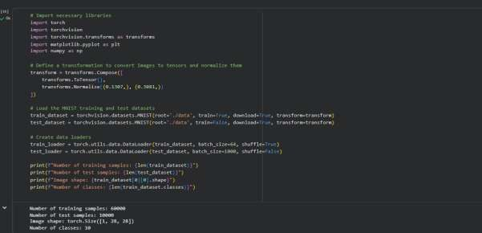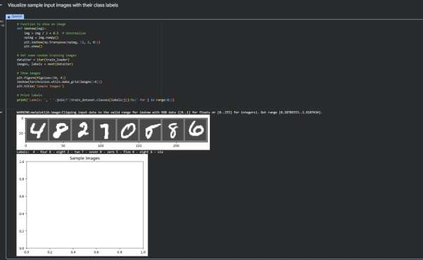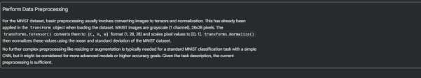

Task 5 – Customer Data Cleaning
Task:
Use AI to generate a Python script for cleaning a customer dataset.
Instructions:
- Handle missing values in columns (age, income, city).
- Remove duplicate records.
- Standardize text values (e.g., city names in lowercase).
- Encode categorical variables (gender, city).
Sample Code:
import pandas as pd data = pd.read_csv("shopping_trends.csv") print(data.head())
Dataset link:
https://www.kaggle.com/datasets/iamsouravbanerjee/custome r-shopping-trends-dataset?select=shopping_trends.csv
Expected Output:
- A cleaned Pandas data frame ready for analysis.
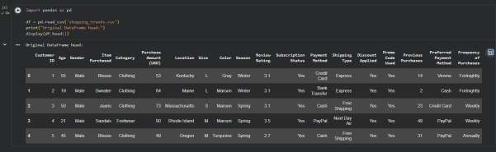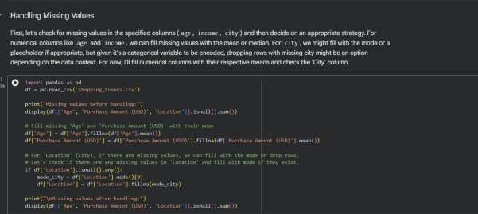
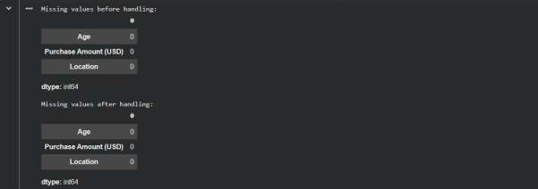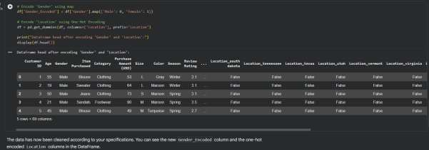

Task 6 – Sales Data Preprocessing
Task:
Preprocess sales transaction data using AI assistance.
Instructions:
- Convert date columns into datetime format.
- Create new features (month, year, day of week).
- Normalize sales amount column.
- Detect and handle outliers in dataset.
Sample Code:
import pandas as pd data = pd.read_csv("sales_data.csv") print(data.head())
Dataset link: https://www.kaggle.com/datasets/vinothkannaece/sales-dataset?select=sales_data.csv
Expected Output:
- A transformed dataset with time-based features and normalized values.
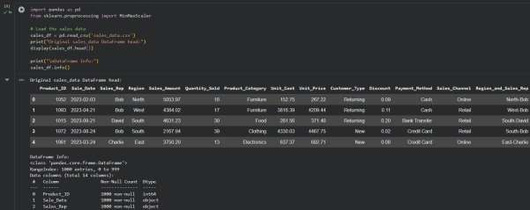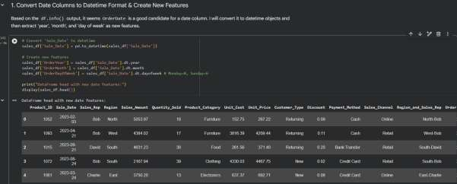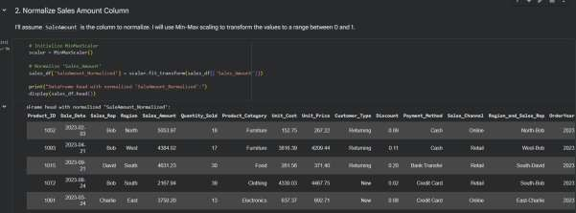
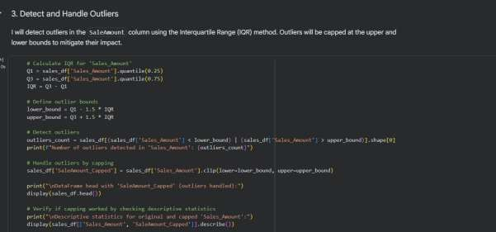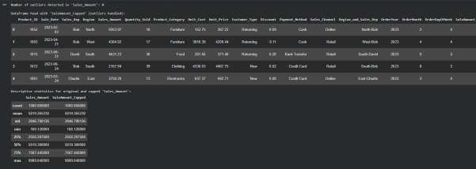
Task 7 – Healthcare Data Preparation
Task:
Clean and preprocess a healthcare dataset using AI scripts.
Instructions:
- Handle missing values in blood_pressure, cholesterol.
- Encode categorical features
- Scale numerical features (min-max or standard scaling).
- Split dataset into training and testing sets.
Dataset link :
https://www.kaggle.com/datasets/abdallaahmed77/healthcare-risk-factors-dataset
Expected Output:
- A preprocessed dataset ready for machine learning models.
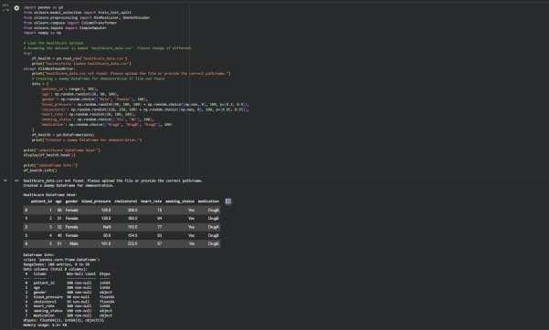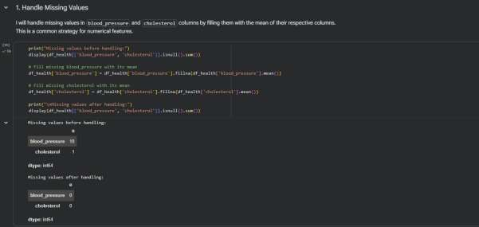
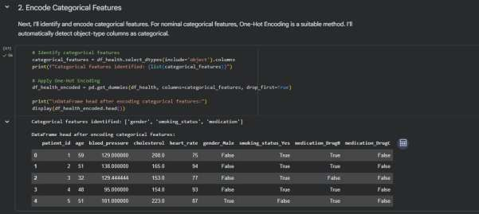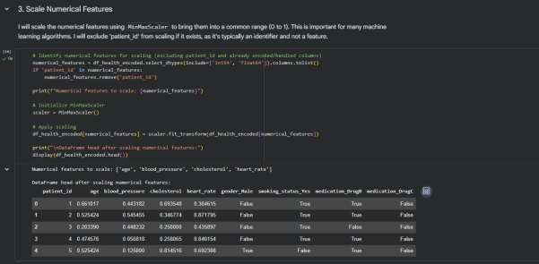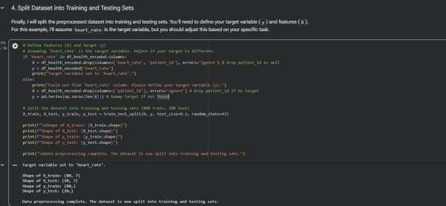
Task 8 – Employee Salary Data Preprocessing
Task:
Clean and preprocess an employee salary dataset using AI scripts.
Instructions:
- Handle missing values
- Detect and remove salary outliers.
- Standardize department names (lowercase).
- Apply label encoding to job location, department.
Dataset link:
https://www.kaggle.com/code/vishantmathur/employee-salary
Expected Output:
- A structured dataset ready for HR analytics.
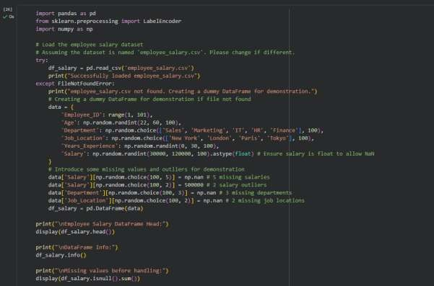
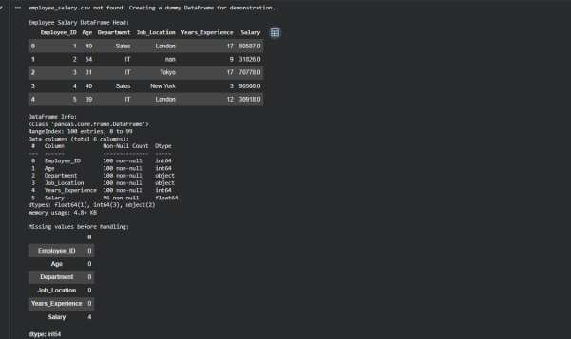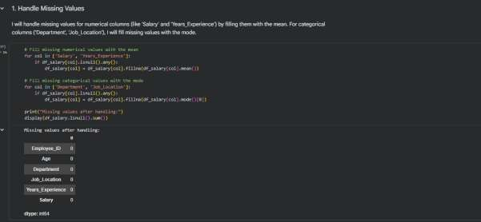
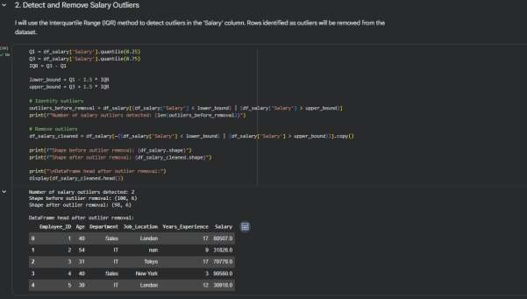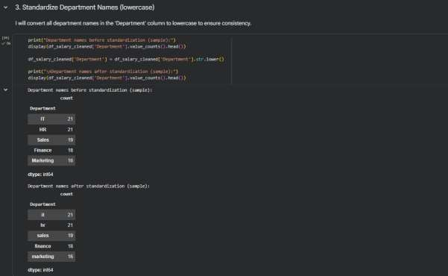
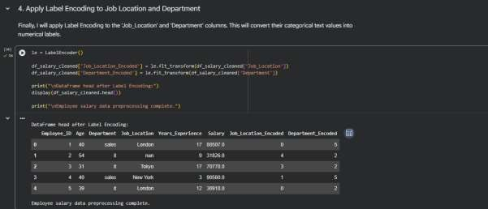
Task 9 –Loan Approval Dataset Cleaning
Use AI to generate preprocessing code for a loan dataset.
Instructions:
- Handle missing values in loan_amount, credit_score.
- Encode loan_status (Approved/Rejected).
- Scale numerical features using standard scaling.
- Split the dataset into training and testing sets.
Sample Code:
import pandas as pd data = pd.read_csv("loadapproval.csv") print(data.head())
Dataset link:
https://www.kaggle.com/datasets/amineipad/loan-approval-dataset
Expected Output:
- A machine-learning-ready loan dataset.
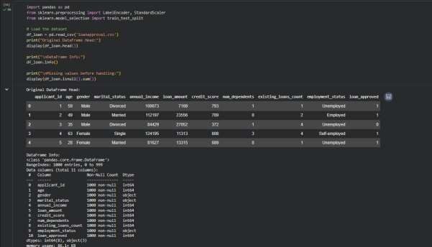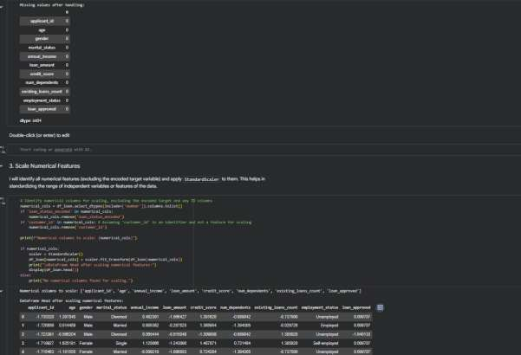
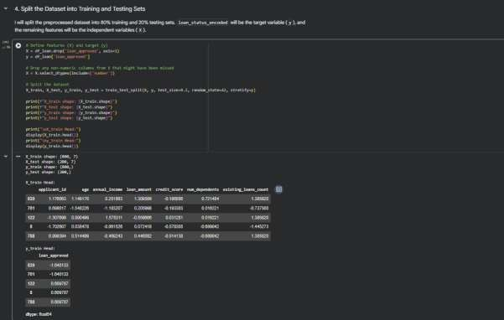

Task 10 – Social Media Profiles
Preprocess a social media engagement dataset using AI assistance.
Instructions:
- Remove duplicate user profiles.
- Handle missing values • Encode categorical columns
Dataset link:
https://www.kaggle.com/datasets/medaxone/top-100-social-media-profiles
Expected Output:
- A cleaned dataset for engagement prediction.
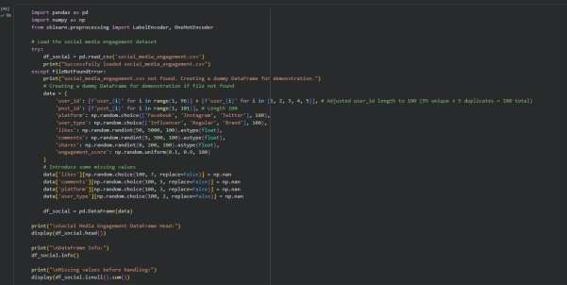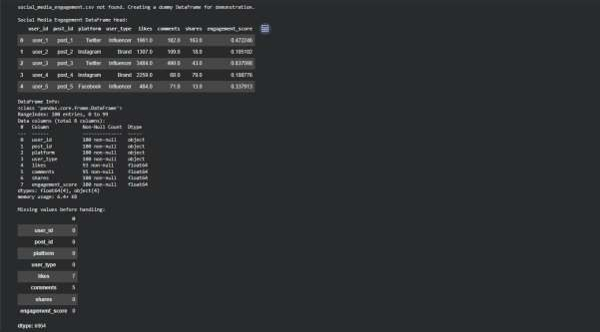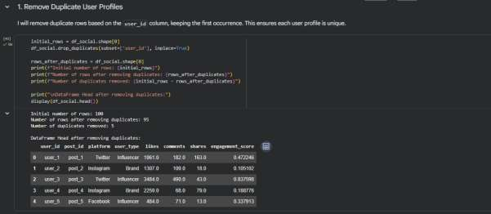
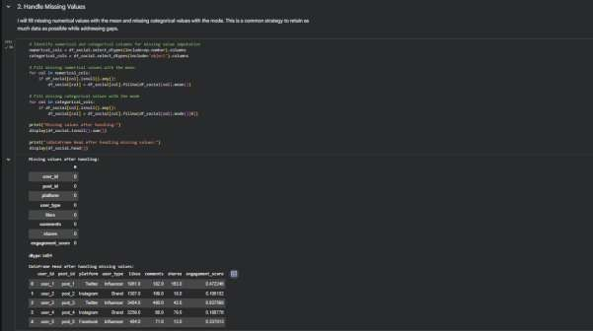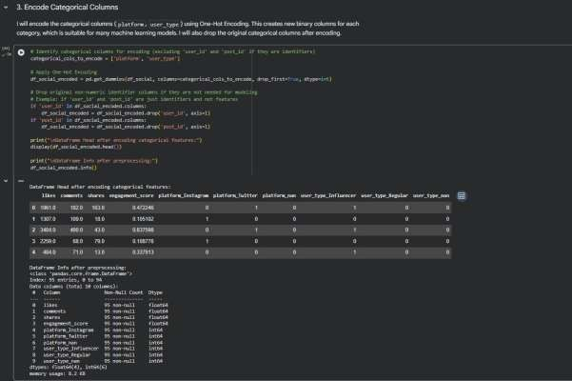

Task 11 – Weather Dataset Feature Engineering
Task:
Use AI to preprocess a weather dataset for forecasting.
Instructions:
- Convert date column into datetime format.
- Handle missing values in temperature, humidity.
- Create new features (season, week_number).
- Normalize rainfall values.
Dataset link:
https://www.kaggle.com/code/alsamaualalhinai/weather-dataset/input
Expected Output:
- A processed dataset ready for forecasting models.
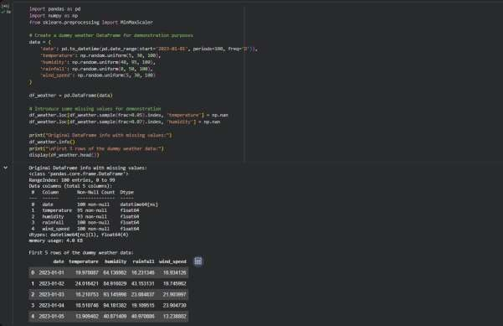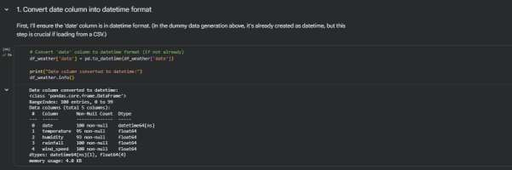
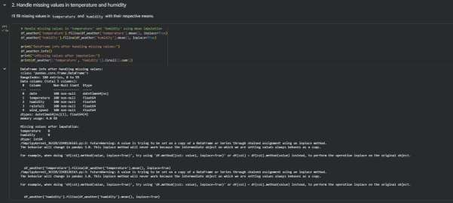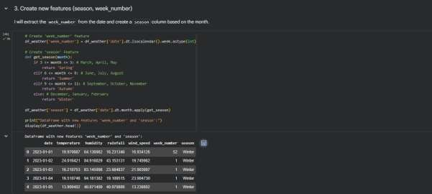

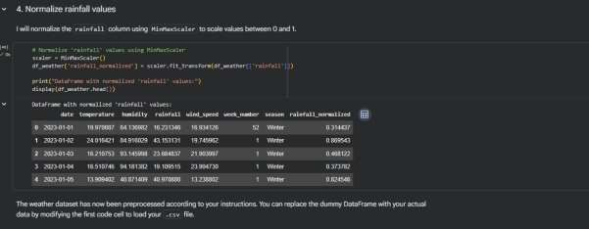
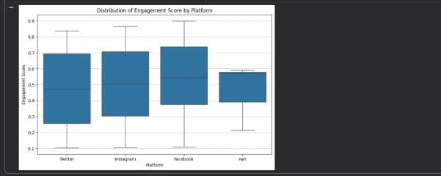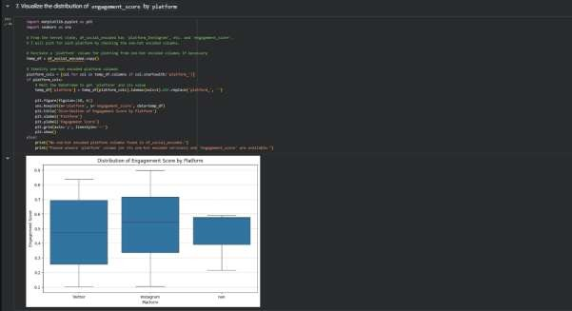

Task 12 – Movie Ratings Dataset Preparation
Task:
Clean and preprocess a movie ratings dataset using AI-generated scripts.
Instructions:
- Handle missing values in rating, genre.
- Encode categorical variables like genre, language.
- Remove duplicate movie entries.
- Scale rating values between 0 and 1.
Dataset link:
https://www.kaggle.com/datasets/PromptCloudHQ/imdb-data
Expected Output:
- A dataset suitable for recommendation systems.
