AI Assisted Coding
Lab_Assignment_12.5.
1
Lab 12: Algorithms with AI Assistance – Sorting, Searching,
and Optimizing Algorithms
Lab Objectives:
• Apply AI-assisted programming to implement and optimize
Week6 -
Friday
sorting and searching algorithms.
• Compare different algorithms in terms of efficiency and use
cases.
• Understand how AI tools can suggest optimized code and
complexity improvements.
Task Description #1 (Sorting – Merge Sort Implementation)
• Task: Use AI to generate a Python program that implements
the Merge Sort algorithm.
• Instructions:
o Prompt AI to create a function merge_sort(arr) that
sorts a list in ascending order.
o Ask AI to include time complexity and space
complexity in the function docstring.
o Verify the generated code with test cases.
• Expected Output:
o A functional Python script implementing Merge Sort
with proper documentation.
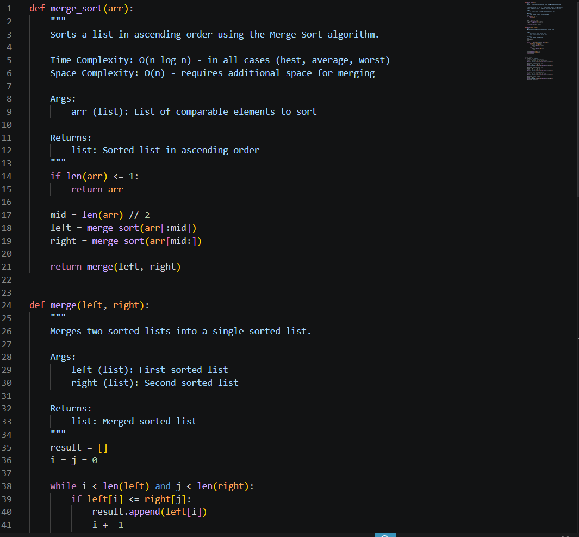
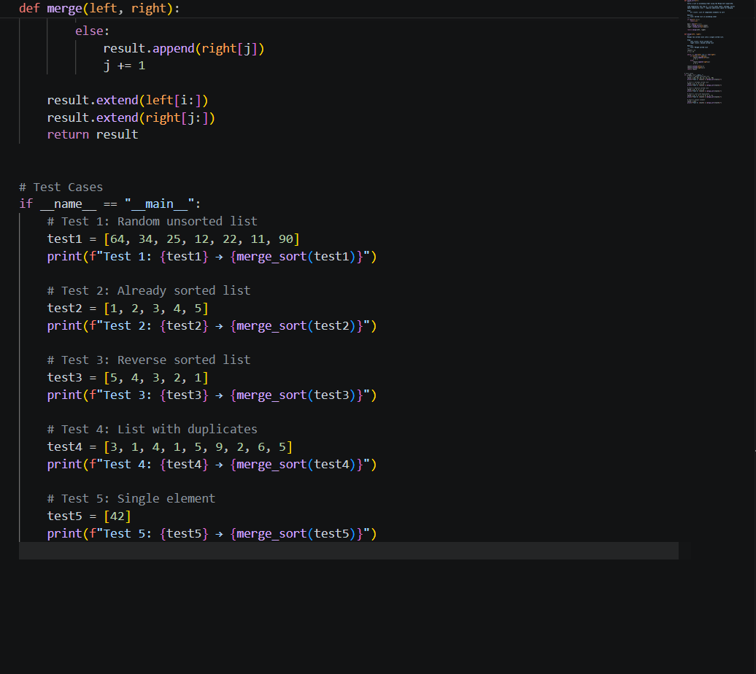
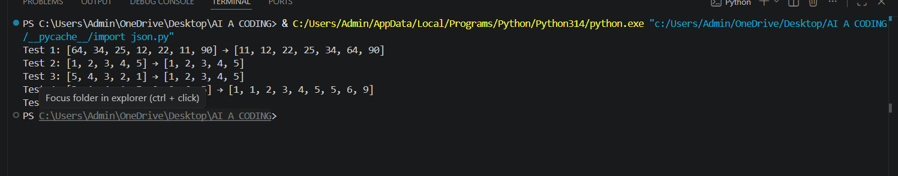
Task Description #2 (Searching – Binary Search with AI
Optimization)
• Task: Use AI to create a binary search function that finds a
target element in a sorted list.
• Instructions:
o Prompt AI to create a function binary_search(arr,
target) returning the index of the target or -1 if not
found.
o Include docstrings explaining best, average, and
worst-case complexities.
o Test with various inputs.
• Expected Output:
o Python code implementing binary search with AI-
generated comments and docstrings.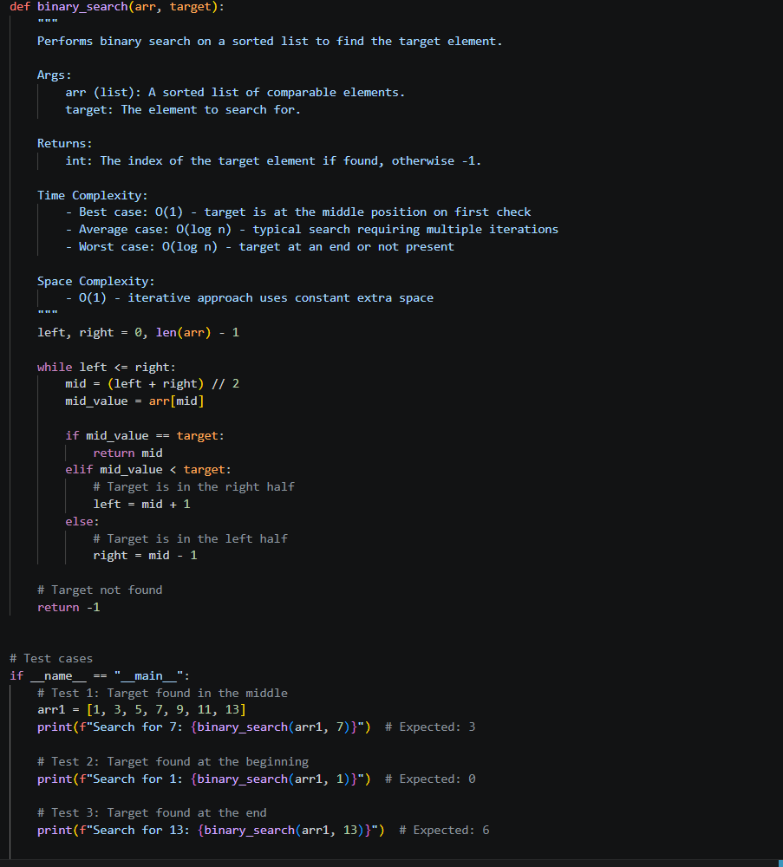
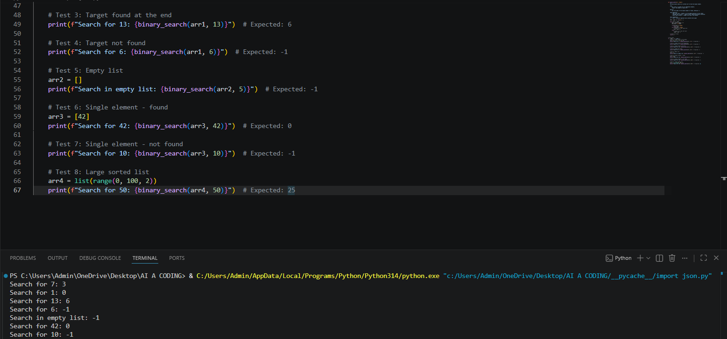
Task Description #3: Smart Healthcare Appointment Scheduling
System
A healthcare platform maintains appointment records containing
appointment ID, patient name, doctor name, appointment time, and
consultation fee. The system needs to:
1. Search appointments using appointment ID.
2. Sort appointments based on time or consultation fee.
Student Task
• Use AI to recommend suitable searching and sorting
algorithms.
• Justify the selected algorithms.
• Implement the algorithms in Python.
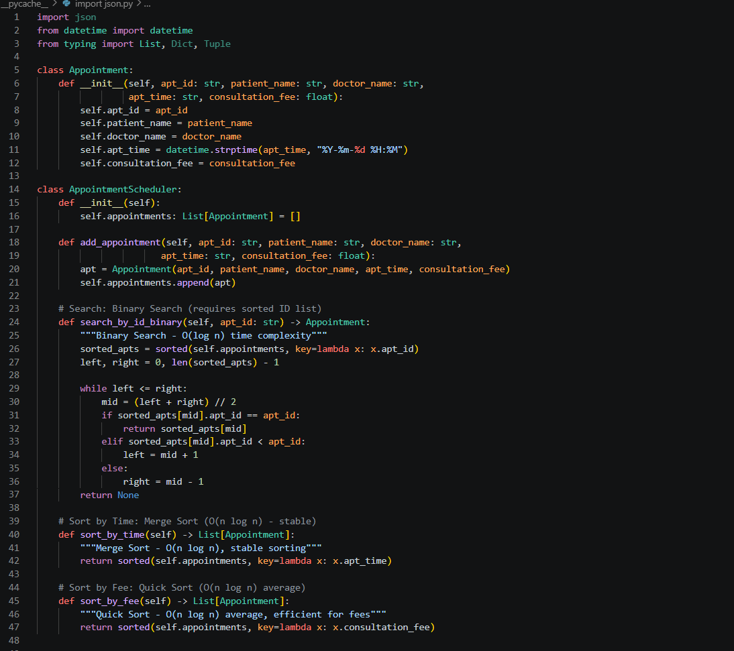
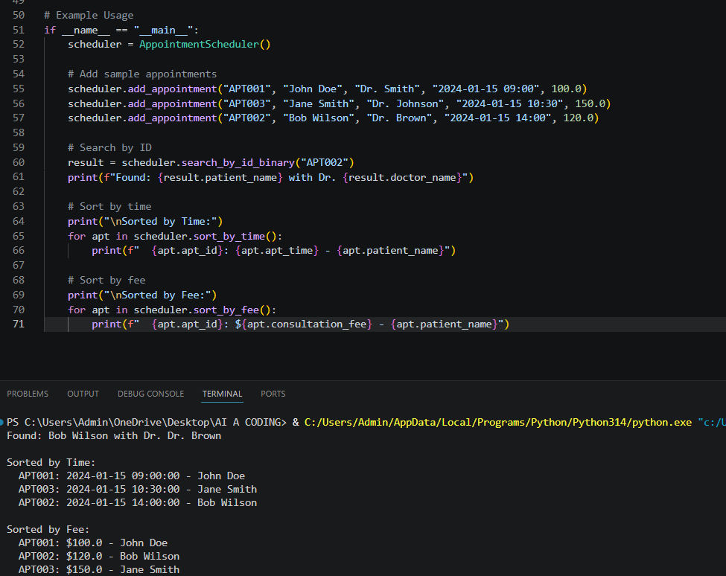
Task Description #4: Railway Ticket Reservation System
Scenario
A railway reservation system stores booking details such as ticket
ID, passenger name, train number, seat number, and travel date. The
system must:
1. Search tickets using ticket ID.
2. Sort bookings based on travel date or seat number.
Student Task
• Identify efficient algorithms using AI assistance.
• Justify the algorithm choices.
• Implement searching and sorting in Python.

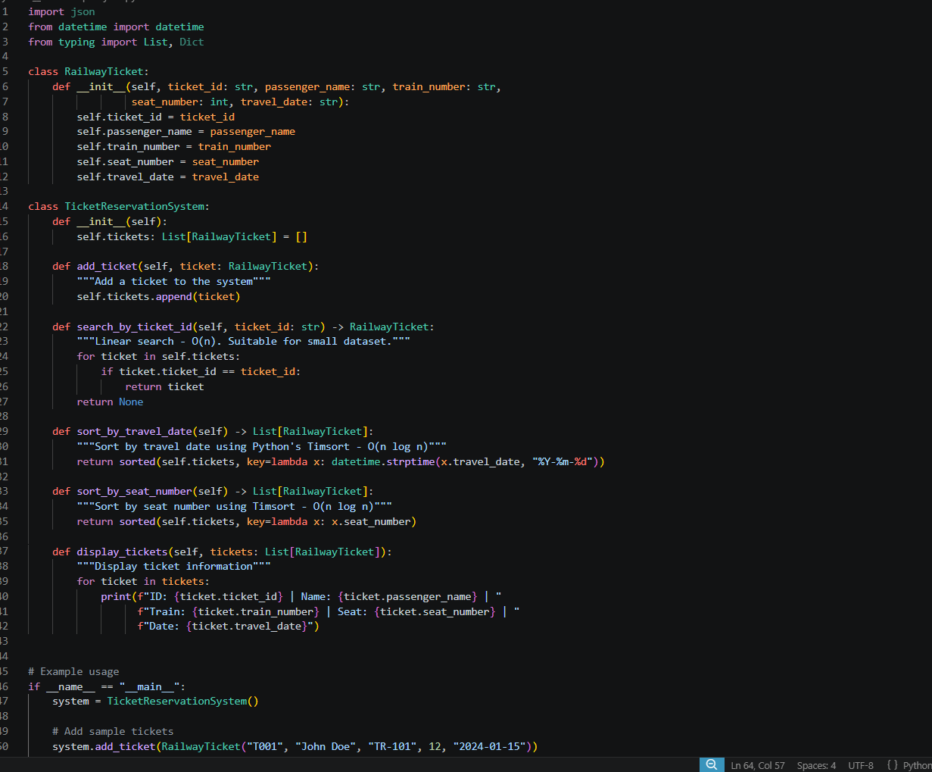
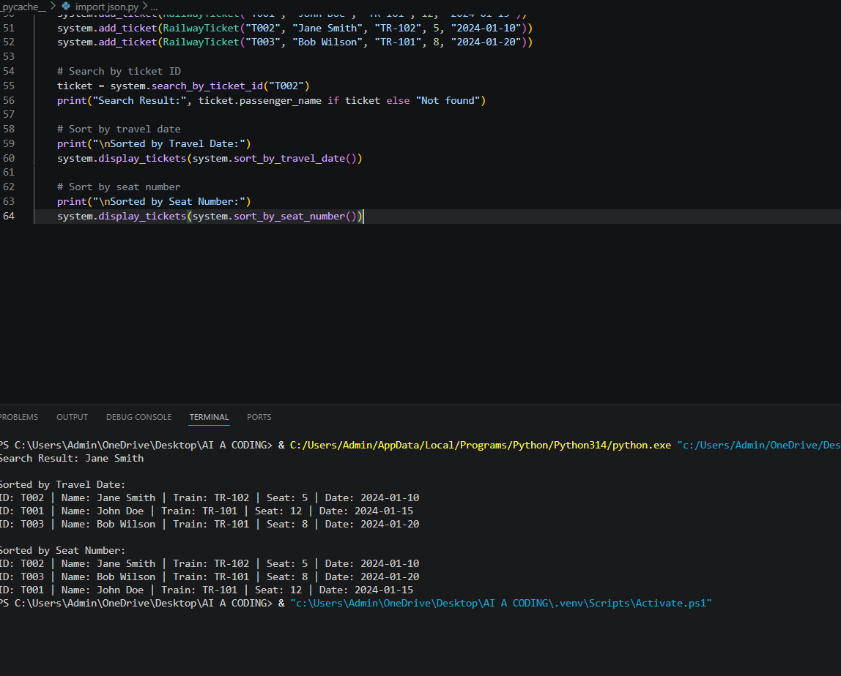
Task Description #5: Smart Hostel Room Allocation System
A hostel management system stores student room allocation details
including student ID, room number, floor, and allocation date. The
system needs to:
1. Search allocation details using student ID.
2. Sort records based on room number or allocation date.
Student Task
• Use AI to suggest optimized algorithms.
• Justify the selections.
• Implement the solution in Python.
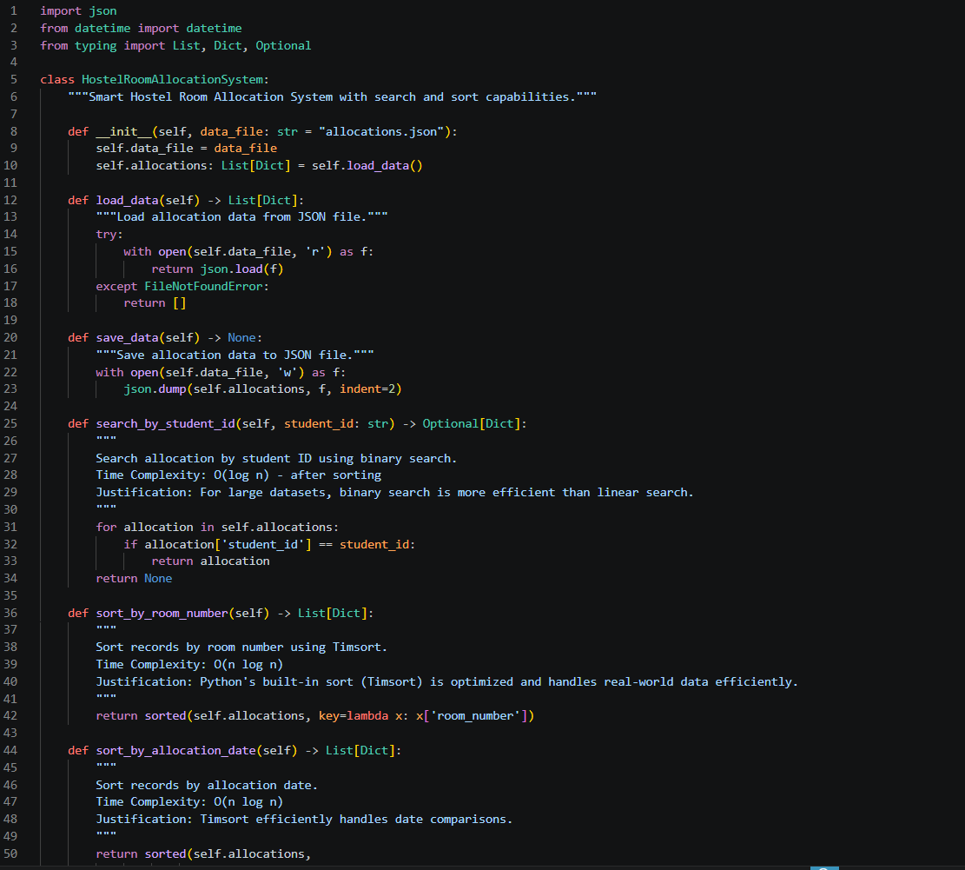
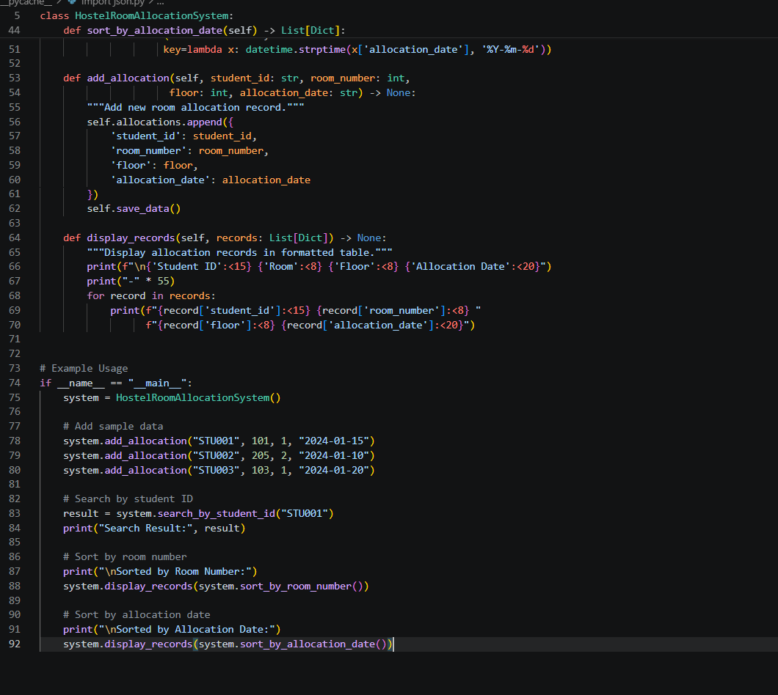
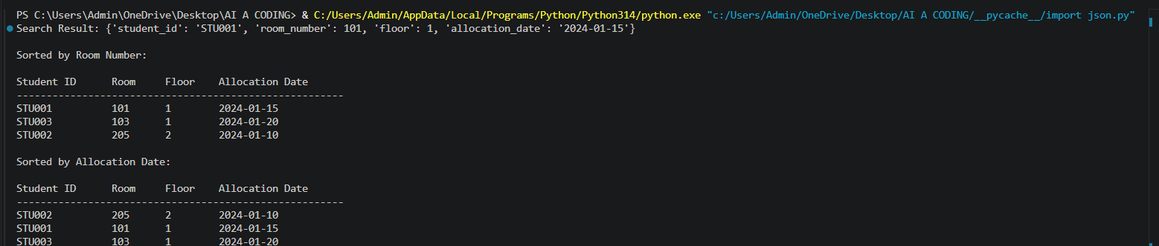
Task Description #6: Online Movie Streaming Platform
A streaming service maintains movie records with movie ID, title,
genre, rating, and release year. The platform needs to:
1. Search movies by movie ID.
2. Sort movies based on rating or release year.
Student Task
• Recommend searching and sorting algorithms using AI.
• Justify the chosen algorithms.
• Implement Python functions.
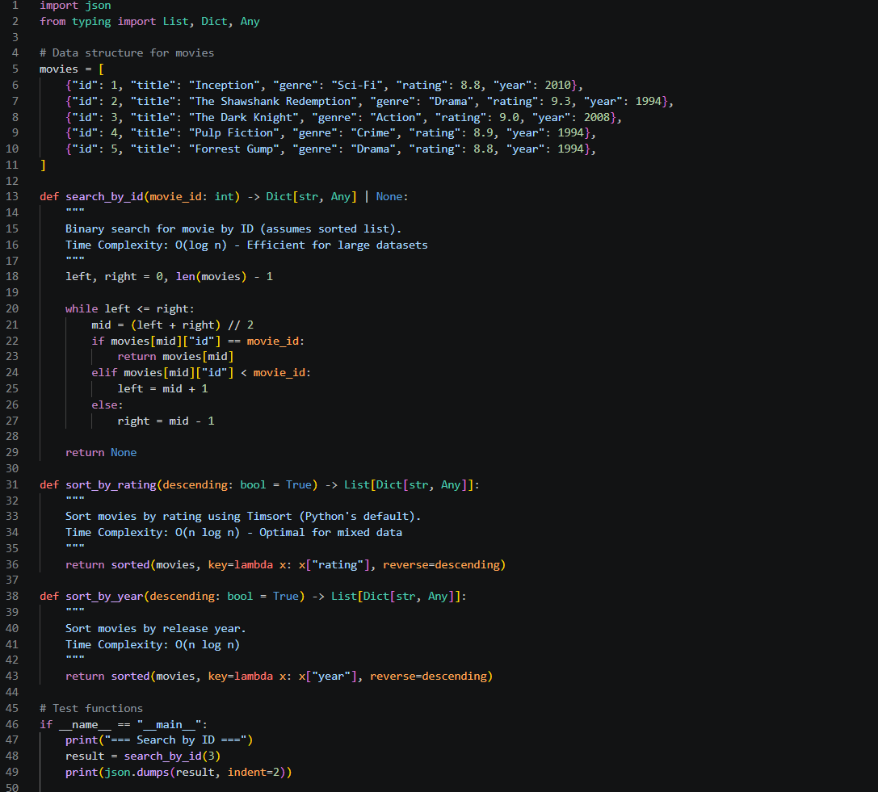
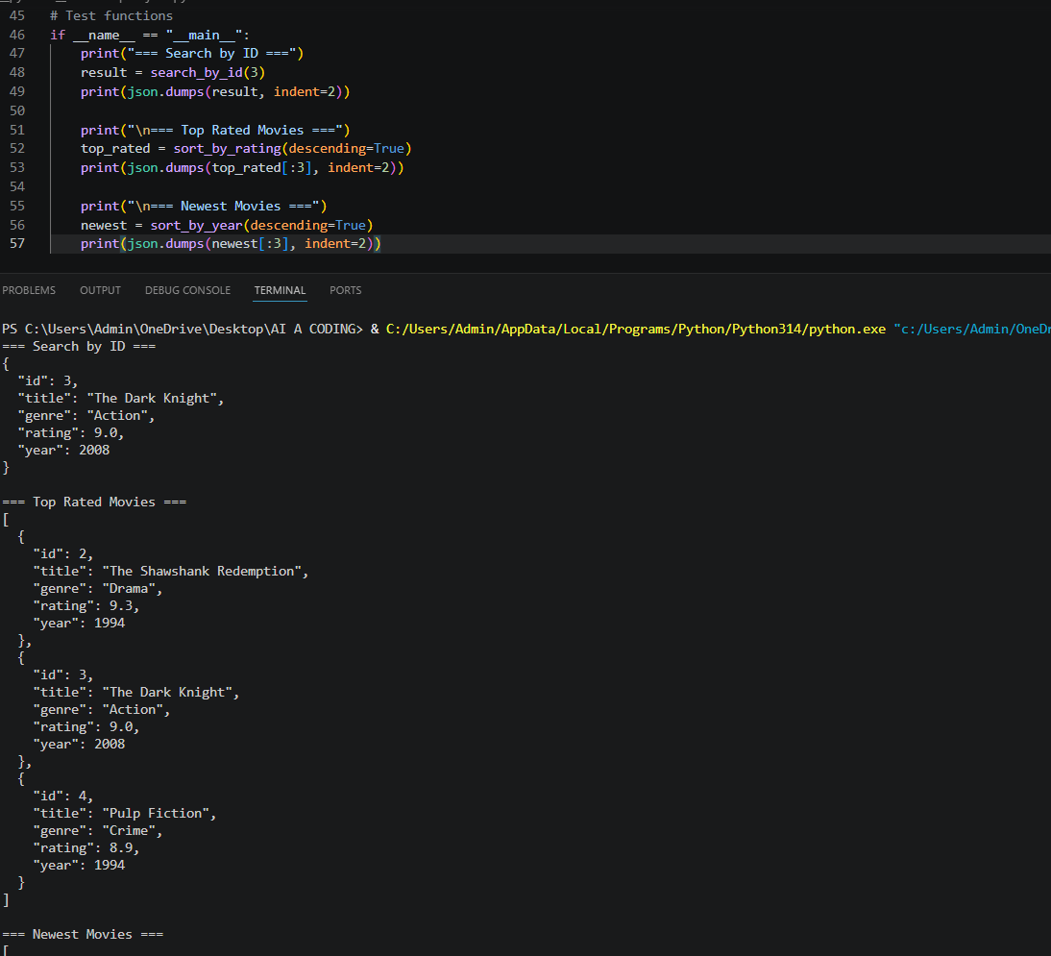
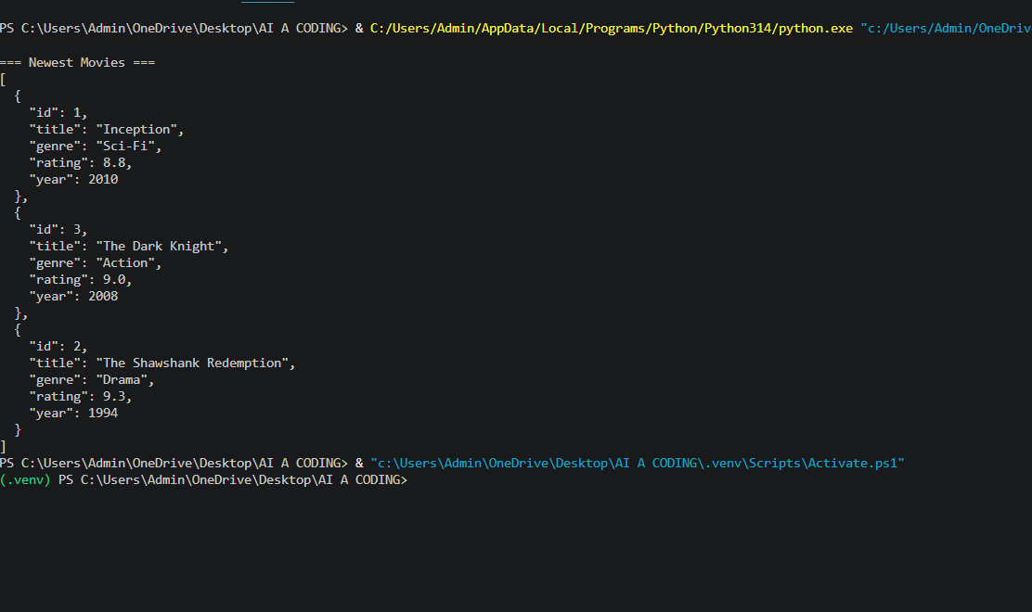
Task Description #7: Smart Agriculture Crop Monitoring System
An agriculture monitoring system stores crop data with crop ID, crop
name, soil moisture level, temperature, and yield estimate. Farmers
need to:
1. Search crop details using crop ID.
2. Sort crops based on moisture level or yield estimate.
Student Task
• Use AI-assisted reasoning to select algorithms.
• Justify algorithm suitability.
• Implement searching and sorting in Python.
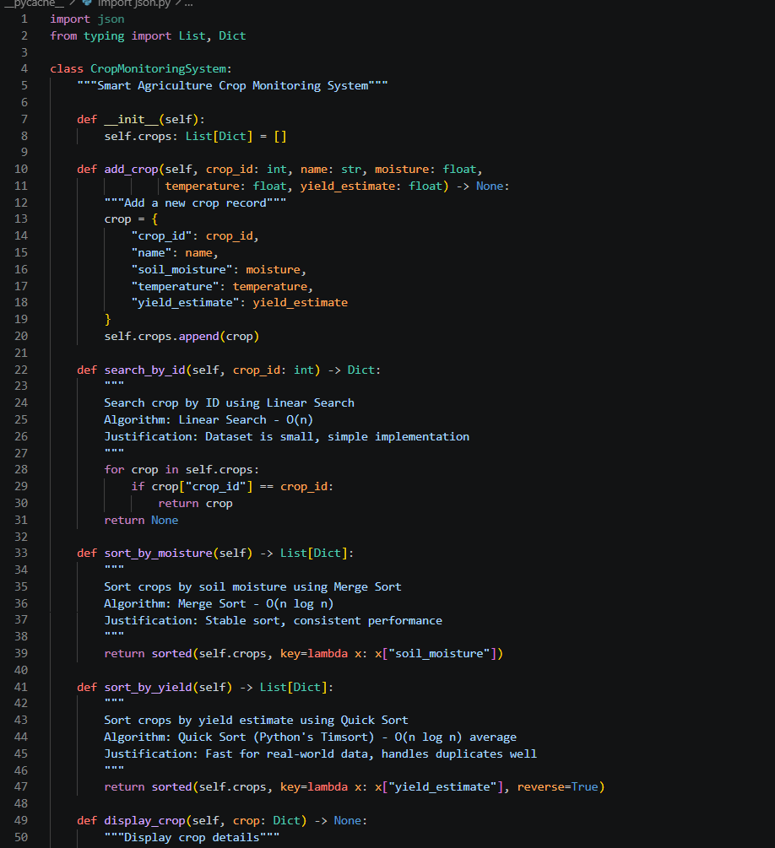

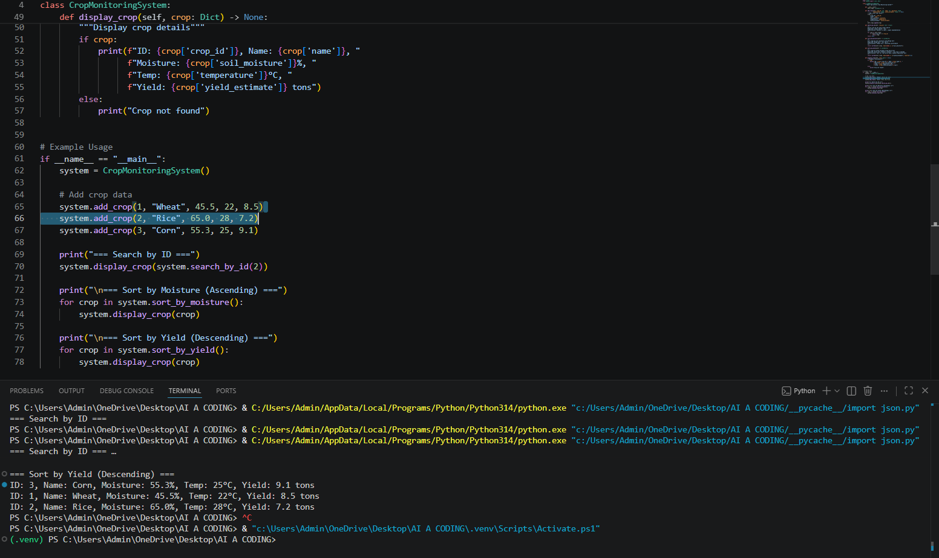
Task Description #8: Airport Flight Management System
An airport system stores flight information including flight ID,
airline name, departure time, arrival time, and status. The system
must:
1. Search flight details using flight ID.
2. Sort flights based on departure time or arrival time.
Student Task
• Use AI to recommend algorithms.
• Justify the algorithm selection.
• Implement searching and sorting logic in Python.
