Lab Assignment-08
Task Description #1 (Password Strength Validator – Apply AI in Security Context)
- Task: Apply AI to generate at least 3 assert test cases for is_strong_password(password) and implement the validator function.
- Requirements:
  - Password must have at least 8 characters. o Must include uppercase, lowercase, digit, and special character.
  - Must not contain spaces.
Example Assert Test Cases:
assert is_strong_password("Abcd@123") == True assert is_strong_password("abcd123") == False assert is_strong_password("ABCD@1234") == True
Expected Output #1:
Password validation logic passing all AI-generated test cases.
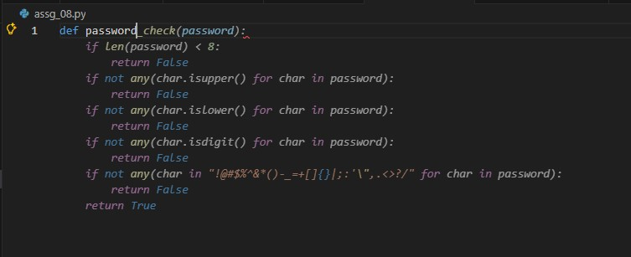
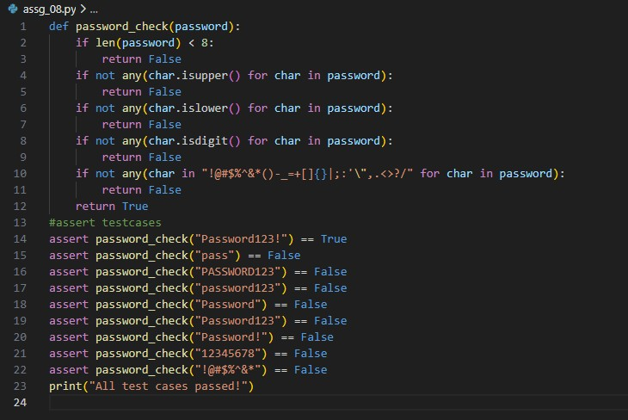
Code:
def password_check(password):
if len(password) < 8:
return False if not any(char.isupper() for char in password): return False if not any(char.islower() for char in password): return False if not any(char.isdigit() for char in password):
return False if not any(char in "!@#$%^&*()-_=+[]{}|;:'\",.<>?/" for char in password):
return False return True #assert testcases assert password_check("Password123!") == True assert password_check("pass") == False assert password_check("PASSWORD123") == False assert password_check("password123") == False assert password_check("Password") == False assert password_check("Password123") == False assert password_check("Password!") == False assert password_check("12345678") == False assert password_check("!@#$%^&*") == False print("All test cases passed!")

output:
Task Description #2 (Number Classification with Loops – Apply AI for Edge Case Handling)
- Task: Use AI to generate at least 3 assert test cases for a classify_number(n) function. Implement using loops.
- Requirements:
  - Classify numbers as Positive, Negative, or Zero. o Handle invalid inputs like strings and None.
  - Include boundary conditions (-1, 0, 1).
Example Assert Test Cases:
assert classify_number(10) == "Positive" assert classify_number(-5) == "Negative" assert classify_number(0) == "Zero"
Expected Output #2:
- Classification logic passing all assert tests.

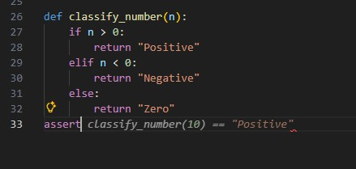
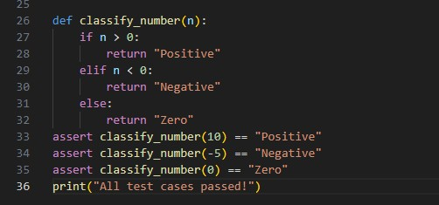
Code:
def classify_number(n):
if n > 0:
return "Positive" elif n < 0:
return "Negative" else:
return "Zero" assert classify_number(10) == "Positive" assert classify_number(-5) == "Negative" assert classify_number(0) == "Zero" print("All test cases passed!")

output:
Task Description #3 (Anagram Checker – Apply AI for String Analysis)
- Task: Use AI to generate at least 3 assert test cases for is_anagram(str1, str2) and implement the function.
- Requirements:
  - Ignore case, spaces, and punctuation.
  - Handle edge cases (empty strings, identical words).
Example Assert Test Cases:
assert is_anagram("listen", "silent") == True assert is_anagram("hello", "world") == False assert is_anagram("Dormitory", "Dirty Room") == True
Expected Output #3:
- Function correctly identifying anagrams and passing all AI-generated tests.

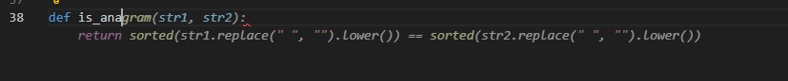
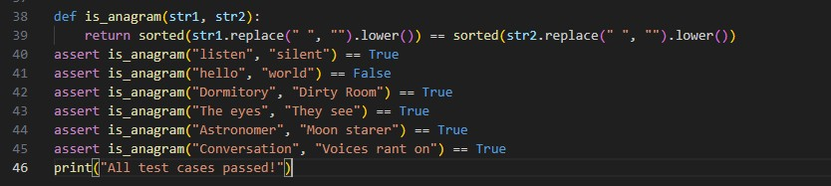
Code:
def is_anagram(str1, str2):
return sorted(str1.replace(" ", "").lower()) == sorted(str2.replace(" ", "").lower()) assert is_anagram("listen", "silent") == True assert is_anagram("hello", "world") == False assert is_anagram("Dormitory", "Dirty Room") == True assert is_anagram("The eyes", "They see") == True assert is_anagram("Astronomer", "Moon starer") == True assert is_anagram("Conversation", "Voices rant on") == True print("All test cases passed!")

output:
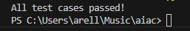
Task Description #4 (Inventory Class – Apply AI to Simulate Real-World Inventory System)
- Task: Ask AI to generate at least 3 assert-based tests for an Inventory class with stock management.
- Methods:
  - add_item(name, quantity)
  - remove_item(name, quantity) o get_stock(name)
Example Assert Test Cases: inv = Inventory() inv.add_item("Pen", 10) assert inv.get_stock("Pen") == 10 inv.remove_item("Pen", 5) assert inv.get_stock("Pen") == 5 inv.add_item("Book", 3) assert inv.get_stock("Book") == 3
Expected Output #4:
- Fully functional class passing all assertions.

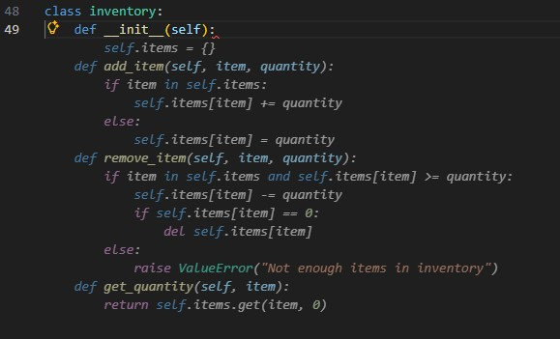

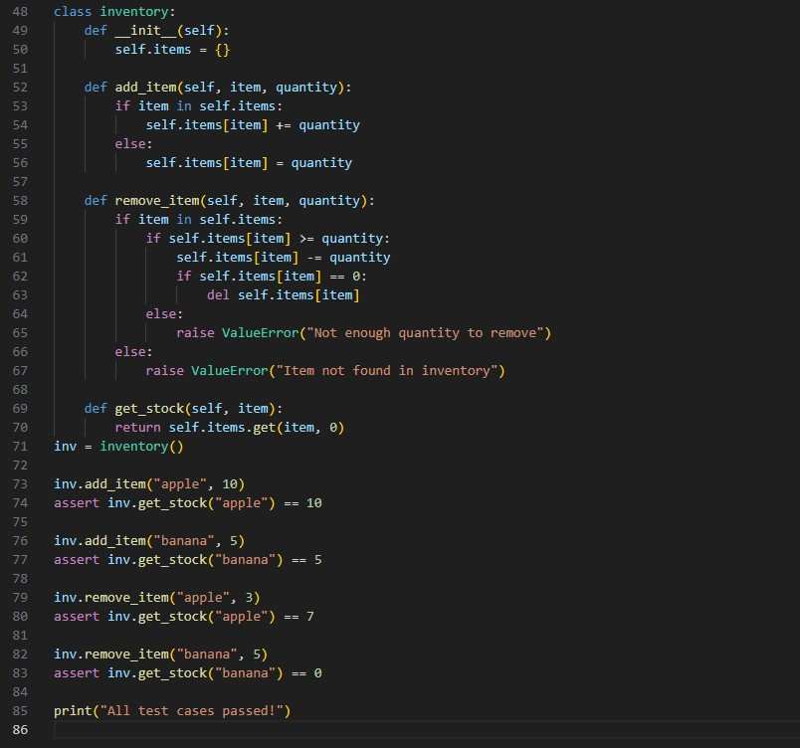
Code:
class inventory: def __init__(self): self.items = {}

def add_item(self, item, quantity): if item in self.items:
self.items[item] += quantity
else:
self.items[item] = quantity

def remove_item(self, item, quantity): if item in self.items:
if self.items[item] >= quantity: self.items[item] -= quantity if self.items[item] == 0: del self.items[item] else:
raise ValueError("Not enough quantity to remove")
else:
raise ValueError("Item not found in inventory")

def get_stock(self, item):
return self.items.get(item, 0) inv = inventory()

inv.add_item("apple", 10) assert inv.get_stock("apple") == 10

inv.add_item("banana", 5) assert inv.get_stock("banana") == 5

inv.remove_item("apple", 3) assert inv.get_stock("apple") == 7

inv.remove_item("banana", 5) assert inv.get_stock("banana") == 0

print("All test cases passed!")

output:
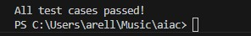
Task Description #5 (Date Validation & Formatting – Apply AI for Data Validation)
- Task: Use AI to generate at least 3 assert test cases for validate_and_format_date(date_str) to check and convert dates.
- Requirements:
  - Validate "MM/DD/YYYY" format. o Handle invalid dates.
  - Convert valid dates to "YYYY-MM-DD".
Example Assert Test Cases:
assert validate_and_format_date("10/15/2023") == "2023-10-15" assert validate_and_format_date("02/30/2023") == "Invalid Date" assert validate_and_format_date("01/01/2024") == "2024-01-01"
Expected Output #5:
- Function passes all AI-generated assertions and handles edge cases.
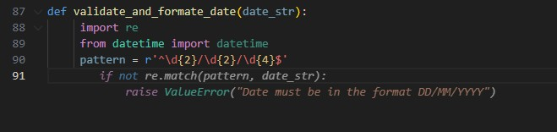
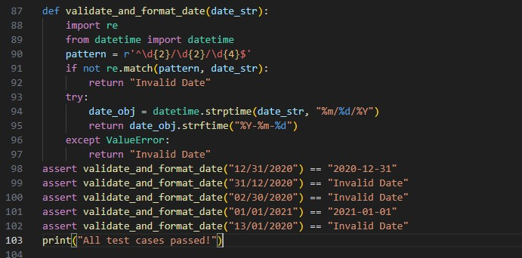
Code:
def validate_and_format_date(date_str):
import re from datetime import datetime pattern = r'^\d{2}/\d{2}/\d{4}$' if not re.match(pattern, date_str):
return "Invalid Date"
try:
date_obj = datetime.strptime(date_str, "%m/%d/%Y") return date_obj.strftime("%Y-%m-%d") except ValueError:
return "Invalid Date" assert validate_and_format_date("12/31/2020") == "2020-12-31" assert validate_and_format_date("31/12/2020") == "Invalid Date" assert validate_and_format_date("02/30/2020") == "Invalid Date" assert validate_and_format_date("01/01/2021") == "2021-01-01" assert validate_and_format_date("13/01/2020") == "Invalid Date" print("All test cases passed!")

output:

