AI ASSISTED CODING ASSIGNMENT - 1.1
E.ASMAJA
BATCH : 01
2303A51011
Task 0:
● Install and configure GitHub Copilot in VS Code. Take screenshots of
each step.
Expected Output:
● Install and configure GitHub Copilot in VS Code. Take screenshots of
each step.
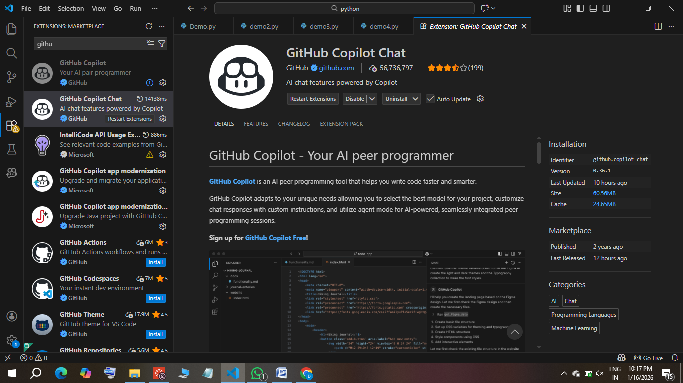

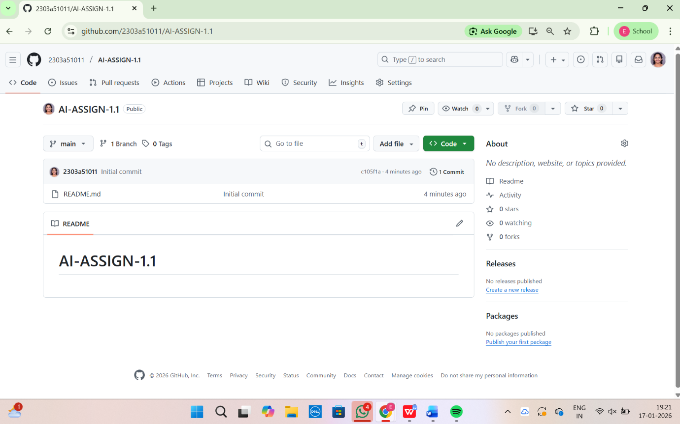
Task 1: AI-Generated Logic Without Modularization (Factorial without
Functions)
• Scenario
You are building a small command-line utility for a startup intern onboarding
task. The program is simple and must be written quickly without modular
design.
• Task Description
Use GitHub Copilot to generate a Python program that computes a
mathematical product-based value (factorial-like logic) directly in the main
execution flow, without using any user-defined functions.
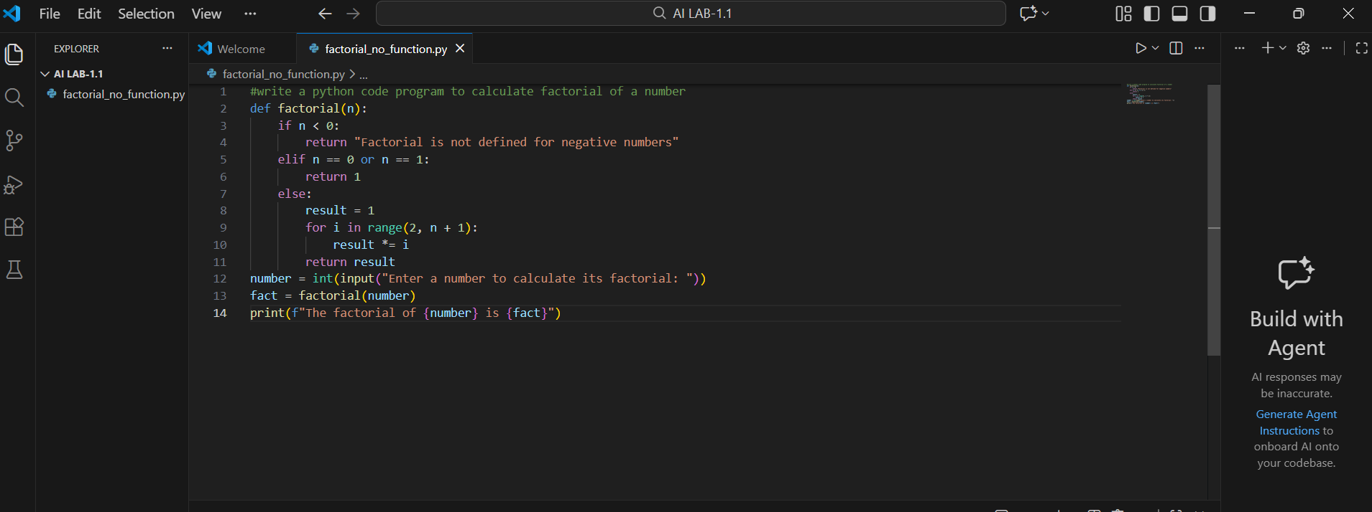
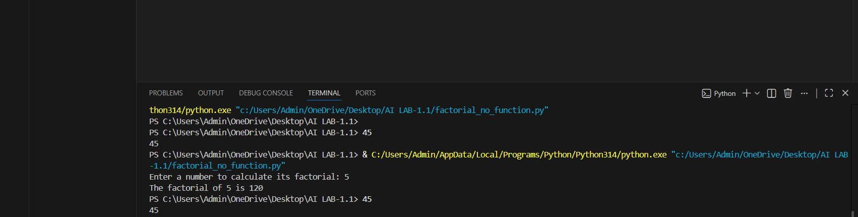
Task 2: AI Code Optimization & Cleanup (Improving Efficiency)
❖ Scenario
Your team lead asks you to review AI-generated code before committing it to
a shared repository.
❖ Task Description
Analyze the code generated in Task 1 and use Copilot again to:
➢ Reduce unnecessary variables
➢ Improve loop clarity
➢ Enhance readability and efficiency
Hint:
Prompt Copilot with phrases like
“optimize this code”, “simplify logic”, or “make it more readable”
❖ Expected Deliverables
➢ Original AI-generated code
➢ Optimized version of the same code
➢ Side-by-side comparison
➢ Written explanation:
▪ What was improved?
▪ Why the new version is better (readability, performance,
maintainability.
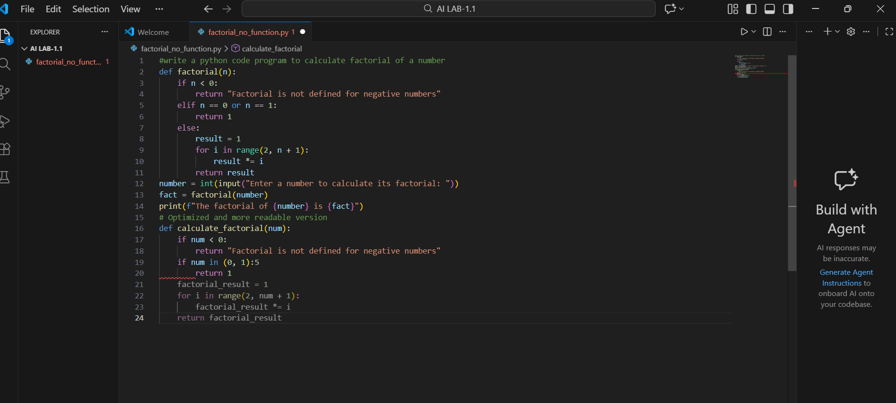
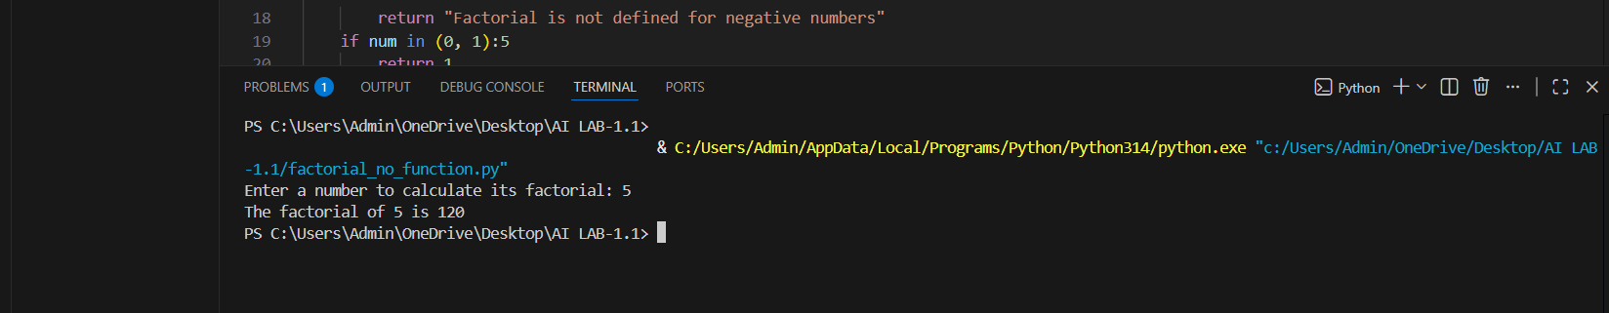
Original | Optimized
Loop starts from 1 | Loop starts from 2
Extra multiplication | No extra work
Old print style | f-string
Slightly messy | Cleaner
Task 3: Modular Design Using AI Assistance (Factorial with Functions)
❖ Scenario
The same logic now needs to be reused in multiple scripts.
❖ Task Description
Use GitHub Copilot to generate a modular version of the program by:
➢ Creating a user-defined function
➢ Calling the function from the main block
❖ Constraints
➢ Use meaningful function and variable names
➢ Include inline comments (preferably suggested by Copilot)
❖ Expected Deliverables
➢ AI-assisted function-based program
➢ Screenshots showing:
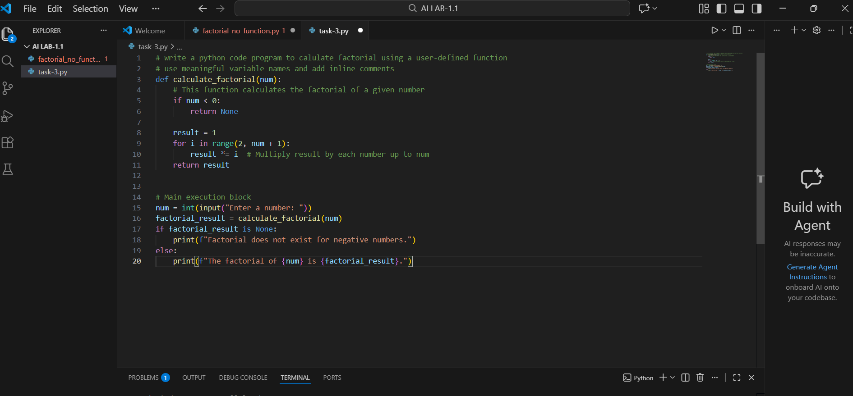
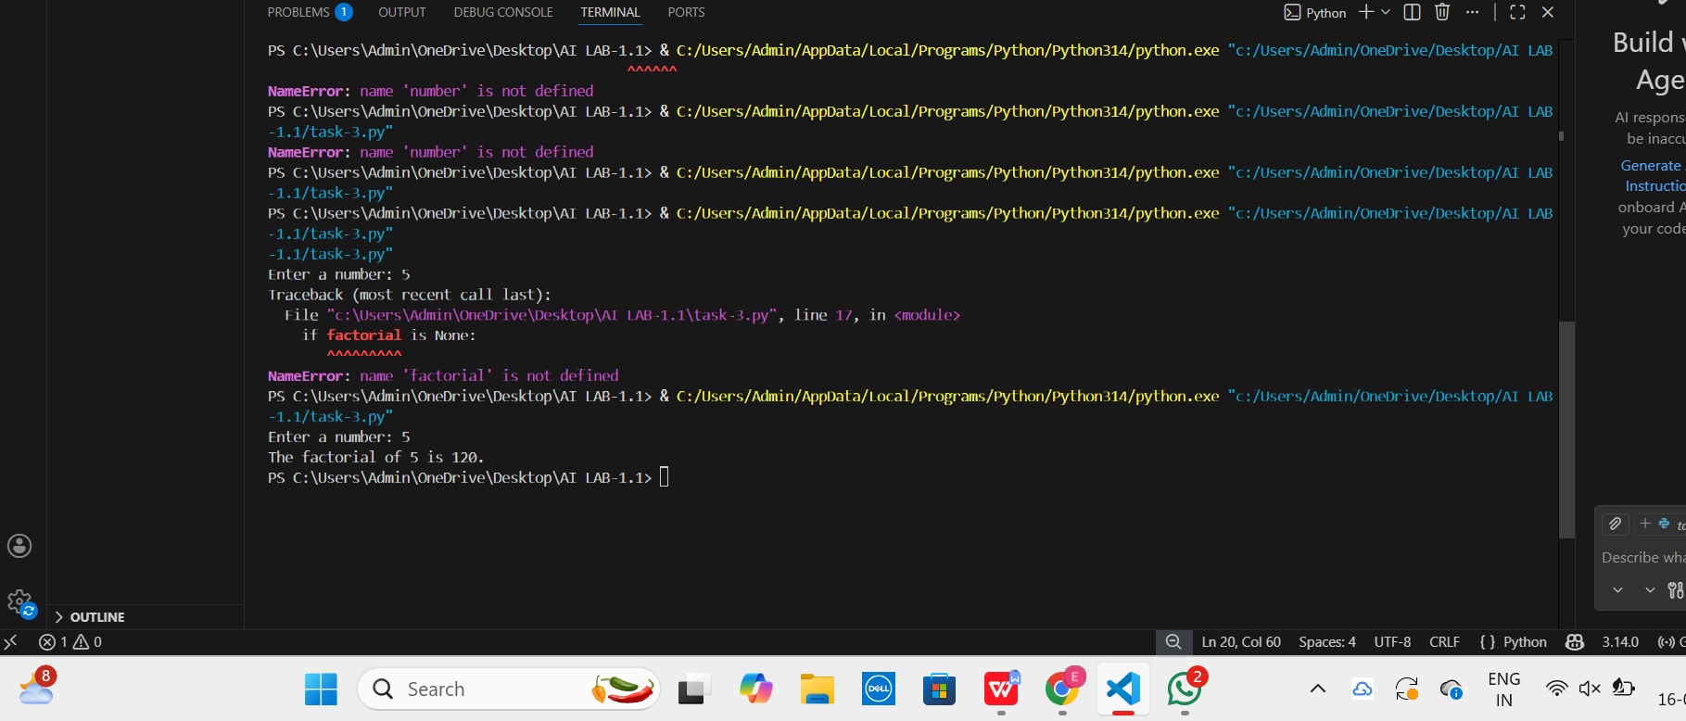
o Prompt evolution
# write a python program to calculate factorial using a user-defined function
# use meaningful variable names and add inline comments

o Copilot-generated function logic
result = 1
for i in range(2, number + 1):
result *= i
➢ Sample inputs/outputs
5
120
➢ Short note:
o How modularity improves reusability
Using modular design allows the factorial logic to be reused across multiple programs without rewriting code.
Task 4: Comparative Analysis – Procedural vs Modular AI Code (With vs
Without Functions)
❖ Scenario
As part of a code review meeting, you are asked to justify design choices.
❖ Task Description
Compare the non-function and function-based Copilot-generated
programs on the following criteria:
➢ Logic clarity
➢ Reusability
➢ Debugging ease
➢ Suitability for large projects
➢ AI dependency risk
❖ Expected Deliverables
Choose one:
➢ A comparison table
Criteria | Procedural Code (Without Functions) | Modular Code (With Functions)
Logic Clarity | Logic is written in one continuous flow, which is easy for small programs but becomes harder to follow as code grows. | Logic is clearly separated into a function, making the program easier to read and understand.
Reusability | Logic cannot be reused easily and must be copied into other scripts. | Function can be reused in multiple scripts by calling it, reducing code duplication.
Debugging Ease | Debugging is harder because all logic is mixed together in one block. | Debugging is easier since issues can be isolated within the function.
Suitability for Large Projects | Not suitable for large projects as code becomes lengthy and difficult to manage. | Highly suitable for large projects due to better structure and separation of concerns.
AI Dependency Risk | High risk: developers may blindly accept AI-generated code without structure. | Lower risk: modular design encourages understanding and reviewing AI-generated logic.
Task 5: AI-Generated Iterative vs Recursive Thinking
❖ Scenario
Your mentor wants to test how well AI understands different
computational paradigms.
❖ Task Description
Prompt Copilot to generate:
An iterative version of the logic
A recursive version of the same logic
❖ Constraints
Both implementations must produce identical outputs
Students must not manually write the code first
❖ Expected Deliverables
Two AI-generated implementations
Execution flow explanation (in your own words)
#Function starts with result = 1
Loop runs from 2 to n
Multiplies result step by step
Returns final value

Comparison covering:
➢ Readability
➢ Stack usage
➢ Performance implications
Criteria | Iterative Approach | Recursive Approach
Readability | Easier to understand for beginners | Cleaner mathematical representation
Stack Usage | Uses constant memory | Uses call stack for each function call
Performance | Faster and memory-efficient | Slower due to function call overhead
When Recursion is NOT Recommended |  | When input is large or stack overflow risk exists

➢ When recursion is not recommended.
Input size is large (e.g., factorial of 10,000)
Stack memory is limited
Performance is critical
Iterative solution is simpler
