AI ASSISTED CODING
ASSIGNMENT-6.3
NAME: E.Asmaja
H.T.NO: 2303A51011

Task Description #1 (Loops – Automorphic Numbers in a Range)
- Task: Prompt AI to generate a function that displays all Automorphic numbers between 1 and 1000 using a for loop.
- Instructions:
o Get AI-generated code to list Automorphic numbers using a for loop. o Analyze the correctness and efficiency of the generated logic. o Ask AI to regenerate using a while loop and compare both implementations.
Expected Output #1:
• Correct implementation that lists Automorphic numbers using both loop types, with explanation.
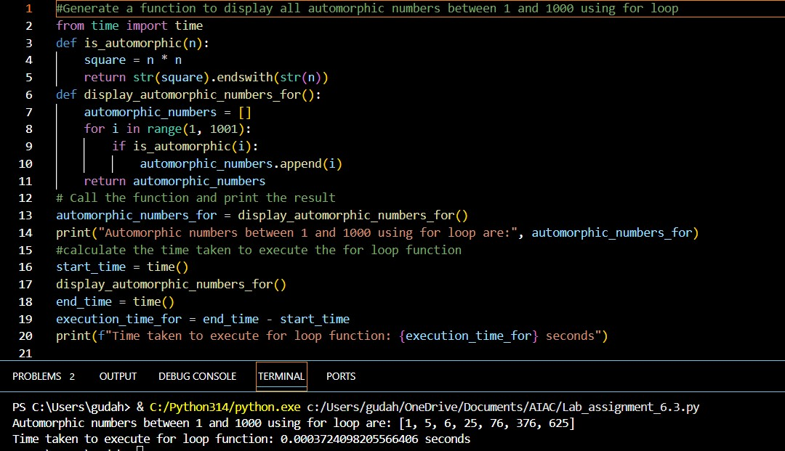
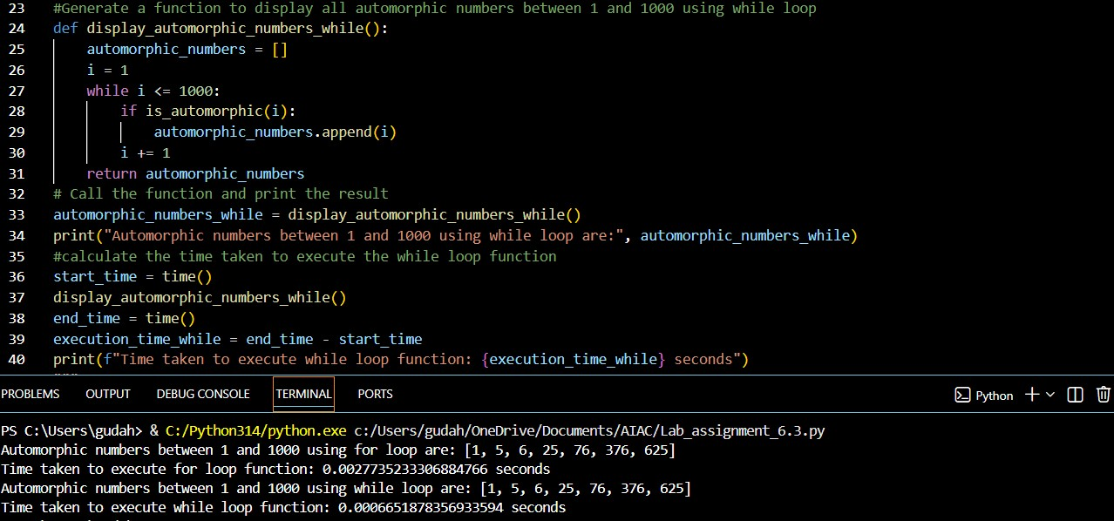
- Both methods take about the same time because each number is checked once and string conversion adds a little extra work, so time complexity is O(n log n).
- They use very little memory since only a small list of automorphic numbers is stored.
- A for loop is faster because it is optimized inside Python.
- A for loop makes the code cleaner and easier to understand because no manual counter is needed.
- A for loop is safer and less error-prone since it avoids skipping numbers or running into infinite loops.

Task Description #2 (Conditional Statements – Online Shopping Feedback Classification)
- Task: Ask AI to write nested if-elif-else conditions to classify online shopping feedback as Positive, Neutral, or Negative based on a numerical rating (1–5).
- Instructions:
o Generate initial code using nested if-elif-else. o Analyze correctness and readability. o Ask AI to rewrite using dictionary-based or match-case structure.
Expected Output #2:
• Feedback classification function with explanation and an alternative approach.
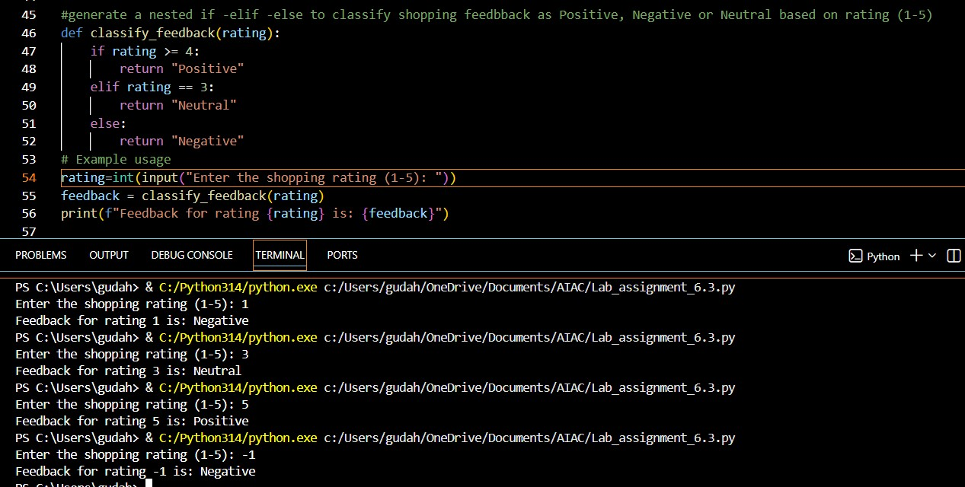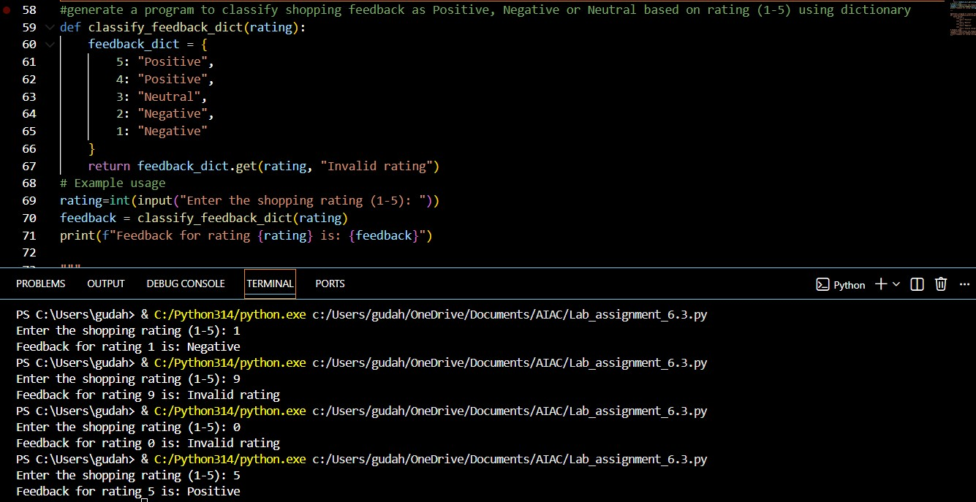
- A dictionary makes things clear because all rating-to-feedback pairs are visible in one place.
- It is easy to maintain since you can add or change ratings without changing the main logic.
- It handles invalid ratings more safely by letting you check or give a default message.
- It follows Python’s standard and clean way of mapping values, so the code looks natural.
- It stays clean and readable even if the number of rating categories increases.

Task 3: Statistical_operations
Define a function named statistical_operations(tuple_num) that performs the following statistical operations on a tuple of numbers:
- Minimum, Maximum
- Mean, Median, Mode
- Variance, Standard Deviation
While writing the function, observe the code suggestions provided by GitHub Copilot.Make decisions to accept, reject, or modify the suggestions based on their relevance and correctness
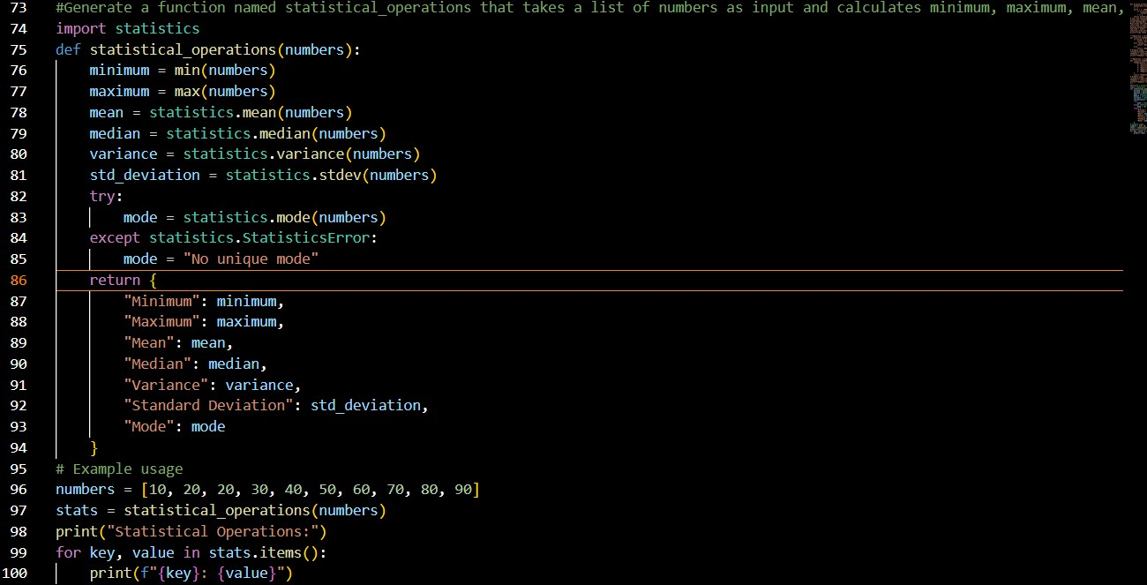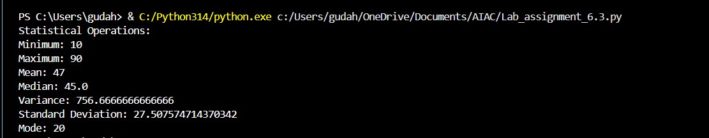

Task 4: Teacher Profile
- Prompt: Create a class Teacher with attributes teacher_id, name,subject, and experience. Add a method to display teacher details.
- Expected Output: Class with initializer, method, and object creation.
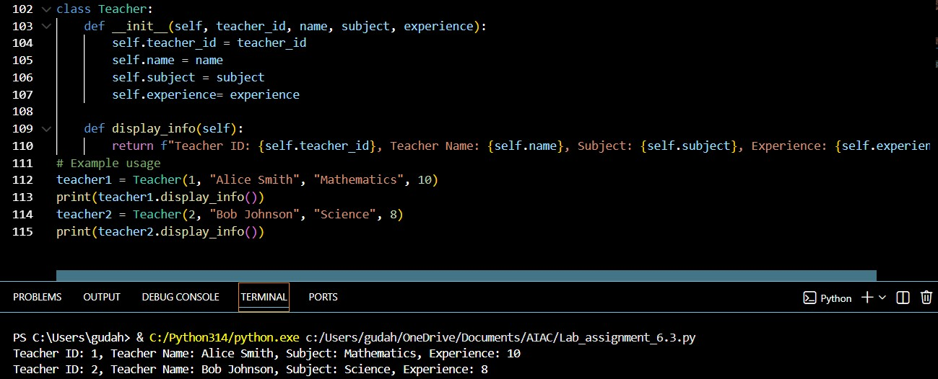

Task #5 – Zero-Shot Prompting with Conditional Validation
Use zero-shot prompting to instruct an AI tool to generate a function that validates an Indian mobile number.
Requirements
• The function must ensure the mobile number:
o Starts with 6, 7, 8, or 9 o Contains exactly 10 digits

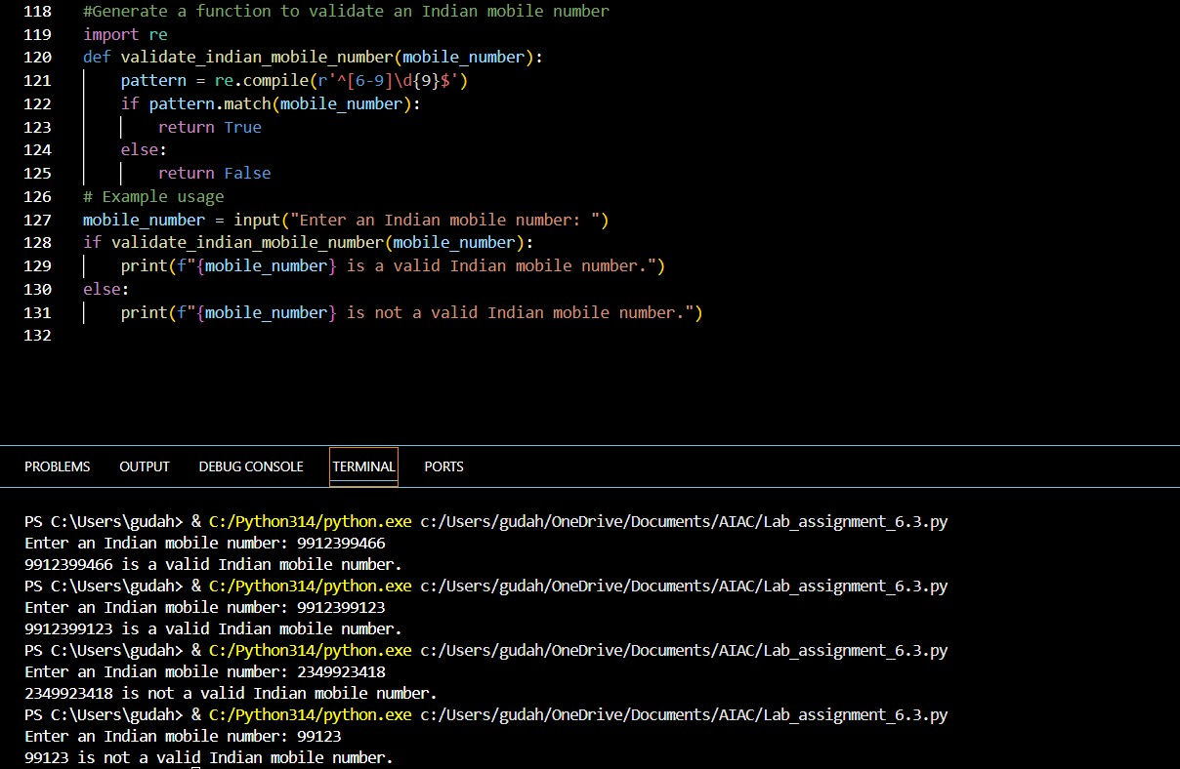

Task Description #6 (Loops – Armstrong Numbers in a Range)
Task: Write a function using AI that finds all Armstrong numbers in a user- specified range (e.g., 1 to 1000).
Instructions:
- Use a for loop and digit power logic.
- Validate correctness by checking known Armstrong numbers (153, 370, etc.).
- Ask AI to regenerate an optimized version (using list comprehensions).
Expected Output #7:
- Python program listing Armstrong numbers in the range.
- Optimized version with explanation.
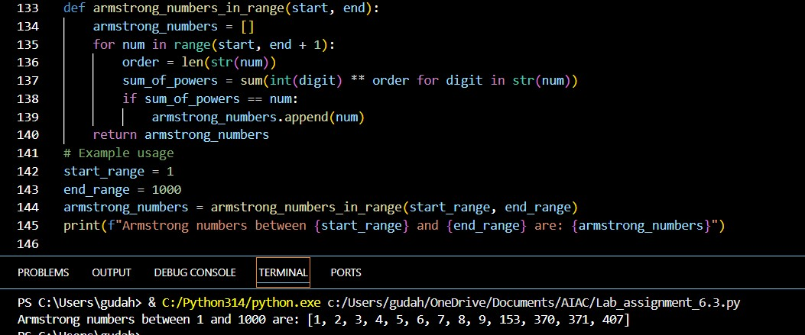
Optimized code:
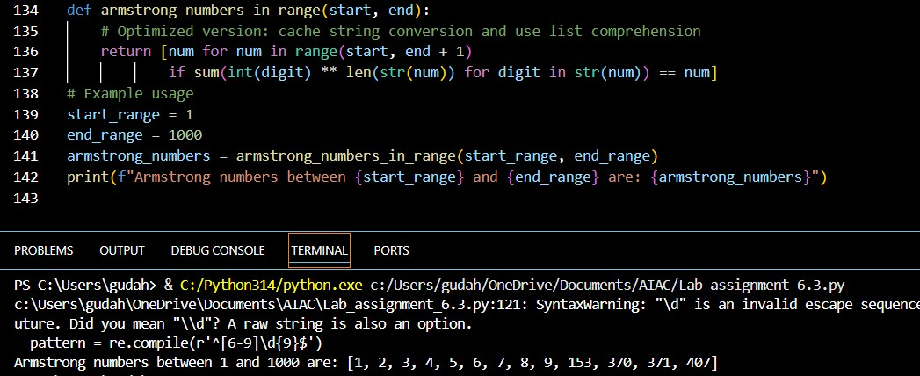
  - It does the same work in fewer lines, so there is less overhead and faster execution.
  - It calculates the digit powers directly instead of using extra variables, reducing unnecessary steps.
  - List comprehension is faster than manually appending values in a loop.
  - It avoids storing extra temporary values, so memory usage stays low.
  - The code is cleaner and easier to read while giving the same correct result.

Task Description #7 (Loops – Happy Numbers in a Range)
Task: Generate a function using AI that displays all Happy Numbers within a user-specified range (e.g., 1 to 500).
Instructions:
- Implement the logic using a loop: repeatedly replace a number with the sum of the squares of its digits until the result is either 1 (Happy Number) or enters a cycle (Not Happy).
- Validate correctness by checking known Happy Numbers (e.g., 1, 7, 10,13, 19, 23, 28…).
- Ask AI to regenerate an optimized version (e.g., by using a set to detect cycles instead of infinite loops).
Expected Output #8:
- Python program that prints all Happy Numbers within a range.
- Optimized version using cycle detection with explanation.
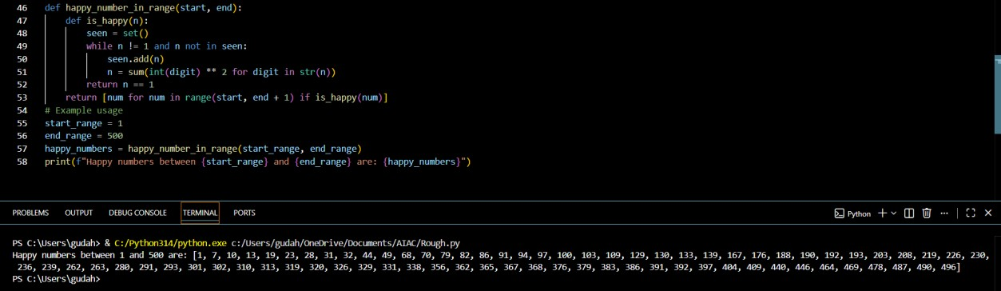
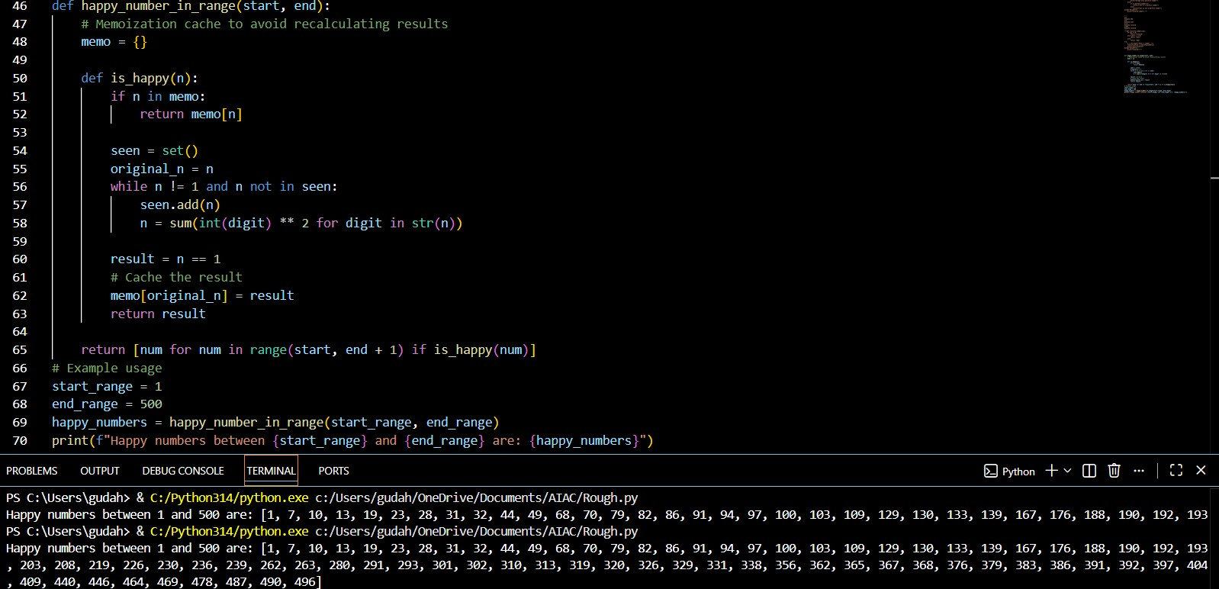
  - It saves results of numbers already checked, so the same calculations are not done again and again.
  - This avoids repeated loops for the same digit sequences, which makes it much faster for large ranges.
  - Using a set still prevents infinite loops, but caching adds an extra speed boost.
  - The work per number is reduced because many numbers reuse previously computed results.
  - Overall, it runs faster with only a small amount of extra memory, making it more efficient and scalable.

Task Description #8 (Loops – Strong Numbers in a Range)
Task: Generate a function using AI that displays all Strong Numbers (sum of factorial of digits equals the number, e.g., 145 = 1!+4!+5!) within a given range.
Instructions:
- Use loops to extract digits and calculate factorials.
- Validate with examples (1, 2, 145).
- Ask AI to regenerate an optimized version (precompute digit factorials).
Expected Output #9:
- Python program that lists Strong Numbers.
- Optimized version with explanation.
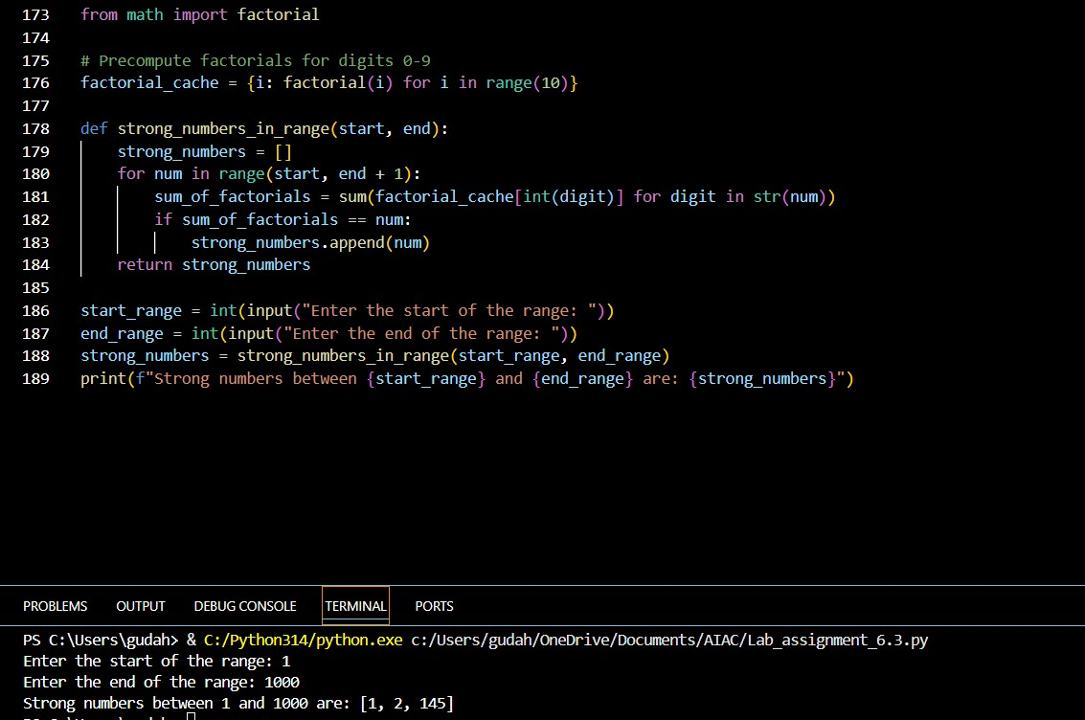
Optimized:
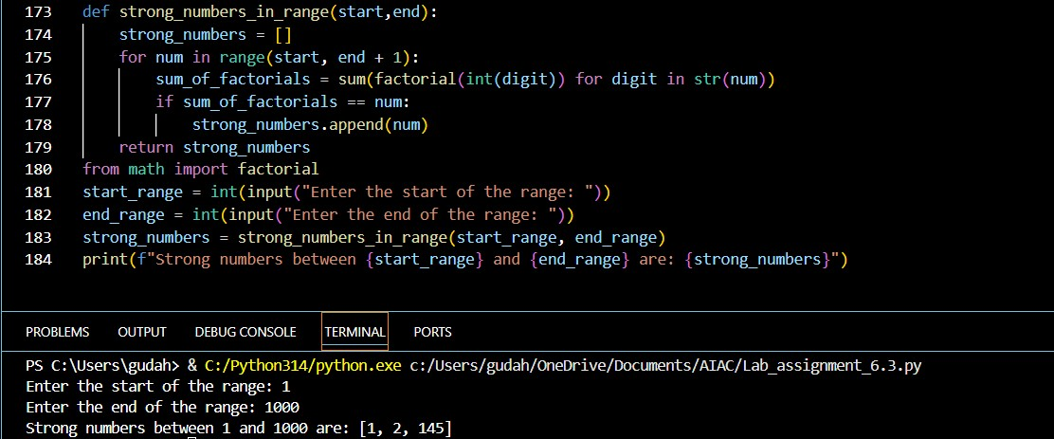

Time Complexity Comparison:
- Original: O(n × d × f) where n = range size, d = digits per number, f = factorial computation cost
- Optimized: O(10 × f) + O(n × d) = effectively O(n × d) since the precomputation happens only once
For larger ranges, this makes a significant performance difference since you're trading a tiny bit of extra memory (10 dictionary entries) for substantial computation savings across the entire loop.

Task #9 – Few-Shot Prompting for Nested Dictionary Extraction
Objective
Use few-shot prompting (2–3 examples) to instruct the AI to create a function that parses a nested dictionary representing student information.
Requirements
• The function should extract and return:
o Full Name o Branch o SGPA
Expected Output
A reusable Python function that correctly navigates and extracts values from nested dictionaries based on the provided examples
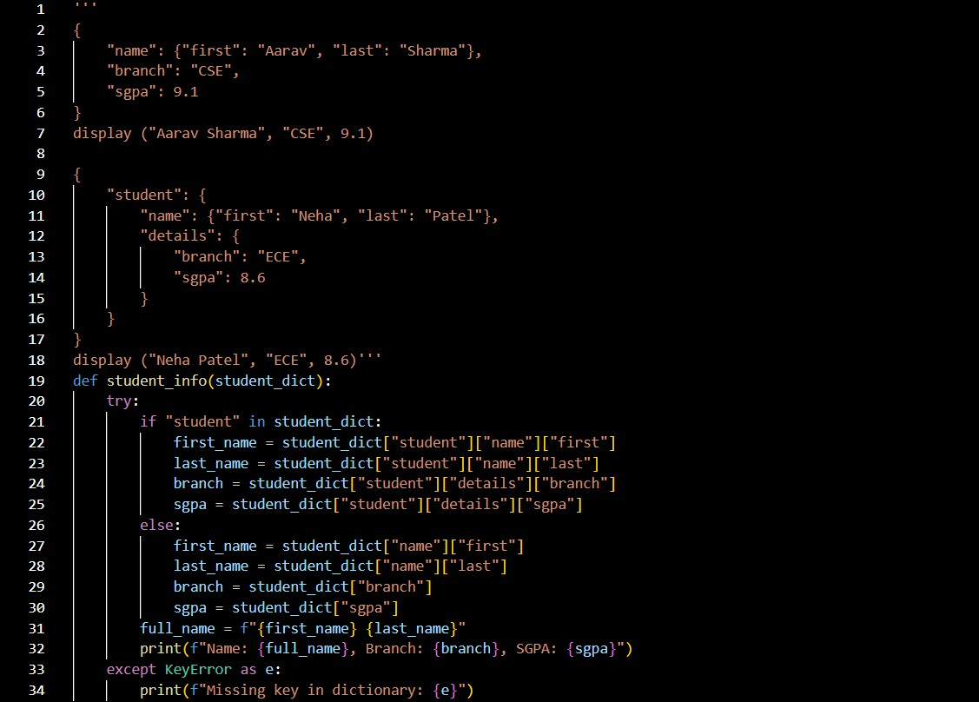
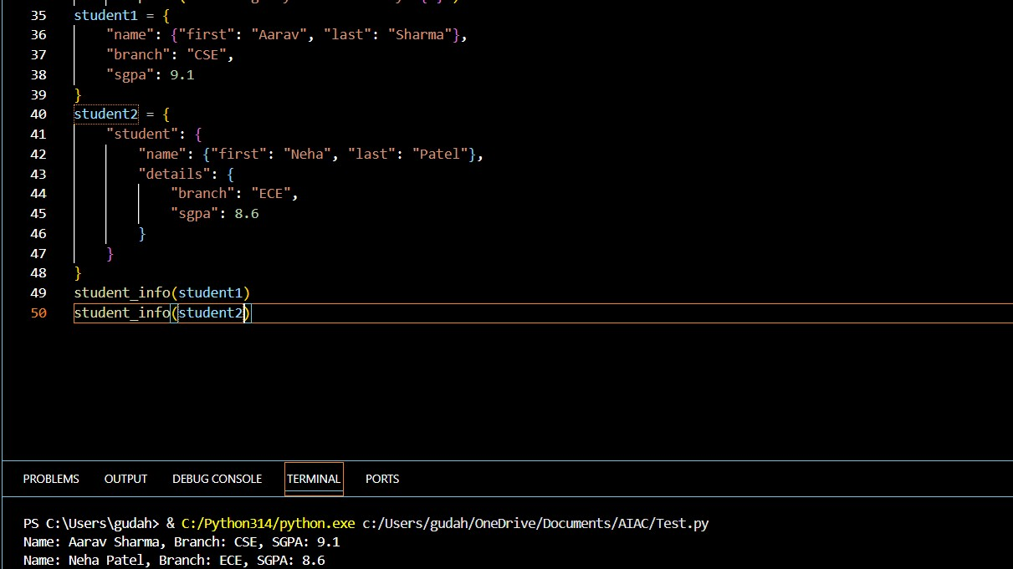

Task Description #10 (Loops – Perfect Numbers in a Range)
Task: Generate a function using AI that displays all Perfect Numbers within a user-specified range (e.g., 1 to 1000).
Instructions:
- A Perfect Number is a positive integer equal to the sum of its proper divisors (excluding itself). o Example: 6 = 1 + 2 + 3, 28 = 1 + 2 + 4 + 7 + 14.
- Use a for loop to find divisors of each number in the range.
- Validate correctness with known Perfect Numbers (6, 28, 496…).
- Ask AI to regenerate an optimized version (using divisor check only up to root n
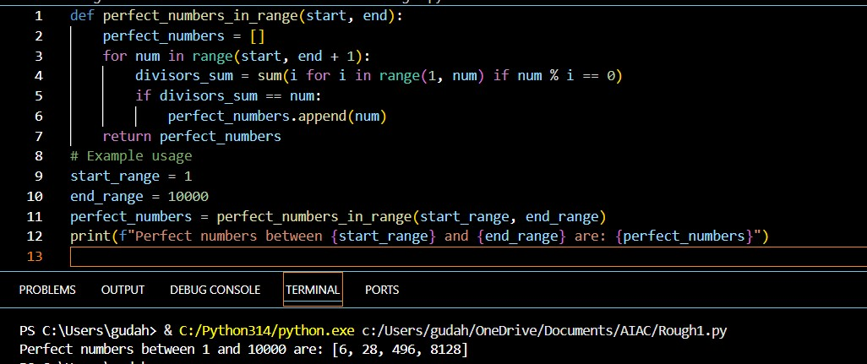
Optimized:
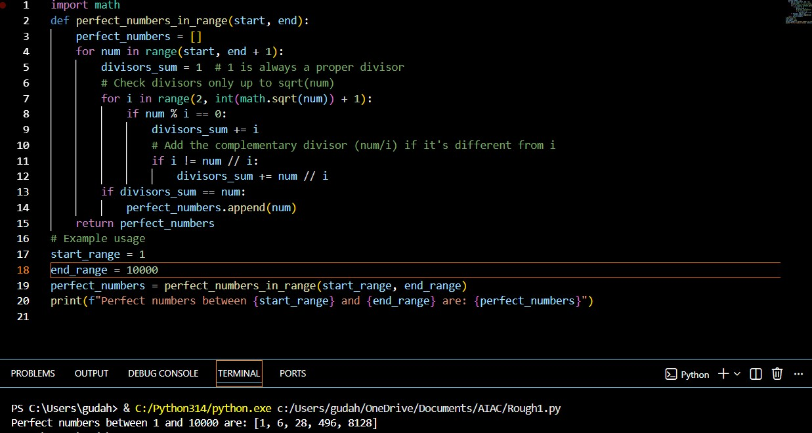

  - The optimized code checks only up to √n instead of all numbers from 1 to n, which greatly reduces the amount of work.
  - It uses the fact that divisors come in pairs, so when it finds one divisor, it automatically gets the other (n ÷ i) in the same step.
  - It avoids counting the same divisor twice by checking that i and n // i are different, which is important for perfect squares like 36.
  - The original method is very slow because it works in O(n × m), while the optimized one works in O(n × √m).
  - For numbers up to 10,000, the optimized version checks about 100 values instead of 10,000, making it roughly 100 times faster.

