Lab Assignment 9.5
Name:E.Asmaja
Hall ticket: 2303a51011
Batch:01
1
Lab Experiment: Documentation Generation -Automatic
documentation and code comments Week5 -
Friday
Lab Objectives
1. To understand automatic documentation generation.
2. To generate code comments and docstrings using AI tools.
3. To learn the importance of documentation in software
development.
Lab Outcomes
1. Students will be able to generate documentation
automatically for code.
2. Students will be able to add clear comments and docstrings to
programs.
3. Students will be able to improve code readability and
maintainability using documentation.
Problem 1: String Utilities Function
Consider the following Python function:
def reverse_string(text):
return text[::-1]
Task:
1. Write documentation in:
o (a) Docstring
o (b) Inline comments
o (c) Google-style documentation
2. Compare the three documentation styles.
3. Recommend the most suitable style for a utility-based string
library.
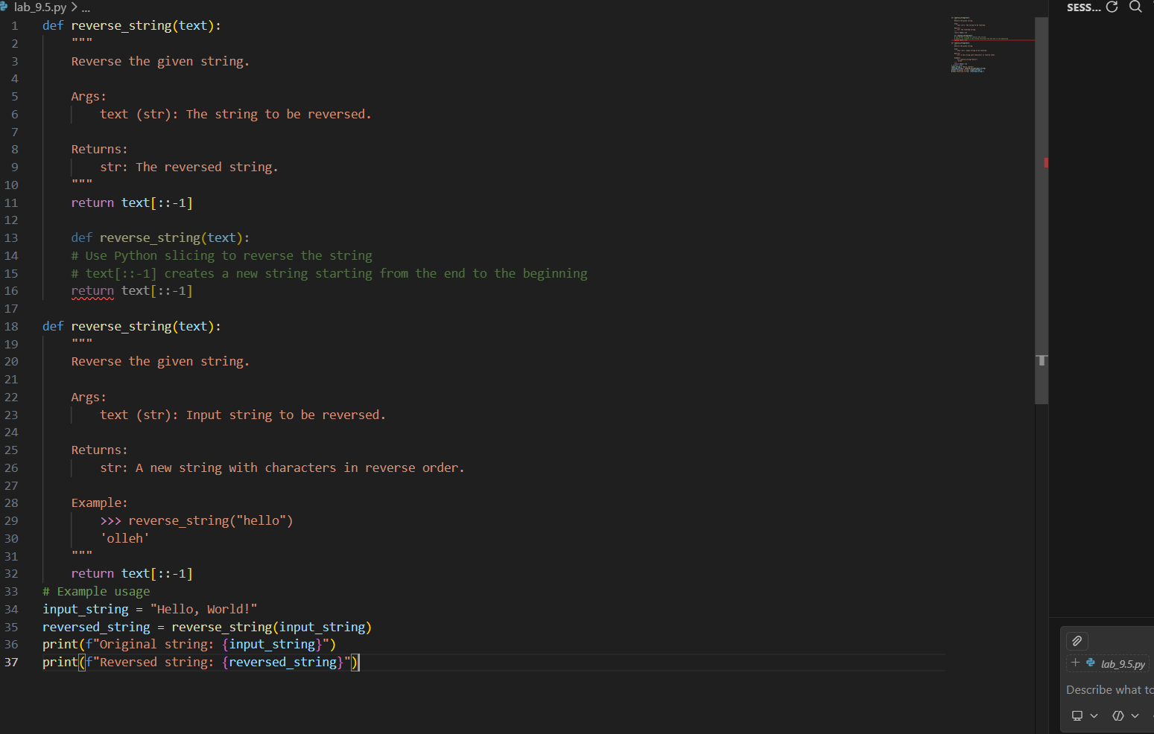
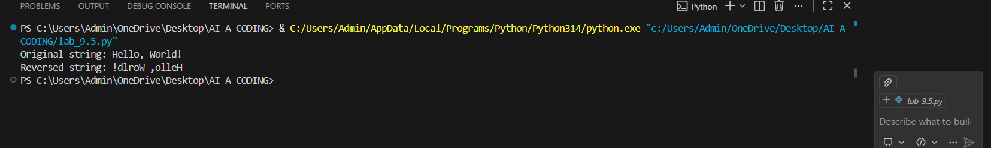
Problem 2: Password Strength Checker
Consider the function:
def check_strength(password):
return len(password) >= 8
Task:
1. Document the function using docstring, inline comments, and
Google style.
2. Compare documentation styles for security-related code.
3. Recommend the most appropriate style.
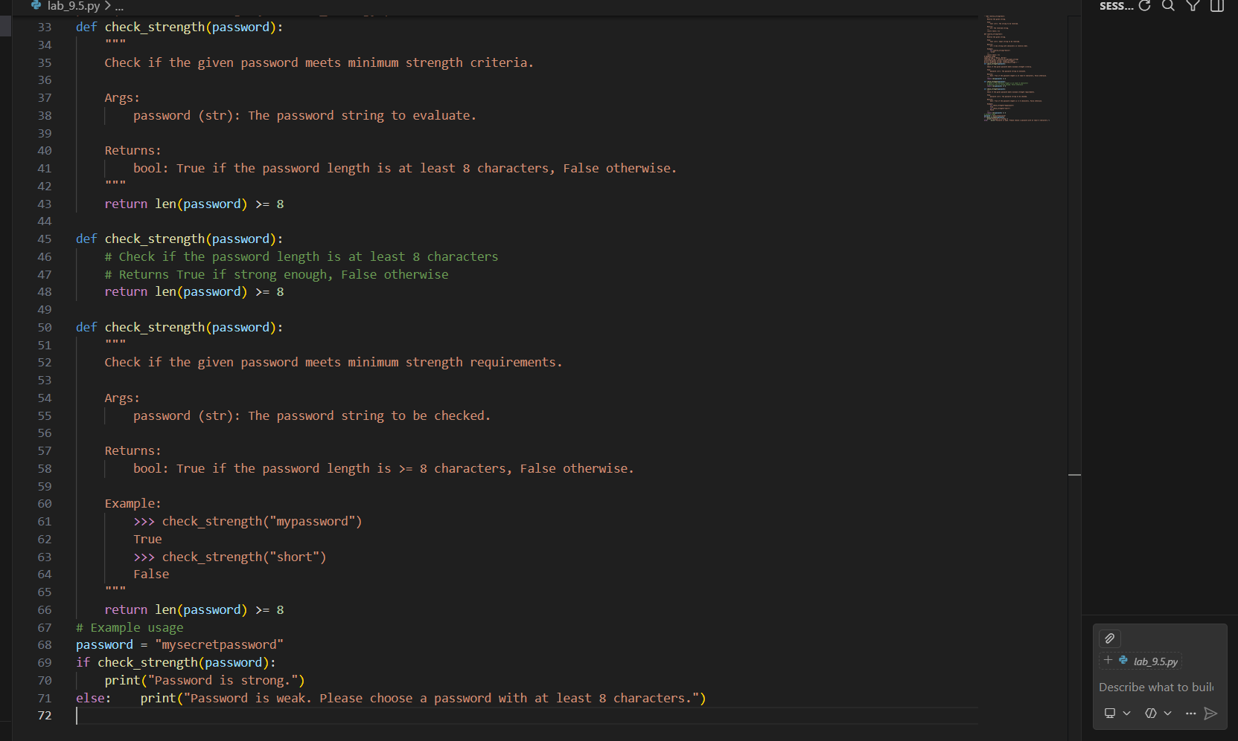
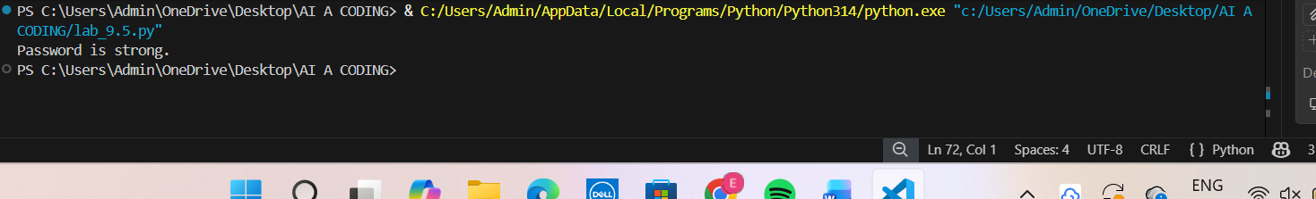
Problem 3: Math Utilities Module
Task:
1. Create a module math_utils.py with functions:
o square(n)
o cube(n)
o factorial(n)
2. Generate docstrings automatically using AI tools.
3. Export documentation as an HTML file.
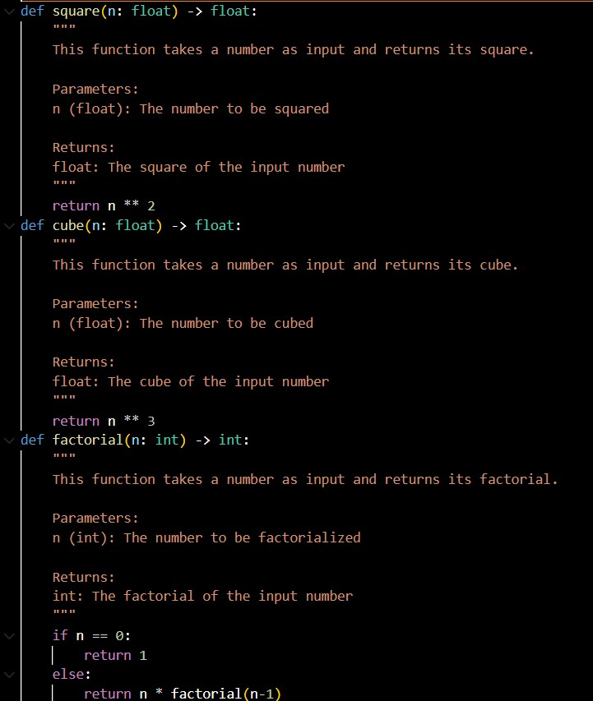
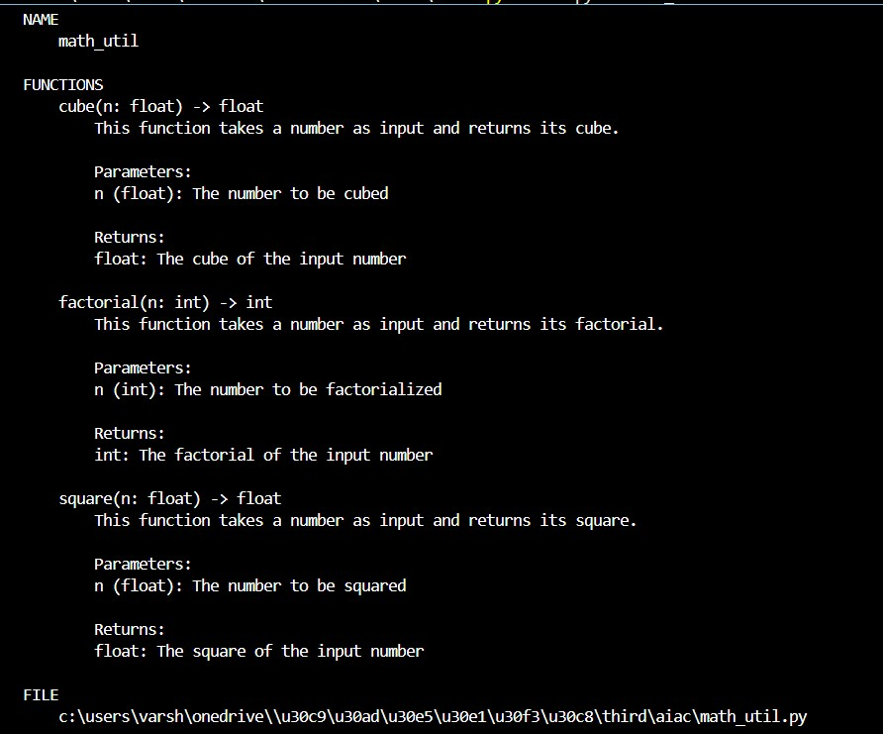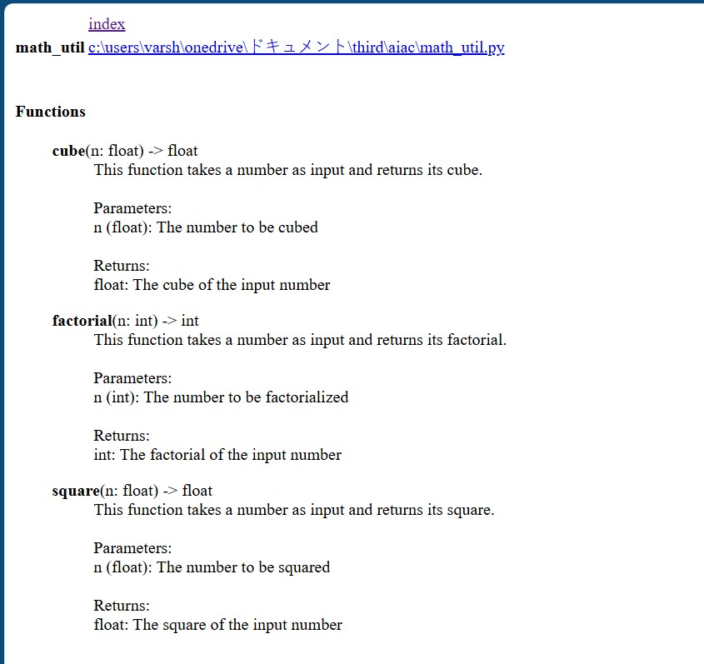

Problem 4: Attendance Management Module
Task:
1. Create a module attendance.py with functions:
o mark_present(student)
o mark_absent(student)
o get_attendance(student)
2. Add proper docstrings.
3. Generate and view documentation in terminal and browse
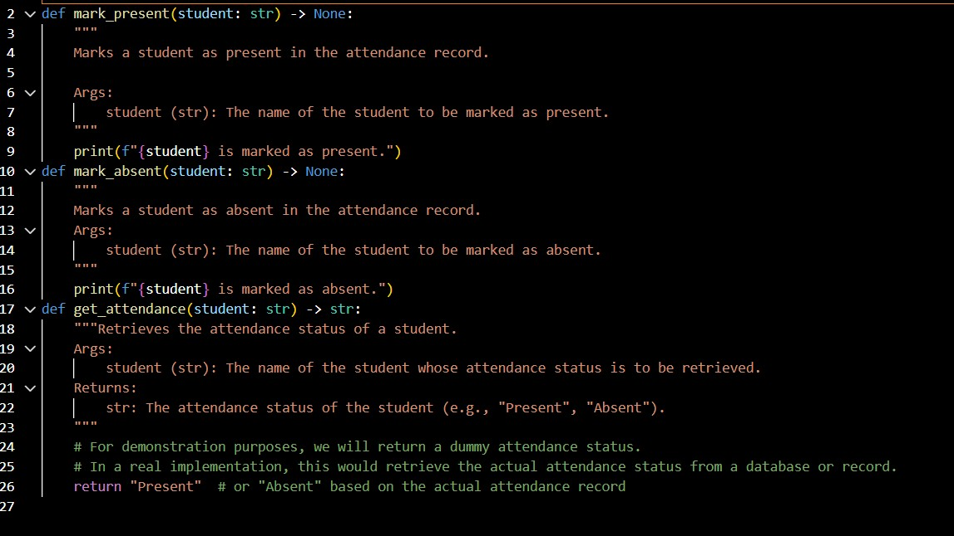

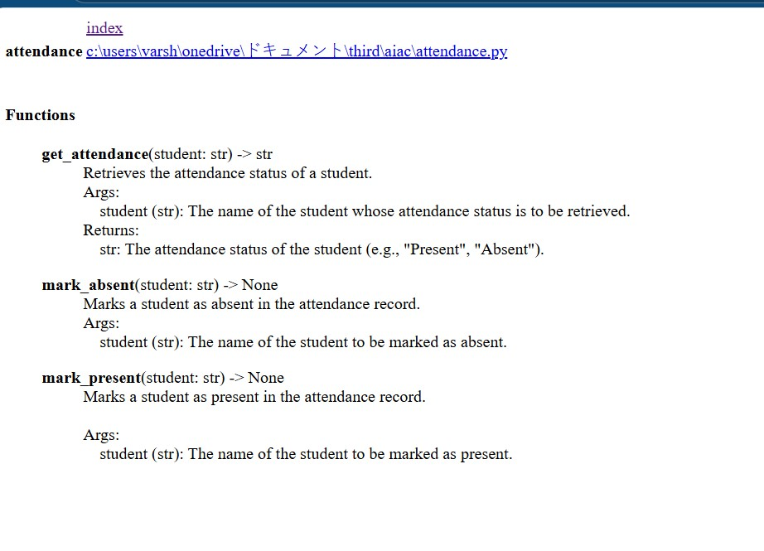
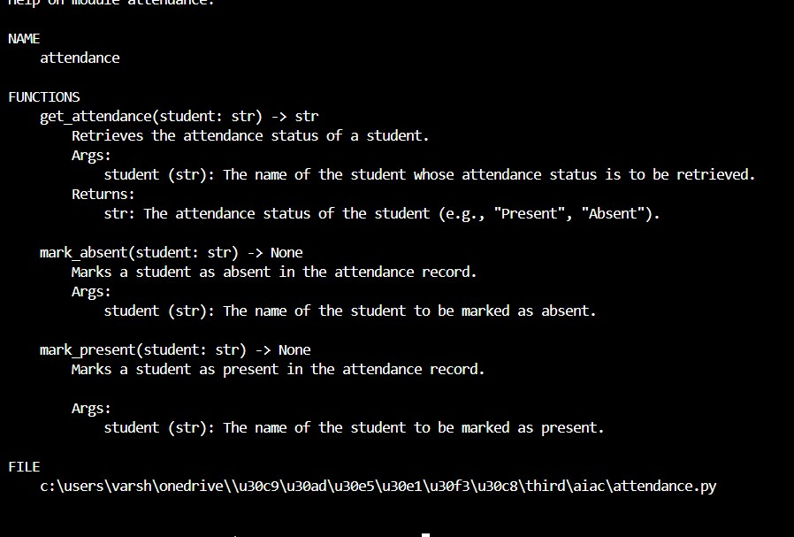

Problem 5: File Handling Function
Consider the function:
def read_file(filename):
with open(filename, 'r') as f:
return f.read()
Task:
1. Write documentation using all three formats.
2. Identify which style best explains exception handling.
3. Justify your recommendation.
