ASSIGNMENT 3.1

Name:Shivanand Rama
Hallticket:2303a51037

Task1
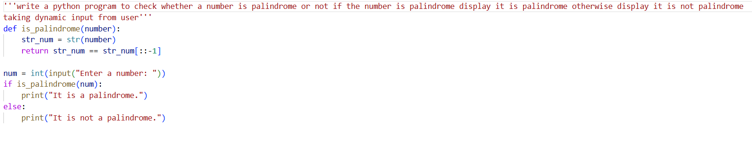
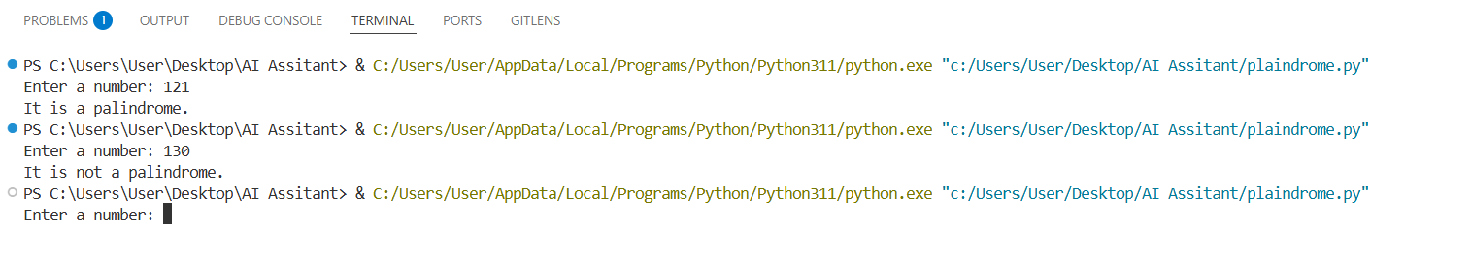
Task2
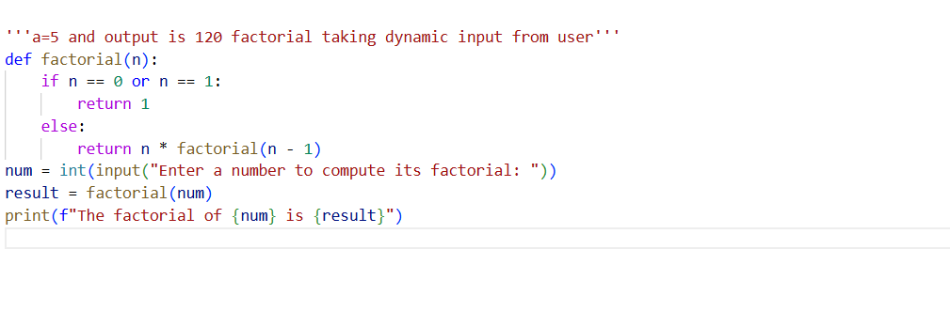
Task3
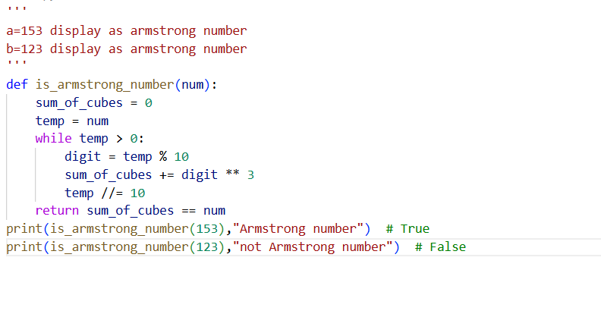
TASK4
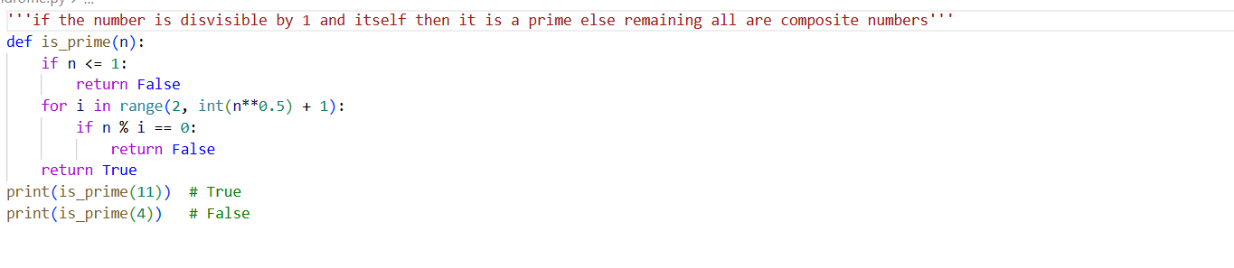
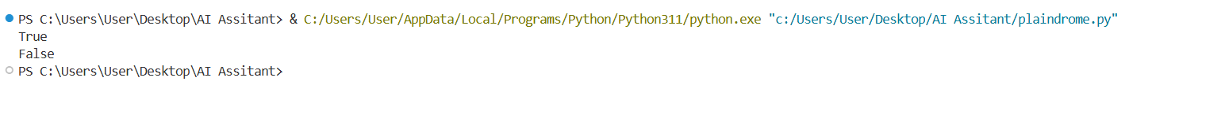
Task5
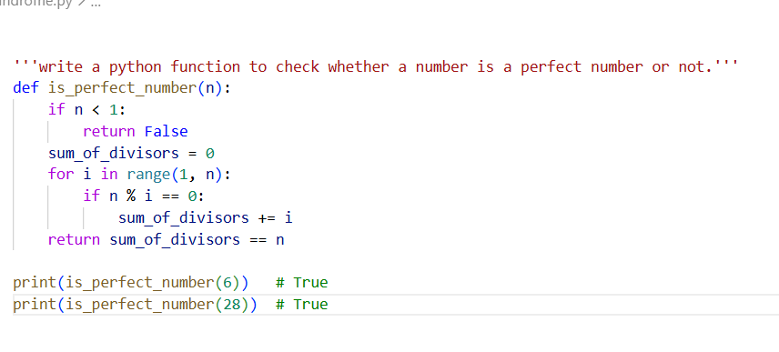
Task6
