Lab Assignment_18_05
Name : R SRIJA
Hall ticket : 2303A51043
Batch No. : 01

Task 1 – Weather API Integration
Connect to a Weather API to fetch current weather details for a given city.
Instructions:
- Prompt AI to generate Python code using the requests library. • Handle errors: invalid city name, API key errors, and network failures.
- Display temperature, humidity, and weather descrip on in a readable format.
Expected Output:
- A working Python script that fetches and displays weather data with proper error handling.
Screenshots:
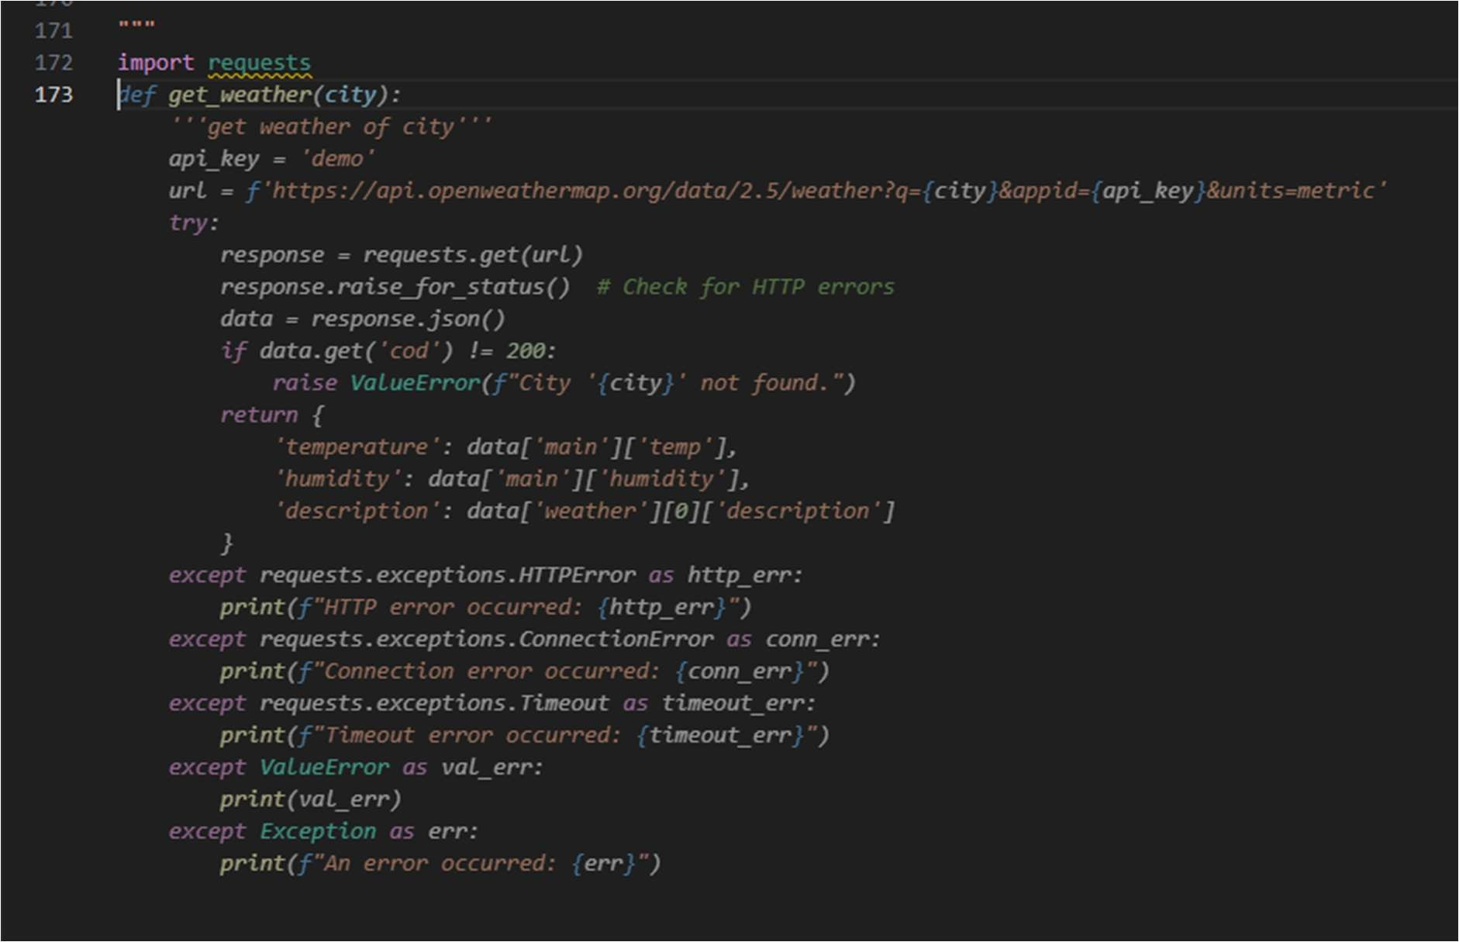
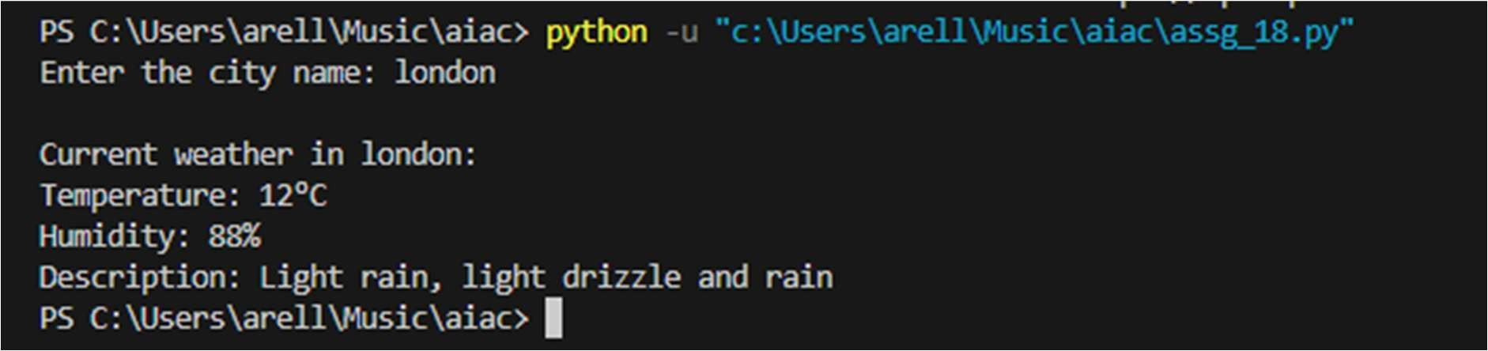

Task 2 – Currency Exchange Rates
Integrate a Currency Exchange API to convert INR to USD, EUR, and GBP.
Instructions:
- Use AI to generate API request code.
- Validate user input for amount and currency codes.
- Implement error handling for invalid responses and API down me.
- Show conversion results clearly in tabular format.
Expected Output:
- A script that converts INR to mul ple currencies with graceful error handling.
Screenshots:
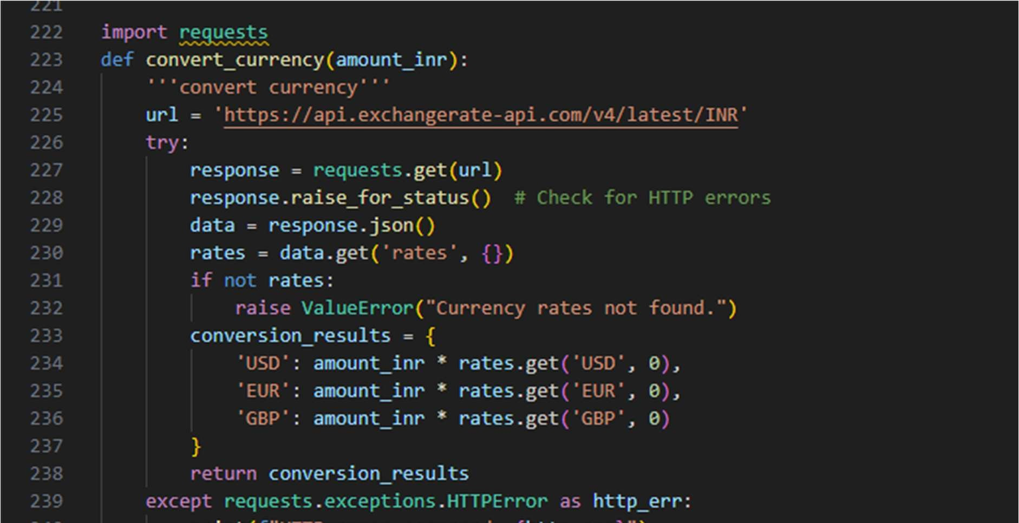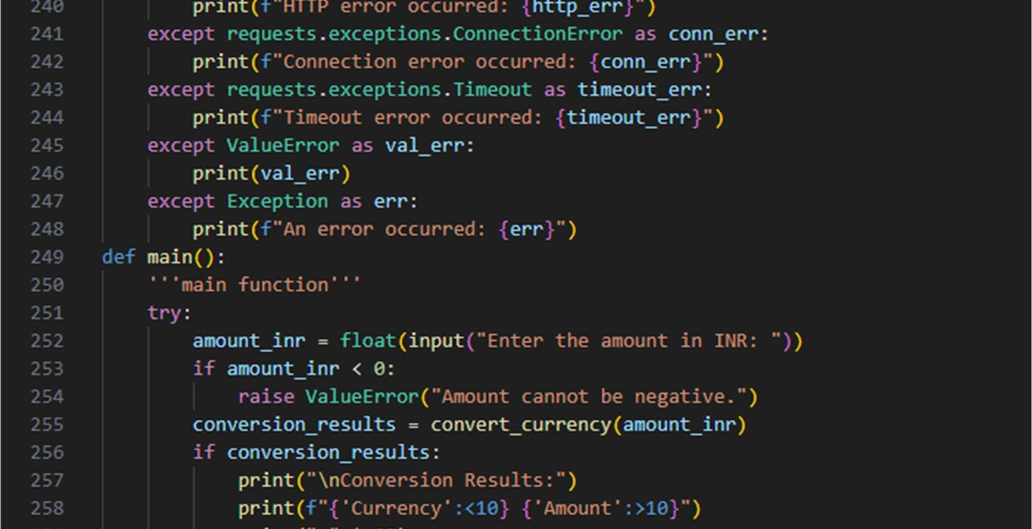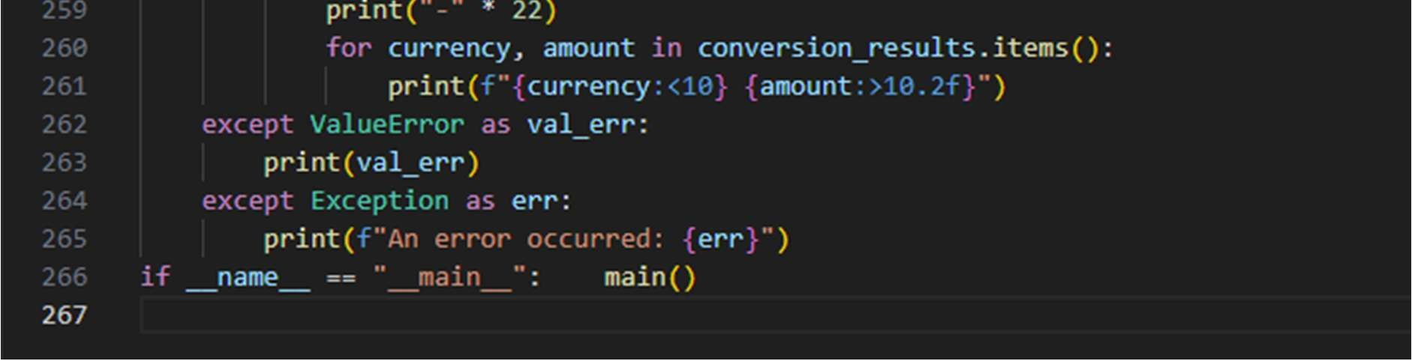
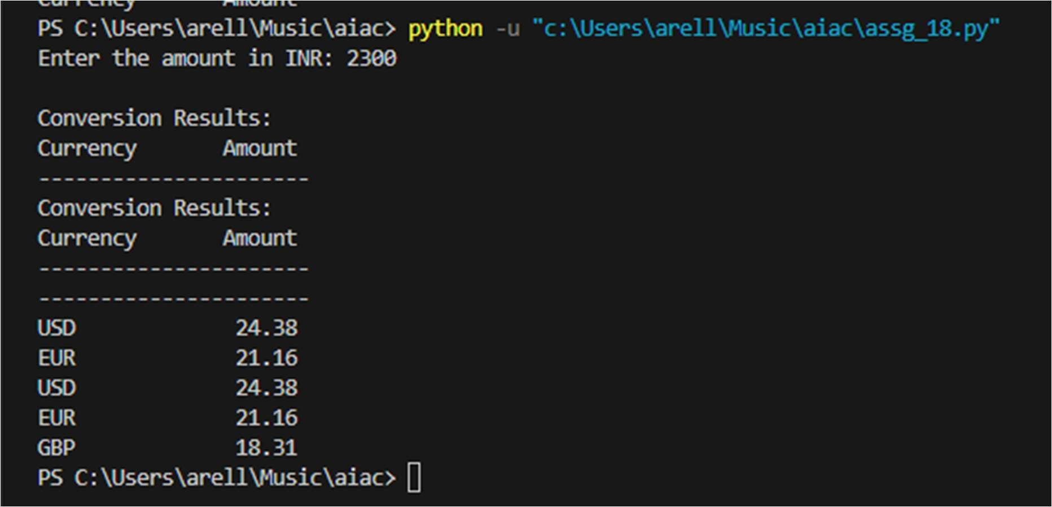

Task 3 – GitHub Repository Info Fetcher
Connect to the GitHub API to fetch details of a repository (e.g., stars, forks, issues).
Instructions:
- Prompt AI to write a Python func on to send GET requests to GitHub API.
- Handle rate limit errors, 404 (repo not found), and invalid input. • Display repository name, descrip on, stars, forks, and open issues.
Expected Output:
- A Python program that retrieves and displays GitHub repository information with robust error handling.
Screenshots:
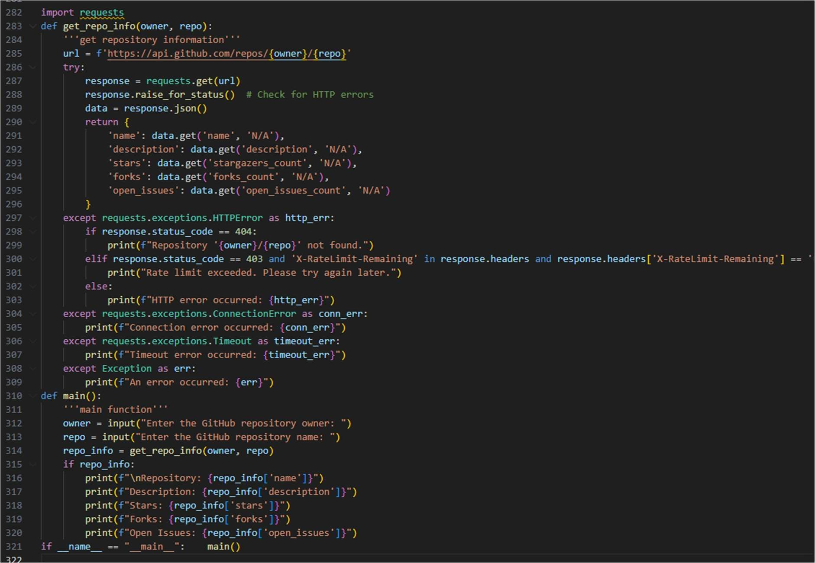

Task 4 – Real-Time Applica on: News Headlines Aggregator
Scenario: Build a News Aggregator using a free News API.
Requirements:
- Fetch top 5 headlines for a given category (sports, technology, health).
- Handle errors like invalid category, missing API key, and request failures.
- Display headlines in a user-friendly numbered list format.
- Include a retry mechanism if the first request fails.
Expected Output:
- A working Python script that retrieves and displays news headlineor handling
SCREENSHOTS:
Task 4 – Real-Time Application: News Headlines Aggregator
Scenario: Build a News Aggregator using a free News API.
Task 4 – Real-Time Application: News Headlines Aggregator
Scenario: Build a News Aggregator using a free News API.
Requirements:
• Fetch top 5 headlines for a given category (sports,
technology, health).
• Handle errors like invalid category, missing API key, and
request failures.
• Display headlines in a user-friendly numbered list format.
• Include a retry mechanism if the first request fails.
Expected Output:
• A working Python script that retrieves and displays news
headlines with proper error handling
