Assignment-19.1
NAME: R.SRIJA
HALLTICKET NUMBER:2303A51043
BATCH:01
Task 1 – Python to Java Conversion
Task:
Translate a simple Python class into Java using AI assistance.
Instructions:
• Prompt AI to convert a Python class with attributes and
methods into equivalent Java code.
• Verify that constructors, method signatures, and data types
are properly handled.
• Run both versions (Python & Java) to compare expected
outputs.
Expected Output:
• Equivalent working Java class translated from Python.
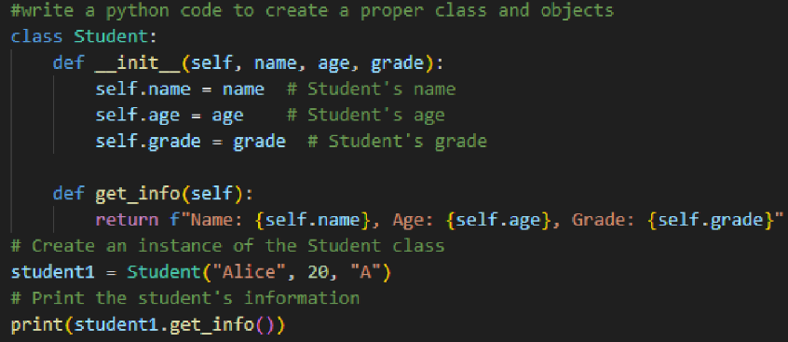
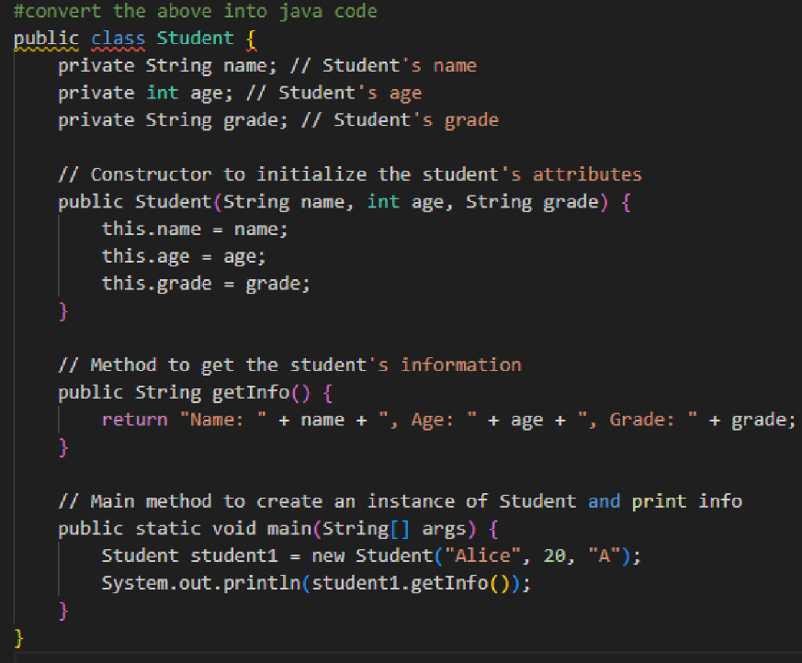
OUTPUT:
Task 2 – C++ to Python Function Conversion
Task:
Convert a C++ function for factorial calculation into Python.
Instructions:
• Ask AI to translate a recursive C++ factorial function into
Python.
• Validate correctness by testing with sample inputs.
• Ensure Python version follows Pythonic conventions.
Expected Output:
• A correct Python implementation equivalent to the original
C++ factorial function
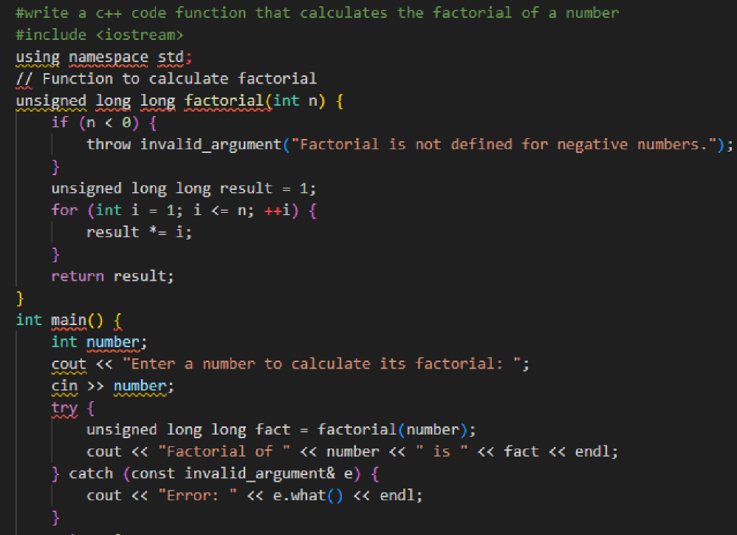
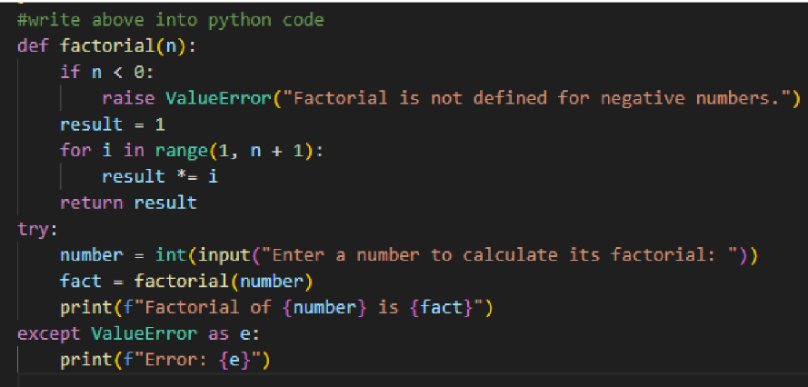
OUTPUT:
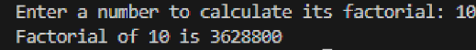
Task 3 – SQL to Pandas Query
Task:
Translate a SQL query into a Pandas DataFrame operation in
Python.
Instructions:
• Provide AI with a SQL query (e.g., SELECT name, salary
FROM employees WHERE salary > 50000).
• Ask AI to generate equivalent Pandas code.
• Test the generated code on a sample DataFrame.
Expected Output:
• Equivalent Pandas query that retrieves the correct subset of
data.
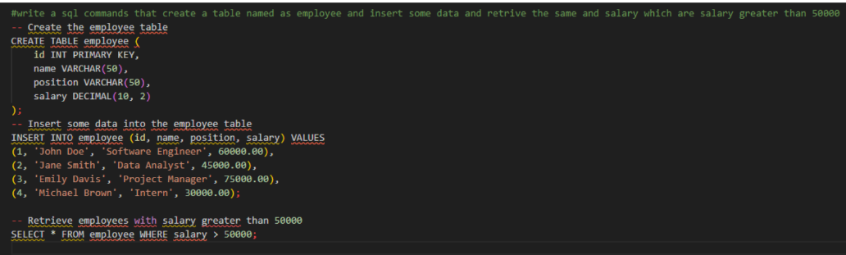
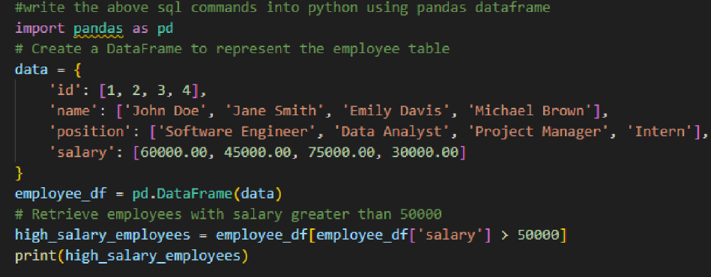
OUTPUT:
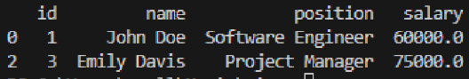
Task 4 – Real-Time Application: Multi-Language Snippet
Converter
Scenario:
Students will choose a real-time use case where they need code in
multiple languages. Example:
• Converting a Python web scraping snippet into JavaScript
for browser automation.
• Translating a Java method into C# for enterprise
applications.
Instructions:
• Prompt AI to translate code between two chosen languages.
• Test both implementations to ensure they produce the same
results.
• Document challenges faced during translation (e.g., syntax,
libraries).
Expected Output:
• Working equivalent code snippets in at least two different
programming languages.
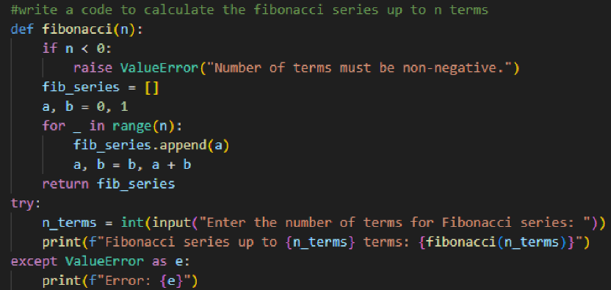
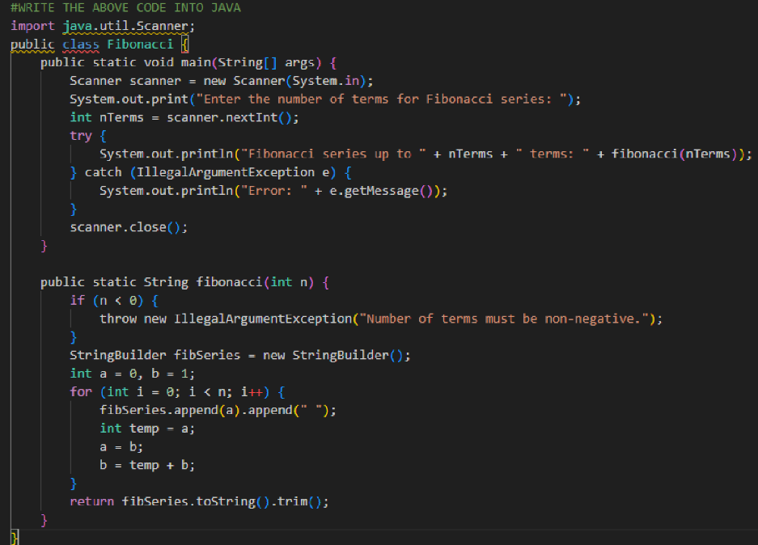
OUTPUT:
