ASSIGNMENT-20.5
NAME:R SRIJA
HALLTICKET NUMBER: 2303A51043
Task 1 – Password Storage Vulnerability Check
Task:
Analyze an AI-generated signup script for insecure password
storage.
Instructions:
• Prompt AI to generate a Python user registration program.
• Check whether passwords are stored in plain text.
• Improve the script using hashing (bcrypt or hashlib).
Expected Output:
• A secure registration script with hashed password storage.
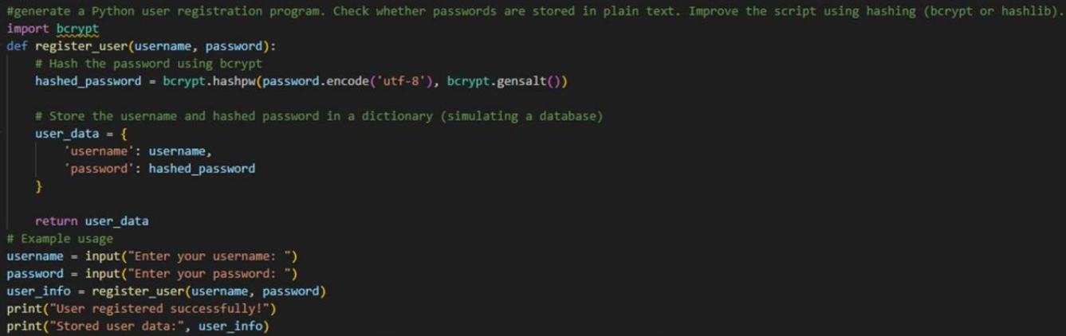
Task 2 – Hardcoded Secrets Detection
Task:
Evaluate AI-generated code for hardcoded API keys or credentials.
Instructions:
• Ask AI to generate a script that connects to an external API.
• Identify if API keys/passwords are written directly in code.
• Refactor using environment variables or config files.
Expected Output:
• A secure script with secrets managed properly.
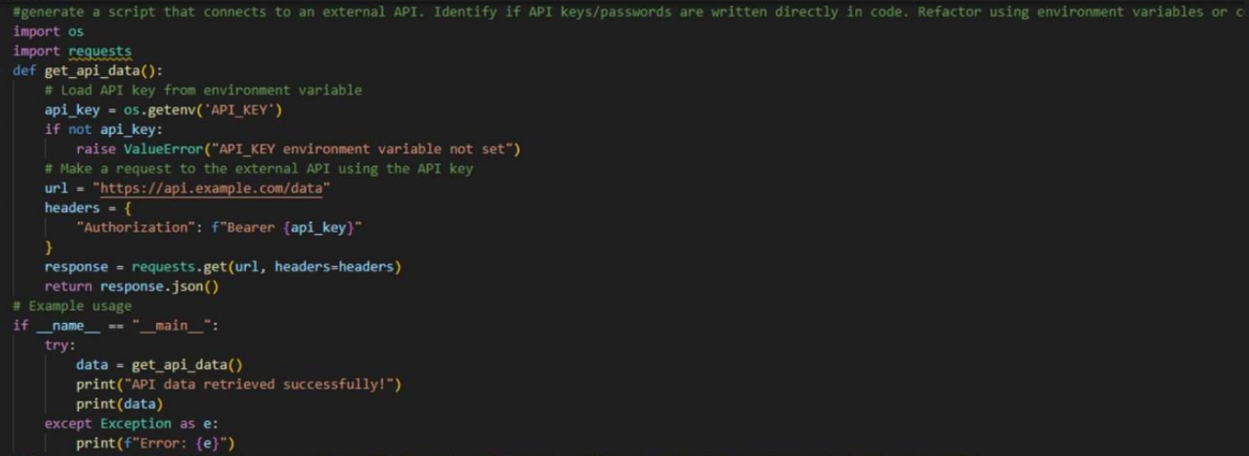
OUTPUT:
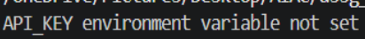
Task 3 – File Upload Security Validation
Task:
Test an AI-generated file upload program for unsafe file handling.
Instructions:
• Prompt AI to generate a Flask file upload example.
• Check for vulnerabilities like uploading executable files.
• Add validation for file type, size, and secure filename
handling.
Expected Output:
• A secure file upload implementation.
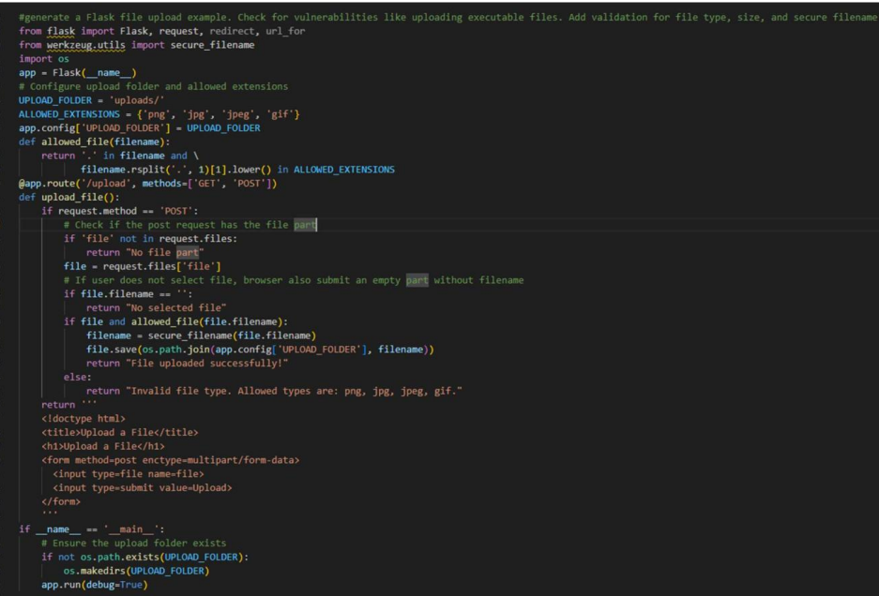
OUTPUT:
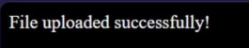
Task 4 – Command Injection Prevention
Task:
Analyze an AI-generated Python script that executes system
commands.
Instructions:
• Ask AI to generate code using os.system() or subprocess.
• Identify command injection risks with user input.
• Fix using safe subprocess calls and input validation.
Expected Output:
• A secure command execution script.
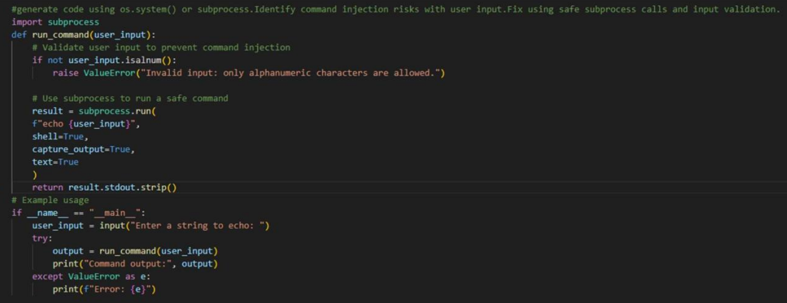
OUTPUT:
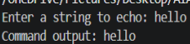
Task 5 – Secure Input Handling in Web Forms
Task:
Check AI-generated web form code for improper input validation.
Instructions:
• Ask AI to generate an HTML + Flask feedback form.
• Identify missing validation and unsafe rendering.
• Fix using server-side validation and sanitization.
Expected Output:
• A secure form resistant to injection attacks.
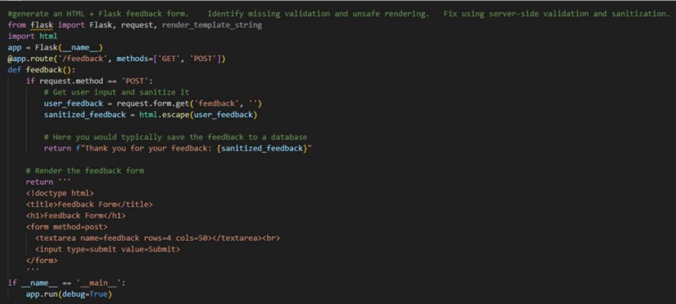
OUTPUT:
