Lab Assignment _14_5

Name : R SRIJA
Hall ticket : 2303A51043
Batch No. : 01
Task 1 – Image Gallery Website Create an image gallery web page.
Requirements:
Display images in a grid layout.
Use AI to:
Op mize layout using CSS Grid. o Add hover zoom or overlay effects.
Ensure mobile responsiveness.
Screenshots:
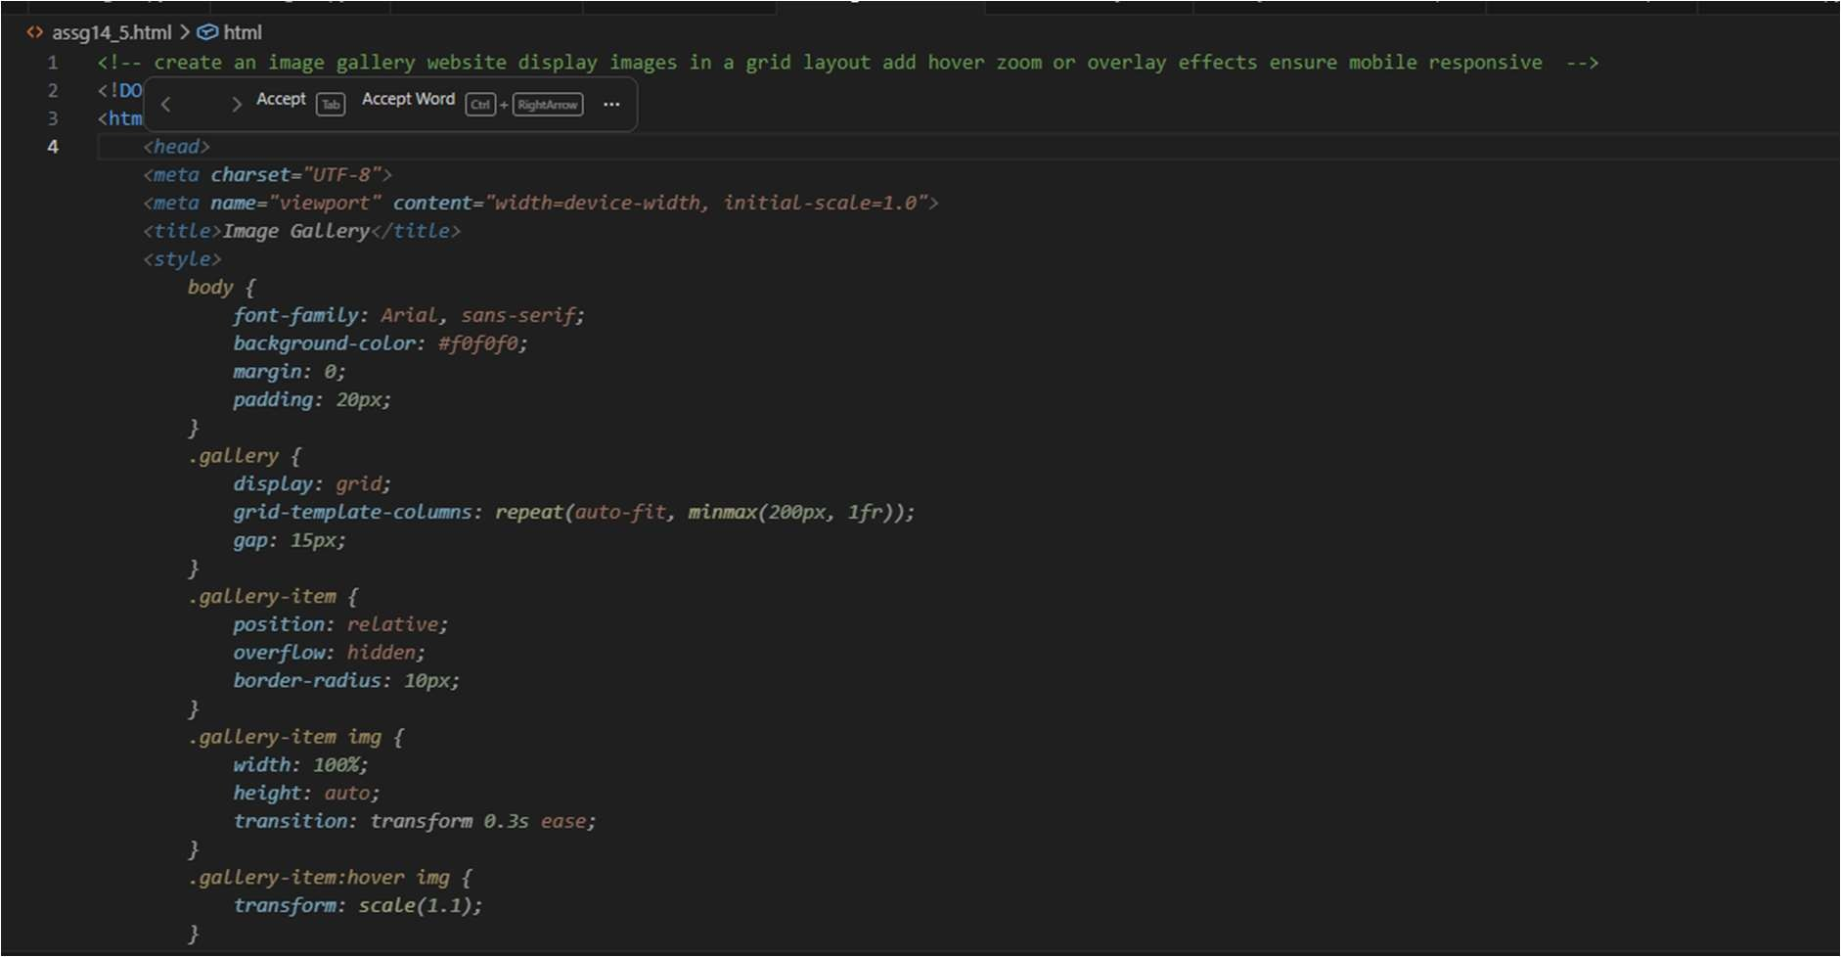


Task 2 – Profile Card Generator
Create a profile card web page.
Requirements:
.Display user image, name, role, and social media links.
Use AI to:
Suggest modern UI colors and fonts.
Design the card using Flexbox.
Add hover anima on and shadow effects
screenshots:
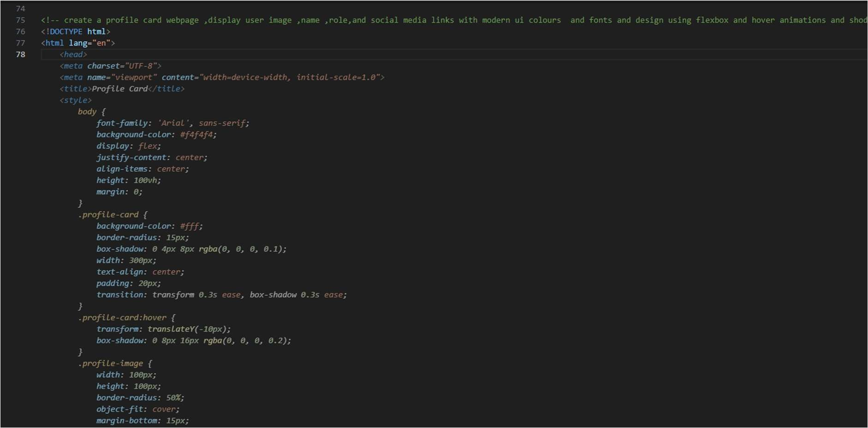


Task 3 -Develop a dynamic shopping cart system.
Requirements:
Add, remove, and update product quan es.
Display real- me total price.
Use AI to:
Manage cart state using JavaScript objects.
Persist cart data in localStorage.
Screenshots:
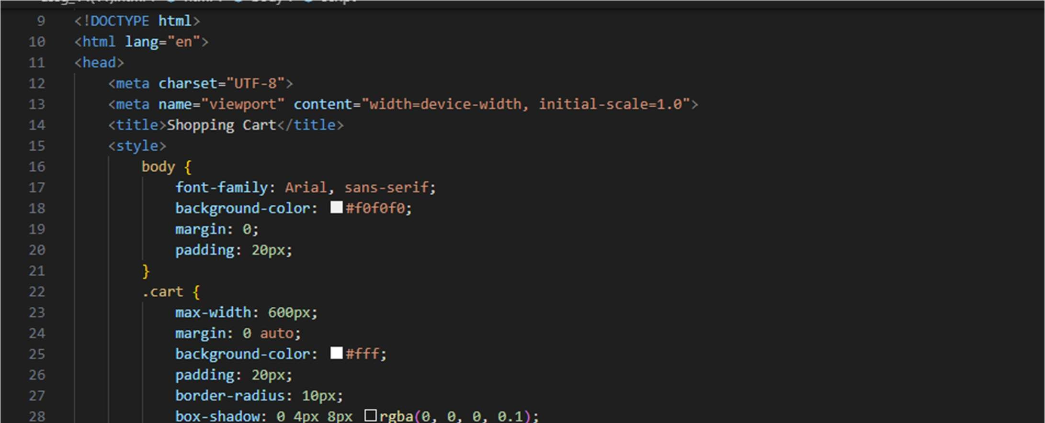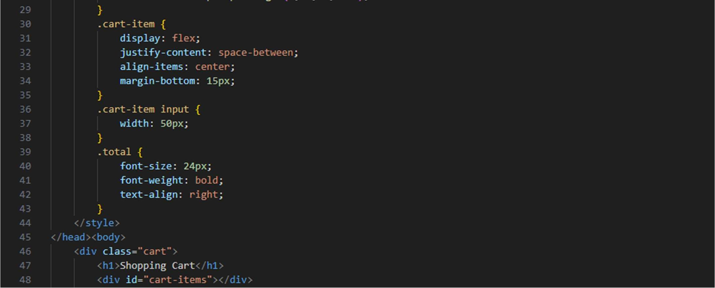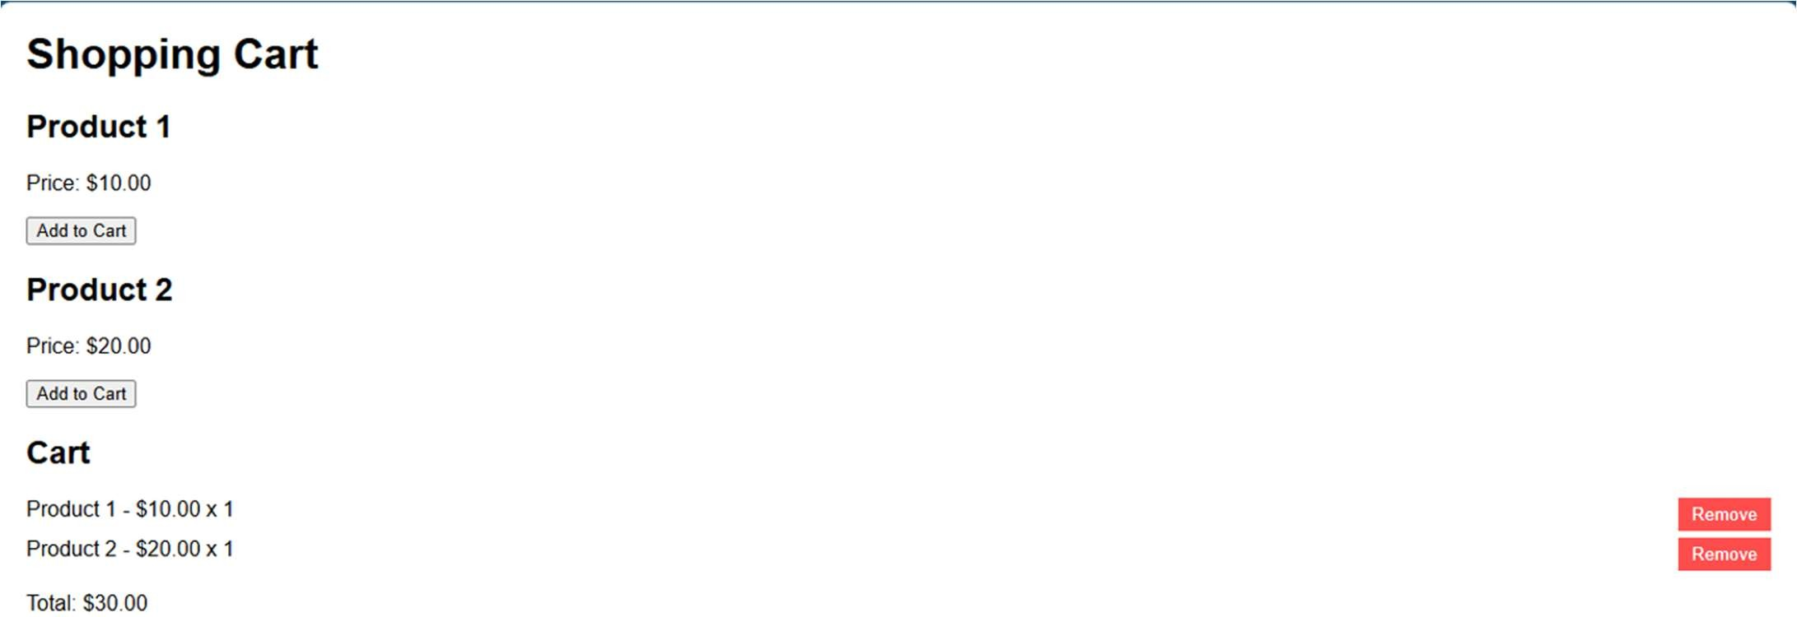
Task 4 – Role-Based Access Control Applica on
Create a role-based web applica on.
Requirements:
Admin, Editor, User roles.
Condi onal UI rendering.
Use AI to:
Design access control logic.
Maintain secure state transi ons. o Create scalable UI components.
Screenshots:
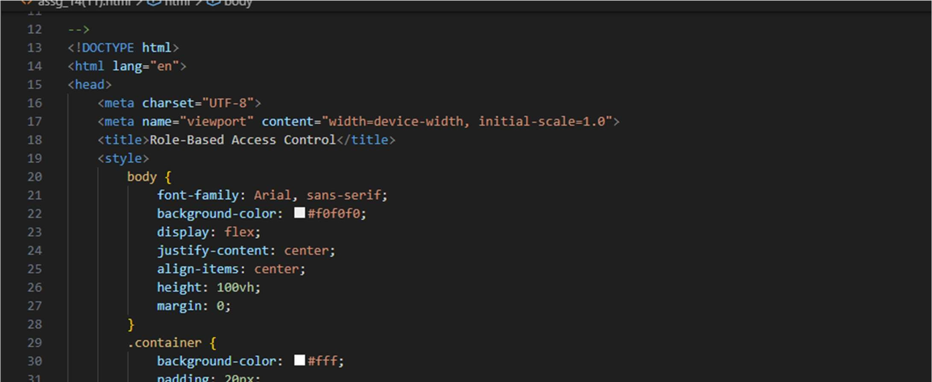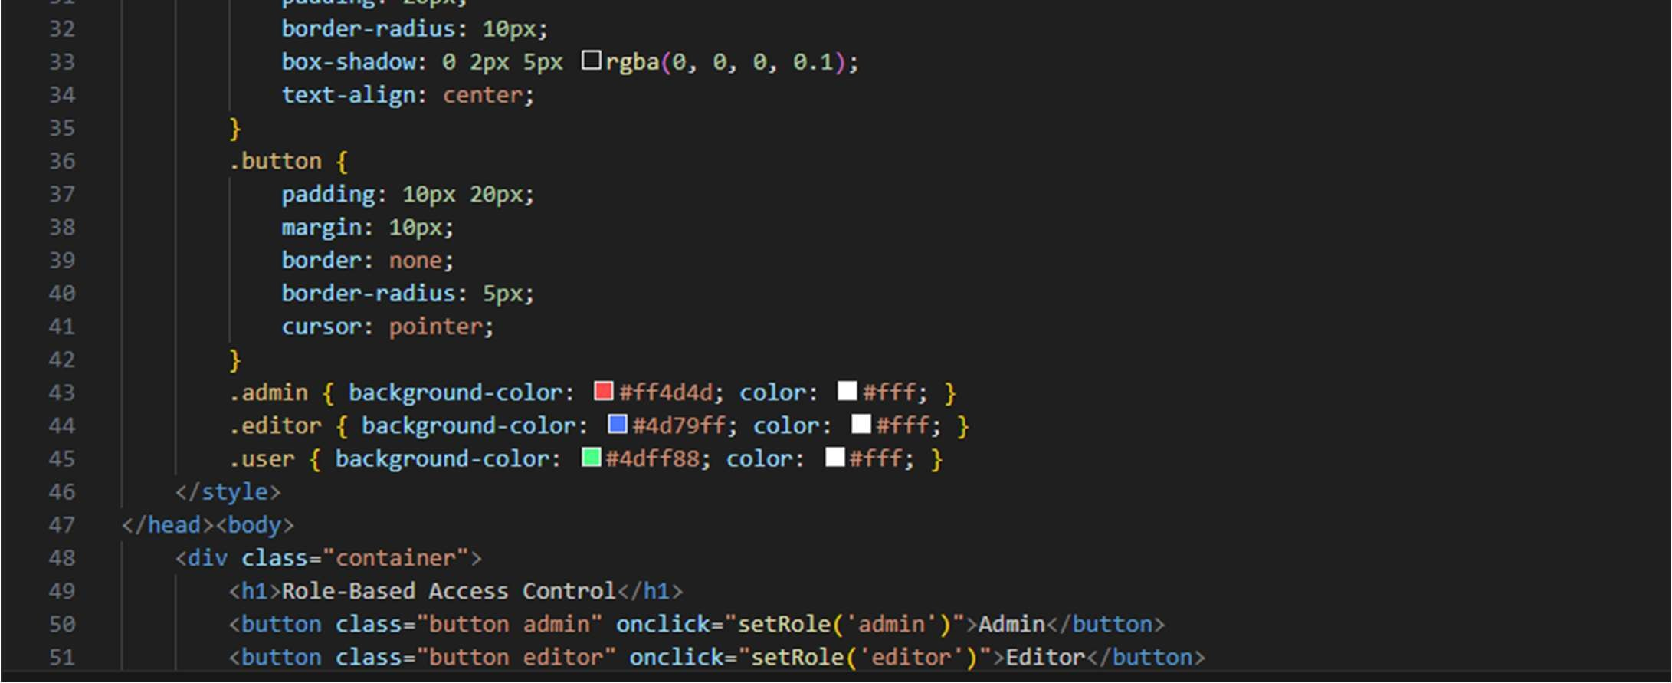



Task 5 – Mul -Language Website
Design a mul lingual website.
Requirements:
Switch languages dynamically.
Persist language preference.
Use AI to:
Structure transla on files. o Handle RTL/LTR layouts. o Improve accessibility.
Screenshots:
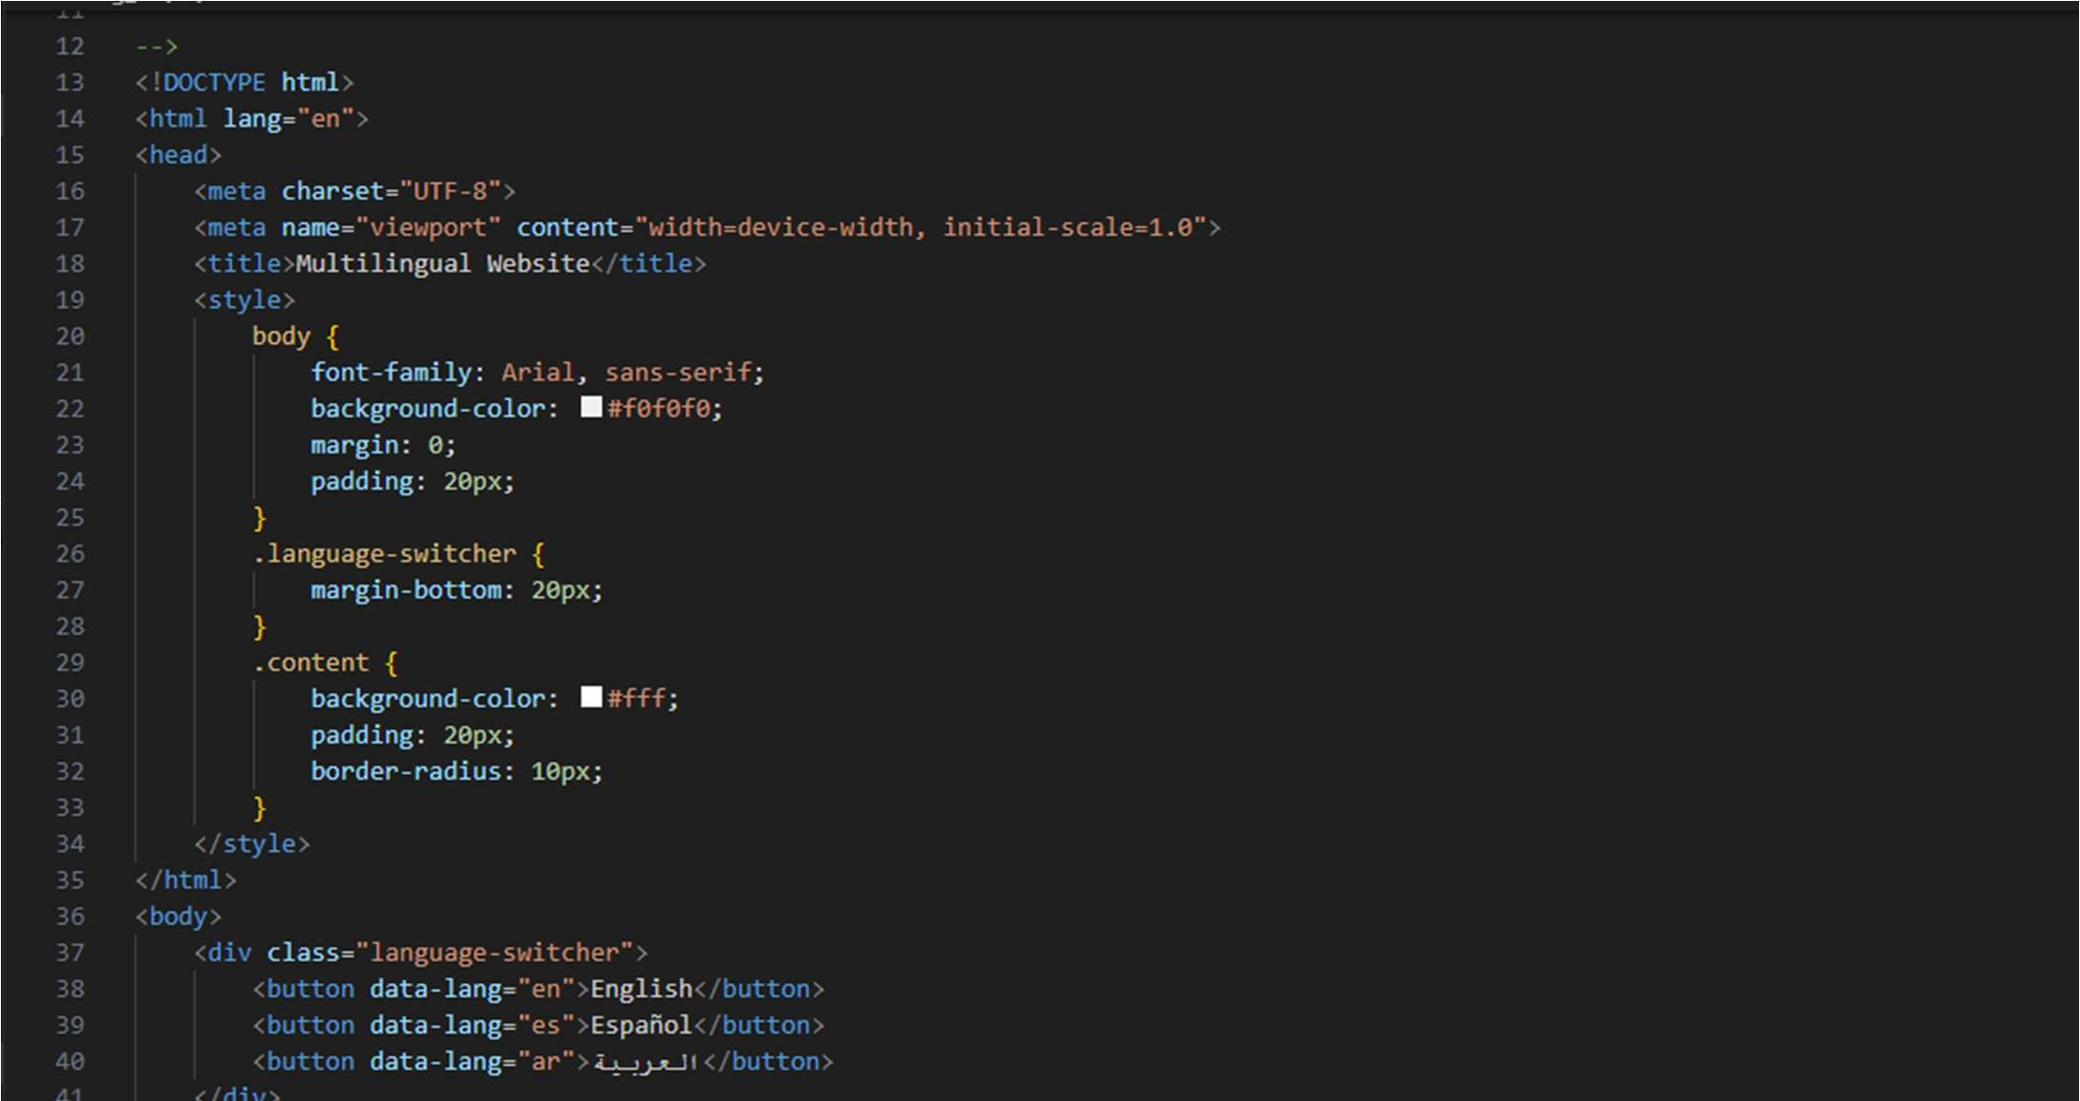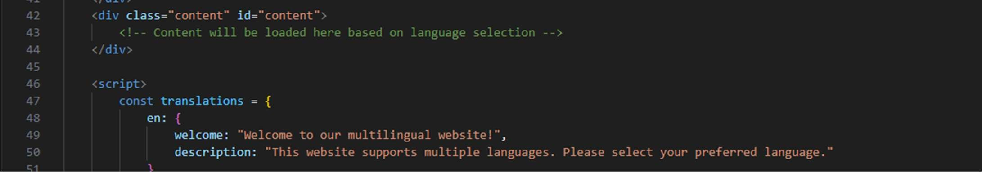
Task 6 – Online Examina on System Create an online exam interface.
Requirements:
Timer, ques ons, and submission.
Prevent mul ple submissions.
Use AI to:
Manage exam state. o Improve exam UX. o Ensure accessibility.
Screenshots:
