ASSIGNMENT-6.3
NAME:R SRIJA
HALLTICKETNUMBER:2303A51043
BATCH:01
1 (Loops – Automorphic Numbers in a Range)
• Task: Prompt AI to generate a function that displays all Automorphic numbers between 1 and 1000 using a for loop.
• Instructions:
o Get AI-generated code to list Automorphic numbers using a for loop
o Analyze the correctness and efficiency of the generated logic.
o Ask AI to regenerate using a while loop and compare both
implementations.
Expected Output #1:
• Correct implementation that lists Automorphic numbers using both loop types, with explanation.
CODE:
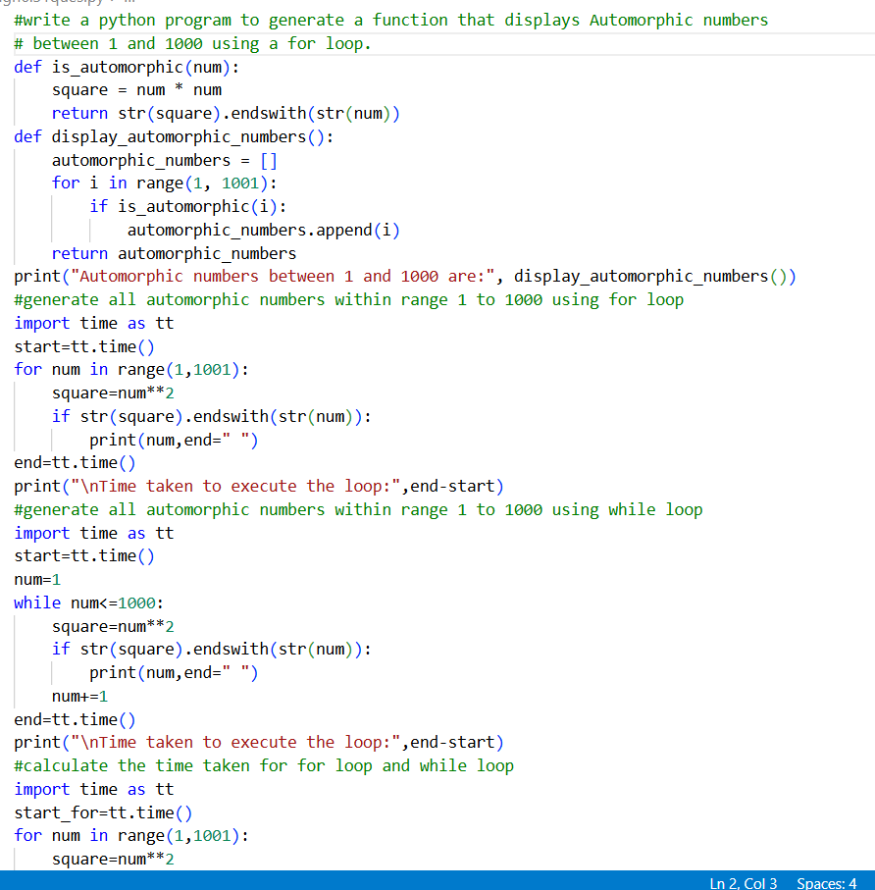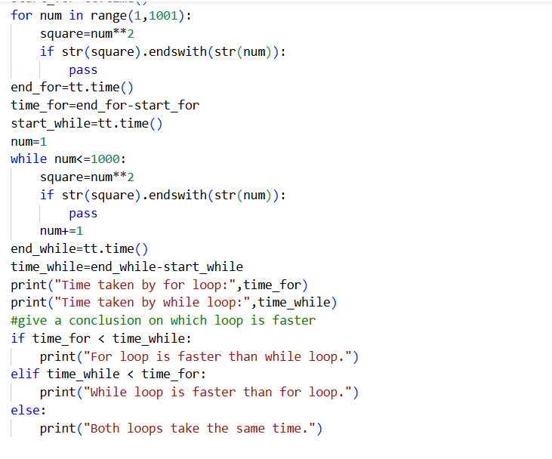
OUTPUT:
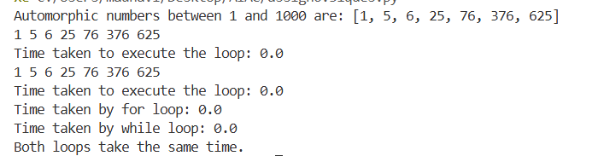
QUESTION 2:
(Conditional Statements – Online Shopping Feedback Classification)
• Task: Ask AI to write nested if-elif-else conditions to classify online shopping feedback as Positive, Neutral, or Negative based on a numerical rating (1–5).
• Instructions:
o Generate initial code using nested if-elif-else.
o Analyze correctness and readability.
o Ask AI to rewrite using dictionary-based or match-case structure.
Expected Output #2:
• Feedback classification function with explanation and an alternative approach.
CODE:
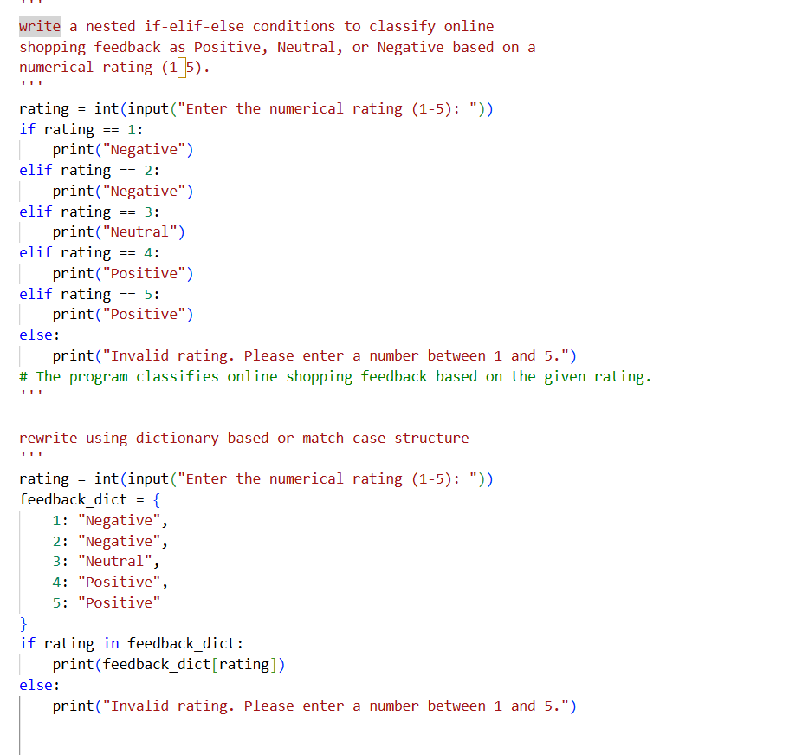
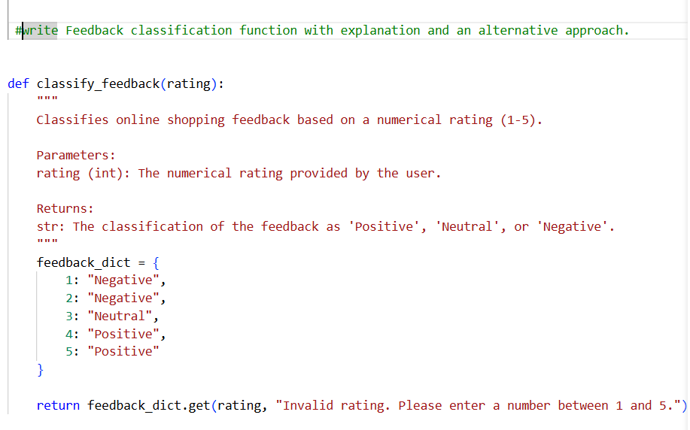

OUTPUT:
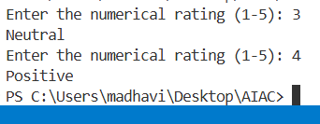

QUESTION 3 :
Task 3: Statistical_operations
Define a function named statistical_operations(tuple_num) that performs the following statistical operations on a tuple of numbers:
• Minimum, Maximum
• Mean, Median, Mode
• Variance, Standard Deviation
While writing the function, observe the code suggestions provided by GitHub Copilot.Make decisions to accept, reject, or modify the suggestions based on
their relevance and correctness
CODE:
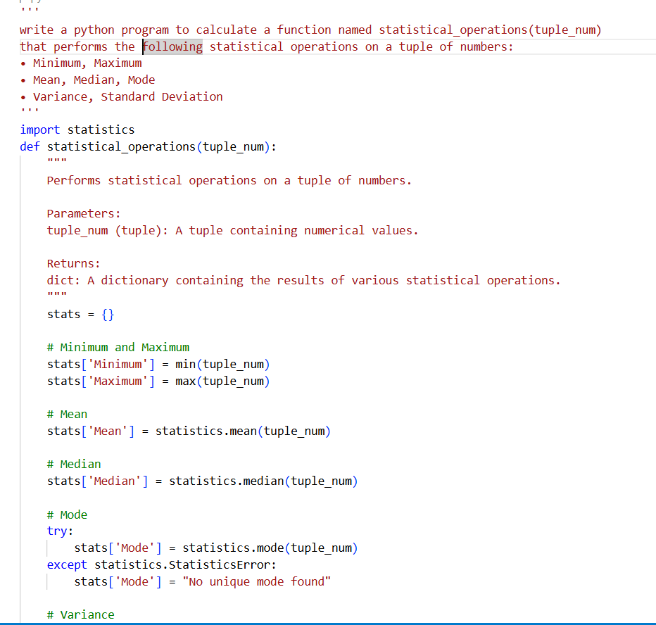
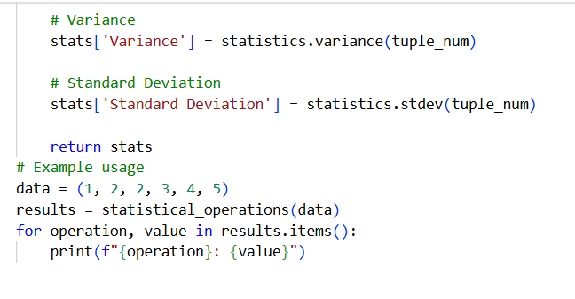
OUTPUT:
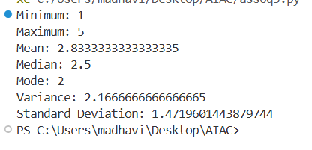
QUESTION 4: Teacher Profile
• Prompt: Create a class Teacher with attributes teacher_id, name, subject, and experience. Add a method to display teacher details.
• Expected Output: Class with initializer, method, and object creation.
CODE:
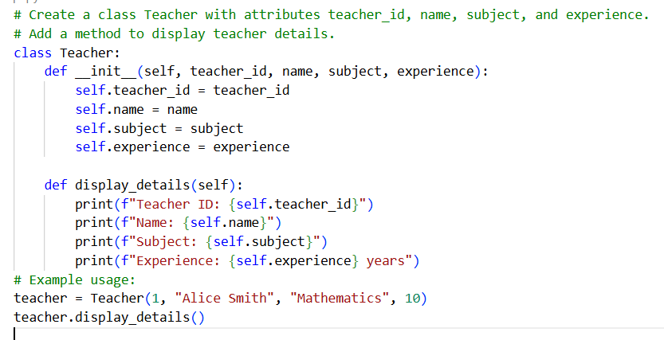
OUTPUT:
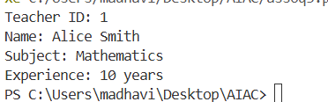
QUESTION 5: Zero-Shot Prompting with Conditional Validation
Use zero-shot prompting to instruct an AI tool to generate a function that validates an Indian mobile number.
Requirements
• The function must ensure the mobile number:
o Starts with 6, 7, 8, or 9
o Contains exactly 10 digits
Expected Output
• A valid Python function that performs all required validations without using any input-output examples in the prompt.
CODE:
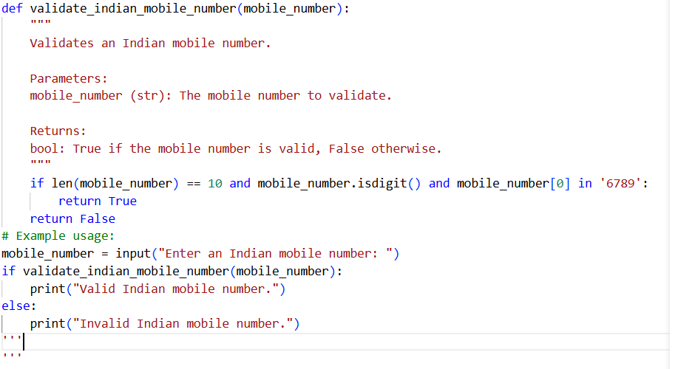
OUTPUT:
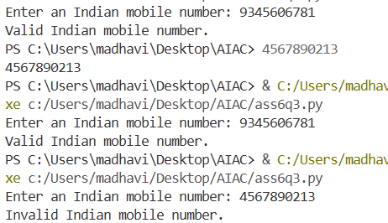
QUESTION 6:(Loops – Armstrong Numbers in a Range)
Task: Write a function using AI that finds all Armstrong numbers in a user- specified range (e.g., 1 to 1000).
Instructions:
• Use a for loop and digit power logic.
• Validate correctness by checking known Armstrong numbers (153, 370, etc.).
• Ask AI to regenerate an optimized version (using list comprehensions).
Expected Output #7:
• Python program listing Armstrong numbers in the range.
• Optimized version with explanation.7
CODE:
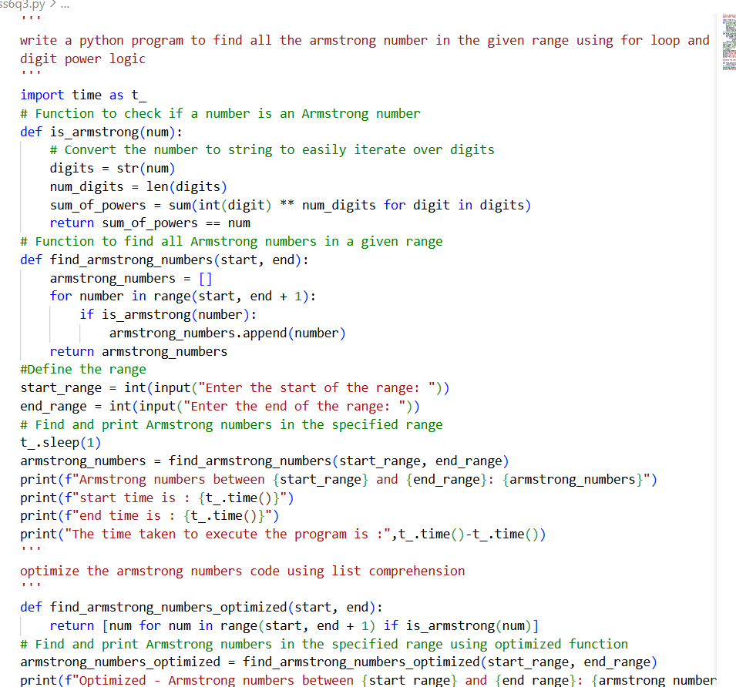
OUTPUT:
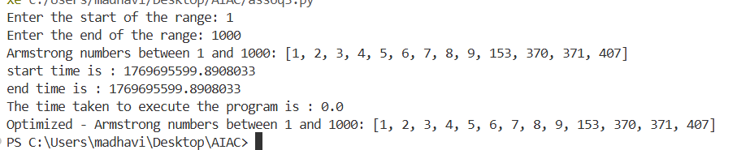
QUESTION :7 (Loops – Happy Numbers in a Range)
Task: Generate a function using AI that displays all Happy Numbers within a user-specified range (e.g., 1 to 500).
Instructions:
• Implement the logic using a loop: repeatedly replace a number with the sum of the squares of its digits until the result is either 1 (Happy Number) or enters a cycle (Not Happy).
• Validate correctness by checking known Happy Numbers (e.g., 1, 7, 10, 13, 19, 23, 28…).
• Ask AI to regenerate an optimized version (e.g., by using a set to detect cycles instead of infinite loops).
Expected Output #8:
• Python program that prints all Happy Numbers within a range.
• Optimized version using cycle detection with explanation.
CODE:
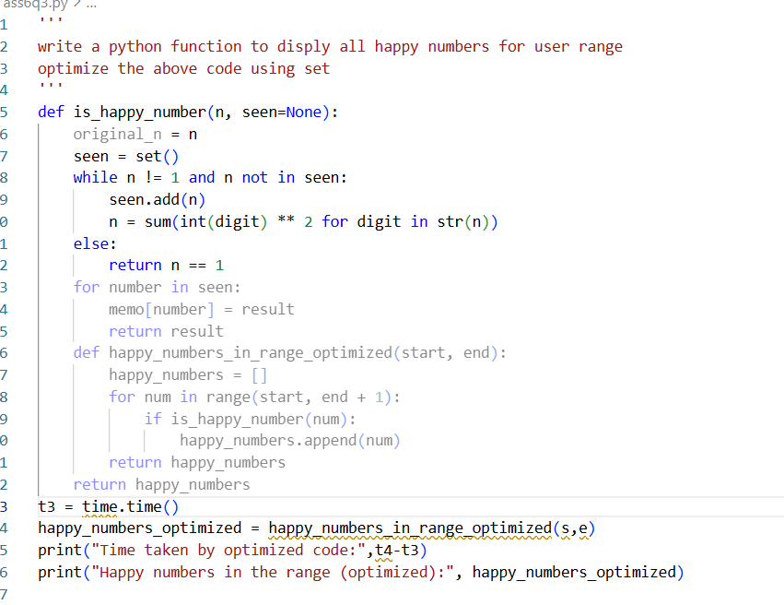
QUESTION 8:(Loops – Strong Numbers in a Range)
Task: Generate a function using AI that displays all Strong Numbers (sum of factorial of digits equals the number, e.g., 145 = 1!+4!+5!) within a given range.
Instructions:
• Use loops to extract digits and calculate factorials.
• Validate with examples (1, 2, 145).
• Ask AI to regenerate an optimized version (precompute digit factorials).
Expected Output #9:
• Python program that lists Strong Numbers.
• Optimized version with explanation.9
CODE:
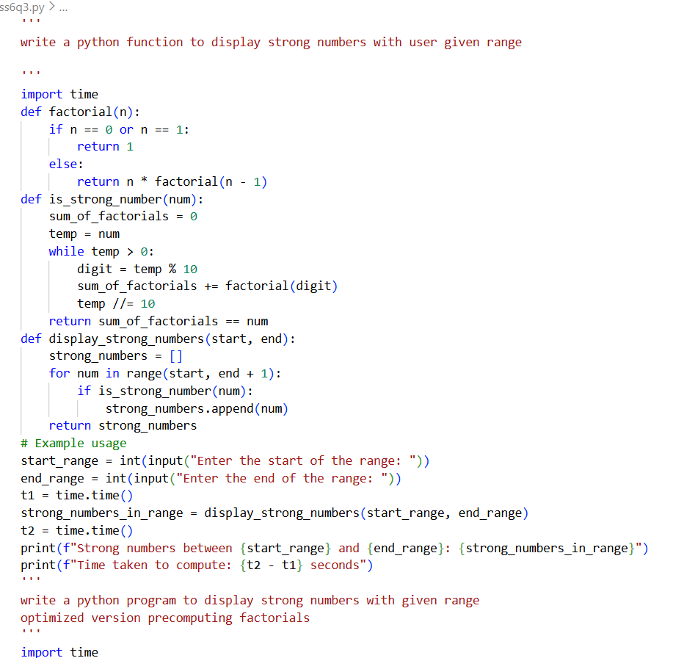
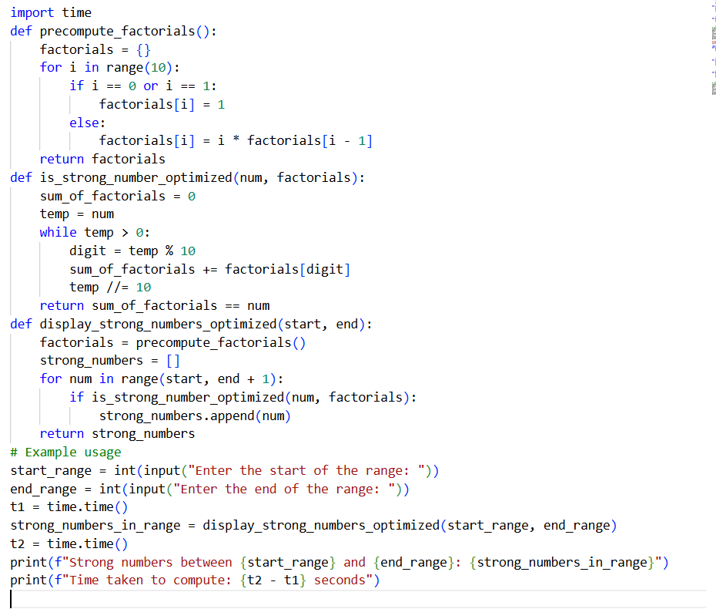
OUTPUT:
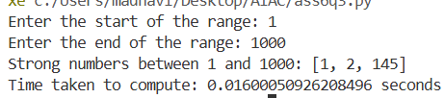
QUESTION 9 – Few-Shot Prompting for Nested Dictionary Extraction
Objective
Use few-shot prompting (2–3 examples) to instruct the AI to create a function that parses a nested dictionary representing student information.
Requirements
• The function should extract and return:
o Full Name
o Branch
o SGPA
Expected Output
A reusable Python function that correctly navigates and extracts values from nested dictionaries based on the provided examples
10
CODE:
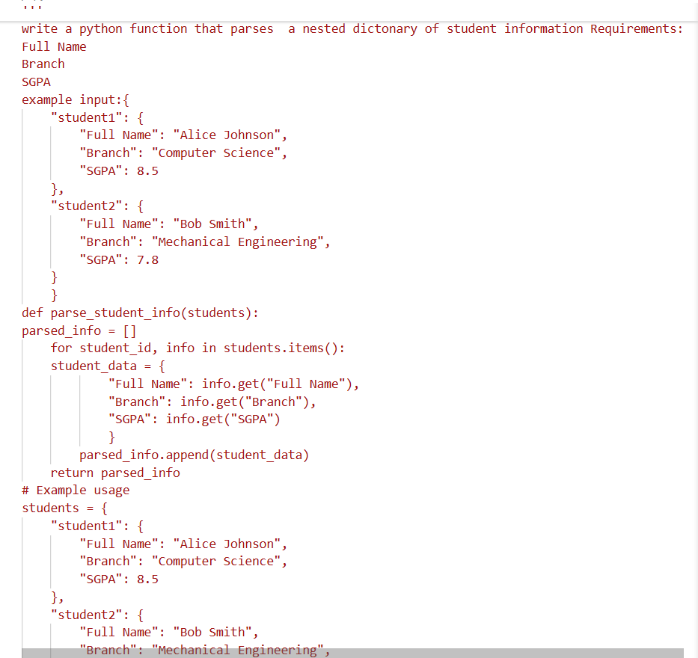
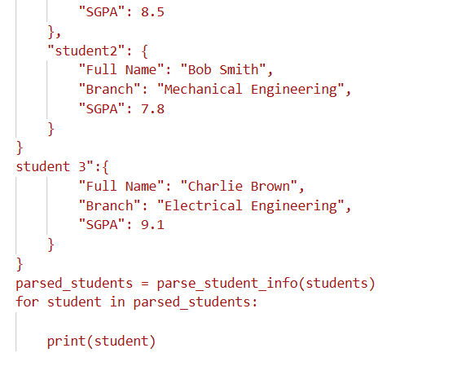
QUESTION #10 (Loops – Perfect Numbers in a Range)
Task: Generate a function using AI that displays all Perfect Numbers within a user-specified range (e.g., 1 to 1000).
Instructions:
• A Perfect Number is a positive integer equal to the sum of its proper divisors (excluding itself).
o Example: 6 = 1 + 2 + 3, 28 = 1 + 2 + 4 + 7 + 14.
• Use a for loop to find divisors of each number in the range.
• Validate correctness with known Perfect Numbers (6, 28, 496…).
• Ask AI to regenerate an optimized version (using divisor check only up to √n).
Expected Output #12:
• Python program that lists Perfect Numbers in the given range.
• Optimized version with explanation.
CODE:
OUTPUT: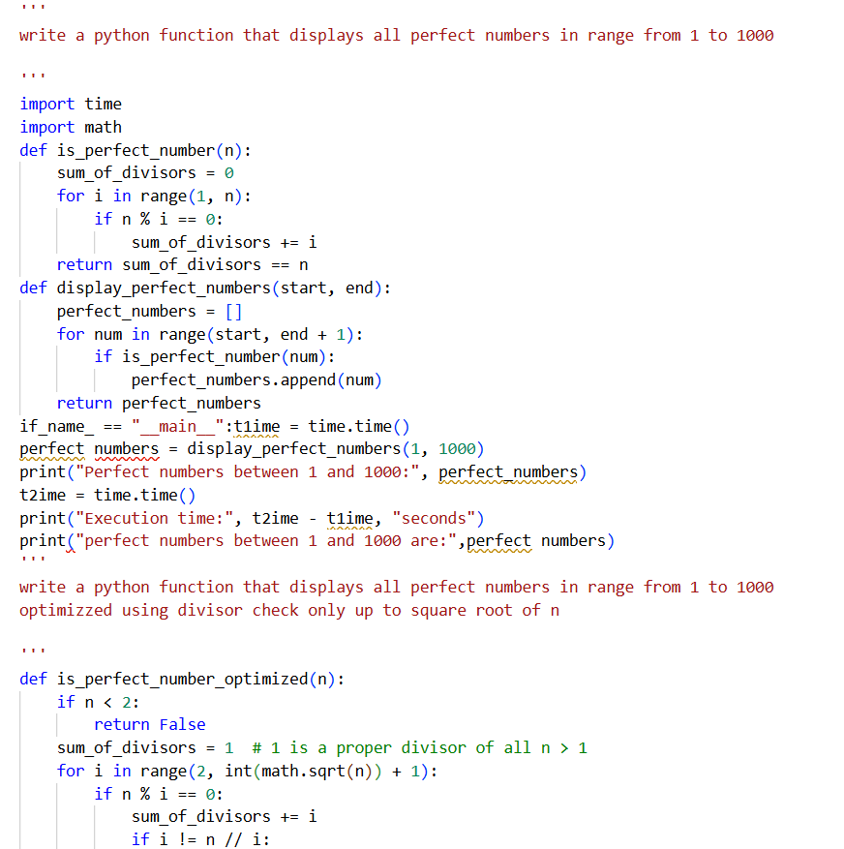
O