ASSIGNMENT-7.5

NAME: R SRIJA
HALLTICKET NO:2303A51043
BATCH:01
Task 1 (Mutable Default Argument – Function Bug):
CODE:
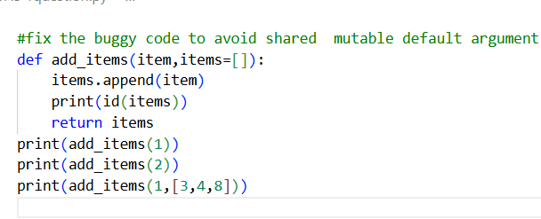
OUTPUT:
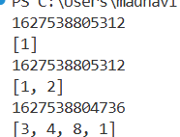
Task 2 (Floating-Point Precision Error):
CODE:
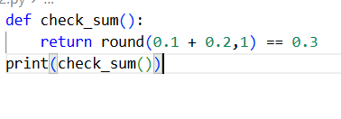
OUTPUT:
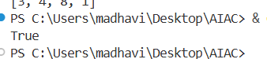
Task 3 (Recursion Error – Missing Base Case):
CODE:
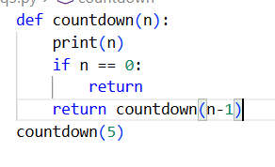
OUTPUT:
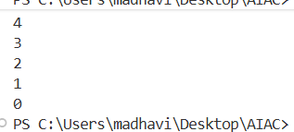
Task 4 (Dictionary Key Error):
CODE:
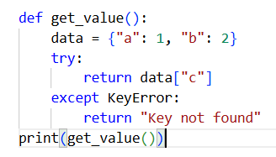
OUTPUT:
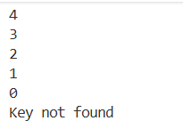
Task 5 (Infinite Loop – Wrong Condition):
CODE:
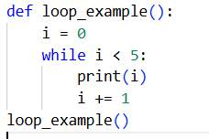
OUTPUT:
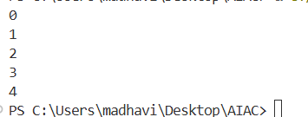

Task 6 (Unpacking Error – Wrong Variables):
CODE:
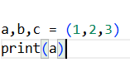
OUTPUT:
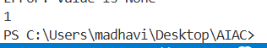
Task 7 (Mixed Indentation – Tabs vs Spaces):
CODE:
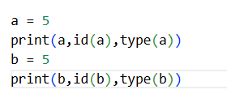
OUTPUT:
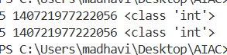
Task 8 (Import Error – Wrong Module Usage):
CODE:
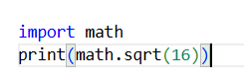
OUTPUT:
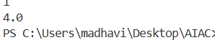
Task 9 (Unreachable Code – Return Inside Loop):
CODE:
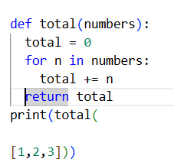
OUTPUT:
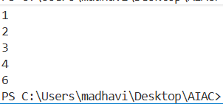
Task 10 (Name Error – Undefined Variable):
CODE:
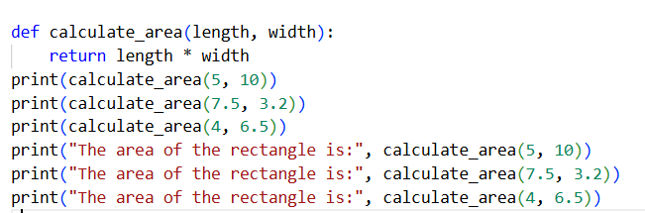
OUTPUT:
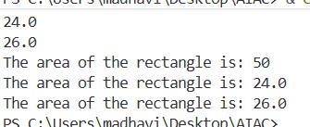
Task 11 (Type Error – Mixing Data Types Incorrectly):
CODE:
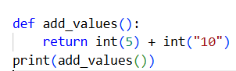
OUTPUT:
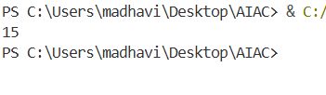
Task 12 (Type Error – String + List Concatenation):
CODE:
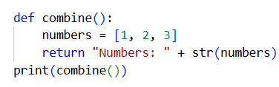
OUTPUT:
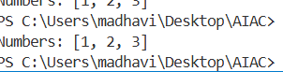
Task 13 (Type Error – Multiplying String by Float):
CODE:
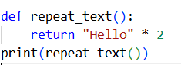
OUTPUT:
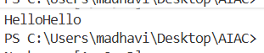
Task 14 (Type Error – Adding None to Integer):
CODE:
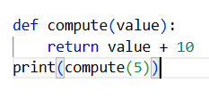
OUTPUT:
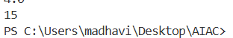
Task 15 (Type Error – Input Treated as String Instead of Number):
CODE:
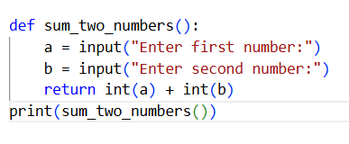
OUTPUT:
