ASSIGNMENT – 11.3
2303A51060
Batch-10

Task-1
Prompt: Smart Contact Manager (Arrays & Linked Lists)
#Generate a Python Contact Manager with add, search, and delete operations using both array (list) and linked list implementations. Include time complexity comparison.
# Array-Based Implementation and take input from user.
# Array-Based Implementation
code :
class ArrayContactManager:
def __init__(self): self.contacts = [] def add_contact(self, name, phone):
self.contacts.append({"name": name,
"phone": phone}) print(f"Contact '{name}' added.") def search_contact(self, name): for contact in self.contacts:
if contact["name"].lower() == name.lower():
return contact return None def delete_contact(self, name): for i, contact in enumerate(self.contacts): if contact["name"].lower() == name.lower():
self.contacts.pop(i)
print(f"Contact '{name}' deleted.")
return
print(f"Contact '{name}' not found.") def display_all(self): if not self.contacts:
print("No contacts found.") for c in self.contacts:
print(f"Name: {c['name']}, Phone:
{c['phone']}") # Linked List-Based Implementa on class Node:
def __init__(self, name, phone):
self.name = name self.phone = phone self.next = None class LinkedListContactManager:
def __init__(self): self.head = None def add_contact(self, name, phone): new_node = Node(name, phone)
if not self.head:
self.head = new_node
else:
curr = self.head while curr.next: curr = curr.next curr.next = new_node print(f"Contact '{name}' added.") def search_contact(self, name):
curr = self.head while curr:
if curr.name.lower() == name.lower(): return {"name": curr.name, "phone":
curr.phone}
curr = curr.next return None def delete_contact(self, name):
curr = self.head prev = None while curr:
if curr.name.lower() == name.lower():
if prev: prev.next = curr.next else:
self.head = curr.next print(f"Contact '{name}' deleted.")
return prev = curr curr = curr.next print(f"Contact '{name}' not found.") def display_all(self): curr = self.head if not curr: print("No contacts found.") while curr:
print(f"Name: {curr.name}, Phone:
{curr.phone}")
curr = curr.next
# -------- Menu Driven Program -------- print("Choose Contact Manager") print("1. Array Contact Manager") print("2. Linked List Contact Manager") choice = int(input("Enter choice: ")) if choice == 1:
manager = ArrayContactManager() else: manager = LinkedListContactManager() while True:
print("\n1.Add Contact") print("2.Search Contact") print("3.Delete Contact") print("4.Display All Contacts") print("5.Exit") op on = int(input("Enter op on: ")) if op on == 1:
name = input("Enter name: ") phone = input("Enter phone: ") manager.add_contact(name, phone) elif op on == 2:
name = input("Enter name to search: ") result = manager.search_contact(name)
if result:
print("Found:", result)
else:
print("Contact not found") elif op on == 3:
name = input("Enter name to delete: ") manager.delete_contact(name) elif op on == 4:
manager.display_all() elif op on == 5: print("Exi ng...") break else:
print("Invalid choice")

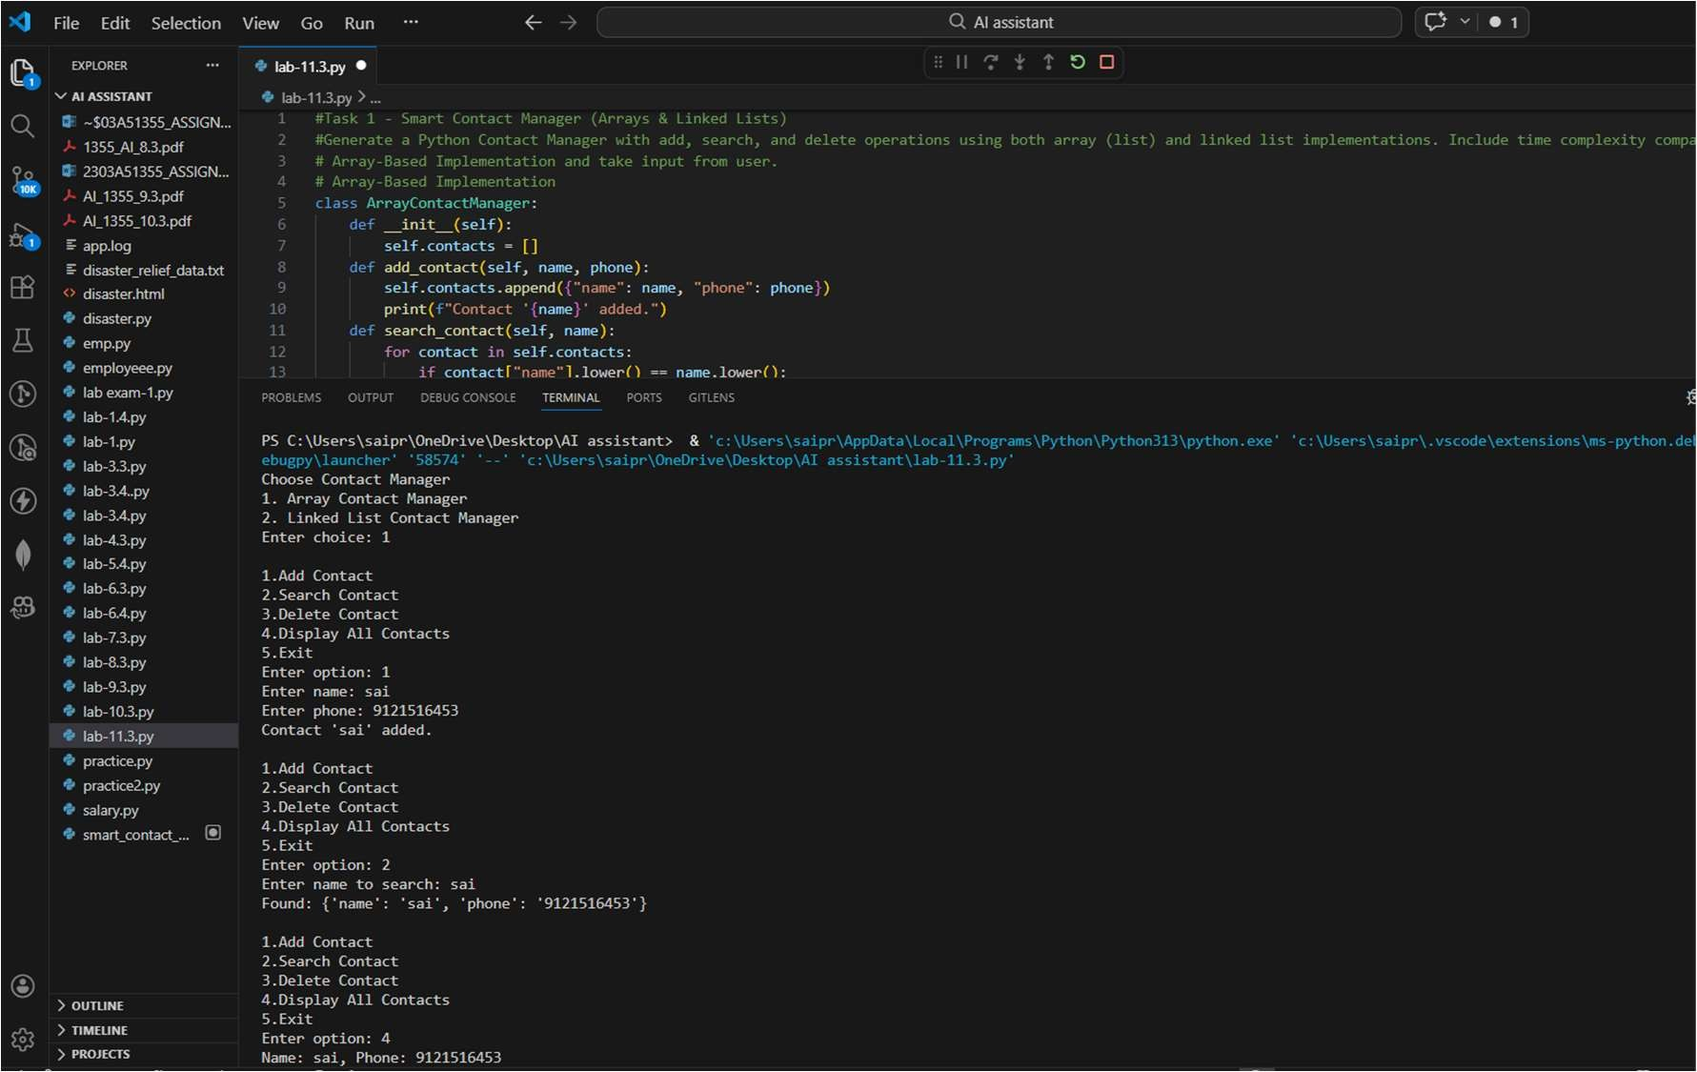
Code Analysis:
- Uses Array (Python list) and Linked List to store contact details (name, phone).
- Supports operations: add, search, delete, and display contacts.
- Array Implementation: Add  O(1), Search/Delete  O(n).
- Linked List Implementation: Add  O(n) (traverse to end), Search/Delete  O(n).
- Menu-driven program allows the user to manage contacts interactively.

Task-2
Prompt: Library Book Search System (Queue & Priority Queue)
#Generate a Python Queue for FIFO book requests and a Priority Queue that prioritizes faculty over student requests. Include enqueue and dequeue methods with test cases.

Code :
from collec ons import deque import heapq class BookRequestQueue:
def __init__(self):
self.queue = deque() def enqueue(self, requester, book): self.queue.append((requester, book)) print(f"Request added: {requester} -> '{book}'") def dequeue(self): if self.queue:
requester, book = self.queue.pople () print(f"Processing request: {requester} -> '{book}'")
else:
print("Queue is empty.") def display(self):
print("Current Queue:", list(self.queue)) # Priority Queue (Faculty = 0, Student = 1) class PriorityBookQueue: def __init__(self):
self.heap = [] self.counter = 0 def enqueue(self, requester, book, role):
priority = 0 if role.lower() == "faculty" else 1 heapq.heappush(self.heap, (priority, self.counter, requester, book)) self.counter += 1 print(f"[{role.upper()}] Request added: {requester} -> '{book}'") def dequeue(self):
if self.heap:
priority, _, requester, book = heapq.heappop(self.heap) role = "Faculty" if priority == 0 else "Student" print(f"Processing [{role}]: {requester} -> '{book}'")
else:
print("Priority queue is empty.") def display(self):
print("Priority Queue:", self.heap) print("Choose Queue Type") print("1. Simple Queue") print("2. Priority Queue") choice = int(input("Enter choice: ")) if choice == 1:
q = BookRequestQueue() while True:
print("\n1. Add Request") print("2. Process Request") print("3. Display Queue") print("4. Exit") op = int(input("Enter op on: ")) if op == 1:
name = input("Enter requester name: ") book = input("Enter book name: ")
q.enqueue(name, book)
elif op == 2:
q.dequeue() elif op == 3:
q.display() elif op == 4: break else: print("Invalid choice") else:
q = PriorityBookQueue() while True:
print("\n1. Add Request") print("2. Process Request") print("3. Display Queue") print("4. Exit") op = int(input("Enter op on: "))
if op == 1:
name = input("Enter requester name: ") book = input("Enter book name: ") role = input("Enter role (faculty/student): ")
q.enqueue(name, book, role) elif op == 2:
q.dequeue() elif op == 3:
q.display() elif op == 4:
break else:
print("Invalid choice")

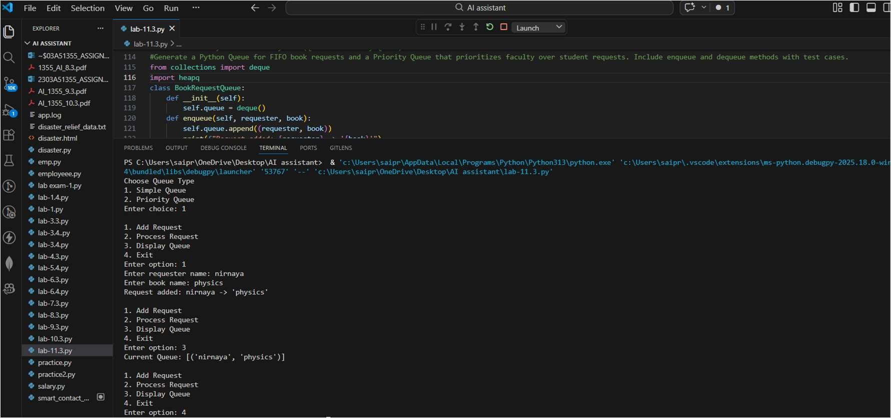
Code Analysis:
- Implements FIFO Queue using collec ons.deque for normal book requests.
- Implements Priority Queue using heapq where faculty requests have higher priority than students.
- Main operations: enqueue (add request) and dequeue (process request).
- Queue Complexity: Enqueue O(1), Dequeue O(1).
- Priority Queue Complexity: Enqueue O(log n), Dequeue O(log n).
Task-3
Prompt: Emergency Help Desk (Stack Implementation)
#Generate a Python Stack for IT Help Desk ticket management using LIFO. Include push, pop, peek, is_empty, and is_full operations. Simulate 5 tickets being raised and resolved.
.

Code :
class HelpDeskStack: def __init__(self, max_size=10):
self.stack = [] self.max_size = max_size def push(self, cket):
if self.is_full():
print("Stack is full. Cannot add cket.")
return
self.stack.append( cket) print(f"Ticket raised: '{ cket}'") def pop(self): if self.is_empty():
print("No ckets to resolve.")
return cket = self.stack.pop() print(f"Ticket resolved: '{ cket}'") def peek(self):
if self.is_empty():
print("Stack is empty.") return print(f"Top cket: '{self.stack[-1]}'") def is_empty(self):
return len(self.stack) == 0 def is_full(self):
return len(self.stack) >= self.max_size def display(self):
print("Current Tickets (top to bo om):", list(reversed(self.stack))) size = int(input("Enter maximum stack size: ")) hd = HelpDeskStack(size) while True:
print("\n1. Raise Ticket") print("2. Resolve Ticket") print("3. View Top Ticket") print("4. Display Tickets") print("5. Check Empty") print("6. Check Full") print("7. Exit") choice = int(input("Enter choice: ")) if choice == 1:
cket = input("Enter cket descrip on: ") hd.push( cket) elif choice == 2: hd.pop() elif choice == 3: hd.peek() elif choice == 4: hd.display()

elif choice == 5:
print("Is Empty:", hd.is_empty()) elif choice == 6:
print("Is Full:", hd.is_full()) elif choice == 7: print("Exi ng...") break
else:
print("Invalid choice")

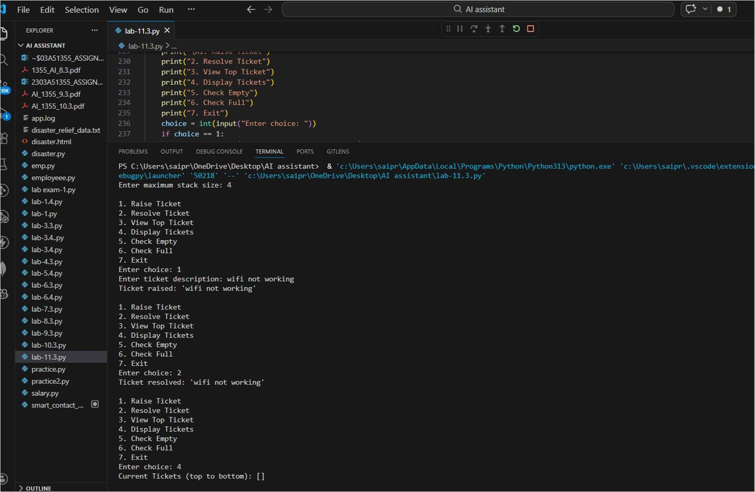
Code Analysis :
- Uses Stack (LIFO) to manage IT help desk ckets.
- Operations implemented: push, pop, peek, is_empty, is_full.
- Push: Adds new ticket to the top of stack.
- Pop: Resolves the most recent ticket first.
- Time Complexity: Push O(1), Pop O(1), Peek O(1).

Task-4
Prompt: Task 4 - Hash Table with Collision Handling (Chaining)
#Generate a Python Hash Table class with insert, search, and delete methods. Use chaining (linked list at each bucket) for collision handling. Add comments explaining each method.
Code : class HashTable: def __init__(self, size=10):
self.size = size self.table = [[] for _ in range(self.size)] def _hash(self, key):
return sum(ord(c) for c in str(key)) % self.size def insert(self, key, value): index = self._hash(key) bucket = self.table[index] for i, (k, v) in enumerate(bucket):
if k == key:
bucket[i] = (key, value) print(f"Updated: '{key}' = '{value}'") return
bucket.append((key, value)) print(f"Inserted: '{key}' = '{value}'") def search(self, key): index = self._hash(key) bucket = self.table[index] for k, v in bucket: if k == key: print(f"Found: '{key}' = '{v}'") return print(f"Key '{key}' not found.") def delete(self, key): index = self._hash(key) bucket = self.table[index]
for i, (k, v) in enumerate(bucket): if k == key: bucket.pop(i) print(f"Deleted: '{key}'") return print(f"Key '{key}' not found.") def display(self):
print("\n--- Hash Table ---") for i, bucket in enumerate(self.table):
if bucket:
print(f"Bucket {i}: {bucket}") print("------------------") size = int(input("Enter hash table size: ")) ht = HashTable(size) while True:
print("\n1. Insert") print("2. Search") print("3. Delete") print("4. Display") print("5. Exit") choice = int(input("Enter choice: ")) if choice == 1:
key = input("Enter key: ") value = input("Enter value: ") ht.insert(key, value) elif choice == 2: key = input("Enter key to search: ") ht.search(key)
elif choice == 3: key = input("Enter key to delete: ") ht.delete(key) elif choice == 4: ht.display() elif choice == 5: print("Exi ng...") break else: print("Invalid choice")

Output:
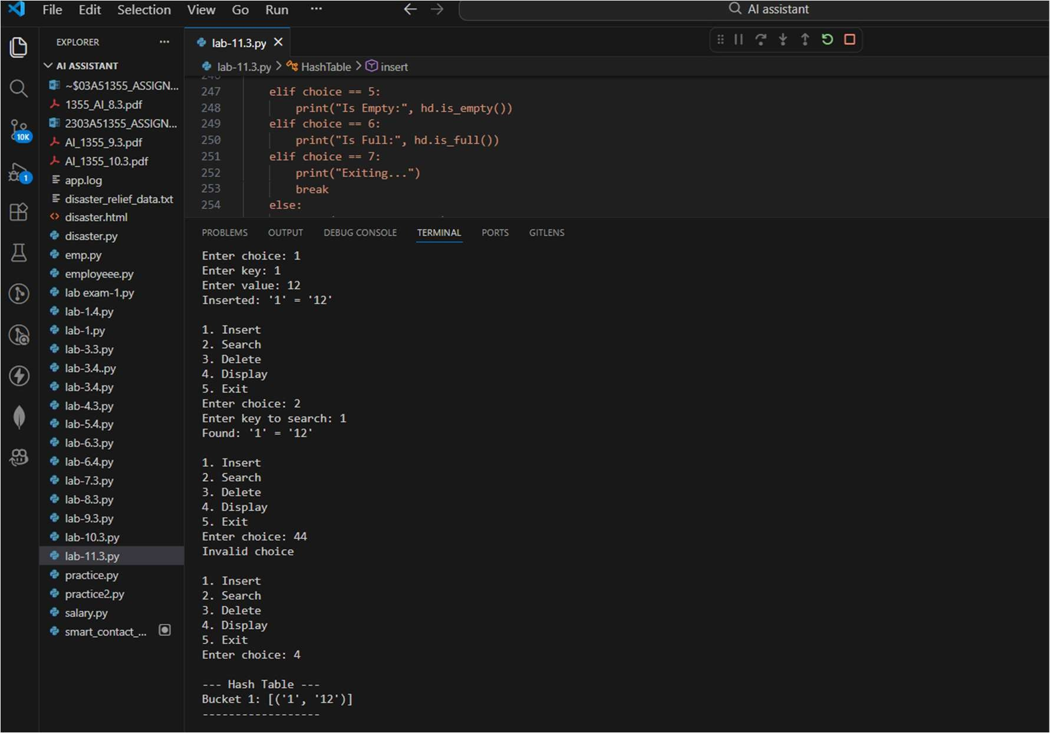
Code Analysis :
- Implements a Hash Table using chaining (list at each bucket).
- Uses a hash function based on ASCII values of the key.
- Supports insert, search, delete, and display operations.
- Handles collisions by storing multiple key-value pairs in the same bucket.
- Average Time Complexity: Insert/Search/Delete → O(1), Worst case O(n).
Task-5
Prompt: Campus Resource Management System
# Generate a Python Campus Resource Management System with: Student Attendance
Tracking (Hash Table), Event Registration (Queue), Library Book Borrowing (Priority Queue), Bus Scheduling (Queue), Cafeteria Order Queue (Stack). Implement one feature fully.

class HashTable: def __init__(self, size=10):
self.size = size self.table = [[] for _ in range(self.size)]

def _hash(self, key):
return sum(ord(c) for c in str(key)) % self.size

def insert(self, key, value): index = self._hash(key) bucket = self.table[index]

for i, (k, v) in enumerate(bucket): if k == key:
bucket[i] = (key, value) print(f"Updated: '{key}' = '{value}'")
return

bucket.append((key, value))
print(f"Inserted: '{key}' = '{value}'")

def search(self, key): index = self._hash(key) bucket = self.table[index]

for k, v in bucket: if k == key: print(f"Found: '{key}' = '{v}'") return
print(f"Key '{key}' not found.")

def delete(self, key): index = self._hash(key) bucket = self.table[index]

for i, (k, v) in enumerate(bucket): if k == key: bucket.pop(i) print(f"Deleted: '{key}'") return
print(f"Key '{key}' not found.")

def display(self):
print("\n--- Hash Table ---") for i, bucket in enumerate(self.table): if bucket:
print(f"Bucket {i}: {bucket}") print("------------------")

# ---- User Input ---- print("=== Hash Table ===")

size = int(input("Enter hash table size: ")) ht = HashTable(size)

n = int(input("Enter number of elements to insert: "))

for i in range(n):
key = input("Enter key: ") value = input("Enter value: ") ht.insert(key, value)

ht.display()

search_key = input("Enter key to search: ") ht.search(search_key)

delete_key = input("Enter key to delete: ") ht.delete(delete_key)

ht.display()

Output :
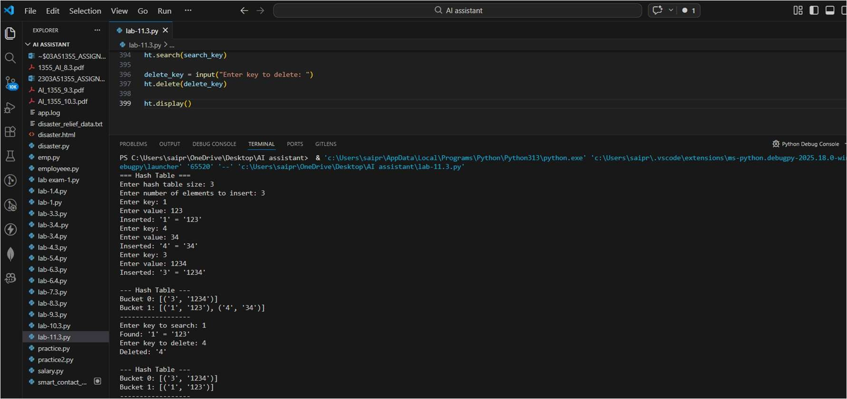
Code Analysis :
- Simulates campus systems like attendance tracking, event registration, book borrowing, bus scheduling, and cafeteria orders.
- Uses multiple data structures: Hash Table, Queue, Priority Queue, and Stack.
- Fully implements Student Attendance Tracking using a Hash Table.
- Allows inserting, searching, deleting, and displaying attendance records. ➢ Demonstrates efficient data storage and quick retrieval using hashing.

