Assignment: 5.4
Name: N.PRASHANTH
Hno: 2303A51063

Task Description #1:
• Prompt GitHub Copilot to generate a Python script that collects
user data (e.g., name, age, email). Then, ask Copilot to add
comments on how to anonymize or protect this data.

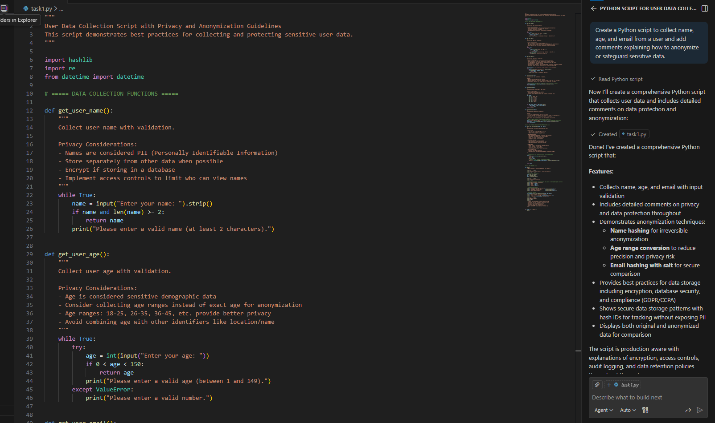
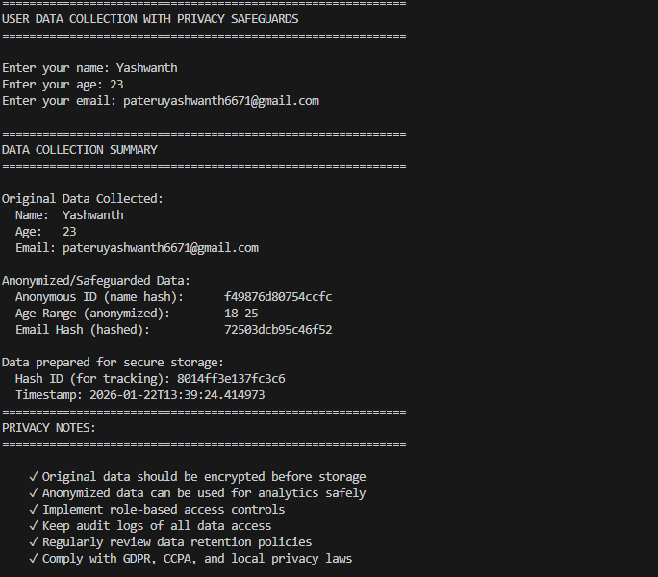
Task Description #2:
• Ask Copilot to generate a Python function for sentiment analysis.
Then prompt Copilot to identify and handle potential biases in the
data.
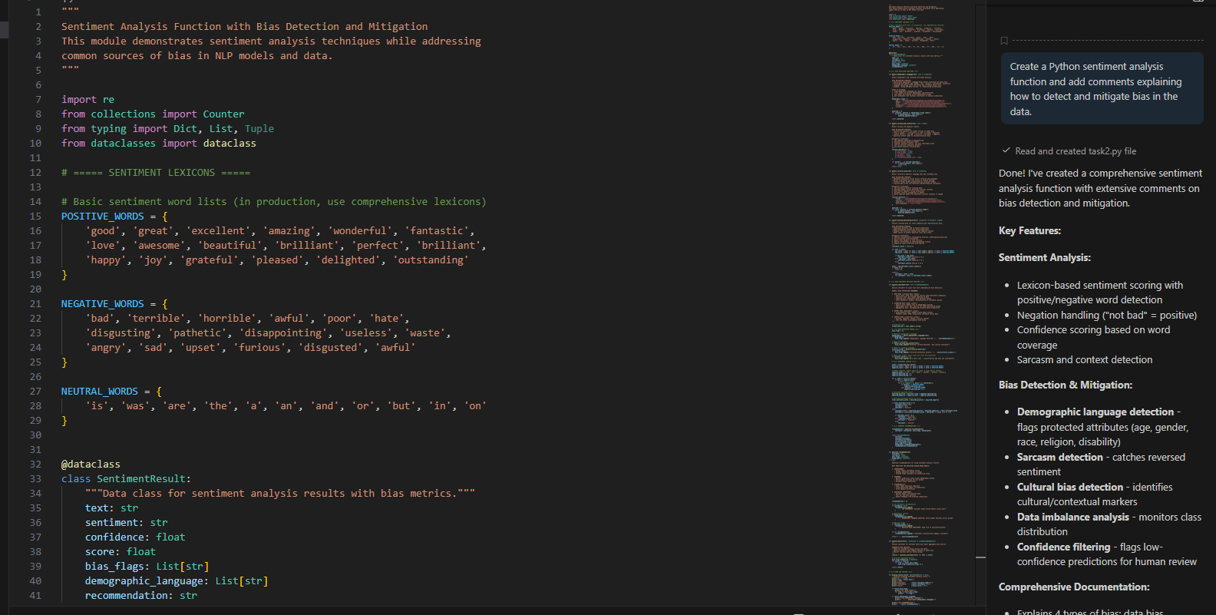
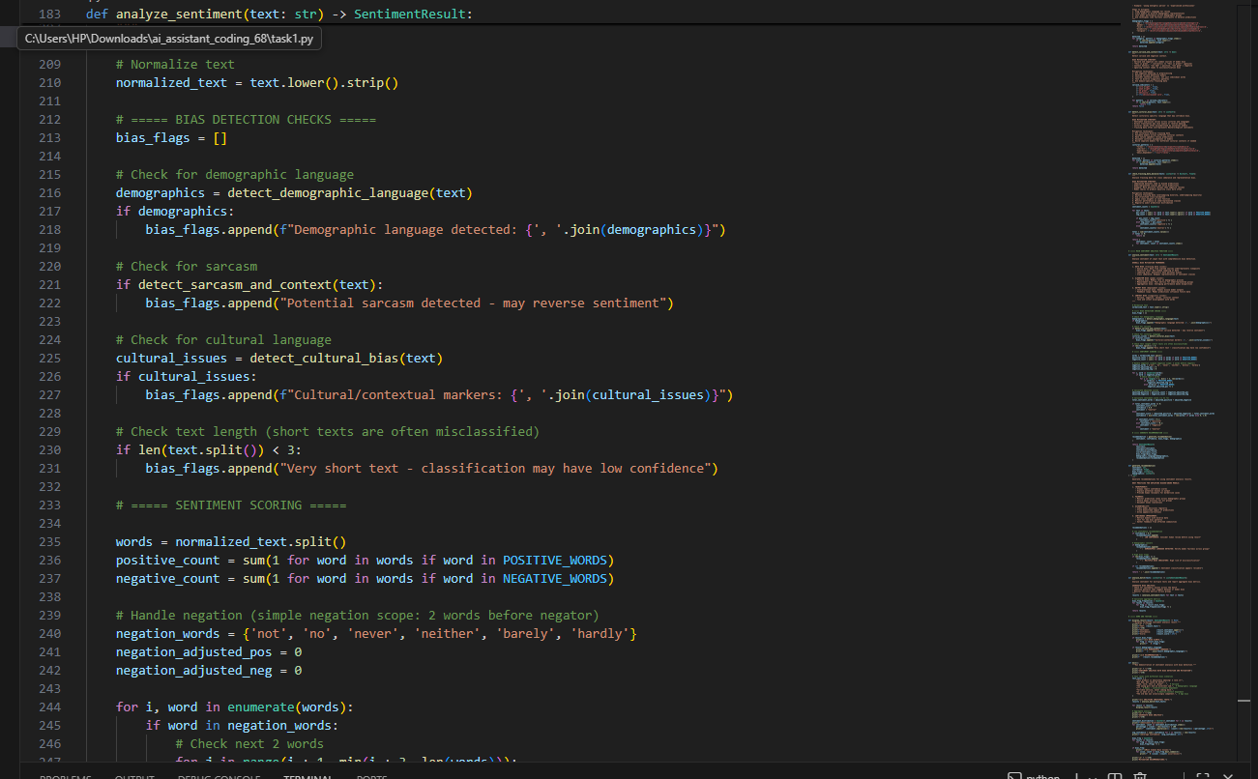
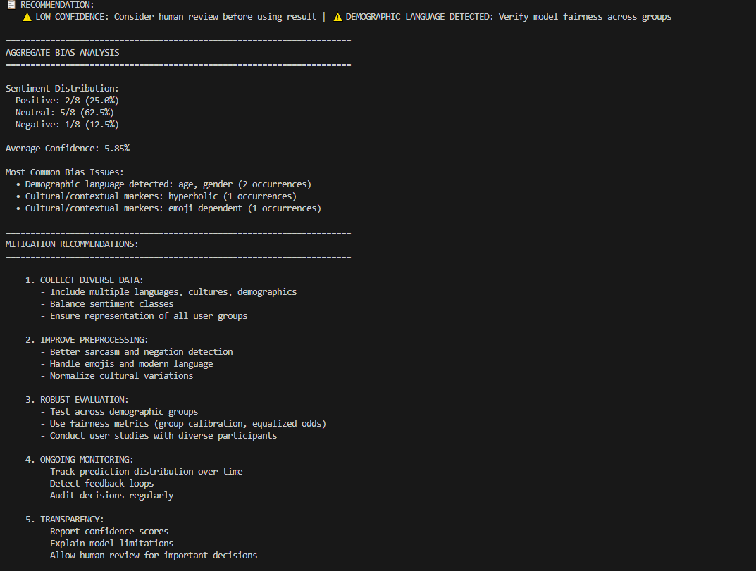

Task Description #3:
• Use Copilot to write a Python program that recommends
products based on user history. Ask it to follow ethical guidelines
like transparency and fairness.
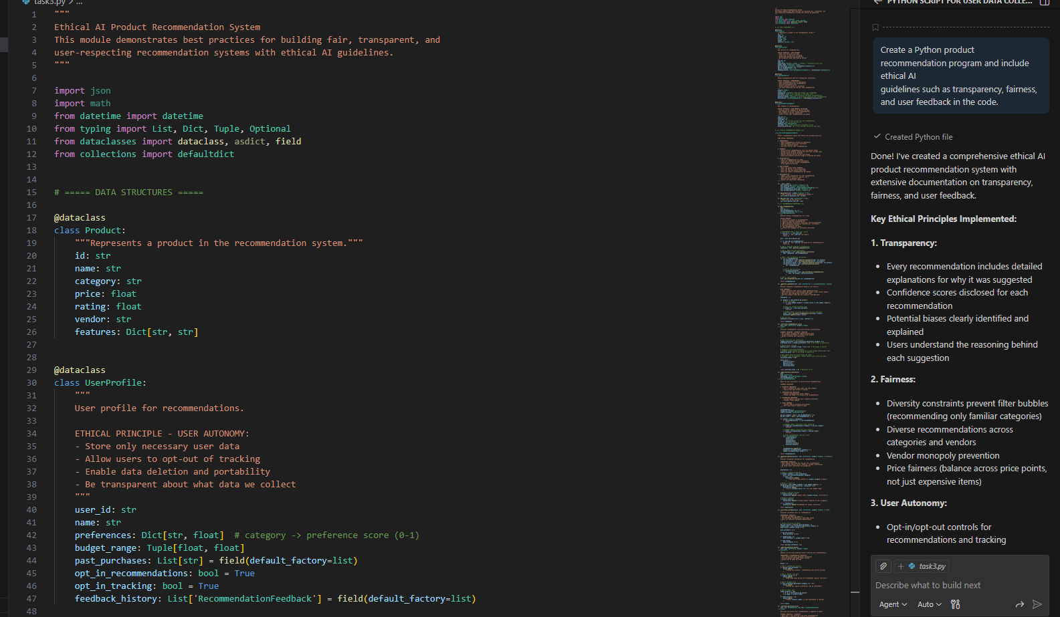
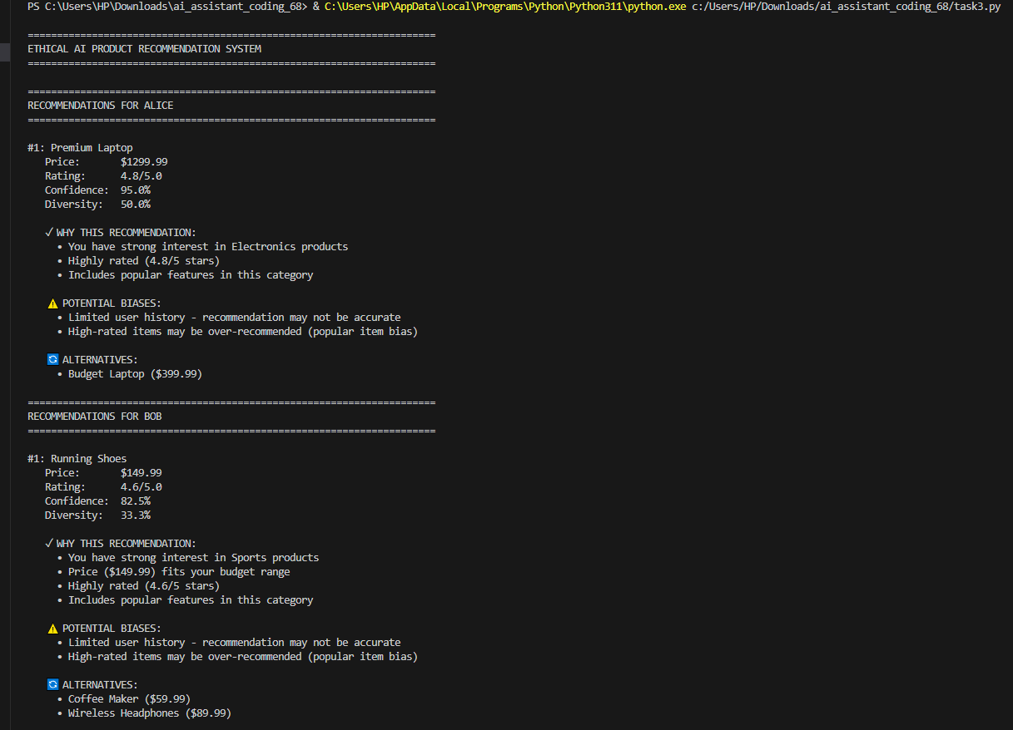
Task Description #4:
• Prompt Copilot to generate logging functionality in a Python web
application. Then, ask it to ensure the logs do not record sensitive
information.

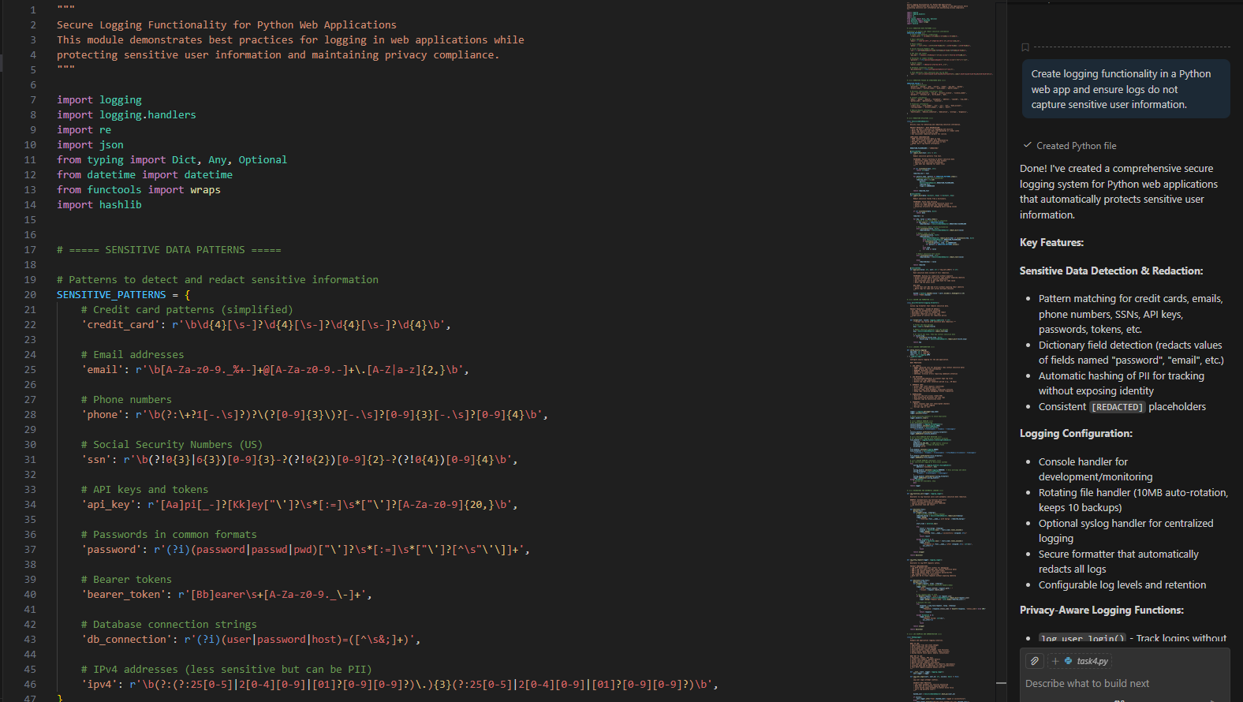
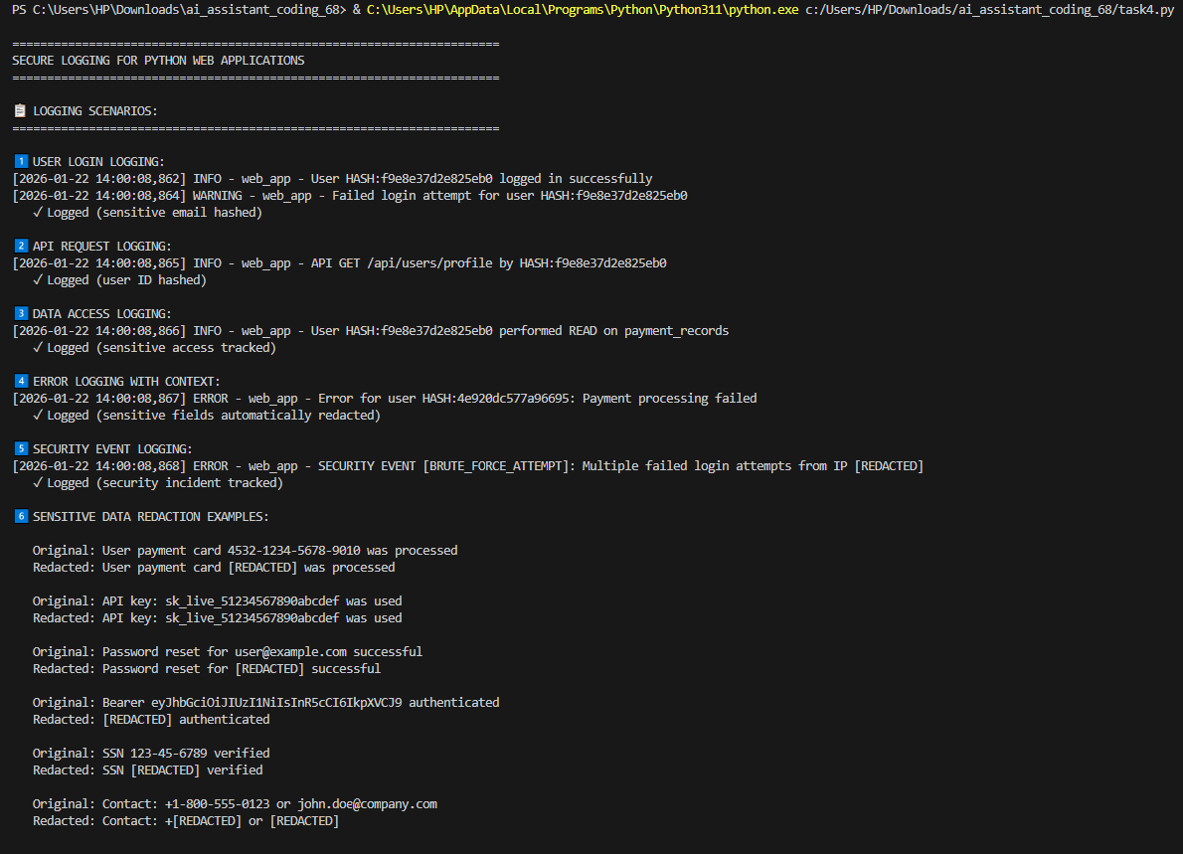
Task Description #5:
• Ask Copilot to generate a machine learning model. Then, prompt
it to add documentation on how to use the model responsibly
(e.g., explainability, accuracy limits).
